PRESENTING CLINICAL SIGNS

History: P transferred from rDVM yesterday for HGE and Pancreatitis

Abnormal lab-work values:
ALT: 934
T-Bili: 1.5
Phos: 12.7
Mild Azotemia
Calcium, TP, Alb, Glob, and Chol are all low. CPL positive

ULTRASONOGRAPHIC EXAMINATION OF THE ABDOMEN

Urinary System
The urinary bladder is moderately distended with anechoic urine, and no luminal sediment is present. The ureteral papillae, trigone and pelvic urethra are of normal appearance, and the ureters are not visible (normal). No masses, calculi or mucosal irregularities are noted.

The kidneys are of normal size and shape and exhibit appropriate corticomedullary differentiation with a normal 1:3 cortex to medulla ratio. There is no evidence of nephrolithiasis, mineralization, pyelectasia, cystic change or hydronephrosis. The proximal ureter is not visible (normal). The left kidney is 4.1 cm in length. The right kidney is 4.4 cm in length.

Adrenal Glands
The left adrenal gland is identified in its normal location. It is of normal size and shape with appropriate parenchymal echogenicity and normal phrenic vasculature. The left adrenal gland height is 3.4 mm at the cranial pole and 4.3 mm at the caudal pole. The right is not distinctly visualized, but the region appears unremarkable.

Spleen
The spleen is of appropriate size and has a normal, homogenous parenchyma with a smooth, continuous capsular surface. The splenic vasculature is normal with no evidence of congestion or thrombosis, and blood flow through the splenic hilus appears normal.

Liver
The liver is of appropriate size and shape, with a diffusely hypoechoic parenchyma and increased portal markings. The portal and hepatic vasculature are of normal size and appearance with no evidence of congestion or thrombosis.

The gallbladder is moderately distended with anechoic contents and a small amount of anechoic sludge. There is a hypoechoic halo surrounding the gall bladder wall, consistent with gallbladder wall edema. The wall is thin and continuous with no evidence of rupture. The cystic duct is not seen (normal).

Gastrointestinal
The stomach is empty. The gastric wall is 2.8 mm with normal deviations due to rugal folds and exhibits appropriate wall layering. The pylorus is of normal appearance.

The visualized portions of the duodenum, jejunum, and ileum are of normal thickness with intact wall layering that exhibits the appropriate 1:3 muscularis to mucosa ratio. There is diffuse mucosal speckling noted within the intestinal wall. The duodenal wall measures 4.0 mm. The jejunal wall measures up to 3.0 mm. Intestinal motility appears normal.

The visible portions of the colon are of normal thickness with intact wall layering. The ileocecal junction is visualized and appears normal.

Pancreas
The left and right limbs of the pancreas is swollen and hypoechoic, surrounded by hyperechoic mesenteric fat. The pancreatic duct appears normal.

Free Abdomen
There is no evidence of free fluid within the peritoneal cavity. The mesenteric lymph nodes are prominent, but still within the normal limits of size at 1.0 cm, with a normal long: short axis ratio and appropriate echogenicity. The aortic trifurcation has normal blood flow with no evidence of thrombosis.

ULTRASONOGRAPHIC FINDINGS

Primary Findings

- Diffusely hypoechoic liver and edematous gallbladder wall, consistent with cholangiohepatitis

- Diffuse mucosal speckling within the small bowel, consistent with inflammation

- Diffusely hypoechoic swollen pancreas

Secondary Findings

- Reactive mesenteric lymph nodes

INTERPRETATION OF THE FINDINGS & FURTHER RECOMMENDATIONS

The appearance of the liver and gallbladder are consistent with cholangiohepatitis. If the albumen is <2.0, then the hypoproteinemia may also contribute to the appearance of the gallbladder wall. Recommendations include:

- Bile acid testing is recommended to further assess severity of hepatic disease.
- Initiation of liver support therapies such as SAMe, Vitamin E and ursodiol
- Broad spectrum antibiotic therapy, such as a combination of amoxicillin or amoxi-clav, in combination with a fluoroquinolone, is recommended. If recheck lab values in 1 week show significant improvement, then a 4–6-week total course of antibiotics is recommended.

The changes in the pancreas are consistent with acute pancreatitis. Recommendations include:

- Supportive care including fluid therapy, antiemetics, analgesics, appetite stimulants (if needed) are warranted.
- A highly digestible, low fat intestinal diet should be encouraged as soon as vomiting can be controlled.
- Complications such as hypoalbuminemia, hyperglycemia and hypokalemia should be managed as they arise.
- If the patient is not responding to medical management, fine needle aspiration with a 25G needle for cytology could be considered after first checking a coagulation profile.

The changes in the small intestines are consistent with inflammations, and given the panhypoproteinemia and low cholesterol, protein-losing nephropathy is deemed likely. If not already performed, a urinalysis would be recommended to rule out protein-losing nephropathy. Additional recommendations include:

- Fecal parasite testing and empiric fenbendazole treatment
- Trials with an ultra-low-fat diet. Some patients may require a hydrolyzed diet, if not responding to initial therapy.
- A complete GI panel, or empiric cobalamin supplementation
- A resting cortisol level is recommended to screen for atypical hypoadrenocorticism, and can be included as part of the Gi panel to Texas A&M. Alternately a urine cortisol:creatinine ratio can be used to screen for hypoadrenocorticism.
- Empiric therapy with prednisolone at 2-4mg /kg initial dose should be instituted if biopsies are not pursued. Given the concern for bacterial infection in the liver, it may be prudent to delay corticosteroids therapy for several days to see whether there is improvement in liver values first.
- Clopidogrel at 1-2mg/kg once daily if albumin levels are <2.0
- Abdominocentesis could be performed for patient comfort if needed.
- Plasma or colloid therapy if clinically significant pleural effusion is present.
- Definitive diagnosis would require biopsy of the affected tissue, ideally with intra-operative ultrasonographic guidance. If there is concurrent lymphadenopathy, ultrasound-guided sampling of the lymph node using a 25 or 22g needle could be considered.

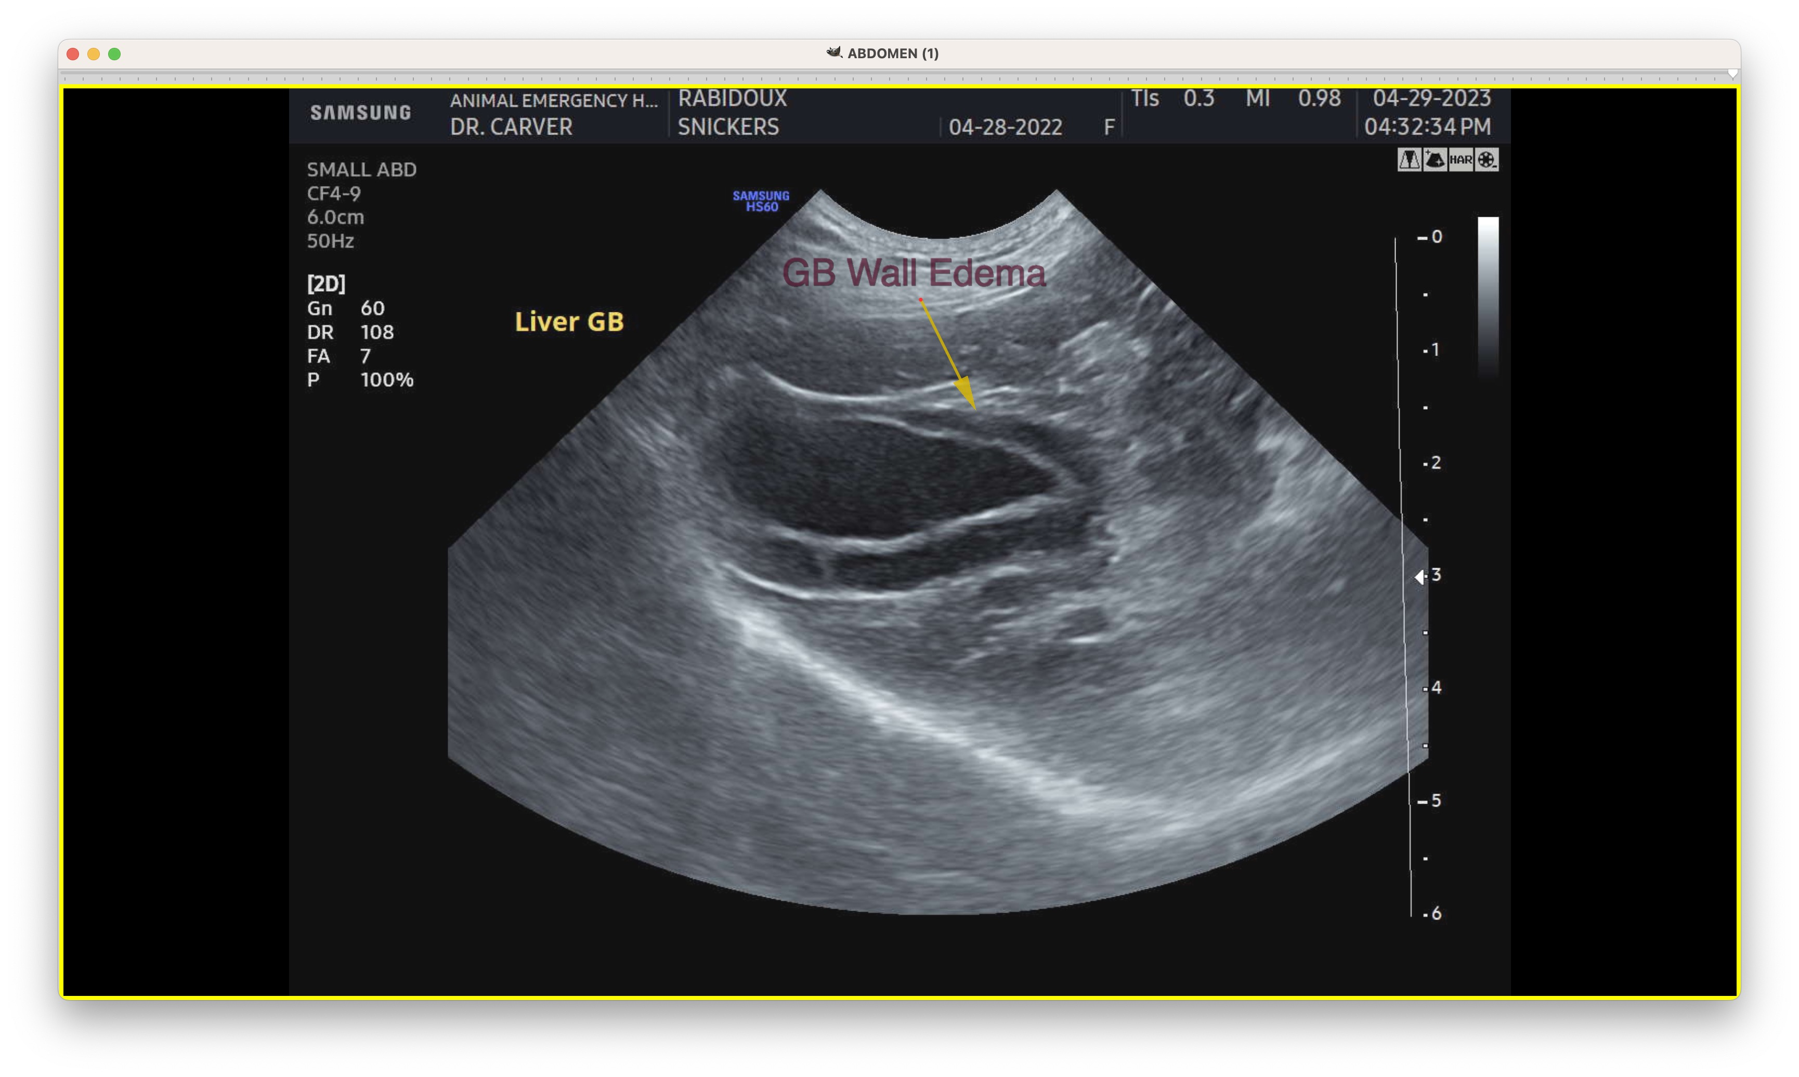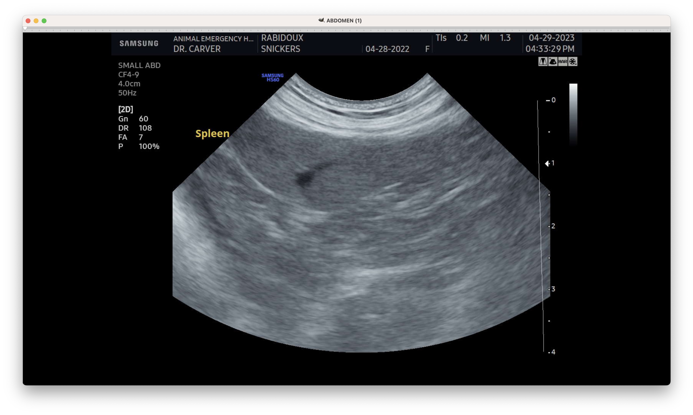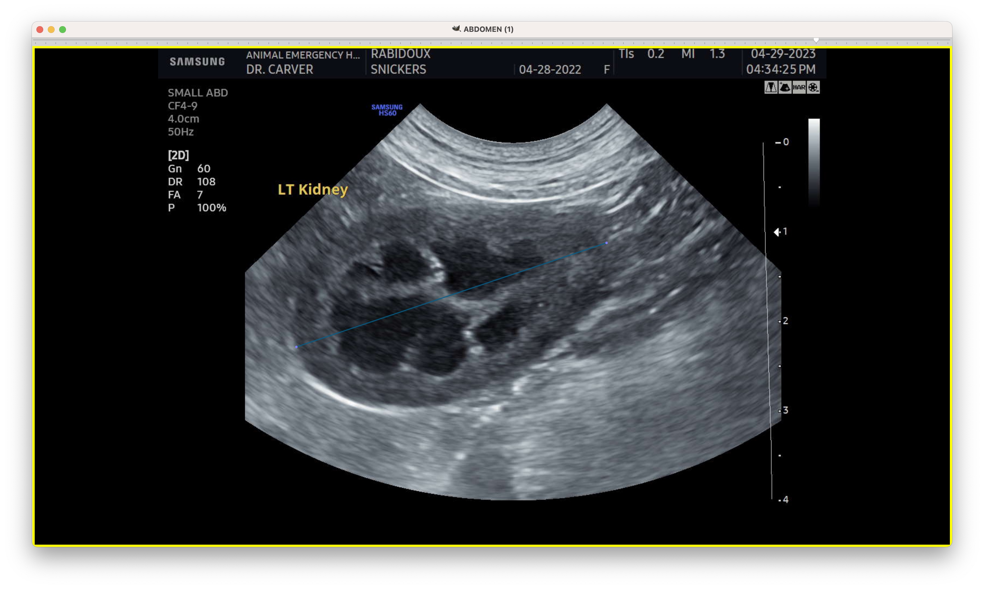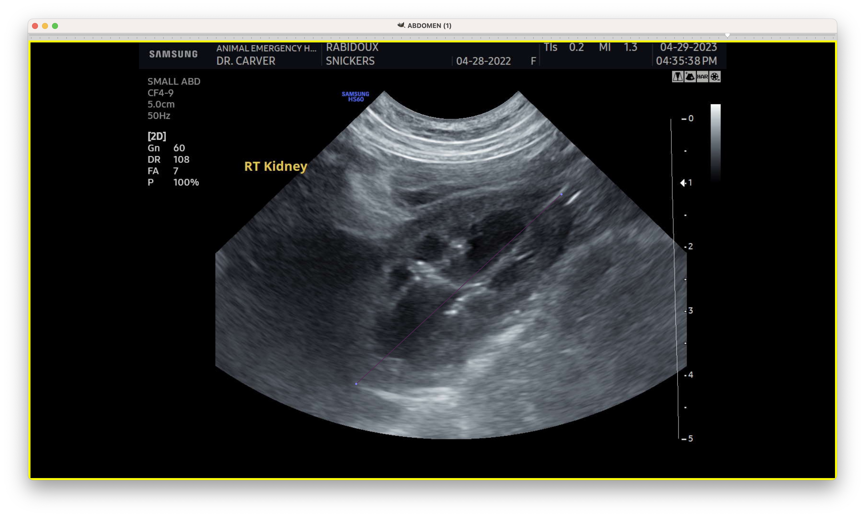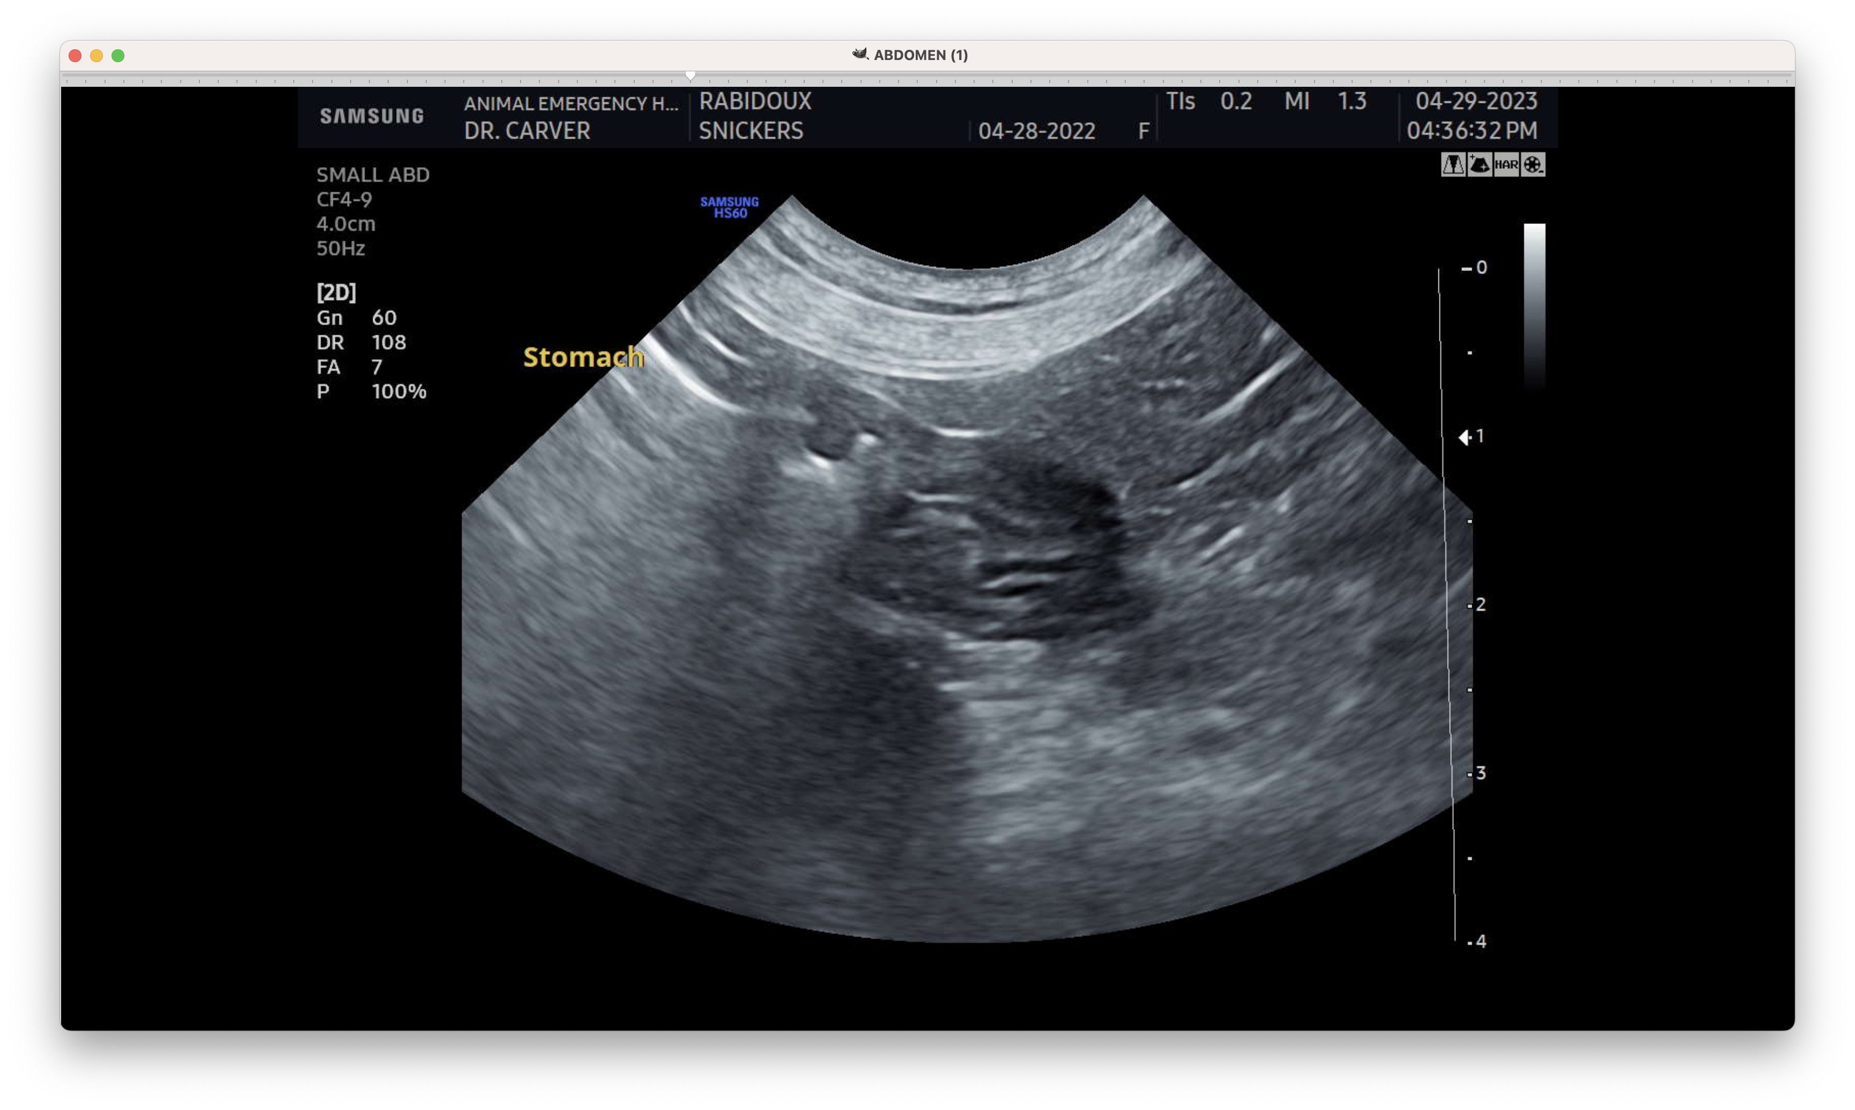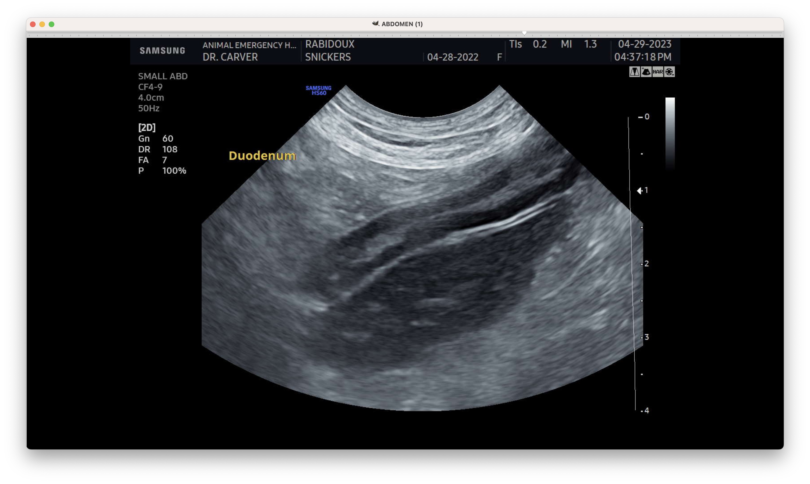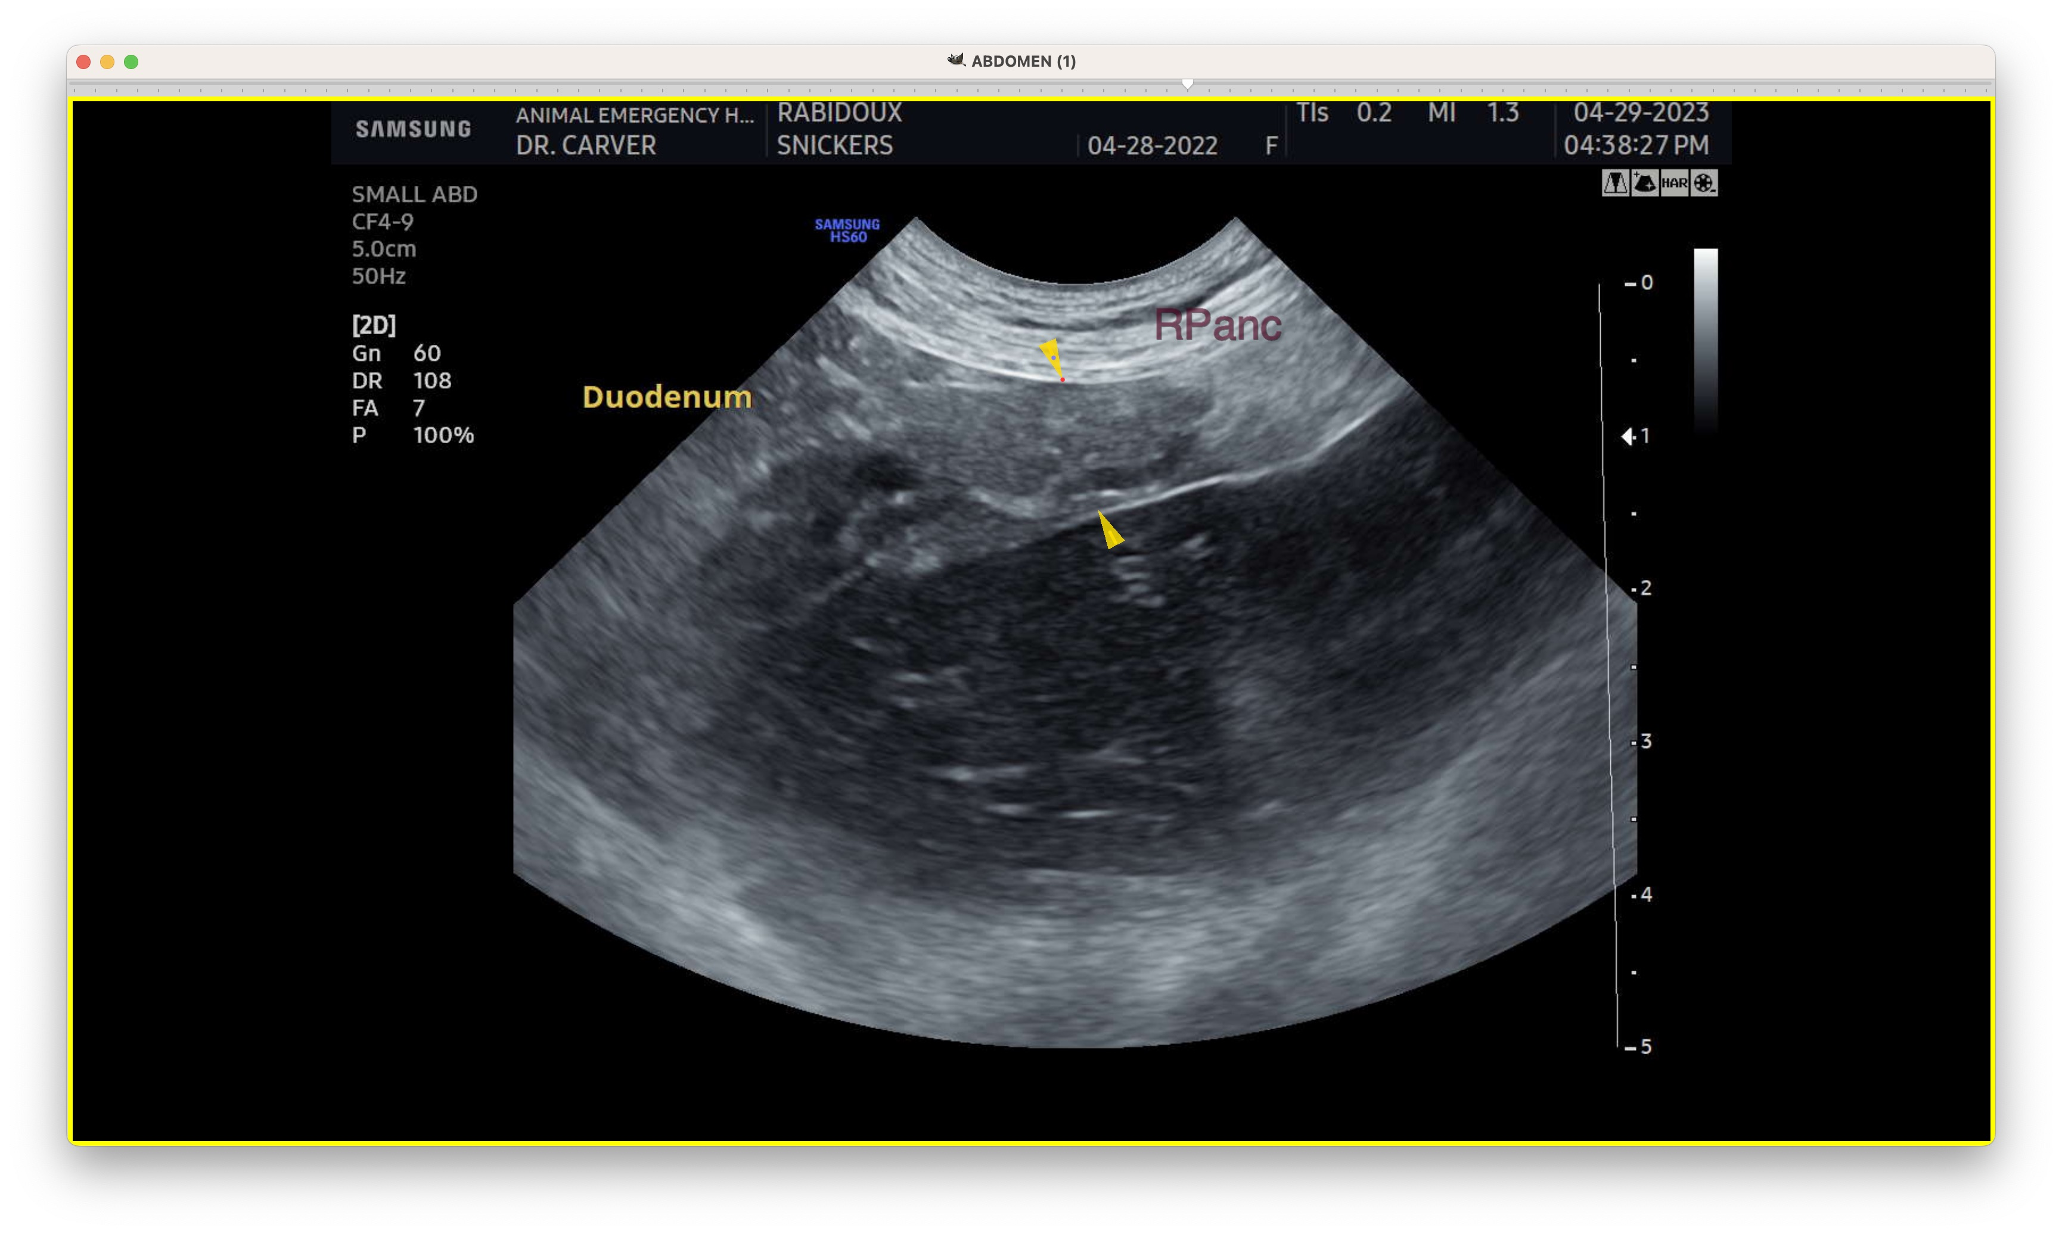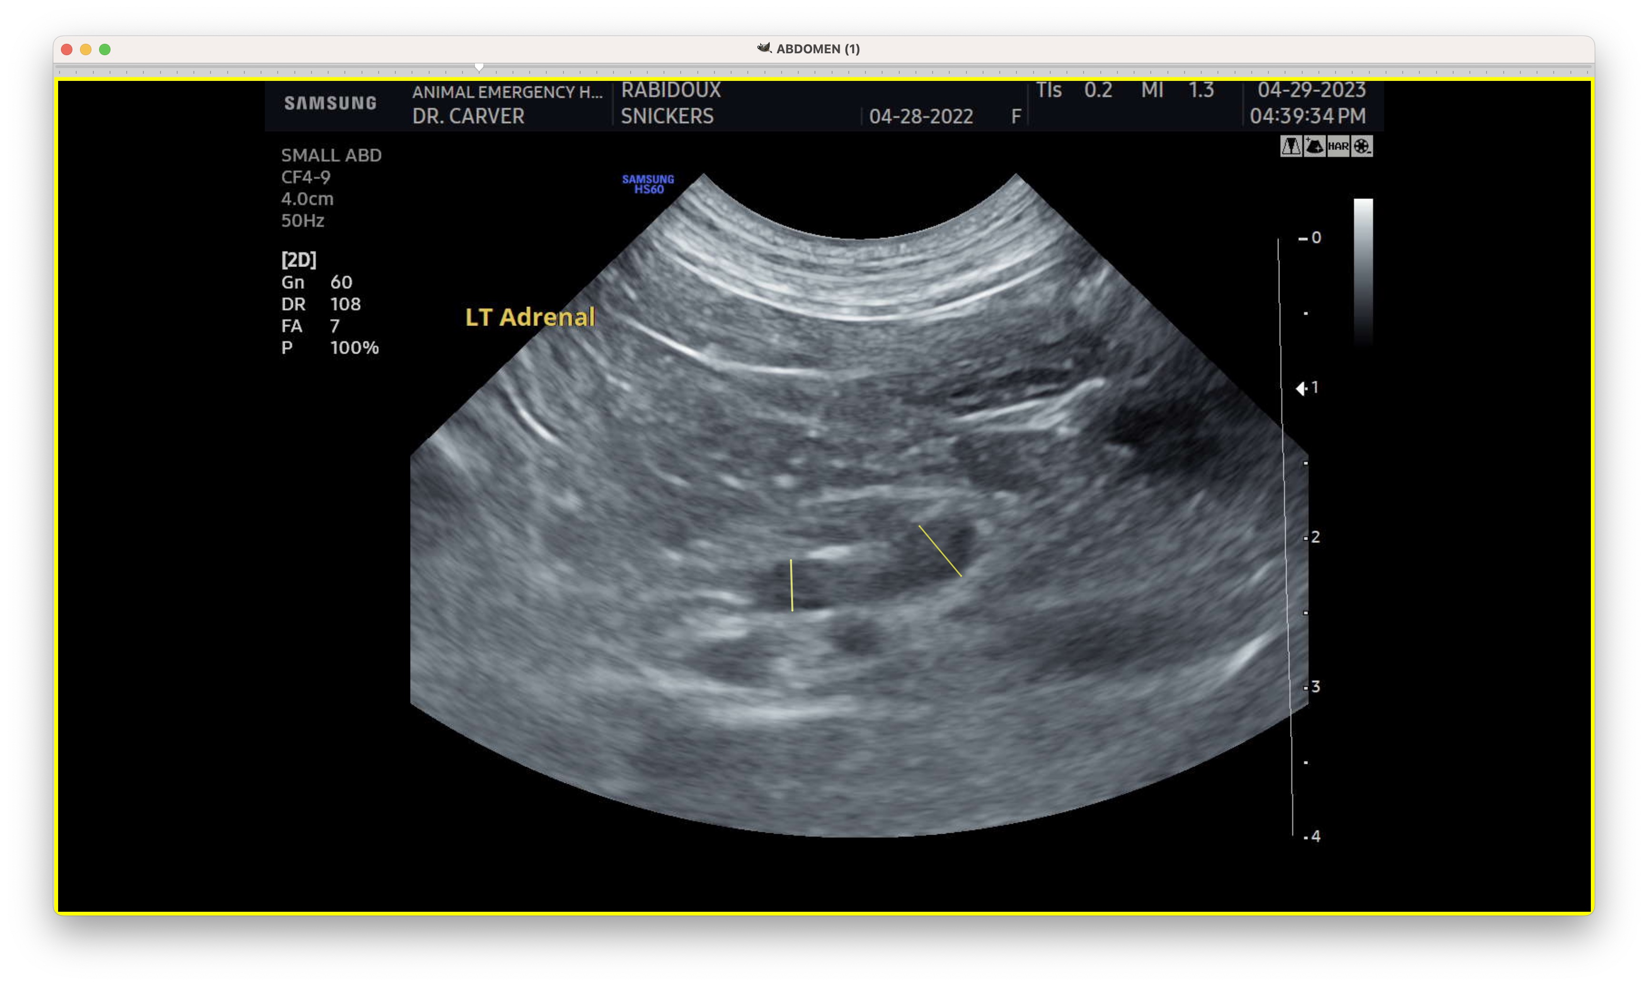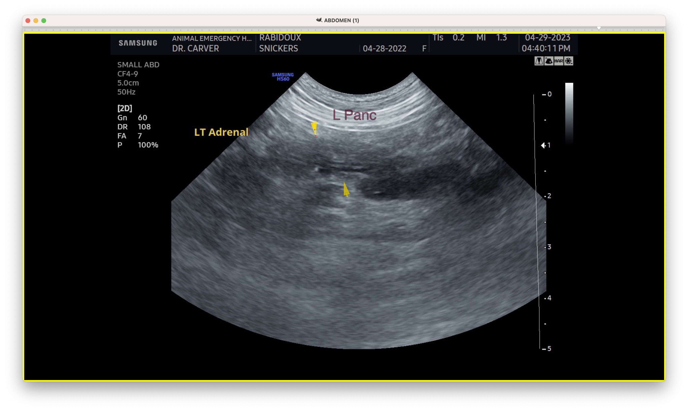
The information and recommendations provided are based on the images presented by the referring veterinarian. No evaluation can be communicated regarding pathology that was not visible in the image/video clips provided.

Thank you for this referral. If the clinical or image interpretation does not parallel your findings or if I can be of any further assistance, please contact me.
Tam Mengine, DVM, DABVP (canine/feline practice) info@SonoPath.com

