PRESENTING CLINICAL SIGNS
History: 18yr FS Russian Blue presented to clinic for ADR. Owners returned home tonight after 2-week vacation and noticed patient hiding under bed. When owner got patient out from under bed, patient was leaning to left side and not walking well. Eating normal and drinking a lot of water. Owner states patient had similar episode 3-4 years ago, diagnostics and MRI performed, no cause found. Improved on Pred, has been off medications for past 2 years.
Abnormal PE/Chem/CBC/UA Results: CBC: lymphopenia COMP: severe azotemia (BUN 298, creatinine 16), hyperphosphatemia (27), hyperglobulinemia (5.7), increased tBili (1.0) EPOC: metabolic acidosis with respiratory compensation, hyponatremia (141), hyperkalemia (7.7), hypocalcemia (0.93), azotemia (BUN too high to read, crea >150) ProBNP: Abnormal FPLi: Abnormal PCV/TS: 32%, 10.4g/dL Blood Pressure: 141/103 M:116 165/89 M:111 138/116 M:123 Radiographs: -Stomach is moderately distended with gas. Small intestines are normal in size, shape and distribution and predominantly gas-filled. Colon is filled with a large amount of gas and mild amount of formed fecal material. -Serosal contrast is adequate. -Liver, spleen and visible kidneys are within normal limits. -Cardiovascular structures, pleura and mediastinum are within normal limits. -Mild diffuse bronchial pulmonary pattern. -Multifocal spondylosis deformans, typically clinically insignificant. Conclusion -Lower airway disease such as feline asthma. -Radiographically normal cardiovascular structures. This does not exclude compensated cardiac disease. Consider further evaluation with echocardiogram, if clinically indicated. -Increased gas throughout the gastrointestinal tract is often associated with nonobstructive gastroenterocolitis. Urinalysis: S.G: 1.018 Leukocytes: +++500 pH: 6.5 Epithelial and Transitional cells present, renal cells, rod and cocci bacteria
ULTRASONOGRAPHIC EXAMINATION OF THE ABDOMEN

Urinary System
The urinary bladder is moderately distended with anechoic urine, and no luminal sediment is present. The ureteral papillae, trigone and pelvic urethra are of normal appearance, and the ureters are not visible (normal). No masses, calculi or mucosal irregularities are noted. Urethra visualized to 2.0 cm.

Both kidneys are hyperechoic and exhibit poor cortico-medullary differentiation. There is moderate dilation of the renal pelvis, with anechoic contents. There is no evidence of nephrolithiasis, mineralization, or hydronephrosis. The proximal ureters are not visible (normal). The left kidney is 1.8 cm in length. The right kidney is 2.1 cm in length.

Adrenal Glands
The left adrenal gland is identified in its normal location. It is of normal size and shape with appropriate parenchymal echogenicity and focal mineralization, which is a normal variation for a cat. The left adrenal gland height is 5.4 mm at the caudal pole. The right adrenal gland is not distinctly visualized, but the region appears unremarkable.

Spleen
The spleen is of appropriate size and has a normal, homogenous parenchyma with a smooth, continuous capsular surface. The splenic vasculature is normal with no evidence of congestion or thrombosis, and blood flow through the splenic hilus appears normal. Thickness at the splenic hilus is normal at 8.0 cm.

Liver
The liver is of appropriate size and shape, with sharp borders and a mildly coarse parenchymal echotexture that is hypoechoic to the spleen. The portal and hepatic vasculature are of normal size and appearance with no evidence of congestion or thrombosis.

The gallbladder is moderately distended with anechoic contents. The wall was thin and continuous with no focal lesions. The cystic and common bile ducts are normal / not visible.

Gastrointestinal
The stomach is partially distended with hypoechoic fluid. The gastric wall is 2.3 mm with normal deviations due to rugal folds and exhibits appropriate wall layering. The pylorus is of normal appearance.

The small bowel has focal changes to the normal 1:3 muscularis to mucosa ratio. Wall measurements are normal up to 2.6 mm for duodenum and 2.2 mm for jejunum. Overall wall layering is preserved. Intestinal motility appears normal.

The visible portions of the colon are of normal thickness, up to 1.1 mm, with intact wall layering. The ileocecal junction is visualized and appears normal.

Pancreas
The left and right limbs of the pancreas are hypoechoic, but of normal size and with no changes to the surrounding mesenteric fat. There is no evidence of peripancreatic inflammation. The pancreatic duct appears normal.

Free Abdomen
There is no evidence of free fluid within the peritoneal cavity. The omentum and intra-abdominal fat are of appropriate echogenicity. Enlarged abdominal lymph nodes are not observed. The aortic trifurcation has normal blood flow with no evidence of thrombosis.

ULTRASONOGRAPHIC FINDINGS

Primary Findings

- Bilaterally small, chronically diseased kidneys with pyelectasia

- Diffusely mottled in appearance hypoechoic pancreas, consistent with either pancreatis or normal aging change

Secondary Findings

- Prominent small intestinal muscularis layer, consistent with infiltrative bowel disease

INTERPRETATION OF THE FINDINGS & FURTHER RECOMMENDATIONS

The changes to both kidneys are severe, and there is likely an element of acute-on-chronic renal failure present. Given the active urine sediment and presence of pyelectasia, pyelonephritis is possible. Additional recommendations include:

- Urine culture
- If pyelonephritis is suspected, then empiric antimicrobial therapy may be started while awaiting culture results. The International Society for Companion Animal Infectious Diseases (ISCAID) Working Group recommends fluoroquinolones or cefpodoxime as initial empiric treatment choices, with a total therapy duration of 10 - 14 days.
- Chronic cases of pyelonephritis may require longer courses of treatment than the recommended 10 -14 days. Historically, treatment for up to 4-6 weeks has been recommended, with follow up culture shortly after discontinuation of therapy.

While the changes to the pancreas can be normal in an older cat, given the elevated pancreatic lipase, concurrent pancreatitis is suspected. Additional recommendations include:

- Supportive care including fluid therapy, antiemetics, analgesics, appetite stimulants (if needed) and cobalamin supplementation are warranted.
- A highly digestible intestinal diet is recommended.
- If the patient is not responding to medical management, fine needle aspiration with a 25G needle for cytology could be considered after first checking a coagulation profile.

The changes to the small intestines are mild and may be incidental. A GI panel may be helpful in determining the significance of this change. Intestinal biopsies would be needed for definitive diagnosis.
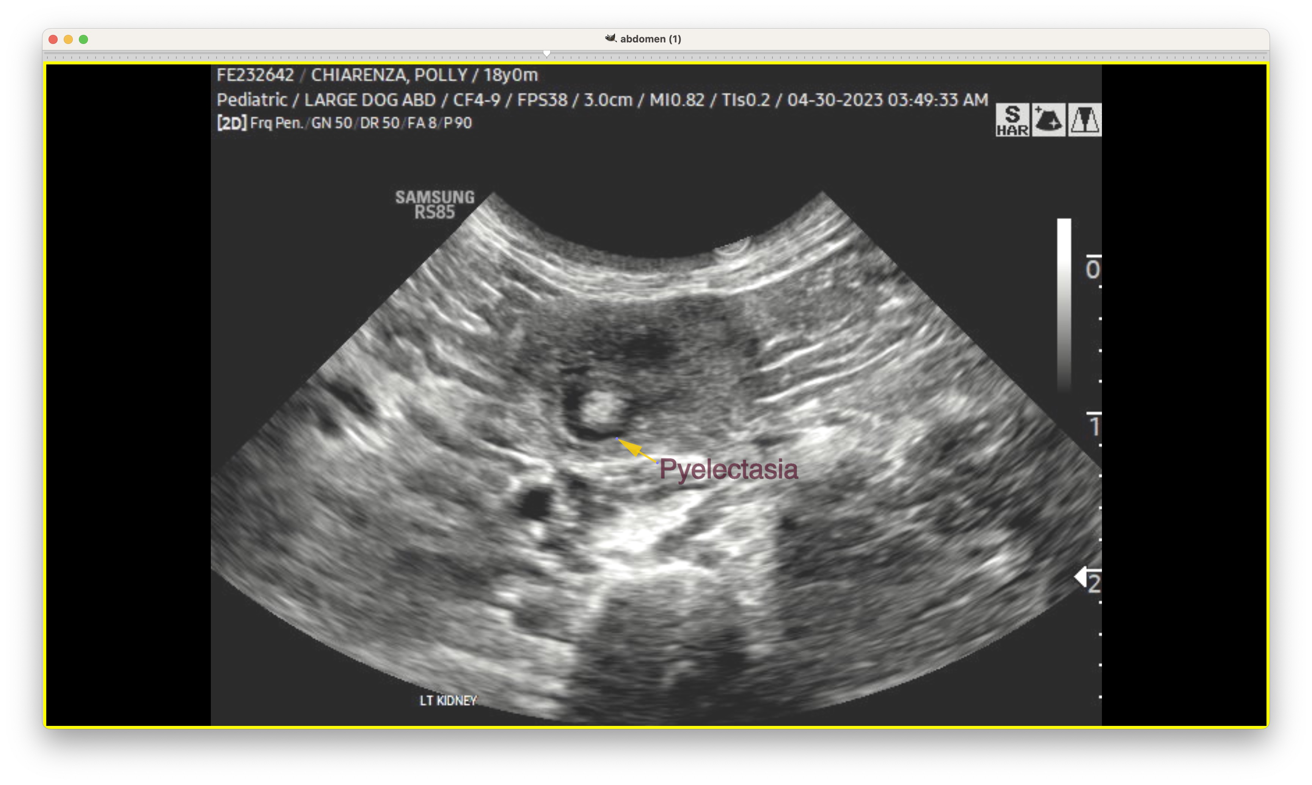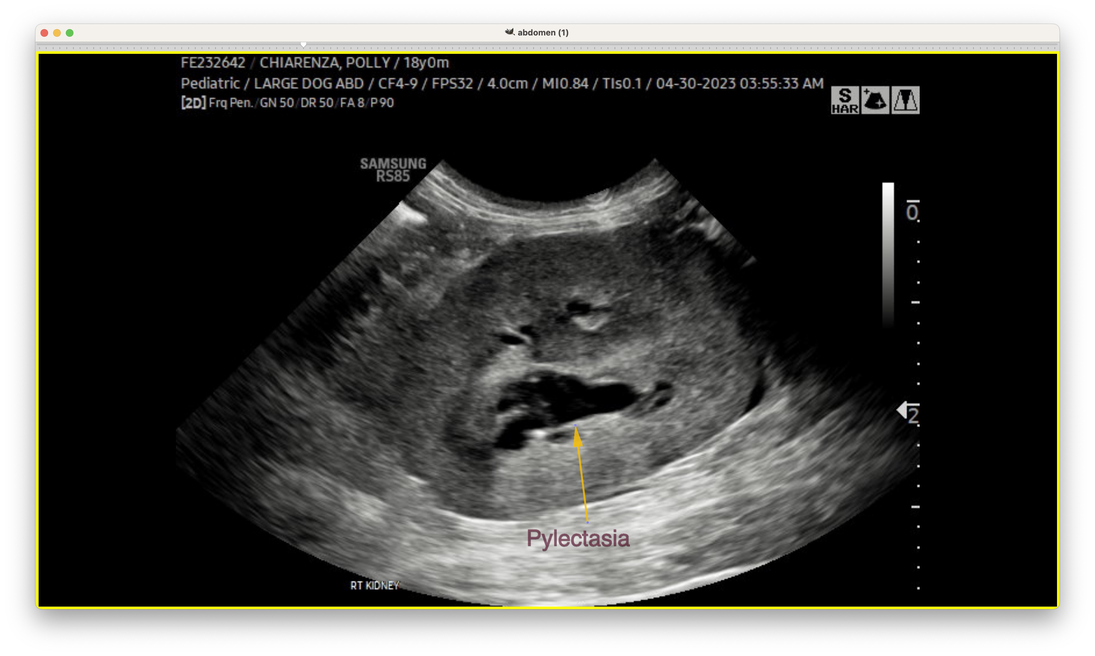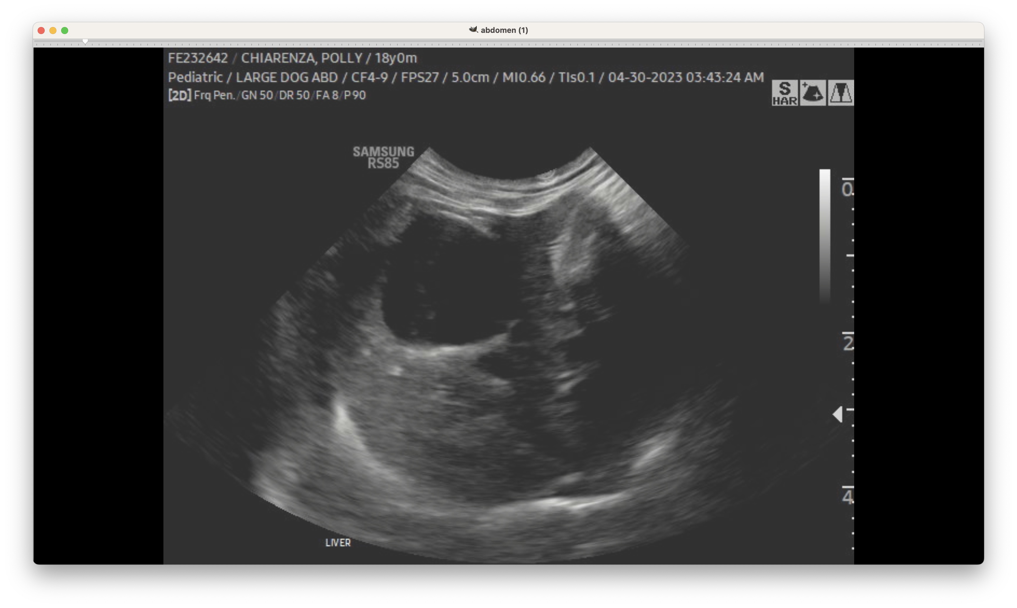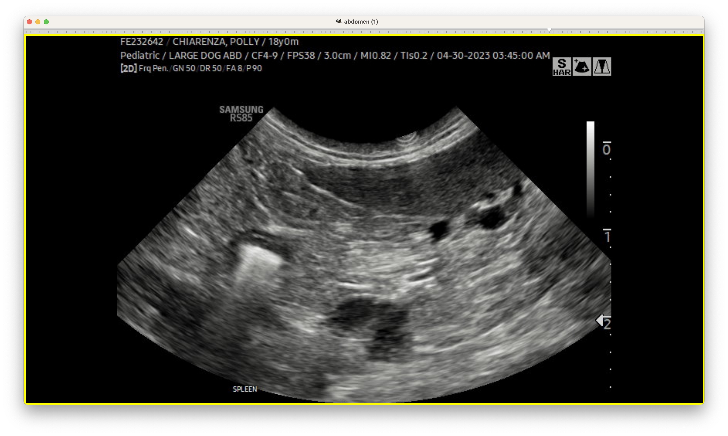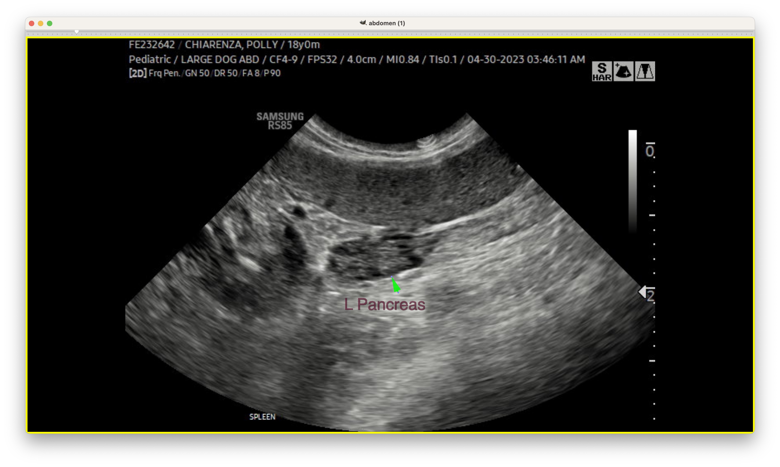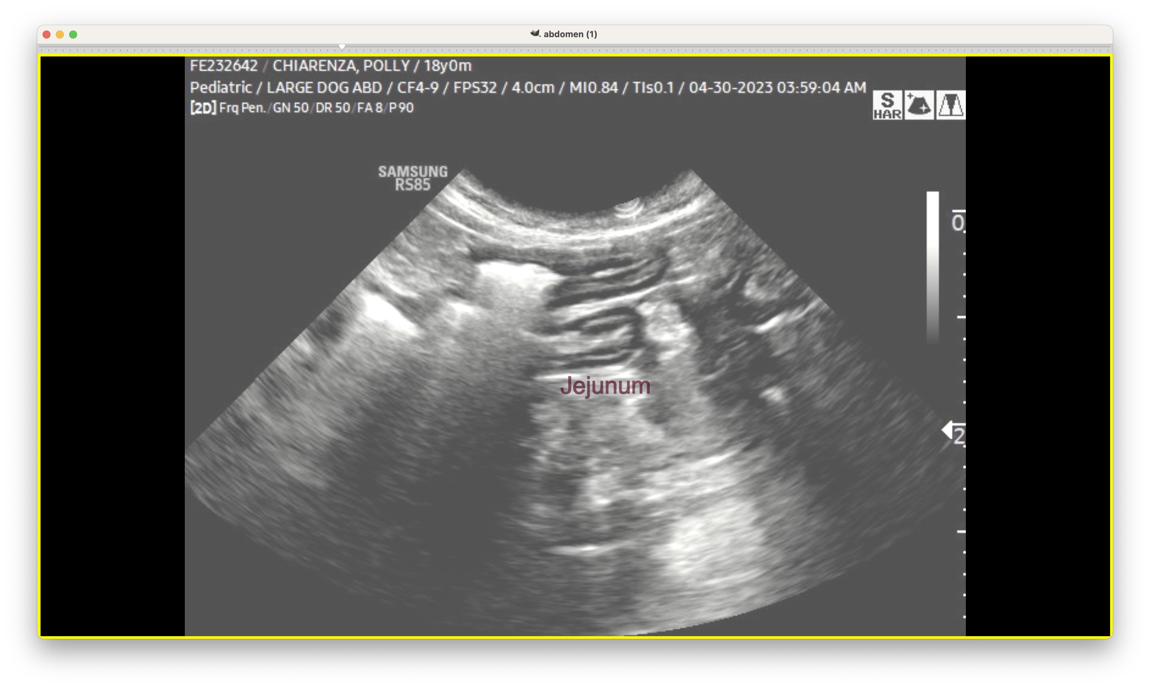
The information and recommendations provided are based on the images presented by the referring veterinarian. No evaluation can be communicated regarding pathology that was not visible in the image/video clips provided.

Thank you for this referral. If the clinical or image interpretation does not parallel your findings or if I can be of any further assistance, please contact me.
Tam Mengine, DVM, DABVP (canine/feline practice) info@SonoPath.com

