PRESENTING CLINICAL SIGNS
- P presented for recheck echo due to previously diagnosed aortic stenosis. Not on any heart meds
ULTRASONOGRAPHIC EXAMINATION OF THE HEART
CANINE  CARDIAC  PARAMETERS | MR  VMAX  (m/s) | TR  VMAX  (m/s) | LA/AO  (M-Mode) | LA/AO  (Heart Base; Swe) | FS  (%) | EF  (%) | EPSS  (cm)
NORMAL PARAMETER | 4.5-5.5 | <2.7 | 1.3 | Up to 1.6 | 28-40 | 40-100 | <0.6
PATIENT | -- | -- | 1.22 | 1.33 | 34.34 | 64.14 | NM
CANINE  CARDIAC  PARAMETERS | HR  (BPM) | AV  VMAX  (m/s) | PV  MAX  (m/s) | BODY WEIGHT  (kg) | LAD  LA MAX 4 Chamber | LVIDd  Avg; 2D and m-mode short axis  (cm) | LVIDs  Avg; 2D and m-mode short axis  (cm)
NORMAL PARAMETER | 50-100 | 0.7-1.7 | 0.7-1.6
PATIENT | -- | 4.71 | 1.86 | 27.27 | 4.2 | 3.8 | 2.49

Cardiac Presentation
The mitral valve leaflets are normal. There is no mitral regurgitation. No prolapse of mitral valve leaflets. Left atrial size is normal. Left ventricular systolic and diastolic function is preserved. Normal right atrial size without evidence of tricuspid regurgitation. Normal tricuspid valve leaflets and no evidence of pulmonary hypertension. The right ventricle subjectively appears normal in structure and function. Pulmonic valve have normal morphology with normal corresponding outflow velocities. There is scant pulmonic insufficiency. The aortic valve is tri-leaflet. There is an increased ridge of tissue in the sub-aortic region. Aortic outflow velocities are severely increased. There is mild to moderate aortic insufficiency. The aorta appears to have a post-stenotic dilation. Pulmonary artery and associated branches are normal. No evidence of pleural effusion, pericardial effusion or intracardiac masses,
ECG
Normal sinus rhythm with tall R-waves.
ULTRASONOGRAPHIC FINDINGS
- Severe sub-aortic stenosis.
- Tall R-waves.

INTERPRETATION OF THE FINDINGS & FURTHER RECOMMENDATIONS
The patient continues to have severe sub-aortic stenosis. With the severity of the sub-aortic stenosis, Atenolol therapy is recommended. An optimal dose of 1.0 mg/kg twice daily at slow incremental increases, i.e. a 0.25 mg/ kg once daily for four days, 0.25 mg/kg twice daily for five days, 0.50 mg/kg twice daily for four days, and then increasing up until you get to 1.0 mg/ kg twice daily until directed otherwise.

Patients with severe sub-aortic stenosis are at a higher risk for complications such as congestive heart failure and arrhythmias. Ideally after the patient is unloaded with Atenolol about four to six weeks later, a Holter monitor should be performed to ensure there are no arrhythmias present. The patient is at an increased risk for endocarditis due to the turbulent blood flow hitting the aortic valve. Anytime bacteremia is suspected, i.e. skin infection, urinary tract infection, etc., prompt antibiotic therapy is recommended.

Additionally, anytime elective anesthetic procedures are to be performed, the patient should be on antibiotics broad spectrum, i.e. Clavamox versus cephalexin three to five days prior, during, and three to five days post. Recheck echo as long as the patient continues to do well without complications in 10 to 12 months, sooner pending Holter monitor results.

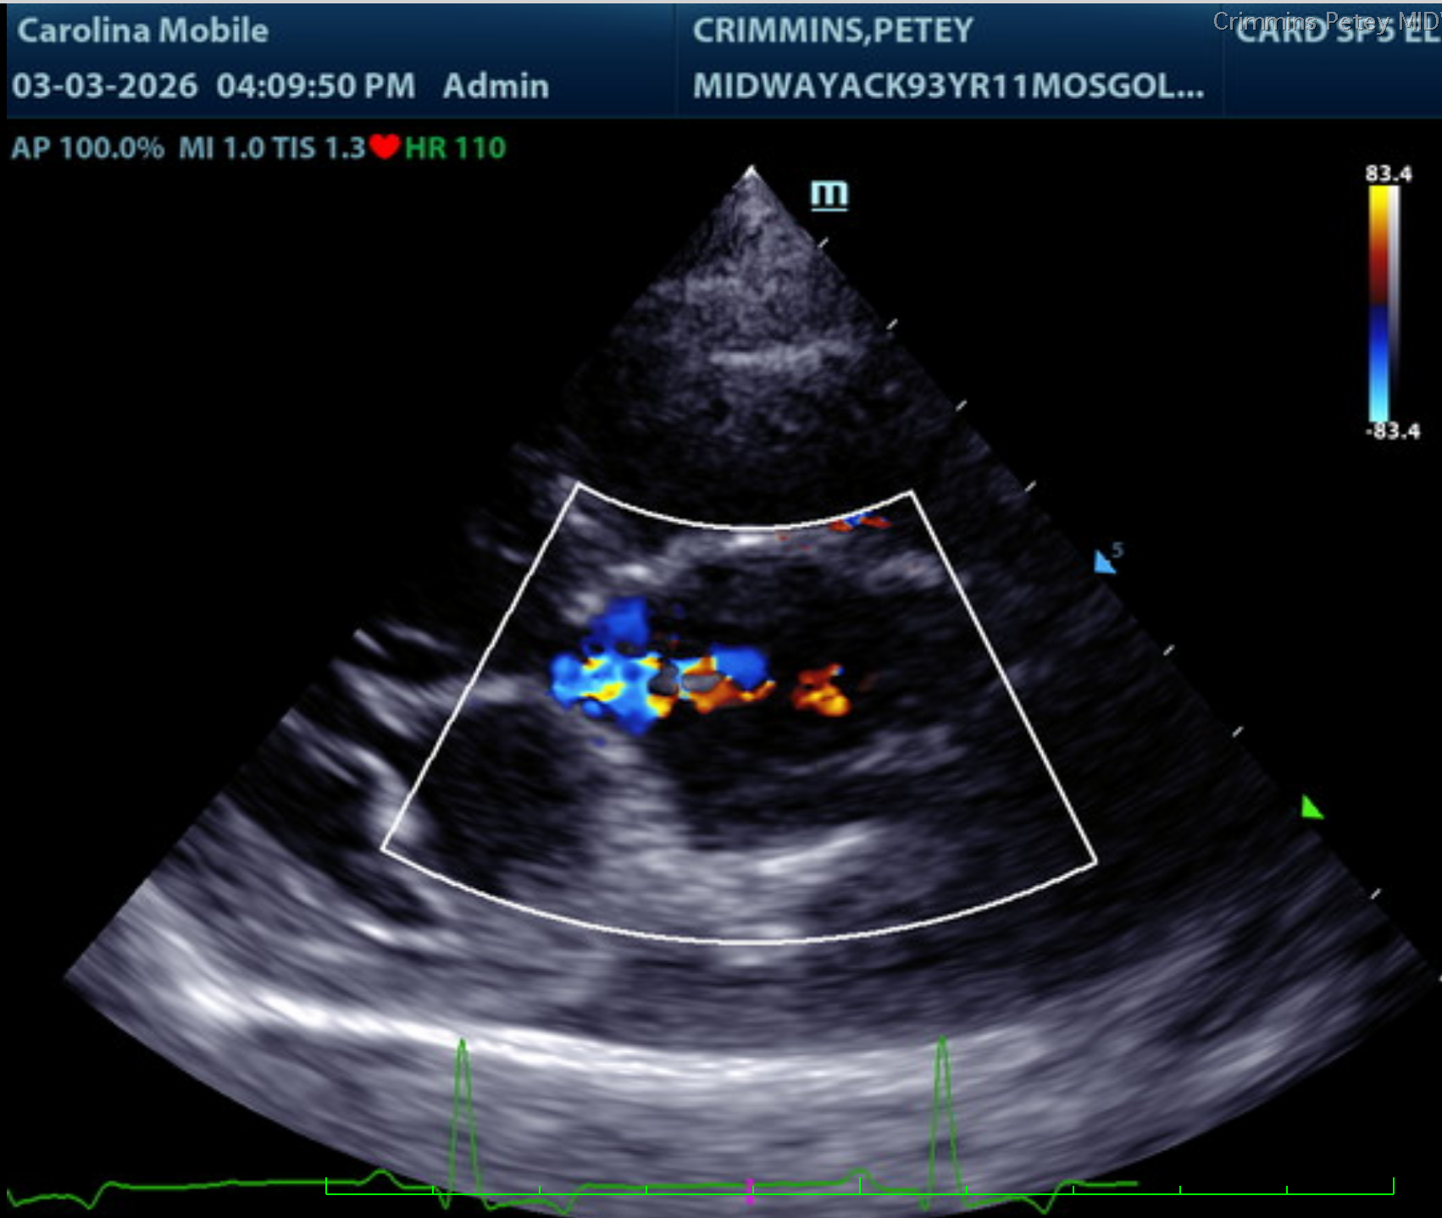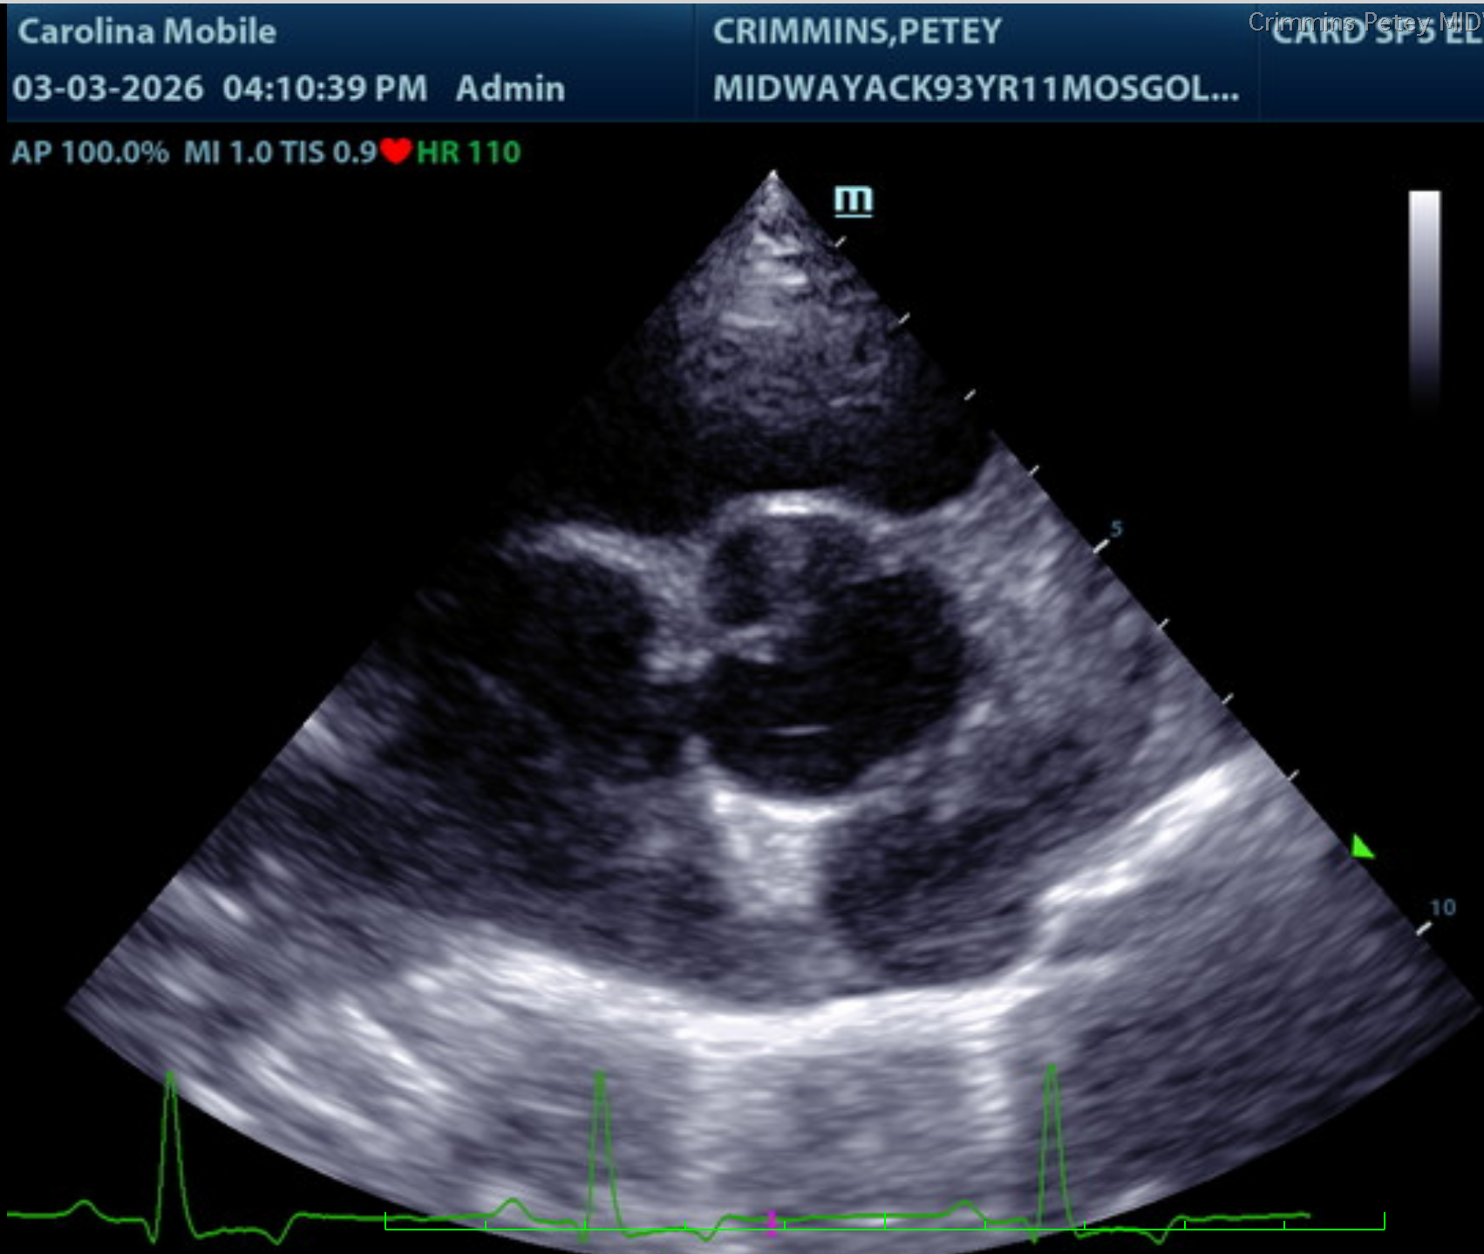
The information and recommendations provided are based on the images presented by the referring veterinarian/sonographer. No evaluation can be communicated regarding pathology that was not visible in the image/video clips provided.
Thank you for this referral. If the clinical or image interpretation does not parallel your findings or if I can be of any further assistance please contact me.
Sara Brethel DVM, DACVIM (Cardiology)
info@SonoPath.com

