PRESENTING CLINICAL SIGNS
Chronic renal disease. Concern for lymphoma as possible cause. Severe weight loss. Currently takes omeprazole, aventi kidney complete, and eprex injections for anemia. Jasper is fed raw rabbit but is currently inappetent. PE is unremarkable.
Abnormal PE/Chem/CBC/UA Results: August 24, 2022: HCT=20 (29-45) Hemoglobin=61 (103-162) nRBC=18% (0-2) WBC=29.4 (3.9-19.0) Neutrophils=21.8 (2.6-15.2) monocytes=0.6 (0.0-0.5) SDMA=29 (0-14) Creatinine=253 (80-203) Urea=14.9 (5.7-13.2) TP=91 (63-88) Globulin=60 (30-59) UA usg=1.021 2+ protein
ULTRASONOGRAPHIC EXAMINATION OF THE ABDOMEN
Urinary System
The urinary bladder was not definitively visualized. The trigone, cystourethral junction, and visible pelvic urethra exhibited normal thickness and tone. Anechoic urine was present in the lumen with no uroliths or sediment. The ureteral papillae were normal. The ureters were not visible which is normal. No evidence of inflammatory or neoplastic changes were noted.
Normal renal size with asymmetrical margination was present in both kidneys. The renal cortex presented uniformly increased in echogenicity with uniform echotexture. The renal cortex appeared to be hypertrophied resulting in an altered cortex: medulla ratio. Mild loss of corticomedullary distinction was also present. The renal medullary volume was subjectively reduced. Minor bilateral pyelectasia was present with intermittent small cortical cysts. The left kidney measured 3.5 cm in length. The right kidney measured 3.8 cm in length.
The area of the aortic trifurcation was free of pathology.
The area of the iliac trifurcation was free of pathology including no evidence of medial, iliac or sublumbar lymphadenopathy.
Adrenal Glands
The left adrenal gland was not definitively visualized. The right adrenal gland was uniform in size and contour with a uniformly hypoechoic parenchyma. The right adrenal gland measured 0.42 cm width.
Spleen
The spleen was not definitively visualized.
Liver
The liver presented normal in size. The hepatic parenchyma revealed diffuse reduced echogenicity compared to the spleen and renal cortical parenchyma with a mild coarse echotexture. Increased portal vein prominence was evident. The capsule of the liver was normal in margination. Distinct masses or nodules were not evident. The hepatic and portal vasculature were normal in appearance.
The gallbladder was non-distended in size with mild non-dependent particulate luminal debris. The cystic and common bile ducts were normal.
Transdiaphragmatic view revealed comet tail lung pattern, which is echogenic sound wave interface with microconsolidations within the caudal lung field. The lung field should not be visualized by sonogram unless pathology is present. Potential for caudal thoracic peri-diaphragmatic nodules visualized. Chest radiographs are recommended to rule out alveolar/lung disease such as neoplasia, thromboembolic disease, chronic inflammatory disease with microconsolidation. No obvious evidence of pleural effusion.
Gastrointestinal
The stomach presented intact wall layering with a normal wall layer ratio. The lumen of the stomach was empty with no signs of ileus, obstruction or foreign material.
The small intestine presented intact wall layering with 1:3 muscularis/mucosa ratio. The lumen of the small intestine was empty with no signs of ileus, obstruction or foreign material.
Normal visible colon wall layers were present with apparent formed feces in lumen.
Pancreas
The pancreas was prominent in size with mild capsule asymmetry and non-homogeneous irregular to indistinctly cystic parenchyma. Evidence of peripancreatic reactive mesentery was present.
Free Abdomen
Non-specific non-homogenous to irregular nodular lesion noted adjacent to or cranial to the cranial mid to right liver yet within the cranial abdominal cavity and directly effacing the caudal associated diaphragm. The lesion measured ~ 2.3 cm in diameter.
No peritoneal effusion was present.
Several locally enlarged mid to cranial abdominal mesenteric lymph nodes were present. These lymph nodes were non-homogenous, mildly hypoechoic and smoothly marginated. A normal width: length ratio was maintained (<0.5). Evidence of perilymphatic inflammation was evident. An example of lymph node size was 2.3 cm x 1.2 cm.
ULTRASONOGRAPHIC FINDINGS
Primary
- Bilateral moderate chronic renal changes exhibiting minor pyelectasia and intermittent cortical cysts-no evidence of renal neoplastic criteria
- Hypoechoic liver
- Unspecified non-homogeneous nodular peri-diaphragmatic cranial abdominal lesion
- Prominent irregular to cystic pancreas
- Sonographically unremarkable visualized GI tract
- Transdiaphragmatic comet tail artefact with possible small caudal thoracic nodules
INTERPRETATION OF THE FINDINGS & FURTHER RECOMMENDATIONS
Although unspecified potential consideration for the cranial abdominal peri-diaphragmatic nodular lesion may include granuloma, consolidated abscess, neoplasia, metastasis or other. Assuming normal clotting status and using a 25g needle a nodular lesion/hepatic parenchyma and lymph node FNA is recommended for screening cytology. Three view chest radiographs suggested if not done to assess for thoracic pathology. Potential for chronic-to-chronic active pancreatitis may be suspected if evidence of cranial abdominal or subxiphoid discomfort on palpation. Correlation with a spec fPL +/- a GI panel to include PLI/TLI/Cobalamin/Folate is recommended. A guarded prognosis is indicated.

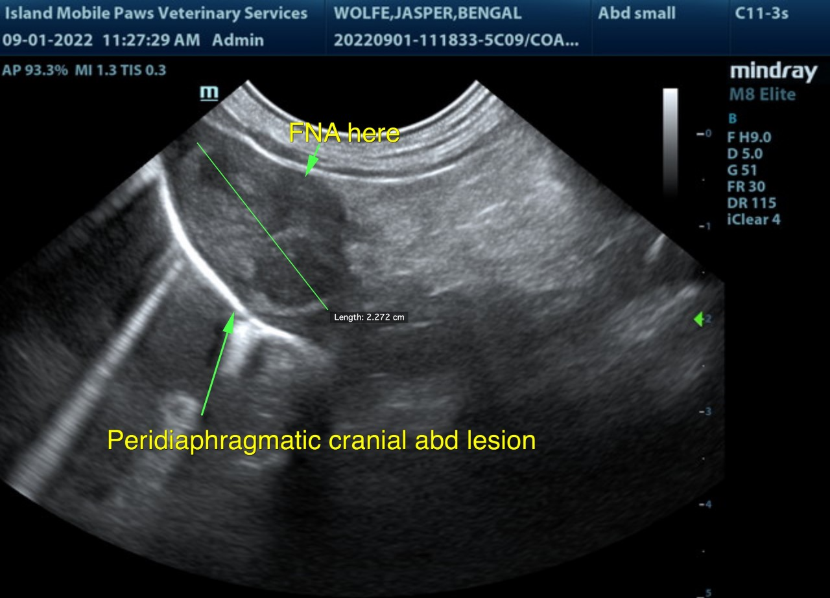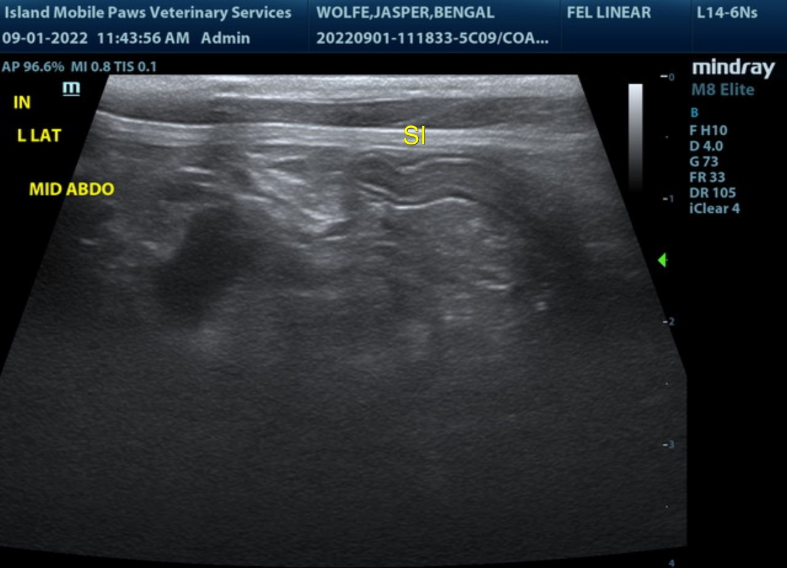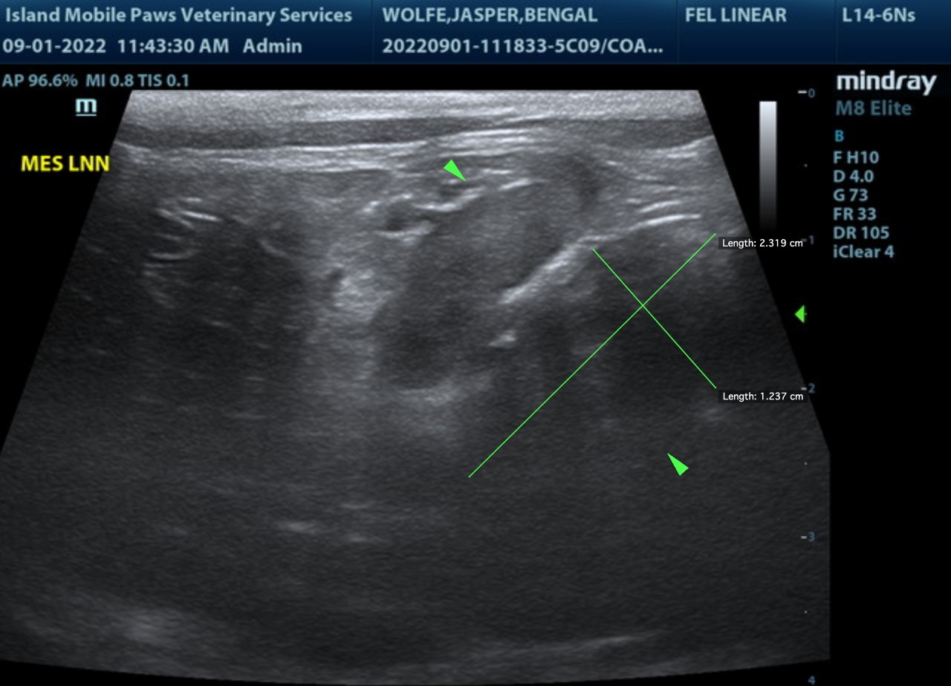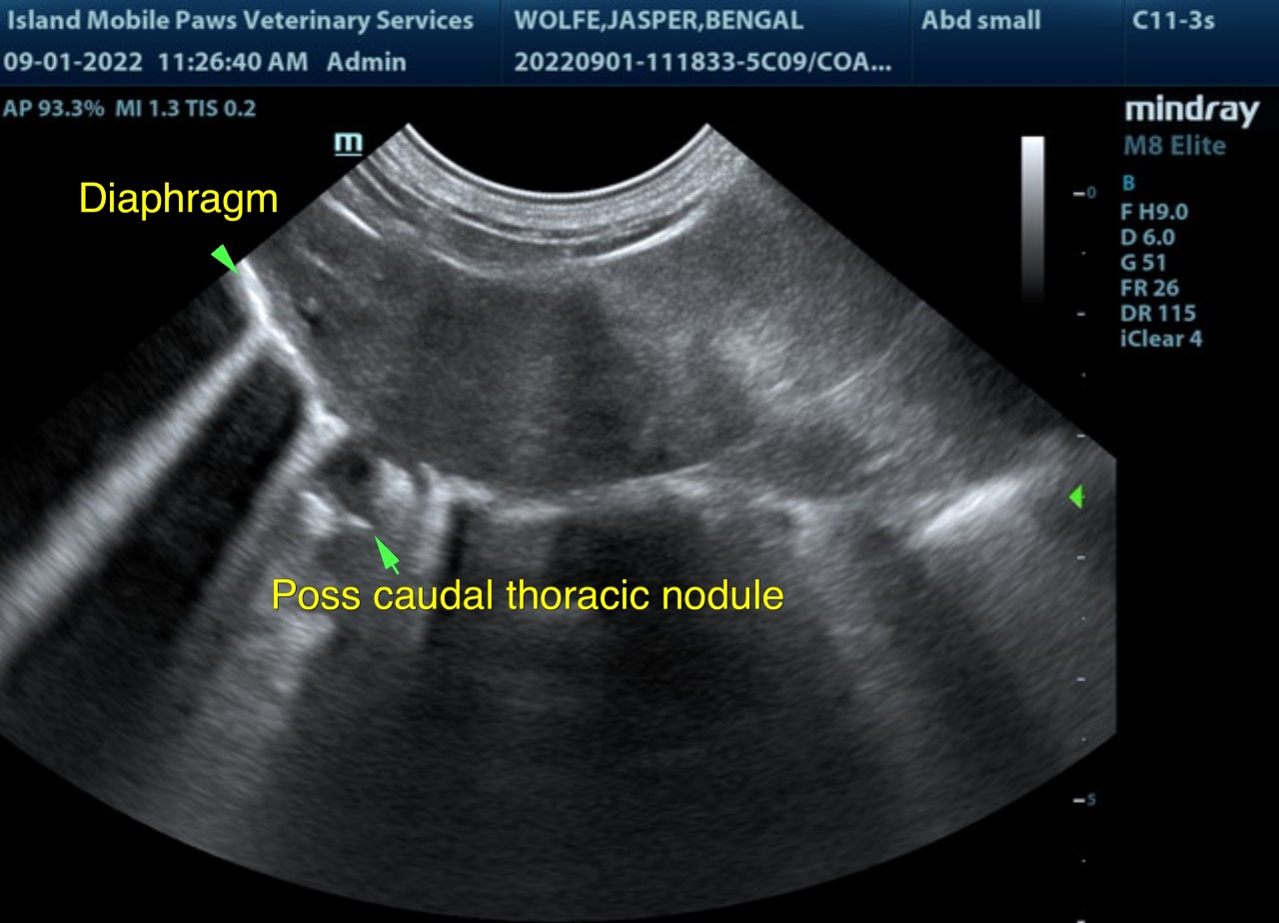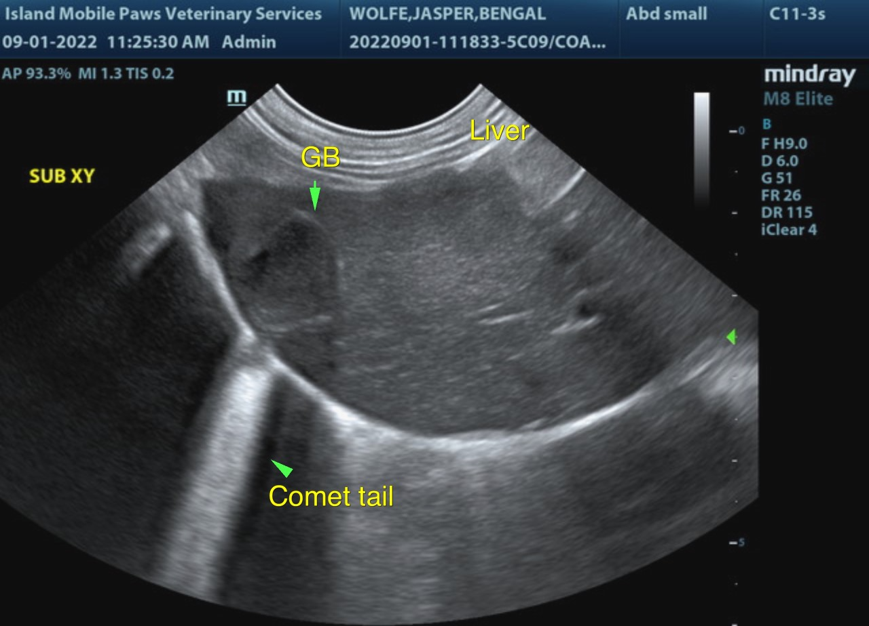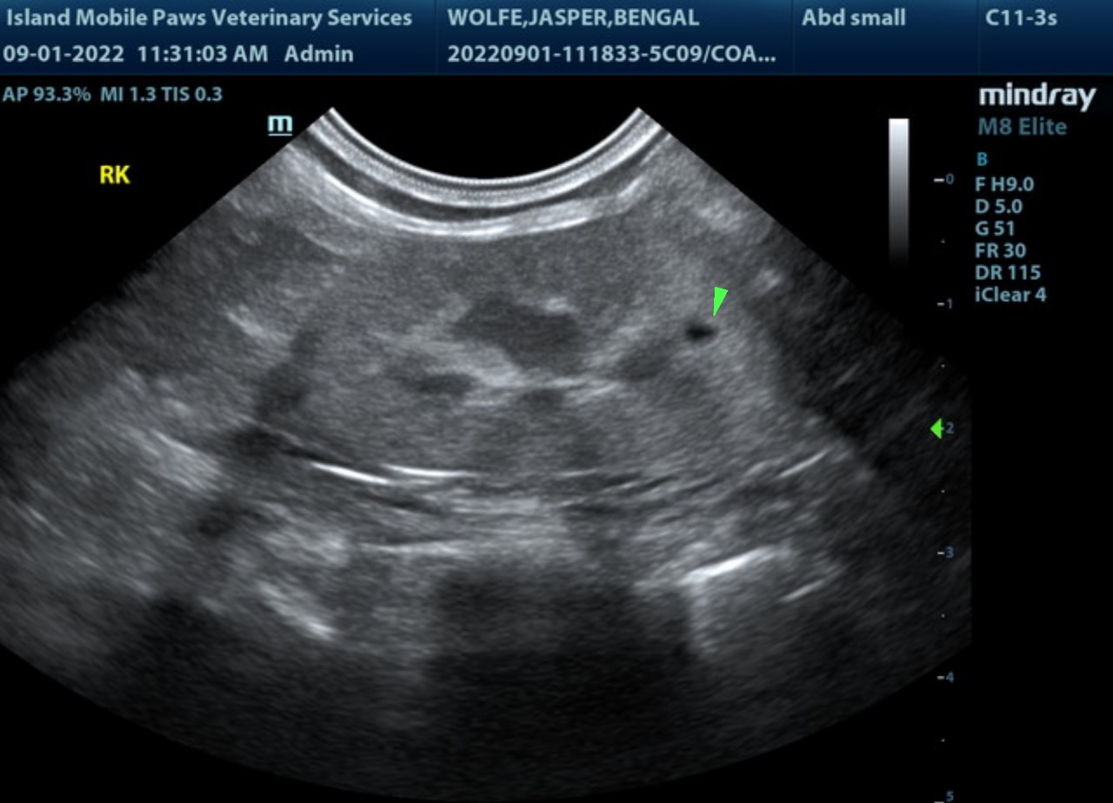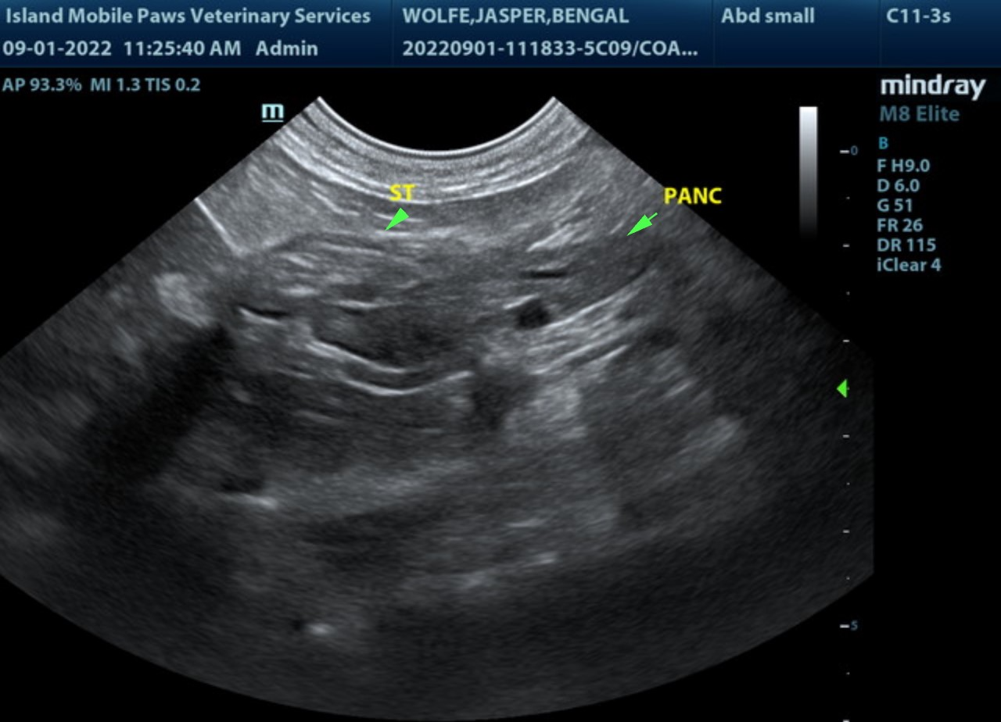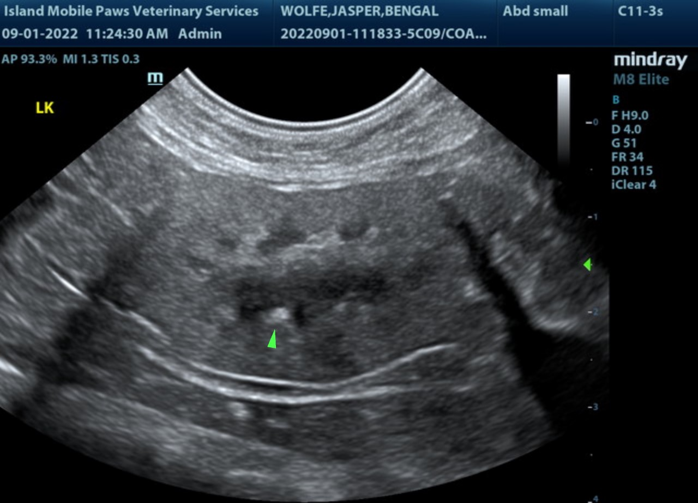

The information and recommendations provided are based on the images presented by the referring veterinarian/sonographer. No evaluation can be communicated regarding pathology that was not visible in the image/video clips provided.
Thank you for this referral. If the clinical or image interpretation does not parallel your findings or if I can be of any further assistance please contact me.
R. McKenzie Daniel, DVM, DABVP (Canine / Feline Practice)
info@SonoPath.com

