PRESENTING CLINICAL SIGNS
Presented for a dental
Abnormal PE/Chem/CBC/UA Results: ALT: 420, GGT:12. ALK: 54.

ULTRASONOGRAPHIC EXAMINATION OF THE ABDOMEN
Urinary System
The urinary bladder, trigone, cystourethral junction, and visible pelvic urethra to a depth of 2.0 cm exhibited normal thickness and tone. Primarily anechoic urine was present in the lumen. Mild particulate, non-dependent sediment was present without evidence of calculus formation. The ureteral papillae were normal. The ureters were not visible which is normal. No evidence of inflammatory or neoplastic mural changes were noted.
The residual prostate was symmetrically normal in size with uniform parenchyma and slight coarse echotexture. The prostate measured 0.75 cm in width.
Normal size and margination were present in the kidneys. A normal 1:3 cortex / medulla ratio and normal corticomedullary definition were maintained. The echogenicity of the cortex was similar to or slightly less than normal liver parenchyma while the medulla echogenicity was hypoechoic to the cortex with no evidence of pelvic dilation. The left kidney measured 5.2 cm. The right kidney measured 4.4 cm.
The area of the aortic trifurcation was free of pathology.
Adrenal Glands
The adrenal glands were uniform in size and contour with a uniformly hypoechoic parenchyma. The left adrenal gland measured 2.23 cm x 0.84 cm. The right adrenal gland measured 2.0 cm x 0.68 cm.
Spleen
The spleen exhibited a finely textured and homogenous parenchyma which was hyperechoic to the liver and renal cortical parenchyma. The capsule was smooth and regular without apparent expansion. The splenic vasculature at the hilus was normal in volume with no evidence of congestion or thrombosis. Acute to chronic inflammatory, neoplastic, or benign parenchyma changes were not noted.
Liver
The liver exhibited subjective mild generalized enlargement with primarily maintained symmetrical capsule contour. Normal hepatic echogenicity noted compared to the spleen and falciform fat with moderate coarse echotexture and subtle increased prominence of portal vasculature borders. No hepatic masses or nodules noted. The gallbladder was non-distended in size with thin walls and primarily anechoic luminal content. The cystic and common bile ducts were normal.
Gastrointestinal
The stomach presented intact wall layering with a normal wall layer ratio. The lumen of the stomach contained mild echogenic, nonshadowing ingesta most consistent with post prandial presentation without signs of ileus, obstruction or foreign material.
The small intestine presented intact wall layering with 1:3 muscularis/mucosa ratio. The lumen of the small intestine was empty with no signs of ileus, obstruction or foreign material.
Normal visible colon wall layers were present with apparent formed feces in lumen.

Pancreas
The parenchyma of the left limb, body and right limb of the pancreas presented isoechoic to the adjacent omental fat. A normal curvilinear capsule contour of the pancreas was present. The visible pancreatic duct was normal. No signs of active inflammation or neoplastic disease was evident.
PRIMARY FINDINGS
- Hepatopathy – subjectively benign, chronic
- Sonographically unremarkable gallbladder
- Mild gastric ingesta – likely post-prandial presentation
SECONDARY FINDINGS
- Mild urinary bladder sediment
INTERPRETATION OF THE FINDINGS & FURTHER RECOMMENDATIONS
The urinary bladder sediment may suggest cellular / crystalline debris or mucus. Cystocentesis for UA +/- C/S if evidence of inflammatory cells is recommended.
The overall appearance of the liver was non-specific yet consistent with benign, likely chronic hepatopathy. Given the ALT elevation, inflammatory hepatic parenchymal diseases such as non-specific hepatitis (infectious, immune mediated or other), copper storage hepatopathy, reactive/vacuolar hepatopathy, and minor non-clinical cholestasis may be possible. Hepatic neoplasia is considered an unlikely differential diagnosis.
Assuming normal clotting status, hepatic FNA could be considered for screening cytology with potential identification of inflammatory cell type. Empirically, hepatosupportive medications are recommended. No overt anesthetic contraindications assuming normal BUN, glucose, albumin and cholesterol levels. Reassessment of hepatic enzymes following dental prophylaxis may also be considered. Ultimately, hepatic parenchymal biopsy may be required for definitive diagnosis.

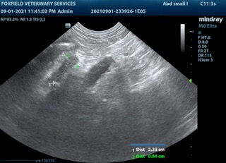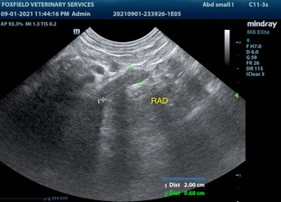
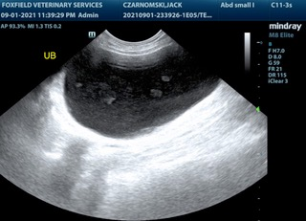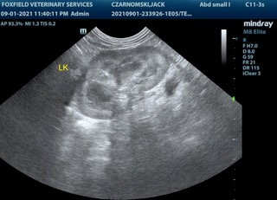
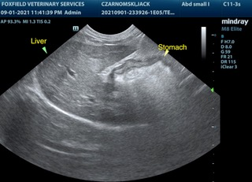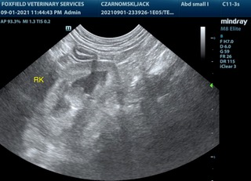
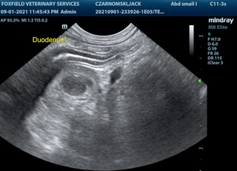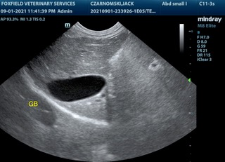
The information and recommendations provided are based on the images presented by the referring veterinarian. No evaluation can be communicated regarding pathology that was not visible in the image/video clips provided.

Thank you for this referral. If the clinical or image interpretation does not parallel your findings or if I can be of any further assistance please contact me.

R. McKenzie Daniel, DVM, DABVP (Canine / Feline Practice)
info@SonoPath.com

