PRESENTING CLINICAL SIGNS
Chico lost a lot of weight (he used to be 11-12 lbs), now he is not eating, he is vomiting and he has diarrhea, he is PU/PD, urine has an abnormal odor.
Abnormal PE/Chem/CBC/UA Results: High AST (163), high ALT (241), high Alk Phosp (405), low albumin (2.4), high BUN (68) and SDMA (29.4), with normal creatinine (1.5). Low T4 (0.5). USG 1.016, high protein (1+), high blood (1+), high RBC (11-20/hpf), high WBC (21-50), high bacteria (rods 26-50).
ULTRASONOGRAPHIC EXAMINATION OF THE ABDOMEN
Urinary System
The urinary bladder was normal in size and tone with overtly normal intact urinary bladder wall. Anechoic urine was present with mild to moderate accumulated particulate sediment with focal sediment mineral. Concurrent mild non-dependent, similar appearing particulate sediment was also noted.
The prostate was enlarged in size with intact, symmetrical capsule contour. The margins of the gland were intact and able to be differentiated from the surrounding tissue. The prostatic parenchyma was mildly echogenic to heteroechoic without parenchymal mineralization. The prostate measured 1.9 cm.
There is no overt pathology associated with the left or right testicles.
No evidence of pathology in the area of the aortic trifurcation.
The left kidney was mildly subnormal in size compared to the right. A normal 1:3 cortex / medulla ratio was maintained. The medulla and cortices were uniform in texture with some increased echogenicity and moderate to marked loss of corticomedullary symmetry and definition expected for the age of the patient. Left kidney cortical cysts with nonobstructive renolithiasis were present. No evidence of pelvic dilation was present. The left kidney measured 2.0 cm in length.
Normal size and margination were present in the right kidney. A normal 1:3 cortex / medulla ratio was maintained. The medulla and cortices were uniform in texture with some increased echogenicity and moderate to marked loss of corticomedullary symmetry and definition expected for the age of the patient. No evidence of pelvic dilation was present. Moderate right kidney hydronephrosis was present. Visualized concurrent mild proximal left hydroureter was noted. The right kidney measured 3.0 cm in length.
Adrenal Glands
The left and right adrenal glands were overt normal in size, position, and shape. The left adrenal gland measured 0.39 cm width at the cranial pole and 0.38 cm width at the caudal pole. The right adrenal gland measured 0.39 cm width at the caudal pole.
Spleen
The spleen exhibited primarily finely textured parenchyma which was hyperechoic to the liver and renal cortical parenchyma. Mild generalized parenchyma heterogeneity was present without evidence of nodular changes. The capsule was smooth and regular without apparent expansion. The splenic vasculature at the hilus was normal in volume with no evidence of congestion or thrombosis. The parenchymal heterogeneity is likely consistent with benign changes such as extramedullary hematopoiesis or age-related remodeling with minor potential for inflammatory or neoplastic disease.
Liver/ Gallbladder
The liver was normal to mildly enlarged with capsule asymmetry and marked generalized nonhomogeneous / nodular hepatic parenchyma. The gallbladder was distended in size with echogenic thickening of the gallbladder wall. There was biliary sludge that appeared to be non-mobile and organized. A stellate pattern to the organized biliary sludge was present. Evidence of pericholecystic omental inflammation and effusion was present. There was no evidence of peripheral gallbladder inflammation. The common bile duct was not definitively visualized without obvious evidence of post hepatic obstruction.
Gastrointestinal
The stomach presented intact wall layering with a normal wall layer ratio. Mild retained gastric echogenic and lumen gas were noted without signs of obstruction or foreign material.
The small intestine presented intact wall layering with 1:3 muscularis/mucosa ratio. The lumen of the small intestine was empty with no signs of ileus, obstruction, or foreign material.
Normal visible colon wall layers were present with apparent formed feces in lumen.
Pancreas
The pancreas was normal in size and contour with isoechoic to heterogeneous parenchyma compared to adjacent omentum, consistent with age-related pancreatic changes. No signs of active inflammation or neoplasia.
Free Abdomen
No overt lymphadenopathy or peritoneal effusion was present.
ULTRASONOGRAPHIC FINDINGS
- Dependent to mildly nondependent particulate sediment with focal mineral - possible pyuria
- Left kidney marked chronic degenerative changes with renolithiasis and cortical cysts
- Right kidney chronic degenerative changes with moderate hydronephrosis, concurrent mild proximal left hydroureter
- Marked nonuniform / nodular liver - chronic active hepatitis, vacuolar hepatopathy, hyperplasia, hematopoiesis, fibrosis / cirrhosis, infiltrative neoplasia, or other hepatopathy, all potentials
- Gallbladder mucocele
- Structurally unremarkable gastrointestinal tract with mild retained gastric fluid

INTERPRETATION OF THE FINDINGS & FURTHER RECOMMENDATIONS
Urine C/S on a sterile urine sample +/- baseline UPC level, if no inflammatory sediment, is recommended. Screening blood pressure is recommended. This patient may be passing mineral from the kidneys into the urinary bladder with concern for non-visualized right ureter obstruction.
Assuming normal clotting status, hepatic FNA cytology may be considered for further clarification. Hepatic core surgical biopsy with cholecystectomy is likely required for a definitive diagnosis.
A GI panel to include PLI/TLI/Cobalamin/Folate and three view chest radiographs may be considered to rule out intrathoracic or occult intestinal / pancreatic disease as a contributing factor. As-needed gastrointestinal support is recommended.

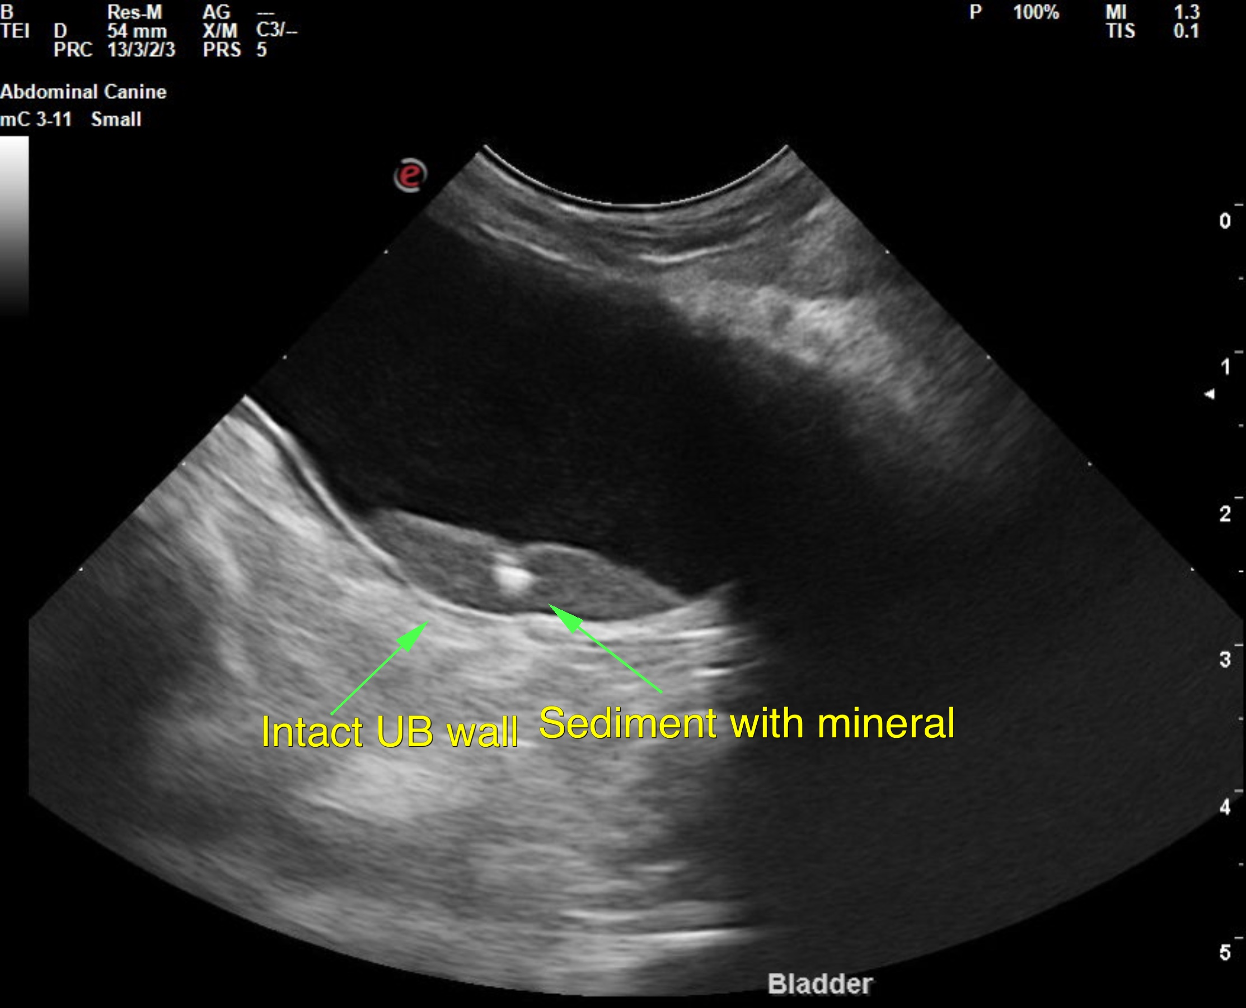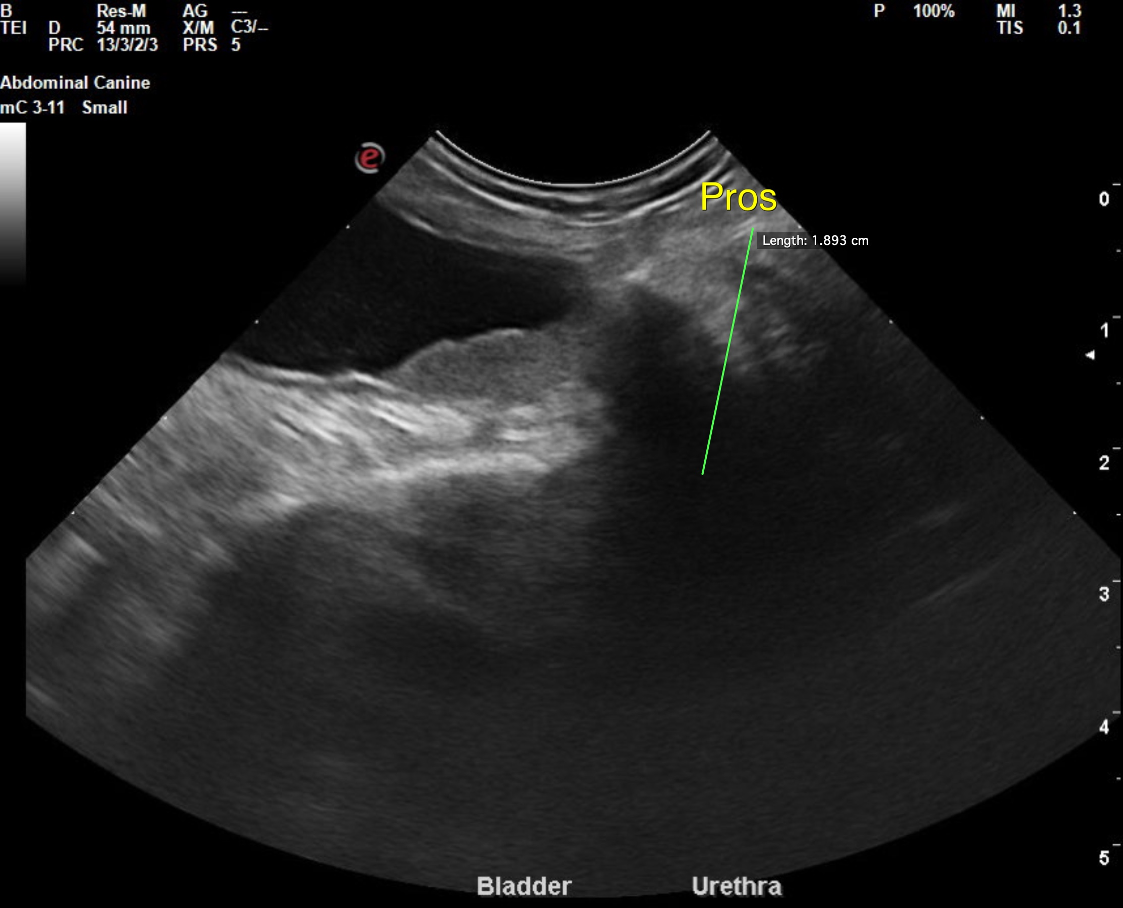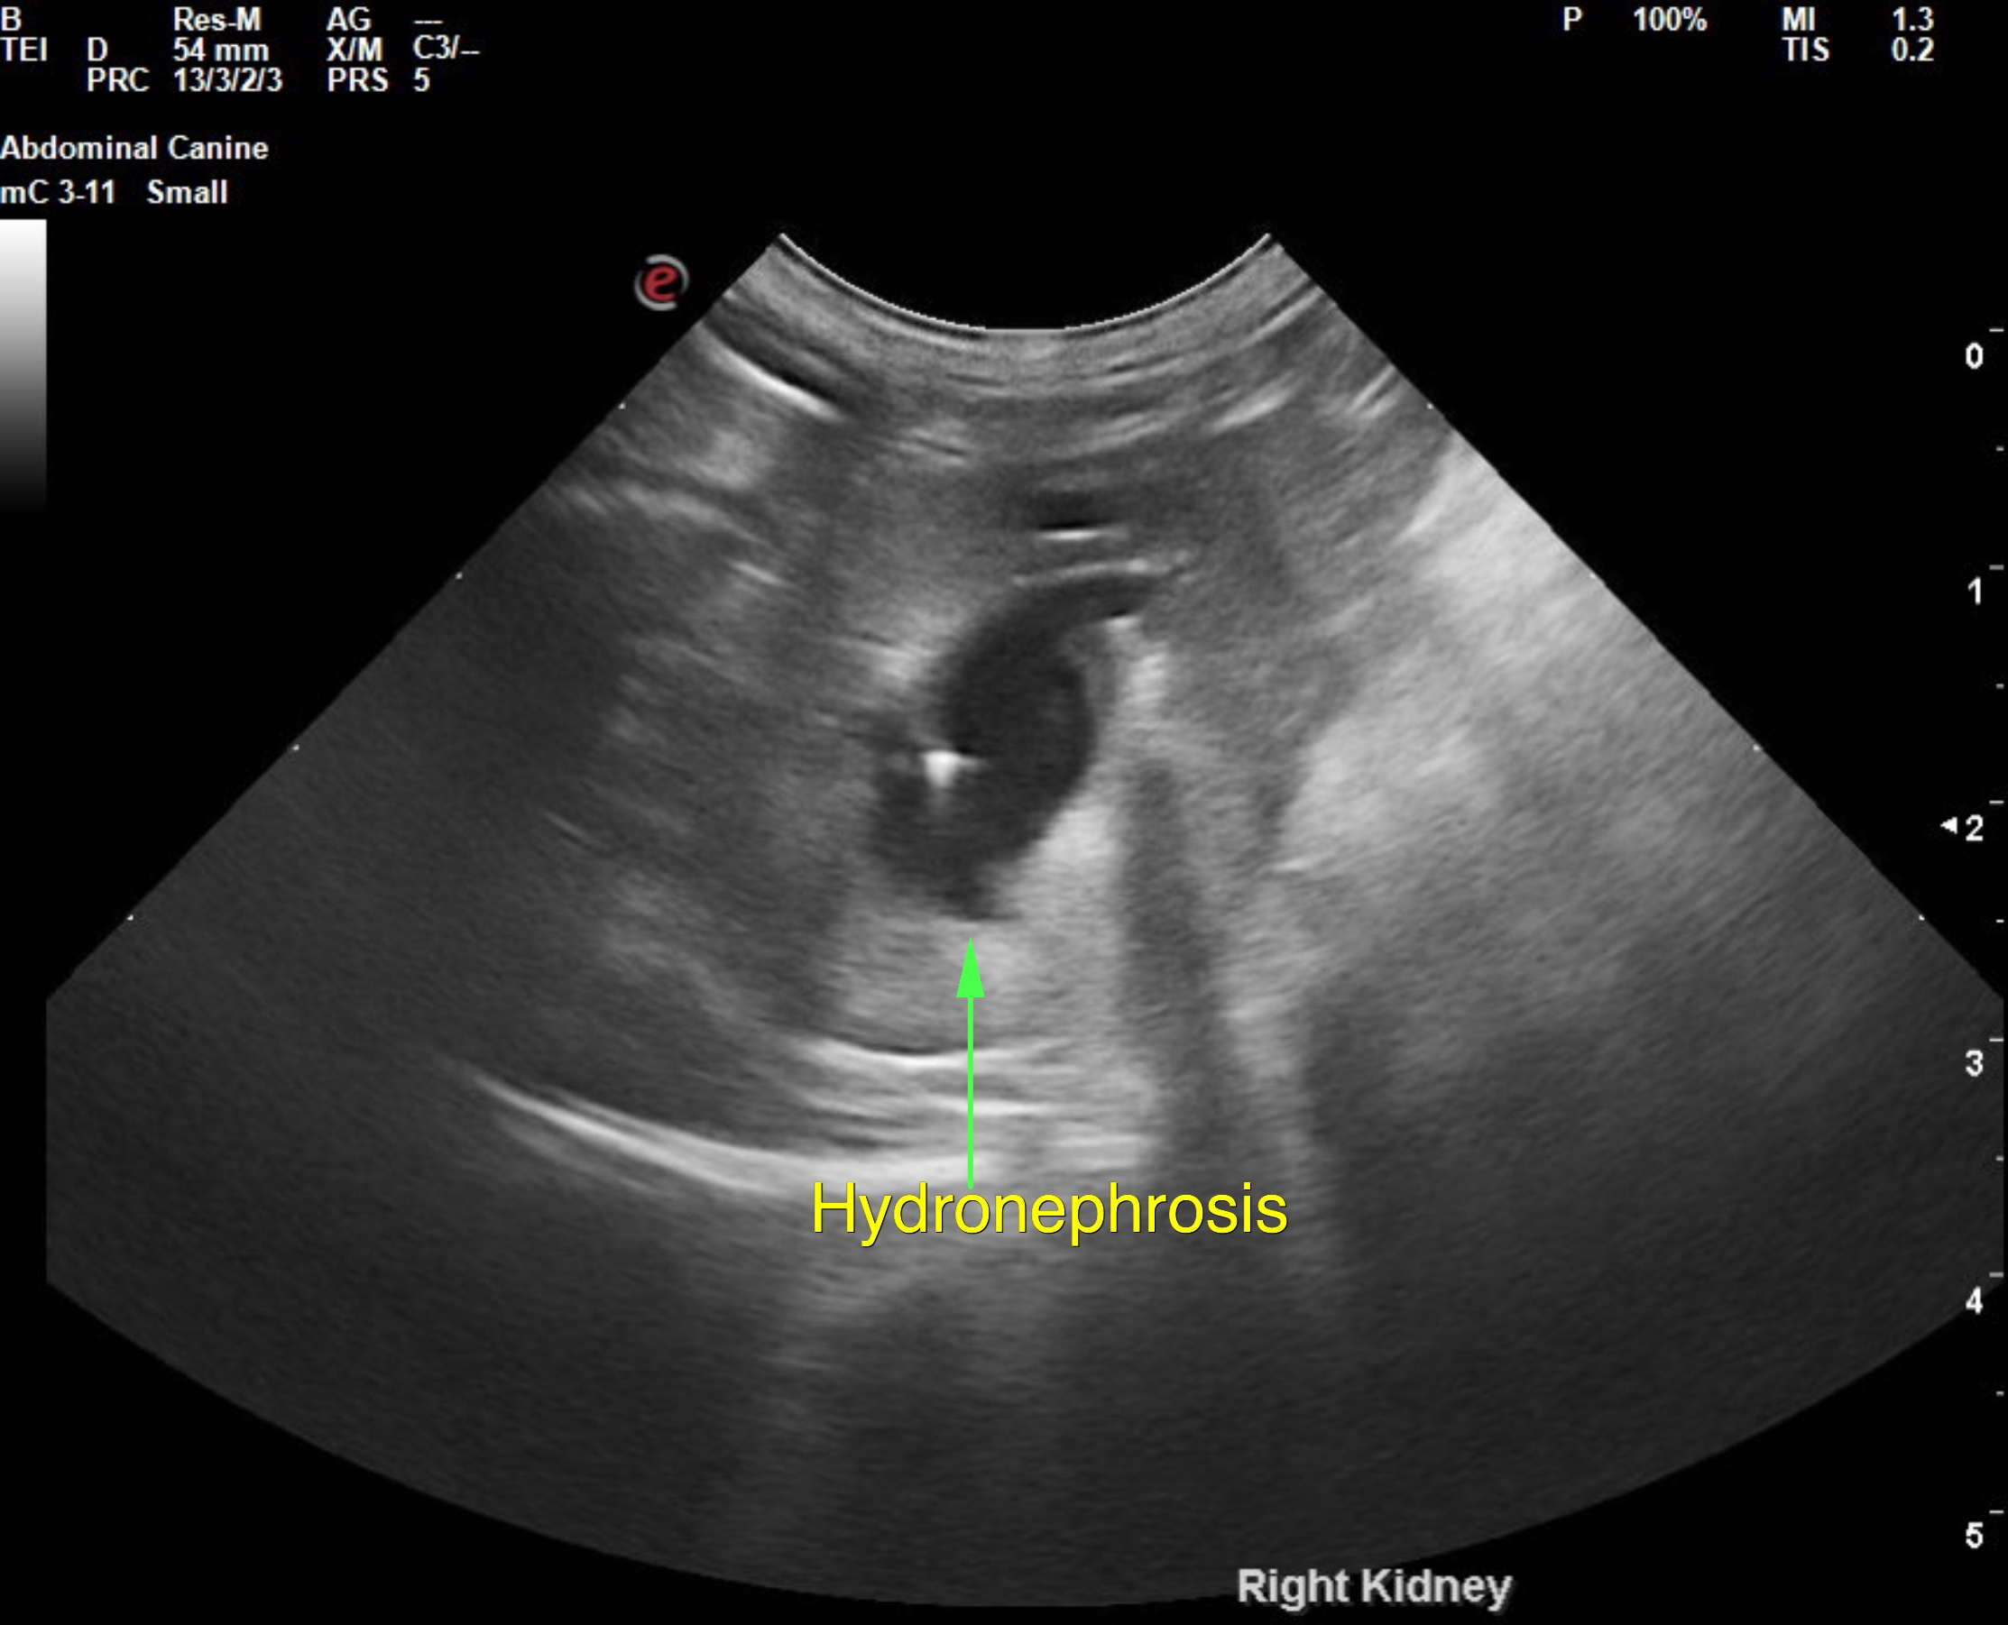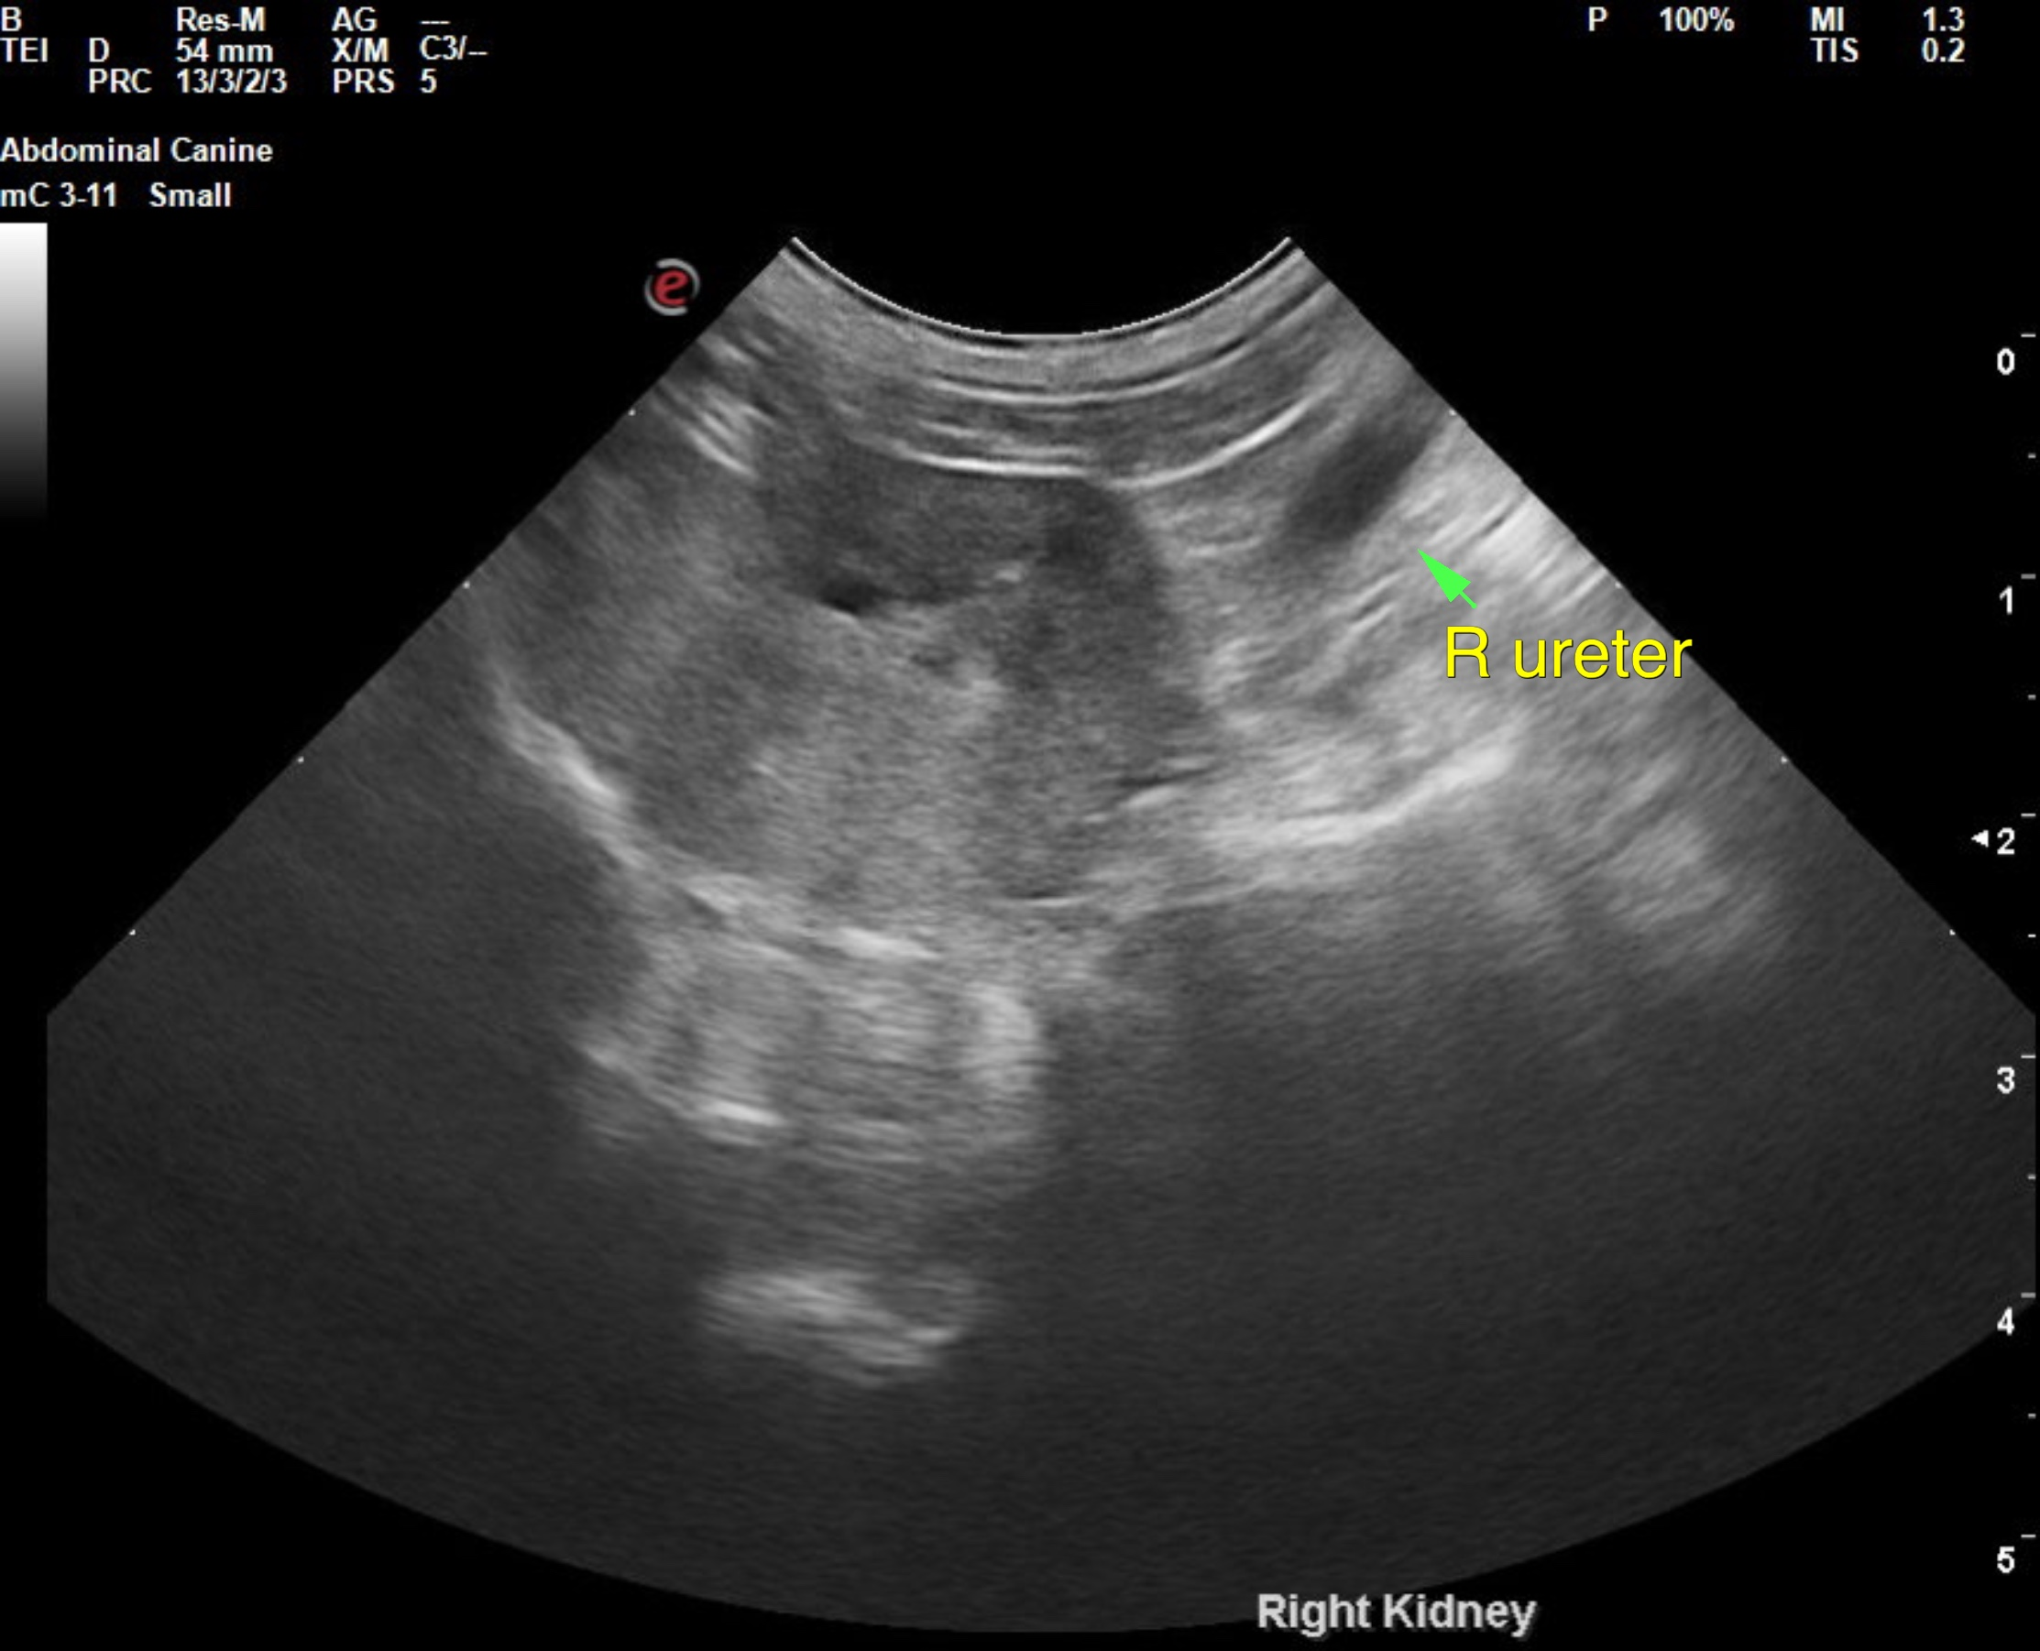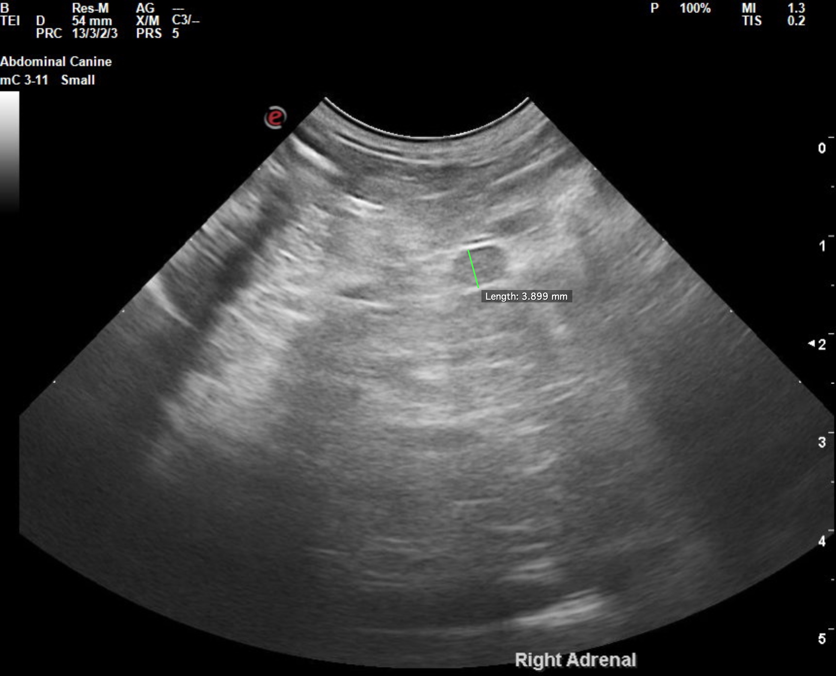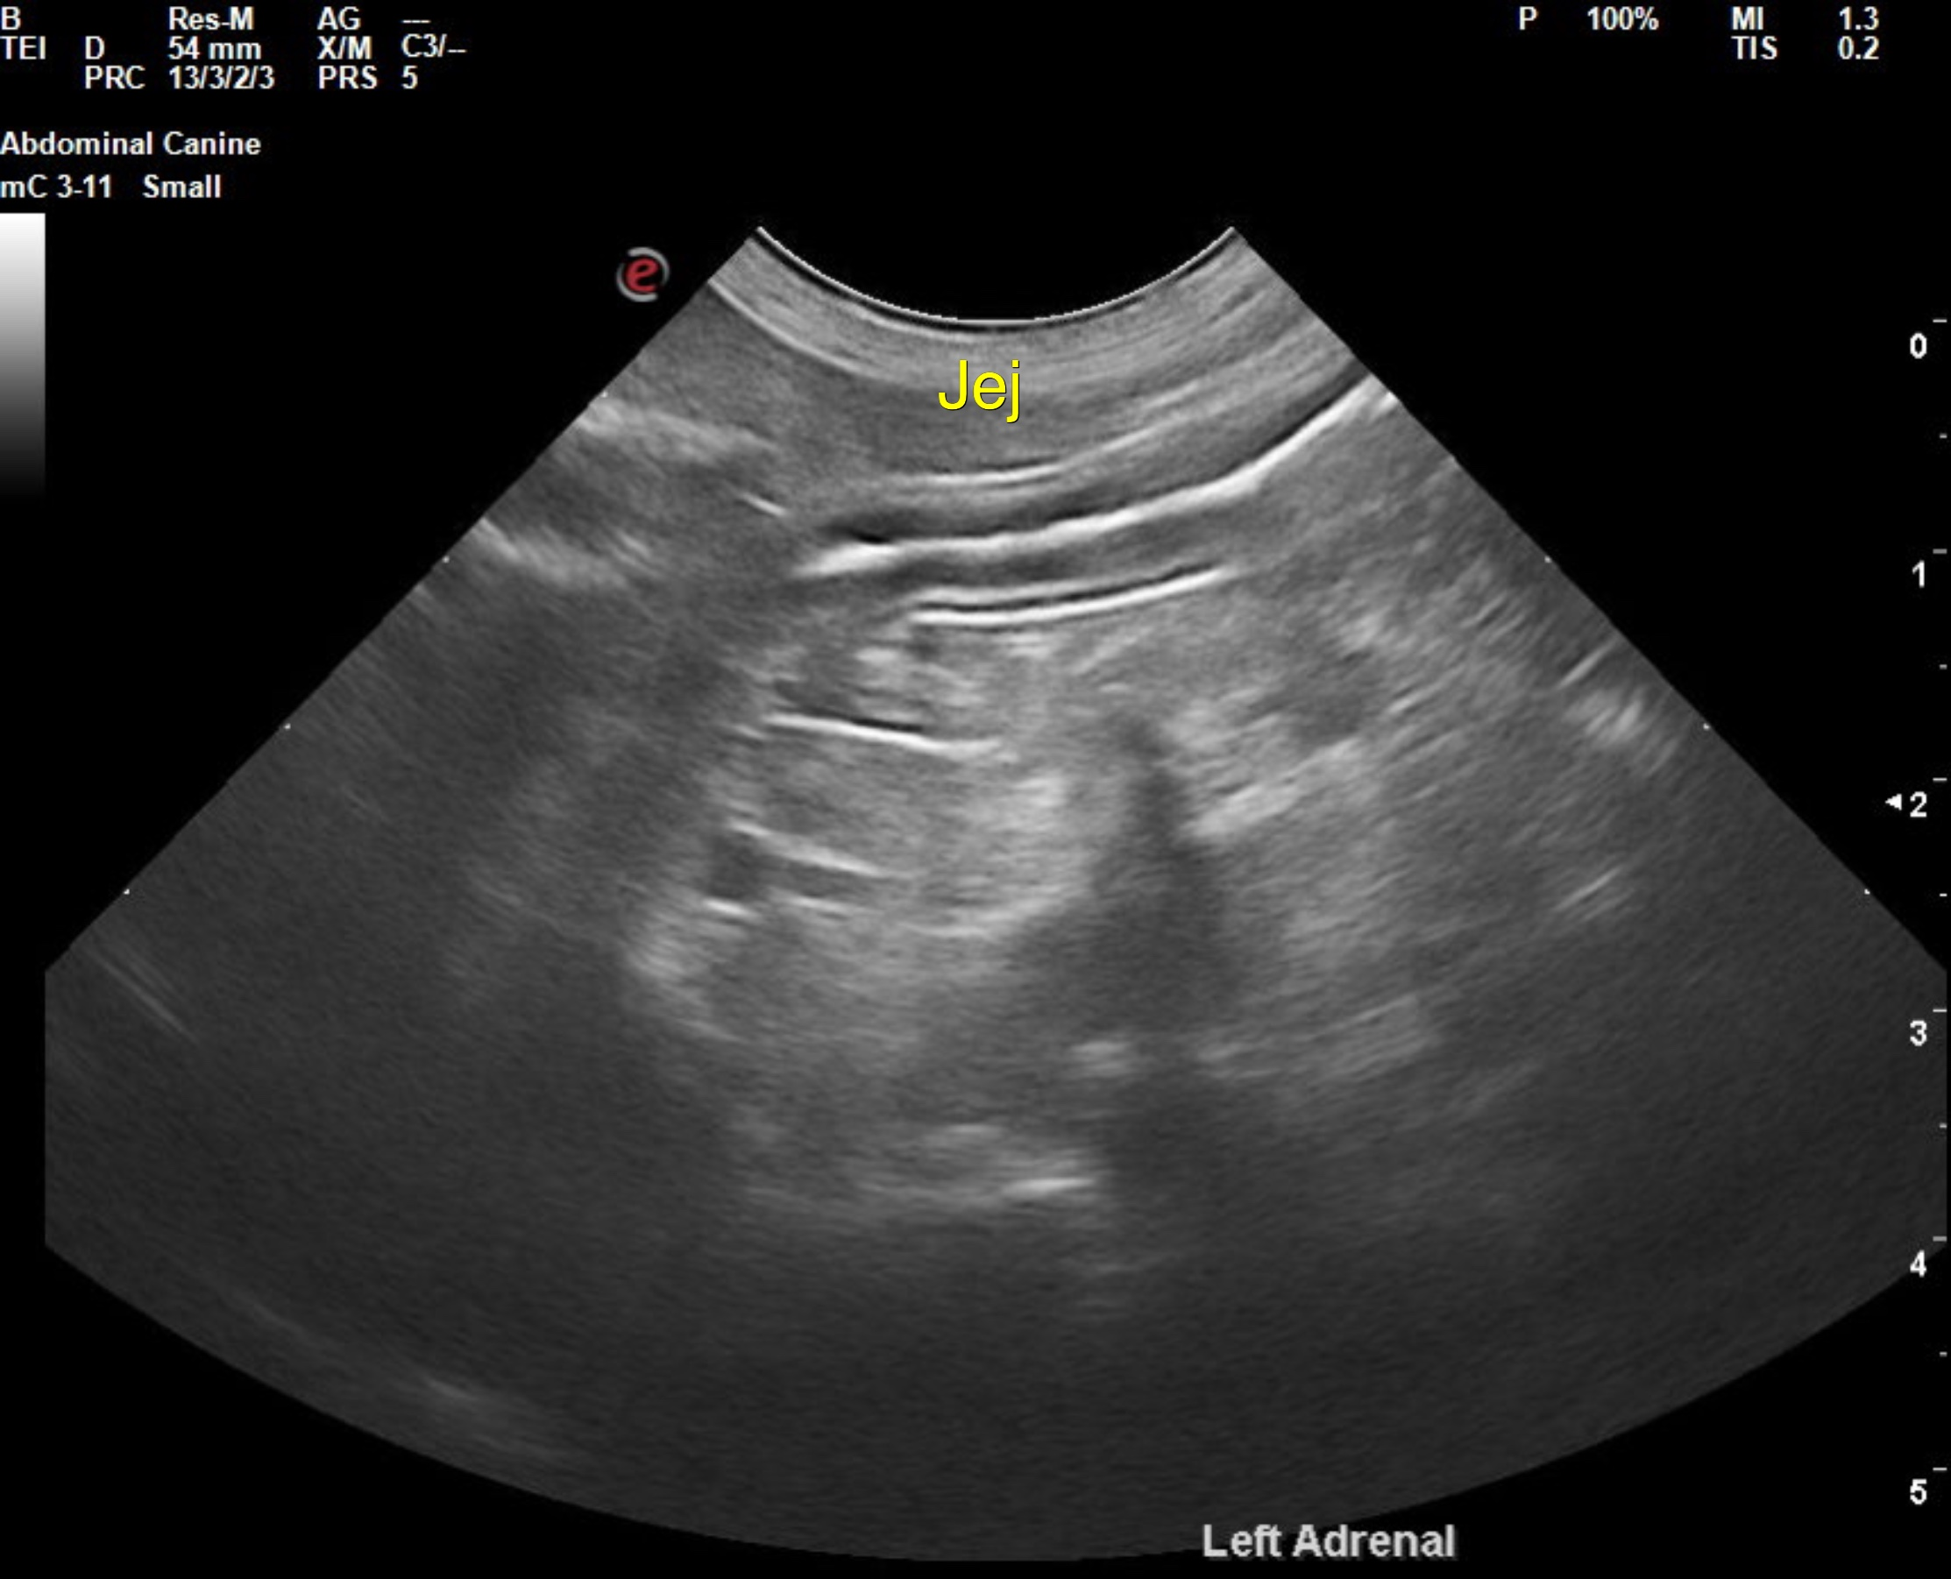
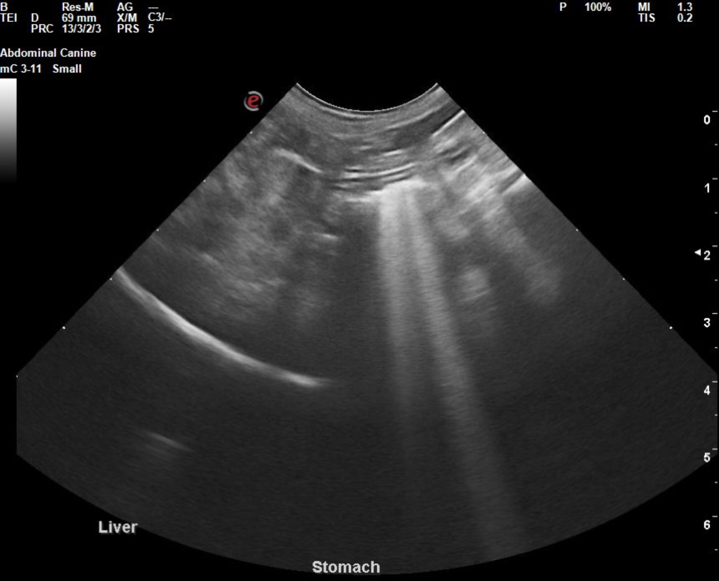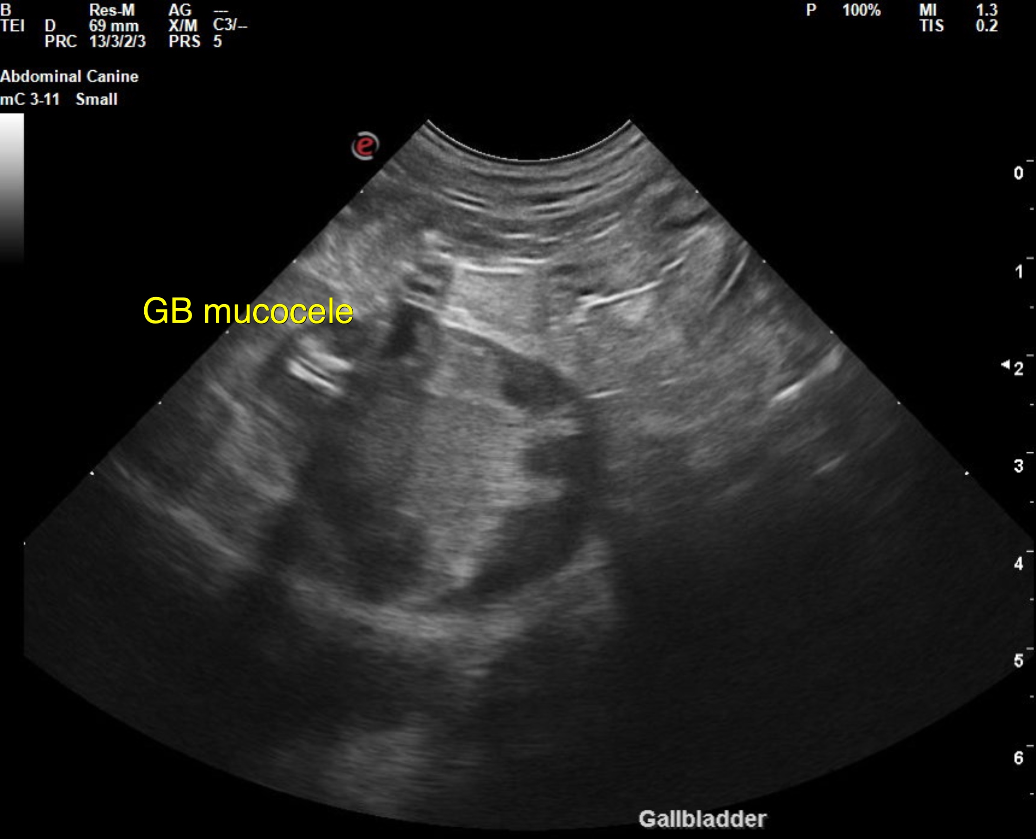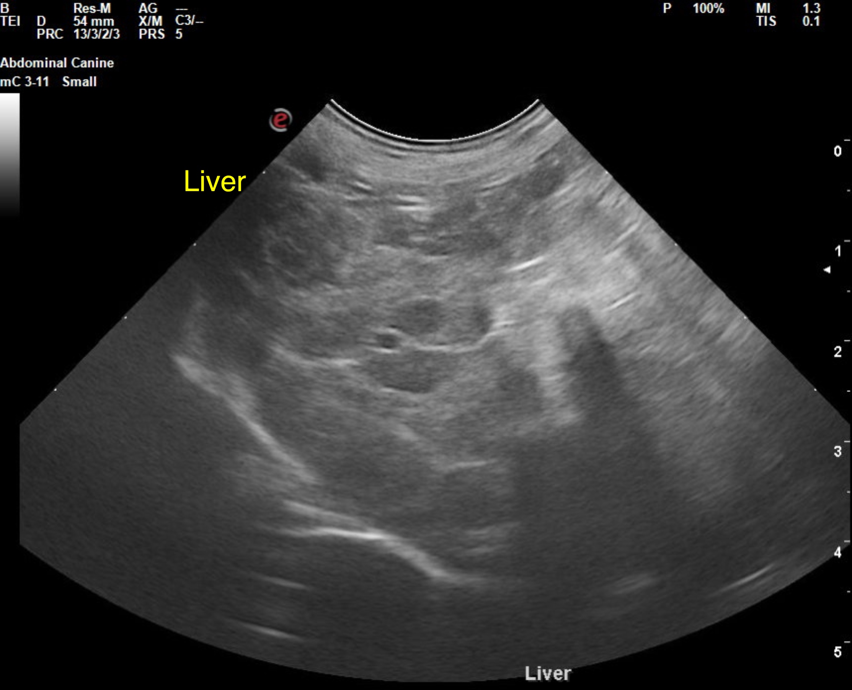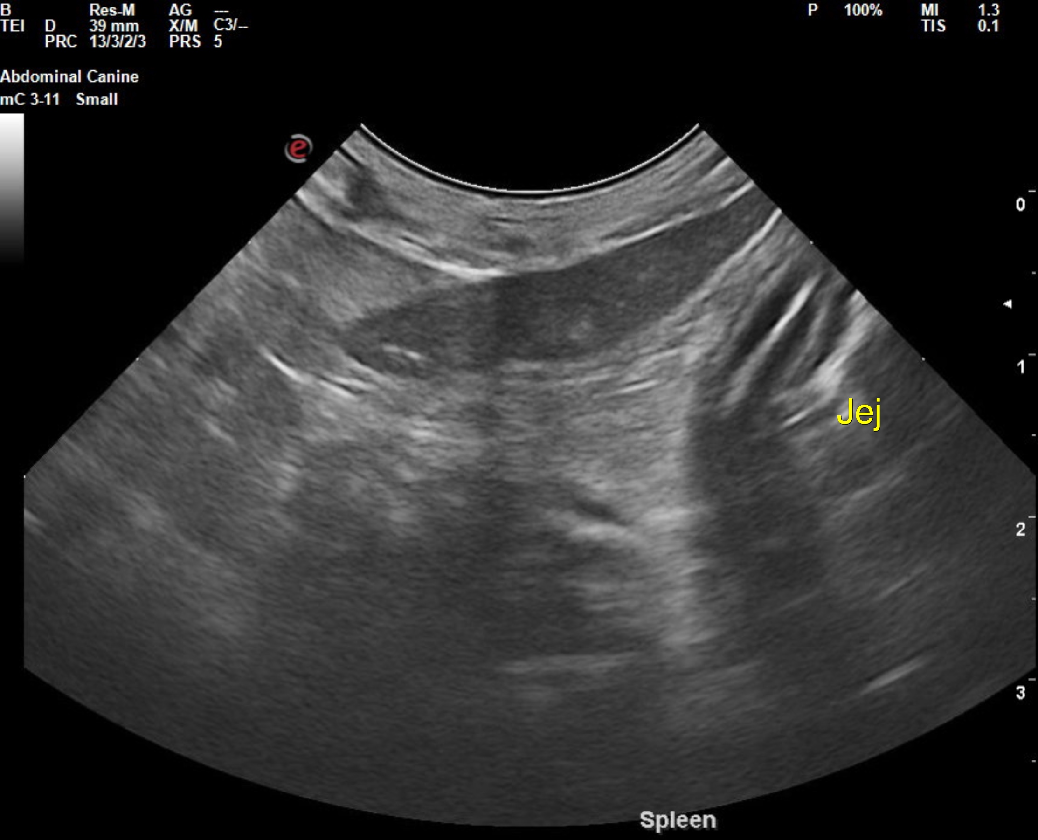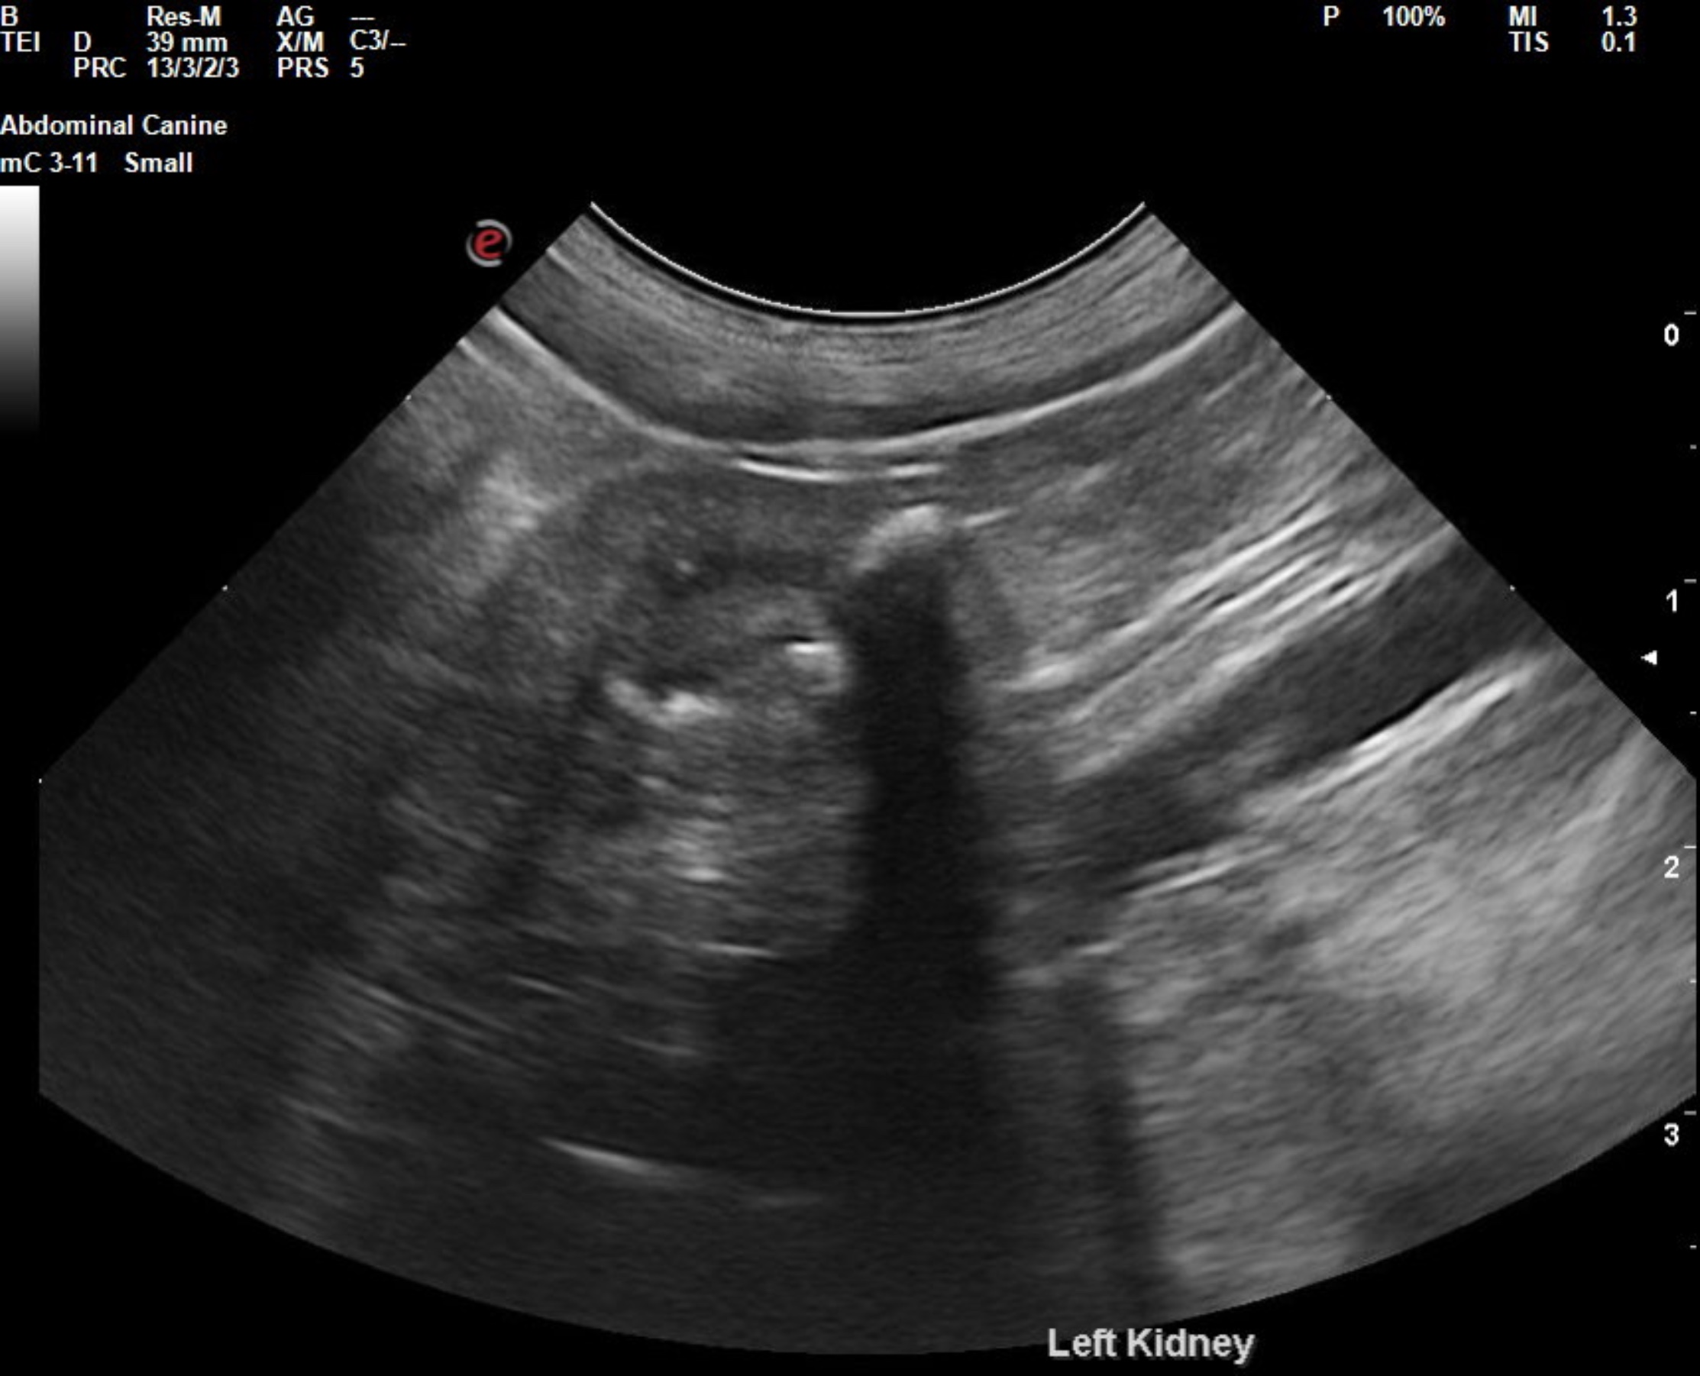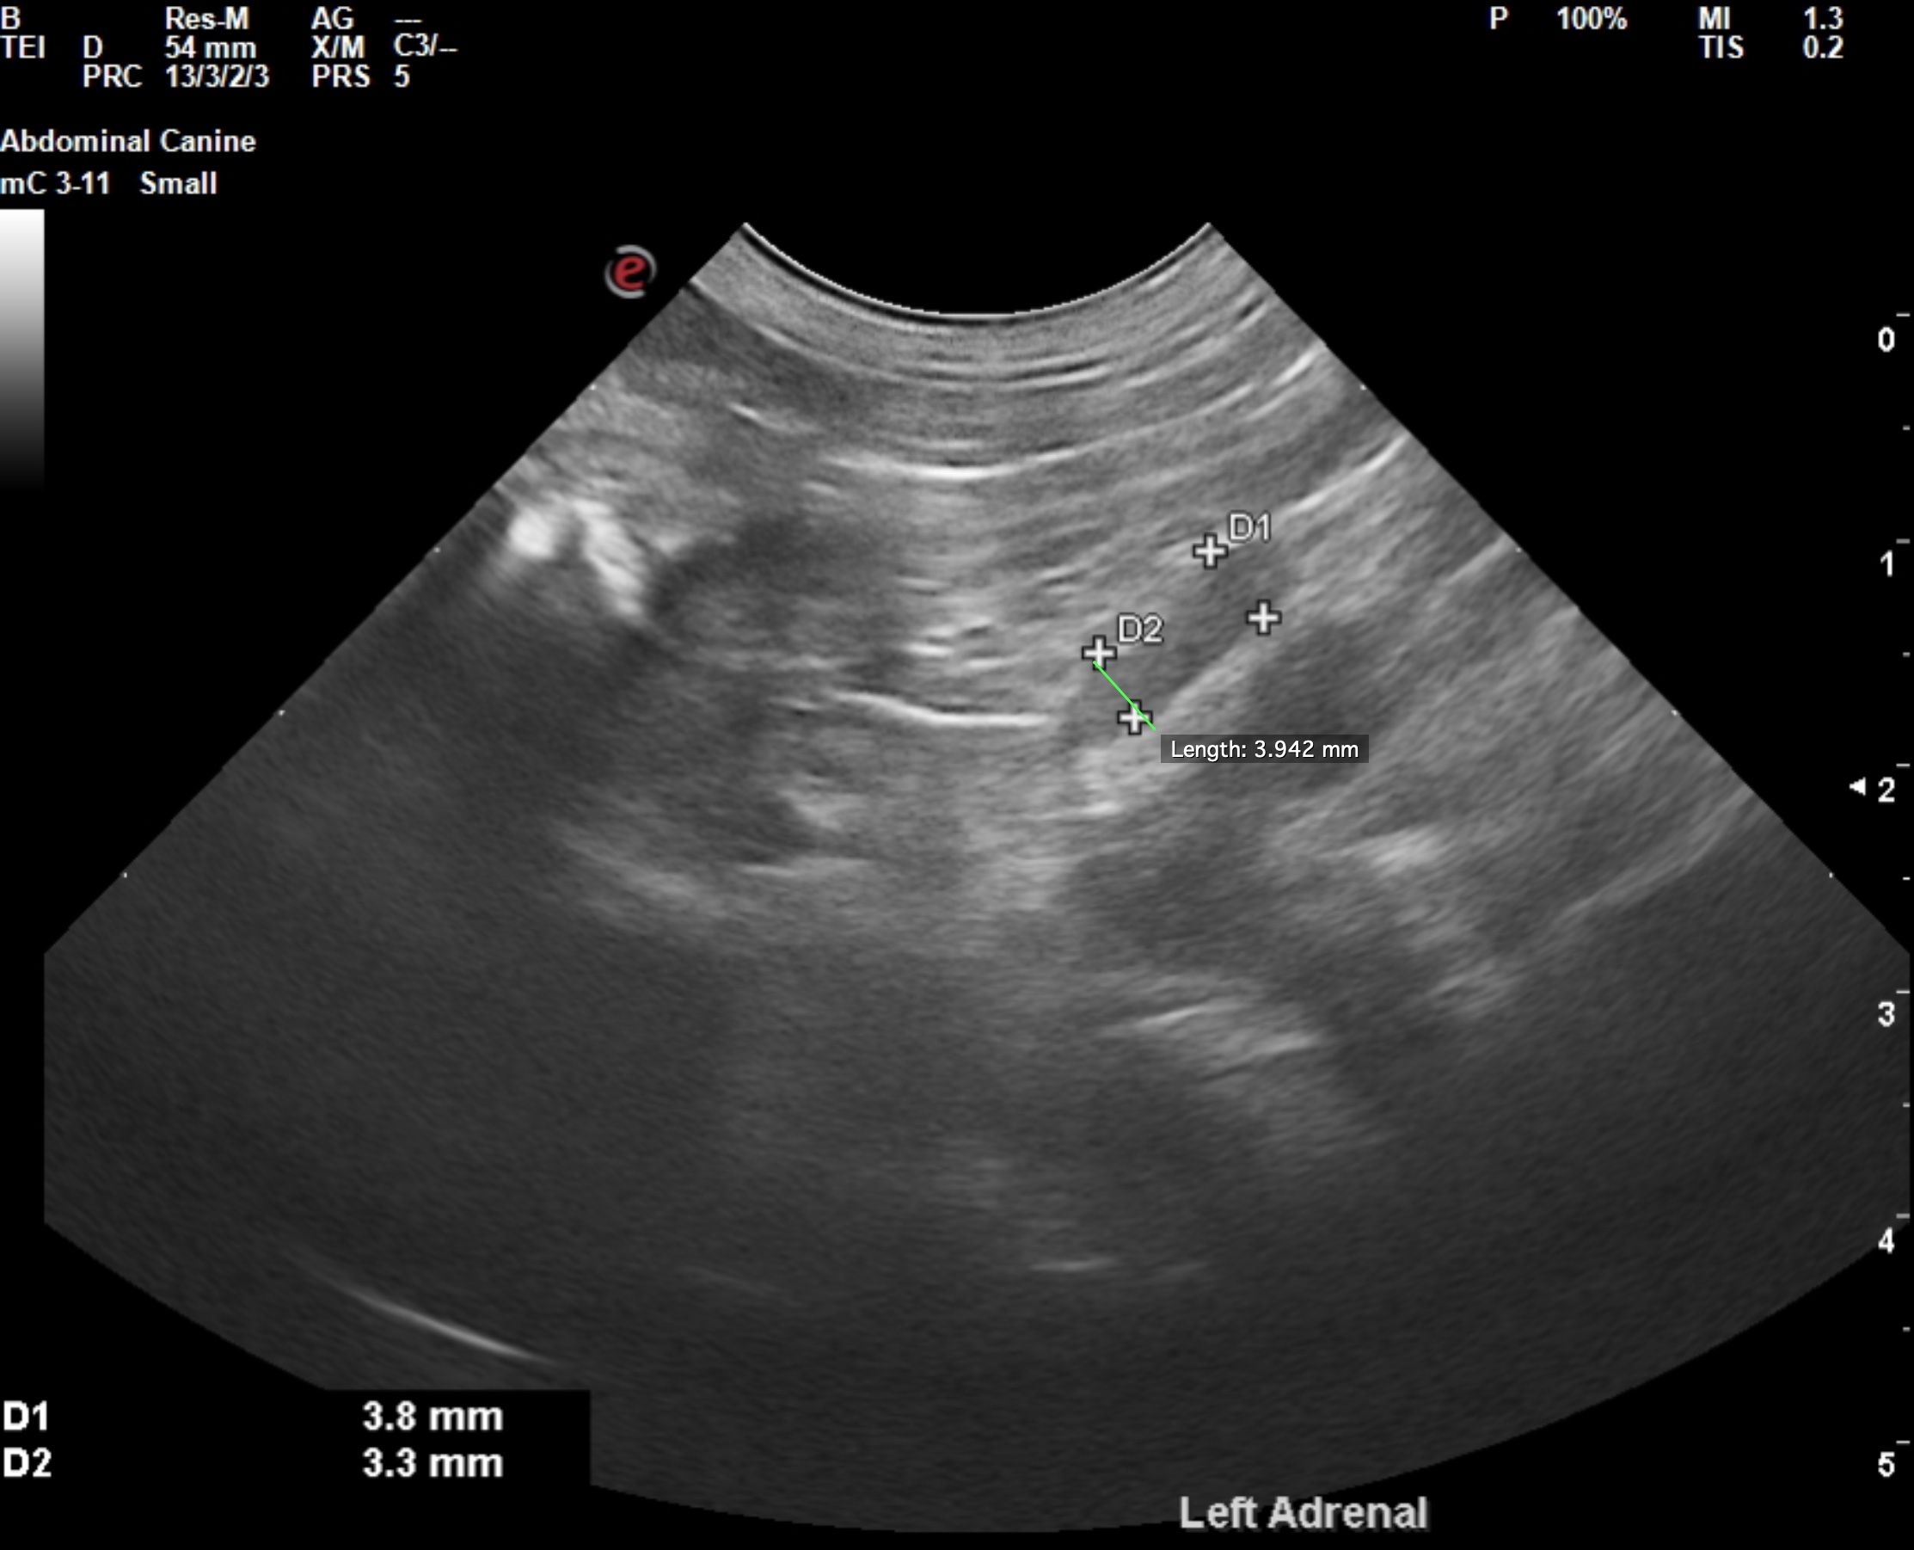

The information and recommendations provided are based on the images presented by the referring veterinarian/sonographer. No evaluation can be communicated regarding pathology that was not visible in the image/video clips provided.

Thank you for this referral. If the clinical or image interpretation does not parallel your findings or if I can be of any further assistance, please contact me.

R. McKenzie Daniel, DVM, DABVP (Canine/Feline Practice)
info@sonopath.com

