PRESENTING CLINICAL SIGNS
History: diarrhea, continous post Metro
ULTRASONOGRAPHIC EXAMINATION OF THE ABDOMEN
Urinary System
The urinary bladder, trigone, cystourethral junction, and visible pelvic urethra exhibited normal thickness and tone. Anechoic urine was present in the lumen with no uroliths or sediment. The ureteral papillae were normal. The ureters were not visible which is normal. No evidence of inflammatory or neoplastic changes were noted.
Normal size and margination were present in the kidneys. A normal 1:3 cortex / medulla ratio and normal corticomedullary definition were maintained. The echogenicity of the cortex was similar to or slightly less than normal liver parenchyma while the medulla echogenicity was hypoechoic to the cortex with no evidence of pelvic dilation. The left kidney measured 5.5 cm in length. The right kidney measured 6.0 cm in length.
The area of the aortic trifurcation was free of pathology.
The prostate was enlarged in size with intact, symmetrical capsule contour. The margins of the gland were intact and able to be differentiated from the surrounding tissue. The prostatic parenchyma was mildly echogenic to heteroechoic without parenchymal mineralization. The prostate measured 5.7 cm x 3.2 cm.
Adrenal Glands
The left adrenal gland was uniform in size and contour with a uniformly hypoechoic parenchyma. The left adrenal gland measured 0.55 cm width at the caudal pole and 0.61 cm width at the cranial pole. The right adrenal gland was not definitively visualized.
Spleen
The spleen exhibited a finely textured and homogenous parenchyma which was hyperechoic to the liver and renal cortical parenchyma. The capsule was smooth and regular without apparent expansion. The splenic vasculature at the hilus was normal in volume with no evidence of congestion or thrombosis. Acute to chronic inflammatory, neoplastic, or benign parenchyma changes were not noted.
Liver
The liver was subjectively normal in size, structure, and contour. The liver parenchyma was uniform and hypoechoic to the spleen with a mild coarse echotexture. The hepatic and portal vasculature were normal in appearance without signs of congestion. The gallbladder was non-distended in size with thin walls and primarily anechoic luminal content. The cystic and common bile ducts were normal.
Gastrointestinal
The stomach presented intact wall layering with a normal wall layer ratio. The lumen of the stomach was empty with no signs of ileus, obstruction or foreign material. The stomach wall measured 0.39 cm in width.
The small intestine presented intact wall layering with 1:3 muscularis/mucosa ratio. The lumen of the small intestine was empty with no signs of ileus, obstruction or foreign material. The small intestine wall measured 0.38 cm in width.
Normal visible colon wall layers were present with apparent formed feces in lumen.
Pancreas
The parenchyma of the left limb, body and right limb of the pancreas presented isoechoic to the adjacent omental fat. A normal curvilinear capsule contour of the pancreas was present. The visible pancreatic duct was normal. No signs of active inflammation or neoplastic disease was evident.
Free Abdomen
No overt lymphadenopathy or peritoneal effusion was present.

ULTRASONOGRAPHIC FINDINGS
- Benign prostatic hyperplasia, minor potential for prostatitis
- Otherwise a sonographically unremarkable abdomen.
INTERPRETATION OF THE FINDINGS & FURTHER RECOMMENDATIONS
No evidence of abdominal visceral pathology specifically no evidence of gastroenterocolic pathology. At times the GI presentation does not always correlate with GI signs present. In patients with persistent/recurrent GI signs. general considerations may include dietary intolerance/food allergy, dysbiosis-which may be considered a primary differential diagnosis in this case if positive previous response to metronidazole, IBD/low grade to chronic pancreatitis-both of which may present sonographically normal, occult parasitism or other gastroenterocolopathy. A GI panel to include PLI/TLI/Cobalamin/Folate is recommended. Empirically, a limited antigen or hydrolyzed diet trial with potential long term dietary therapy, prophylactic deworming (Panacur 50 mg/kg SID x 5 consecutive days with repeat protocol in 3 weeks even if fecal testing is negative), high colony count probiotic (Proviable or Visbiome), antibiotic trial and as needed gastrointestinal support with assessment of clinical response may prove beneficial. Intestinal biopsies may be indicated if GI signs continue despite empirical therapy. Resting cortisol level may be considered to rule out occult Addison’s disease.
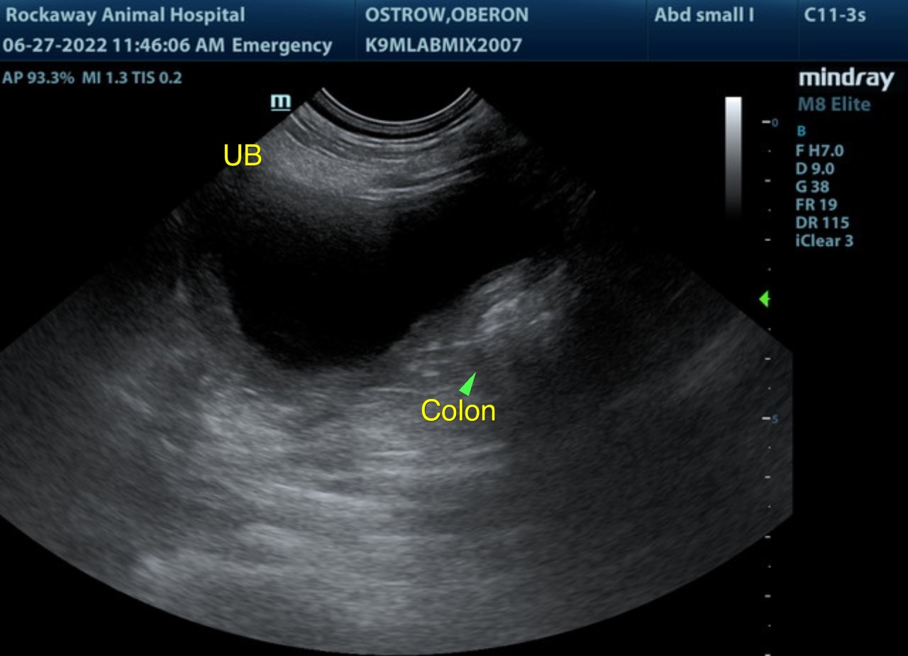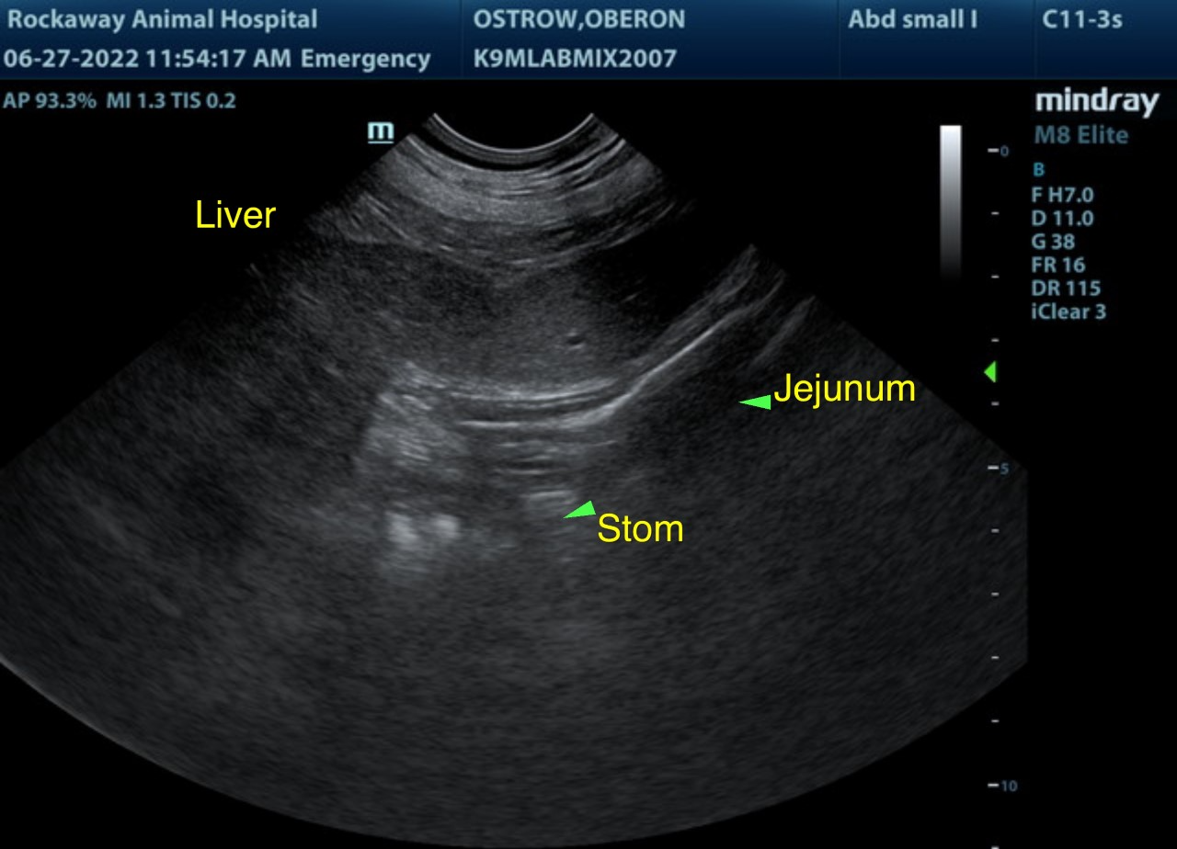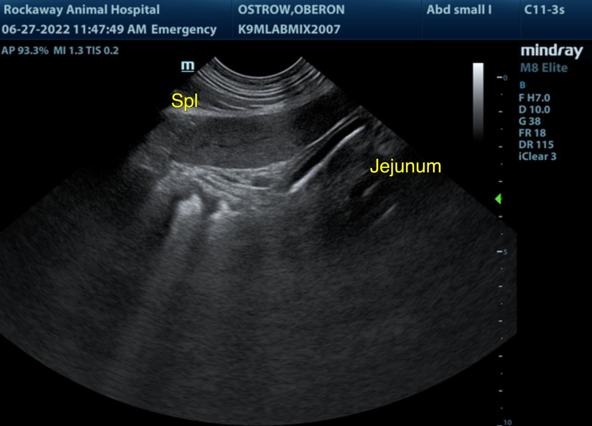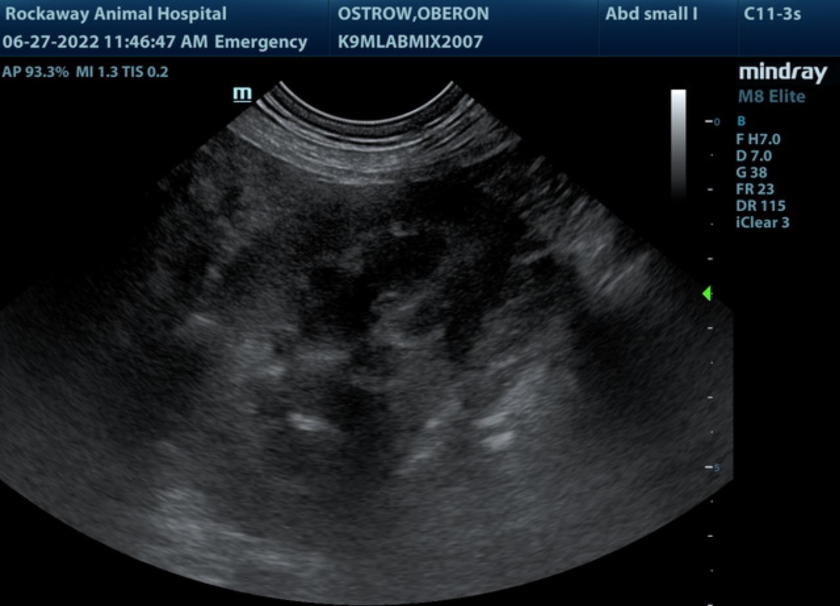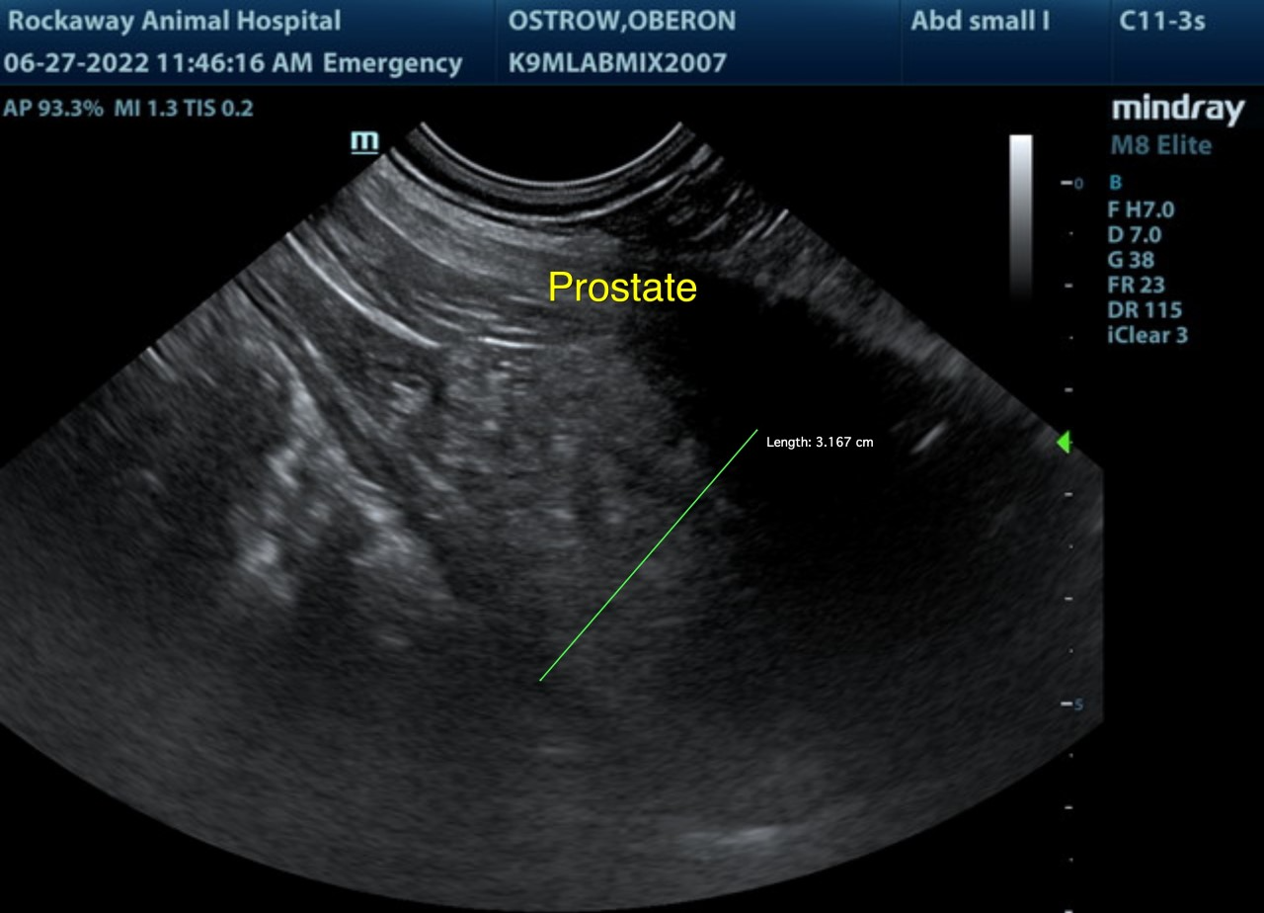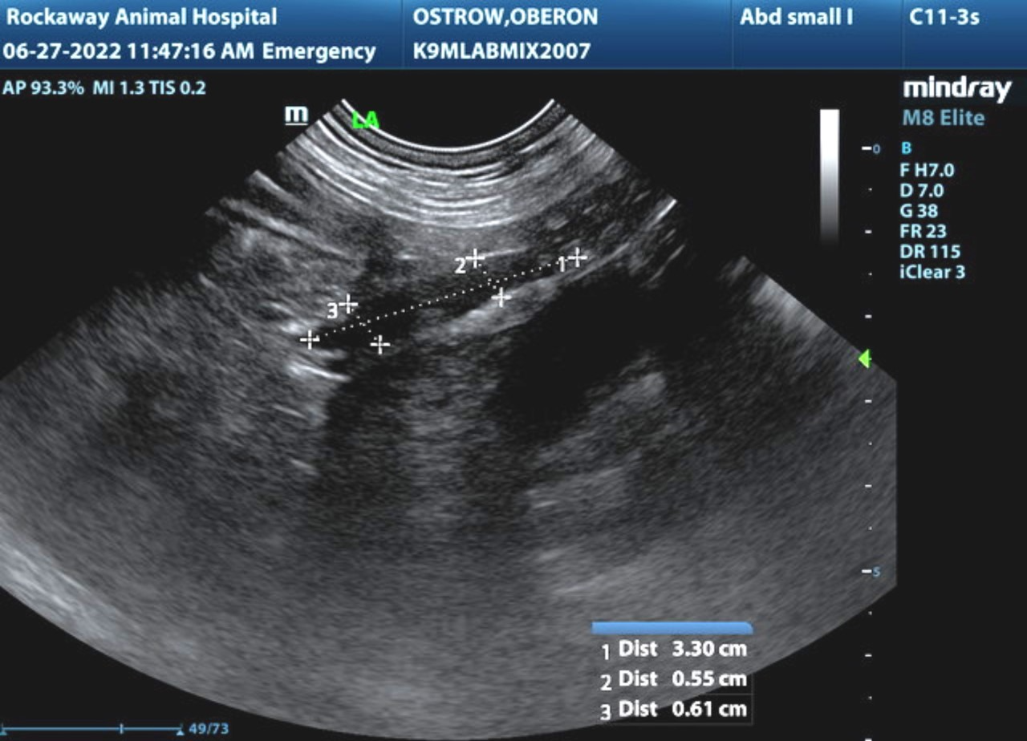
The information and recommendations provided are based on the images presented by the referring veterinarian/sonographer. No evaluation can be communicated regarding pathology that was not visible in the image/video clips provided.
Thank you for this referral. If the clinical or image interpretation does not parallel your findings or if I can be of any further assistance please contact me.
R. McKenzie Daniel, DVM, DABVP (Canine / Feline Practice)
info@SonoPath.com

