PRESENTING CLINICAL SIGNS
History: weight loss of undetermined origin. Occasional vomiting but has always done that. Eating normal amount of food.
Abnormal PE/Chem/CBC/UA Results: Please see attached rads. U/A pH 6.5, trace protein, culture negative. Sp Grav 1.050
ULTRASONOGRAPHIC EXAMINATION OF THE ABDOMEN
Urinary System
The urinary bladder, trigone, cystourethral junction, and visible pelvic urethra to a depth of 2 cm exhibited normal thickness and tone. Anechoic urine was present in the lumen with mild nondependent particulate sediment. The ureteral papillae were normal. The ureters were not visible which is normal. No evidence of inflammatory or neoplastic changes were noted.
The left kidney was subnormal in size compared to the right. A normal 1:3 cortex / medulla ratio was maintained. The medulla and cortices were uniform in texture with some increased echogenicity and mild loss of corticomedullary symmetry and definition expected for the age of the patient. No evidence of pelvic dilation was present. The left kidney measured 2.3 cm in length. The right kidney measured 3.6 cm in length.
The area of the aortic trifurcation was free of pathology.
Adrenal Glands
The bilateral adrenal glands were normal in size and contour. Pinpoint areas of mineralization were present without capsular distortion or overt tumors. This is an age-related finding and not pathological. The left adrenal gland measured 0.43 width and the right adrenal gland measured 0.29 width.
Spleen
The spleen exhibited a finely textured and homogenous parenchyma which was hyperechoic to the liver and renal cortical parenchyma. The capsule was smooth and regular without apparent expansion. The splenic vasculature at the hilus was normal in volume with no evidence of congestion or thrombosis. Acute to chronic inflammatory, neoplastic, or benign parenchyma changes were not noted. The spleen measured 0.69 cm in width at the level of the hilus.
Liver
The liver was subjectively normal in size, structure, and contour. The liver parenchyma was uniform and hypoechoic to the spleen with a mild coarse echotexture. The hepatic and portal vasculature were normal in appearance without signs of congestion. The gallbladder was non-distended in size with thin walls and primarily anechoic luminal content. The cystic and common bile ducts were normal.
Gastrointestinal
The stomach presented intact wall layering with a normal wall layer ratio. The lumen of the stomach was empty with no signs of ileus, obstruction or foreign material. The gastric body wall measured 0.26 cm in width.
The small intestine presented intact yet subjectively prominent to thickened walls without evidence of loss of wall layering or intestinal masses. The lumen of the small intestine was empty with no signs of ileus, obstruction or foreign material. The jejunum wall measured up to 0.33 cm in width. The duodenum wall measured 0.26 cm in width. The ileocolic wall measured 0.32 cm in width.
Normal visible colon wall layers were present with apparent formed feces in lumen.
Pancreas
The pancreas was normal in size and contour with isoechoic to heterogeneous parenchyma compared to adjacent omentum. No signs of active inflammation or neoplasia.
Free Abdomen
No omental masses, overt lymphadenopathy or peritoneal effusion was present.

ULTRASONOGRAPHIC FINDINGS
- Probable IBD
- Possible low grade to chronic pancreatitis
- Bilateral mild chronic renal changes with mild subnormal left kidney size
- Mild urinary bladder sediment-mild cellular debris/protein, crystalline debris or mucus possible
INTERPRETATION OF THE FINDINGS & FURTHER RECOMMENDATIONS
The small intestinal changes are relatively mild and may be a normal patient variant however given the weight loss and GI signs an underlying process/IBD is suspected. Potential for concurrent low grade to chronic pancreatitis is possible. A GI panel to include PLI/TLI/Cobalamin/Folate is recommended. Full thickness intestinal biopsies likely required for a definitive diagnosis. Empirical IBD/low grade pancreatitis therapy protocol with assessment of clinical response would be reasonable.

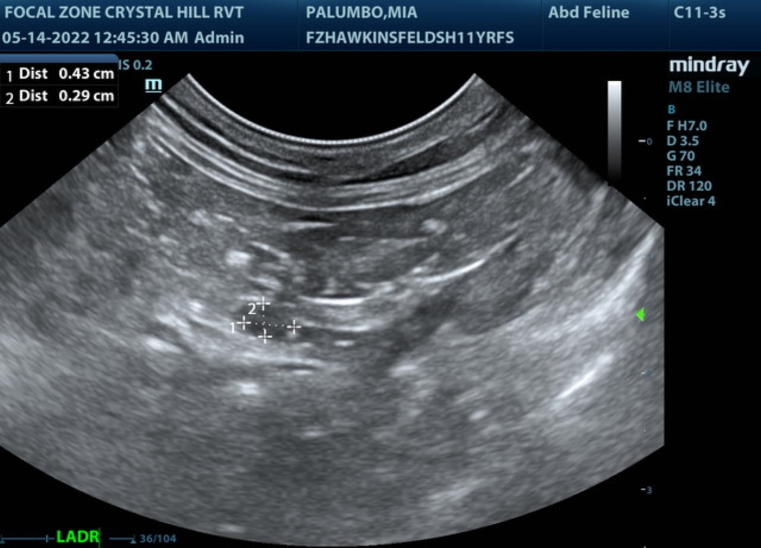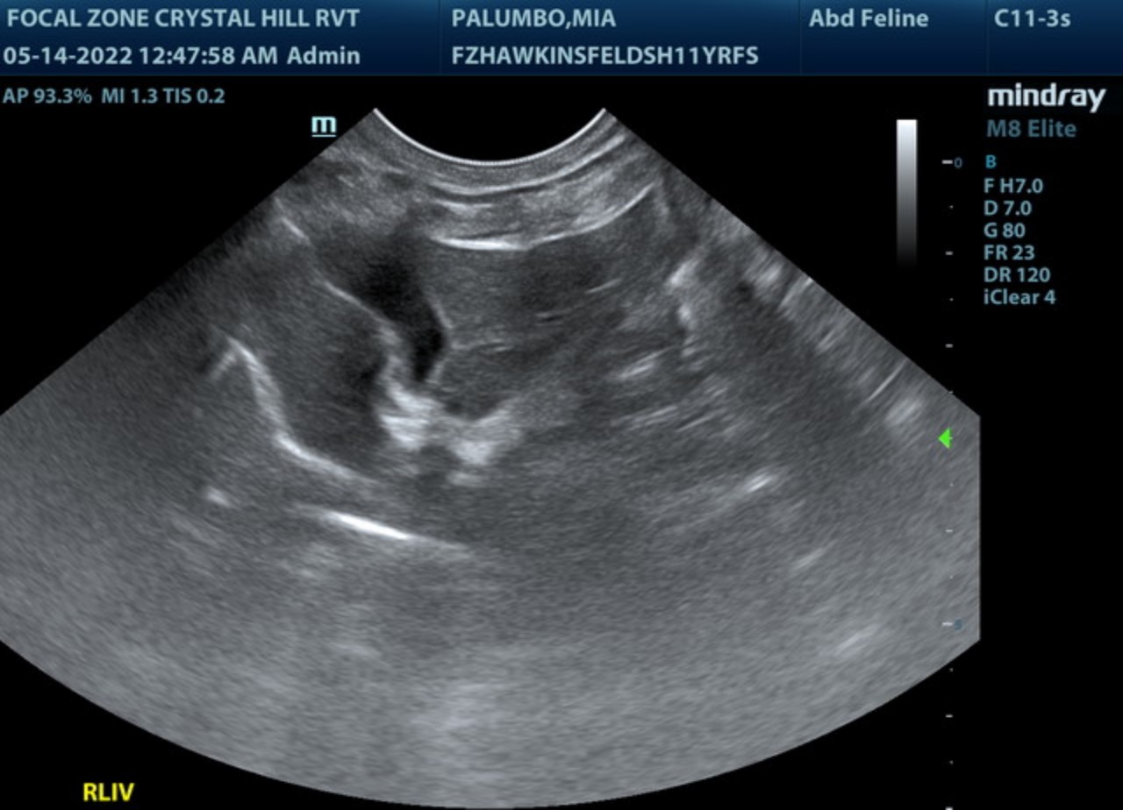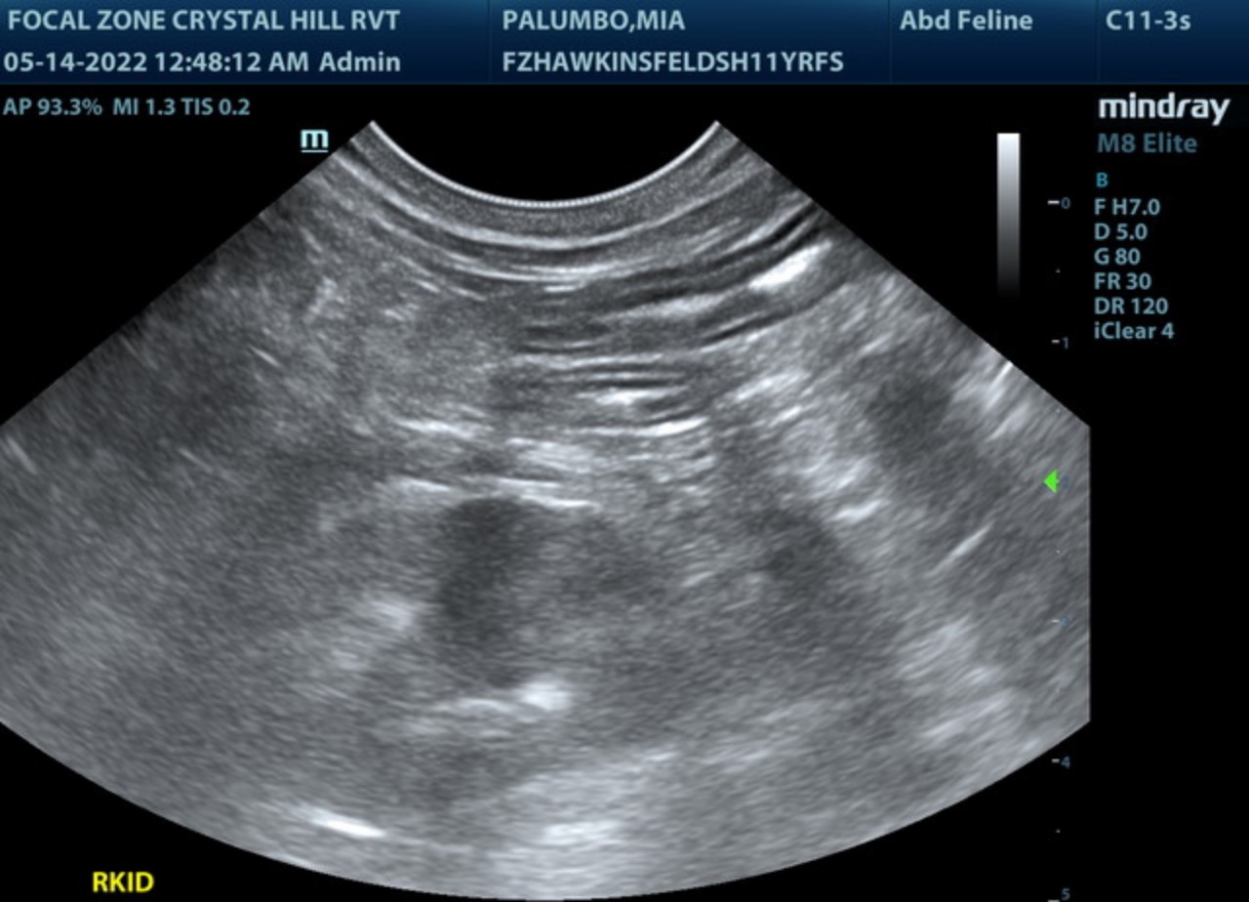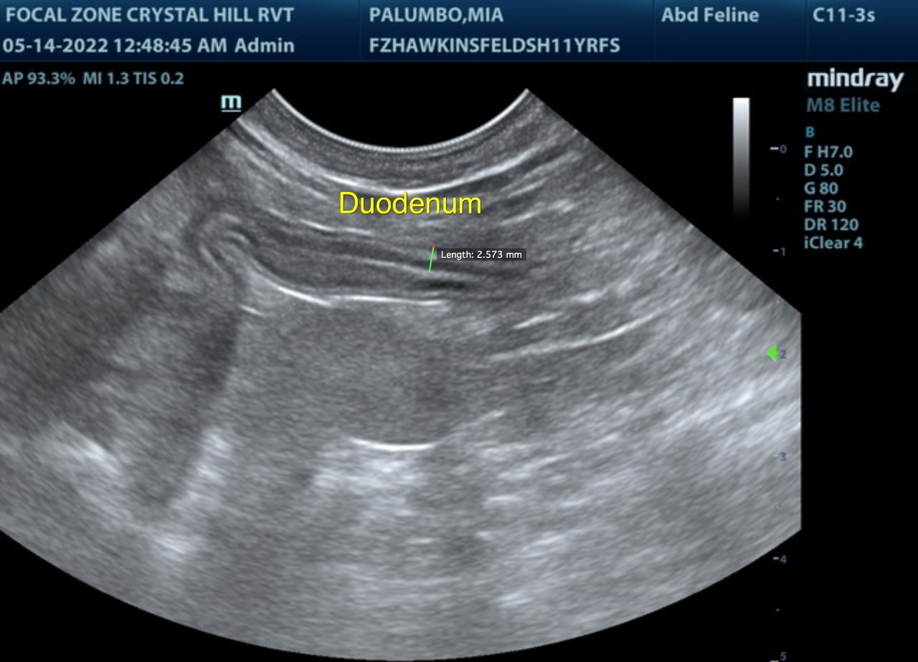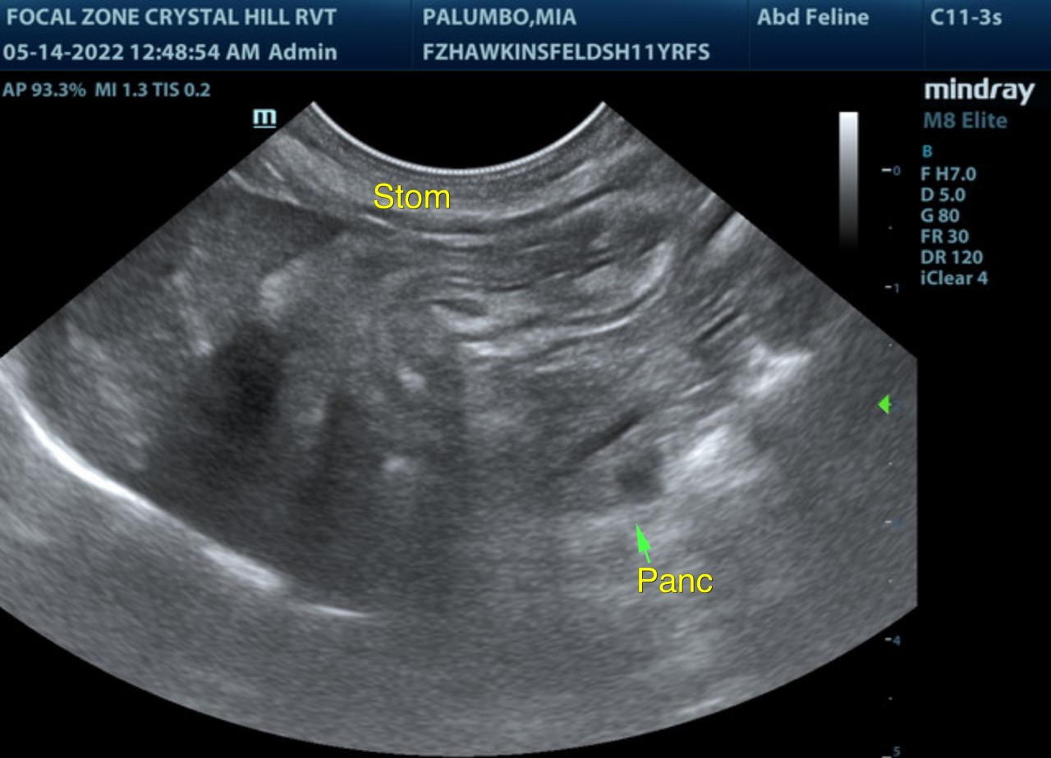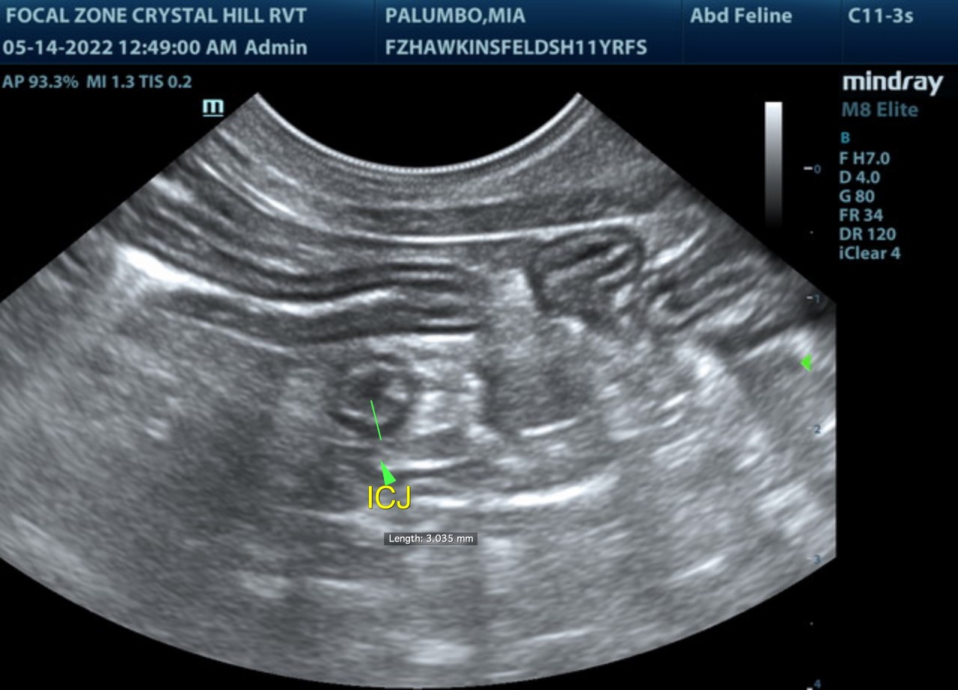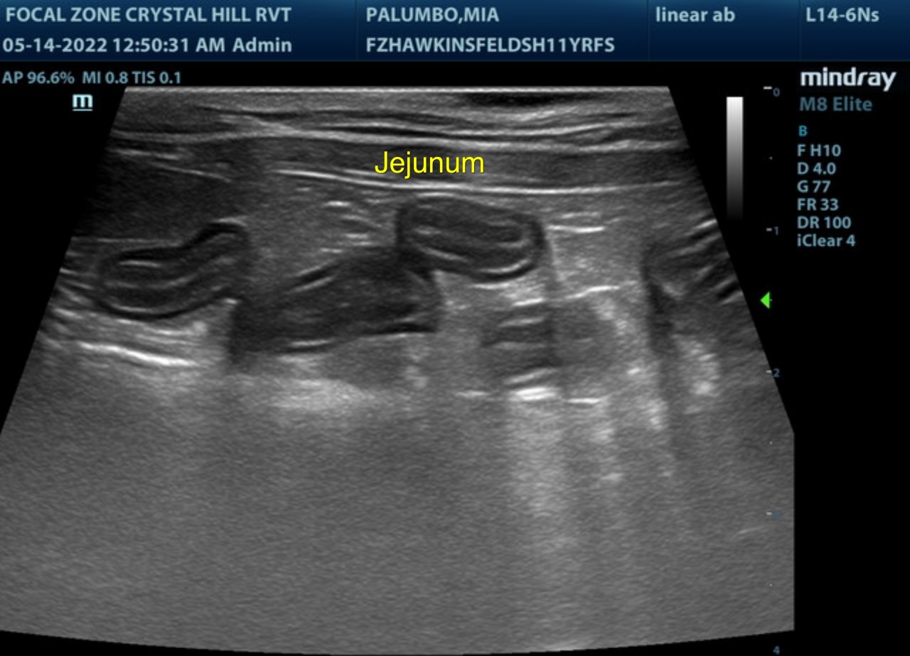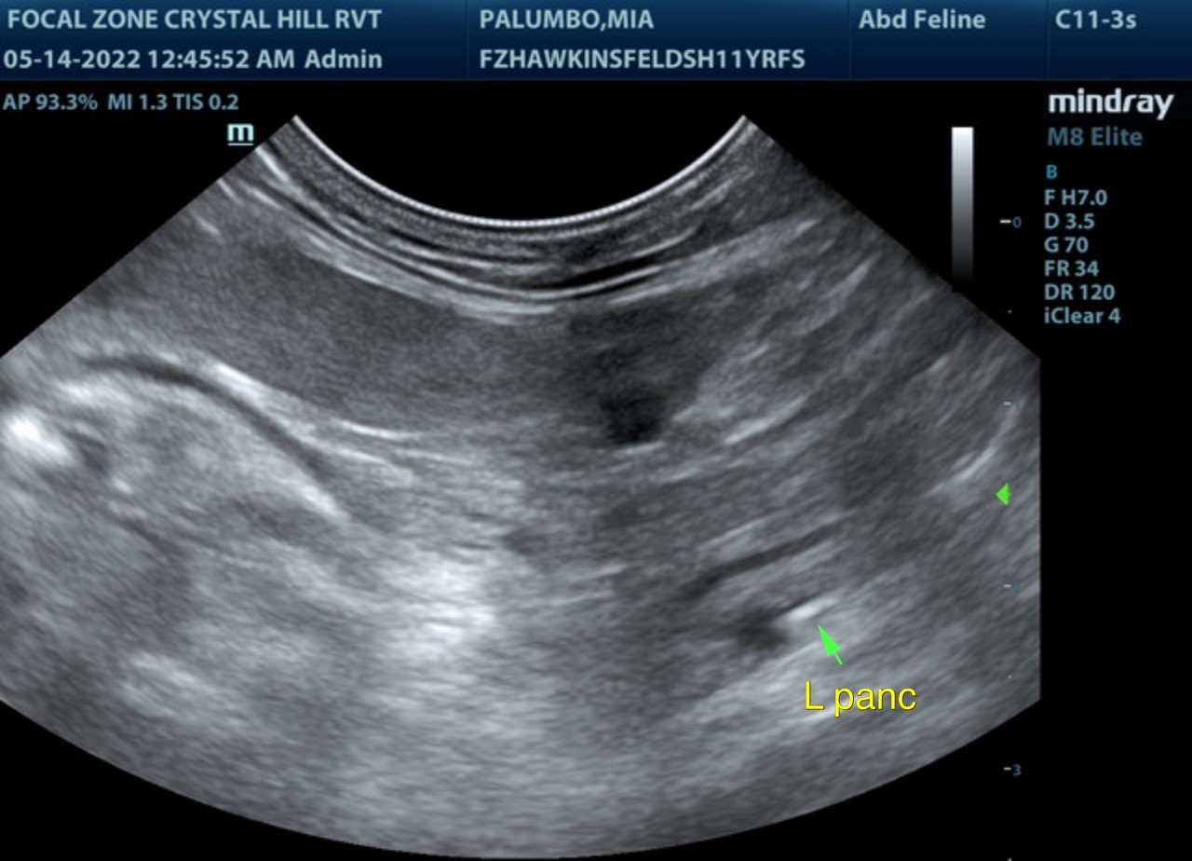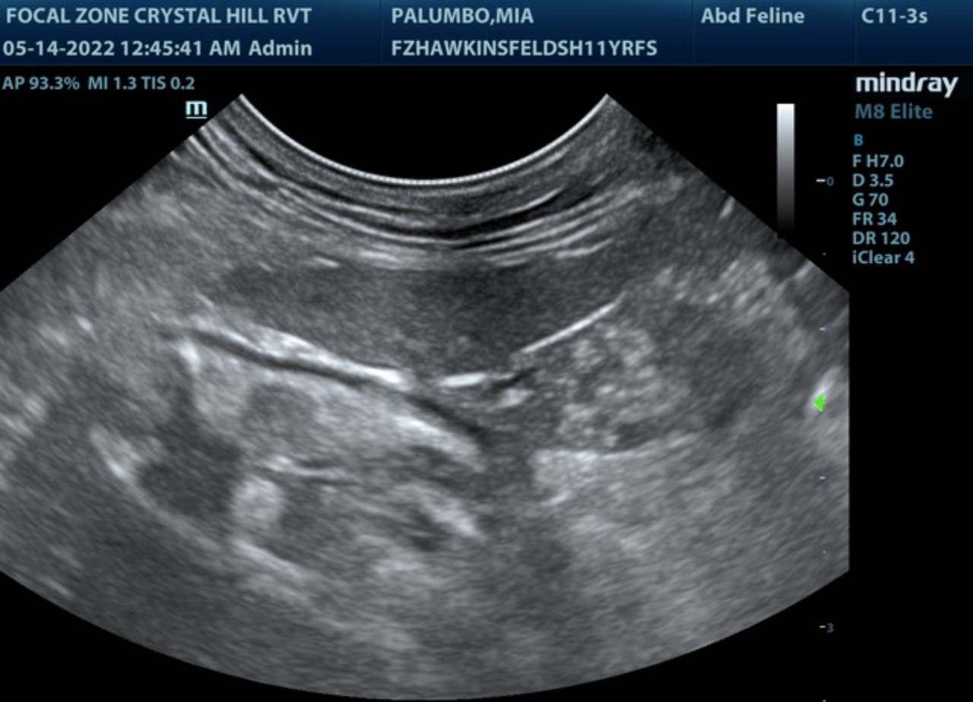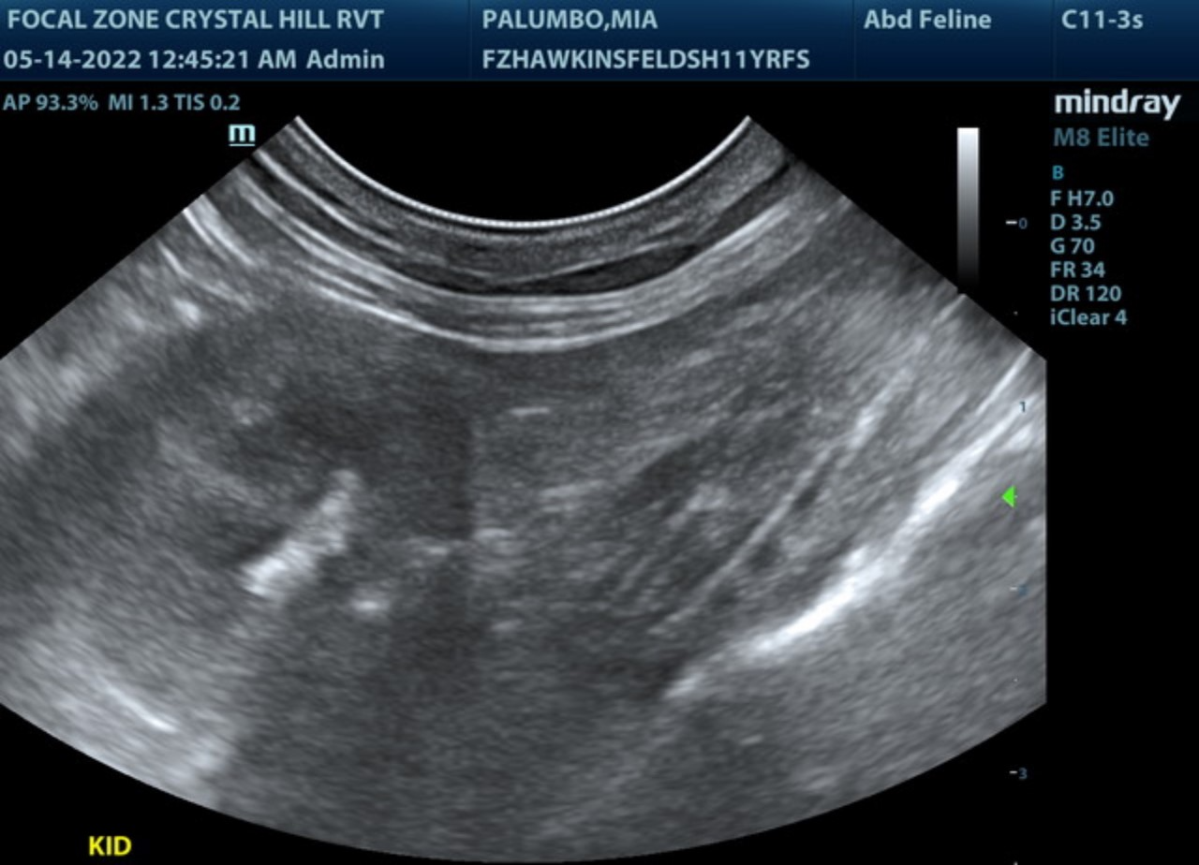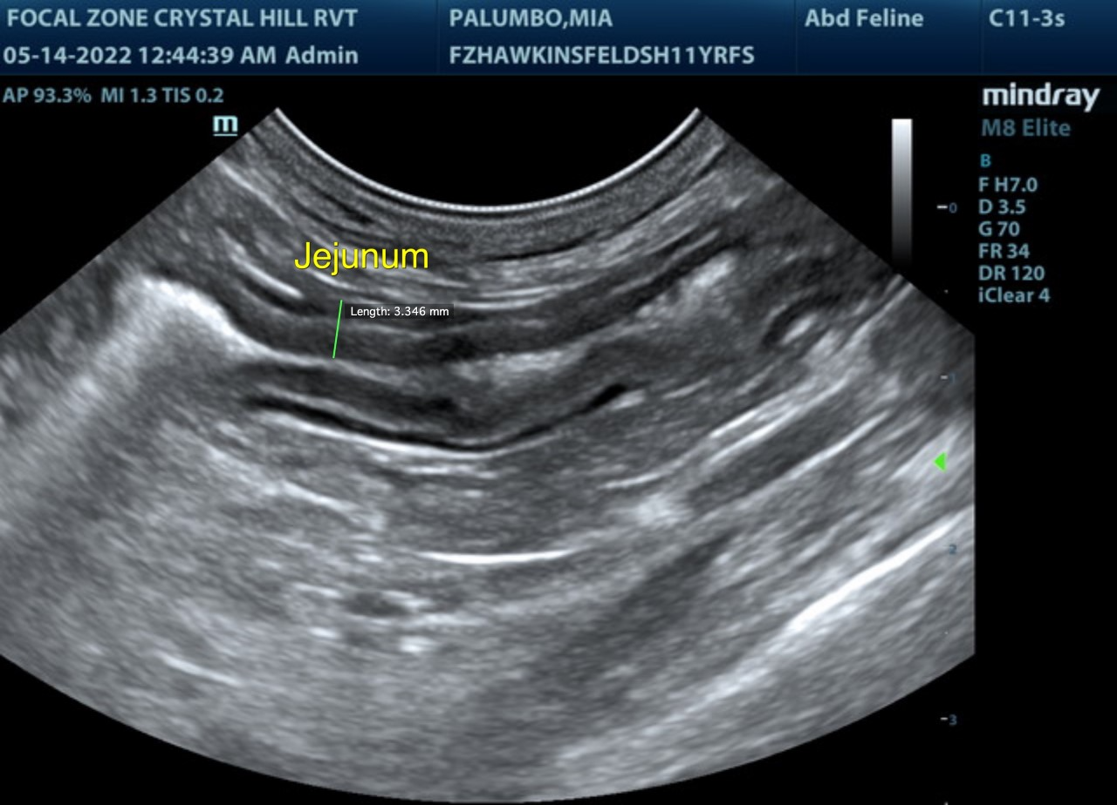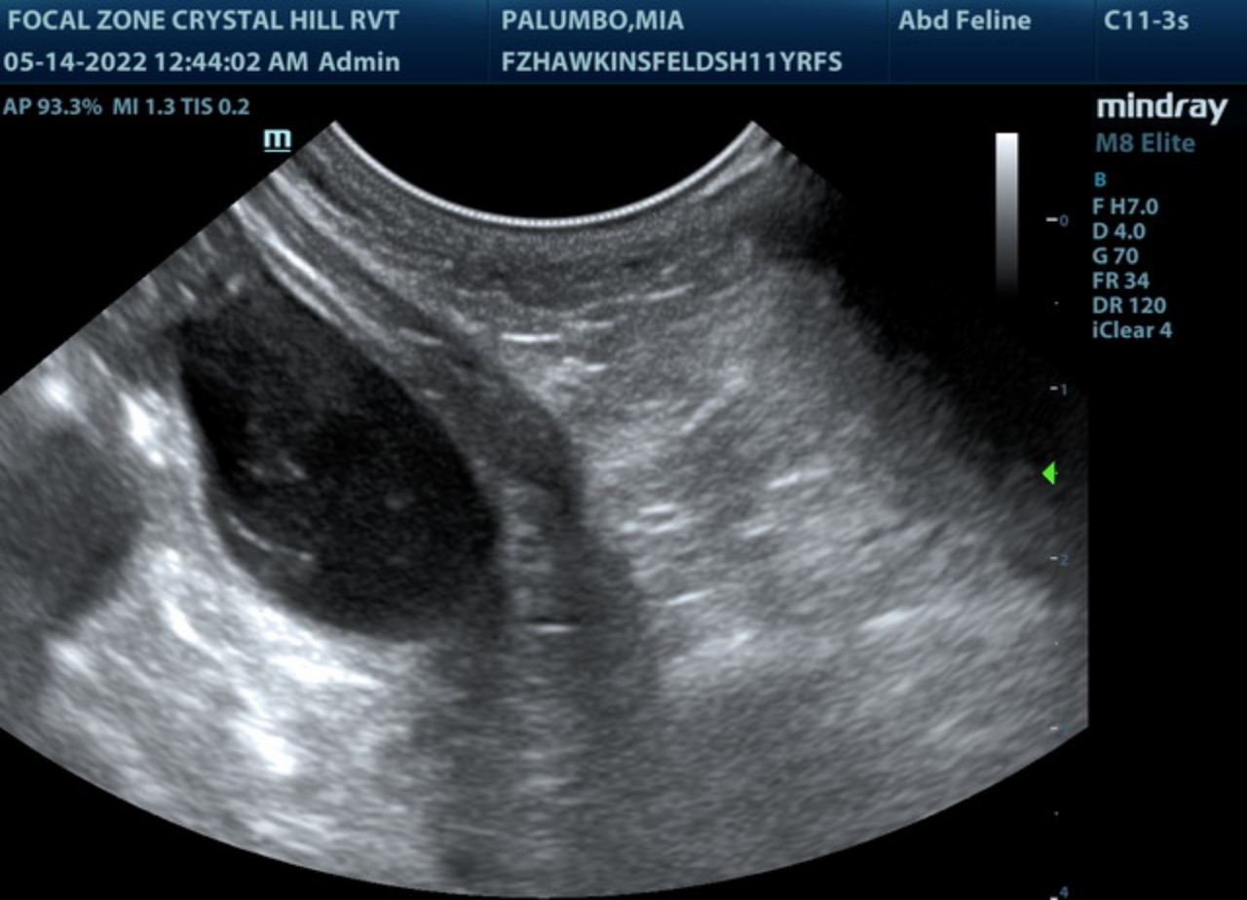

The information and recommendations provided are based on the images presented by the referring veterinarian/sonographer. No evaluation can be communicated regarding pathology that was not visible in the image/video clips provided.
Thank you for this referral. If the clinical or image interpretation does not parallel your findings or if I can be of any further assistance please contact me.
R. McKenzie Daniel, DVM, DABVP (Canine / Feline Practice)
info@SonoPath.com

