PRESENTING CLINICAL SIGNS
lulu came on 4/23/23Cat has been hypoerexic for the past 2 weeks and vomiting on and off for same time. According to the owners, the cat has not eaten in 2 days. The cat has a cery aggressive nature and the owners say that it is due to a nerological problem that she was born with. Today is qar. growling. ate well this morning. no vomiting. currently on fluids, cerenia, pantoprazole, simbadol. radiology report in - no evidence of obstruction, suspect impression of ventral herniation of SI may be artifact.no evidence of strangulation. suspect scarring of both kidneys which may be incidental, given normal labwork. chronic enteropathies as IBD/small cell lymphooma cannot be ruled out as potential causes of c/s and normal radiographs. there is low likelihood of a radiolucent non obstructive intestinal FB. Recommend Abd. US.
Abnormal PE/Chem/CBC/UA Results: S/O: Extremely aggressive. Under sedation - 5% dehydrated HR: 220 RR: 24 MM: Pink CRT< 2 sec EENT: NSF PLN: Normal H/L: No MoA auscutled. Lungs sound clear Abd: No masses of FB can be palpated Ms/N: Could not assess due to the cat been sedated. Int: No abnormalities seen. Palpation of the subcutaneous abdomen could not reveal if there is the presence of a hernia or not. CBC: Mostly unremarkable Chem: Mostly unremarkable. AXR: The small bowel appears to potentially be outside the abdominal wall. Official radiographic review is still pending. Plan to continue hospit with iv fluids, cerenia 1mg/kg iv sid, continue pantoprazole 1mg/kg iv sid, simbadol 0.24mg/kg sq sid, and add unasyn 30mg/kg iv bid in case has UTI.
ULTRASONOGRAPHIC EXAMINATION OF THE ABDOMEN
Urinary System
The urinary bladder, trigone, cystourethral junction, and visible pelvic urethra to a depth of 2.0 cm exhibited normal thickness and tone. Primarily anechoic urine was present in the lumen. Mild non-dependent, particulate sediment was present without evidence of calculus formation. The ureteral papillae were normal. The ureters were not visible which is normal. No evidence of inflammatory or neoplastic mural changes were noted.
The area of the aortic trifurcation was free of pathology.

Normal size and margination were present in the kidneys. A normal 1:3 cortex / medulla ratio was maintained. The medulla and cortices were uniform in texture with some increased echogenicity and mild to moderate loss of corticomedullary symmetry and definition expected for the age of the patient. No evidence of pelvic dilation or pyelectasia was present. Pinpoint medullary mineral was noted in both kidneys. Left kidney caudal lateral cortical infarct was noted. The left kidney measured 3.5 cm in length. The right kidney measured 3.3 cm in length.
Adrenal Glands
The left adrenal gland was uniform in size and contour with a uniformly hypoechoic parenchyma. The left adrenal gland measured 0.43 cm width. The right adrenal gland was uniform in size and contour with a uniformly hypoechoic parenchyma. The right adrenal gland measured 0.37 cm width.

Spleen
The spleen exhibited a finely textured and homogenous parenchyma which was hyperechoic to the liver and renal cortical parenchyma. The capsule was smooth and regular without apparent expansion. The splenic vasculature at the hilus was normal in volume with no evidence of congestion or thrombosis. Acute to chronic inflammatory, neoplastic, or benign parenchyma changes were not noted. The spleen measured 0.9 cm width at the level of the hilus.
Liver/ Gallbladder
The liver was subjectively normal in size, structure, and contour. The liver parenchyma was uniform and hypoechoic to the spleen with a mild coarse echotexture. The hepatic and portal vasculature were normal in appearance without signs of congestion. The gallbladder was non-distended in size with thin walls and primarily anechoic luminal content. The cystic and common bile ducts were normal.
Gastrointestinal
The stomach presented overtly normal visualized wall layering. The stomach contained a mild to moderate amount of nonspecific ingesta exhibiting mild nearfield hyperechogenicity with dirty distal acoustic shadow along with retained echogenic fluid. No evidence of mechanical pyloric outflow obstruction was noted. The area of dirty shadowing ingesta measured approximately 3.0 cm in diameter.
The small intestine presented intact wall layering with 1:3 muscularis/mucosa ratio. The lumen of the small intestine was empty with no signs of ileus, obstruction, or intestinal foreign material. No evidence of altered wall layer ratio or obstructive pattern was noted. The duodenum wall measured 0.57 cm width. The jejunum wall measured 0.23-0.24 cm width. The ileocolic wall measured 0.34 cm width.
Normal visible colon wall layers were present with apparent formed feces in lumen.
Pancreas
The pancreas was normal in size and contour with mild uniform hyperechoic pancreatic parenchyma compared to the adjacent nonreactive omentum with pancreatic duct dilation.
Free Abdomen
No overt lymphadenopathy or peritoneal effusion was present.
ULTRASONOGRAPHIC FINDINGS
- Mild hypomotile stomach containing nonspecific ingesta exhibiting dirty distal acoustic shadow and mild retained gastric fluid
- Sonographically unremarkable small intestine - no evidence of obstructive pattern or mural pathology
- Chronic pancreatitis
- Bilateral chronic renal changes with left kidney infarct
- Mild urinary bladder sediment
INTERPRETATION OF THE FINDINGS & FURTHER RECOMMENDATIONS
The urinary bladder sediment may suggest cellular / crystalline debris or mucus. Cystocentesis for UA +/- C/S if evidence of inflammatory cells is recommended.

Although potential for unknown recent meal ingestion, the presence of gastric ingesta and retained fluid is suggestive of functional gastric stasis without evidence of mechanical pyloric outflow obstruction. The ingesta was nonspecific yet some concern for potential gastric foreign material i.e., stuffing, fabric, hair, or similar and concurrent gastric stasis may be indicated.
Chronic pancreatitis as a contributing factor is possible and may be considered if evidence of cranial abdominal or subxiphoid discomfort on palpation. Correlation with a Spec fPL or full GI panel to include PLI/TLI/Cobalamin/Folate to assess for occult intestinal disease especially if evidence of weight loss may be considered. Recommend 24/hour hospitalization with as-needed IV fluids, gastrointestinal support, documented NPO, and sonographically reassessment of the stomach for evidence of persistent hypomotility and/or persistent gastric ingesta.

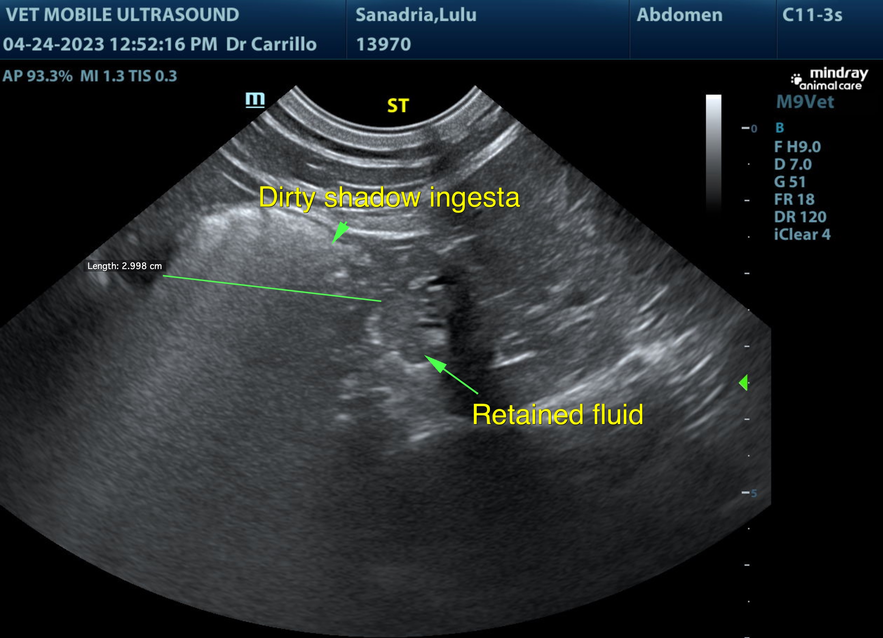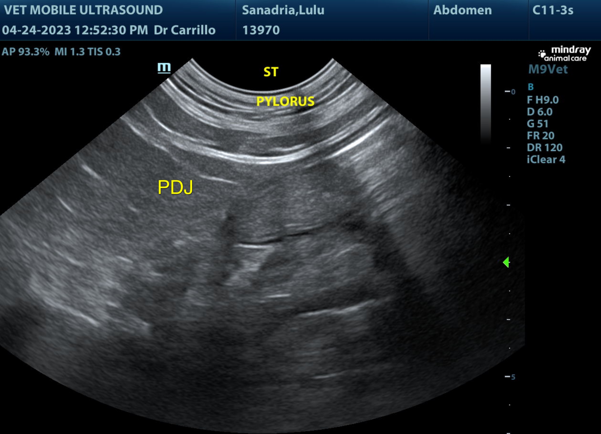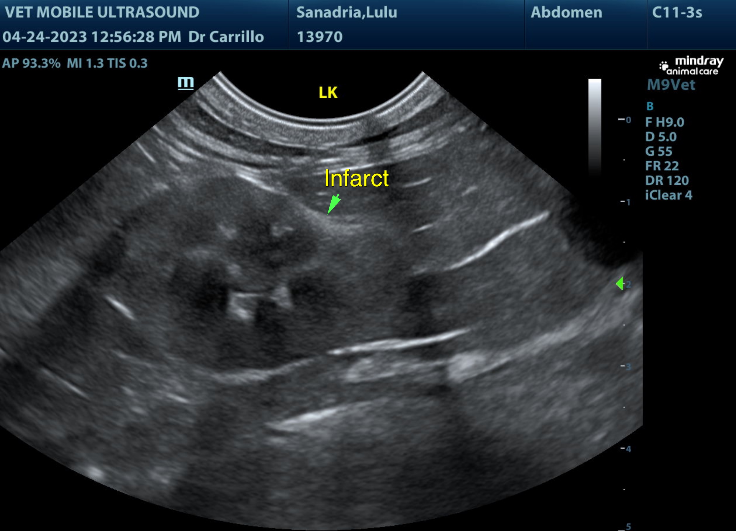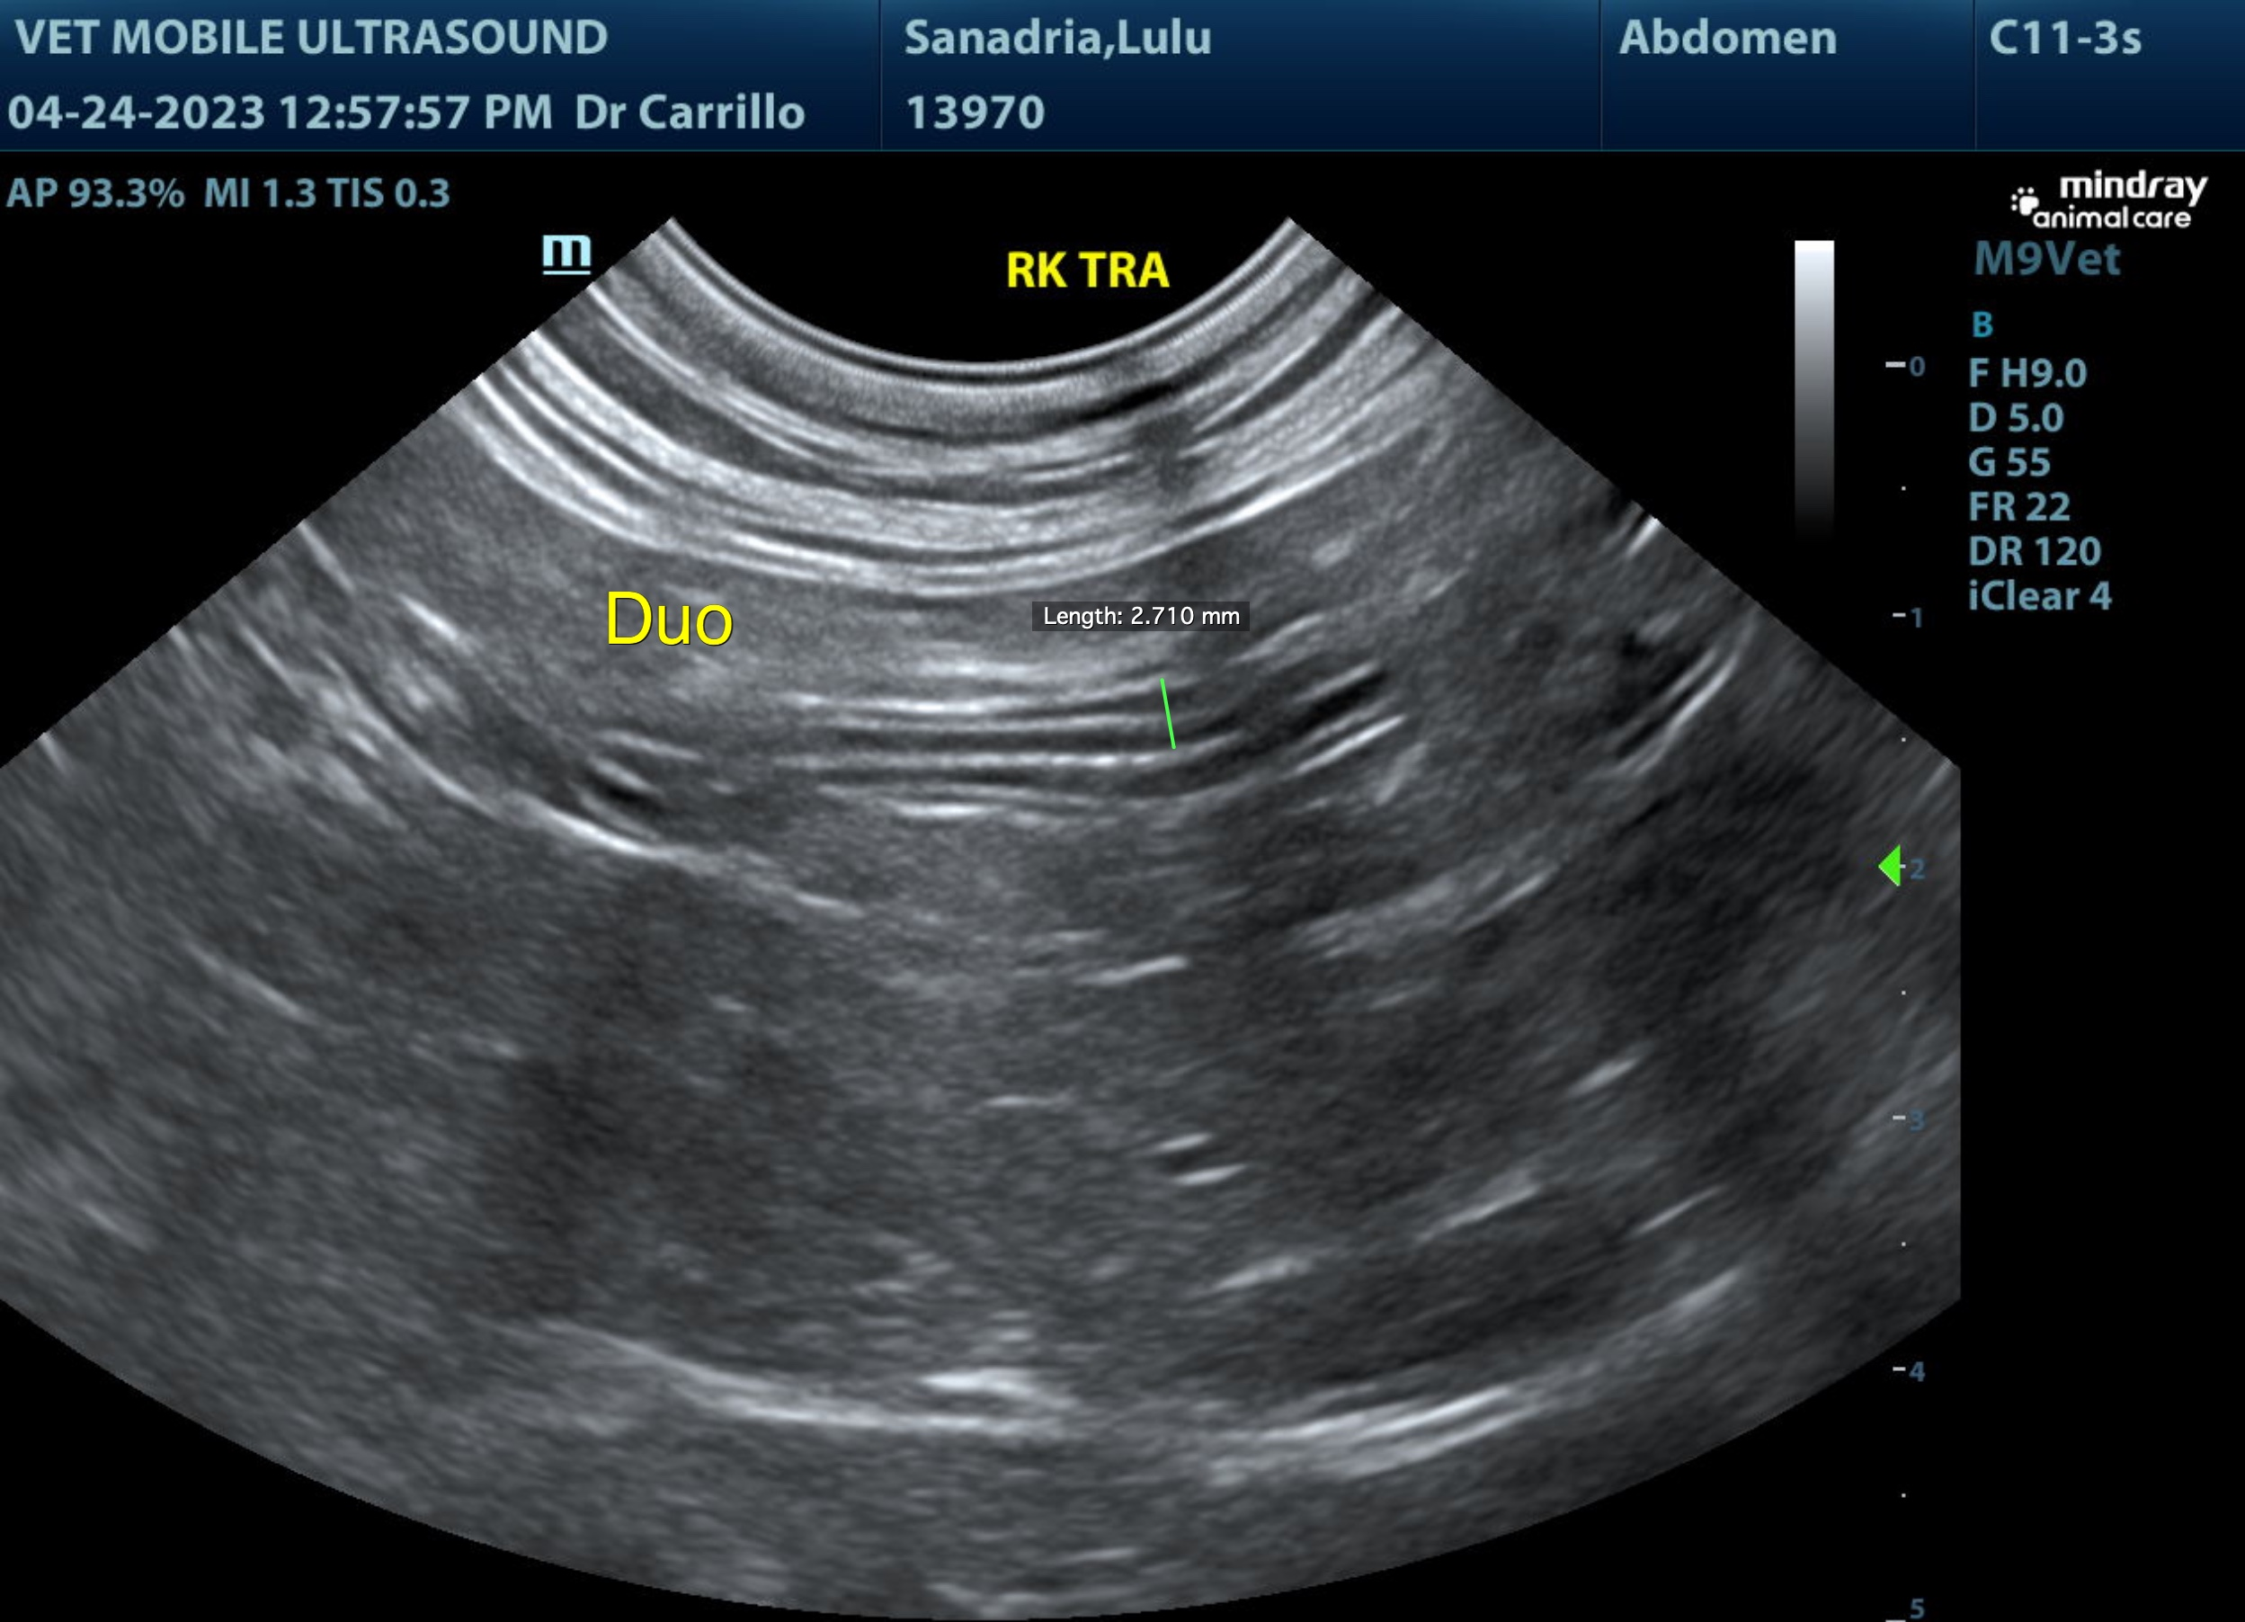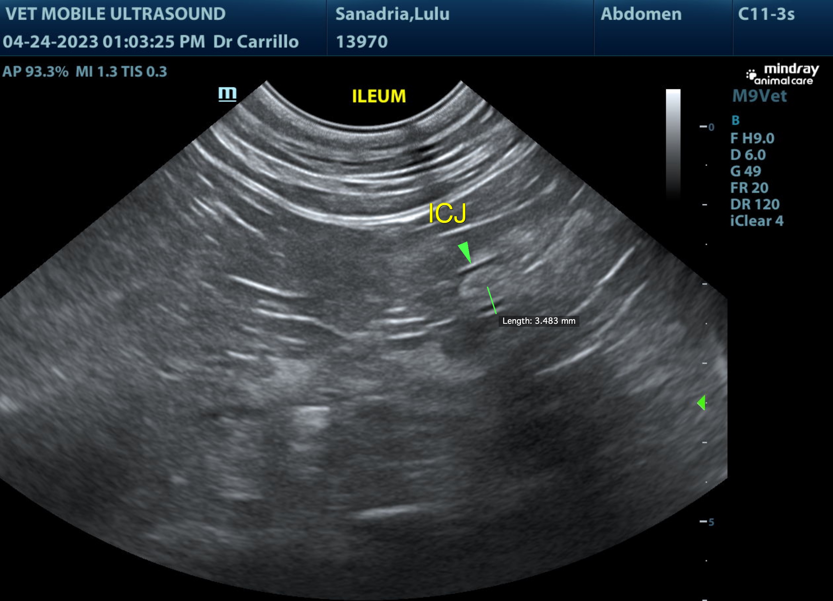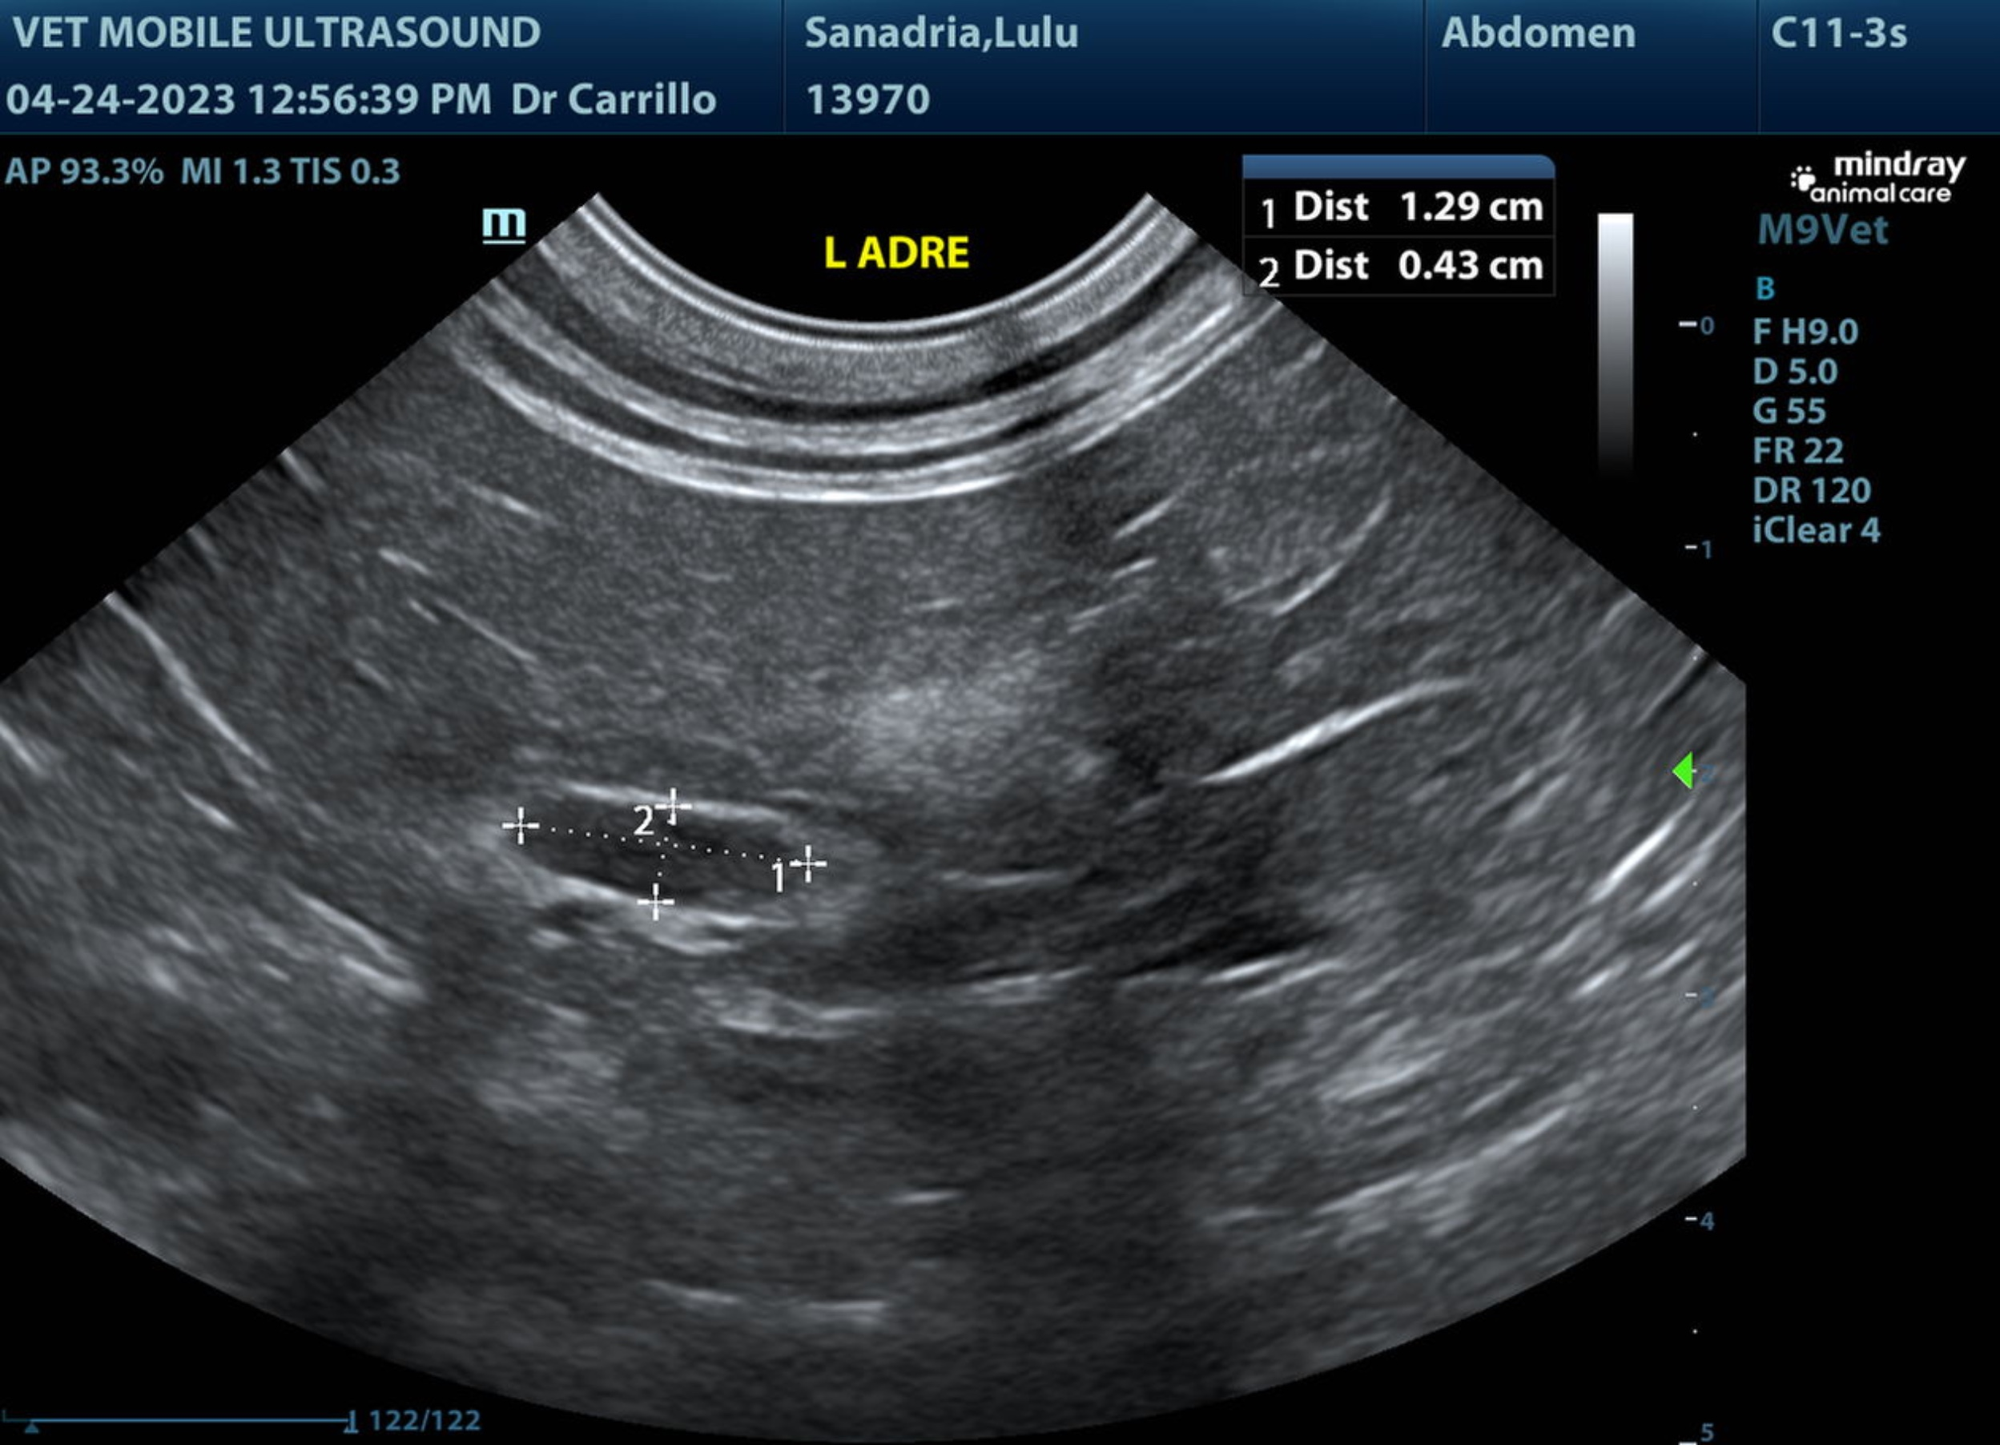
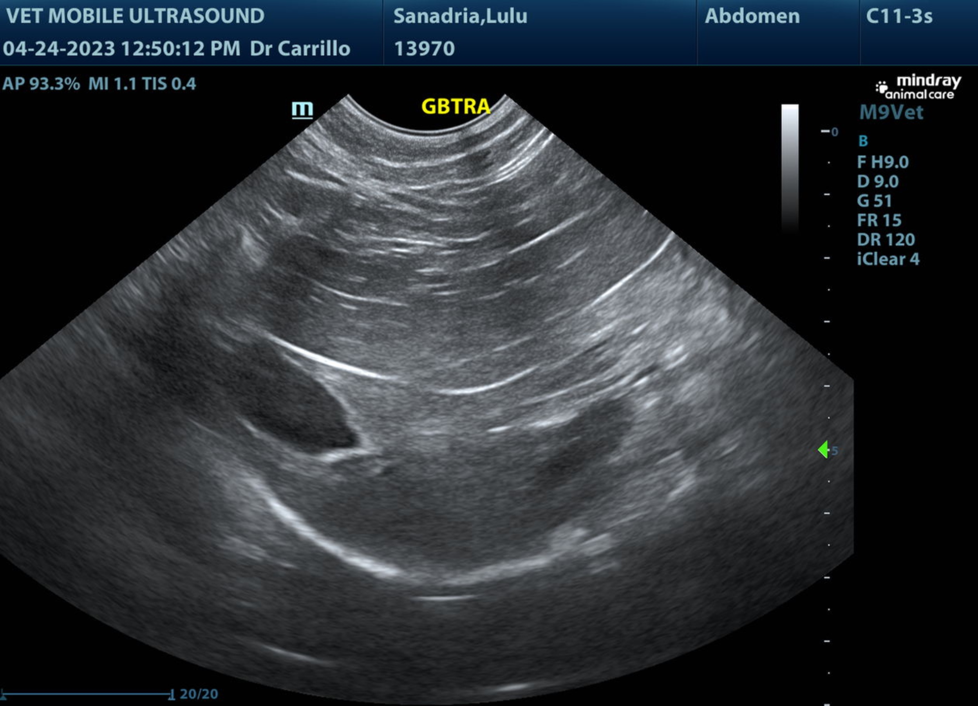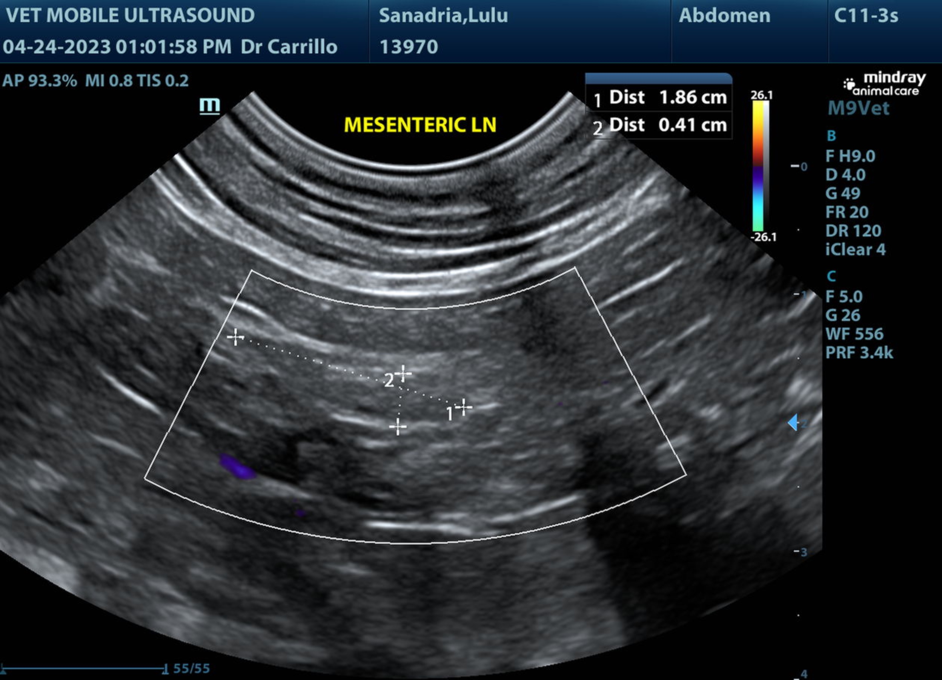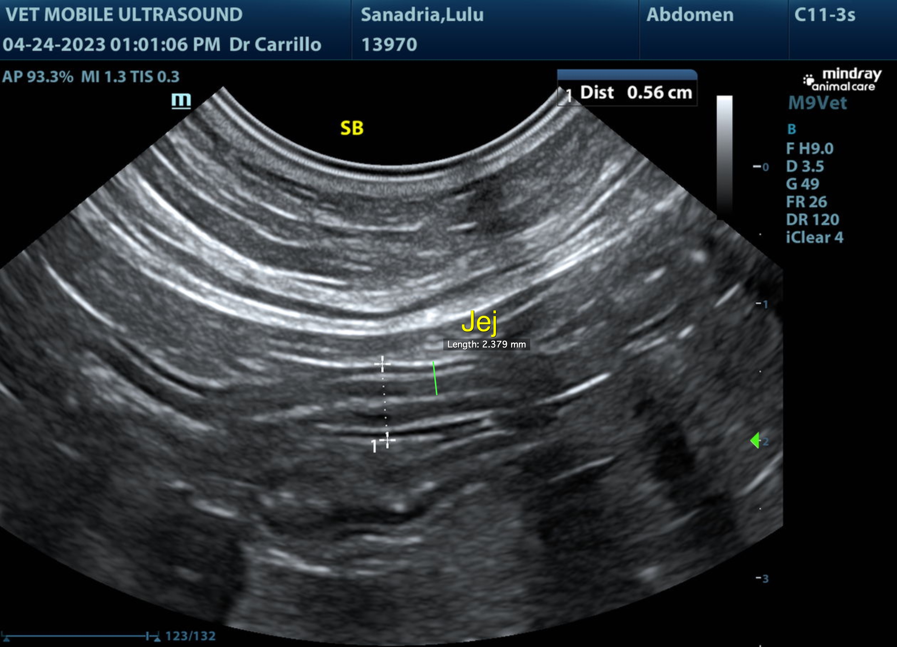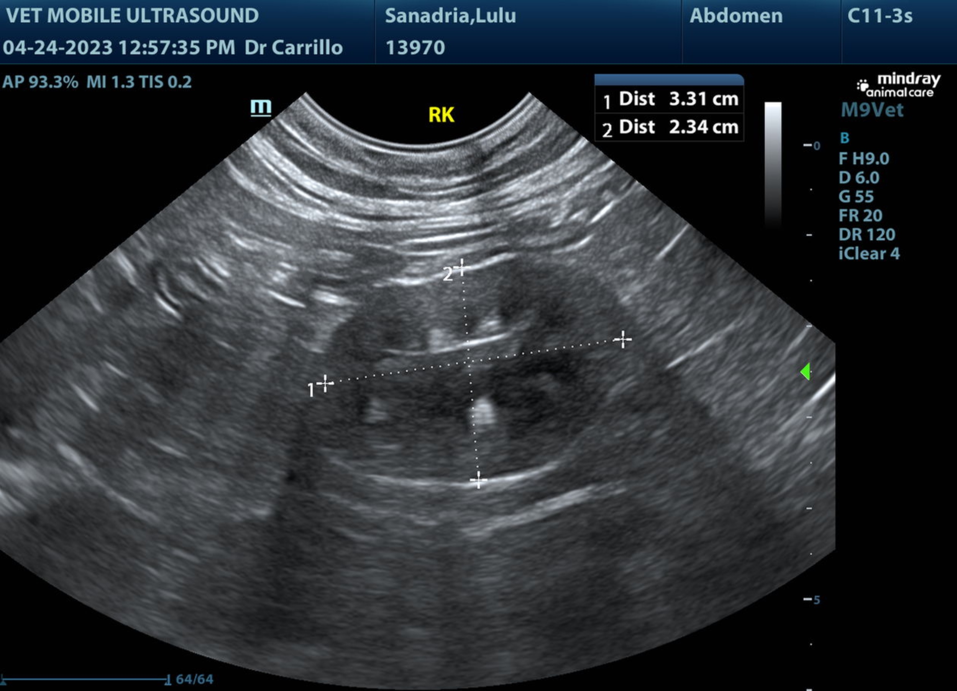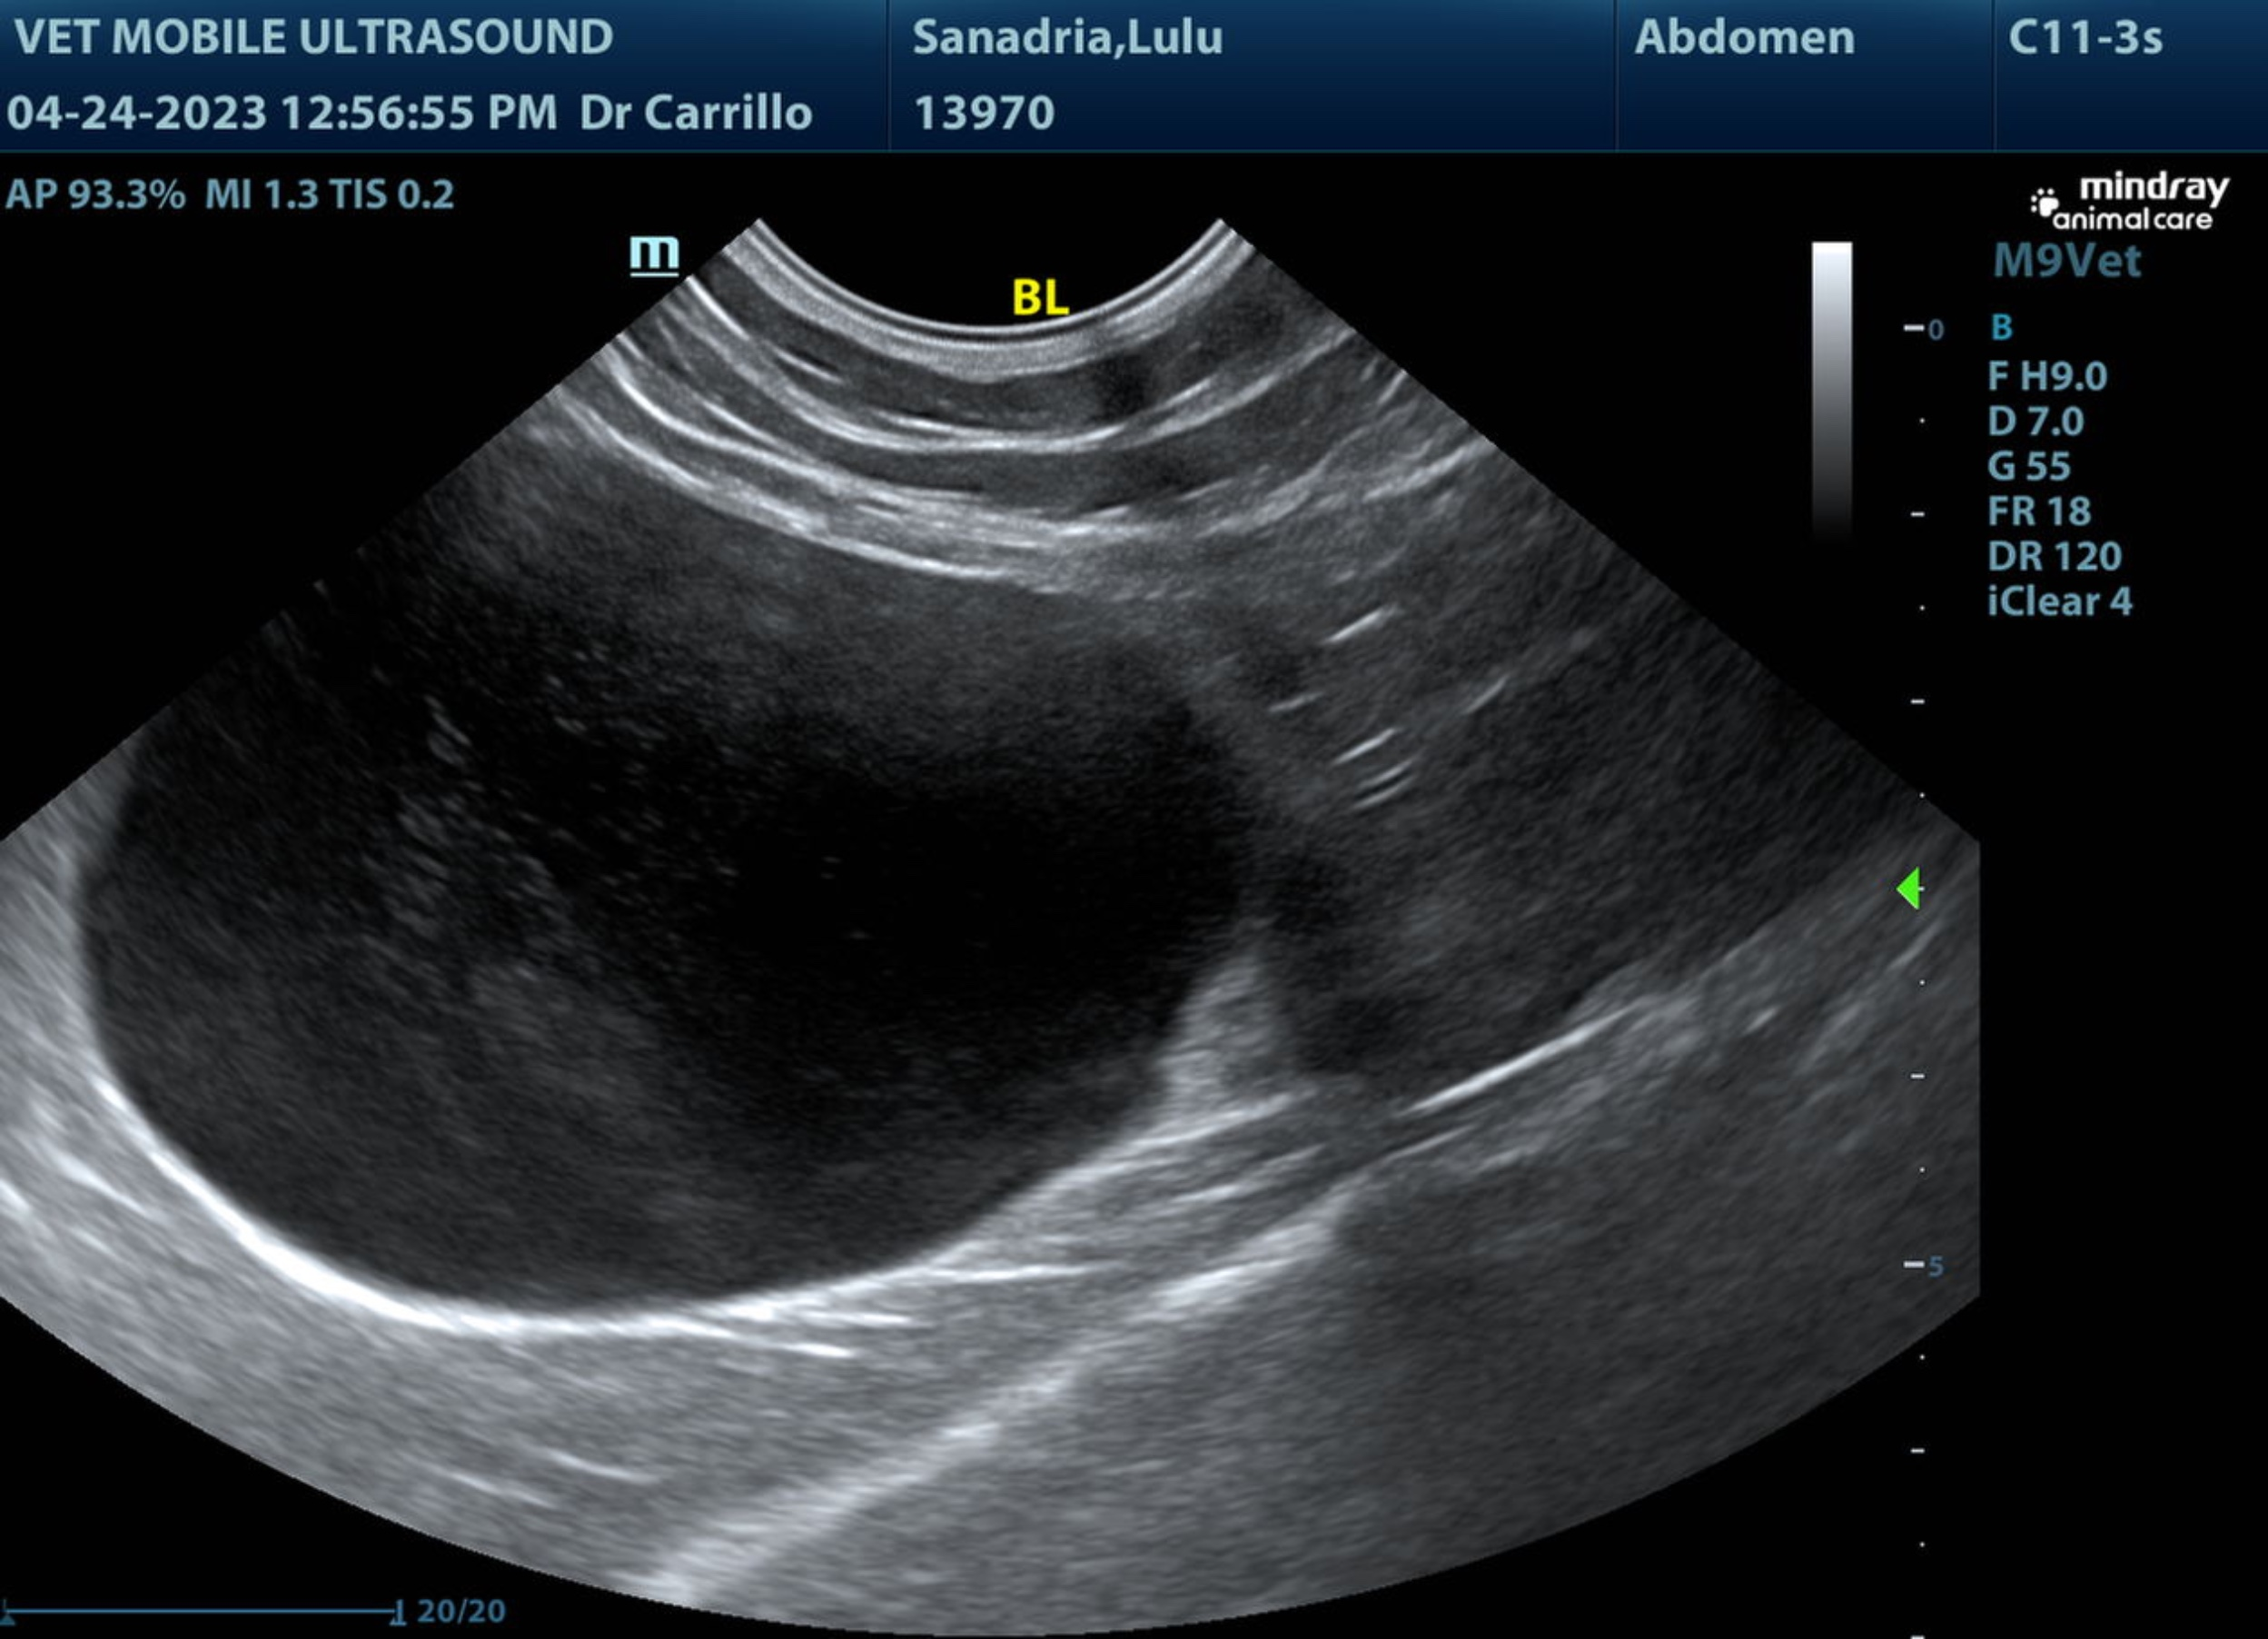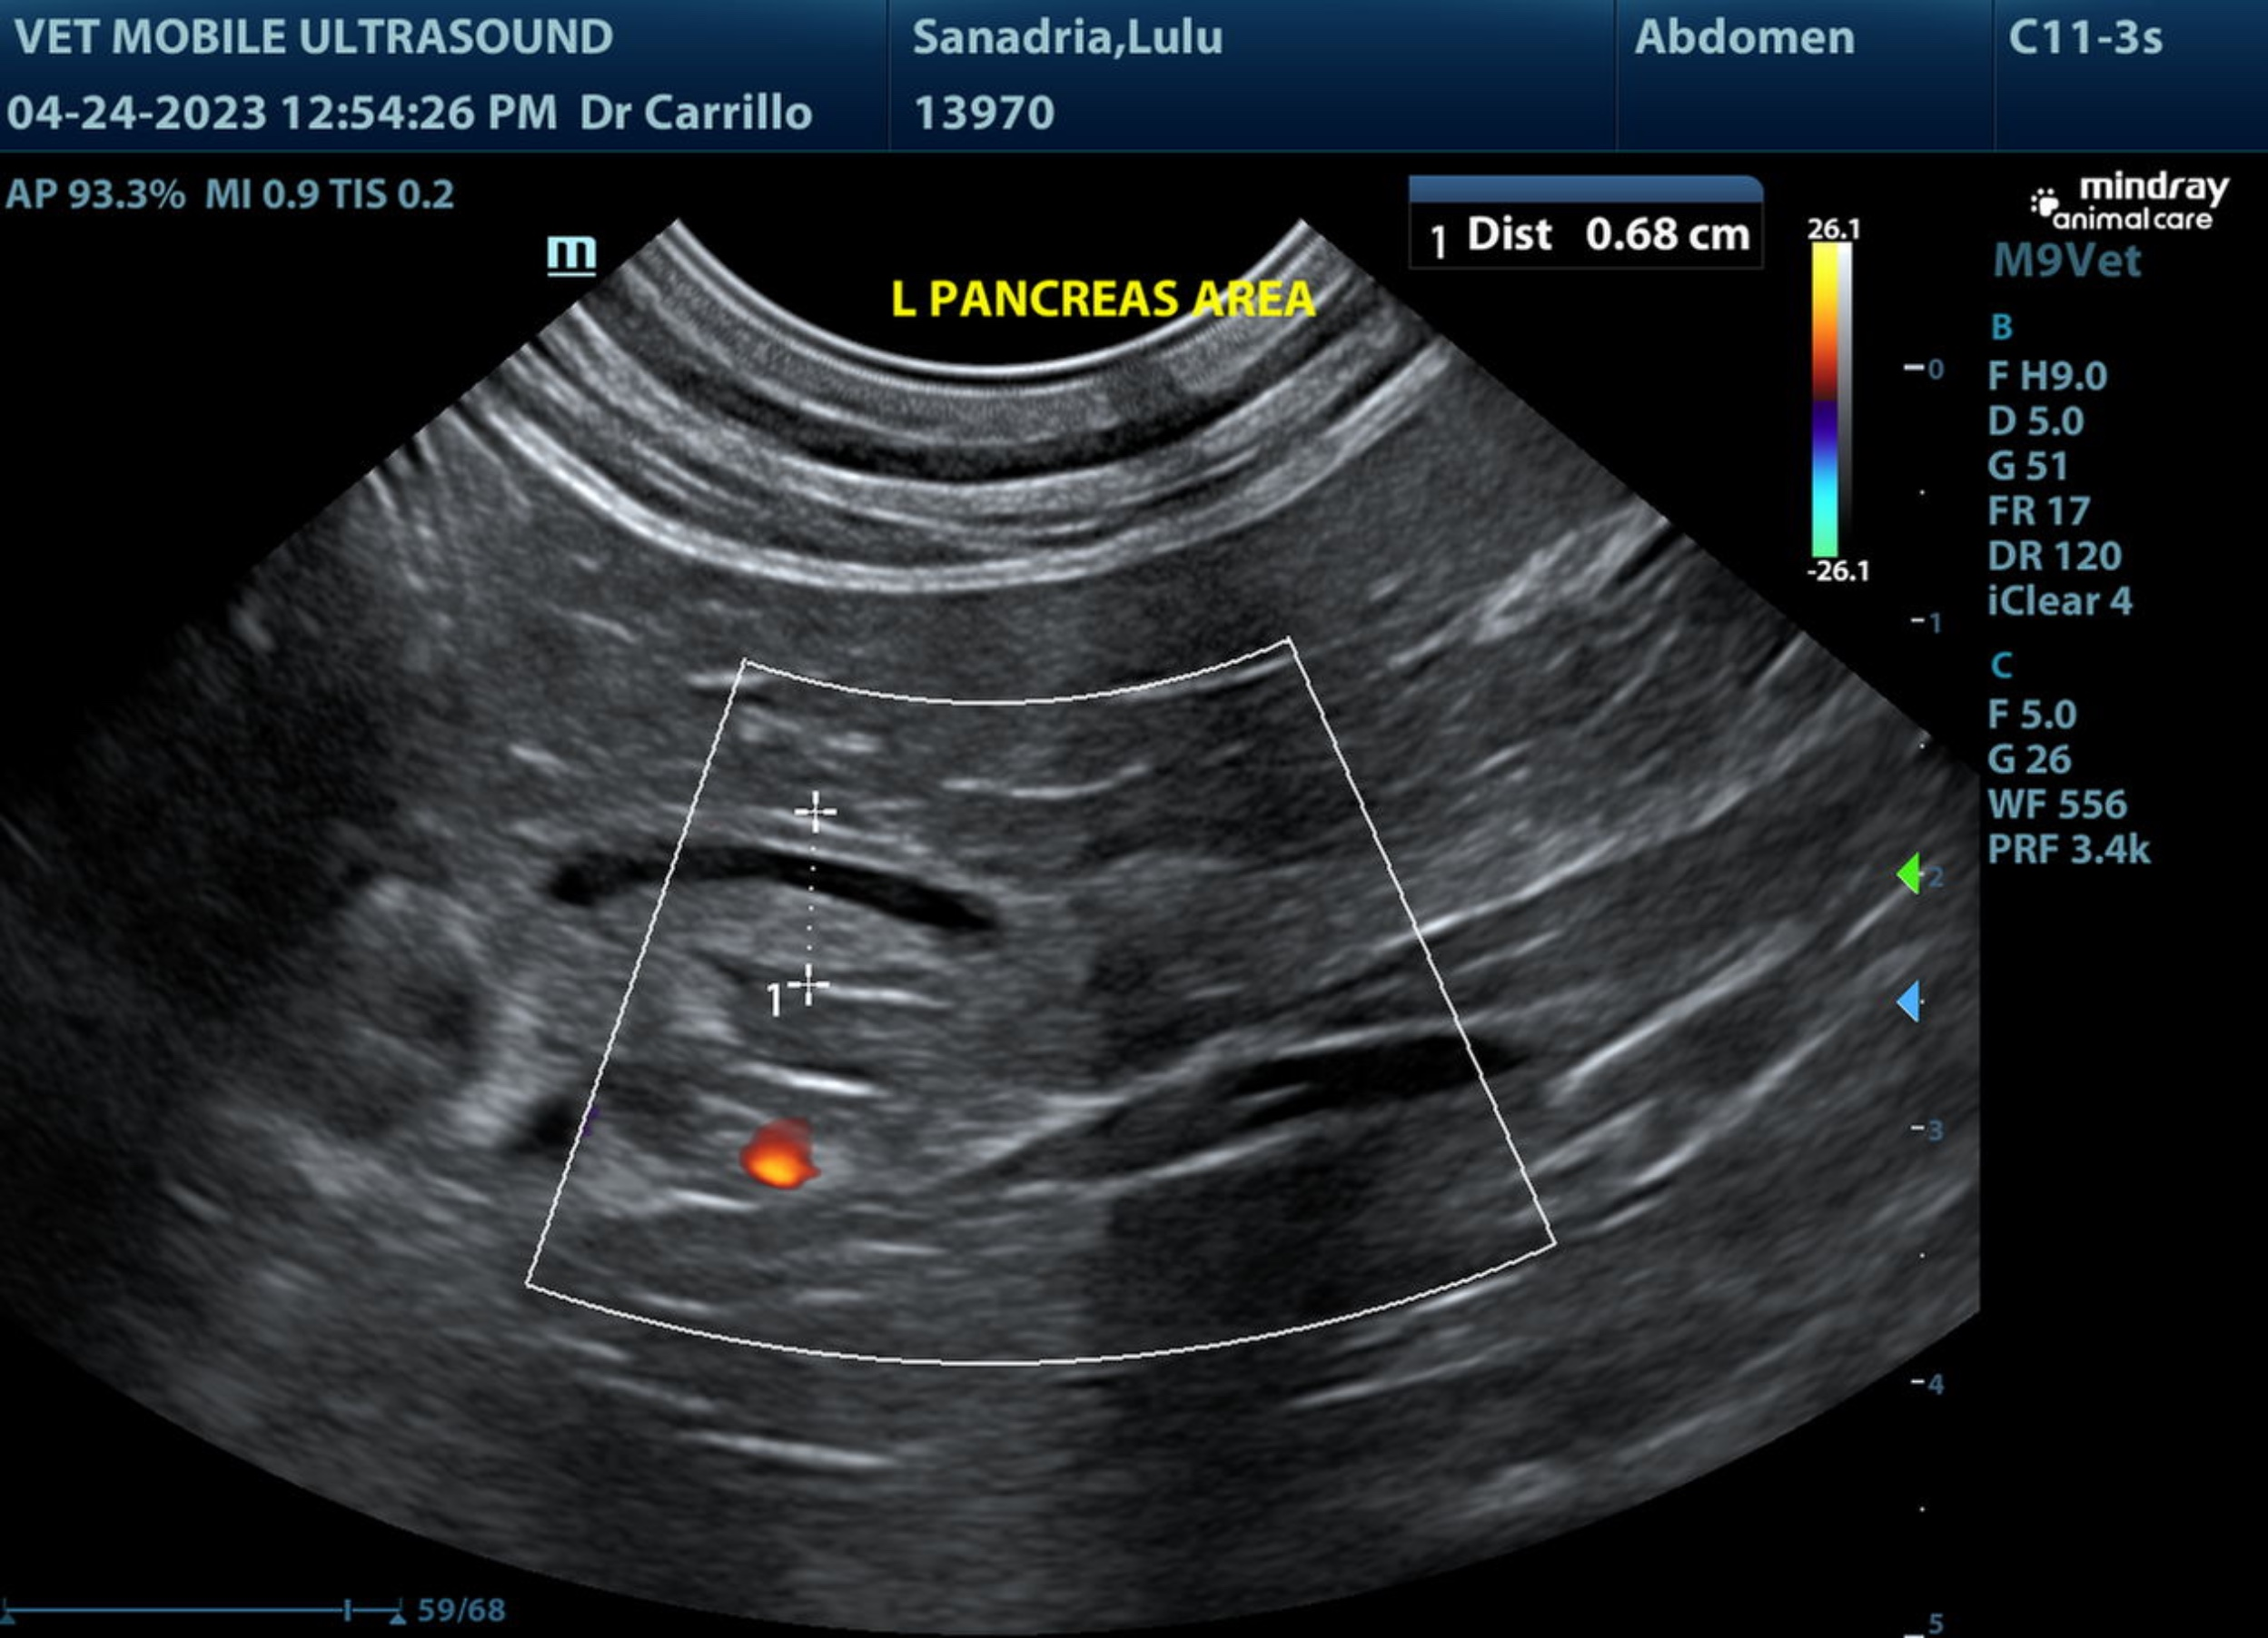

The information and recommendations provided are based on the images presented by the referring veterinarian/sonographer. No evaluation can be communicated regarding pathology that was not visible in the image/video clips provided.

Thank you for this referral. If the clinical or image interpretation does not parallel your findings or if I can be of any further assistance please contact me.

R. McKenzie Daniel, DVM, DABVP (Canine / Feline Practice)
info@SonoPath.com

