PRESENTING CLINICAL SIGNS
History of UTI’s referred from Canmore No history of vomiting or diarrhea.
Abnormal PE/Chem/CBC/UA Results: Non diagnostic

ULTRASONOGRAPHIC EXAMINATION OF THE ABDOMEN
**The submitted study contained 37 still images and 7 videos for review. Please submit primarily videos for interpretation.
Urinary System
The urinary bladder, trigone, cystourethral junction, and visible pelvic urethra to a depth of 2.0 cm exhibited normal thickness and tone. Anechoic urine was present in the lumen with no uroliths or sediment. The ureteral papillae were normal. The ureters were not visible which is normal. No evidence of inflammatory or neoplastic changes were noted.
The area of the aortic trifurcation was free of pathology.
Normal size and margination were present in the right kidney. A normal 1:3 cortex / medulla ratio and normal corticomedullary definition were maintained. The echogenicity of the cortex was similar to or slightly less than normal liver parenchyma while the medulla echogenicity was hypoechoic to the cortex with no evidence of pelvic dilation. The right kidney measured 3.6 cm.
The left kidney was mildly subnormal in size, measuring 2.7 cm. A normal 1:3 cortex / medulla ratio and normal corticomedullary definition were maintained. A focal area of increased cortex echogenicity was noted, consistent with cortical infarct. No evidence of pyelectasia.
Adrenal Glands
The adrenal glands were uniform in size and contour with a uniformly hypoechoic parenchyma. The left adrenal gland measured 0.27 cm. The right adrenal gland measured 0.33 cm.
Spleen
The spleen exhibited primarily finely textured parenchyma which was hyperechoic to the liver and renal cortical parenchyma. The spleen measured 0.66 cm in width at the level of the hilus. Mild generalized parenchyma heterogeneity was present without evidence of nodular changes. The capsule was smooth and regular without apparent expansion. The splenic vasculature at the hilus was normal in volume with no evidence of congestion or thrombosis. The parenchymal heterogeneity is likely consistent with benign changes such as extramedullary hematopoiesis or age related remodeling with minor potential for inflammatory or neoplastic disease.
Liver
The liver was subjectively normal in size, structure, and contour. The liver parenchyma was mildly nonuniform and hypoechoic to the spleen with a moderate coarse echotexture and subjective mild to benign parenchymal remodeling. The hepatic and portal vasculature were normal in appearance without signs of congestion. The gallbladder was non-distended in size with thin walls and primarily anechoic luminal content. The cystic and common bile ducts were normal.
Gastrointestinal
The stomach presented intact wall layering with a normal wall layer ratio. The lumen of the stomach was empty with no signs of ileus, obstruction or foreign material.
The small intestine presented intact wall layering with primarily maintained 1:3 muscularis/mucosa ratio. Segmental to generalized propensity for mildly prominent muscularis layer, yet without evidence of mural hypertrophy. No evidence of loss of intestinal wall layering or masses. Duodenum wall and jejunum wall measured 0.22 cm. Ileocolic wall measured 0.31 cm. The lumen of the small intestine was empty with no signs of ileus, obstruction or foreign material.
Normal visible colon wall layers were present with apparent formed feces in lumen.
Pancreas
The pancreas was normal in size and contour and mildly hypoechoic to non-homogeneous parenchyma with minor pancreatic duct dilation. No evidence of peripancreatic reactive mesentery.
Free Abdomen
Intermittent, mildly prominent jejunocolic lymph nodes were present. Example measured 0.33 cm diameter. The lymph node was essentially isoechoic to adjacent omentum without evidence of peripheral inflammation and maintaining a normal width: length ratio (<0.5).
No free fluid.
ULTRASONOGRAPHIC FINDINGS
- Sonographically unremarkable urinary bladder and visible proximal urethra
- Bilateral mild to moderate chronic renal changes, mild subnormal left kidney size with cortical infarct
- Subjective mildly prominent segmental to generalized small bowel muscularis layer
- Intermittent benign/reactive jejunocolic lymphadenopathy
- Mildly hypoechoic pancreas
INTERPRETATION OF THE FINDINGS & FURTHER RECOMMENDATIONS
Aside from expected bilateral chronic renal changes, no overt evidence of upper or lower urinary tract pathology as a potential cause or nidus for recurrent UTIs. Recheck urine culture and sensitivity on sterile urine sample as well as further renal staging to include baseline UPC could be considered if not recently done.

The small intestine and pancreas exhibited subtle changes that may suggest underlying small intestinal or pancreatic inflammation. However, given the lack of historical gastrointestinal signs in this patient, these findings are non-specific. Further assessment may include GI panel to include PLI, TLI, cobalamin and folate if GI signs or weight loss are noted going forward, or if clinically indicated, given the breed.
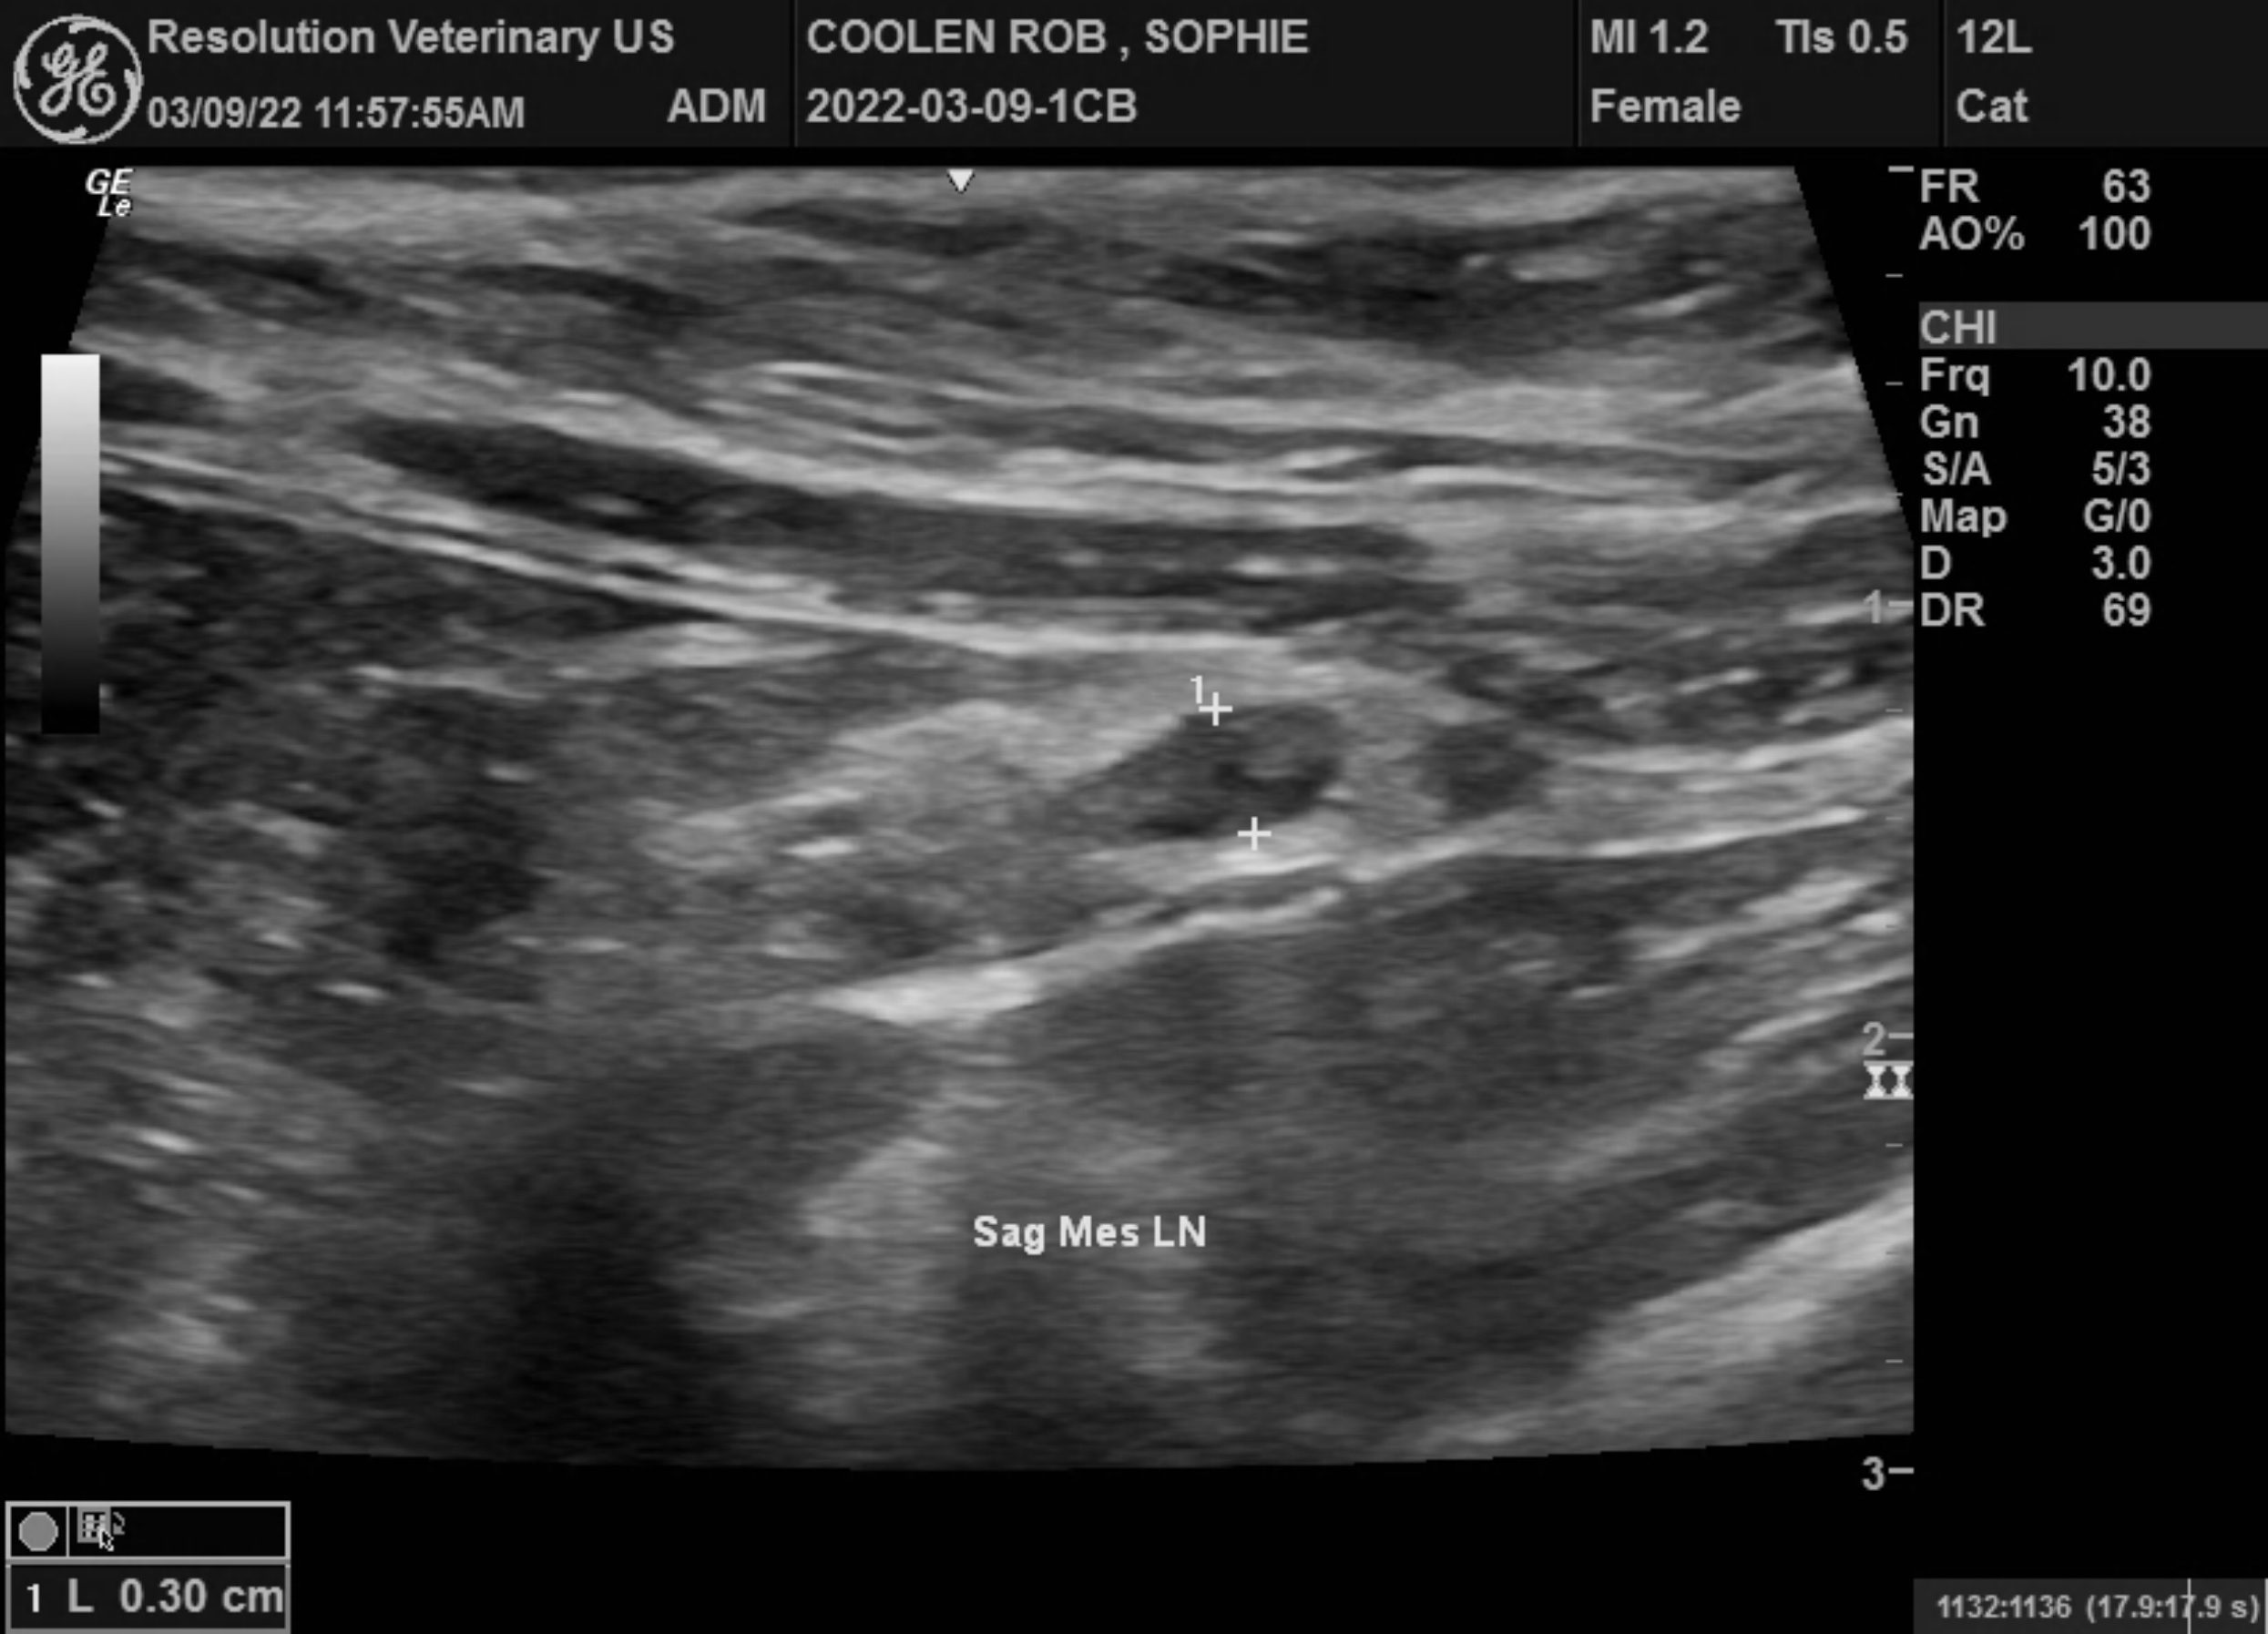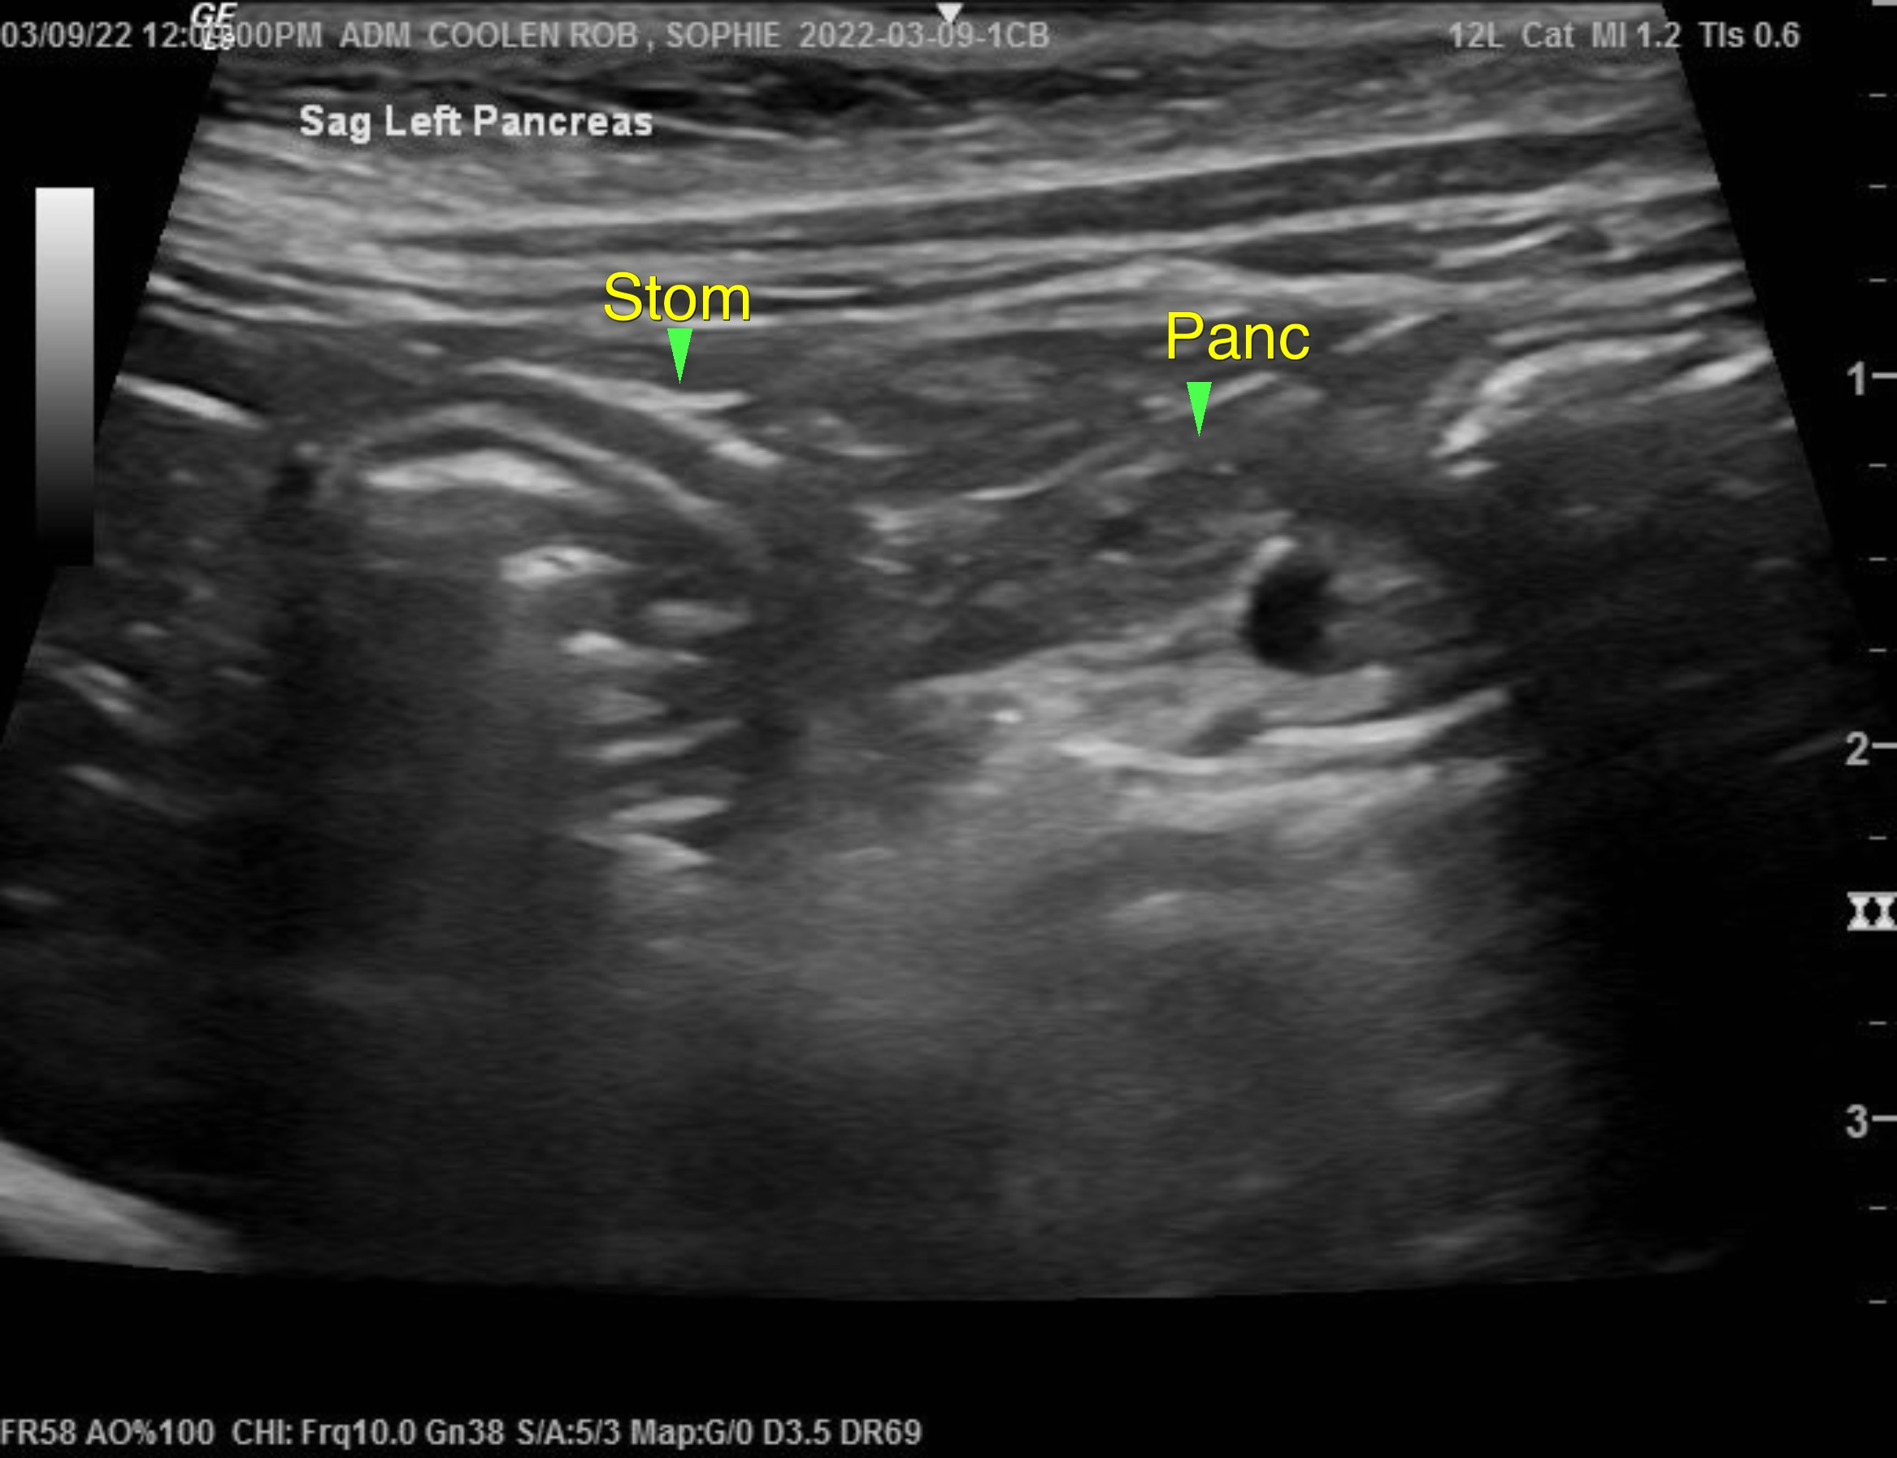
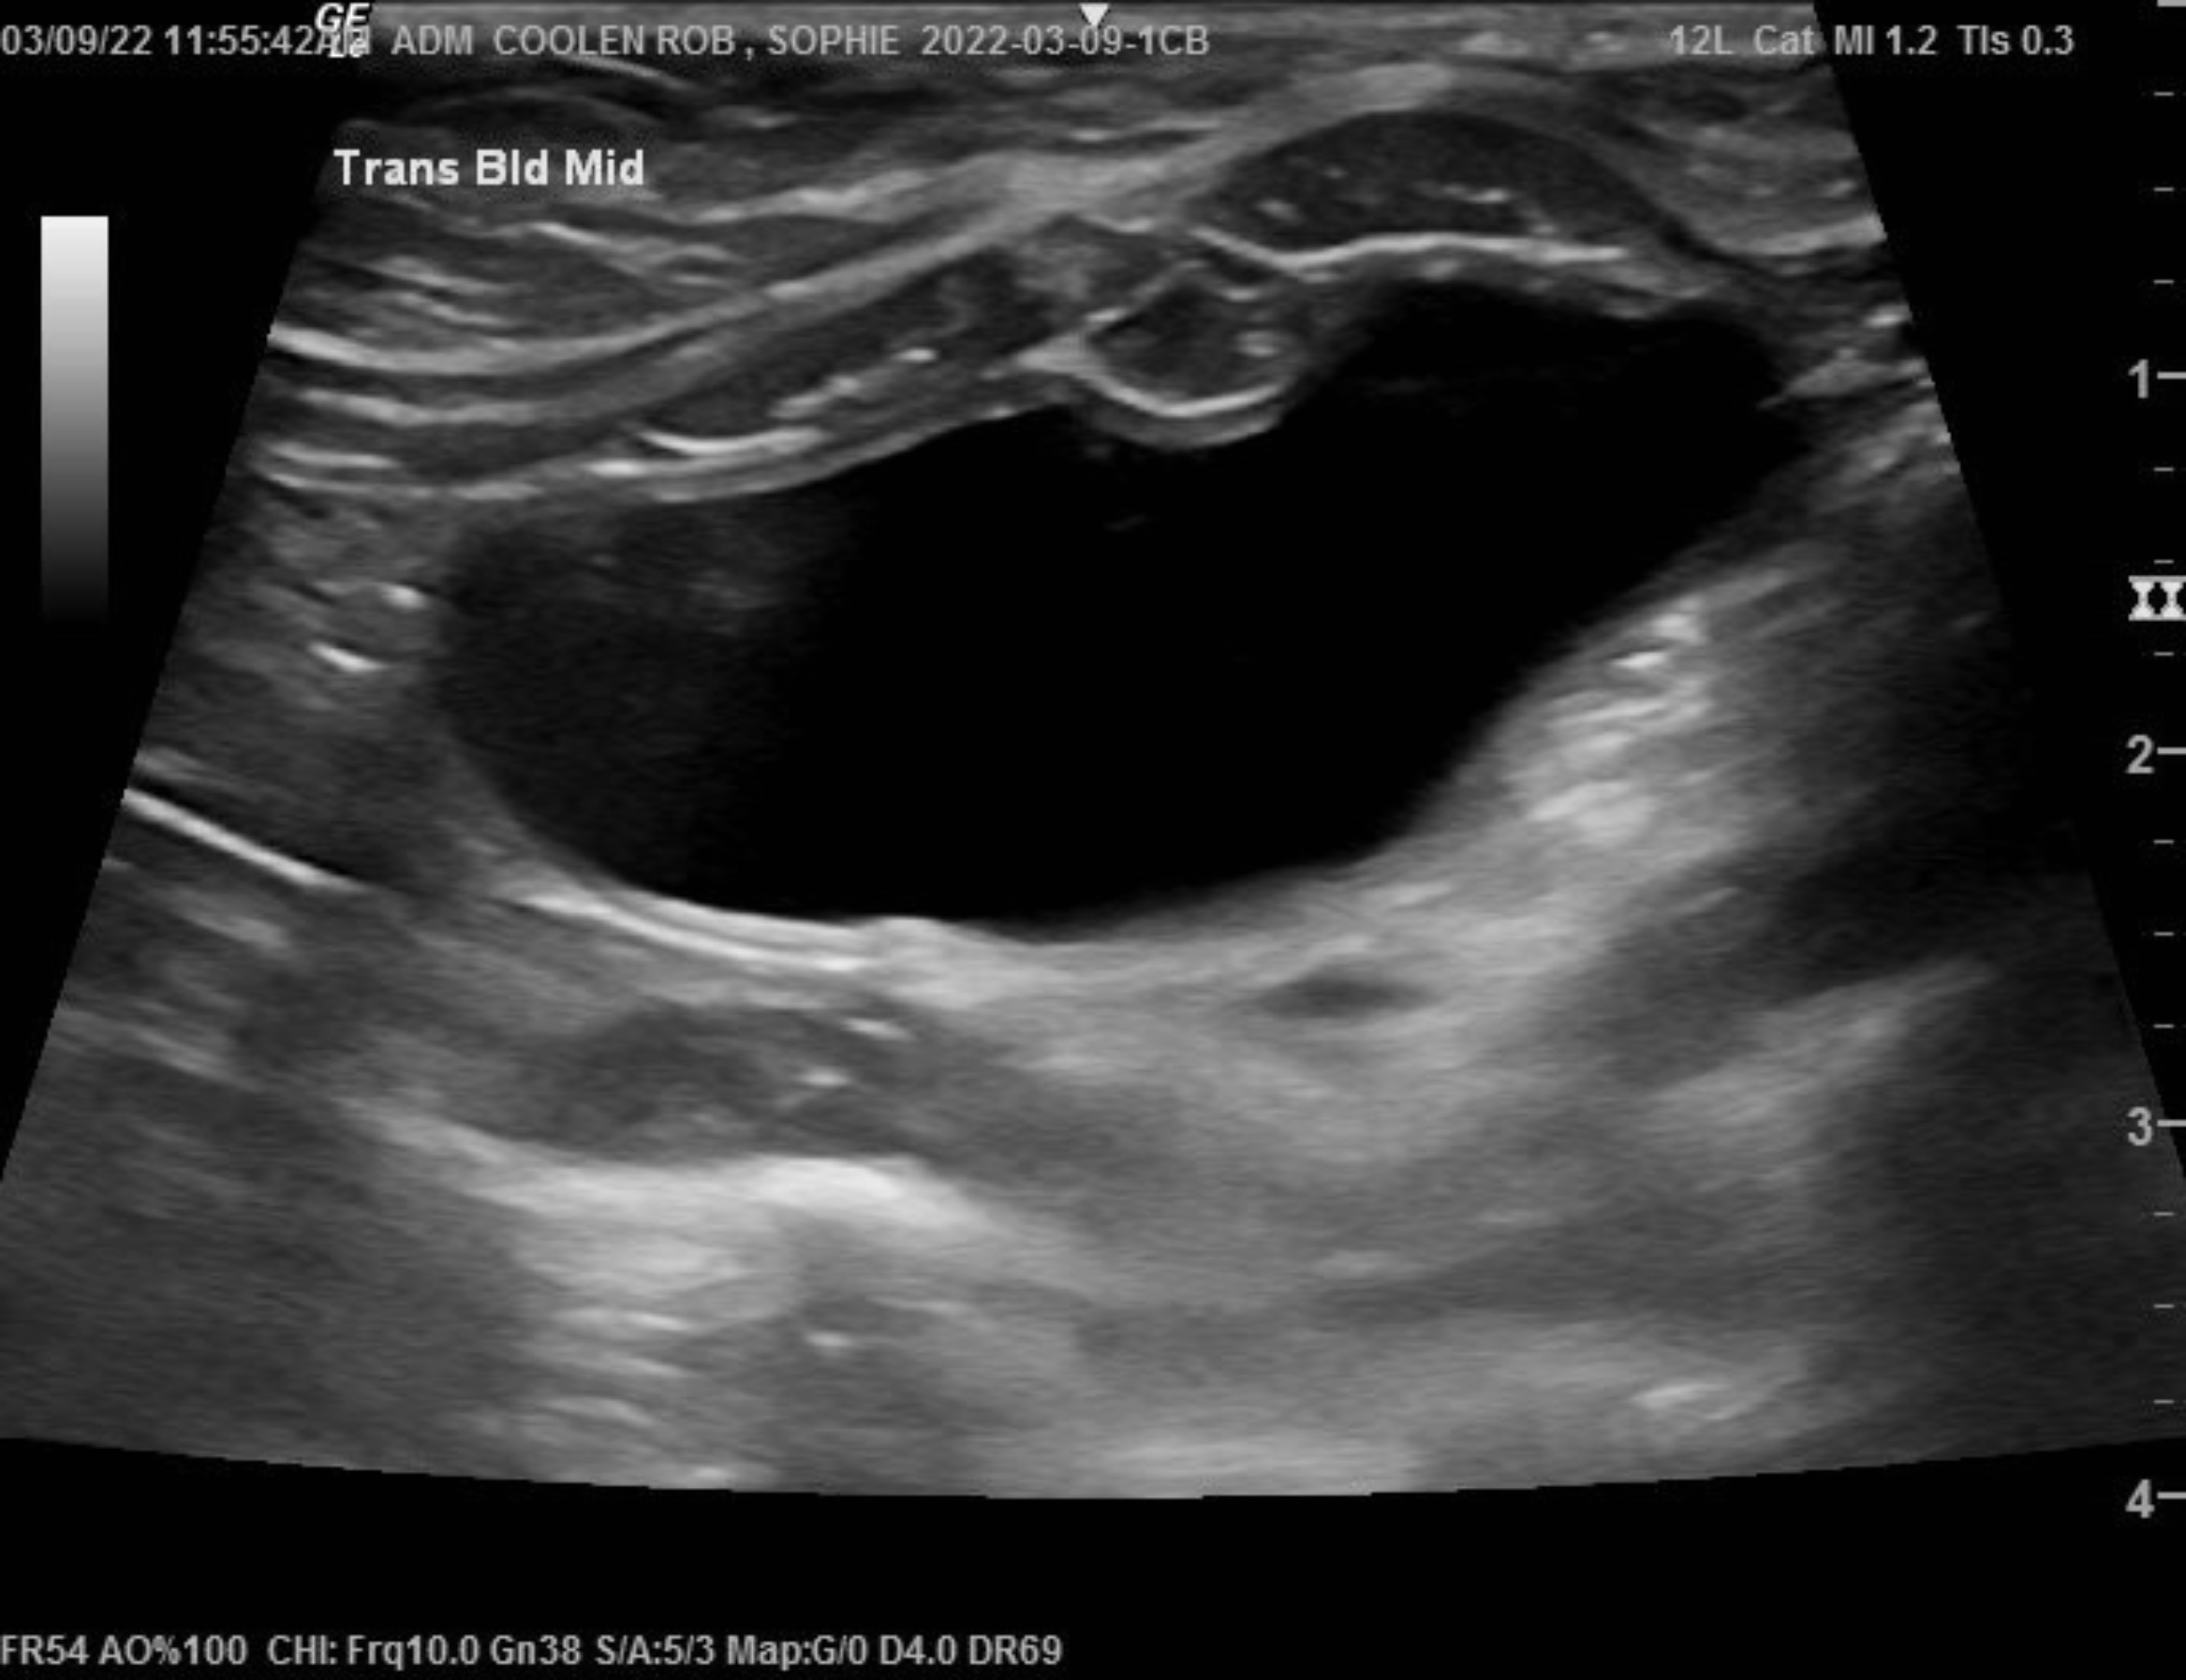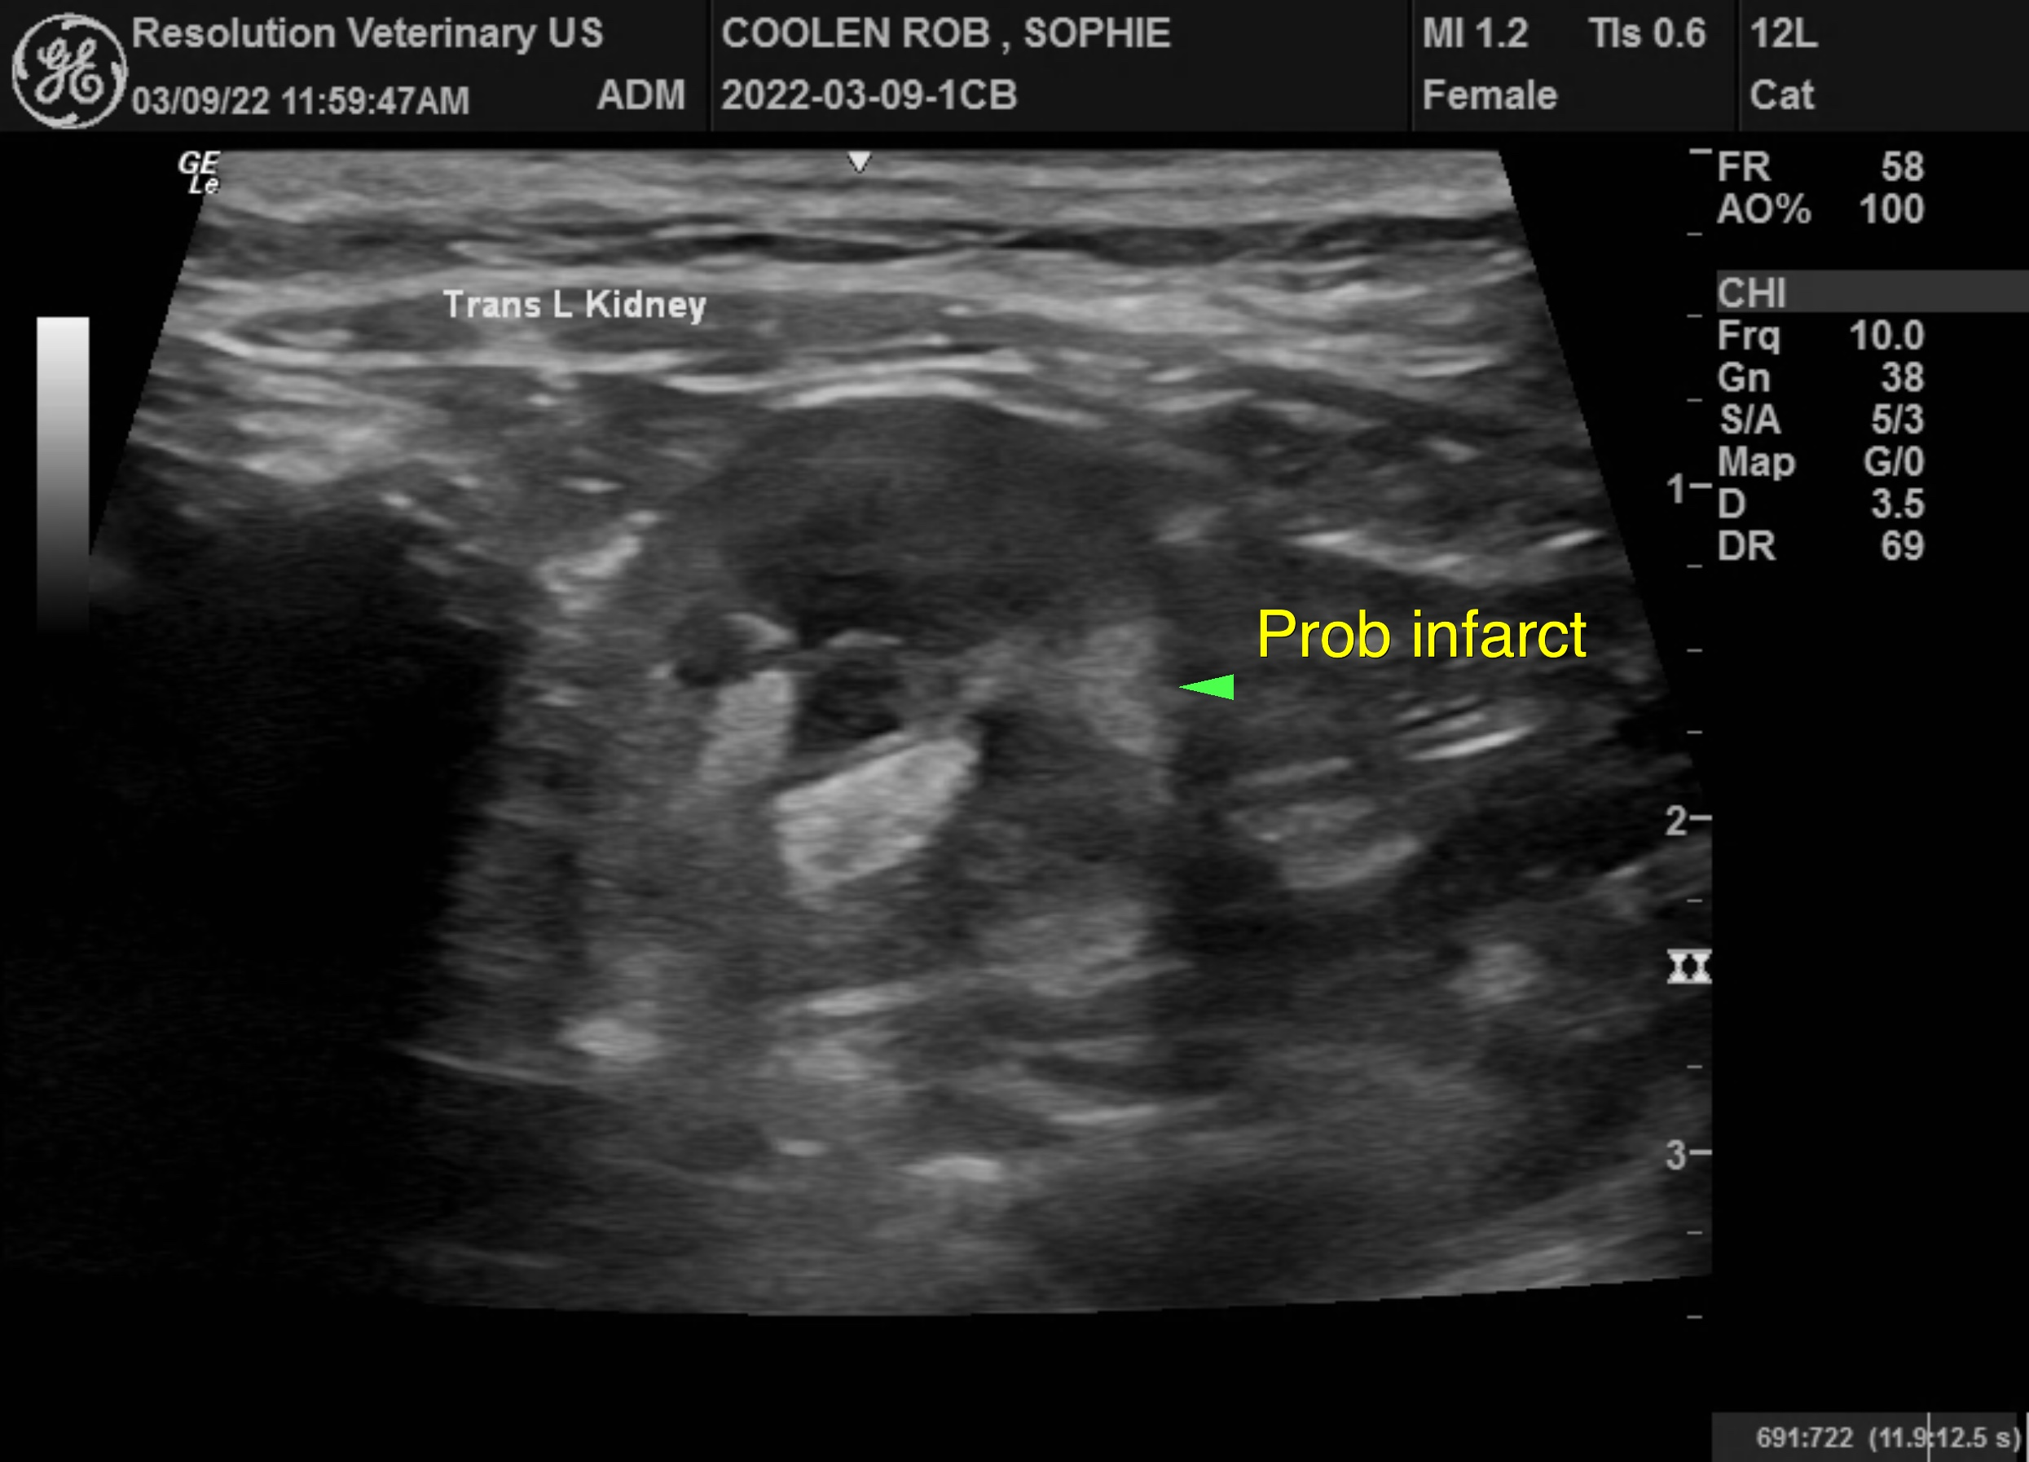
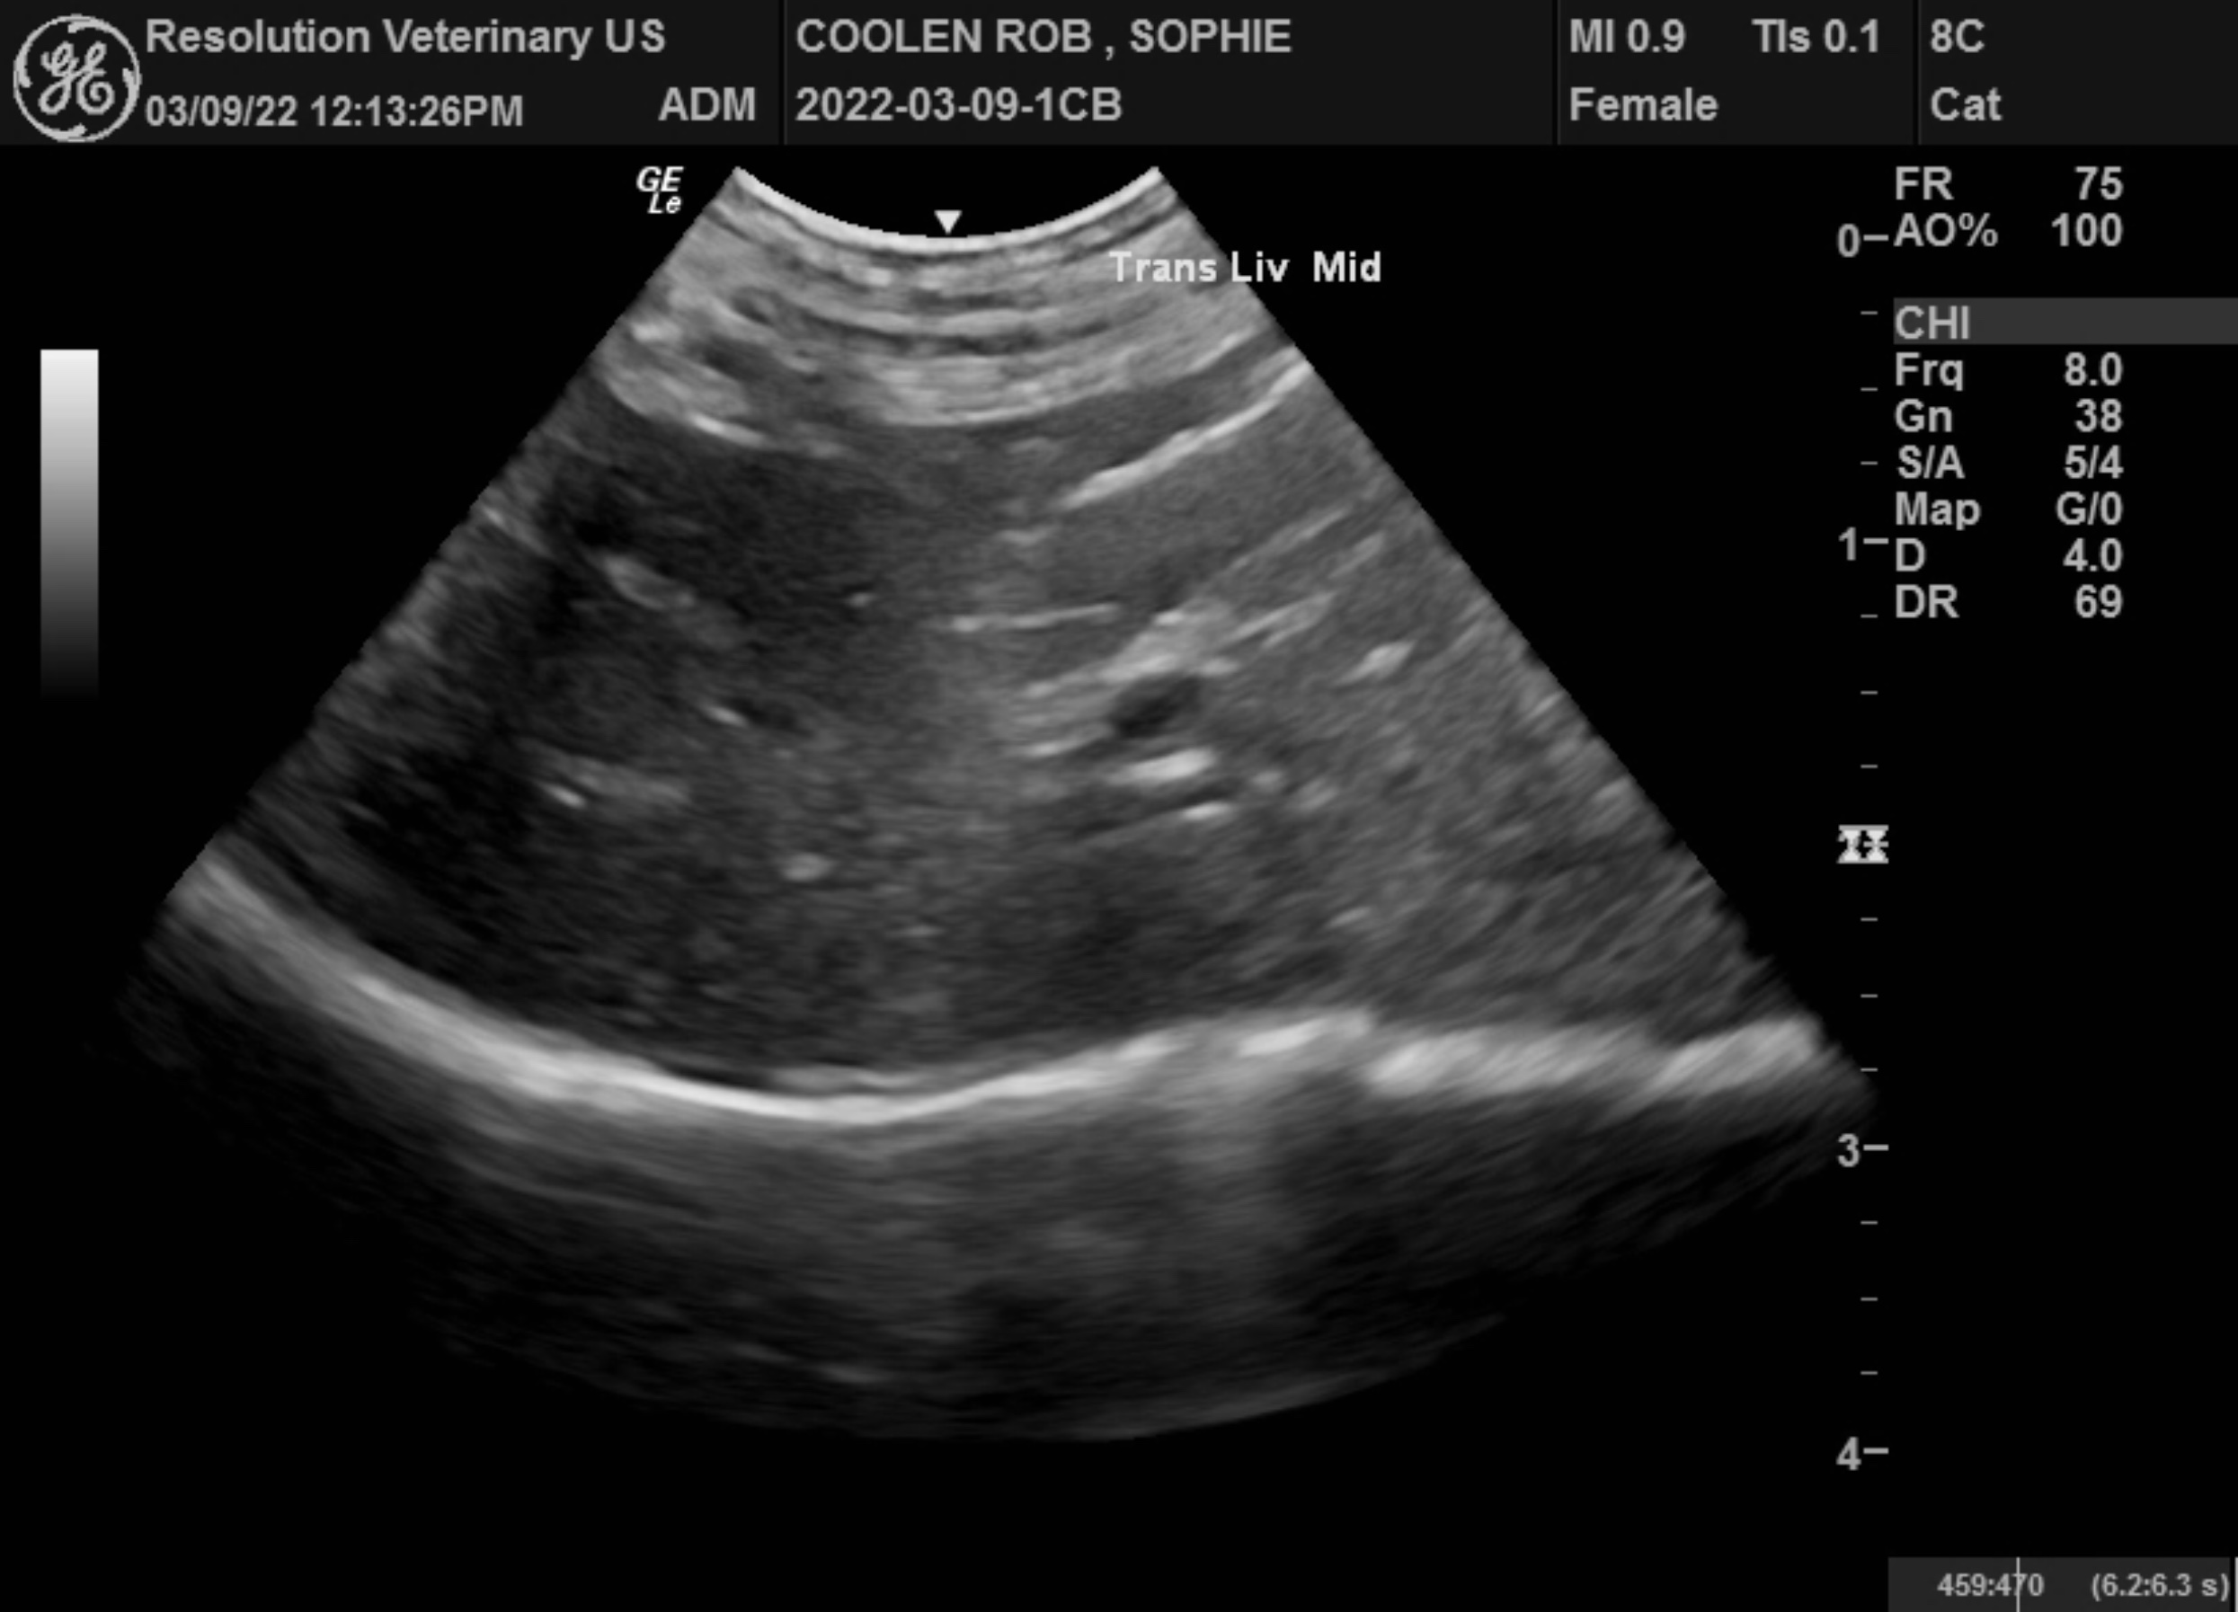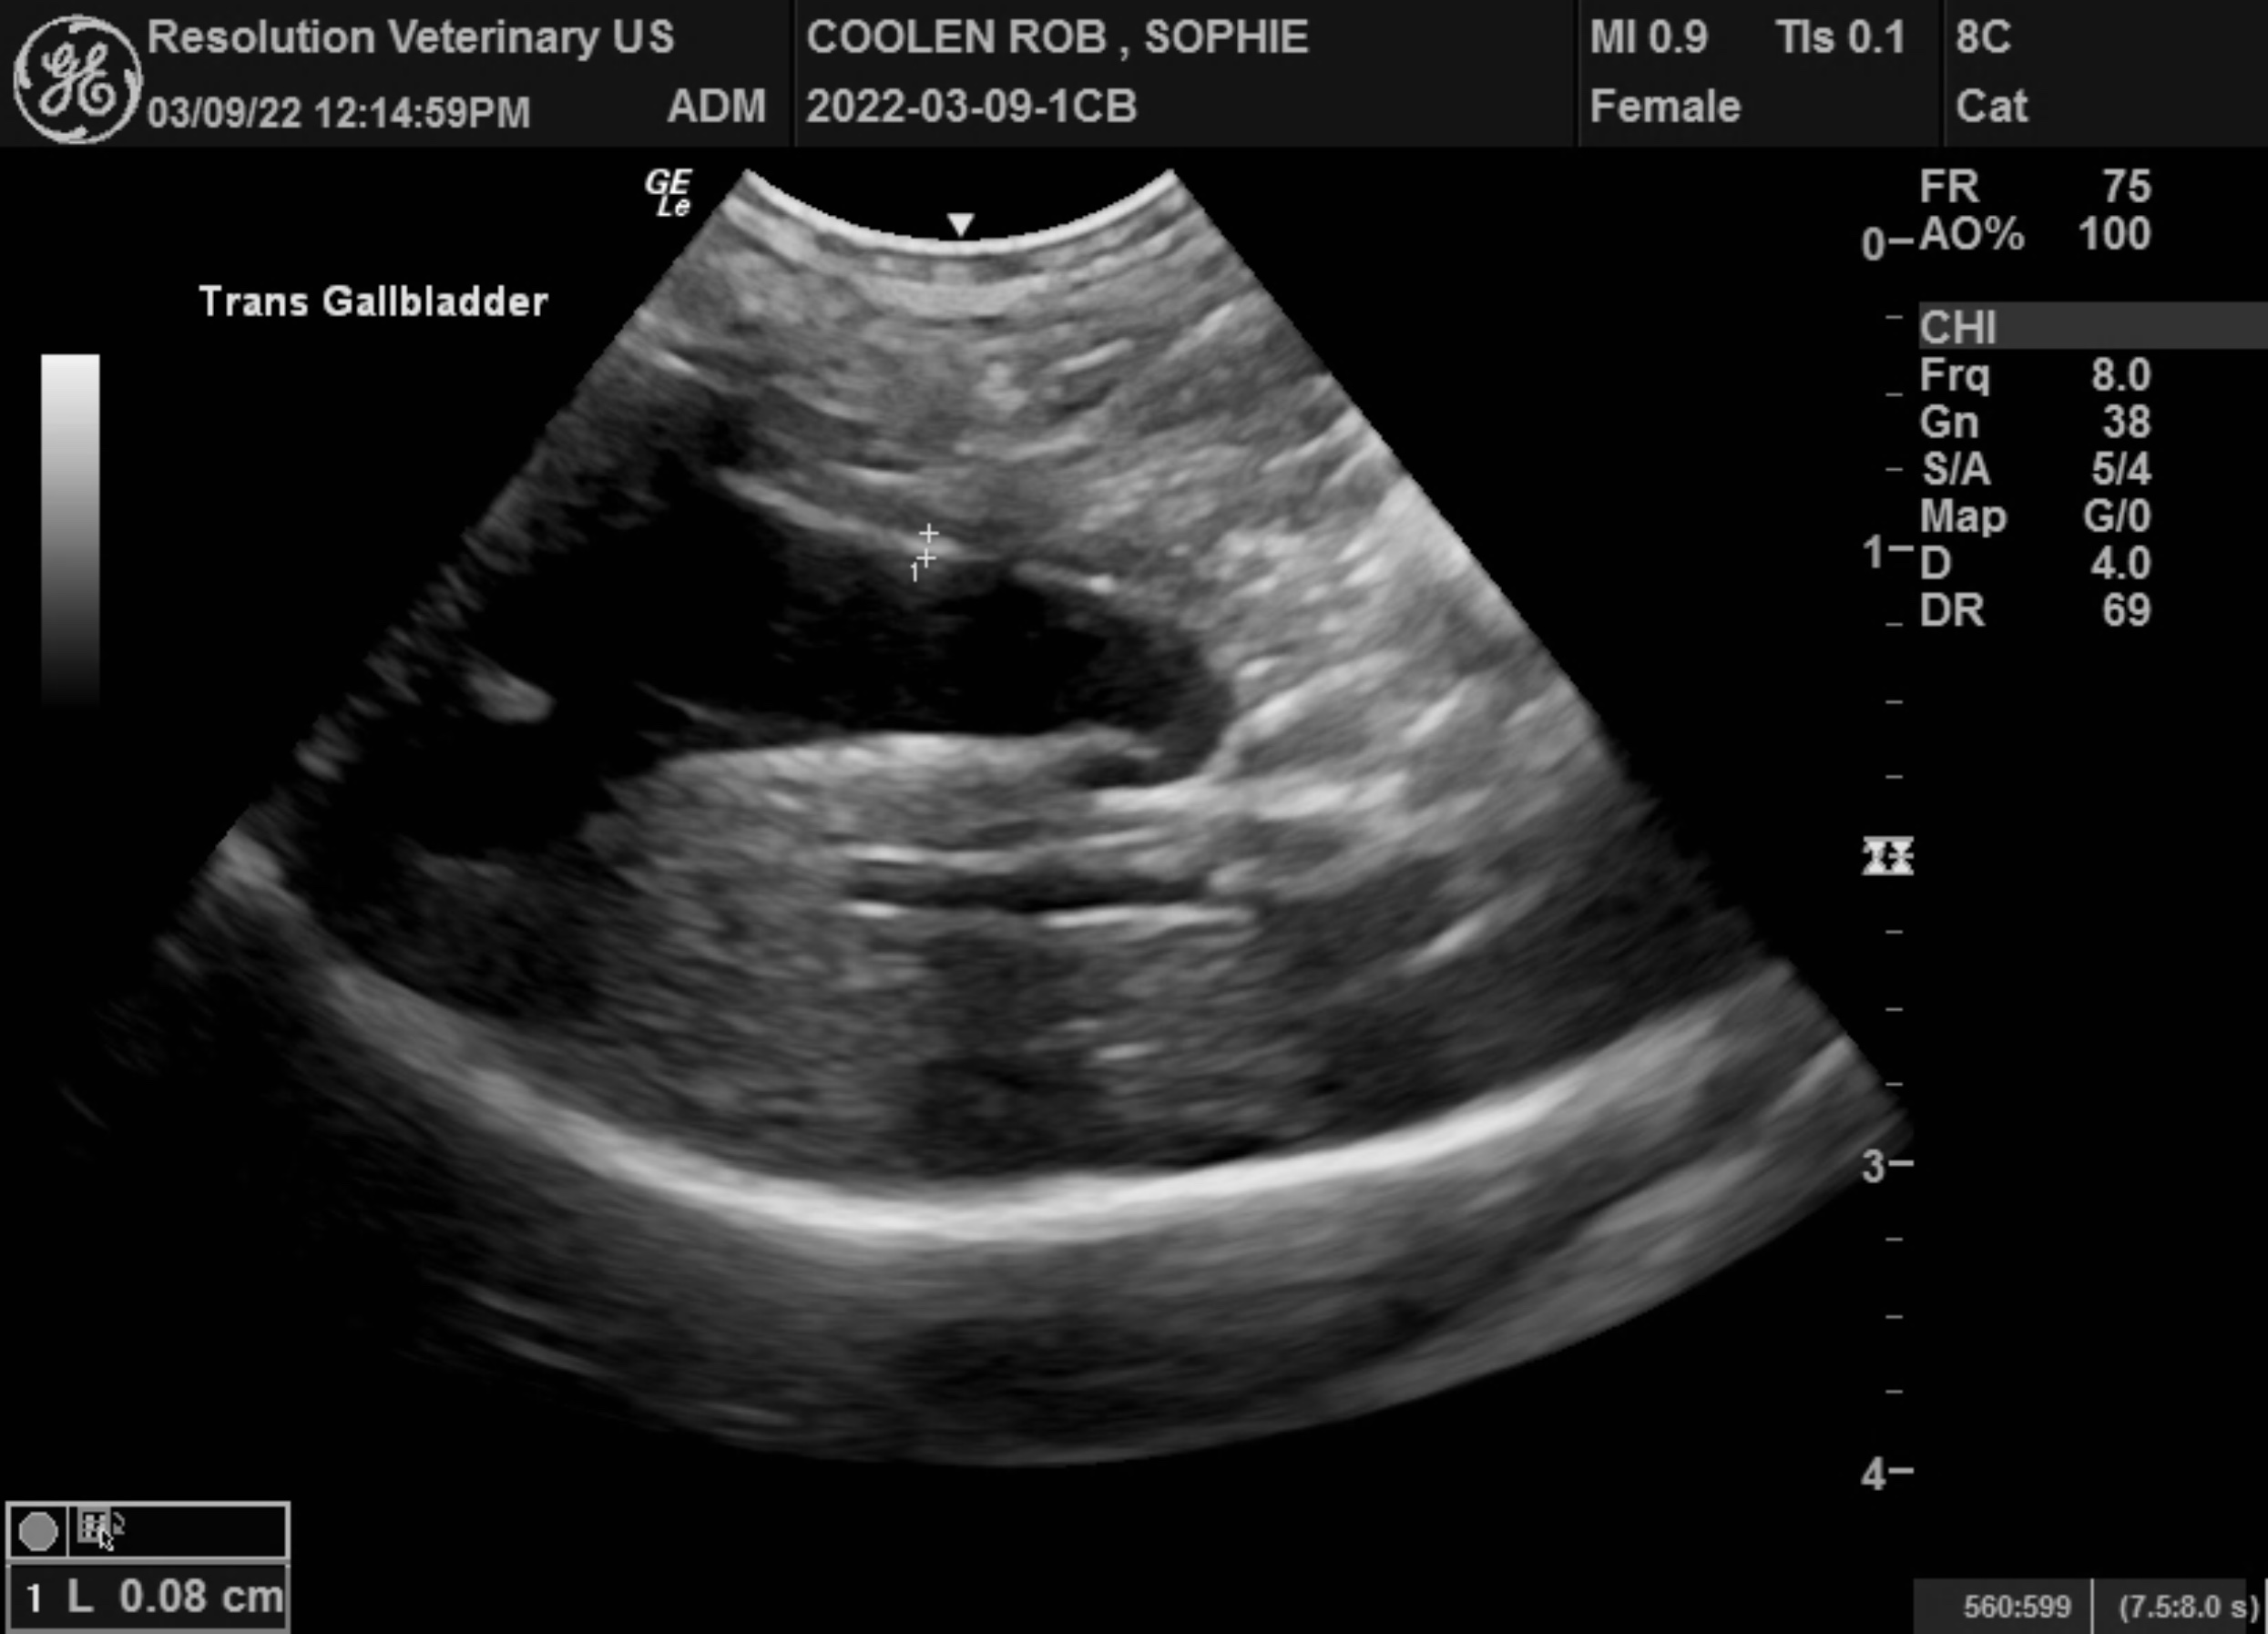
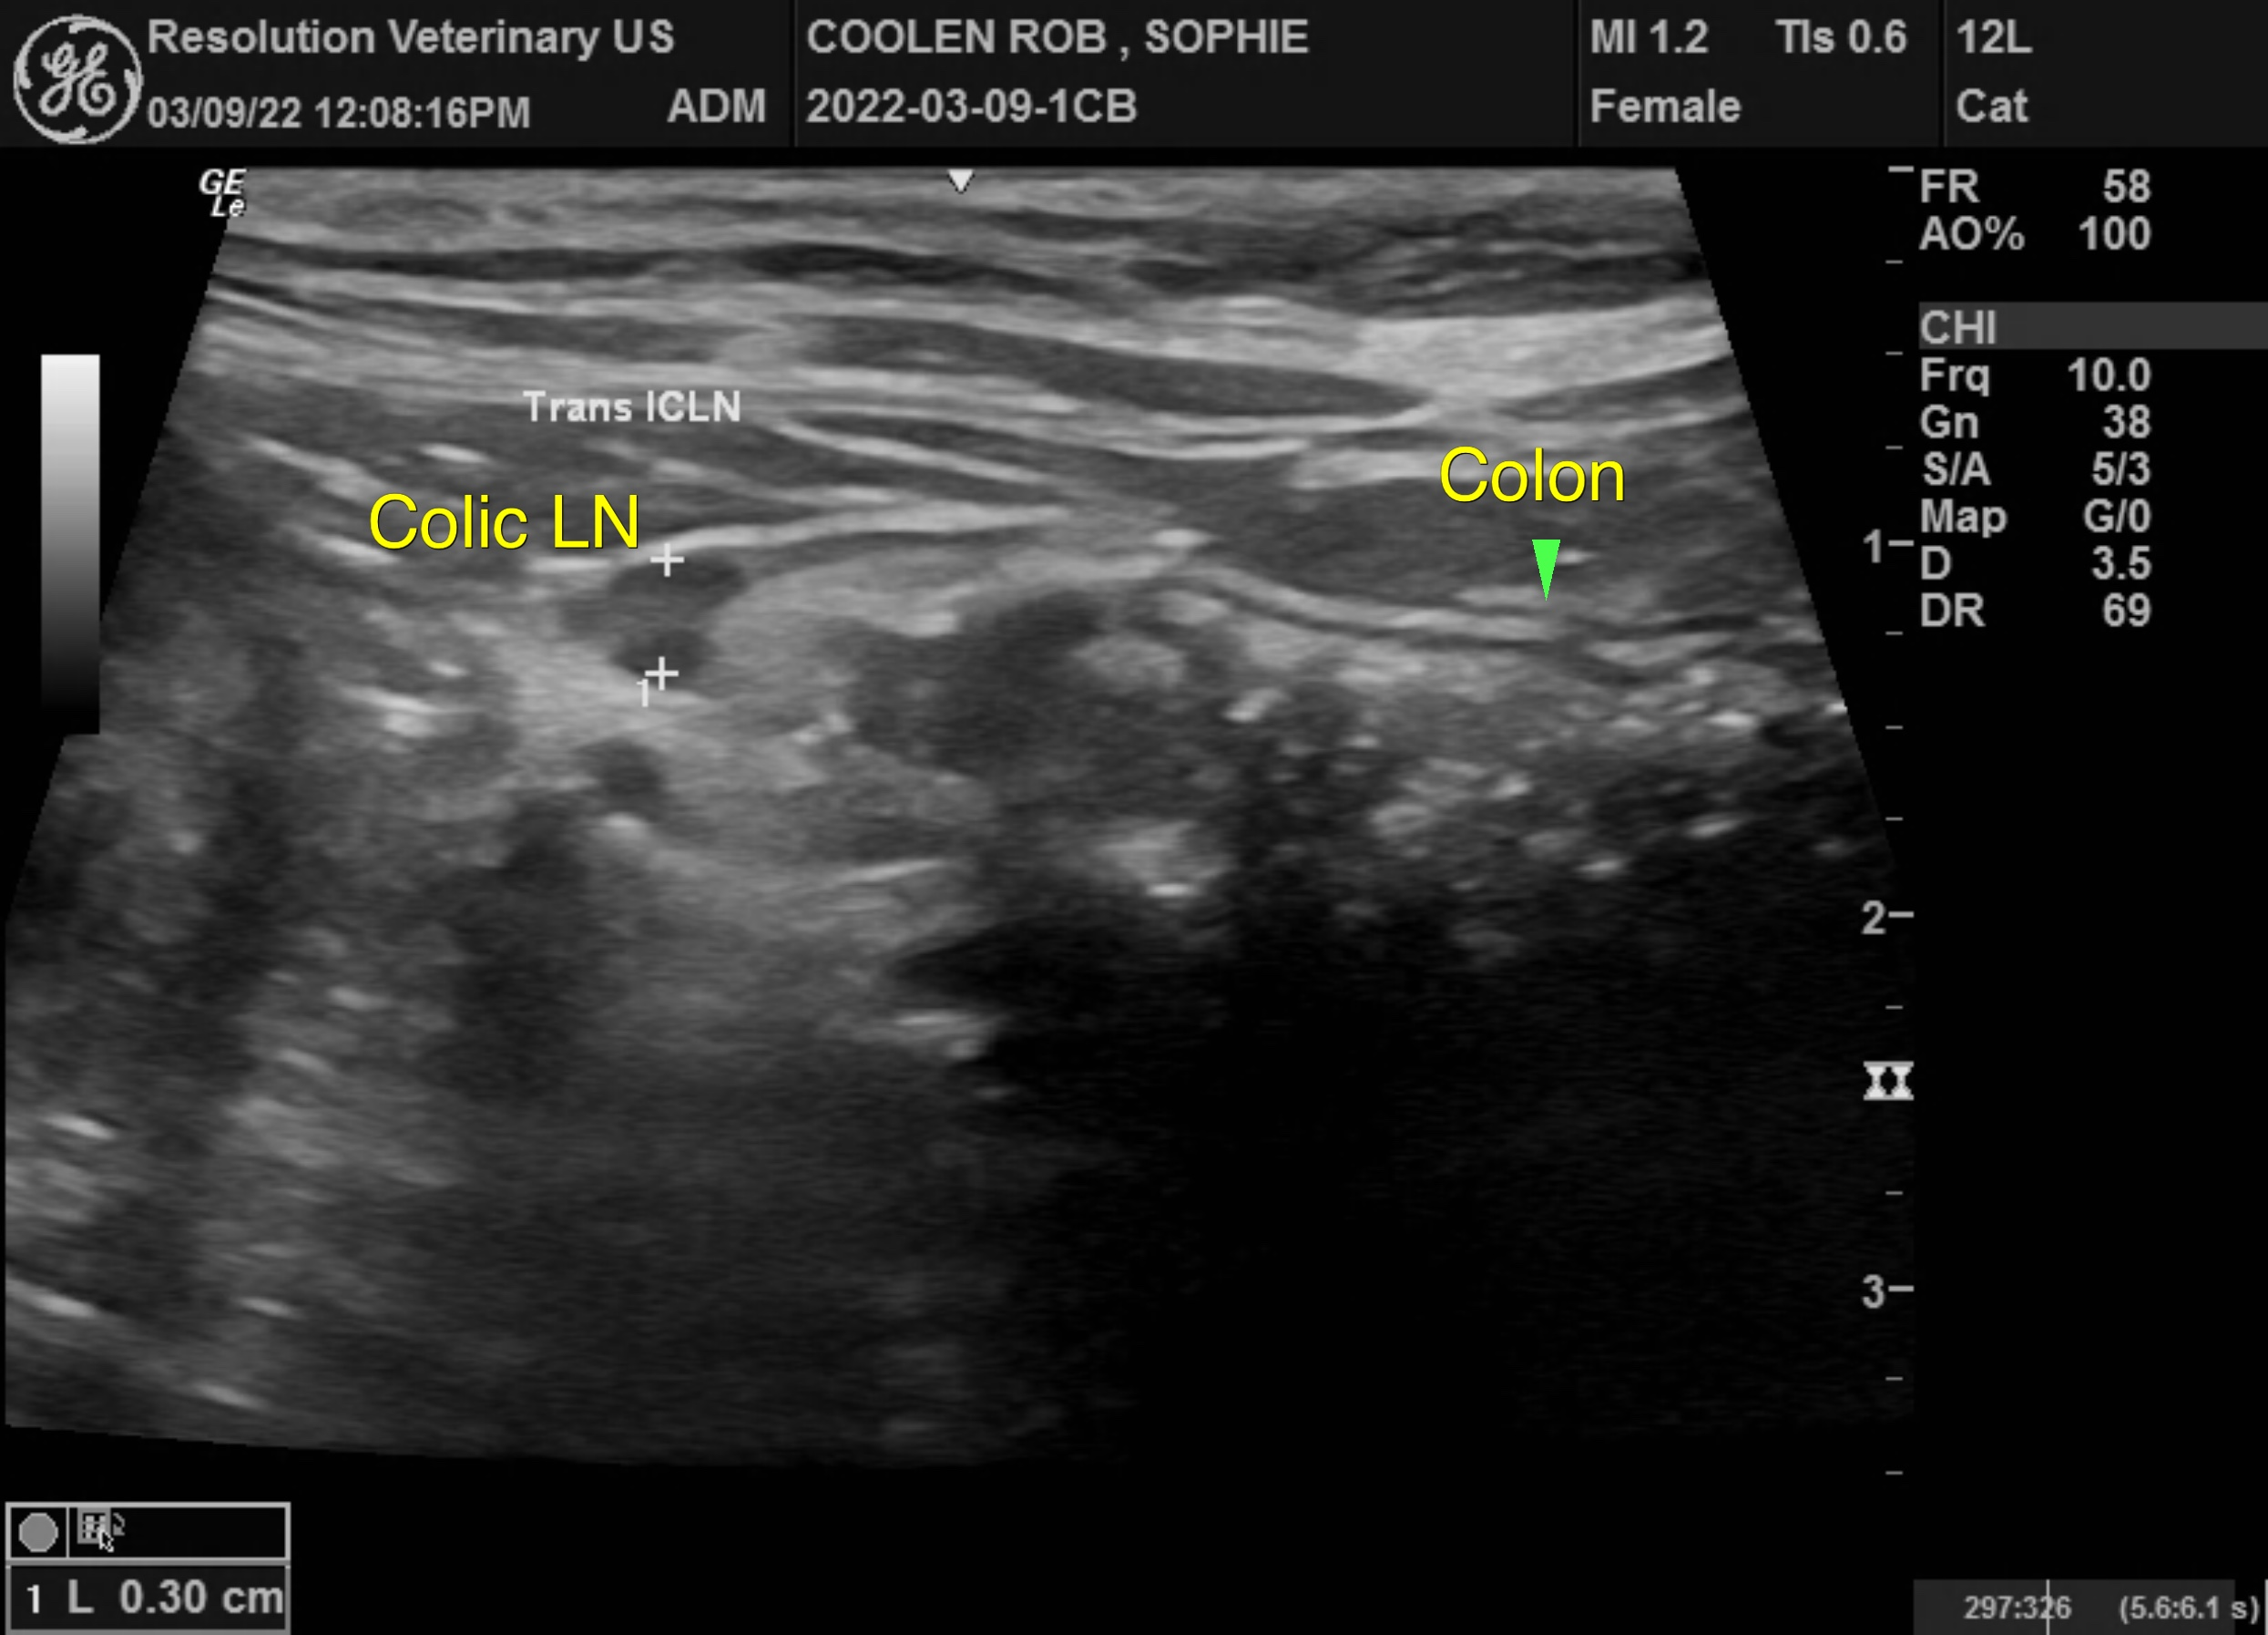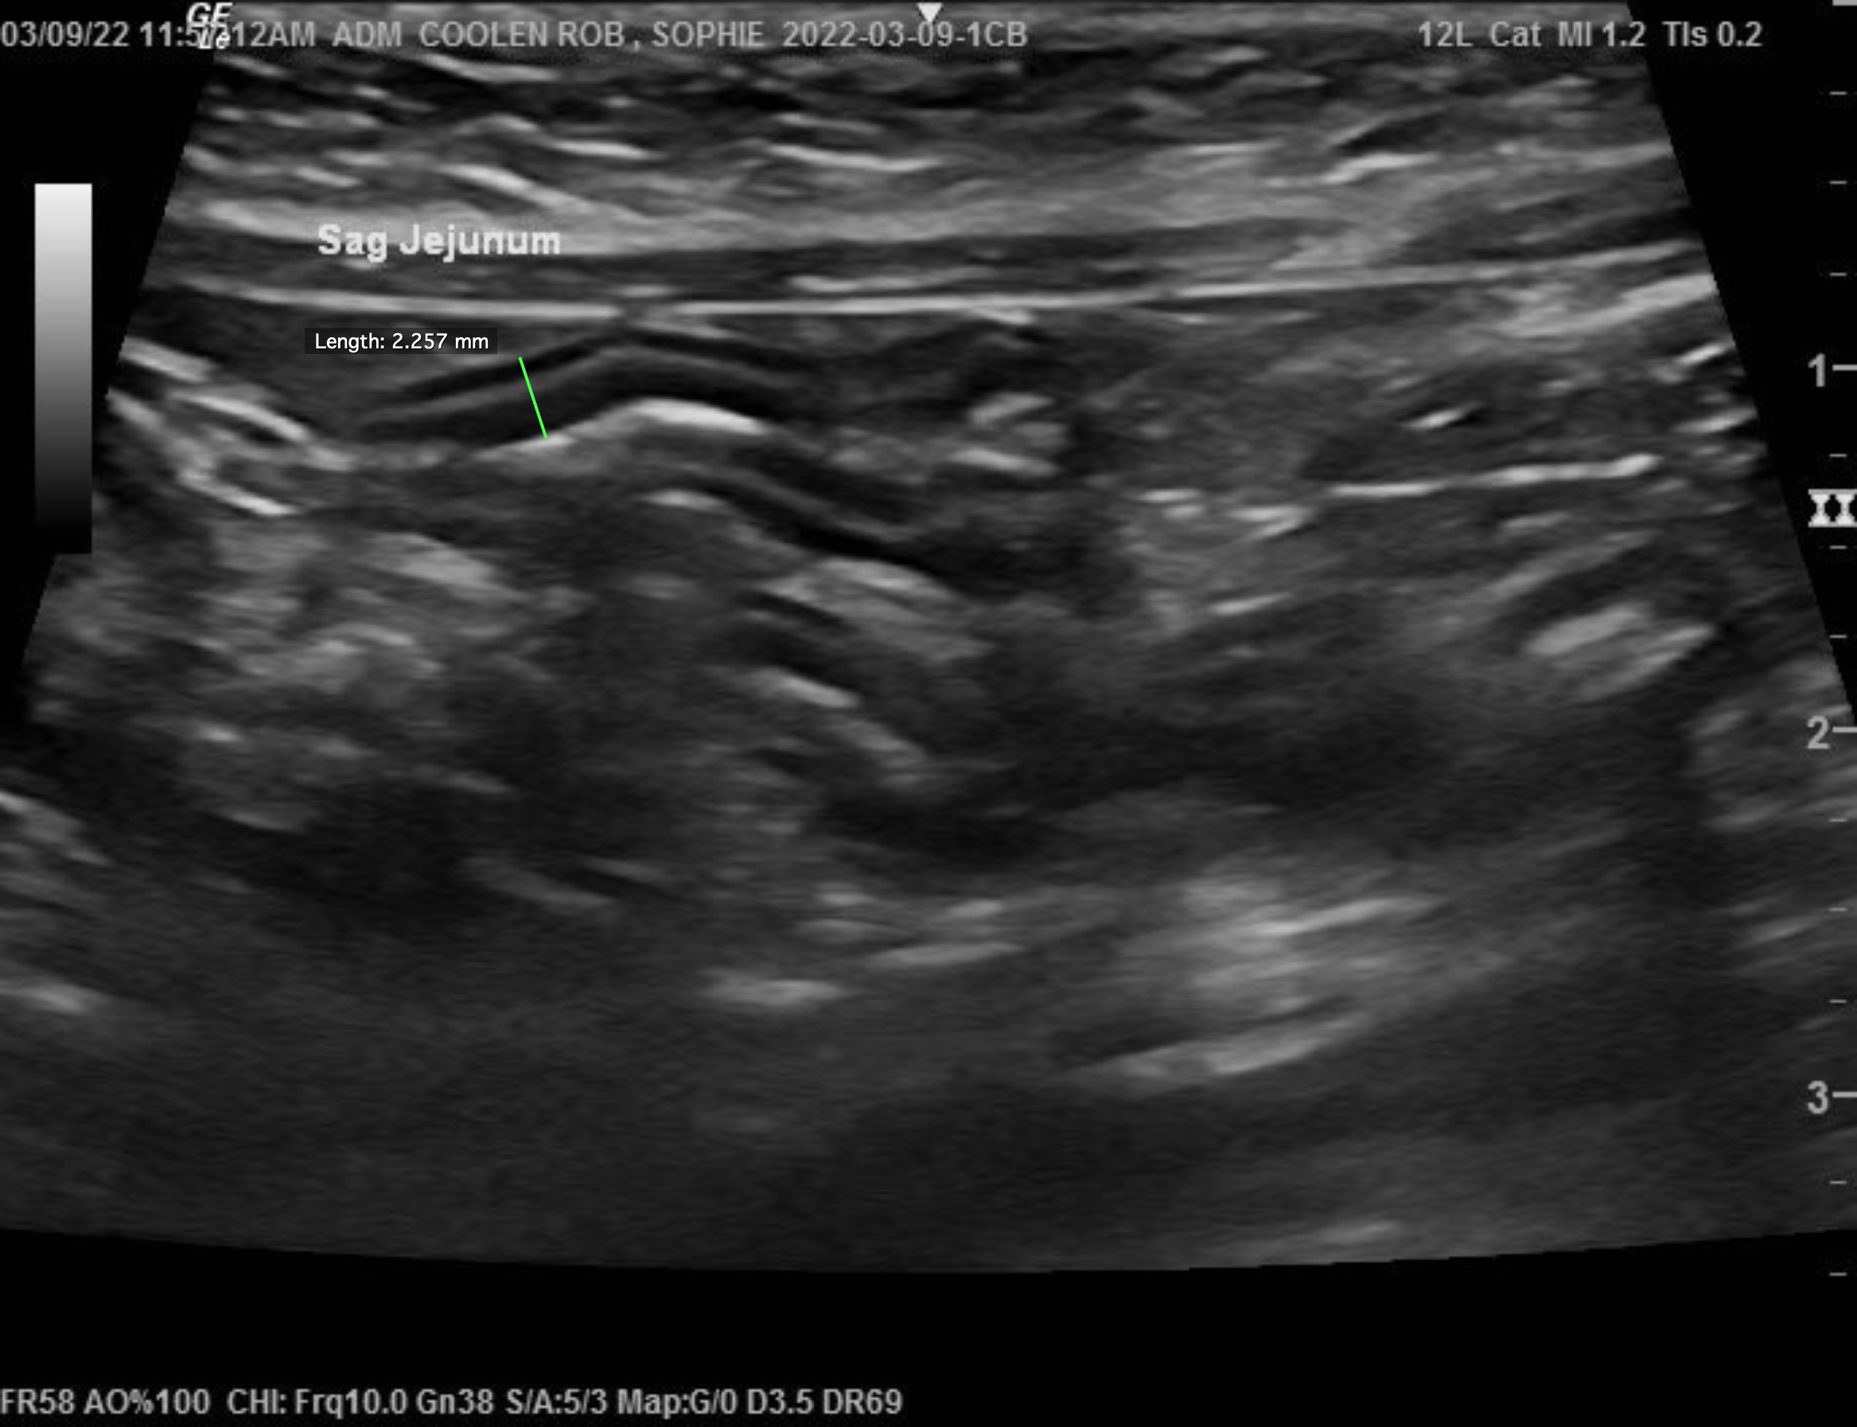
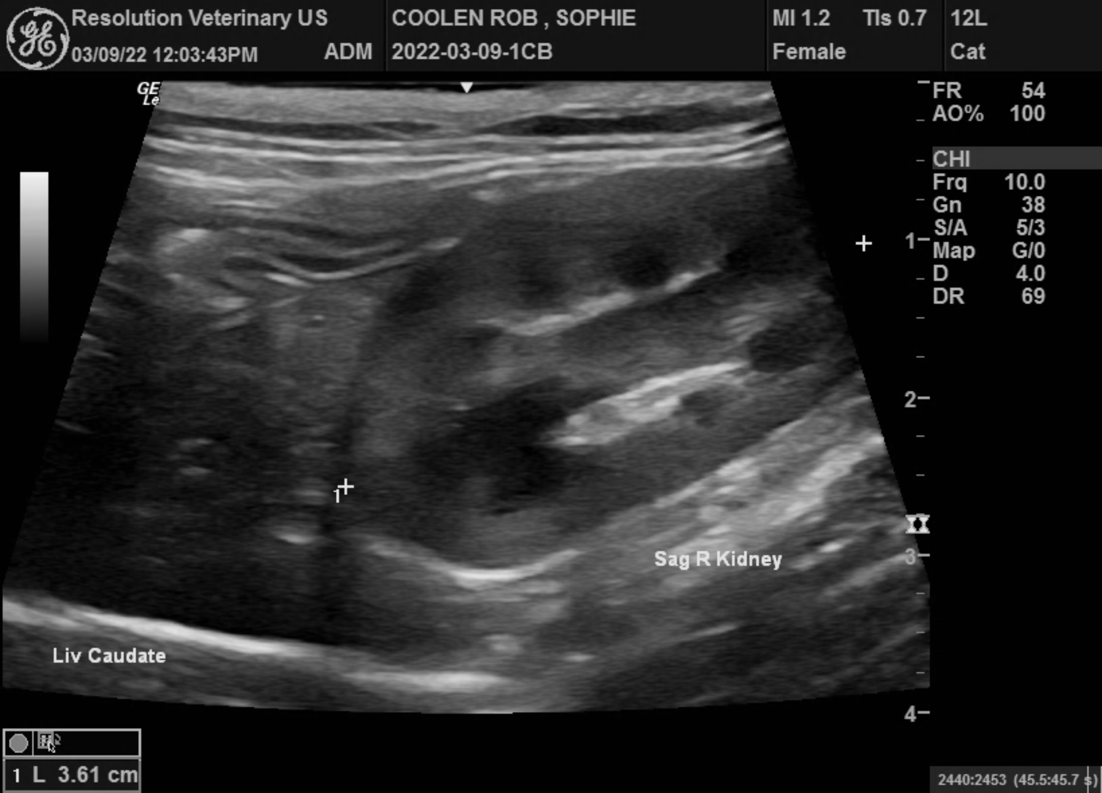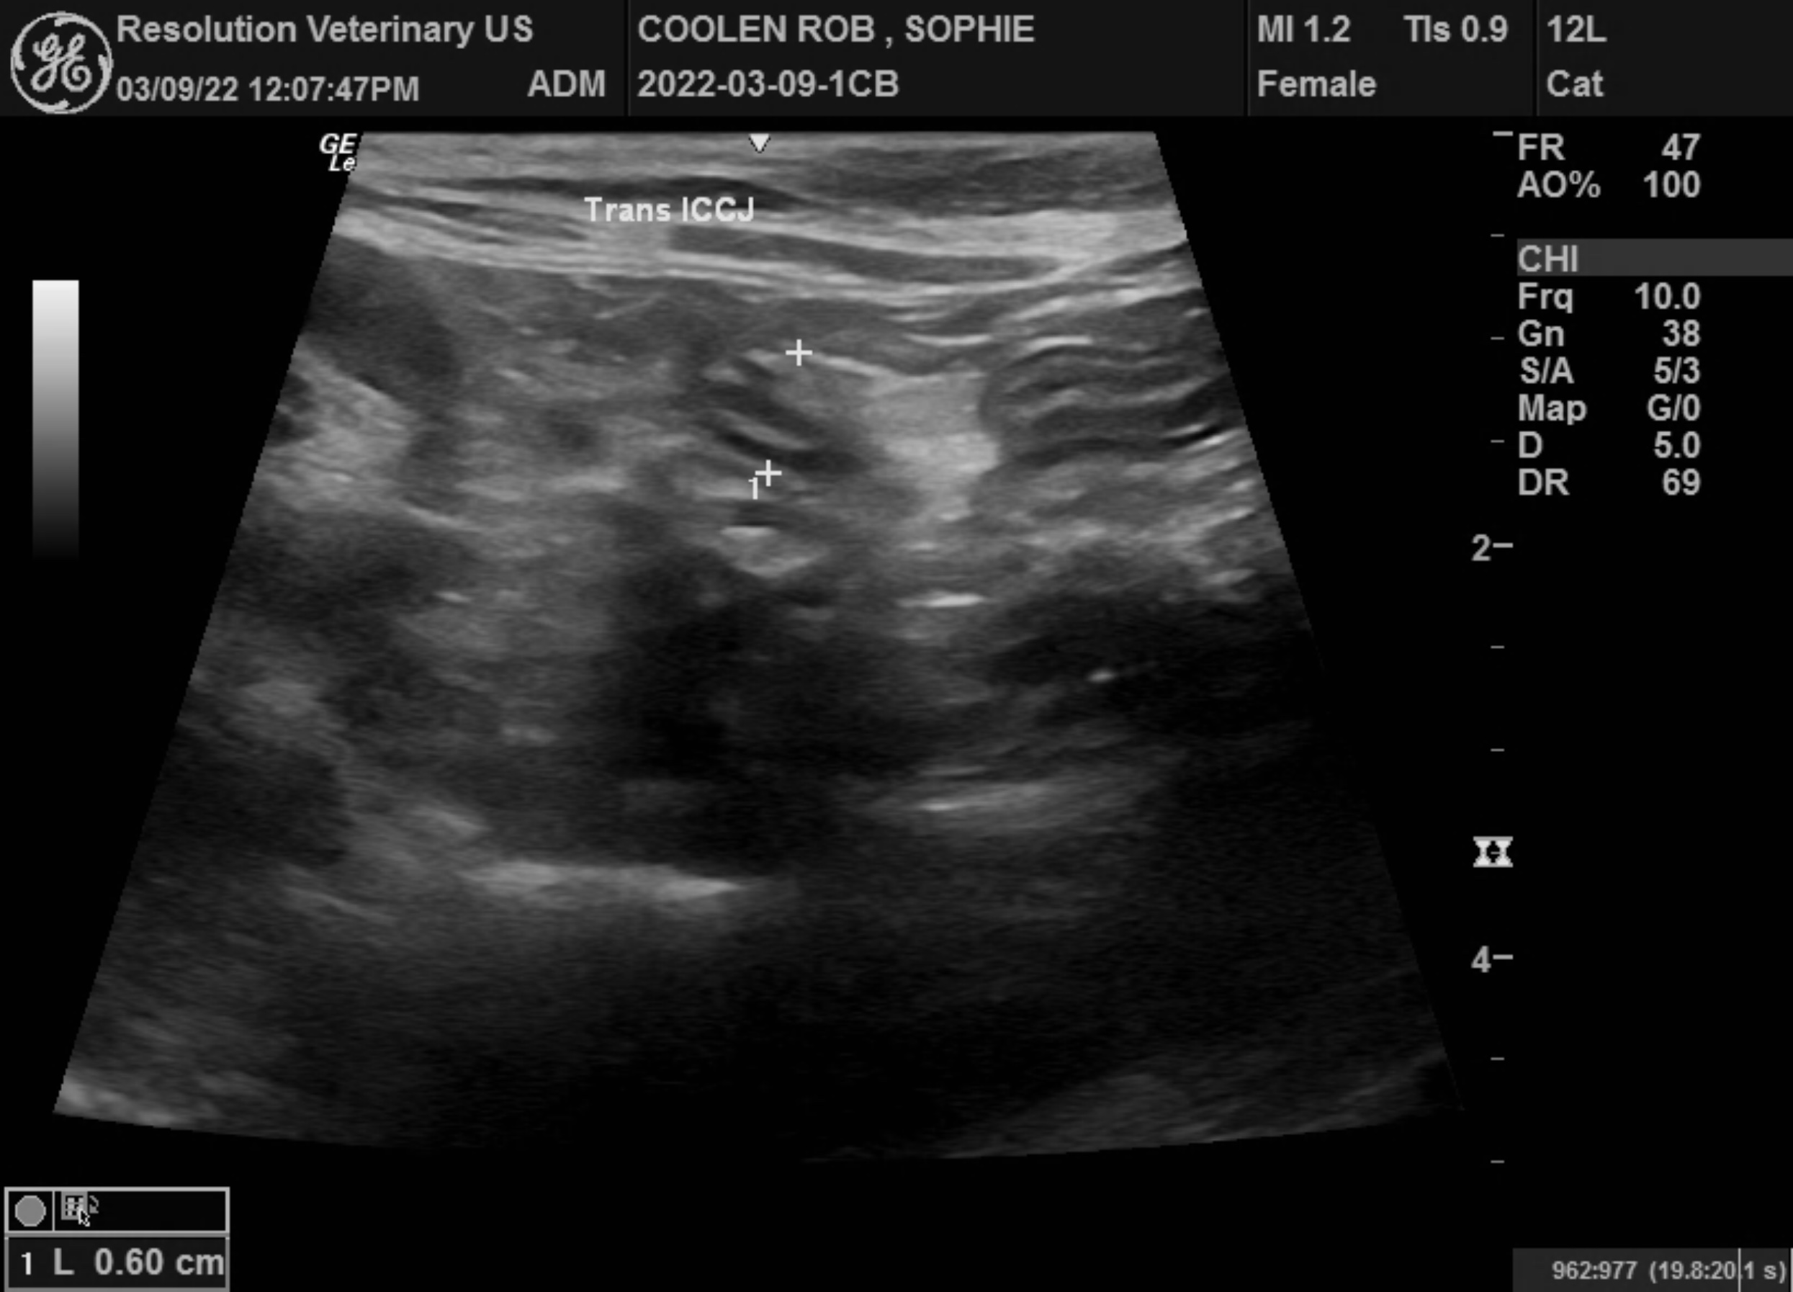

The information and recommendations provided are based on the images presented by the referring veterinarian/sonographer. No evaluation can be communicated regarding pathology that was not visible in the image/video clips provided.
Thank you for this referral. If the clinical or image interpretation does not parallel your findings or if I can be of any further assistance please contact me.
R. McKenzie Daniel, DVM, DABVP (Canine / Feline Practice)
info@SonoPath.com

