PRESENTING CLINICAL SIGNS
History:
- Cat recently adopted from shelter (2 weeks). Since adoption, patient has had chronic, liquid diarrhea.
- Shelter paperwork suggestive of recurrent GI symptoms (vomiting/diarrhea), and normal lab work.
- BCS underweight, and consistent w/ pathologic weight loss (prominent spine, visible ribs)
Abnormal PE/Chem/CBC/UA Results: Chem/CBC/T4/Lytes- run 12/2025 and 1/2026, all appear wnl Prior hx of mild ALT elevation 12/2025- 159 (29-130) UA unremarkable and usg 1.065
ULTRASONOGRAPHIC EXAMINATION OF THE ABDOMEN
Urinary System
The urinary bladder, trigone, cystourethral junction, and visible pelvic urethra to a depth of 2.0 cm exhibited normal thickness and tone. Anechoic urine was present in the lumen with no uroliths or sediment. The ureteral papillae were normal. The ureters were not visible which is normal. No evidence of inflammatory or neoplastic changes were noted.
Normal renal size with asymmetrical margination was present in both kidneys. The renal cortex presented uniformly increased in echogenicity with uniform echotexture. The renal cortex appeared to be hypertrophied resulting in an altered cortex: medulla ratio. Loss of corticomedullary distinction was also present. Pinpoint to focal areas of medullary mineral present. The left kidney measured 3.5 cm in length. The right kidney measured 3.5 cm in length.
Adrenal Glands
The left and right adrenal glands were not definitively visualized.
Spleen
The spleen exhibited a finely textured and homogenous parenchyma which was hyperechoic to the liver and renal cortical parenchyma. The capsule was smooth and regular without apparent expansion. The splenic vasculature at the hilus was normal in volume with no evidence of congestion or thrombosis. Acute to chronic inflammatory, neoplastic, or benign parenchyma changes were not noted. The spleen measured 0.63 cm width level of the mid spleen.
Liver
The liver presented subjective mildly enlarged in size with normal vascular volume. Homogeneous, mildly increased hepatic parenchyma echogenicity compared to the spleen and renal cortices. The echotexture of the liver parenchyma was uniform with a mild coarse echotexture. The capsule of the liver was symmetrical in margination. The hepatic and portal vasculature were normal in appearance without signs of congestion. The gallbladder was non-distended in size with thin walls and primarily anechoic luminal content. The cystic and common bile ducts were normal.

Gastrointestinal
The stomach presented intact wall layering with a normal wall layer ratio. The lumen of the stomach contained minor retained pyloric fluid.
The small intestine presented intact mildly thickened wall owing to propensity for mildly thickened mucosa layer. Segmental, mildly thickened, hypoechoic jejunal submucosal layer. Swollen intestinal wall measured 0.29 – 0.30 cm.
The colon walls presented intact yet thickened wall layering. Soft to non-formed fecal matter was present in the colon lumen. Colon wall measured 0.23 cm.
Pancreas
The pancreas was prominent in size exhibiting capsule asymmetry with isoechoic to heterogeneous parenchyma compared to adjacent omentum. Mildly prominent pancreatic duct and no signs of active inflammation or neoplasia.
Free Abdomen
Minor peritoneal effusion and no obvious visualized swollen or hypoechoic mesenteric lymphadenopathy noted.
ULTRASONOGRAPHIC FINDINGS
- Chronic colitis with concurrent chronic enteropathy pattern – chronic IBD or other inflammatory enterocolonopathy probable, chronic triaditis
- Mildly enlarged echogenic liver
- Minor peritoneal effusion
- Chronic renal changes exhibiting pinpoint to focal medullary mineral
- Heterogeneous remodeled pancreas – probable chronic pancreatitis
INTERPRETATION OF THE FINDINGS & FURTHER RECOMMENDATIONS
Chronic triaditis and concurrent chronic colitis is suspected. Potential for low-grade enterocolic or multicentric round cell neoplasia thought less likely. Assuming normal clotting status and using 25-gauge needle, screening hepatic FNA cytology primarily to assess for evidence of inflammation may be considered.
A GI panel to include PLI/TLI/Cobalamin/Folate and Diarrhea PCR panel are recommended. Cobalamin supplementation, empirical deworming Panacur SID for 7-10 days, and dietary trial such as higher fiber diet w/d or similar or fiber supplementation in hydrolyzed diet may prove beneficial. If biopsies are not possible, a combination of prednisolone 5mg + metronidazole 62.5mg + sulfasalazine 62.5mg compounded into a No. 2 gelcap BID X 14d, then SID may be considered.

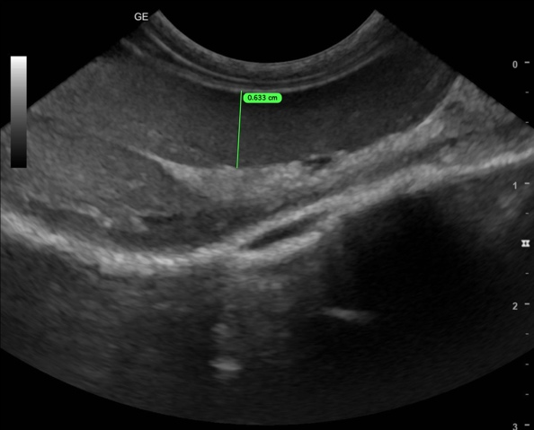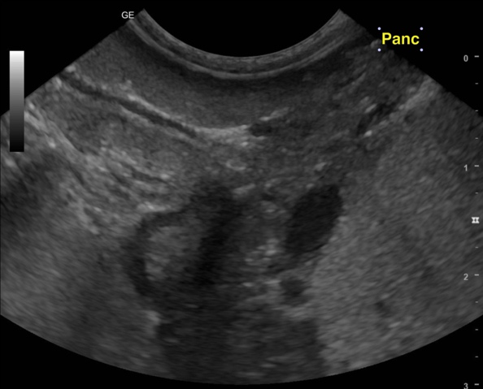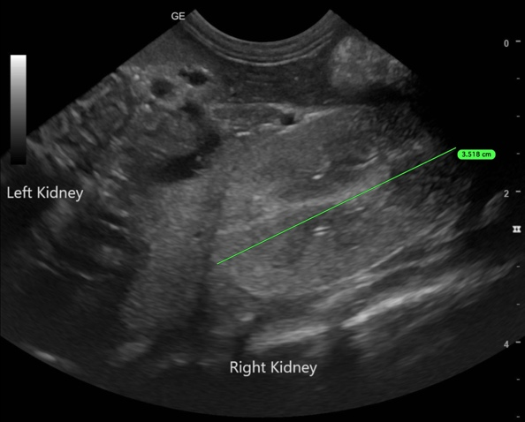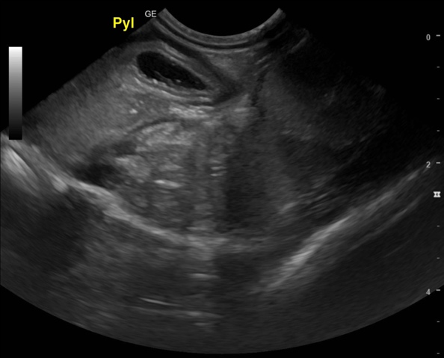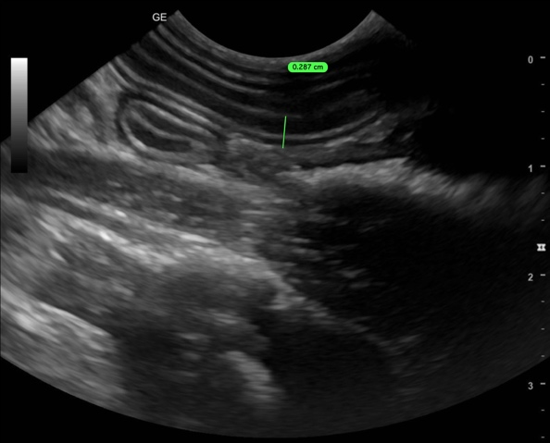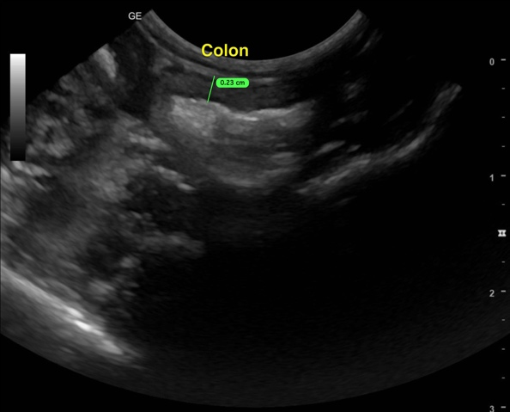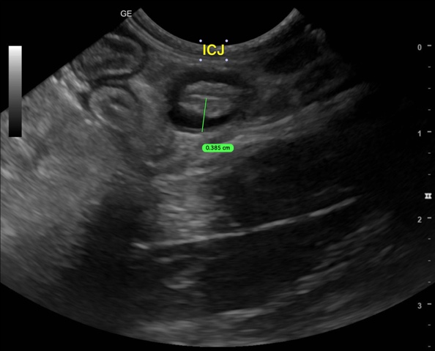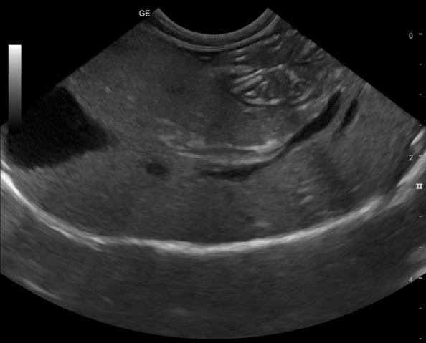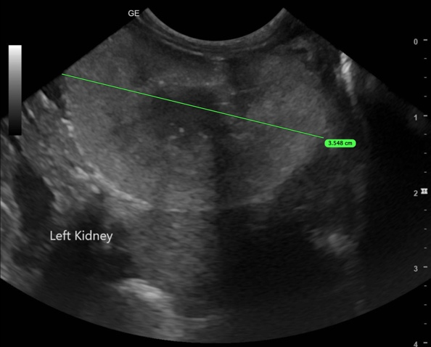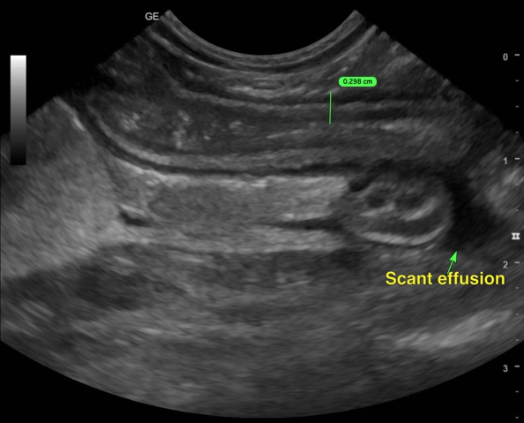

The information and recommendations provided are based on the images presented by the referring veterinarian/sonographer. No evaluation can be communicated regarding pathology that was not visible in the image/video clips provided.
Thank you for this referral. If the clinical or image interpretation does not parallel your findings or if I can be of any further assistance, please contact me.
R. McKenzie Daniel, DVM, DABVP (Canine / Feline Practice)
info@sonopath.com

