PRESENTING CLINICAL SIGNS
- weight loss recurrent UTI's decreased appetite
- Current meds: Cetirizine Nitrofurantoin Cytopoint
ULTRASONOGRAPHIC EXAMINATION OF THE ABDOMEN
Urinary System
The urinary bladder was nondistended with urine prohibiting full evaluation of the bladder wall. Diffusely thickened urinary bladder wall exhibiting mild luminal surface asymmetrical contour. No evidence of urine mineral or calculi or definitive tumors. Urinary bladder wall measured 0.85 cm. The trigone, cystourethral junction, and visible pelvic urethra to a depth of 2.0 cm exhibited normal thickness and tone. Anechoic urine was present in the lumen with no uroliths or sediment. The ureteral papillae were normal. The ureters were not visible which is normal. No evidence of inflammatory or neoplastic change were noted.
The area of the residual prostate appeared normal and free of pathology.
Normal size and margination was present in the kidneys. A normal 1:3 cortex / medulla ratio was maintained. The medulla and cortices were uniform in texture with some increased echogenicity and mild loss of corticomedullary symmetry and definition expected for the age of the patient. No evidence of pelvic dilation was present. The left kidney measured 5.5 cm in length. The right kidney measured 5.9 cm in length.
Adrenal Glands
The left adrenal gland was overtly normal in size, position and shape. The left adrenal gland measured 0.88 cm width at the caudal pole.
The right adrenal gland was indistinctly visualized with no obvious pathology. The right adrenal gland subjectively measured 0.60 cm width at the caudal pole.
Spleen
The spleen exhibited a finely textured and homogenous parenchyma which was hyperechoic to the liver and renal cortical parenchyma. The capsule was smooth and regular without apparent expansion. The splenic vasculature at the hilus was normal in volume with no evidence of congestion or thrombosis. Acute to chronic inflammatory, neoplastic, or benign parenchyma changes were not noted.
Liver & Gallbladder
The liver was subjectively normal in size, structure, and contour. The liver parenchyma was uniform and hypoechoic to the spleen with a mild coarse echotexture. The hepatic and portal vasculature were normal in appearance without signs of congestion.
The gallbladder was indistinctly visualized potentially secondary to the presence of gastric ingesta. No obvious evidence of gallbladder overdistention or pathology. The common bile duct was not visualized.
Gastrointestinal
The stomach presented intact wall layering with a normal wall layer ratio. The lumen of the stomach contained variably echogenic, nonshadowing ingesta without signs of obstruction or foreign material.
The small intestine presented overall intact visualized wall exhibiting subjective propensity for mildly prominent jejunal muscularis layer without evidence of intestinal wall thickening.
Normal visible colon wall layers were present with apparent formed feces in lumen.
Pancreas
The parenchyma of the left limb, body and right limb of the pancreas presented isoechoic to the adjacent omental fat. A normal curvilinear capsule contour of the pancreas was present. The visible pancreatic duct was normal. No signs of active inflammation or neoplastic disease was evident.
Free Abdomen
No overt lymphadenopathy or peritoneal effusion was present.
ULTRASONOGRAPHIC FINDINGS
- Subjective cystitis pattern- mild potential for diffuse urinary bladder tumor.
- Normal residual prostate and visible proximal urethra.
- Possible nonspecific enteropathy.
- Nonshadowing gastric ingesta- consistent with food echogenicity.
- Age-related renal changes.

INTERPRETATION OF THE FINDINGS & FURTHER RECOMMENDATIONS
Recheck urinalysis, urine culture and sensitivity ideally on sterile urine sample +/- BRAF assay is recommended. The presence of gastric ingesta is nonspecific and may indicate post-prandial presentation. Correlation with most recent meal ingestion is recommended. If documented NPO prior to the ultrasound, the presence of gastric ingesta may indicate some degree some of gastric hypomotility or metabolic stasis. The sonographic presentation of the ingesta was most consistent with food, without overt evidence of foreign material.
A GI panel to include PLI, TLI, cobalamin and folate, three view chest radiographs if not done +/-correlation with musculoskeletal/neurological examination to assess non-obvious or occult disease as a contributing factor to the weight loss.
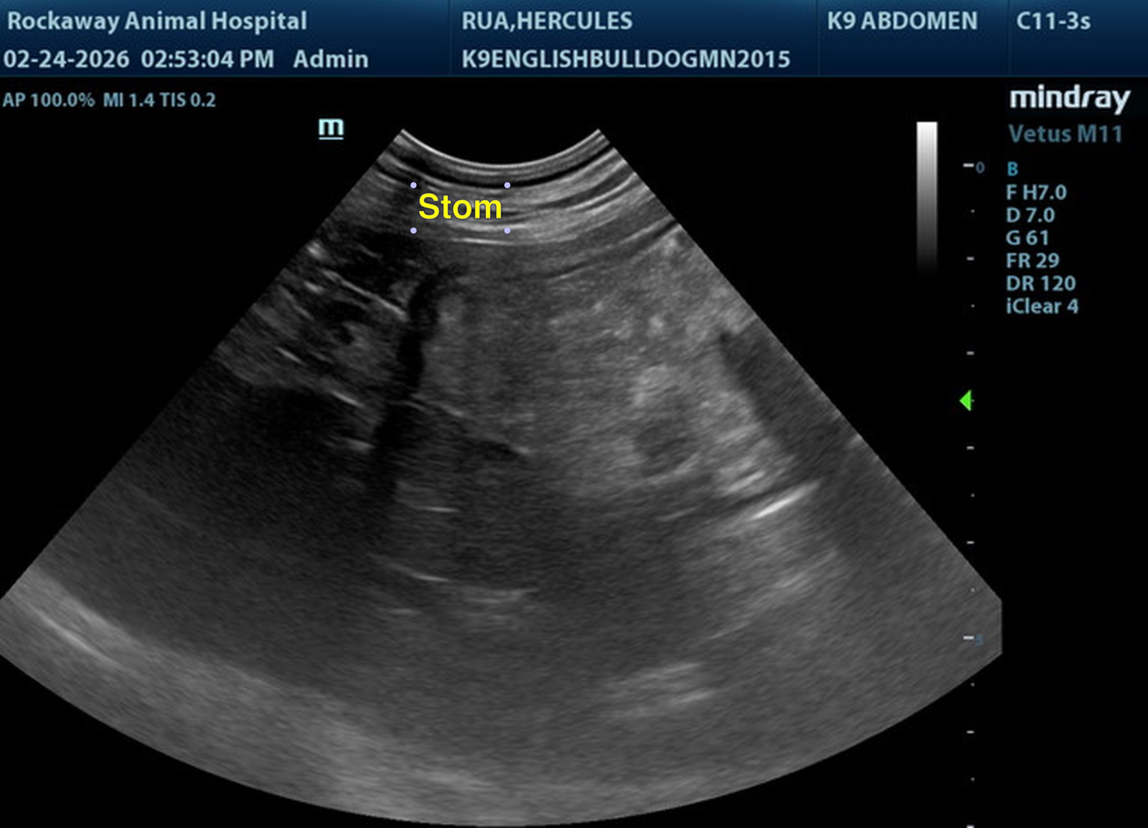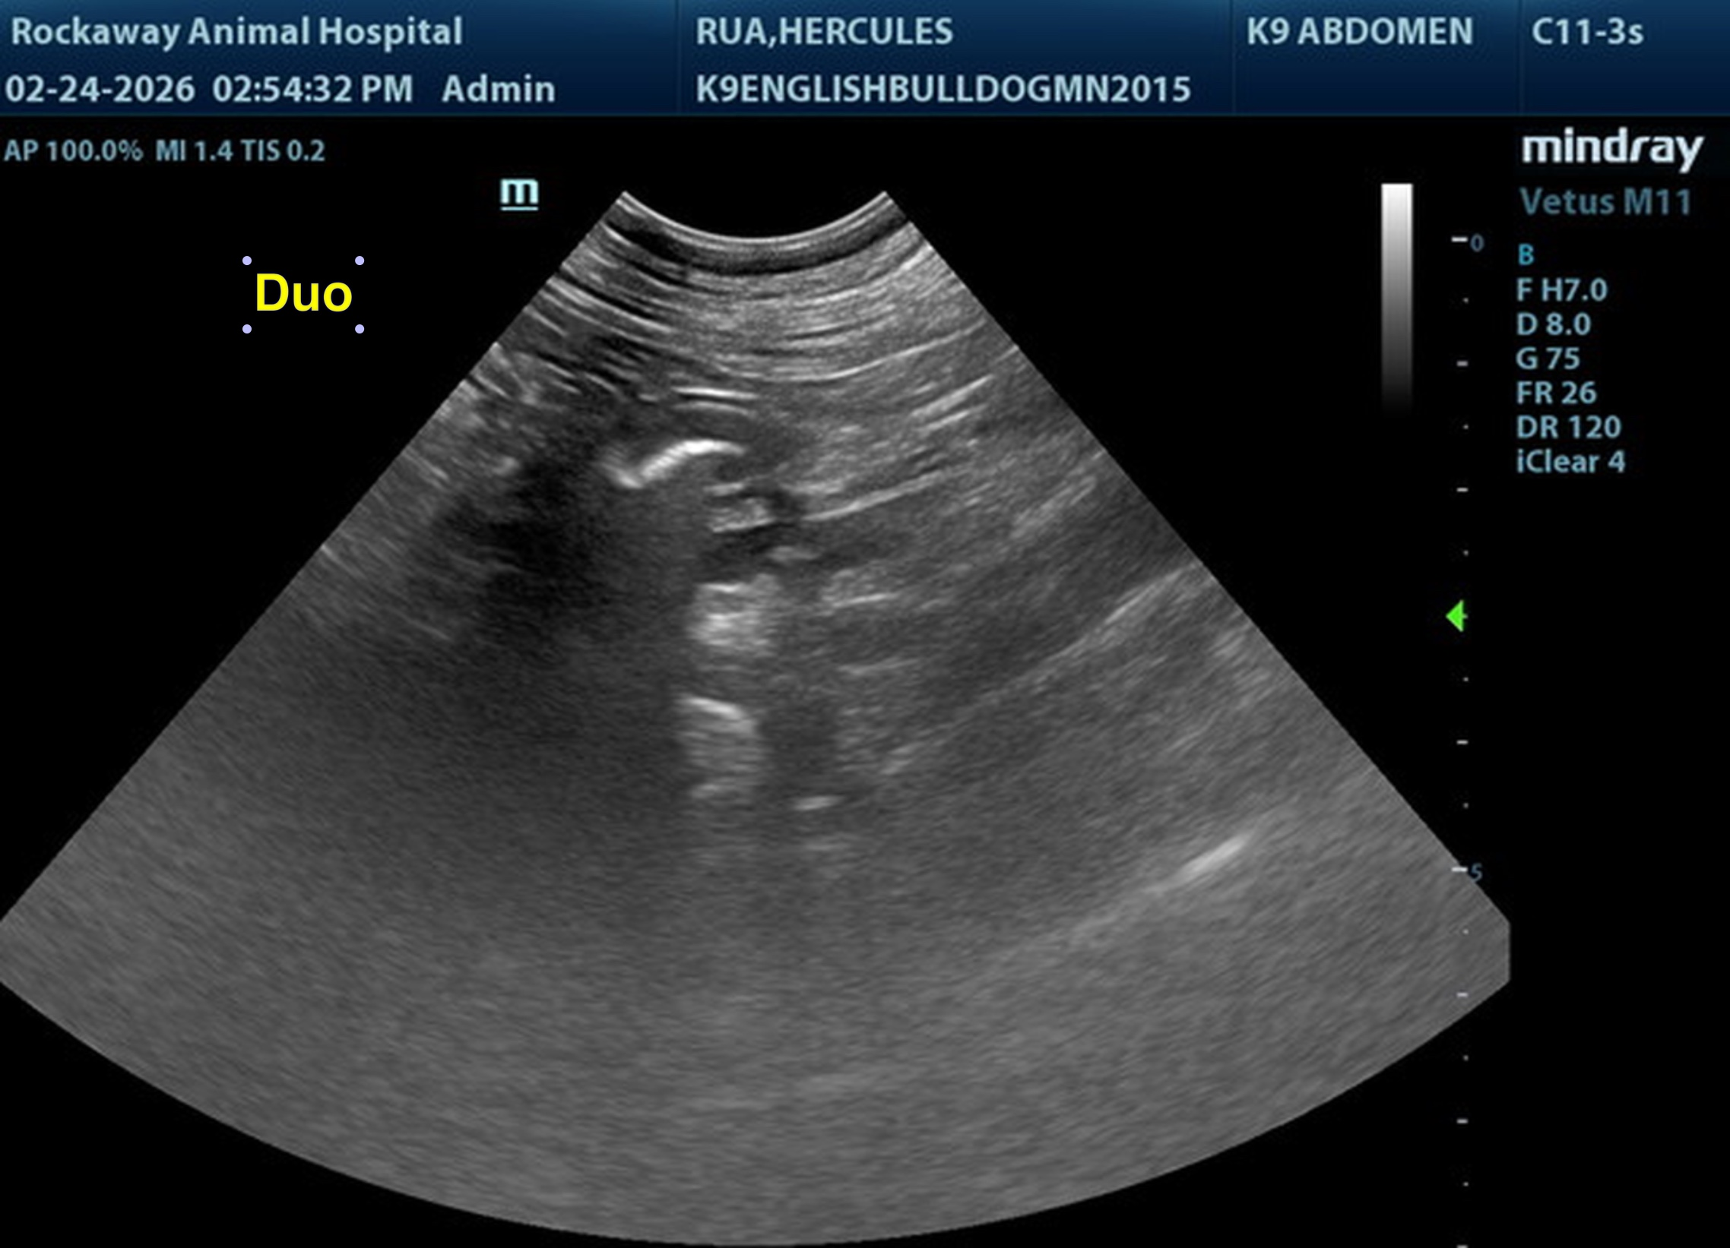
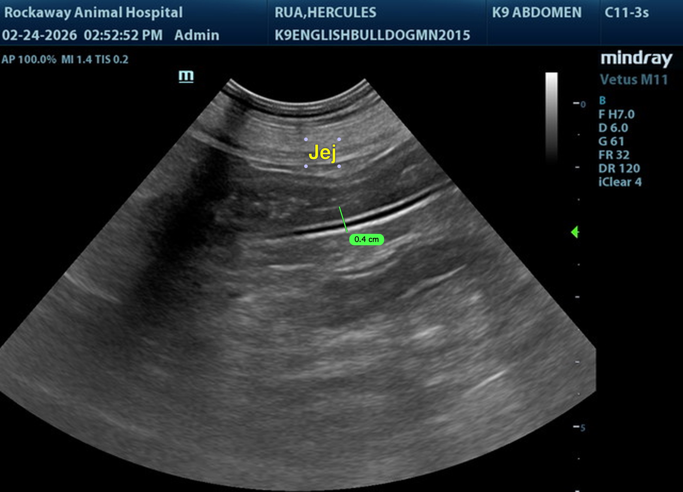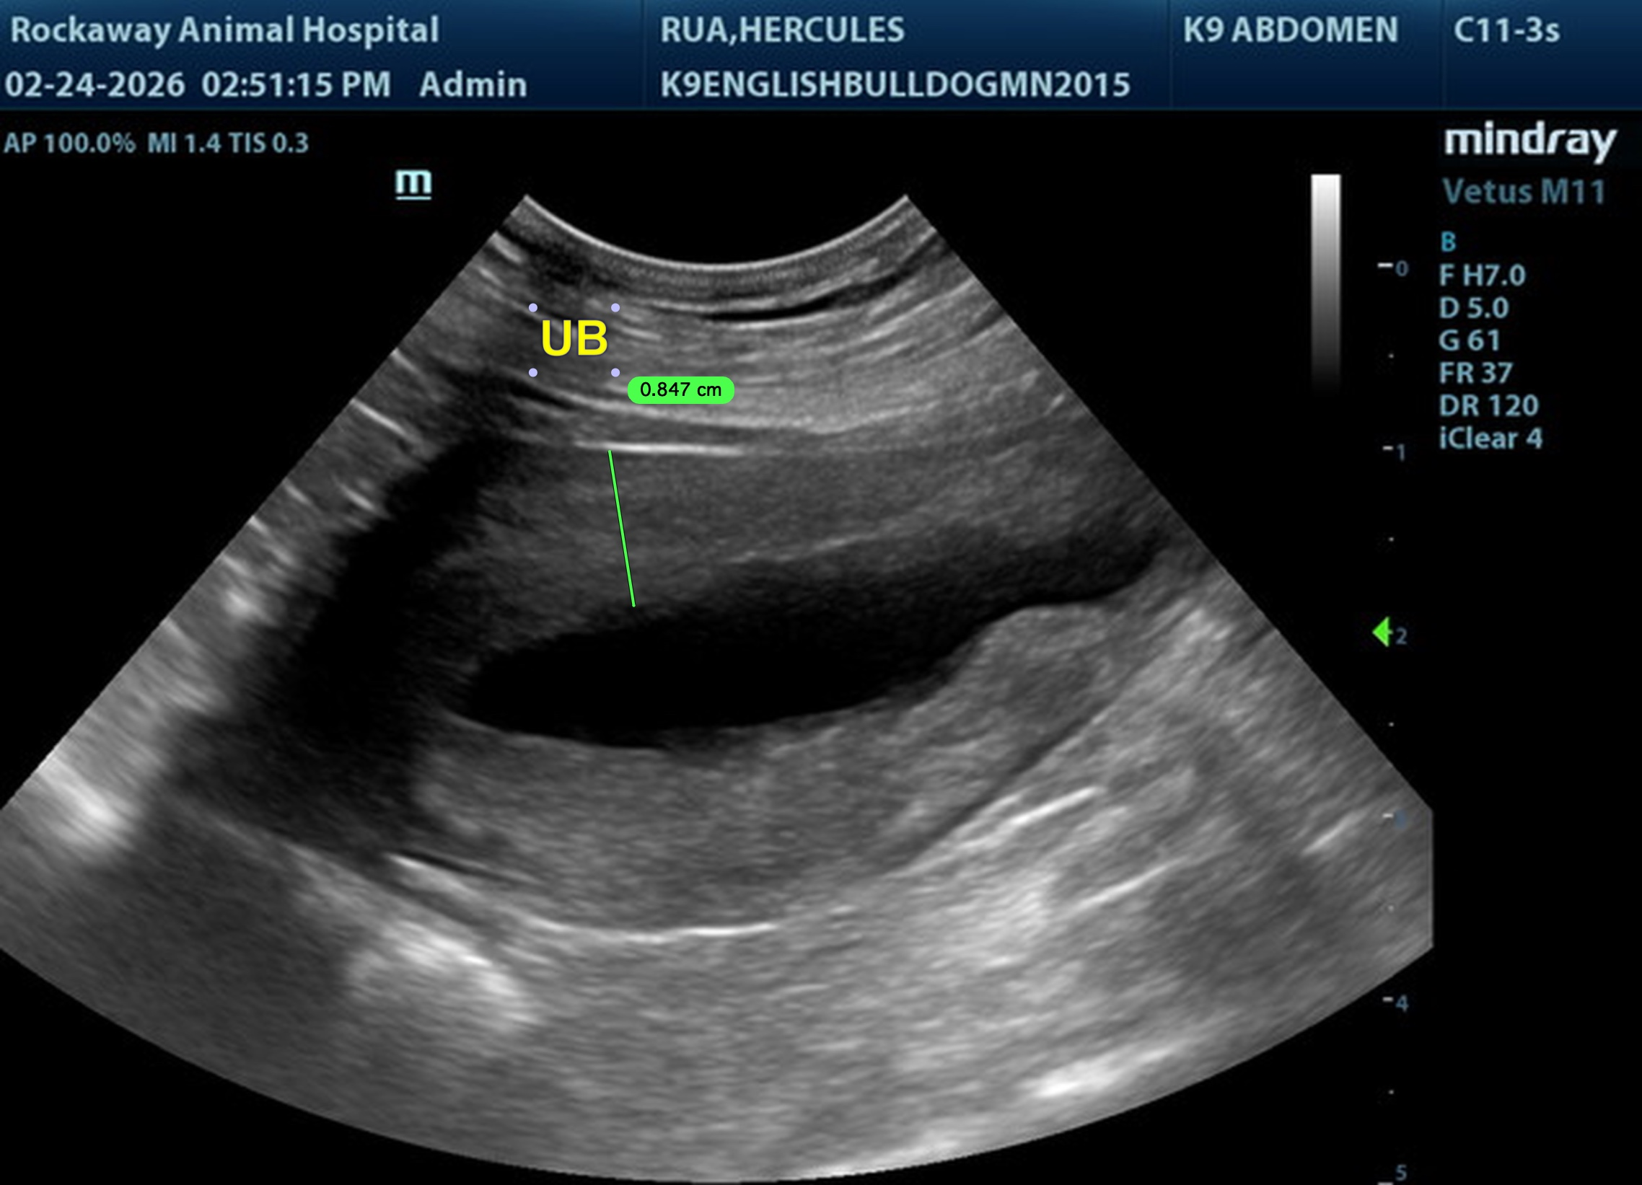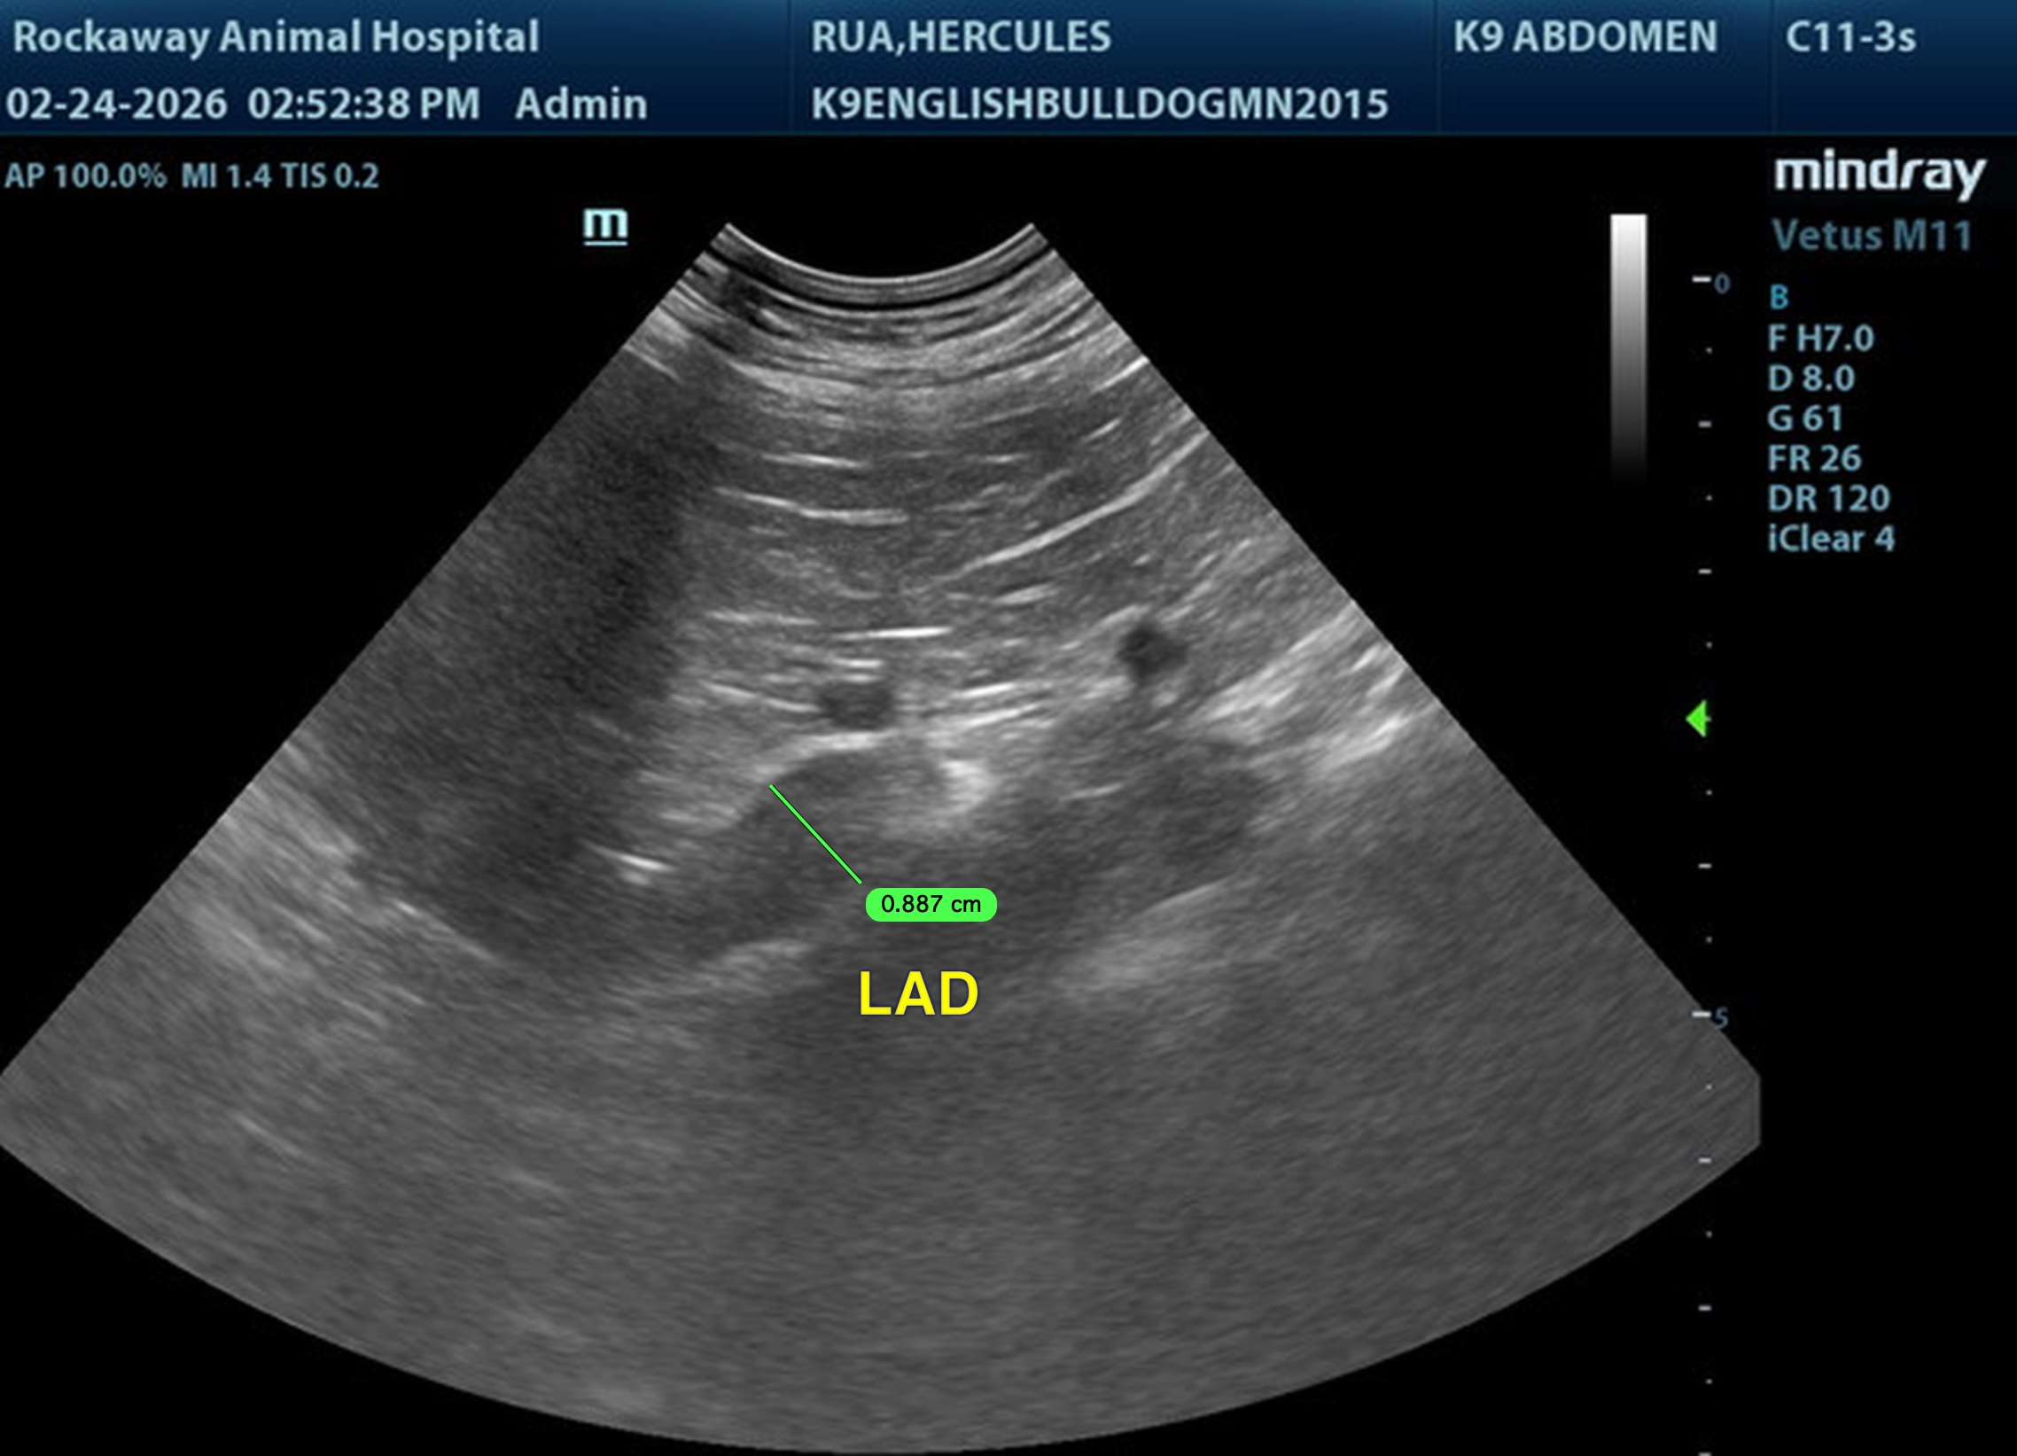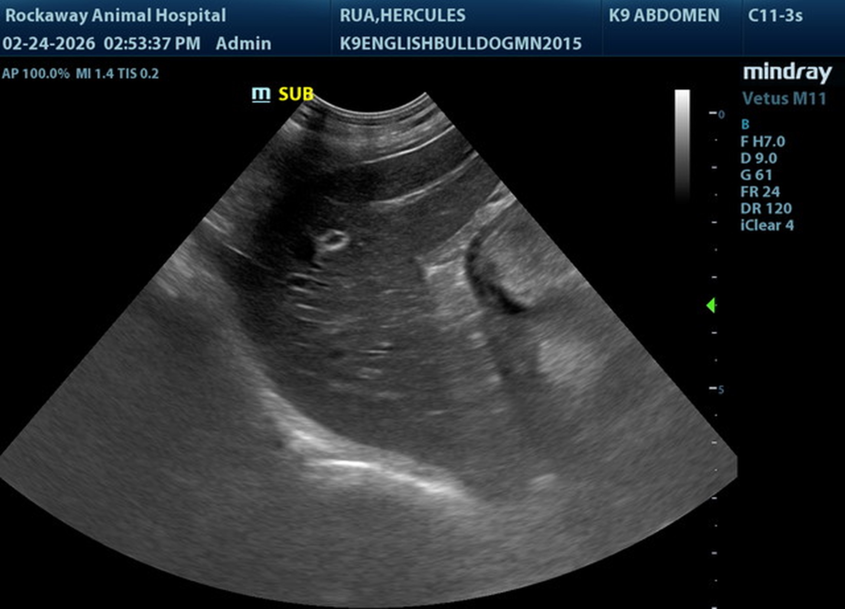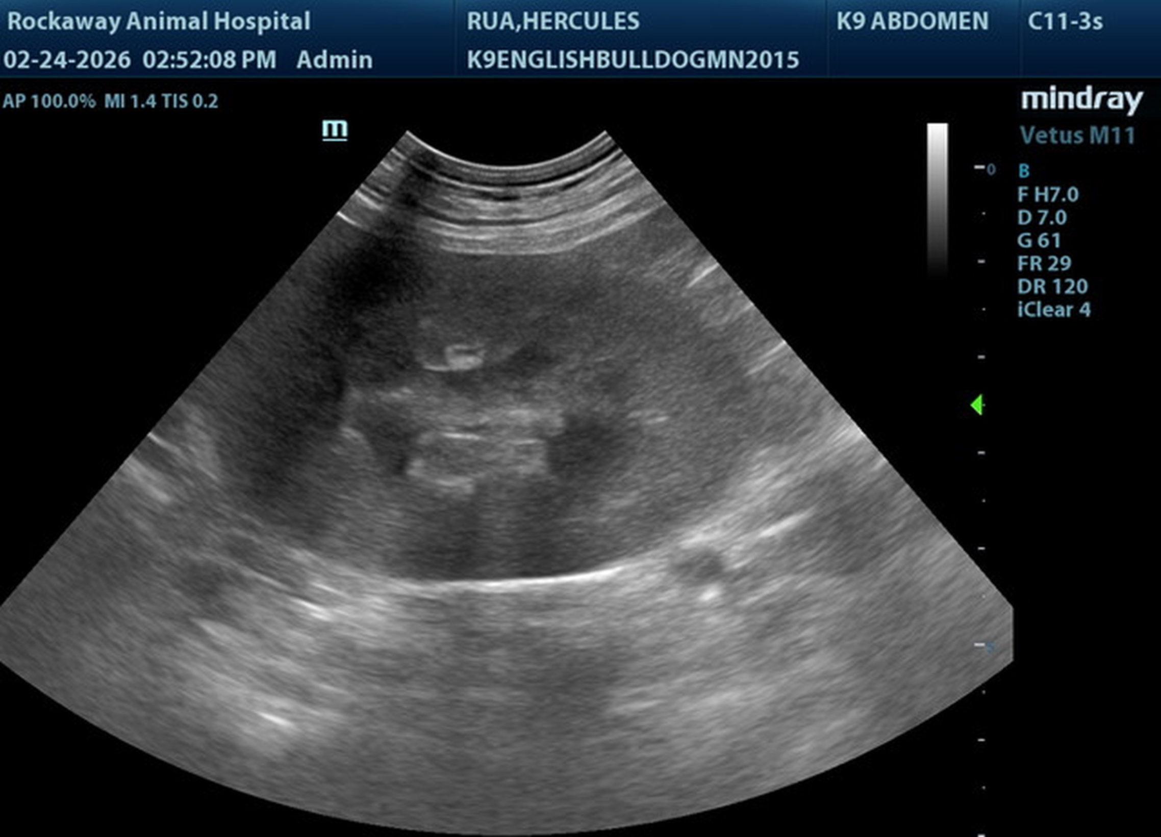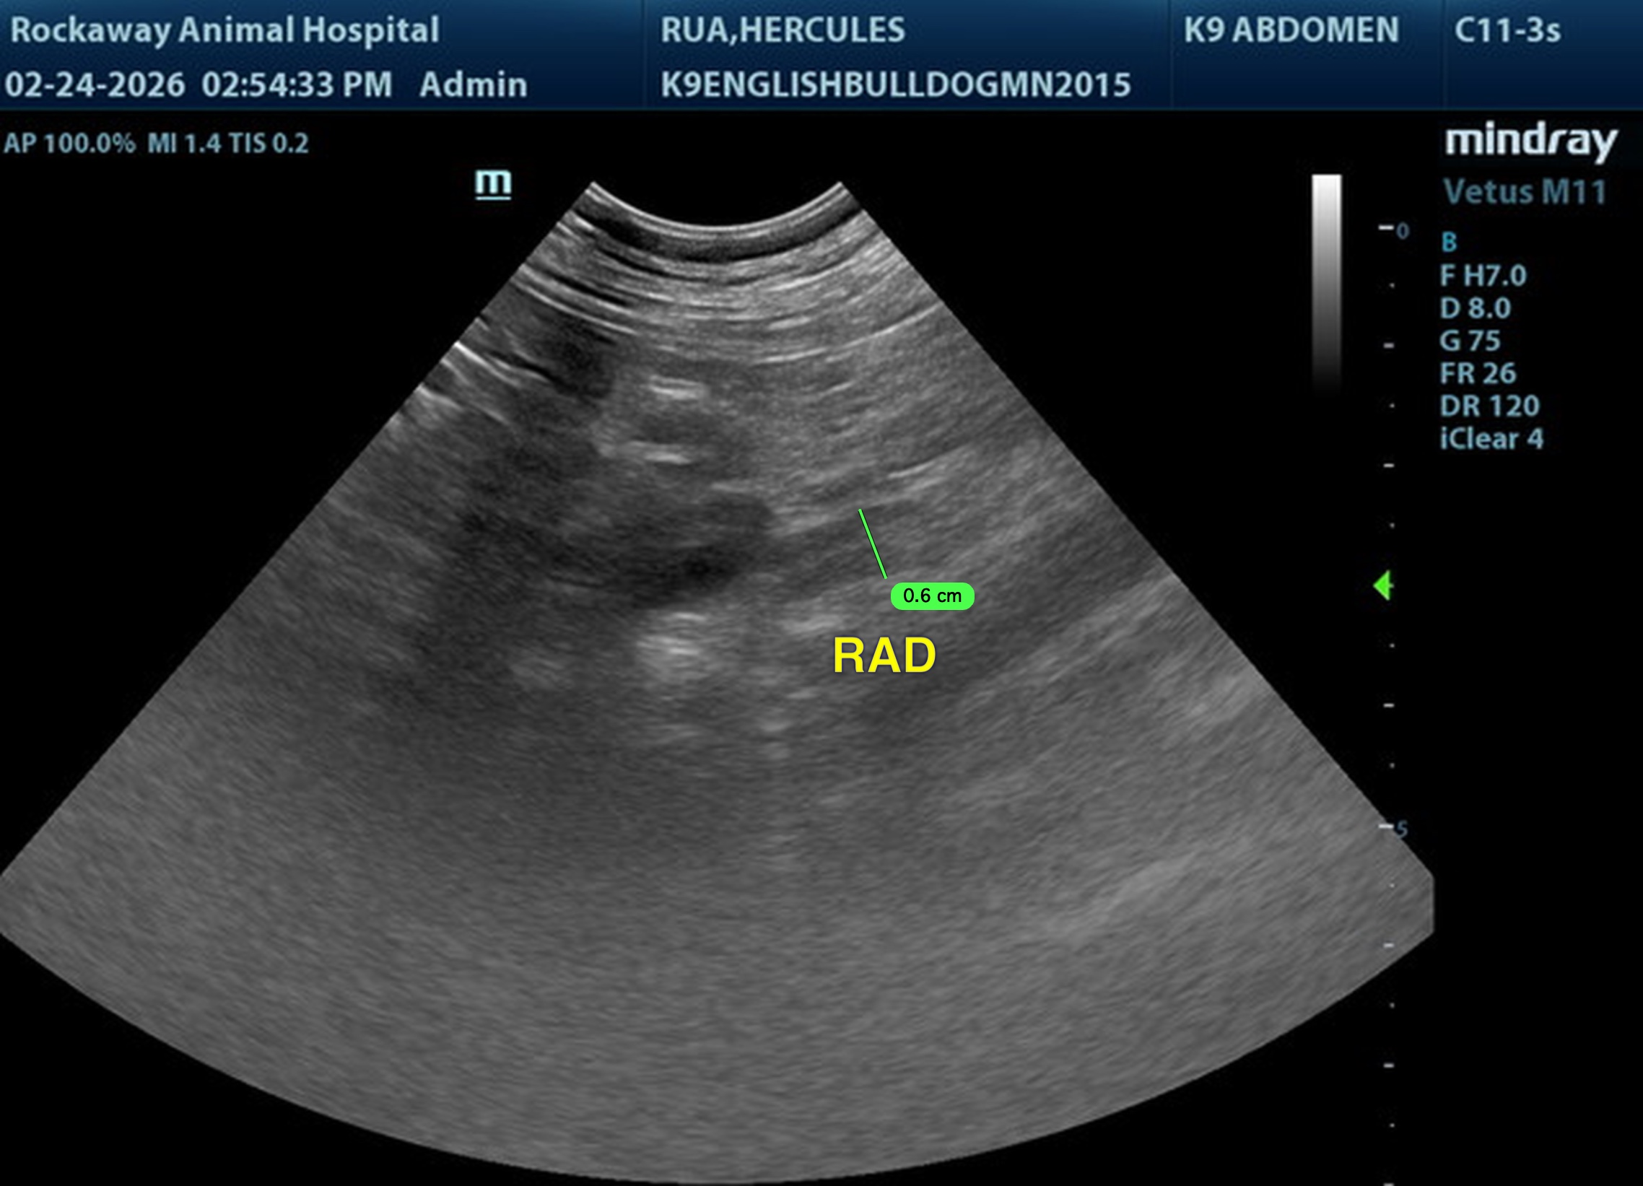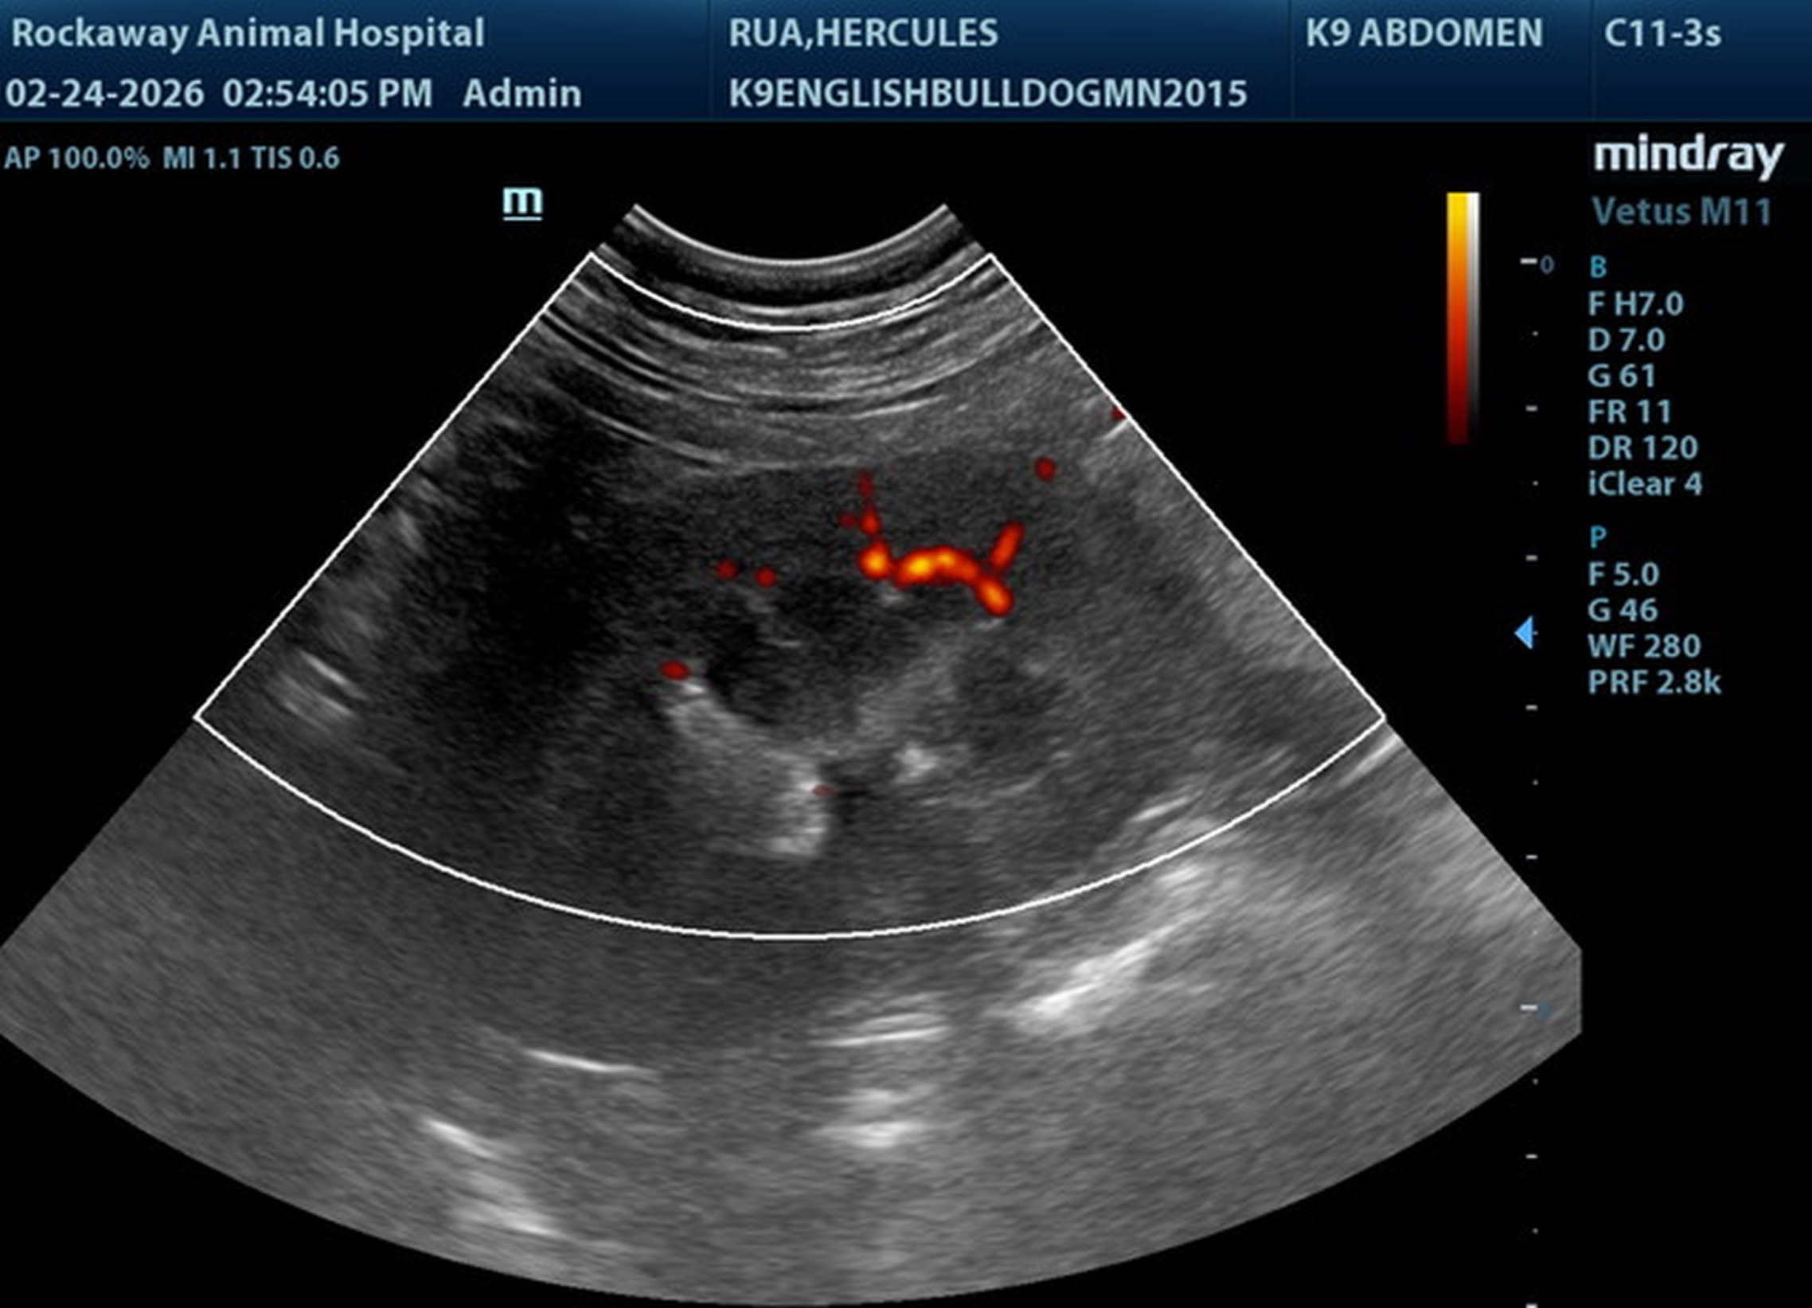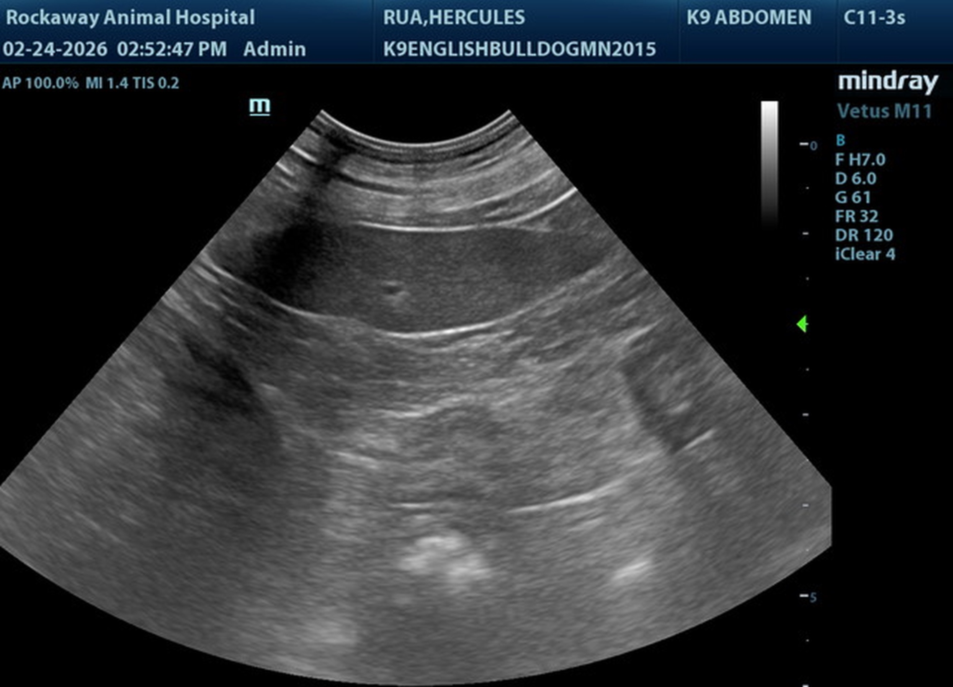
The information and recommendations provided are based on the images presented by the referring veterinarian/sonographer. No evaluation can be communicated regarding pathology that was not visible in the image/video clips provided.
Thank you for this referral. If the clinical or image interpretation does not parallel your findings or if I can be of any further assistance, please contact me.
R. McKenzie Daniel, DVM, DABVP (Canine / Feline Practice)
info@SonoPath.com

