PRESENTING CLINICAL SIGNS
- History or gastric and small intestinal thickening
- Started on prednisone on 12/9/2025
- Albumin has rebounded
Abnormal PE/Chem/CBC/UA Results: Gastric thickening on previous scans Albumin rebounded from 2.4 g/dL to 3.4 g/dL Clinically normal
ULTRASONOGRAPHIC EXAMINATION OF THE ABDOMEN
Urinary System
The urinary bladder, trigone, cystourethral junction, and visible pelvic urethra to a depth of 2.0 cm exhibited normal thickness and tone. Anechoic urine was present in the lumen with no uroliths or sediment. The ureteral papillae were normal. The ureters were not visible which is normal. No evidence of inflammatory or neoplastic change were noted.
The area of the aortic trifurcation was free of pathology.
Normal size and margination was present in the kidneys. A normal 1:3 cortex / medulla ratio was maintained. The medulla and cortices were uniform in texture with some increased echogenicity and mild loss of corticomedullary symmetry and definition expected for the age of the patient. Areas of mild medullary mineral to small renoliths were present. The left kidney measured 3.4 cm in length. The right kidney measured 3.6 cm in length.
Adrenal Glands
The left adrenal gland was normal to borderline prominent in size based on caudal pole width measurement. The left adrenal gland measured 0.50 cm width at the caudal pole.
The right adrenal gland was mildly enlarged in size. Mild parenchyma heterogeneity and mild capsule asymmetry was present without suspicion for overt neoplasia. The right adrenal gland measured 0.66 cm width in the caudal pole.
Spleen
The spleen exhibited a finely textured and homogenous parenchyma which was hyperechoic to the liver and renal cortical parenchyma. The capsule was smooth and regular without apparent expansion. The splenic vasculature at the hilus was normal in volume with no evidence of congestion or thrombosis. Acute to chronic inflammatory, neoplastic, or benign parenchyma changes were not noted.
Liver & Gallbladder
The liver was subjectively normal in size, structure, and contour. The liver parenchyma was mild nonuniform and hypoechoic to the spleen with a mild coarse echotexture and subjective mild to benign parenchymal remodeling. The hepatic and portal vasculature were normal in appearance without signs of congestion.
The gallbladder was non distended in size with mild nonorganized biliary sludge. The cystic duct and common bile ducts were normal without evidence of dilation.
Gastrointestinal
The stomach presented intact mild thickened wall. Intact wall layering was maintained and distinct. The gastric lumen was empty with mild gas. Mild thickened gastric mucosa and mild prominent pyloric muscularis layer.
Generalized increased intestinal mucosa echogenicity with segmental mildly hyperechoic mucosa speckling to echogenic mucosal striations were present. Intestinal wall layering was intact to borderline mild thickened with normal 1:3 muscularis / mucosa ratio given subjective propensity for prominent to mildly thickened mucosa layer. There was no evidence of an obstructive pattern or foreign material. The appearance of the small intestine is most consistent with protein losing enteropathy or lymphangiectasia. There was no evidence of infiltrative or neoplastic intestinal disease which is considered unlikely but cannot be ruled out without full thickness or endoscopic biopsies. The small intestine wall measured 0.44 cm wall width.
Normal visible colon wall layers were present with apparent formed feces in lumen.
Pancreas
The parenchyma of the left limb, body and right limb of the pancreas presented isoechoic to the adjacent omental fat. A normal curvilinear capsule contour of the pancreas was present. The visible pancreatic duct was normal. No signs of active inflammation or neoplastic disease was evident.
Free Abdomen
No visualized significant omental lymphadenopathy was present. Scant peritoneal effusion was present.
ULTRASONOGRAPHIC FINDINGS
- Intact mildly thickened gastrointestinal wall with subtle hyperechoic intestinal mucosal speckling.
- Bilateral borderline to mild prominent adrenal glands.
- Mild hepatic remodeling- static benign.
- Mild gallbladder debris (non-mucocele).
- Age-related renal changes with mild medullary mineral/small renoliths.
- Scant peritoneal effusion.

INTERPRETATION OF THE FINDINGS & FURTHER RECOMMENDATIONS
Similar gastrointestinal presentation compared to the previous study and consistent with chronic gastroenteropathy. Given reported previous subnormal albumin level stabilized with prednisone therapy, non-specific protein losing enteropathy, i.e. IBD, lymphangiectasia, or other may be suspected.
Continued diastolic gastrointestinal support is recommended. Screening GI panel to include PLI, TLI, cobalamin, and folate may be considered. Sonographic monitoring is indicated if recurrent gastrointestinal signs or hypoalbuminemia.
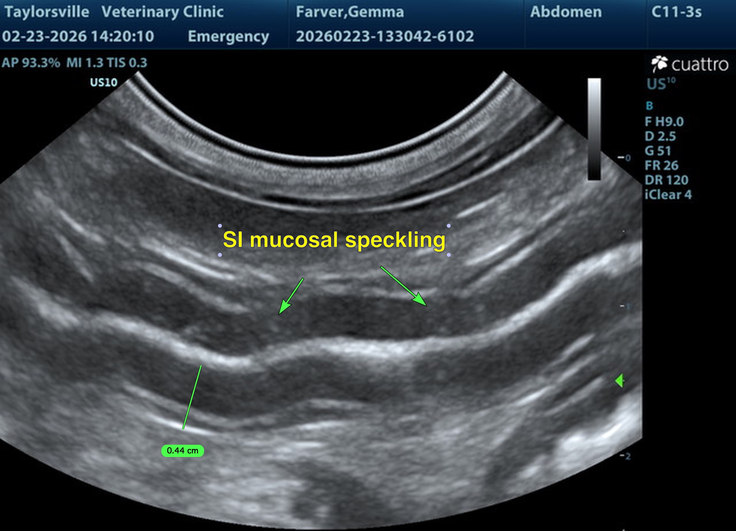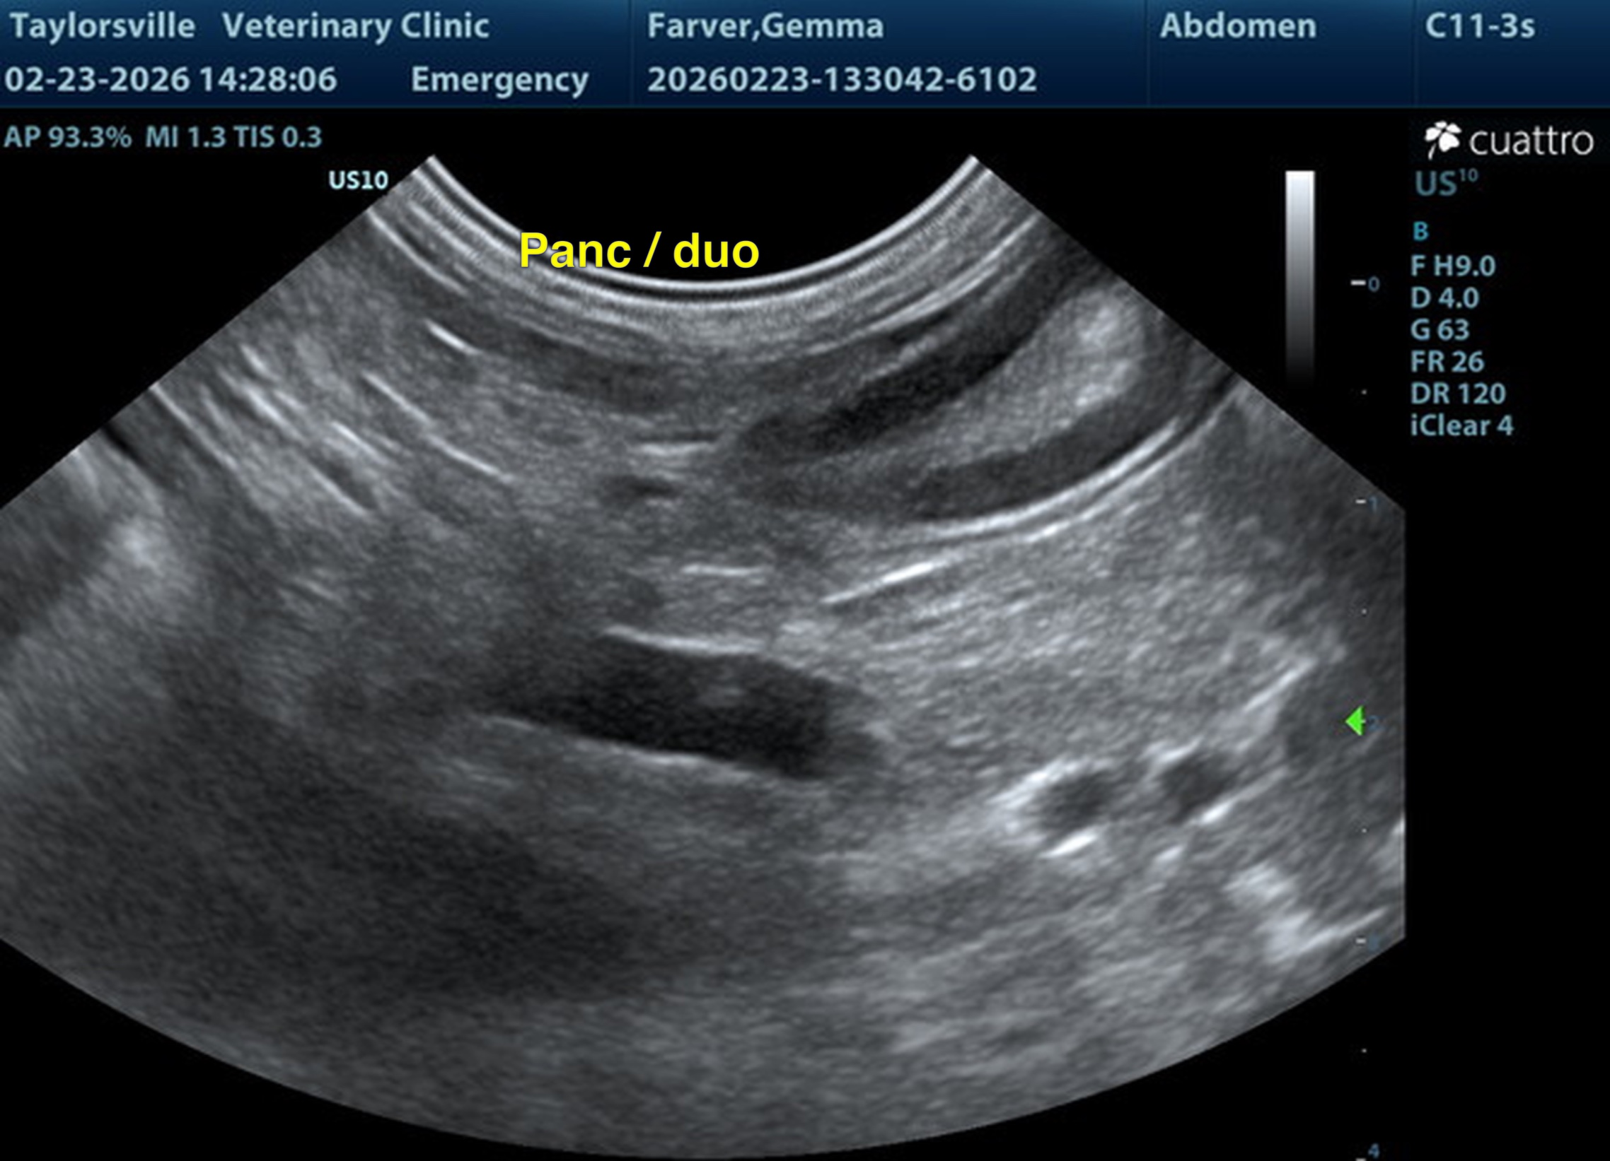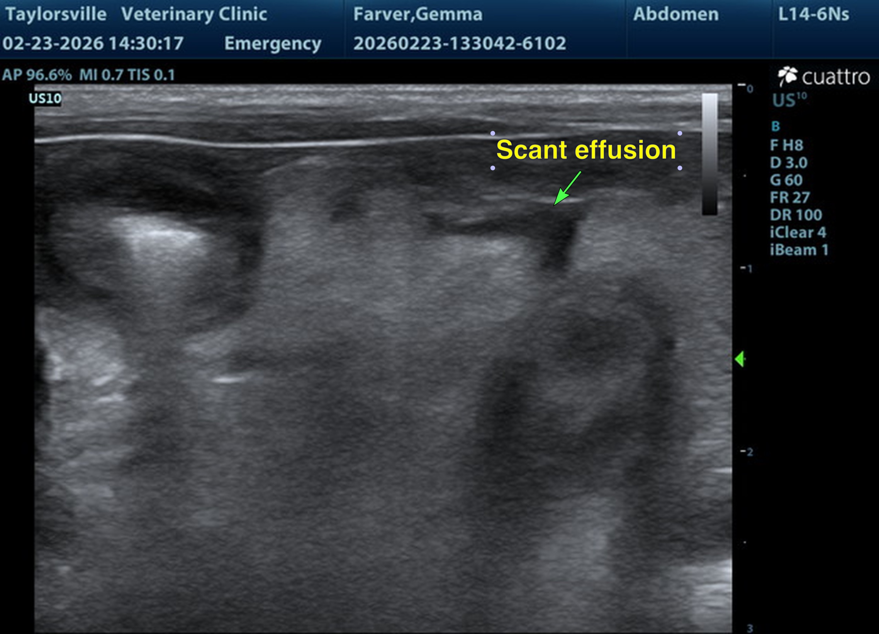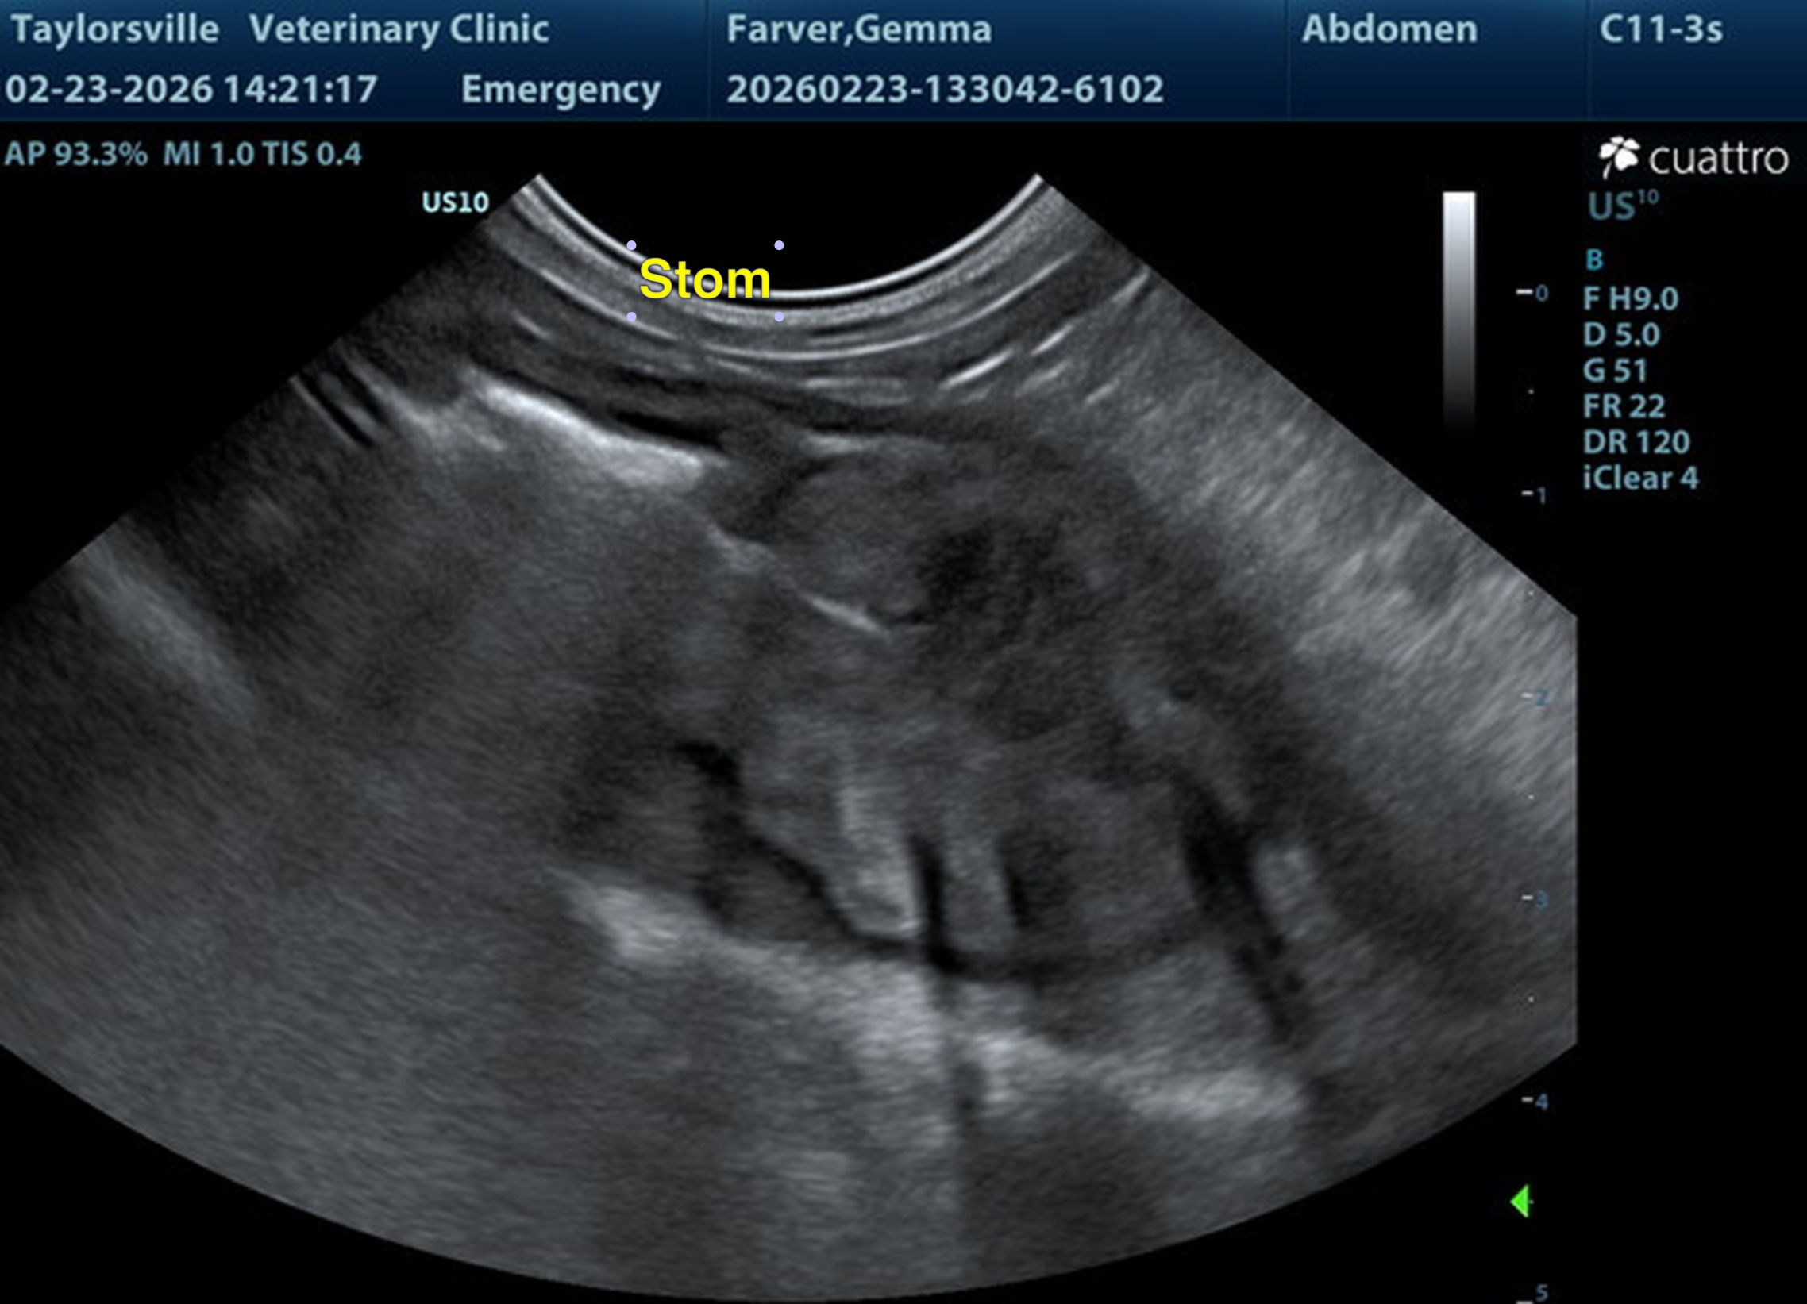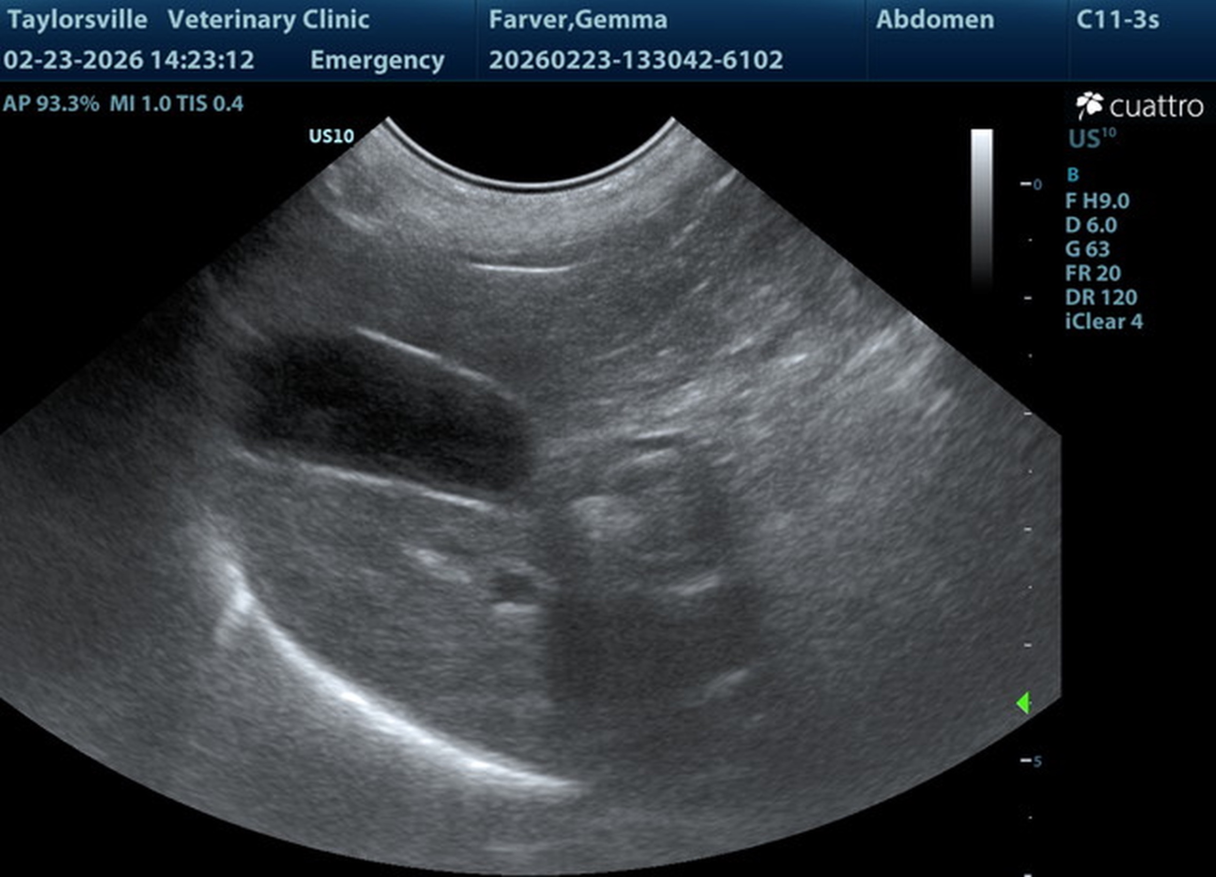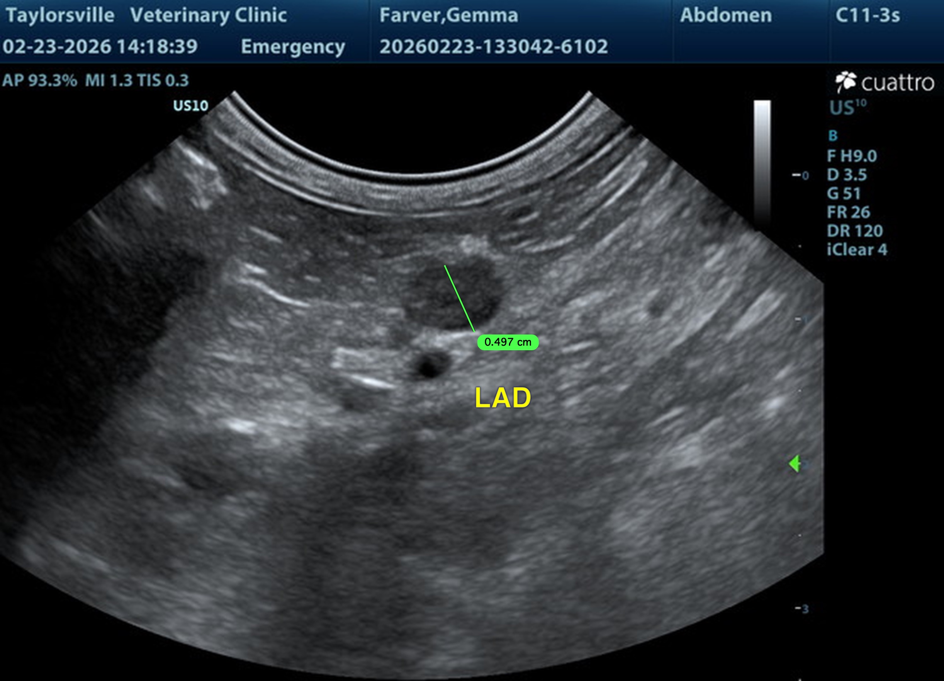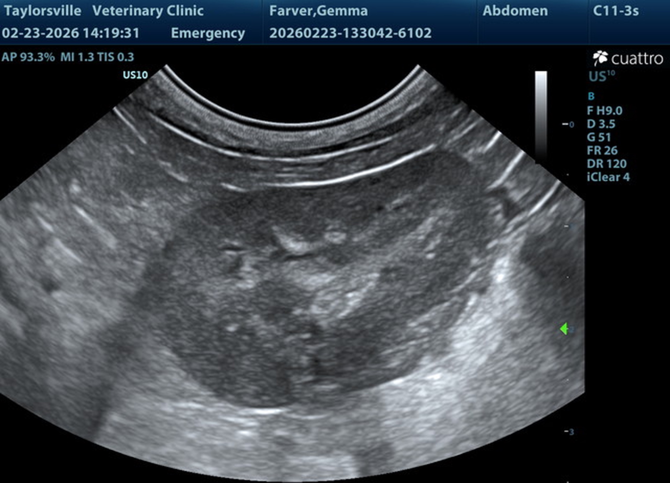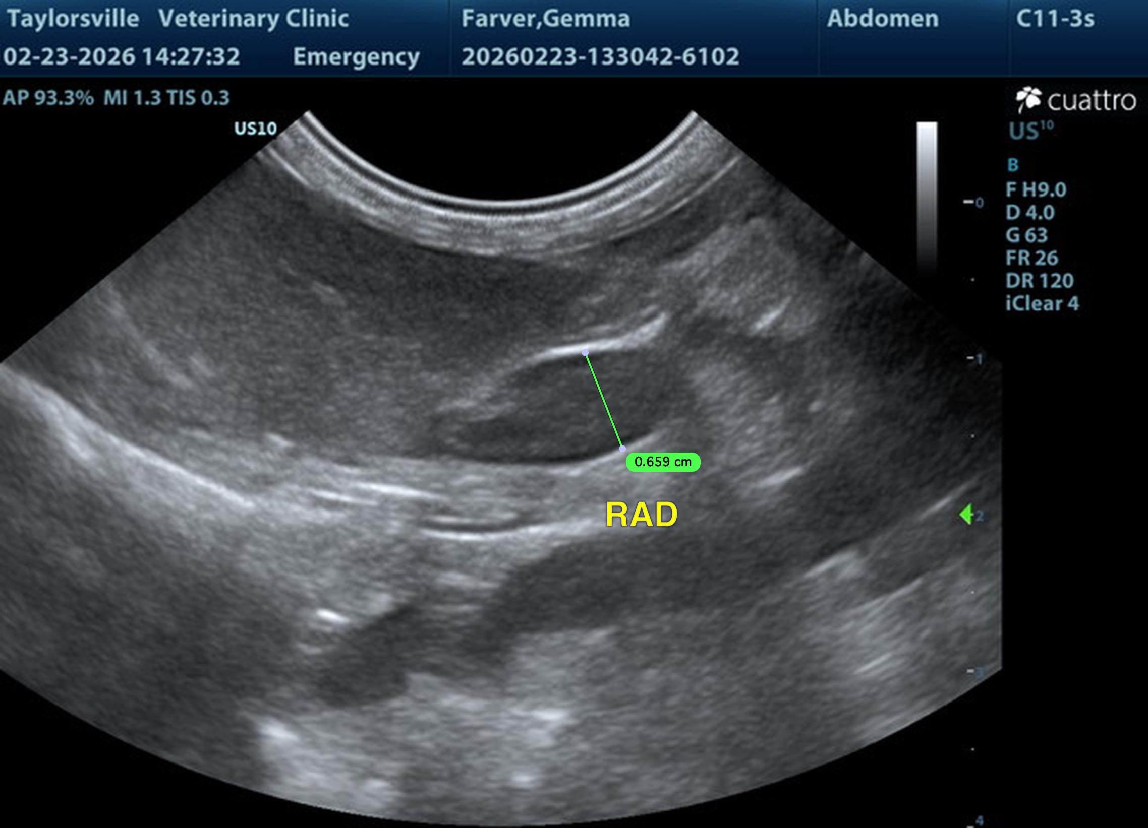
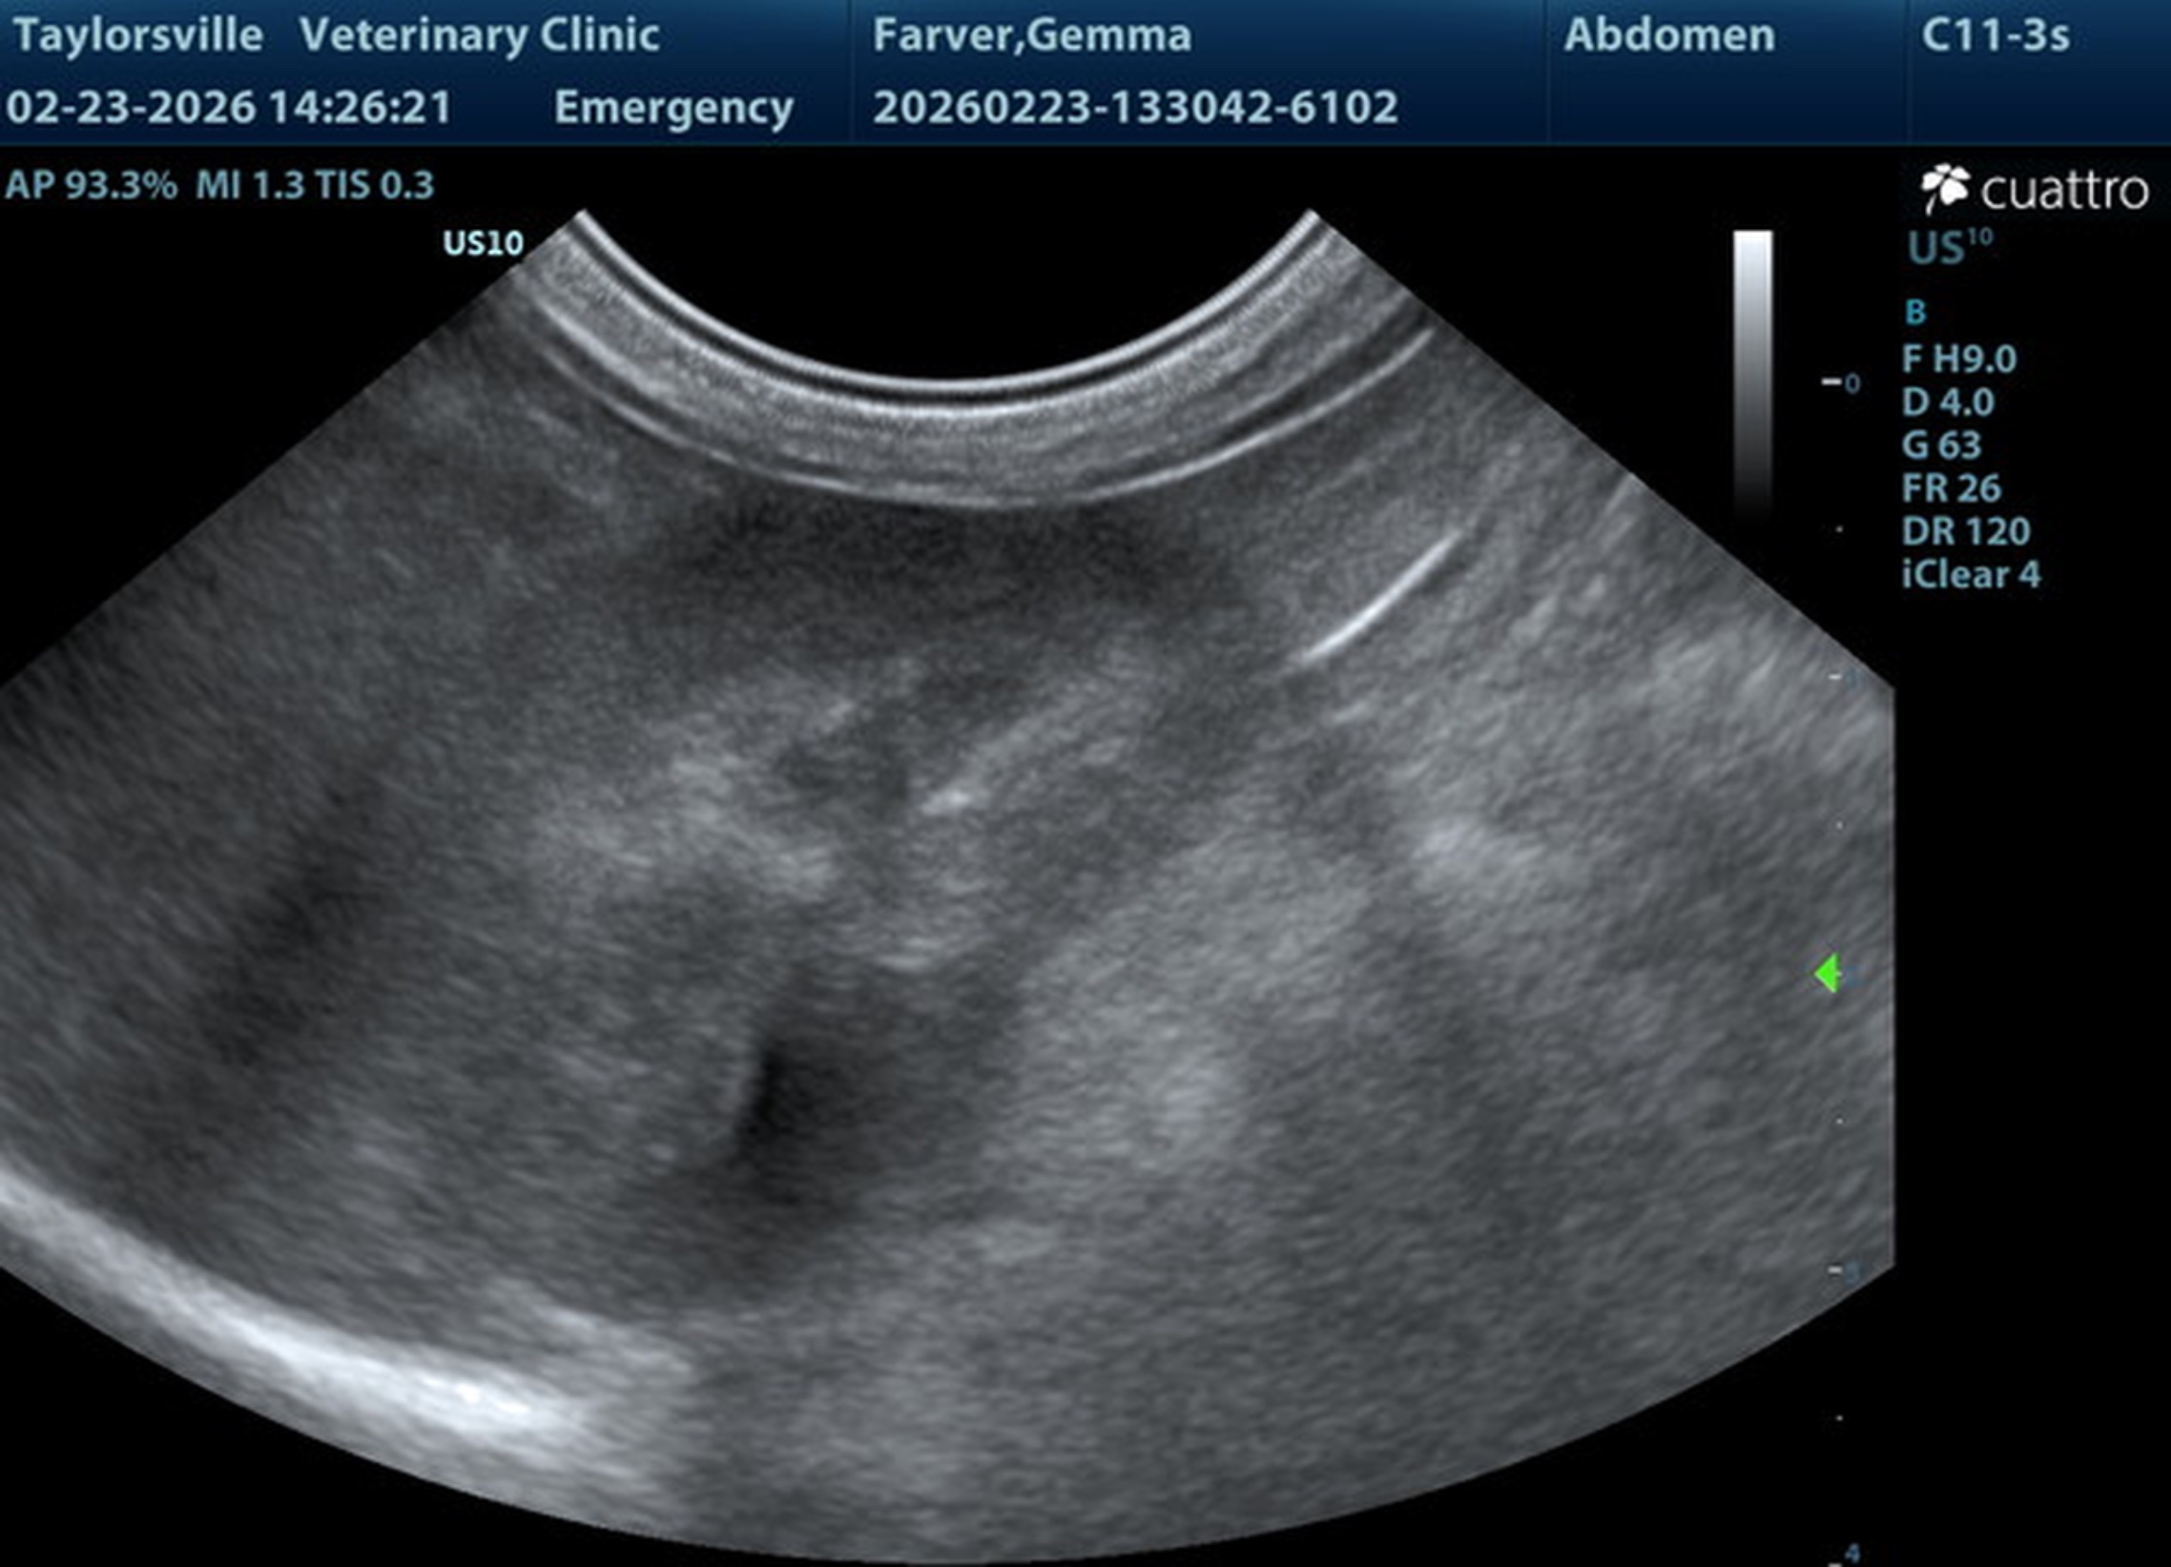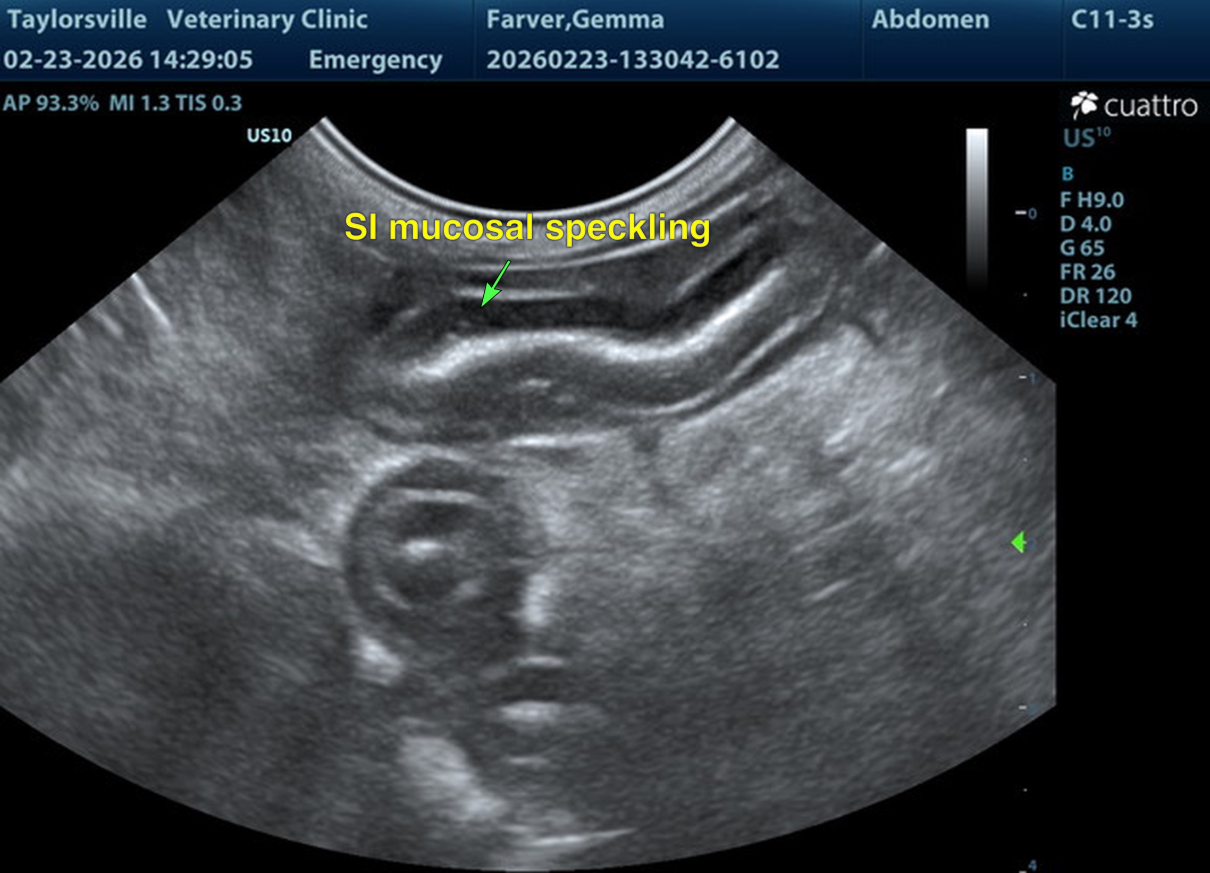
The information and recommendations provided are based on the images presented by the referring veterinarian/sonographer. No evaluation can be communicated regarding pathology that was not visible in the image/video clips provided.
Thank you for this referral. If the clinical or image interpretation does not parallel your findings or if I can be of any further assistance, please contact me.
R. McKenzie Daniel, DVM, DABVP (Canine / Feline Practice)
info@SonoPath.com

