PRESENTING CLINICAL SIGNS
- Patient has experienced 4 lbs of weight loss since July 2025. Patient has been difficult to regulate for hyperthyroidism during that period. Patient has long hx of hyperthyroidism, nodular pancreatitis and cardiomyopathy. FNA's of spleen and pancreas in 7/2025 did not reveal neoplasia at that time
Abnormal PE/Chem/CBC/UA Results: CBC/CHEM/FPL/SDMA wnl T4 was 8.4 on 2/4/26 and now today is 1.5 after increasing felanorm dose
ULTRASONOGRAPHIC EXAMINATION OF THE ABDOMEN
Urinary System
The urinary bladder, trigone, cystourethral junction, and visible pelvic urethra to a depth of 2.0 cm exhibited normal thickness and tone. Anechoic urine was present in the lumen with no uroliths or sediment. The ureteral papillae were normal. The ureters were not visible which is normal. No evidence of inflammatory or neoplastic change were noted.
Normal size and margination was present in the kidneys. A normal 1:3 cortex / medulla ratio was maintained. The medulla and cortices were uniform in texture with some increased echogenicity and mild loss of corticomedullary symmetry and definition expected for the age of the patient. No evidence of pelvic dilation was present. The left kidney measured 3.9 cm in length. The right kidney measured 3.7 cm in length.
Adrenal Glands
The left and right adrenal glands were not definitively visualized.
Spleen
The spleen was mildly enlarged in size and exhibited a finely textured and homogenous parenchyma which was hyperechoic to the liver and renal cortical parenchyma. The capsule was smooth and regular without apparent expansion. The splenic vasculature at the hilus was normal in volume with no evidence of congestion or thrombosis. Acute to chronic inflammatory, neoplastic, or benign parenchyma changes were not noted. The spleen measured 1.2 cm width level of the mid spleen.
Liver & Gallbladder
The liver was subjectively normal in size, structure, and contour. The liver parenchyma was uniform and hypoechoic to the spleen with a mild coarse echotexture. The hepatic and portal vasculature were normal in appearance without signs of congestion.
The gallbladder was non-distended in size with thin walls and primarily anechoic luminal content. The cystic and common bile ducts were normal.
Gastrointestinal
The stomach presented intact wall layering with a normal wall layer ratio. The lumen of the stomach was empty with no signs of ileus, obstruction or foreign material.
The small intestine presented intact wall layering with 1:3 muscularis/mucosa ratio. The lumen of the small intestine was empty with no signs of ileus, obstruction or foreign material. The duodenum wall measured 0.32 cm wall width. The jejunum wall measured 0.24 cm wall width. The ileocolic wall measured 0.47 cm wall width.
Normal visible colon wall layers were present with apparent formed feces in lumen.
Pancreas
The pancreas was mildly prominent in size with capsule asymmetry and heterogeneous remodeled parenchyma compared to adjacent omentum. No signs of active inflammation or neoplasia. Prominent pancreatic duct. A thinly walled cyst was present in the left limb of the pancreas measuring 0.47 cm in diameter.
Free Abdomen
No overt lymphadenopathy or peritoneal effusion was present.
ULTRASONOGRAPHIC FINDINGS
- Chronic pancreatitis with remodeling and left limb cyst.
- Sonographically unremarkable gastrointestinal tract.
- Age-related renal changes.
- Mild splenomegaly.

INTERPRETATION OF THE FINDINGS & FURTHER RECOMMENDATIONS
Assuming the patient is non-sedated, the mild splenomegaly is non-specific with potential for patient variant given the breed, incidental hyperplasia, hematopoiesis, potential splenitis, without overt splenic neoplastic criteria, which is thought less likely yet not excluded.
Assuming normal clotting status and using a 25-gauge needle, recheck splenic FNA cytology could be considered primarily to ensure persistent benign changes are present. Monitoring of body weight given current controlled hyperthyroidism is recommended. A GI panel to include PLI/TLI/Cobalamin/Folate as well as three view chest radiographs, neurological / musculoskeletal examination and rule out competitive eating environment are recommended to assess for or rule out occult disease or contributing factors which may cause weight loss.
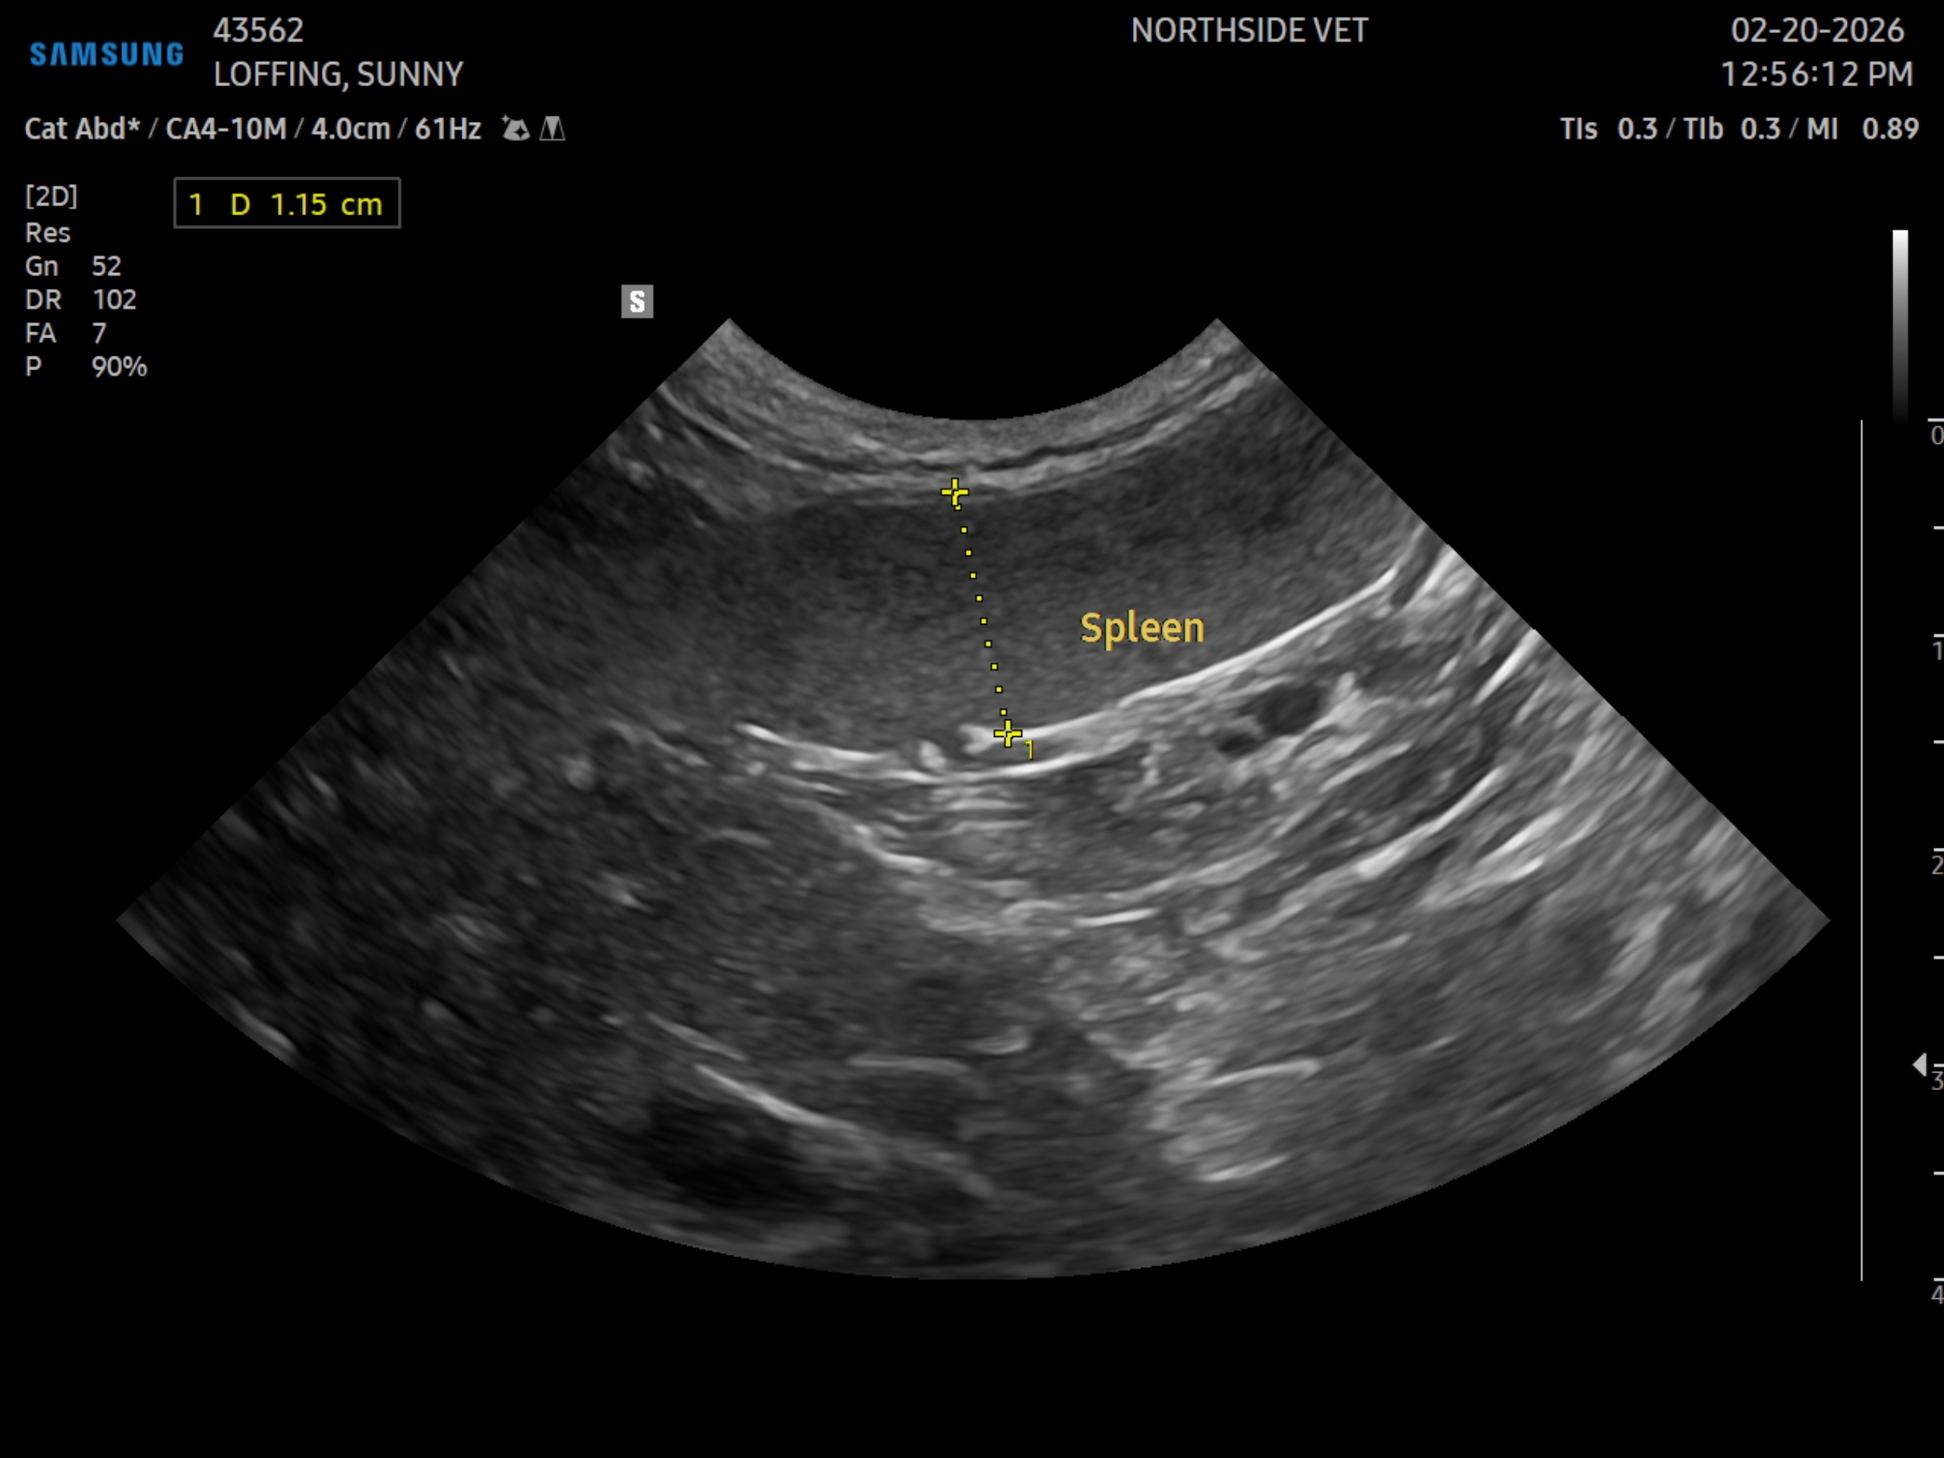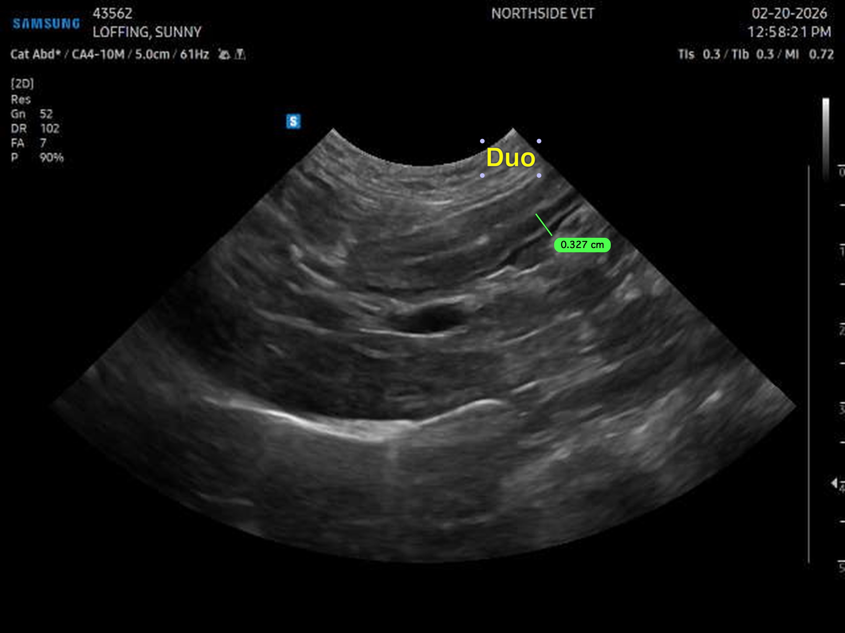
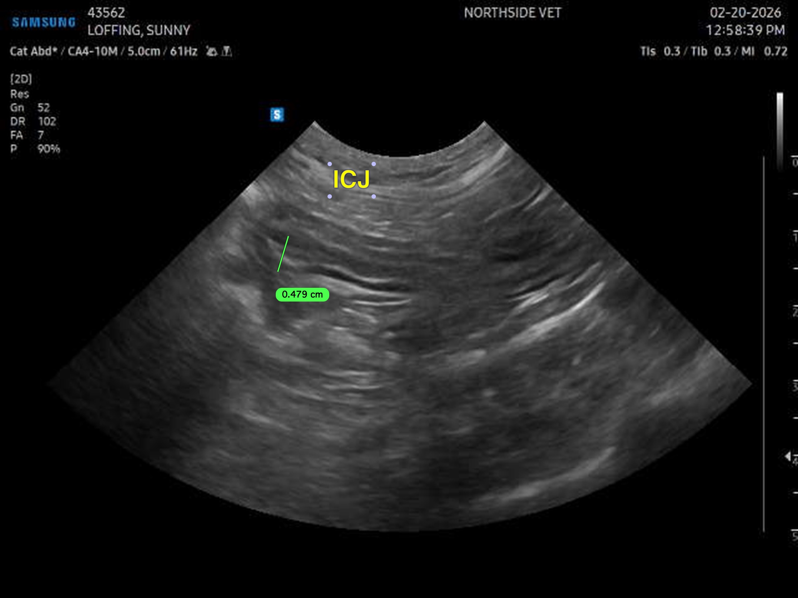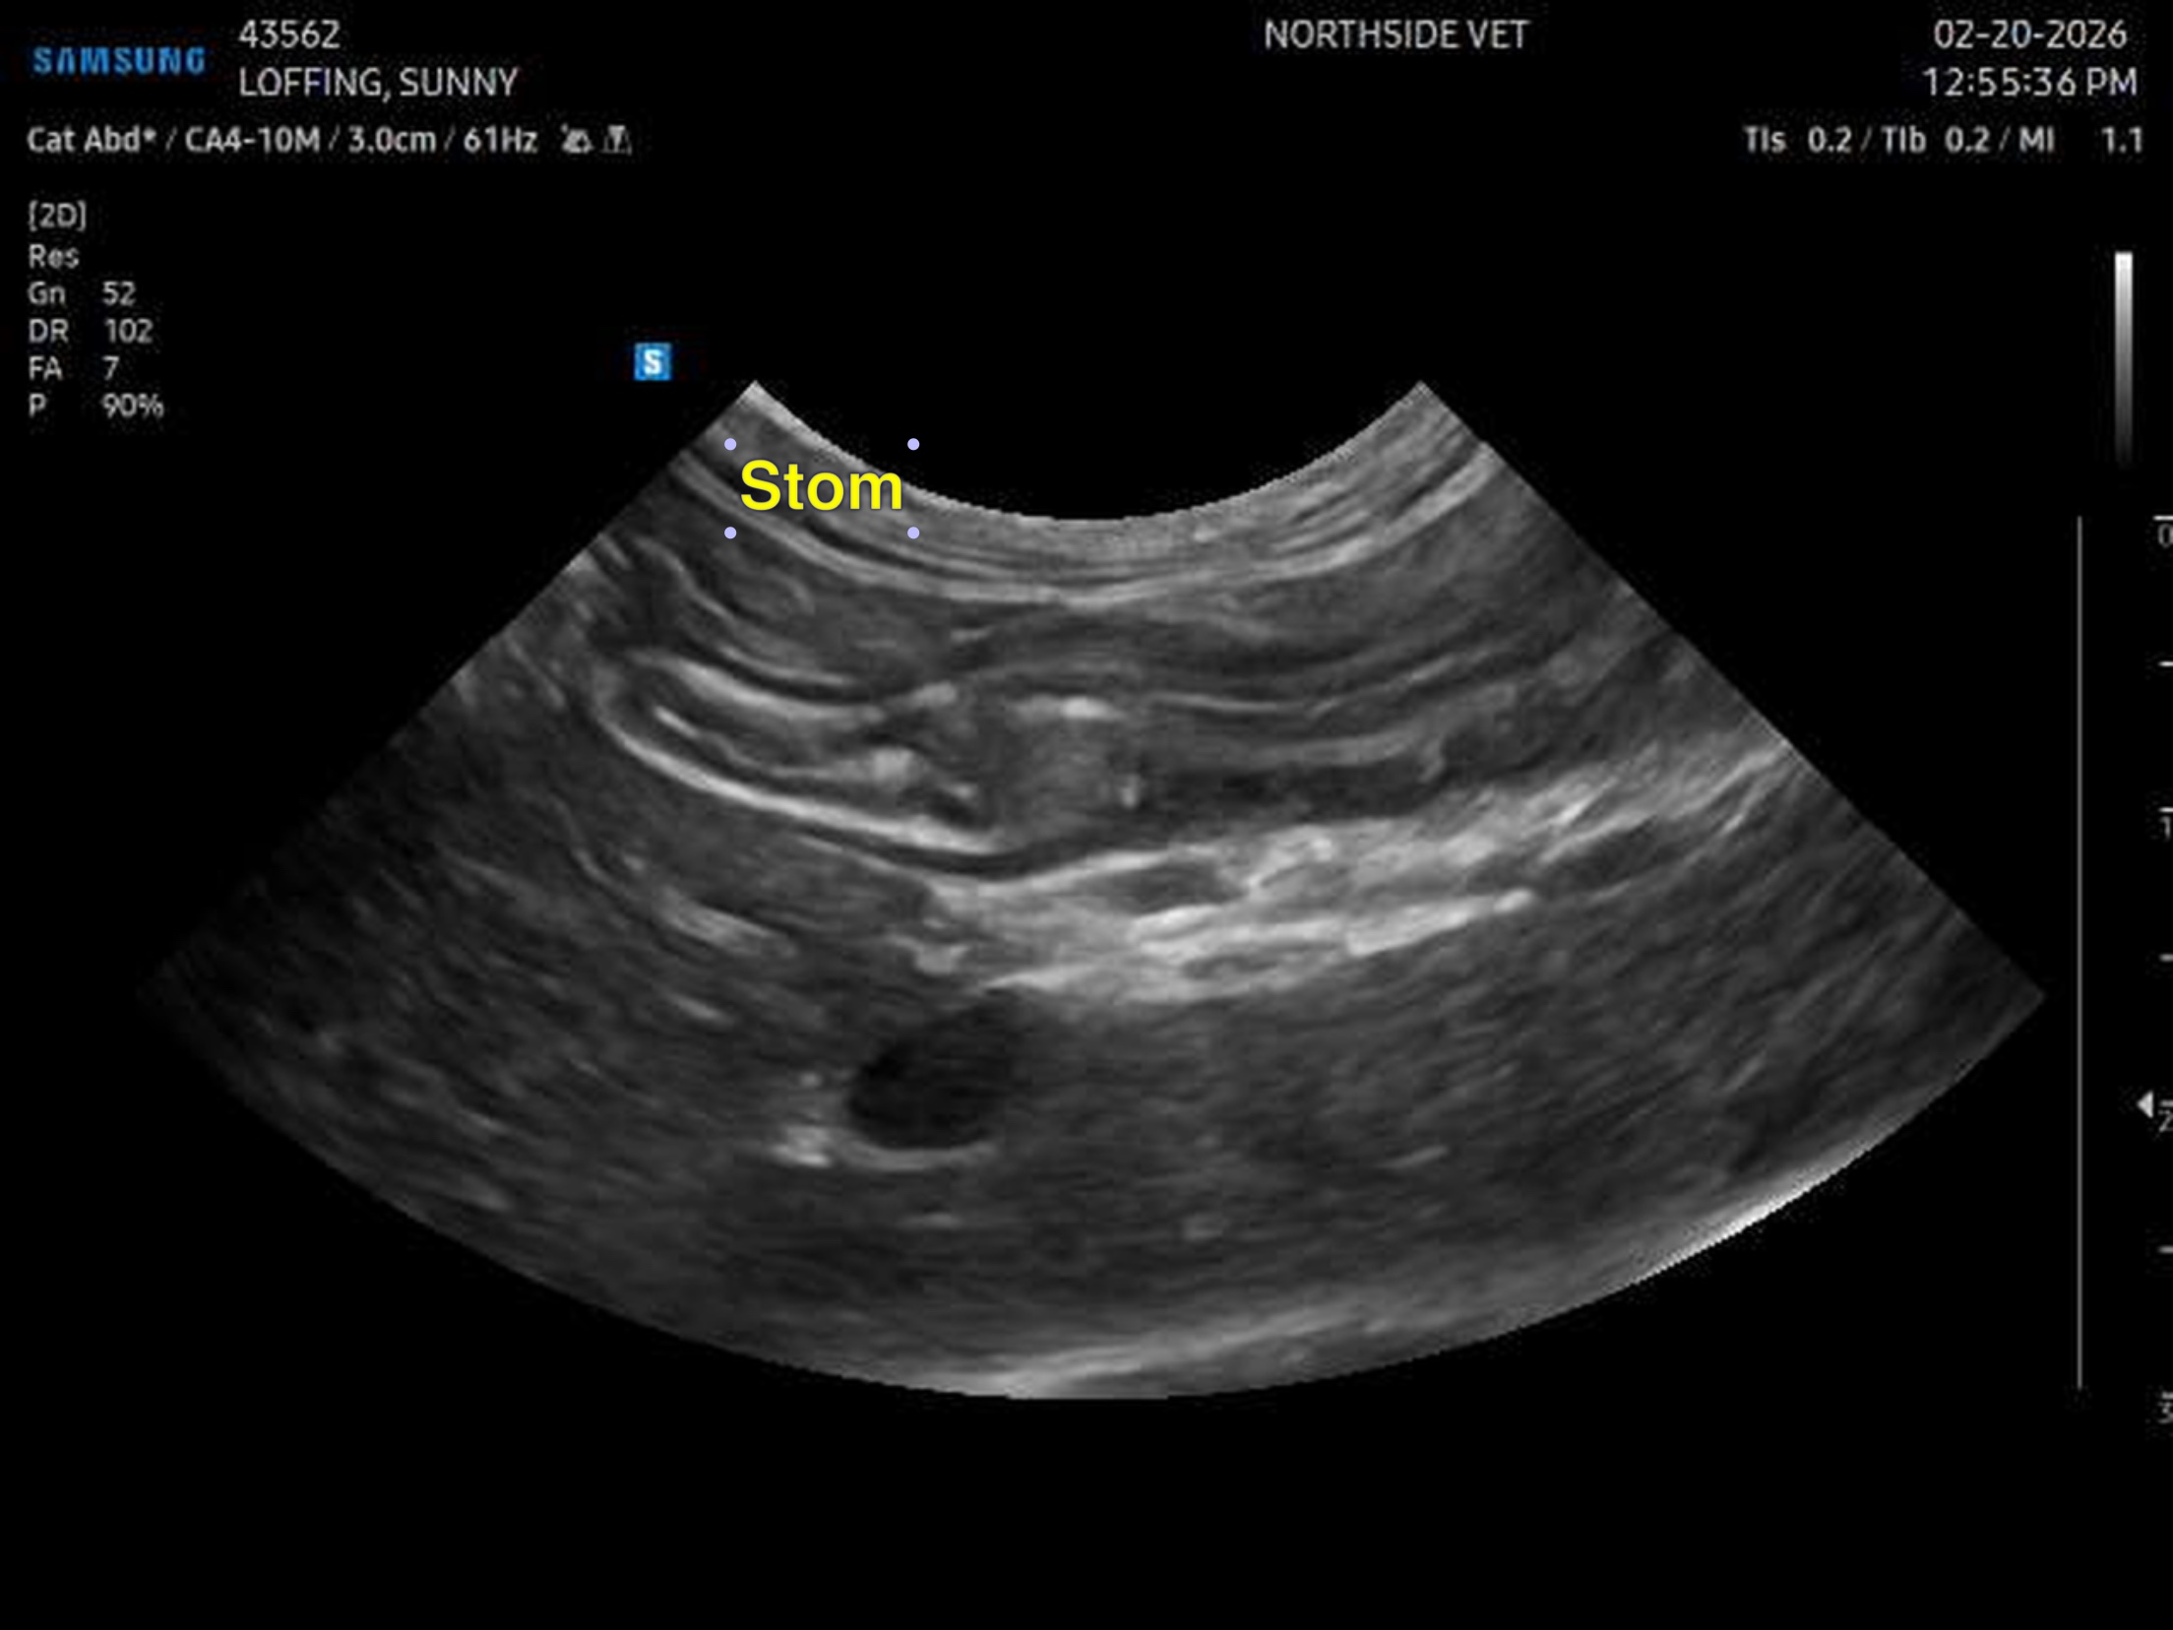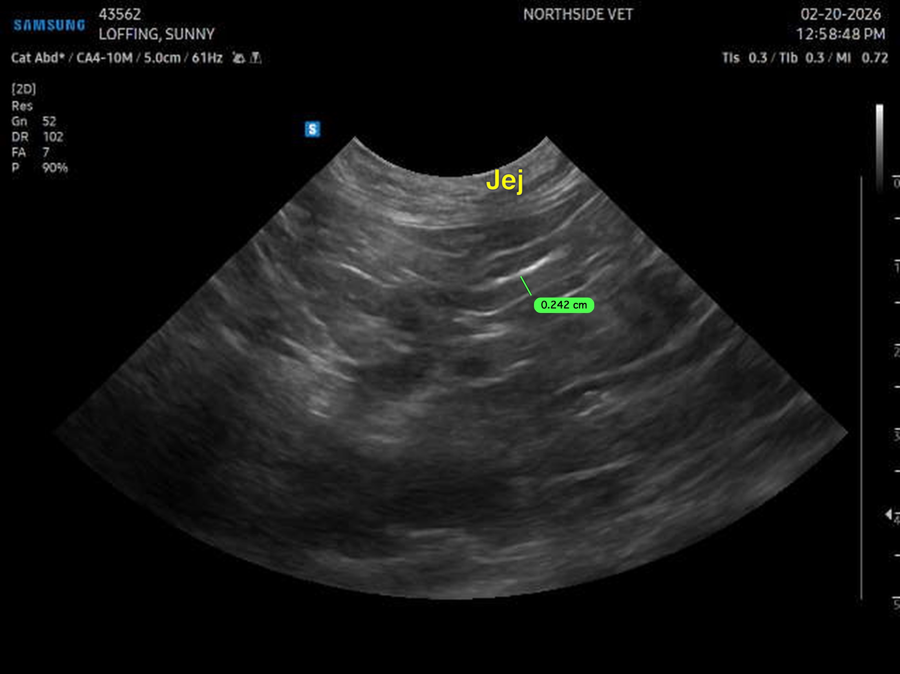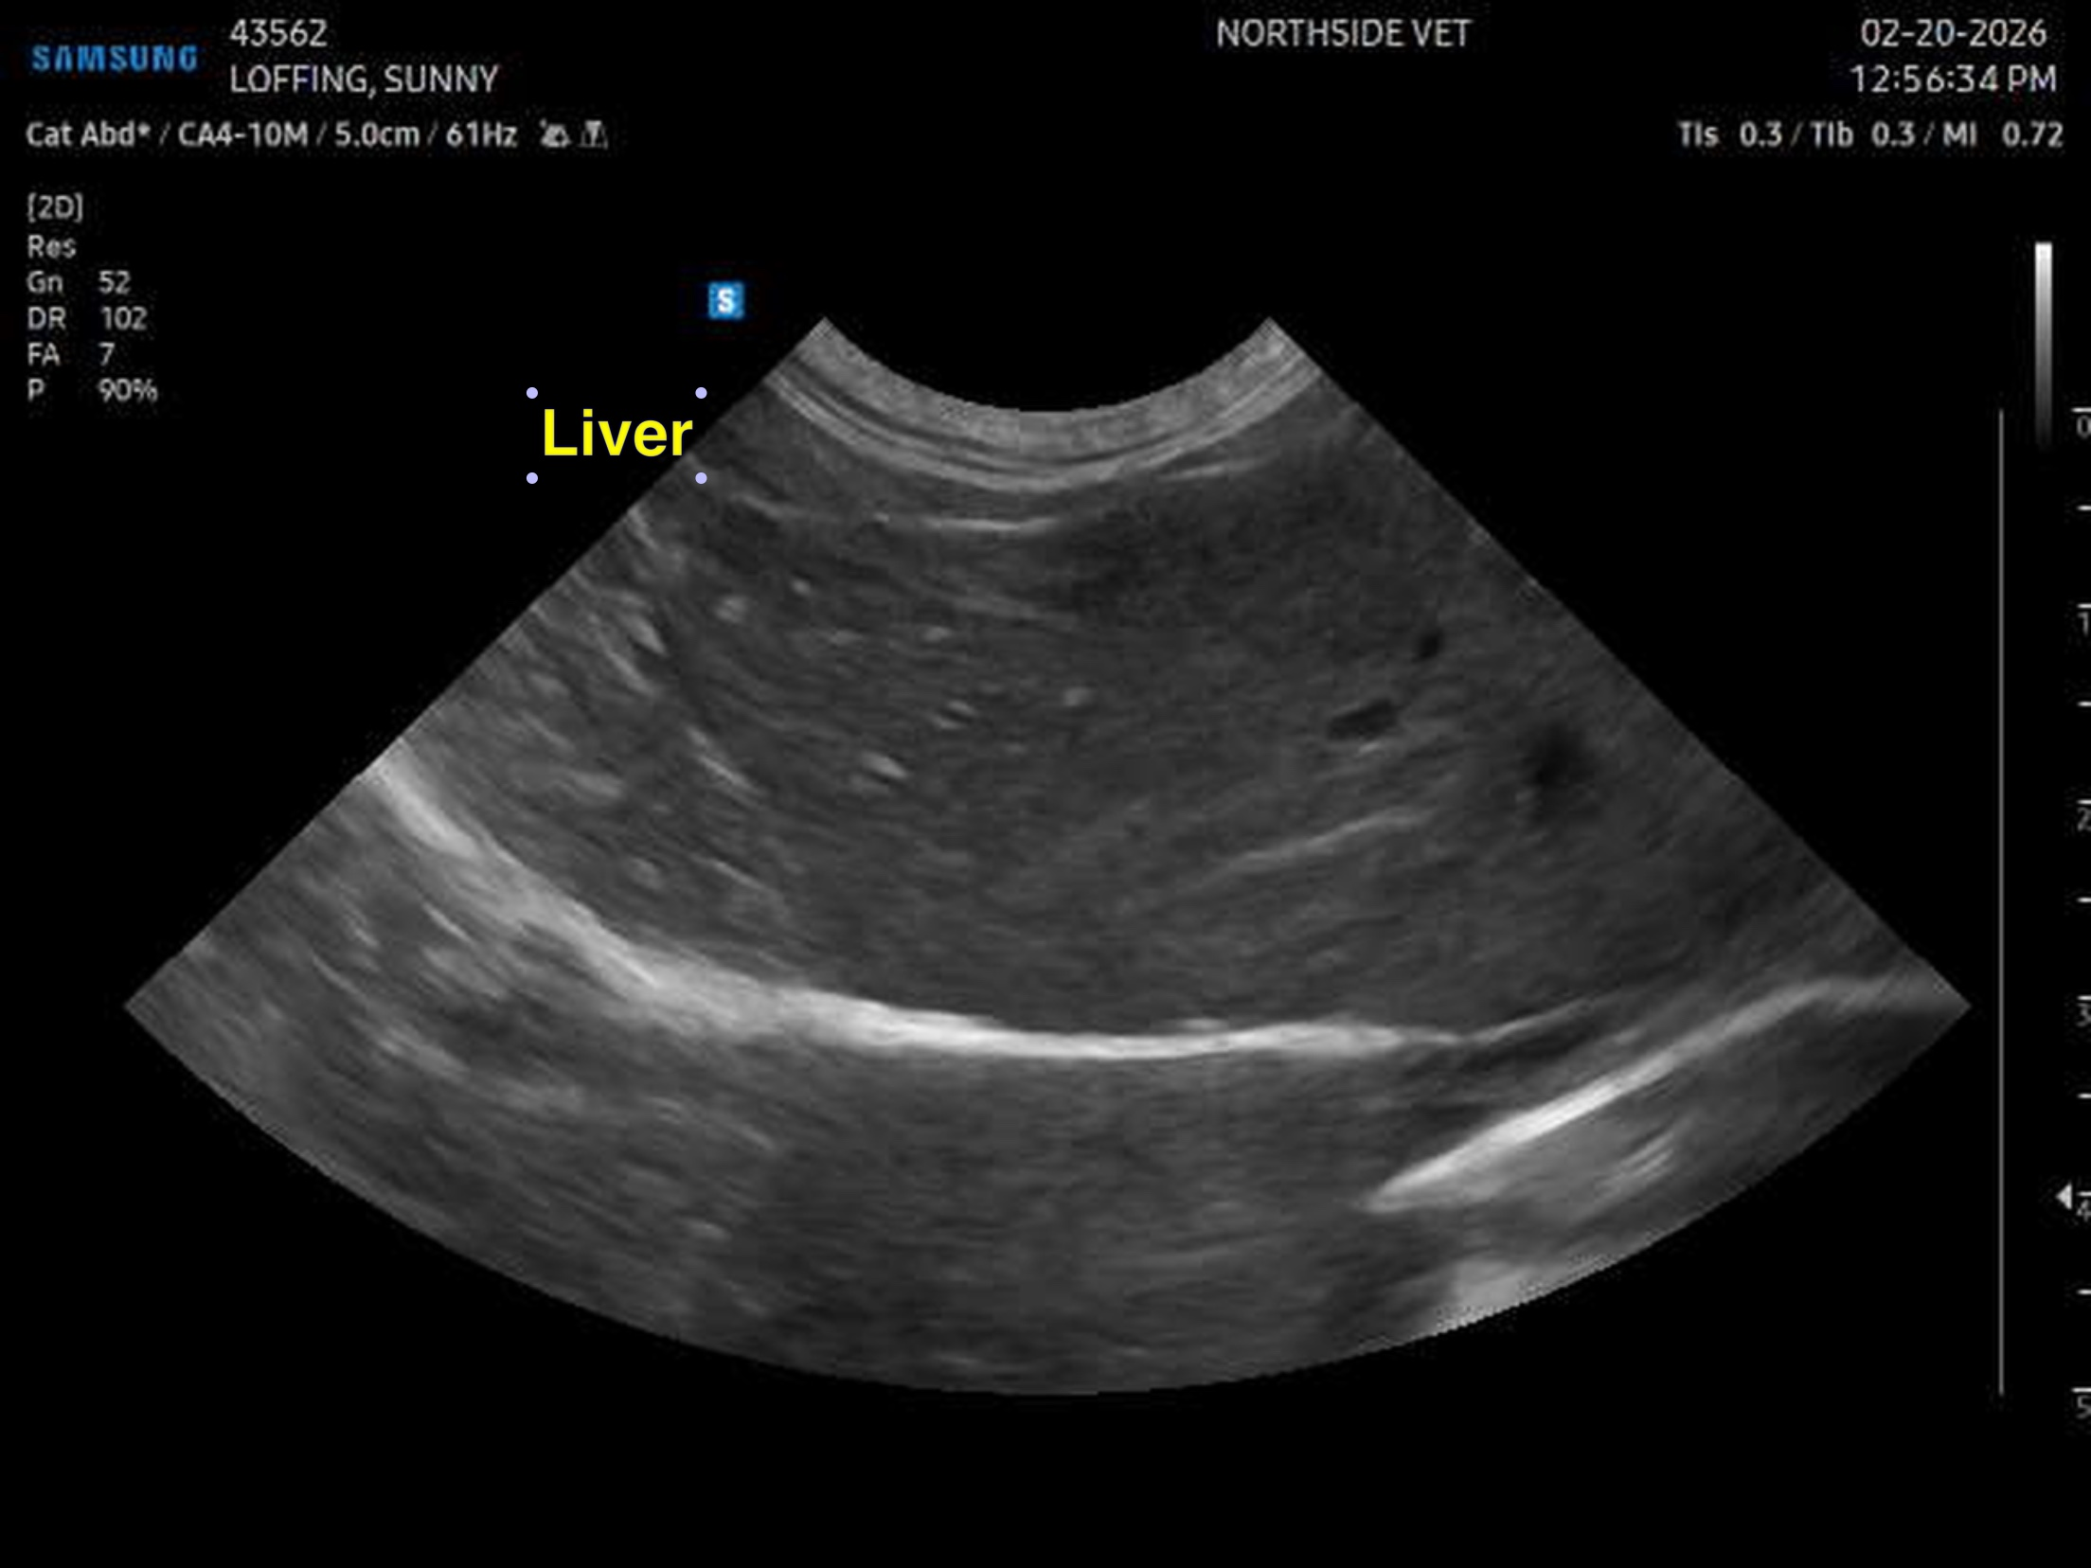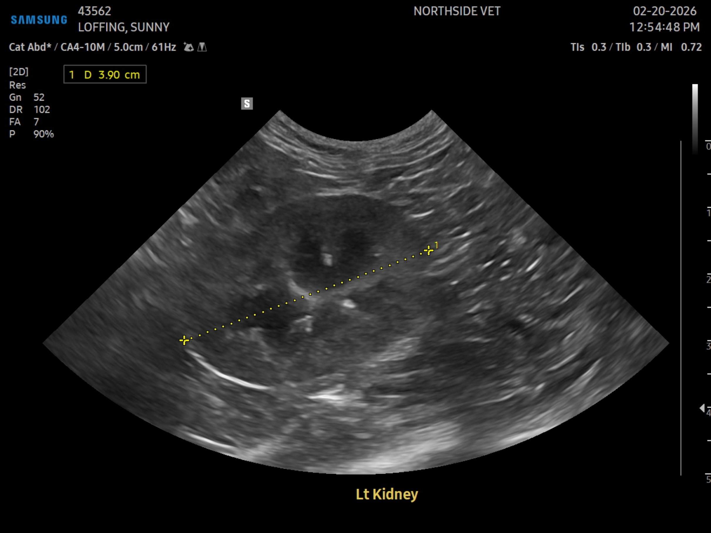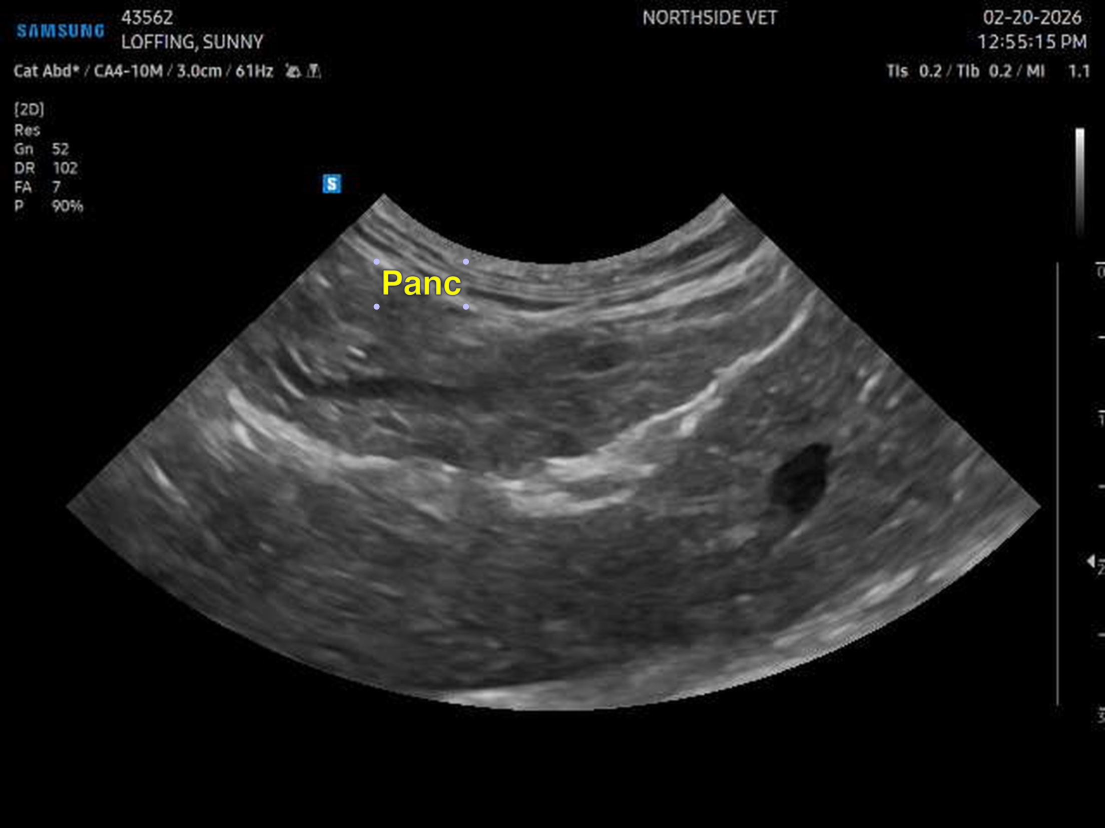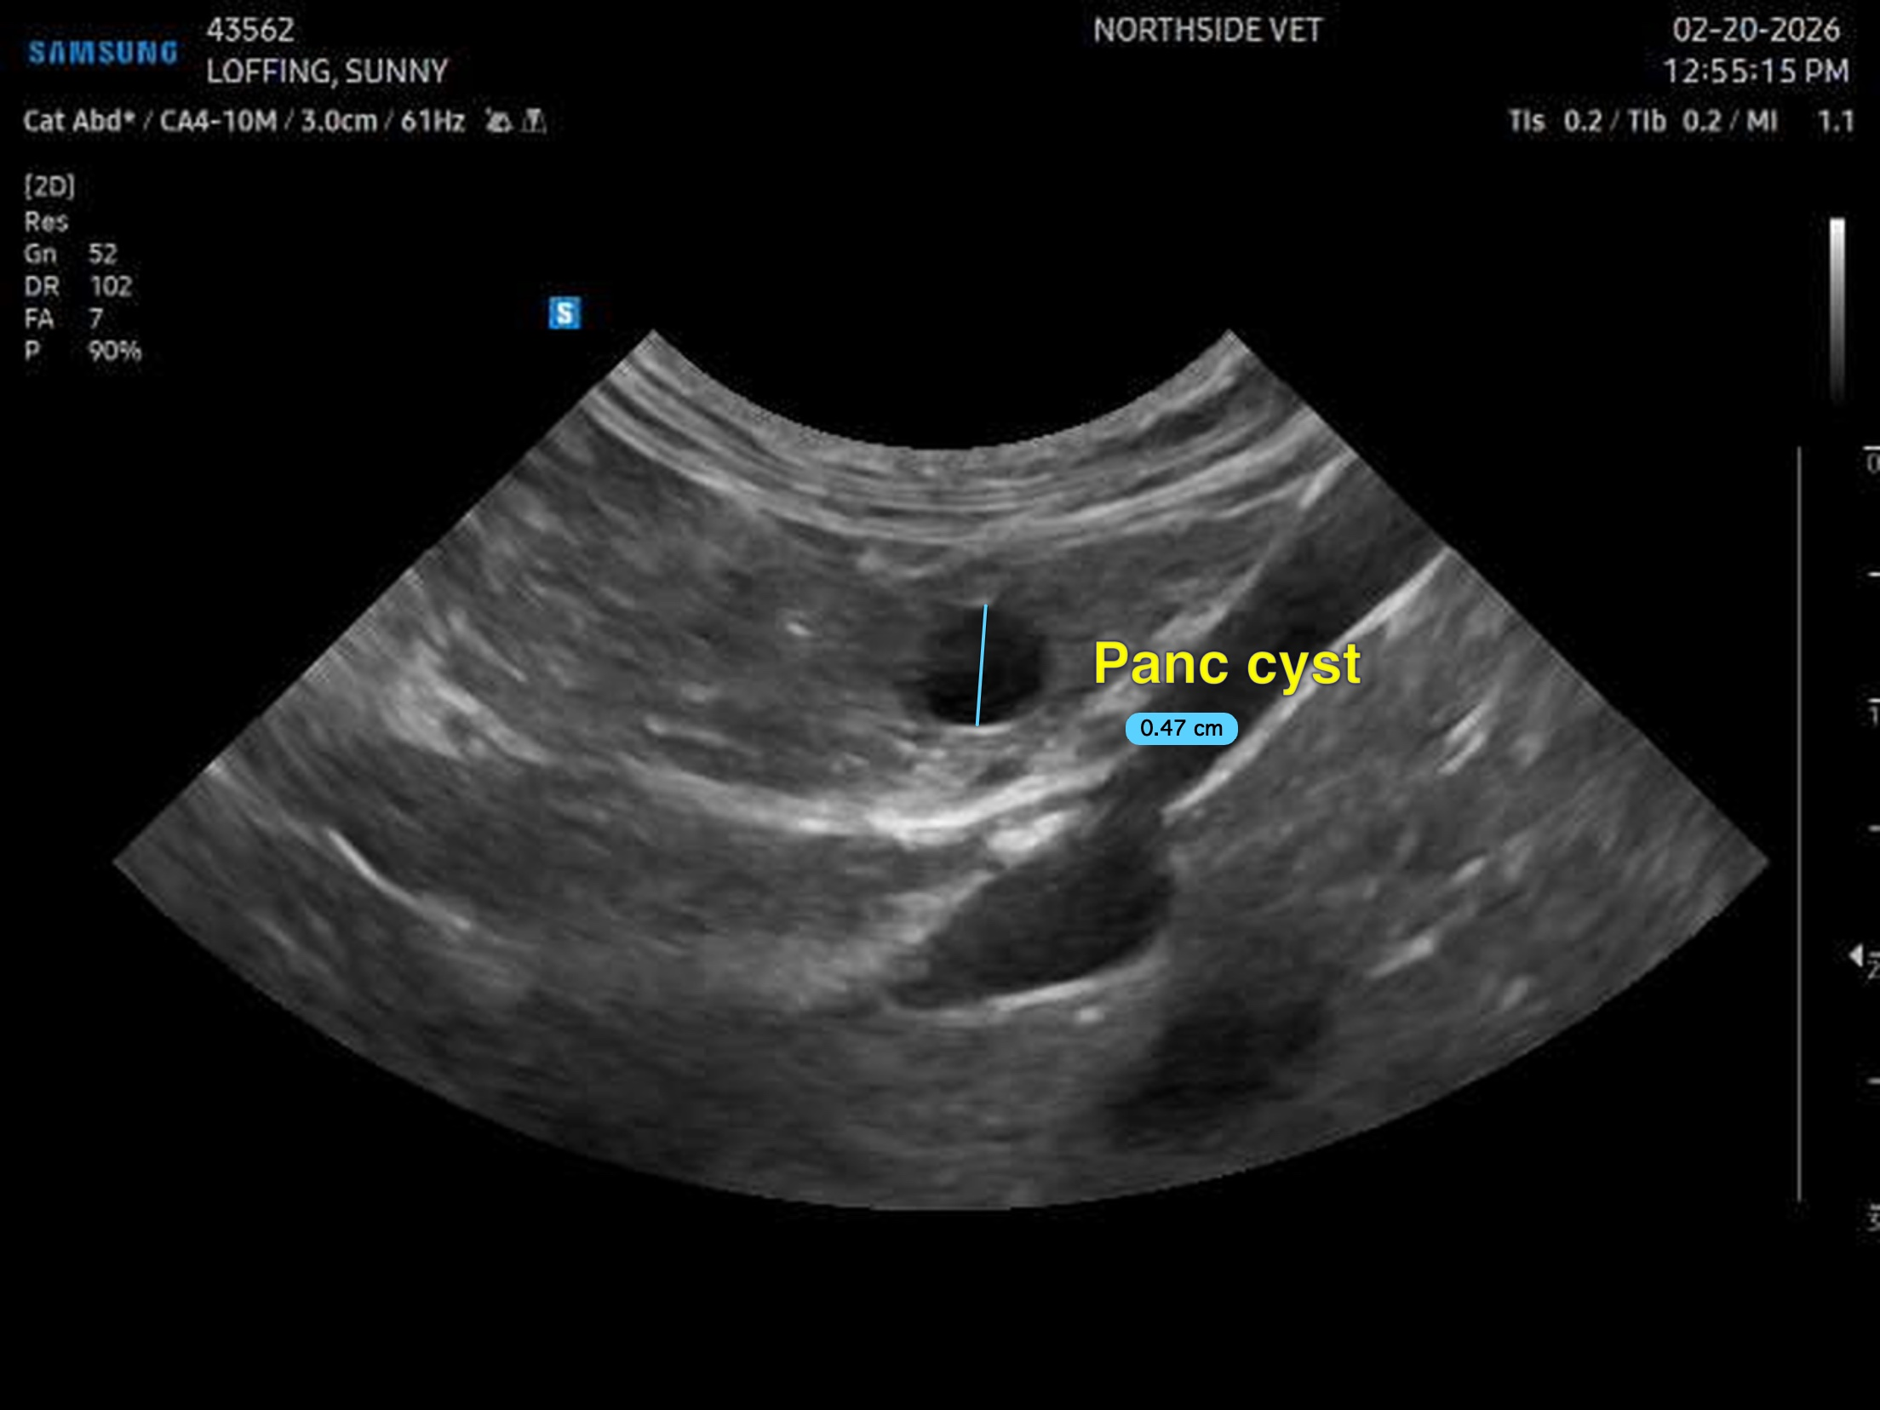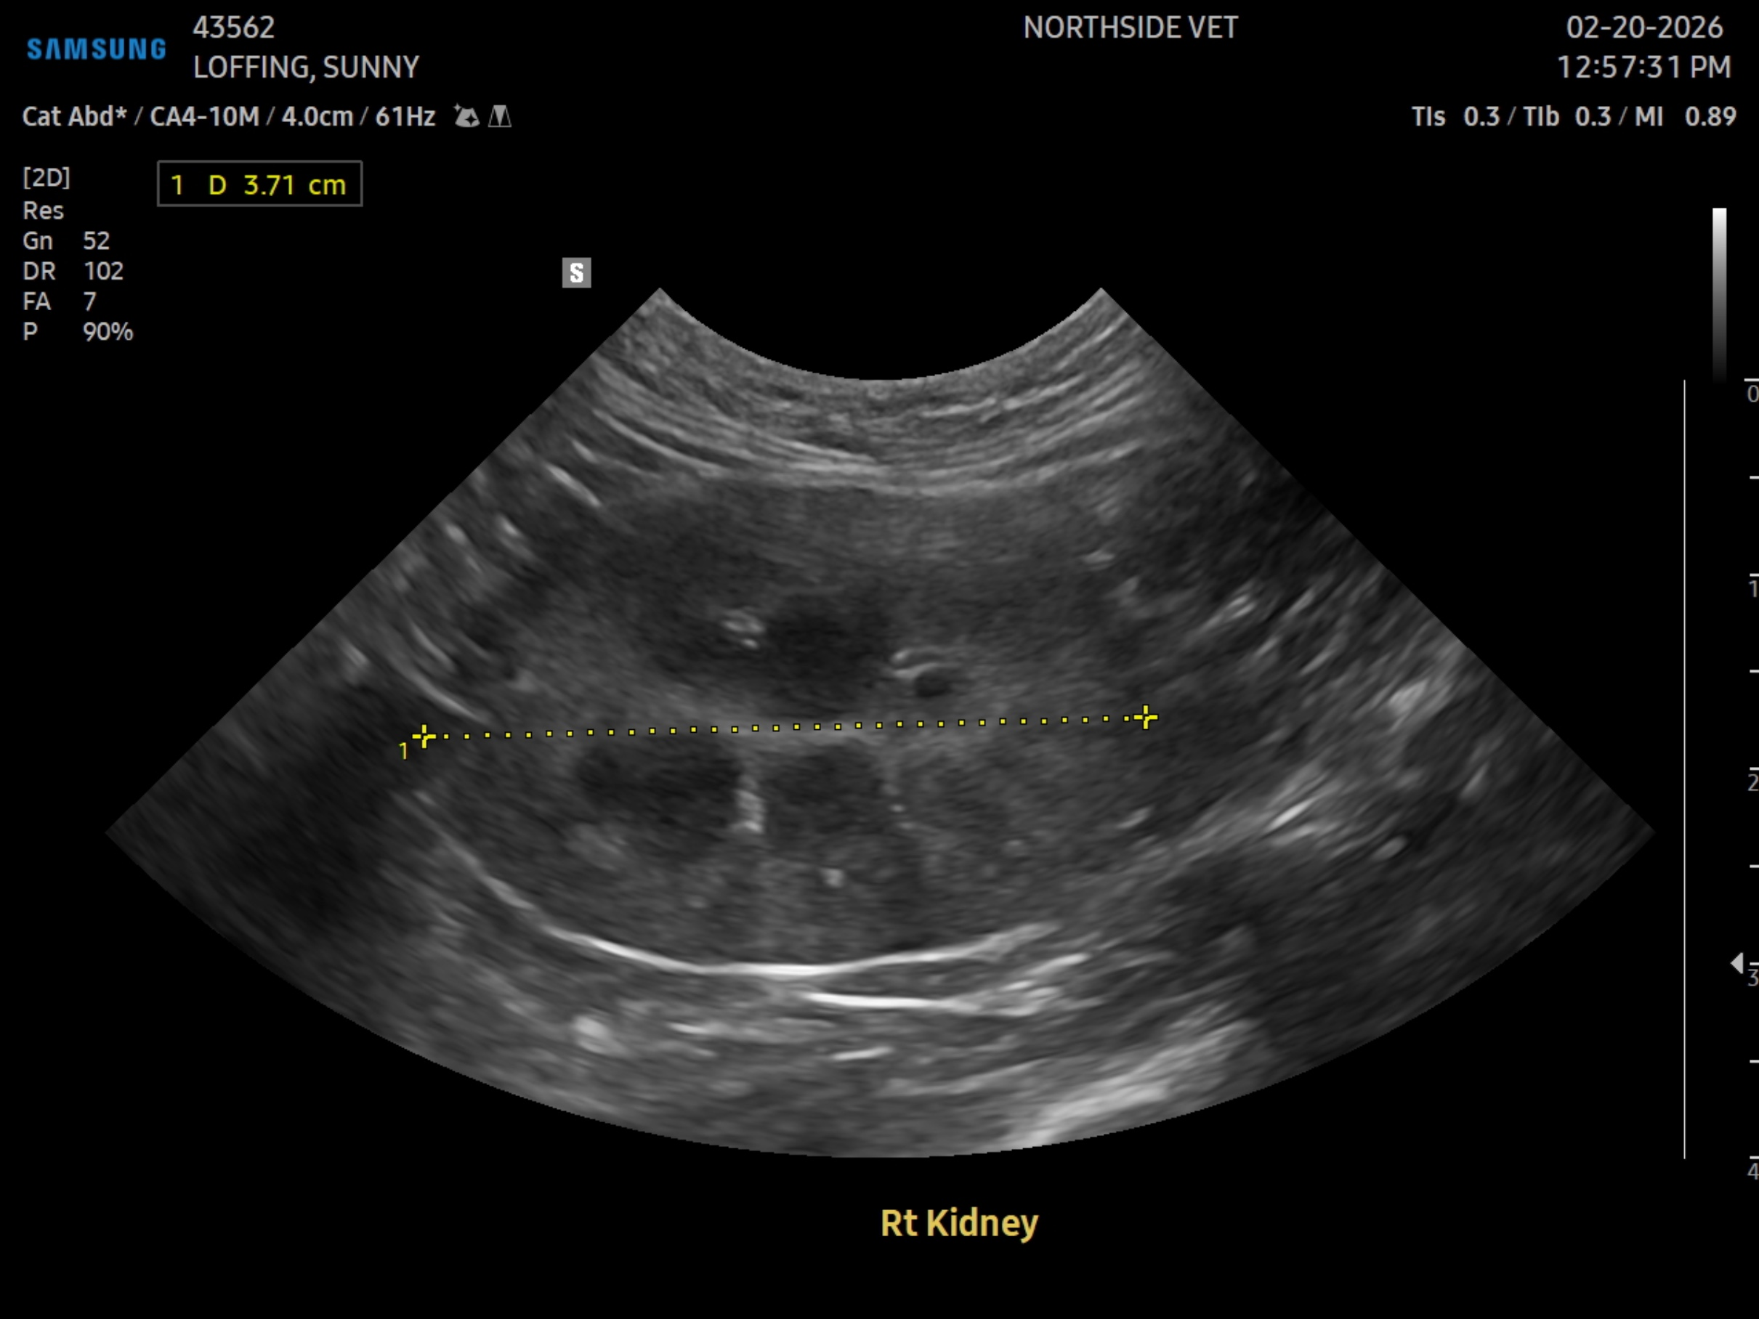
The information and recommendations provided are based on the images presented by the referring veterinarian/sonographer. No evaluation can be communicated regarding pathology that was not visible in the image/video clips provided.
Thank you for this referral. If the clinical or image interpretation does not parallel your findings or if I can be of any further assistance, please contact me.
R. McKenzie Daniel, DVM, DABVP (Canine / Feline Practice)
info@SonoPath.com

