PRESENTING CLINICAL SIGNS
History: Splenic lesion identified in May 2025, and patient has experienced significant weight loss. AUS to re-assess spleen
ULTRASONOGRAPHIC EXAMINATION OF THE ABDOMEN
Urinary System
The urinary bladder, trigone, cystourethral junction, and visible pelvic urethra exhibited normal thickness and tone. Anechoic urine was present in the lumen with no uroliths or sediment. The ureteral papillae were normal. The ureters were not visible which is normal. No evidence of inflammatory or neoplastic changes were noted.
The residual prostate was free of pathology.
Normal size and margination was present in the kidneys. A normal 1:3 cortex / medulla ratio was maintained. The medulla and cortices were uniform in texture with some increased echogenicity and mild loss of corticomedullary symmetry and definition expected for the age of the patient. No evidence of pelvic dilation was present. The left kidney measured 8.9 cm in length. The right kidney measured 7.9 cm in length.
Adrenal Glands
The bilateral adrenal glands were normal in size. Mild parenchyma heterogeneity and mild capsule asymmetry was present without suspicion for overt neoplasia. The left adrenal gland measured 0.81 cm width in the caudal pole. The right adrenal gland measured 0.85 cm width in the caudal pole.
Spleen
Mild generalized splenomegaly exhibiting asymmetrical capsule contour and variable heterogeneous parenchyma with splenic folding. Variably sized to mildly expansive, non-homogeneous to non-homogeneous hypoechoic nodules were present with an example measuring 2.1 cm in diameter. Normal splenic vascularity was noted.
Liver
The liver was subjectively normal in size, structure, and contour. The liver parenchyma was uniform and hypoechoic to the spleen with a mild coarse echotexture. The hepatic and portal vasculature were normal in appearance without signs of congestion. Solitary, small to indistinct, hyperechoic ventral intraparenchymal nodule was present. The gallbladder was non-distended in size with thin walls and primarily anechoic luminal content. The cystic and common bile ducts were normal.
Gastrointestinal
The stomach presented intact wall layering with a normal wall layer ratio. The lumen of the stomach was empty with no signs of ileus, obstruction or foreign material.
The small intestine presented intact wall layering with 1:3 muscularis/mucosa ratio. The lumen of the small intestine was empty with no signs of ileus, obstruction or foreign material.
The proximal colon exhibited normal visible wall layers with apparent soft to non-formed feces in lumen.
Pancreas
The parenchyma of the left limb, body and right limb of the pancreas presented isoechoic to the adjacent omental fat. A normal curvilinear capsule contour of the pancreas was present. The visible pancreatic duct was normal. No signs of active inflammation or neoplastic disease was evident.
Free Abdomen
Focal, mildly prominent to enlarged medial iliac node was present. The lymph node was essentially isoechoic to adjacent omentum without evidence of peripheral inflammation and maintaining a normal width: length ratio (<0.5). The lymph node measured 3.7 cm x 0.97 cm. No obvious visualized omental lymphadenopathy, masses or peritoneal effusion present.
Heart
Brief subjective echocardiogram exhibited normal overall cardiac structure including normal left and right chamber dimension. Subjective mild decreased LV contractility potentially owing to sedation but not suspected to be a clinical issue given no reported clinical signs. No evidence of arrythmia, cardiac tumors or pericardial effusion.
ULTRASONOGRAPHIC FINDINGS
- Irregular non-homogeneous spleen with splenic nodules – primary concern for neoplastic criteria, hyperplasia, hematopoiesis, granulomas, all potentials
- Sonographically normal liver with small benign hepatic nodule – nodule most consistent with focal mild nodular hyperplasia or lipogranuloma
- Mild age-related adrenal/renal changes – benign
- Sonographically normal gastrointestinal tract
- Mild medial iliac lymphadenopathy – not sonographically consistent with inflammatory or metastatic criteria
- Subjective normal echocardiogram
INTERPRETATION OF THE FINDINGS & FURTHER RECOMMENDATIONS
Assuming normal clotting status, splenic parenchyma and accessible FNA cytology warranted for further clarification. Assuming no pathology on 3-view chest radiographs, alternatively direct splenectomy with gross inspection of the peritoneal cavity is warranted. A GI panel to include PLI/TLI/Cobalamin/Folate may be considered to assess for occult intestinal or pancreatic disease as a contributing factor to the weight loss.

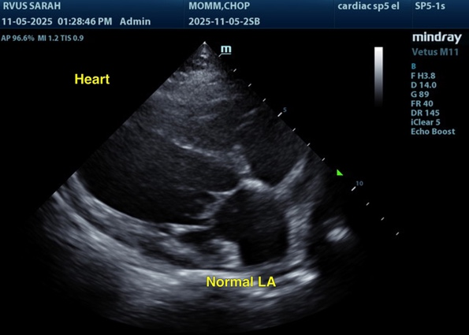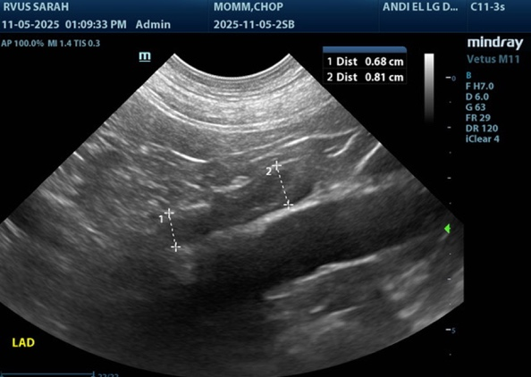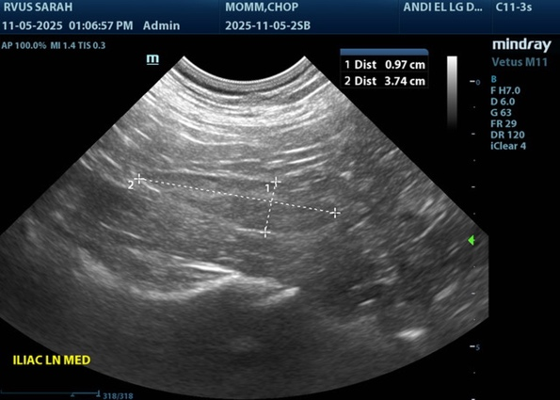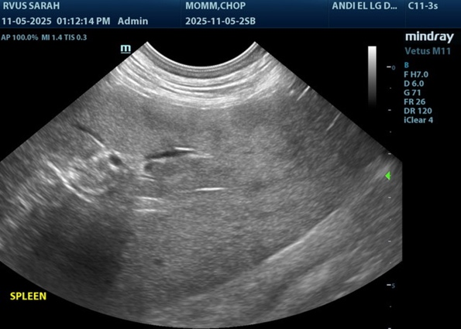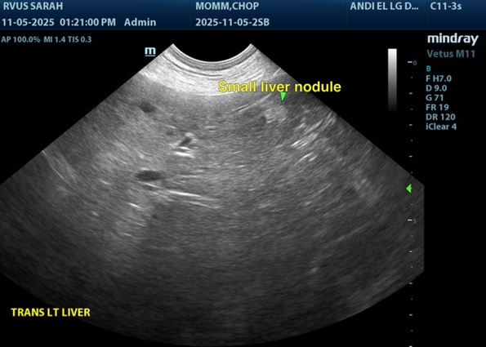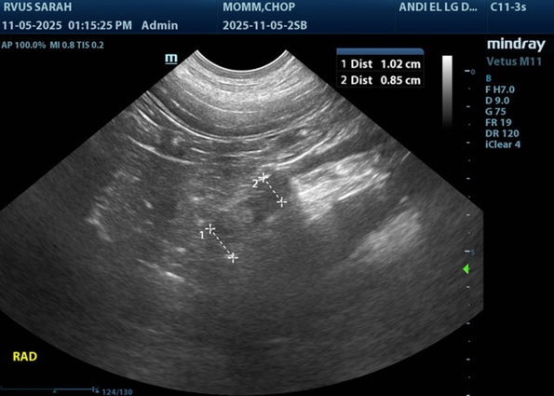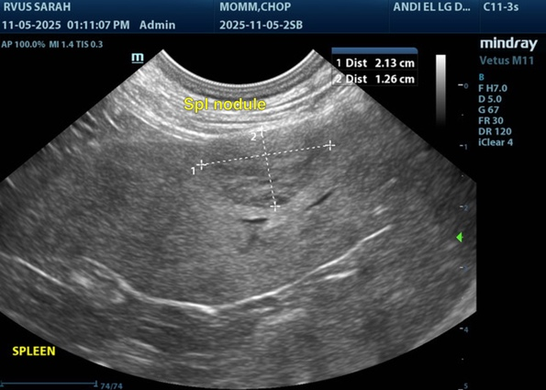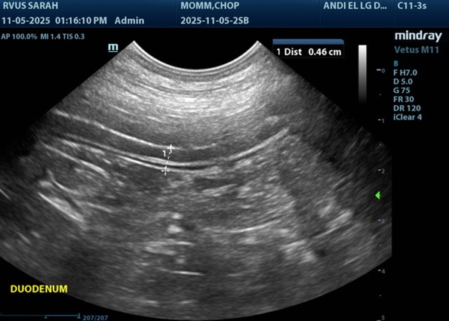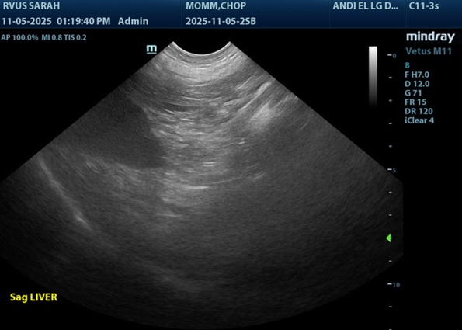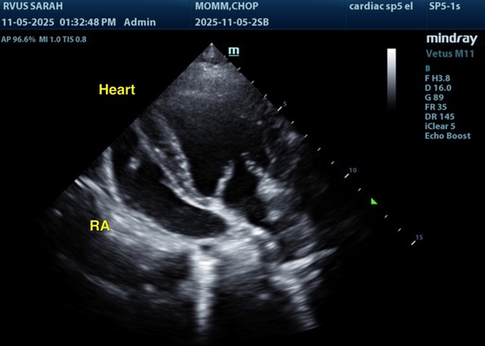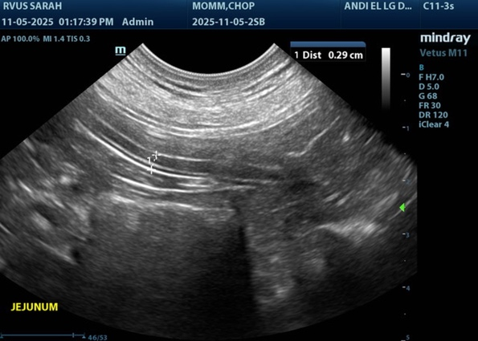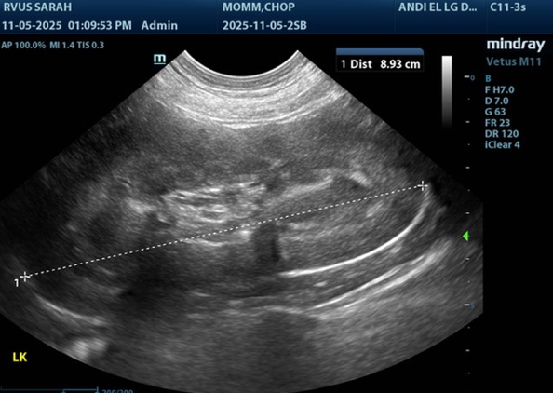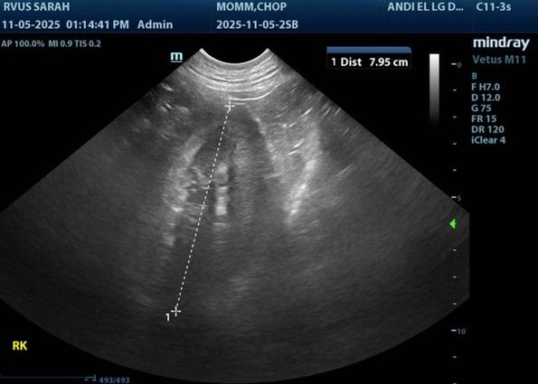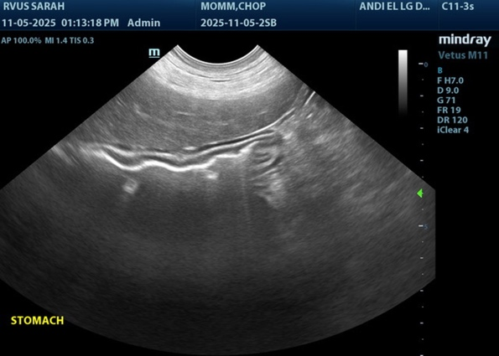

The information and recommendations provided are based on the images presented by the referring veterinarian/sonographer. No evaluation can be communicated regarding pathology that was not visible in the image/video clips provided.
Thank you for this referral. If the clinical or image interpretation does not parallel your findings or if I can be of any further assistance, please contact me.
R. McKenzie Daniel, DVM, DABVP (Canine / Feline Practice)
info@sonopath.com

