PRESENTING CLINICAL SIGNS
Recurrent inappetance. No current meds or blood work reported.
ULTRASONOGRAPHIC EXAMINATION OF THE ABDOMEN
Urinary System
The urinary bladder, trigone, cystourethral junction, and visible pelvic urethra to a depth of 2.0 cm exhibited normal thickness and tone. Anechoic urine was present in the lumen with no uroliths or sediment. The ureteral papillae were normal. The ureters were not visible which is normal. No evidence of inflammatory or neoplastic changes was noted.
The area of the aortic trifurcation was free of pathology.

Normal size and margination were present in the kidneys. A normal 1:3 cortex / medulla ratio and normal corticomedullary definition were maintained. The echogenicity of the cortex was similar to or slightly less than normal liver parenchyma while the medulla echogenicity was hypoechoic to the cortex with no evidence of pelvic dilation. The left kidney measured 4.3 cm in length. The right kidney measured 4.3 cm in length.
Adrenal Glands
The left adrenal gland was uniform in size and contour with a uniformly hypoechoic parenchyma. The left adrenal gland measured 1.9 cm length x 0.50 cm width at the caudal pole. The right adrenal gland was uniform in size and contour with a uniformly hypoechoic parenchyma. The right adrenal gland measured 1.7 cm length x 0.65 cm width at the caudal pole.
Spleen
The spleen exhibited a finely textured and homogenous parenchyma which was hyperechoic to the liver and renal cortical parenchyma. The capsule was smooth and regular without apparent expansion. The splenic vasculature at the hilus was normal in volume with no evidence of congestion or thrombosis. Acute to chronic inflammatory, neoplastic, or benign parenchyma changes were not noted.
Liver/ Gallbladder
The liver was subjectively normal in size, structure, and contour. The liver parenchyma was mildly nonuniform and hypoechoic to the spleen with a moderate coarse echotexture and subjective mild parenchymal remodeling. The hepatic and portal vasculature were normal in appearance without signs of congestion. The gallbladder was non-distended in size with thin walls and primarily anechoic luminal content. The cystic and common bile ducts were normal.
Gastrointestinal
The stomach presented intact wall layering with a normal wall layer ratio. Mild nonshadowing ingesta / chyme was present in the stomach. No evidence of mechanical pyloric outflow obstruction or obstructive pyloric mural pathology was noted. The pylorus wall width measured 0.35 cm. No evidence of pathology was noted at the level of the gastroesophageal junction.

The small intestine presented intact wall layering with 1:3 muscularis/mucosa ratio. The lumen of the small intestine was empty with no signs of ileus, obstruction, or foreign material. The duodenum wall measured 0.35 cm width. The jejunum wall measured 0.33 cm width.
Normal visible colon wall layers were present with apparent formed feces in lumen.
Pancreas
The pancreas was normal in size and contour with isoechoic to heterogeneous parenchyma compared to adjacent omentum. No signs of active inflammation or neoplasia.
Free Abdomen
No overt lymphadenopathy or peritoneal effusion was present.
ULTRASONOGRAPHIC FINDINGS
- Sonographically unremarkable gastrointestinal tract with mild gastric ingesta / chyme
- Mild heterogeneous pancreas
INTERPRETATION OF THE FINDINGS & FURTHER RECOMMENDATIONS
No evidence of overt visceral pathology, specifically gastrointestinal or pancreatic pathology, as an obvious cause or contributing factor to the patient's clinical signs. Potential for structurally insignificant gastrointestinal disease or low-grade to chronic pancreatitis, both of which may present as sonographically normal, cannot be definitively excluded.
A GI panel to include PLI/TLI/Cobalamin/Folate may be considered to assess for occult disease. Although the bilateral adrenal glands were sonographically normal, resting cortisol level to rule out occult Addison's Disease, is also warranted. If not done, three-view chest radiographs are suggested to rule out thoracic or esophageal pathology as a contributing factor. Empirically, as-needed GI support +/- hydrolyzed diet trial may prove beneficial.

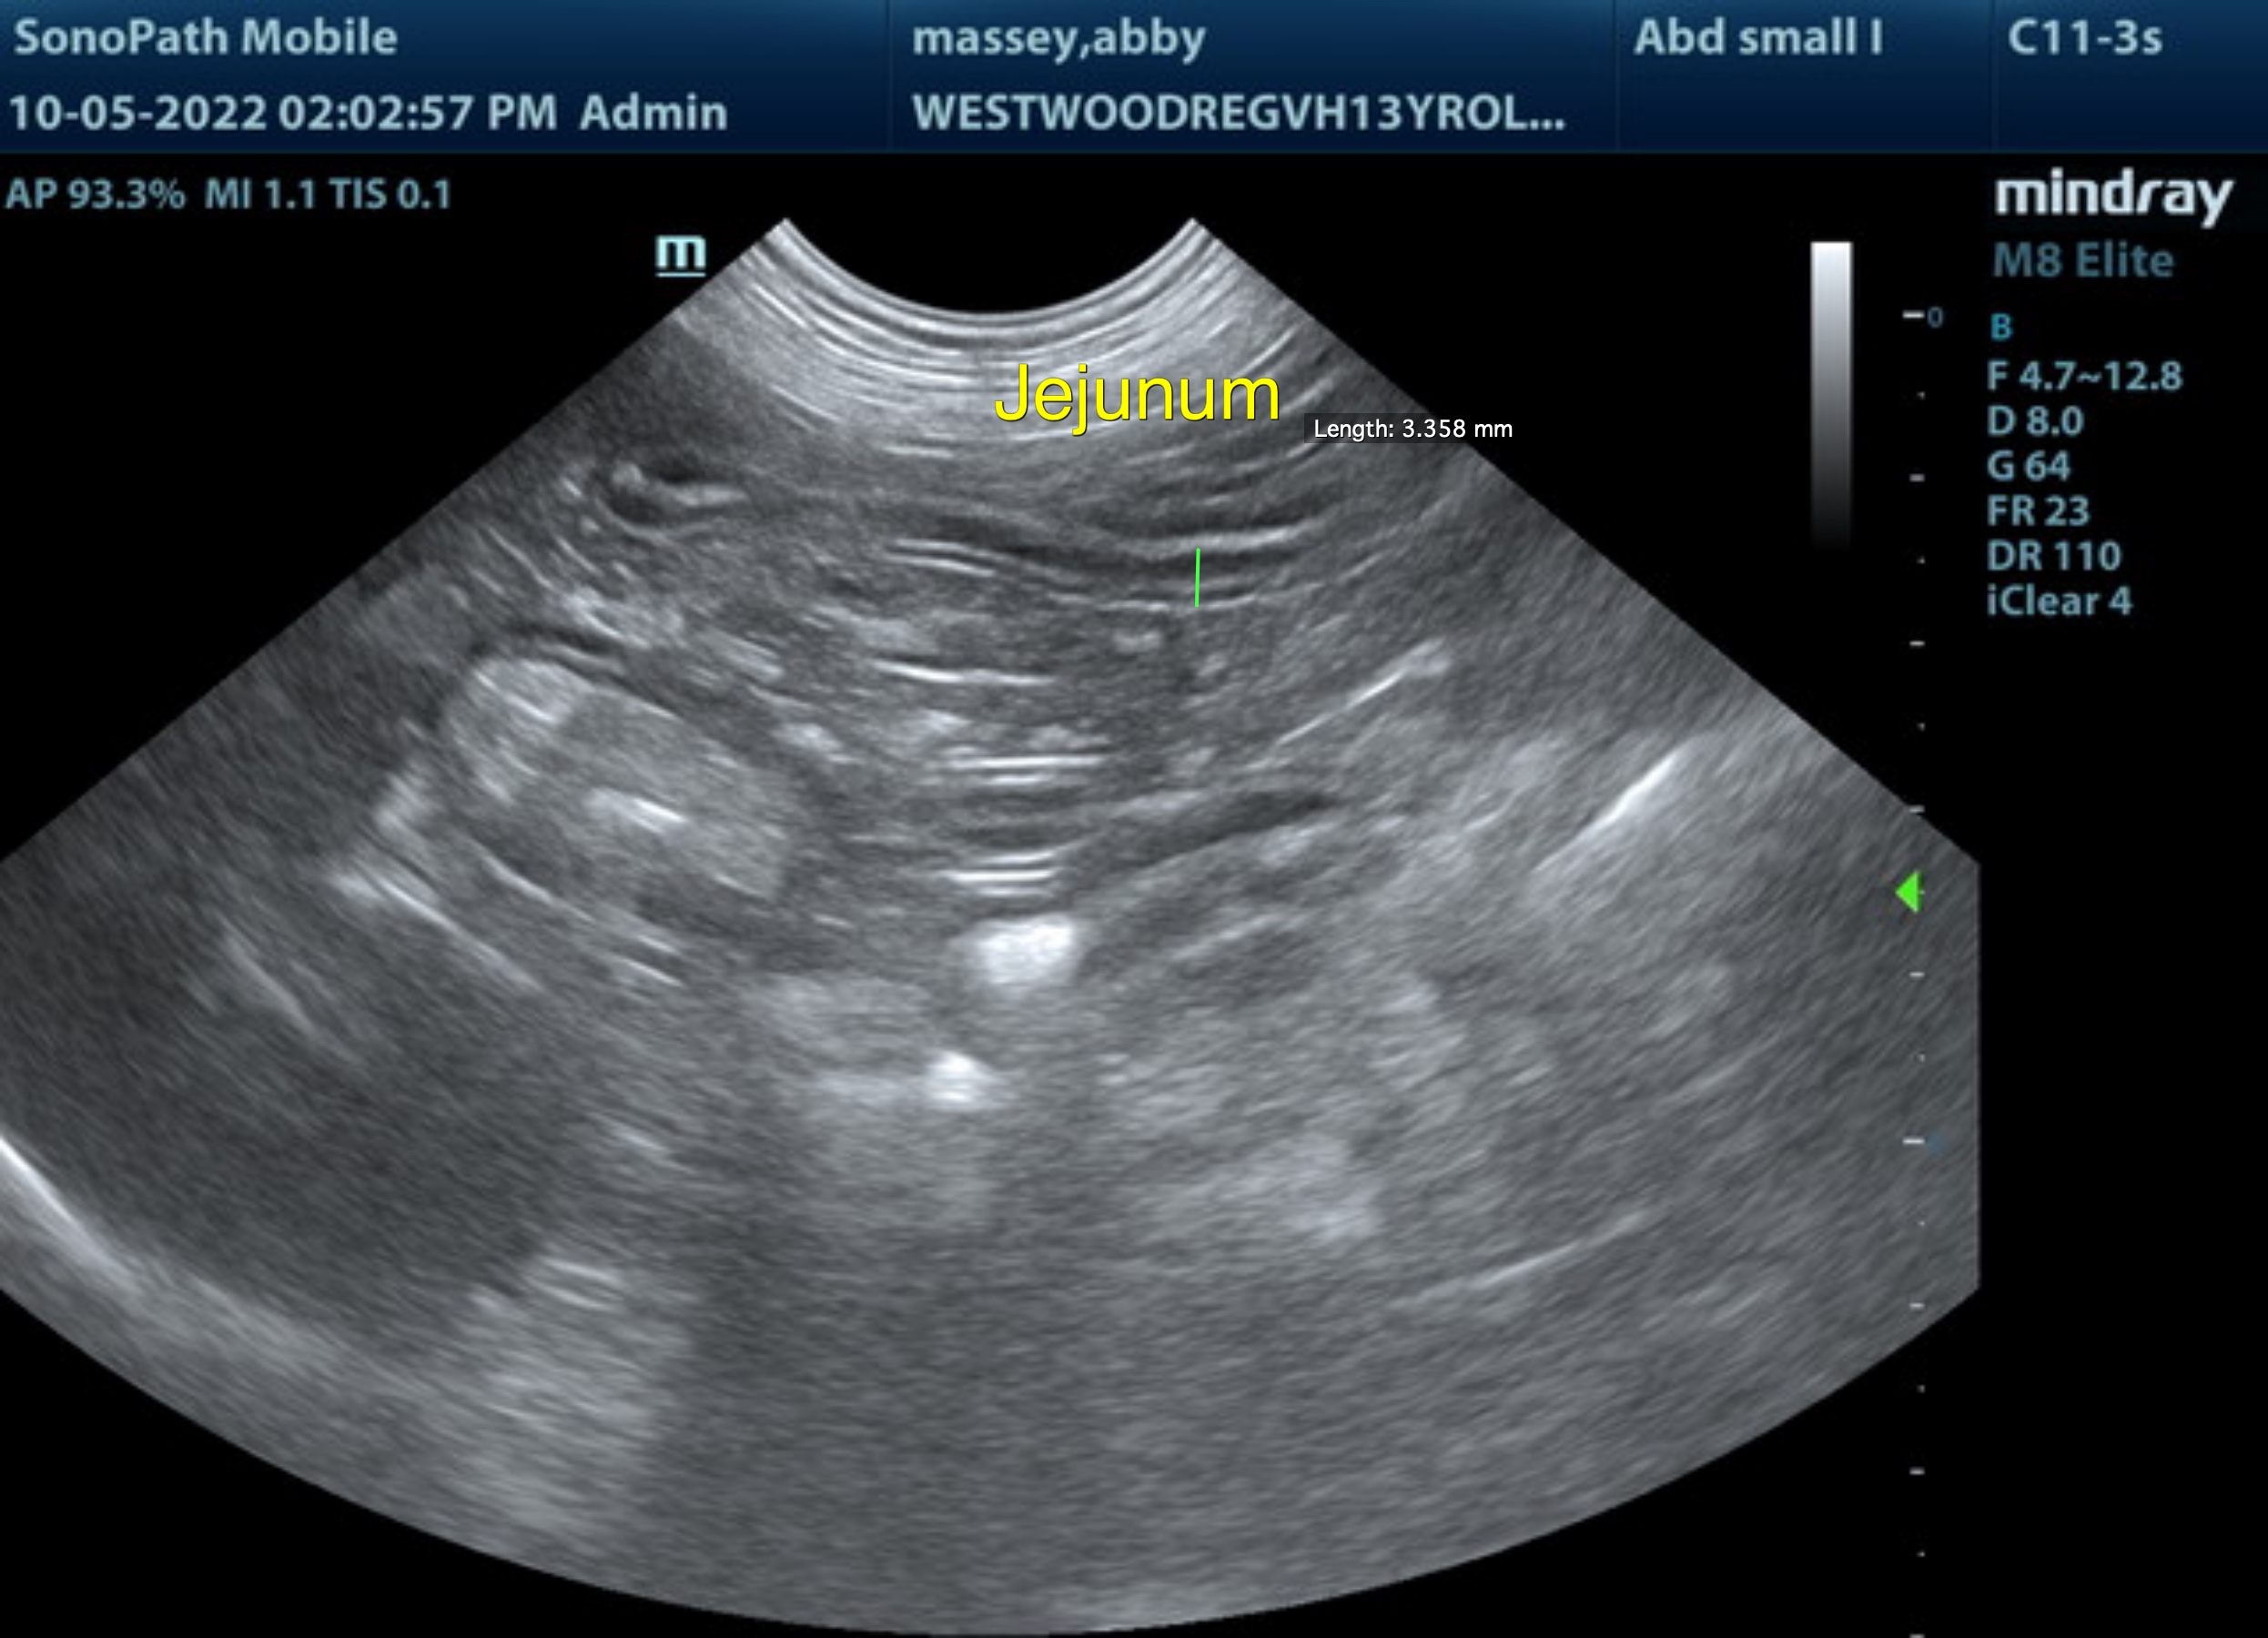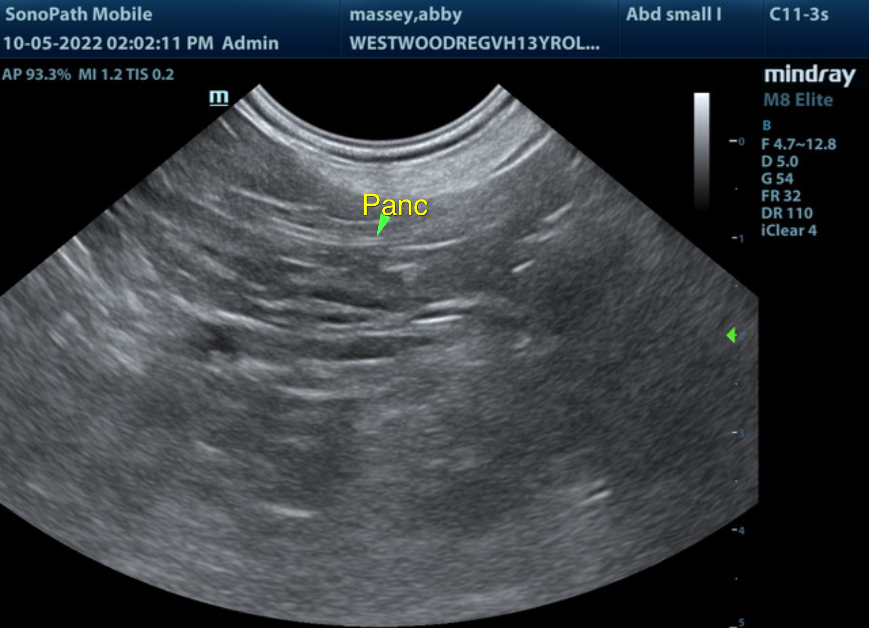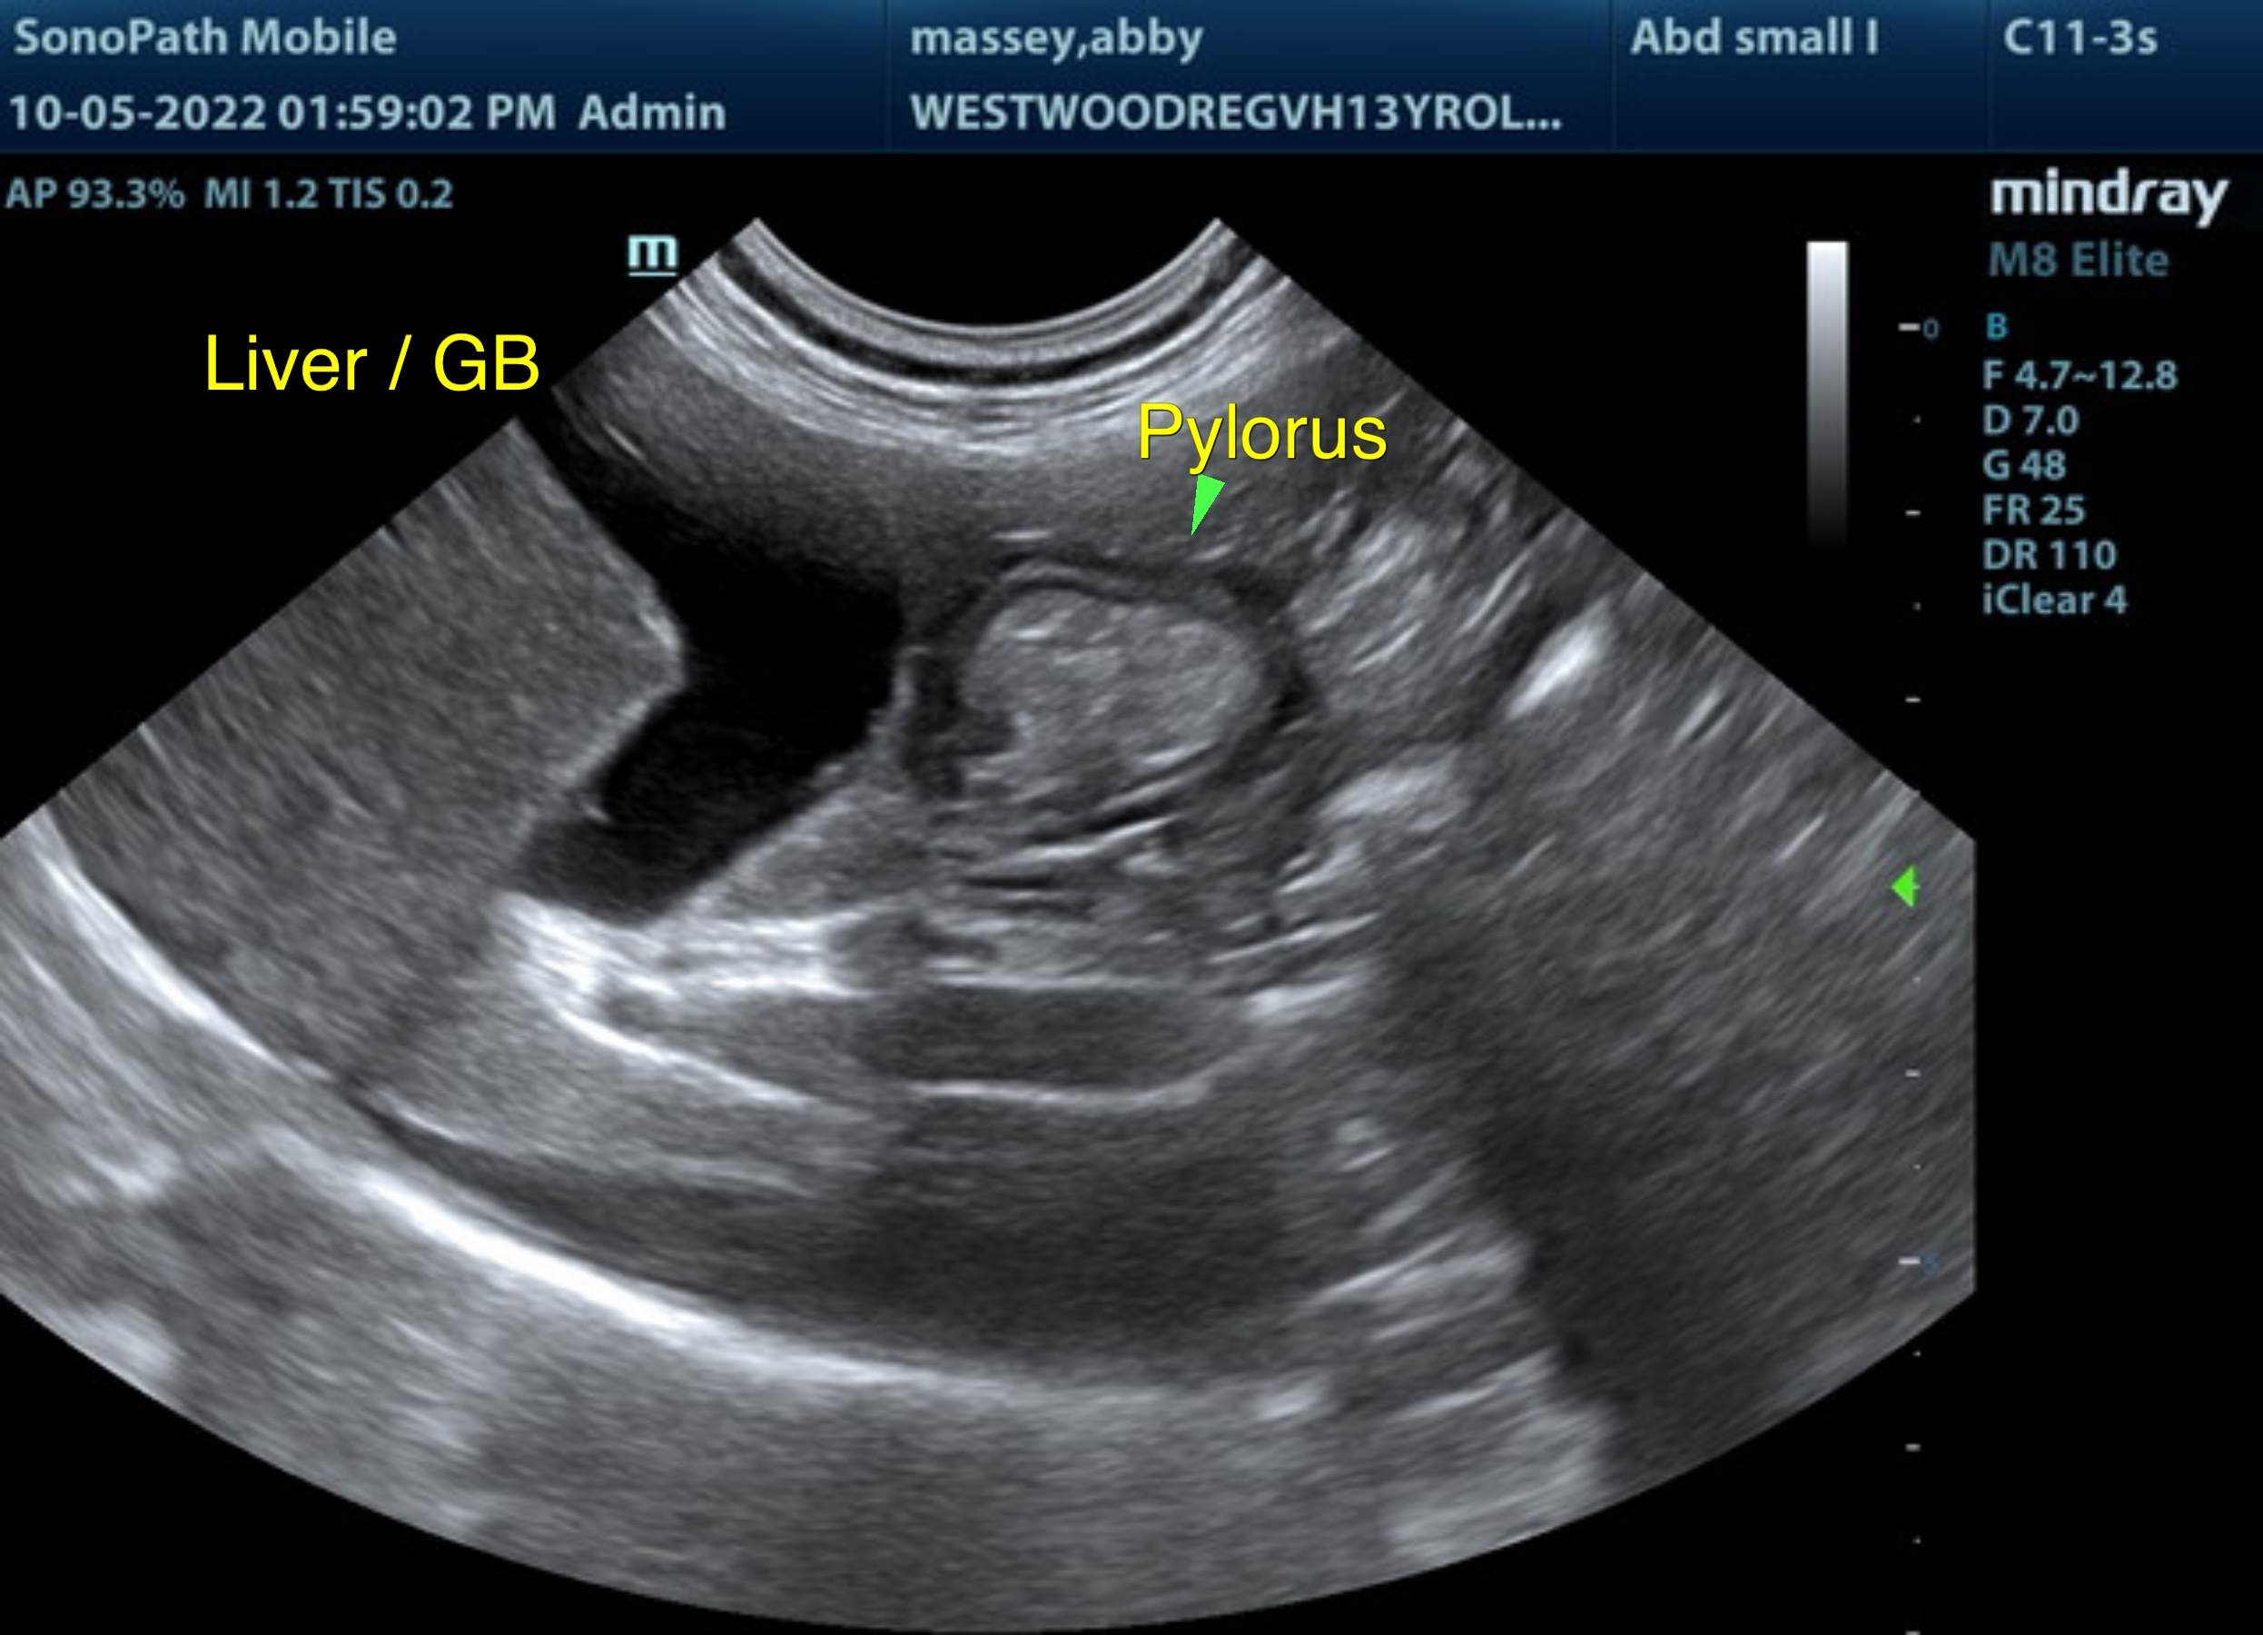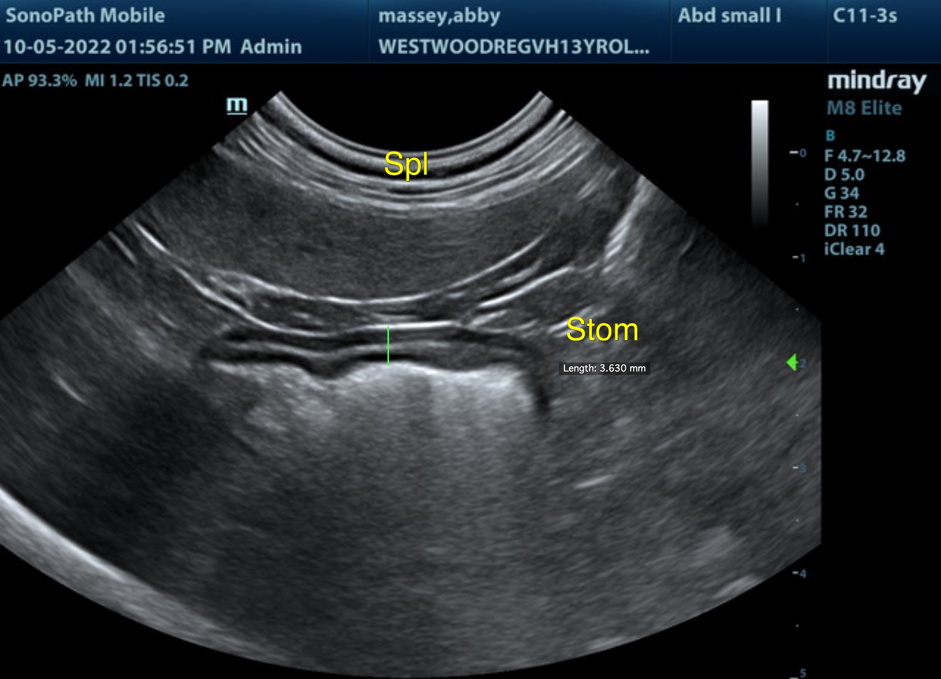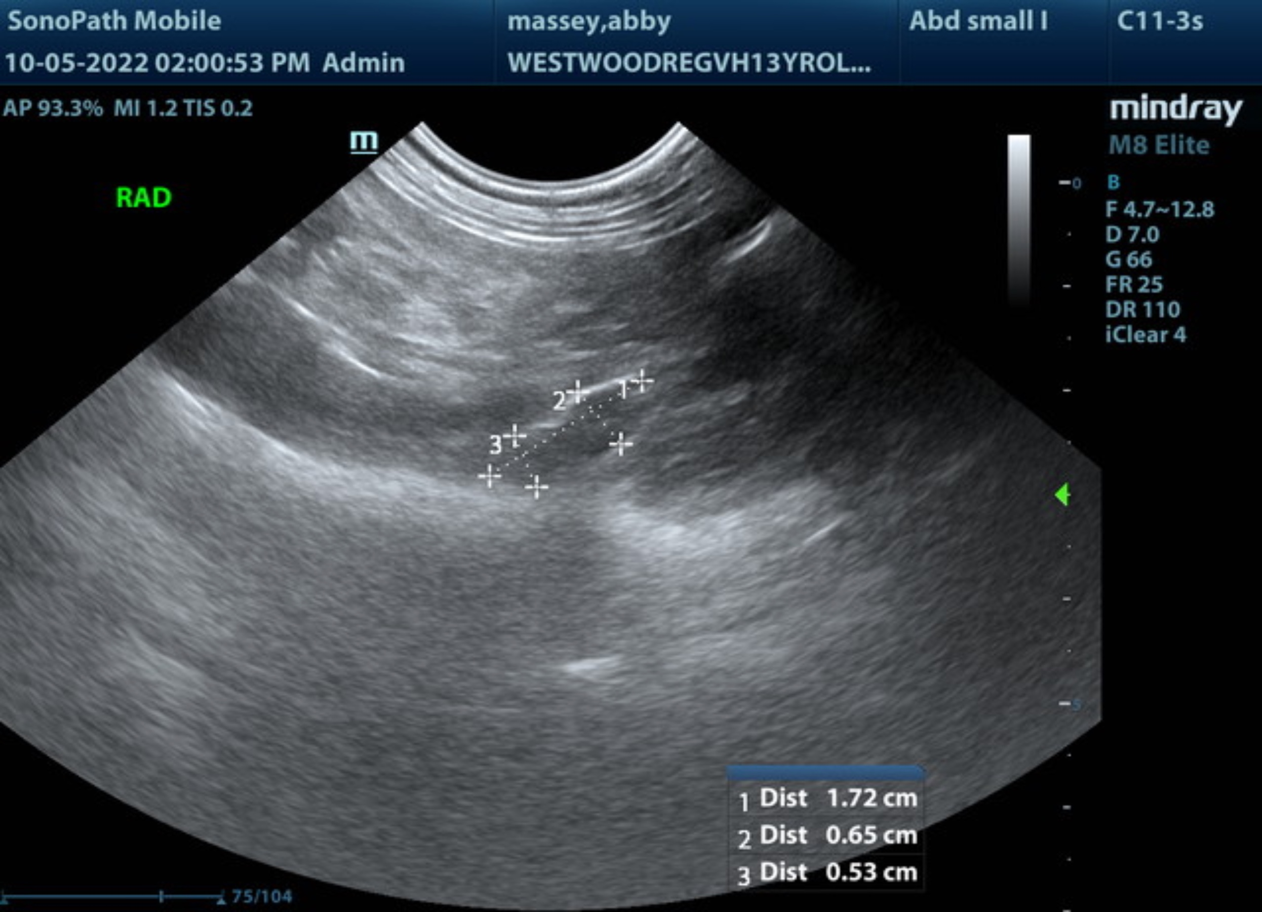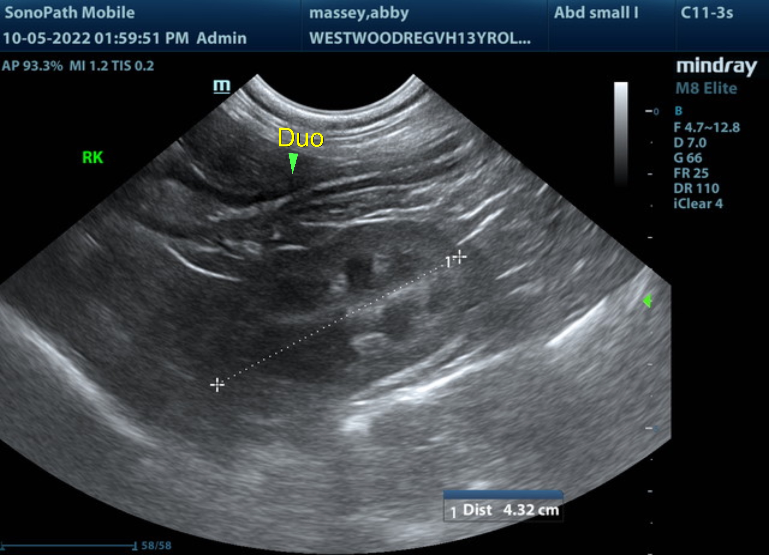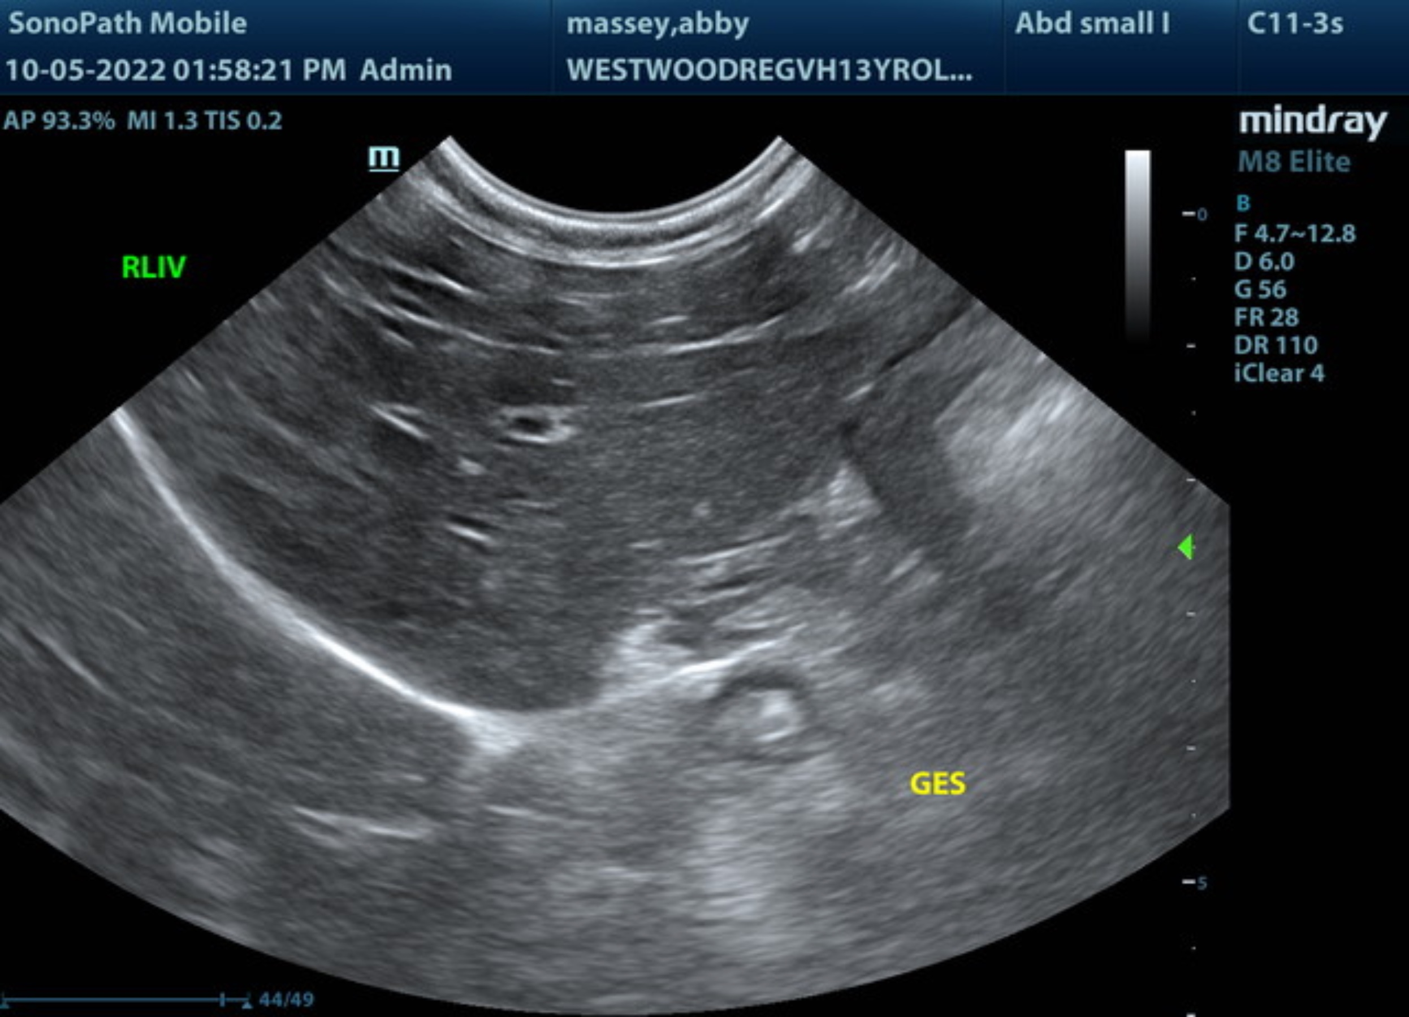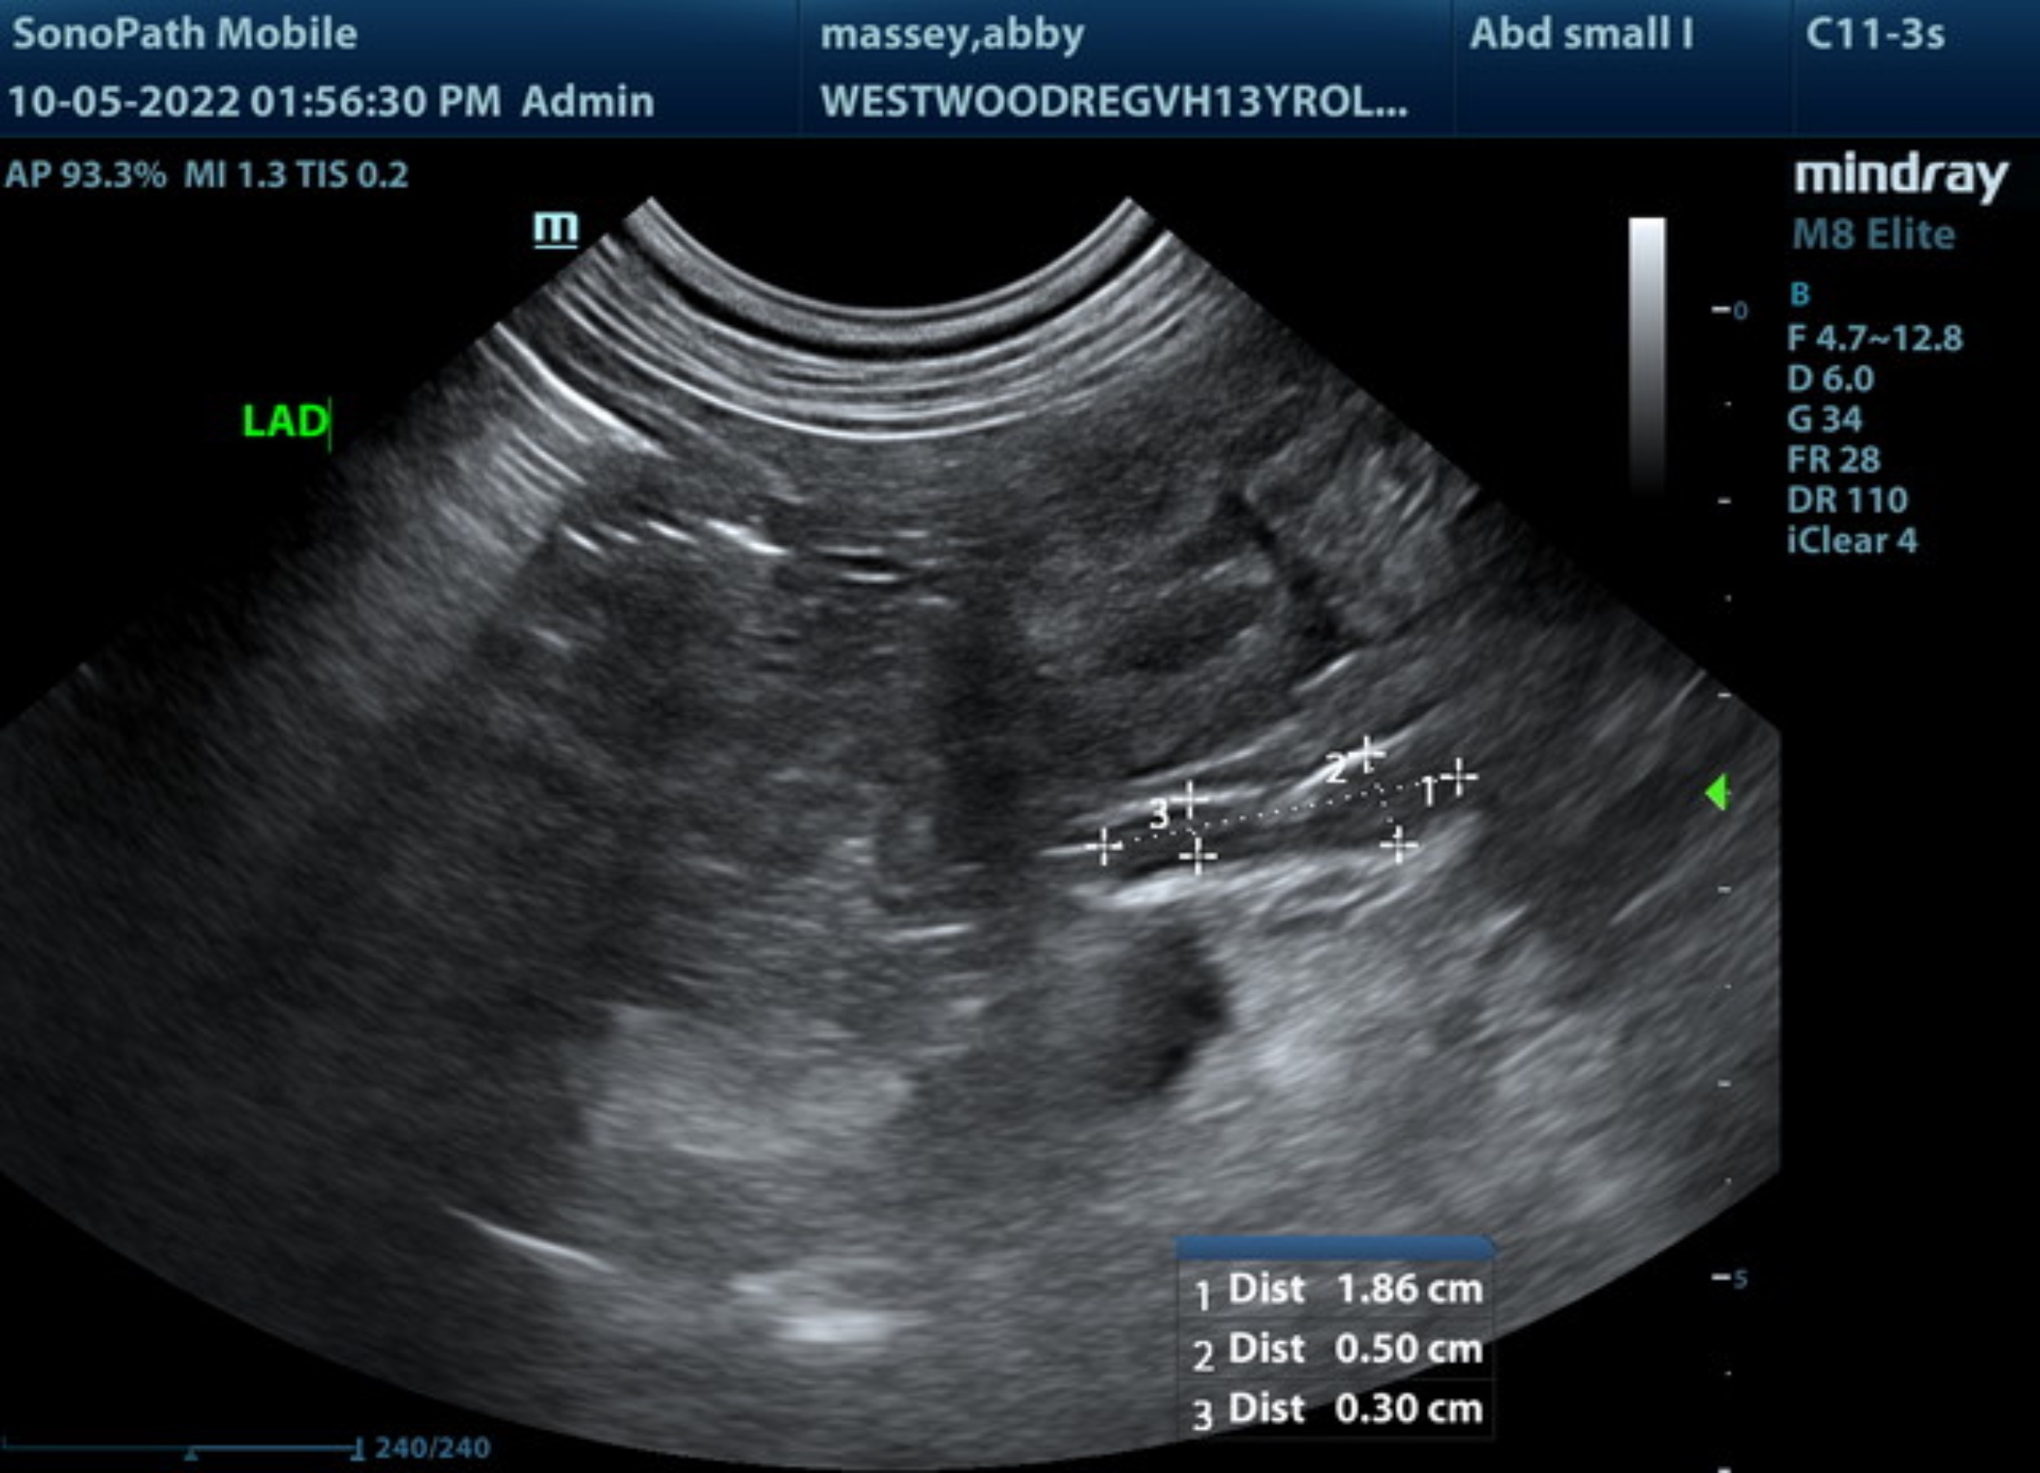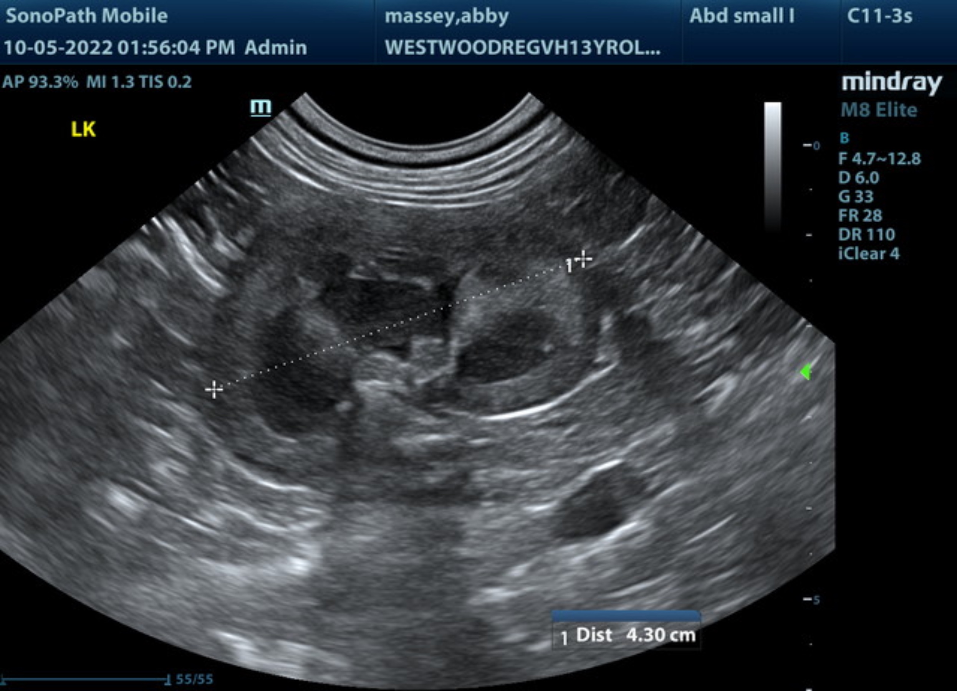
The information and recommendations provided are based on the images presented by the referring veterinarian/sonographer. No evaluation can be communicated regarding pathology that was not visible in the image/video clips provided.

Thank you for this referral. If the clinical or image interpretation does not parallel your findings or if I can be of any further assistance please contact me.

R. McKenzie Daniel, DVM, DABVP (Canine / Feline Practice)
info@SonoPath.com

