PRESENTING CLINICAL SIGNS
Inappetance, nausea, weight loss, tense/painful abdomen. Current meds: Cerenia, famotadine, metronidazole, buprenex.
Abnormal PE/Chem/CBC/UA Results: CBC/Chem/PCV/TP/PT/PTT: WNL.
ULTRASONOGRAPHIC EXAMINATION OF THE ABDOMEN
Urinary System
The urinary bladder, trigone, and cystourethral junction normal thickness and tone. Anechoic urine was present in the lumen with no uroliths or sediment. The ureteral papillae were normal. The ureters were not visible which is normal. No evidence of inflammatory or neoplastic changes was noted.
The area of the aortic trifurcation was free of pathology.

Normal size and margination were present in the kidneys. A normal 1:3 cortex / medulla ratio was maintained. The medulla and cortices were uniform in texture with some increased echogenicity and mild loss of corticomedullary symmetry and definition expected for the age of the patient. No evidence of pelvic dilation was present. The left kidney measured 7.2 cm in length. The right kidney measured 6.8 cm in length.
Adrenal Glands
The left adrenal gland was uniform in size and contour with a uniformly hypoechoic parenchyma. The left adrenal gland measured 2.6 cm length x 0.53 cm width at the caudal pole. The right adrenal gland was not definitively visualized owing to regional increased right periadrenal artifact.
Spleen
The spleen exhibited a finely textured and homogenous parenchyma which was hyperechoic to the liver and renal cortical parenchyma. The capsule was smooth and regular without apparent expansion. The splenic vasculature at the hilus was normal in volume with no evidence of congestion or thrombosis. Acute to chronic inflammatory, neoplastic, or benign parenchyma changes were not noted. The spleen exhibited subjective mild enlargement. Normal splenic vascularity was present.
Liver/ Gallbladder
The liver presented normal in size with mildly hypoechoic parenchyma with maintained uniform parenchyma echogenicity with a mild coarse echotexture. Increased portal vein prominence was evident. The capsule of the liver was normal in margination. Distinct masses or nodules were not evident. The hepatic and portal vasculature were normal in appearance. The gallbladder was non-distended in size with primarily anechoic luminal content. The cystic and common bile ducts were normal.
Gastrointestinal
The stomach presented intact wall layering with a normal wall layer ratio. The lumen of the stomach was empty with no signs of ileus, obstruction, or foreign material.
The small intestine presented intact wall layering with 1:3 muscularis/mucosa ratio. The lumen of the small intestine was empty with no signs of ileus, obstruction, or foreign material.
Normal visible colon wall layers were present with apparent formed feces in lumen.
Pancreas
The parenchyma of the left limb, body, and right limb of the pancreas presented isoechoic to the adjacent omental fat. A normal curvilinear capsule contour of the pancreas was present. The visible pancreatic duct was normal. No signs of active inflammation or neoplastic disease were evident.
Free Abdomen
Multifocal, variably to severely enlarged, hypoechoic to swollen mesenteric lymph nodes were present. The lymph nodes exhibited abnormal width: length ratio (>0.5). An example of a mesenteric lymph node measured 8.0-9.0 cm in diameter. Surrounding perilymphatic to generalized mild hyperechoic mesentery was present. Intermittent small pockets of scant free fluids were noted.
ULTRASONOGRAPHIC FINDINGS
- Multifocal variable to severely enlarged hypoechoic mesenteric lymphadenopathy
- Associated perilymphatic to generalized mild hyperechoic mesentery and scant peritoneal free fluid
- Subjective mild splenomegaly
- Mildly hypoechoic liver
INTERPRETATION OF THE FINDINGS & FURTHER RECOMMENDATIONS
Although sampling is required for further assessment, the mesenteric lymphadenopathy presentation is consistent with neoplastic criteria with primary concern for high-grade lymphoma vs. other round-cell neoplasia. No overt evidence of intestinal involvement, although early multicentric neoplasia cannot be definitively excluded.
Pending lymph node cytology, hepatosplenic FNA cytology could be considered for further staging. Three-view chest radiographs and as-needed GI support are recommended pending lymph node cytology.

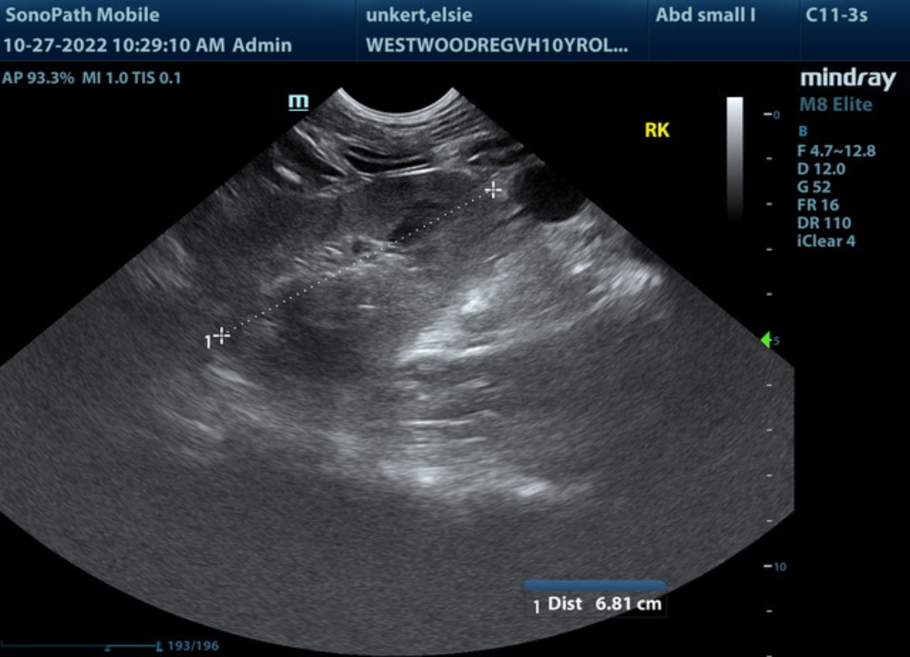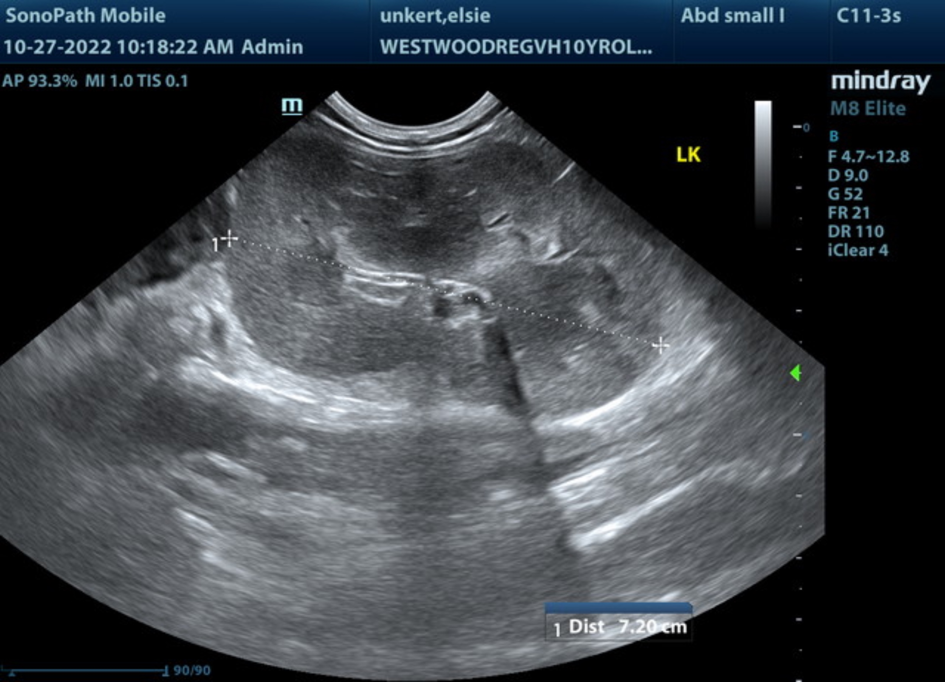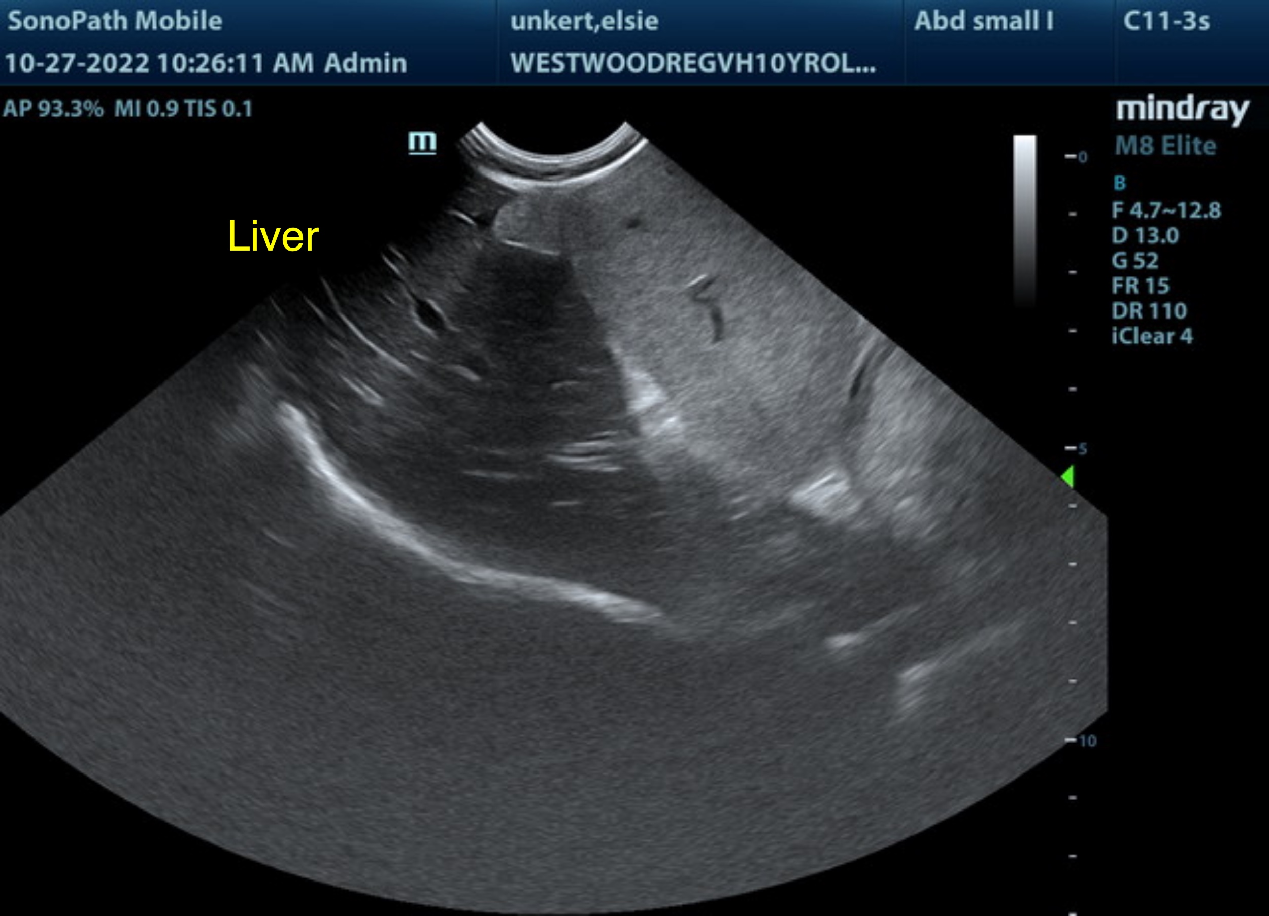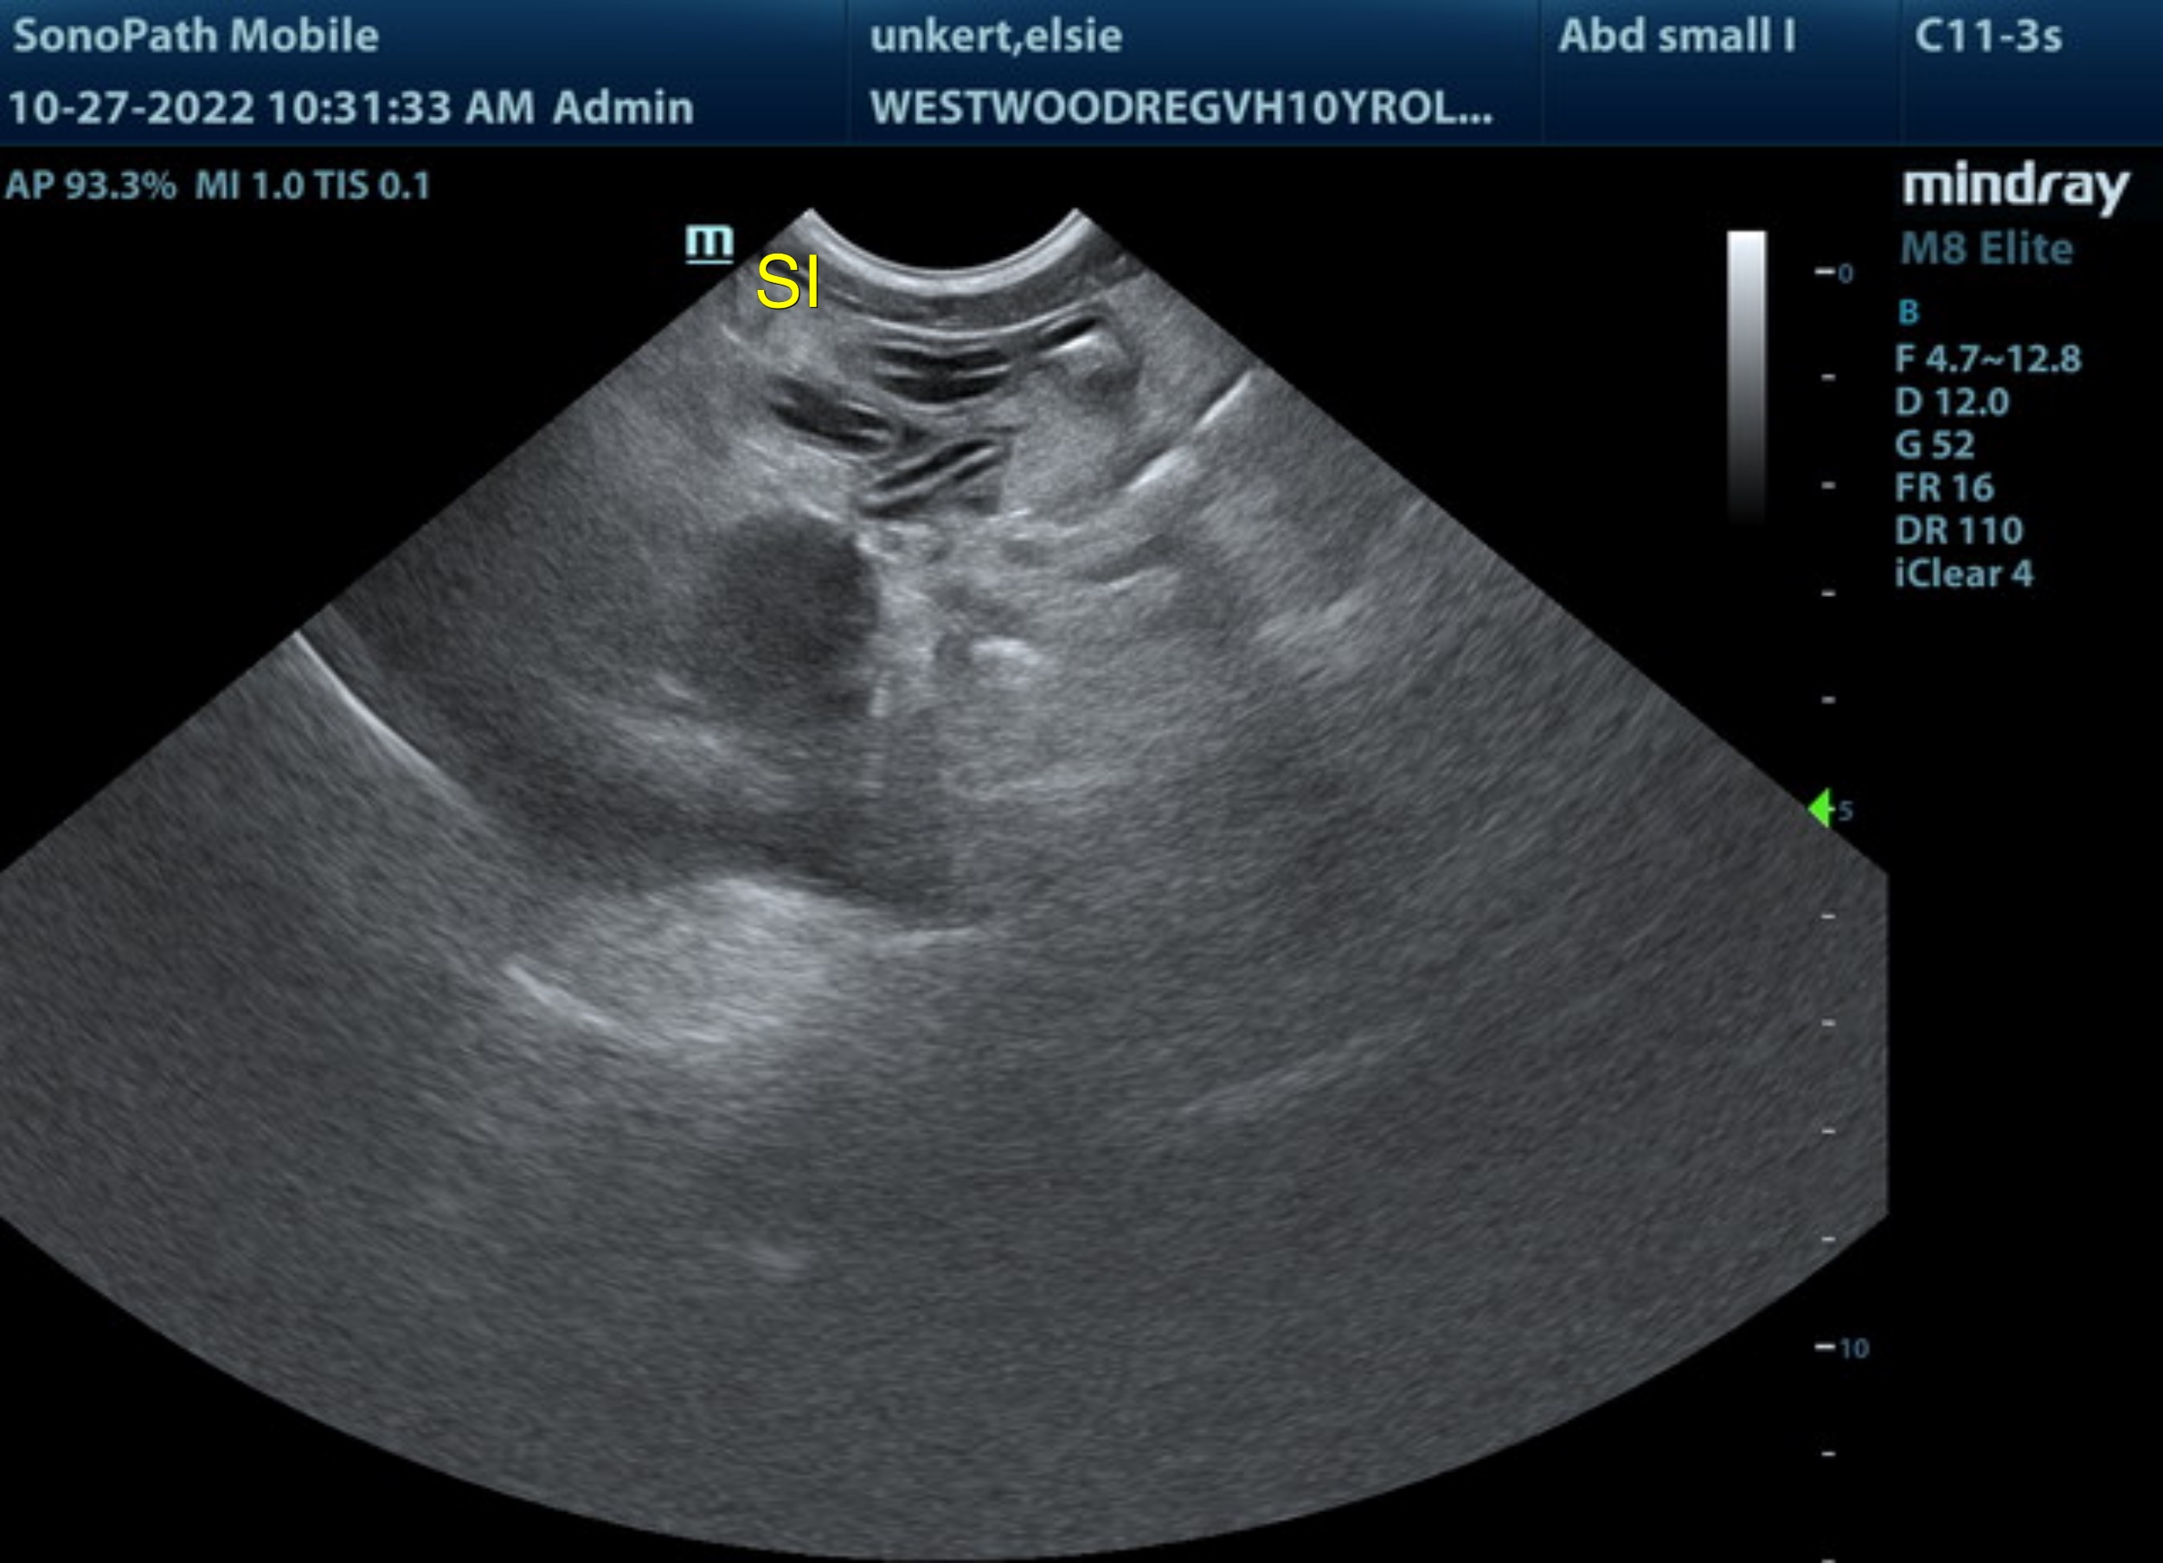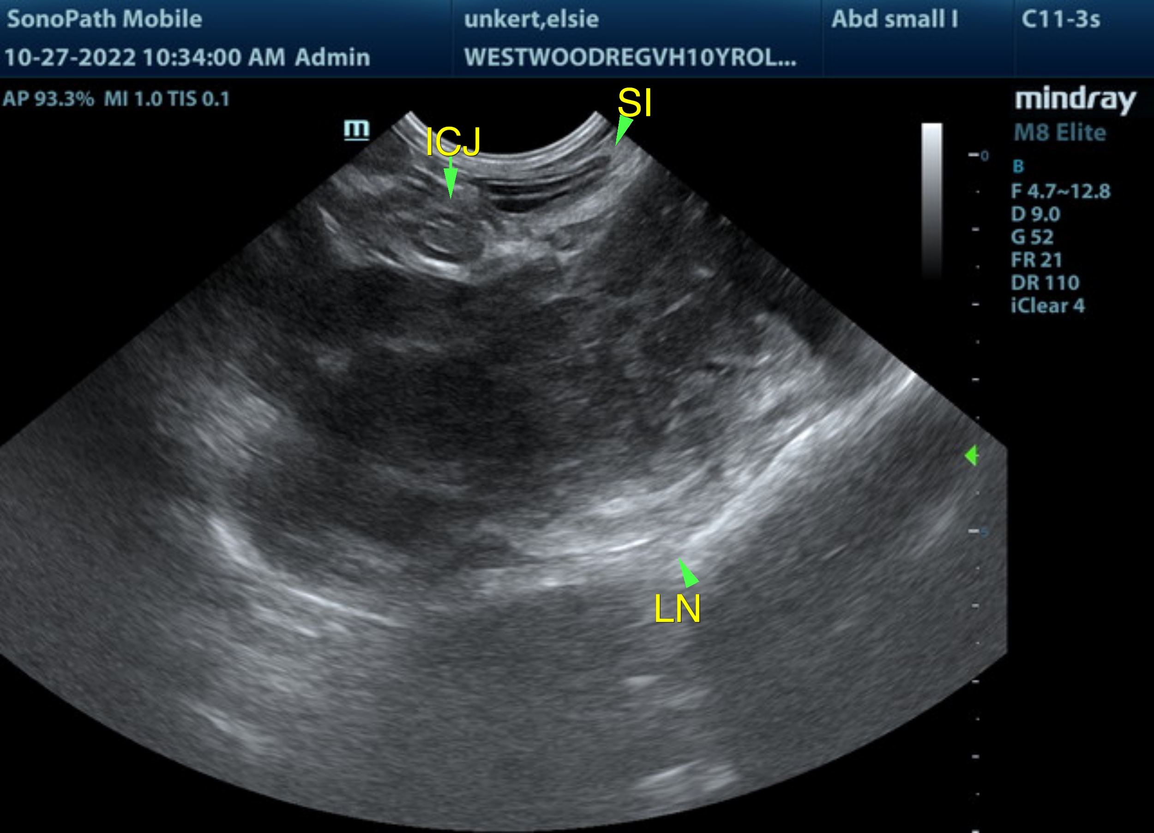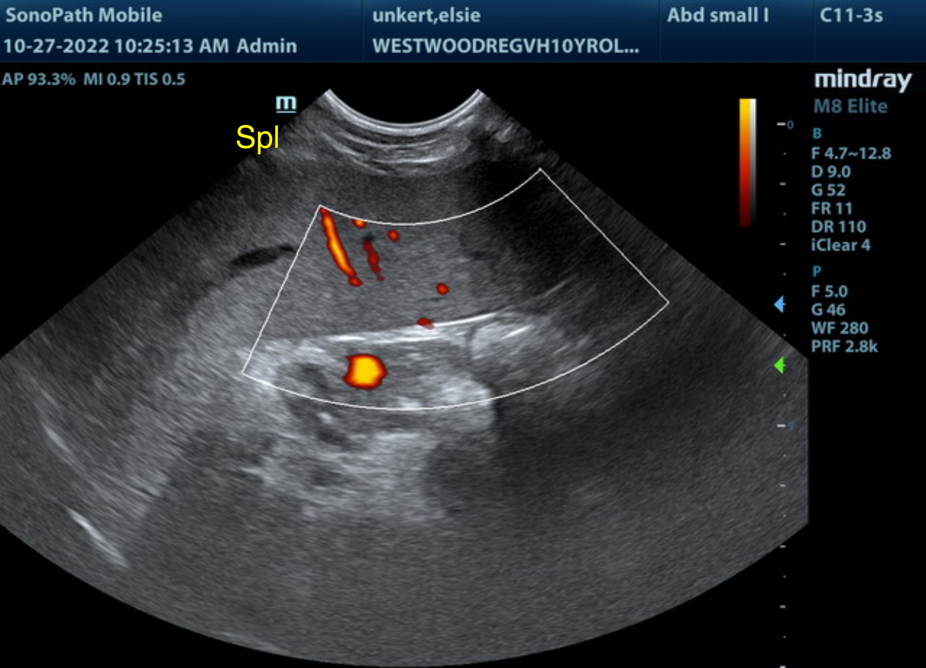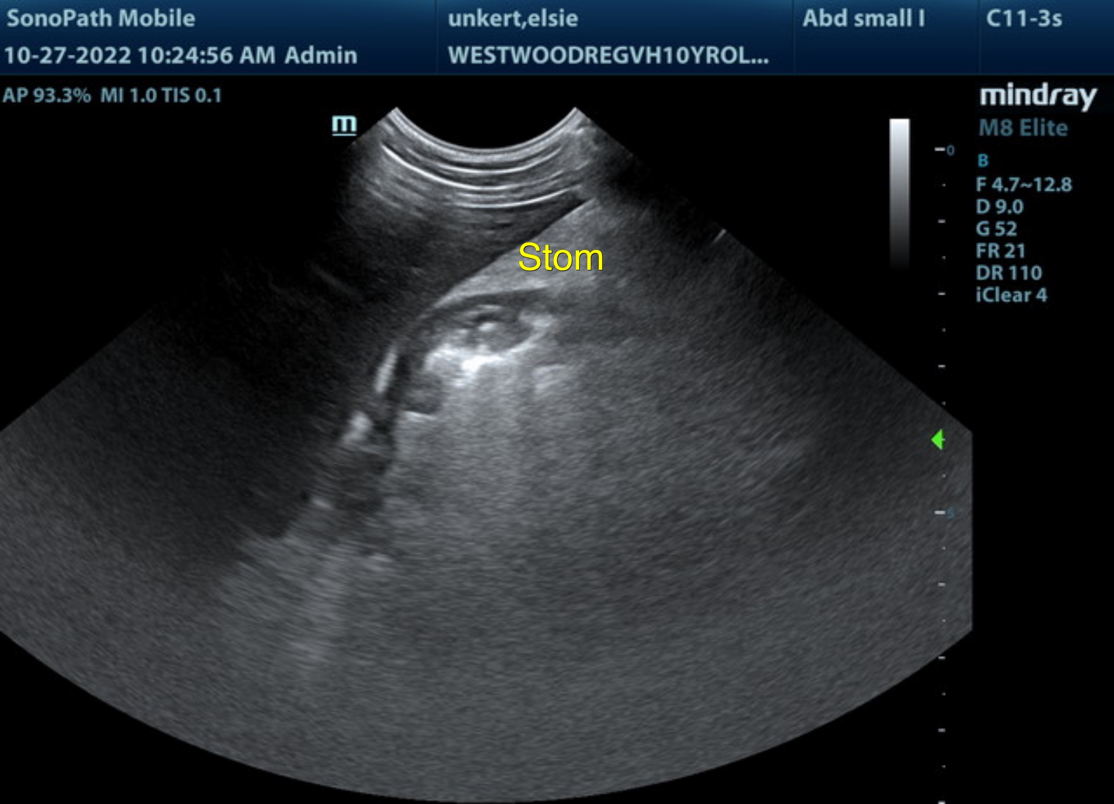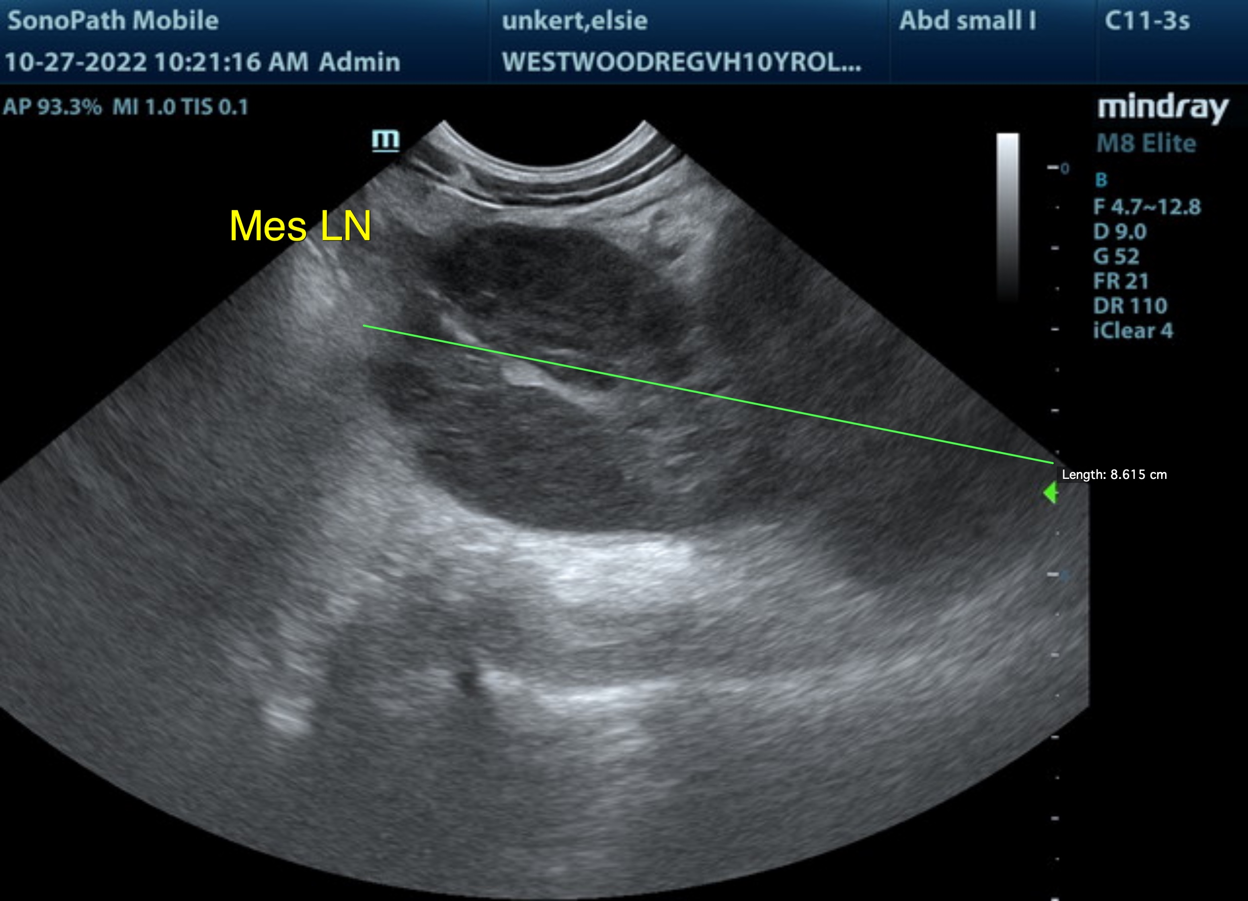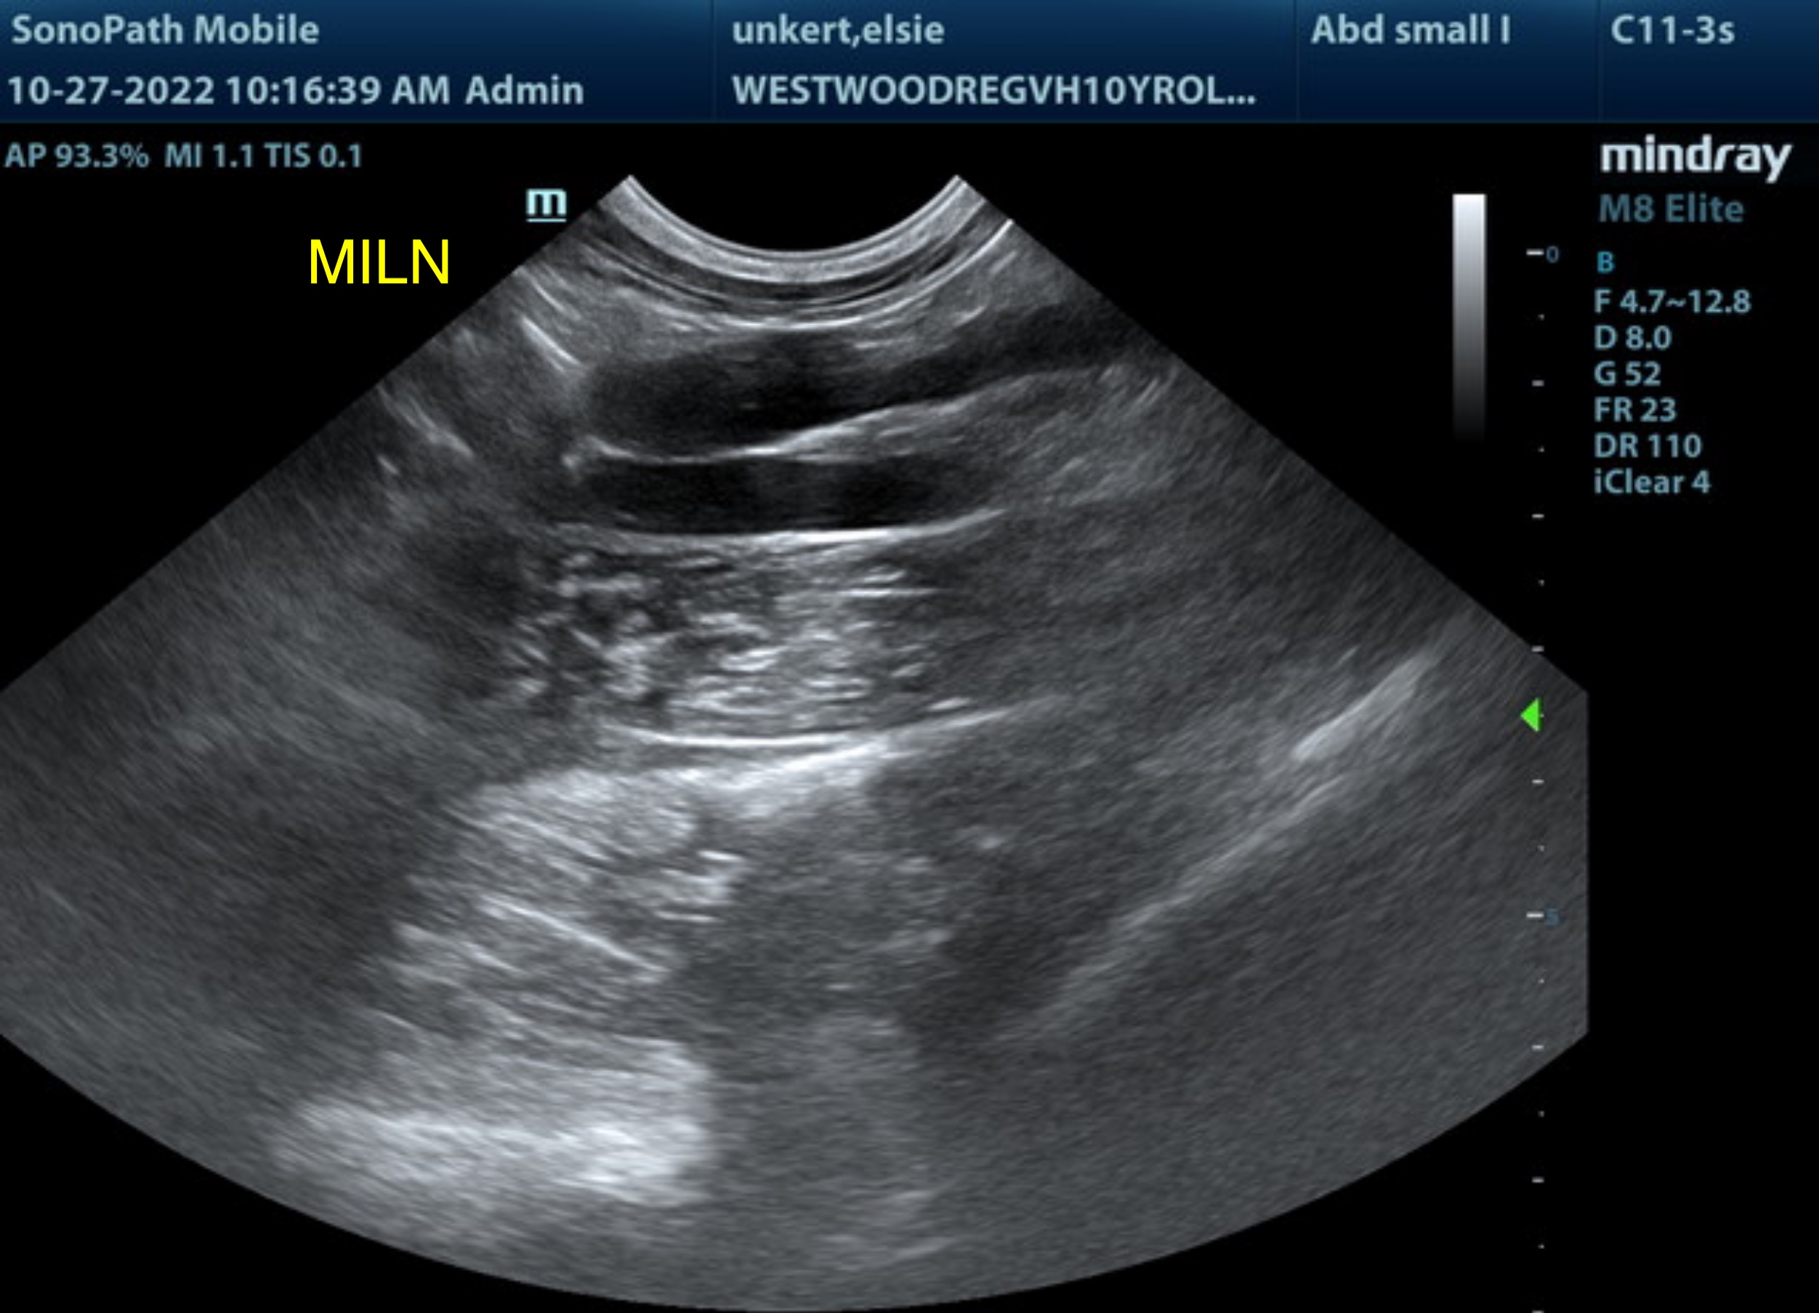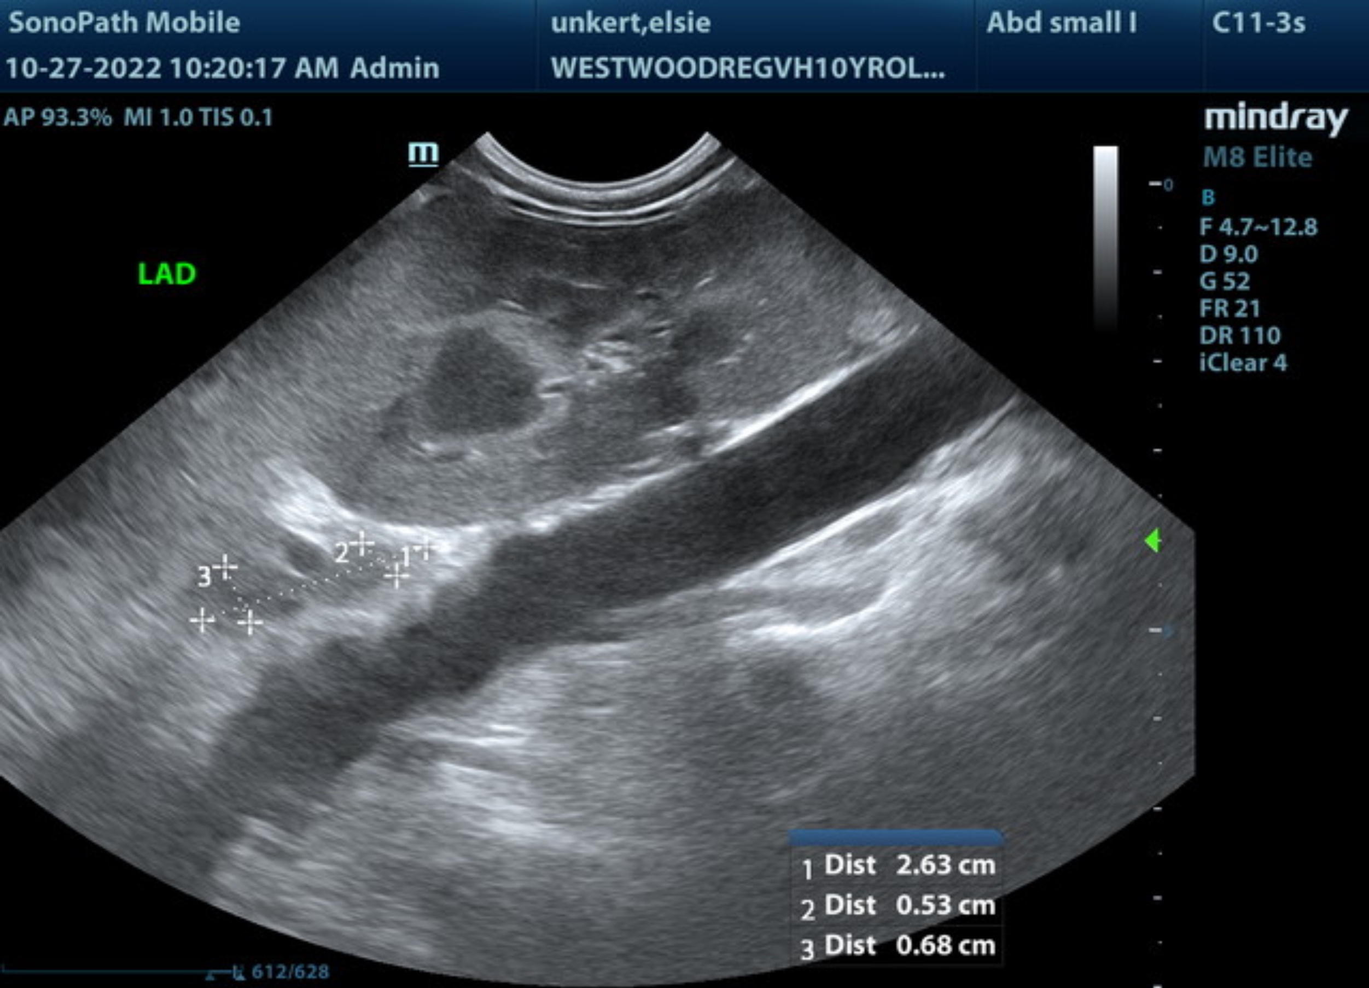

The information and recommendations provided are based on the images presented by the referring veterinarian/sonographer. No evaluation can be communicated regarding pathology that was not visible in the image/video clips provided.

Thank you for this referral. If the clinical or image interpretation does not parallel your findings or if I can be of any further assistance please contact me.

R. McKenzie Daniel, DVM, DABVP (Canine / Feline Practice)
info@SonoPath.com

