PRESENTING CLINICAL SIGNS

Not acting like herself, lethargic. Historically picky with food and now is very picky. Elevated ALT 226.

Current Medications: None listed.
Lab Results: See attached.
Date of Previous IntraPet Ultrasound: No time.
Sedation: Not required to complete full diagnostic ultrasound.
Stat Report: Not requested.

ULTRASONOGRAPHIC EXAMINATION OF THE ABDOMEN
Urinary System
The urinary bladder is moderately distended with anechoic urine. The Bladder wall, trigone, ureteral papillae and visible urethra (to a depth of 2cm) appear normal with no evidence of wall thickening, mucosal irregularities, masses or cystic calculi.

The left kidney has a normal shape and size (3.84 cm). Overall echogenicity is normal with adequate corticomedullary distinction and a typical 1:3 cortex:medulla ratio. There is no evidence of perinephric inflammation or effusion. There is no evidence of pyelectasia, nephroliths, infarcts or hydroureter. Renal vasculature is normal.

The right kidney has a normal shape and size (3.4 cm). Overall echogenicity is normal with adequate corticomedullary distinction and a typical 1:3 cortex:medulla ratio. There is no evidence of perinephric inflammation or effusion. There is no evidence of pyelectasia, nephroliths, infarcts or hydroureter. Renal vasculature is normal.

Adrenal Glands
The left adrenal gland is normal in size measuring 0.44 cm at the caudal pole. It is observed in its normal position cranial to the left renal artery. It is normal in appearance (uniformly hypoechoic) and shape with no evidence of a mass effect.

The right adrenal gland is normal in size measuring 0.40 cm at the caudal pole. It is observed in its normal position between the cranial aspect of the right kidney and the caudal vena cava. It is normal in appearance (uniformly hypoechoic) and shape with no evidence of a mass effect.

Spleen
The spleen is subjectively normal in size, echotexture is homogenous, and the splenic capsule is smooth with no irregularities. The blood flow through the hilus and splenic parenchyma appears normal. No focal parenchymal abnormalities are visualized.

Liver
The liver is subjectively normal in size, and echogenicity with smooth peripheral margins. The parenchyma is homogenous echotexture. The visible portions of the vasculature and biliary tract appear normal. No focal nodules or cystic lesions are observed.

The gall bladder lumen is moderately distended. The wall of the gall bladder is not thickened and has a smooth mucosal surface. There is a moderate amount of hyperechoic sludge. The cystic and common bile ducts are normal/not visible.

Gastrointestinal
The stomach contains minimal luminal contents. It measures at a normal thickness of <0.7cm with some variability due to the presence of rugal folds. The distinction of the gastric wall layers is adequate and there is no impression of reduced peristaltic activity. No masses or focal lesions were observed.

The visualized areas of duodenum, jejunum and ileum have a relatively uniform diameter with minimal fluid distension. Wall thickness is normal. Bowel loops follow a curvilinear path with distinct wall layering maintaining the typical 1:3 muscularis:mucosa layer ratio. Duodenum wall measured 0.30 cm. Jejunum wall measured 0.27 cm. Visualized peristalsis appears appropriate. There were no focal lesions consistent with obstruction or a mass effect observed.

The ileocecal junction was visualized and exhibited normal intact wall layering and is subjectively of normal thickness. Sections of colon are visualized with formed fecal material and gas shadowing distally. There is no observed focal or generalized colon wall thickening or loss of layering.

Pancreas
The pancreas is normal and isoechoic to surrounding mesentery. There is no evidence of nodules or cystic lesions. There is no evidence of regional mesenteric inflammation or fluid.

Free Abdomen
Evaluation of the peritoneal cavity did not reveal any evidence of effusion, or subjective lymphadenomegaly. The Medial iliac nodes appear normal and there was no evidence of a caudal aortic thrombus at the bifurcation. The omentum is of normal uniform echogenicity.

ULTRASONOGRAPHIC FINDINGS

- Moderate gallbladder debris – The significance of the aggregated gallbladder sludge is unclear. This could represent an early mucocele, cholestasis, or may be secondary to fasting.
INTERPRETATION OF THE FINDINGS & FURTHER RECOMMENDATIONS

No focal abnormalities were visualized today associated with the liver. Unfortunately, there are many causes for an elevation in ALT, which cannot be readily identified by ultrasound alone. Additionally, some small portosystemic shunts, etc. can be difficult to detect with ultrasound alone, although there is no strong indicators for a shunt in this patient.

- Consider close evaluation of history for possible toxic changes examine medications, diet, dietary indiscretion etc...
- Consider PCR on urine/serum for leptospirosis (if not on antibiotics)/serology if recent antibiotic history
- If not already done, consider pre and post prandial bile acids to evaluate liver function
- Consider Fine needle aspirate if round cell neoplasia is on your differentia list (25 g needle, normal coags)
- If no response to medical care (denamarin, antibiotics,+/- ursodiol etc…) Consider liver biopsy with samples obtained for histopathology, culture, and copper levels.

The gallbladder appears to have a large amount of hyperechoic sludge within the lumen. The walls appear normal, and there is no evidence of an early mucocele. Recommend either continued monitoring or starting Ursodiol.
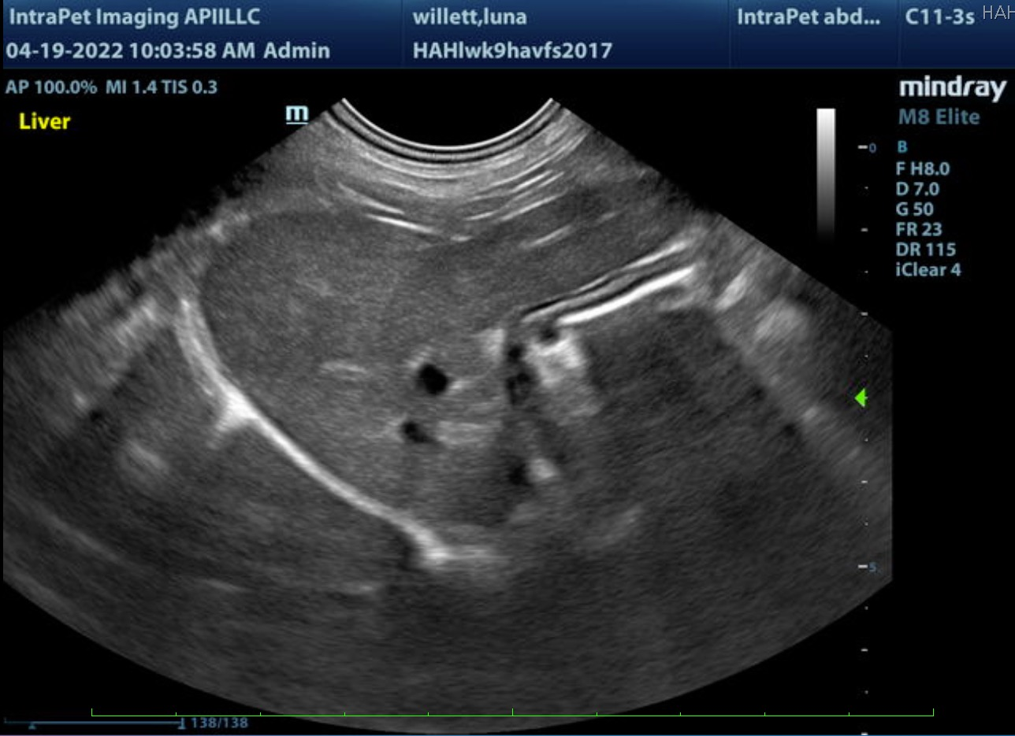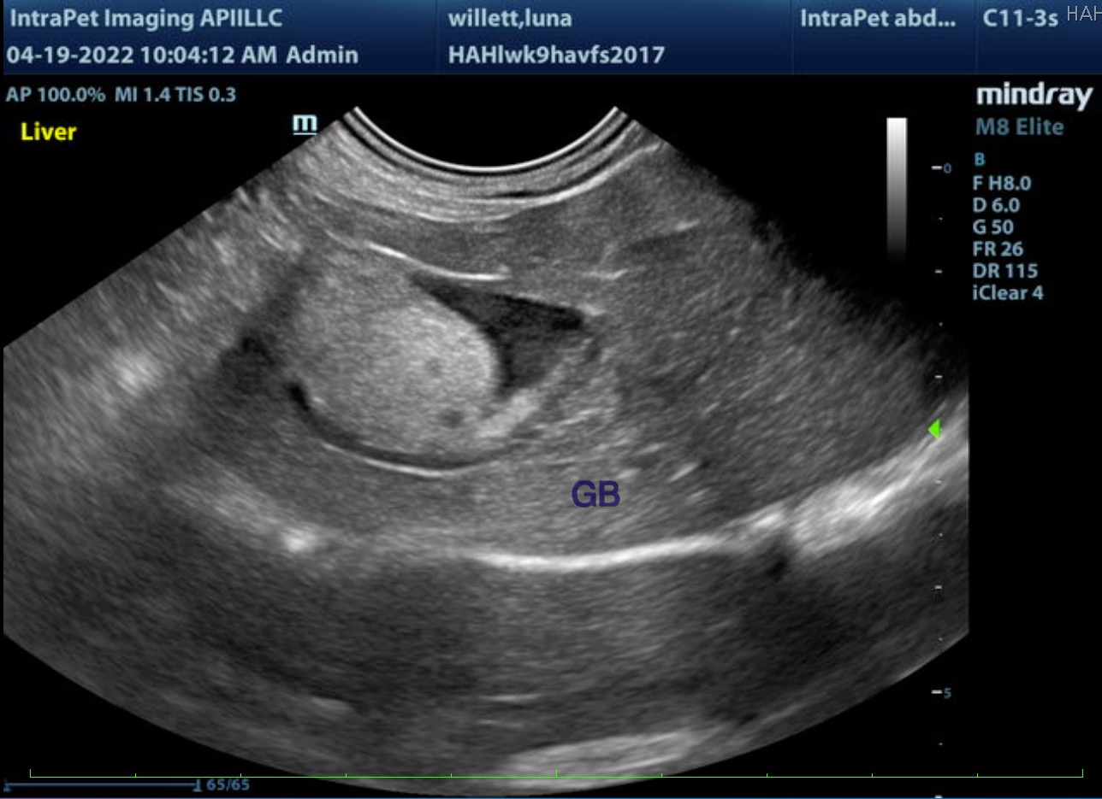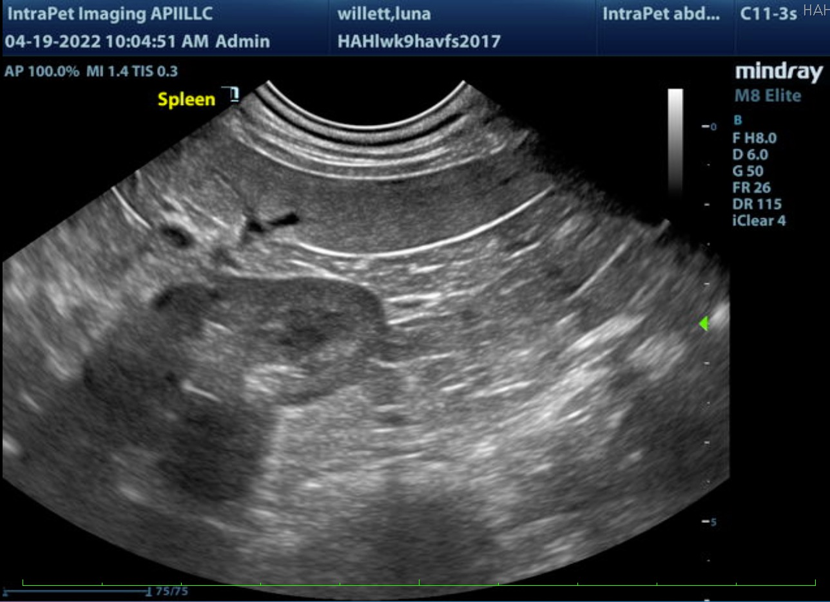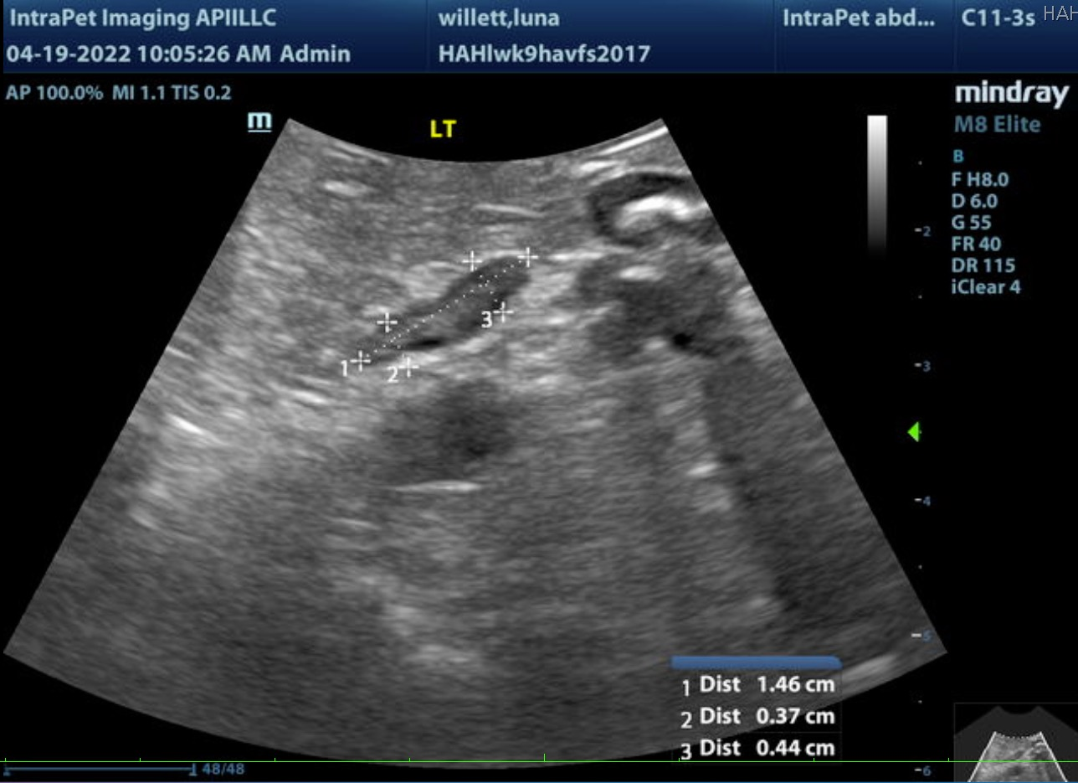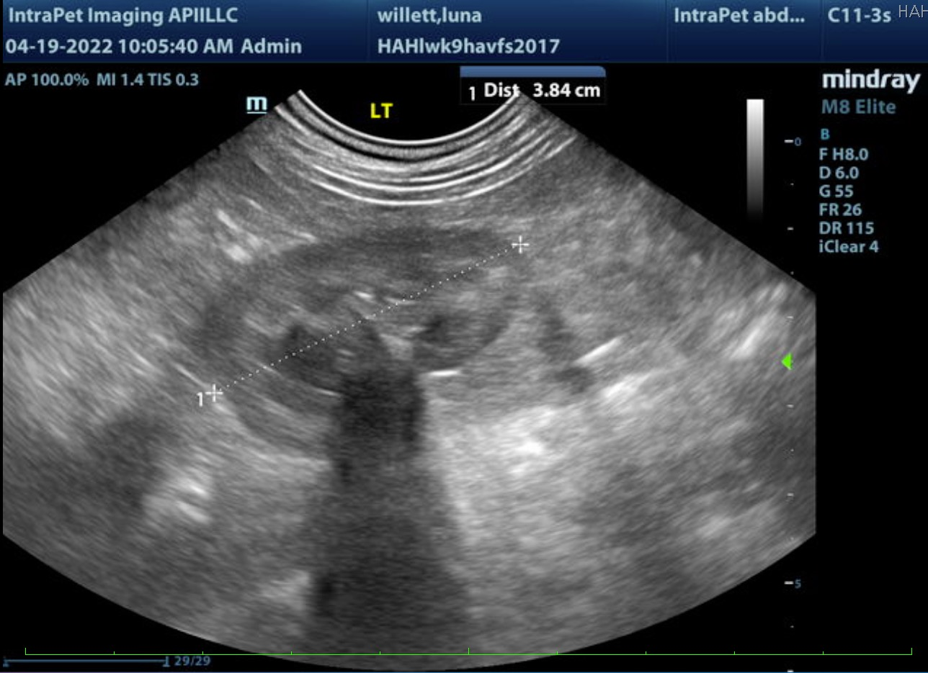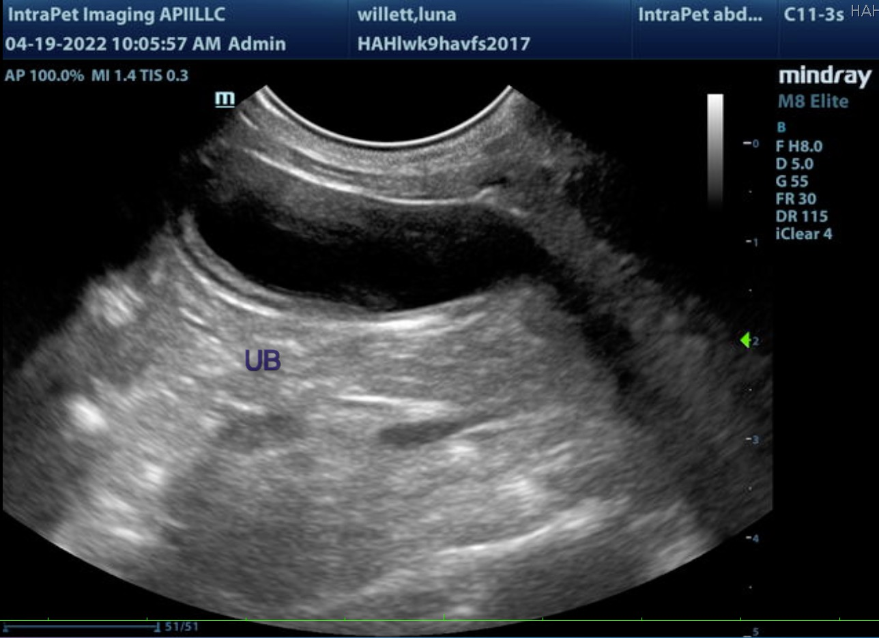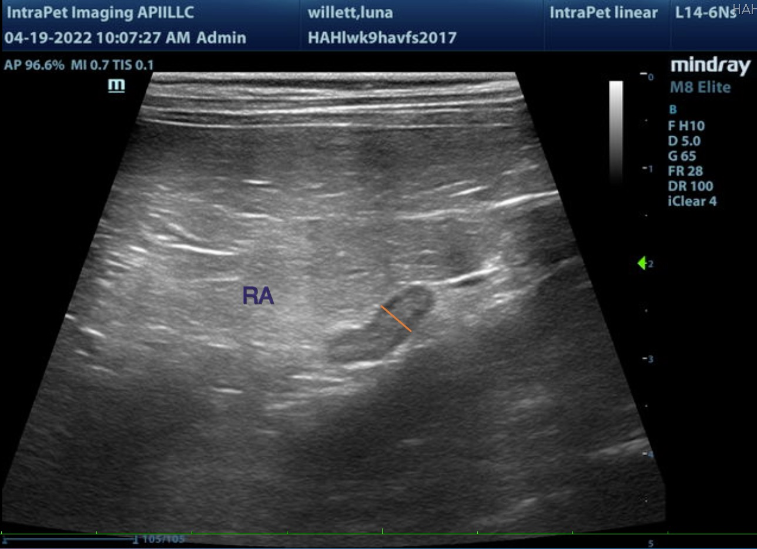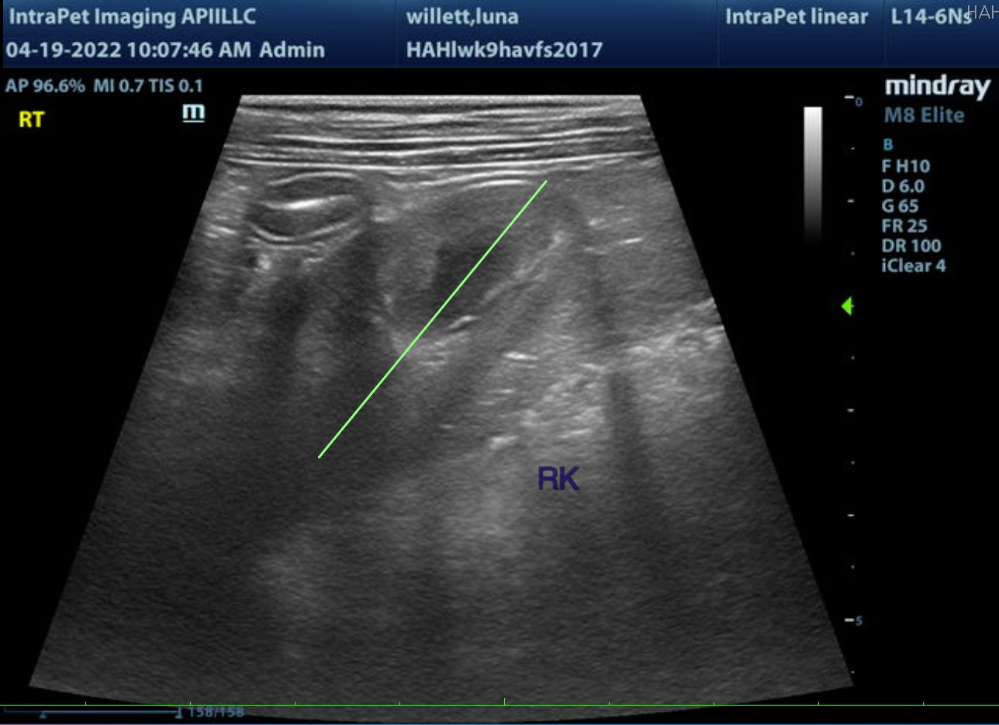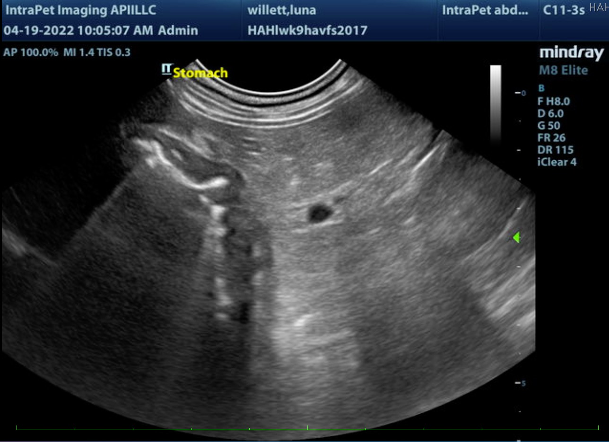

The information and recommendations provided are based on the images presented by the referring veterinarian/sonographer. No evaluation can be communicated regarding pathology that was not visible in the image/video clips provided.

Thank you for this referral. If the clinical or image interpretation does not parallel your findings or if I can be of any further assistance please contact me.

Kathleen Sennello DVM,MS, Diplomate ACVIM (Small animal Internal Medicine)
kathleen.sennello@sonopath.com

