PRESENTING CLINICAL SIGNS
History: Vomiting / Bloody diarrhea, Hepatopathy, CPL abnormal, Hypocalcemia. R/o pancreatitis vs all other. Current meds: IVF, Cerenia, Famotidine, Metronidazol
Abnormal PE/Chem/CBC/UA Results: BUN 33, Cr 0.9, K+ 2.8, ALT 777, GGT 21, Lipase 344
Total # of Files Uploaded

ULTRASONOGRAPHIC EXAMINATION OF THE ABDOMEN

Urinary System
The urinary bladder was normal in size and shape. The serosal and mucosal surfaces were smooth and curvilinear. The bladder wall was normal in thickness for the volume of urine present. The urine was anechoic with no visible sediment or uroliths. The ureters were not visible, which is normal. The trigone was normal. The pelvic urethra was visualized to a depth of 4.00 cm and was normal in thickness and tone.

Both kidneys were a normal size and shape, with a smooth capsule contour. A normal 1:3 cortex to medulla ratio was maintained. The echogenicity of the cortex was normal. There was a hyperechoic corticomedullary band, consistent with a medullary rim sign. This is a non-specific finding. It has been associated with interstitial nephritis, hypercalcemia, tubular necrosis, lymphoma and Leptospirosis. However, it is non-specific and can be seen in normal kidneys. The left kidney measured 5.20 cm in length. The right kidney measured 5.30 cm in length.

The iliac trifurcation was visualized and evaluated with color doppler. There was normal vascular perfusion with no evidence of thrombus formation. There was no iliac lymphadenopathy.

Adrenal Glands
Both adrenal glands were visualized and found to be normal in size, and shape for the age and breed. The parenchyma displayed normal echogenicity. There was no evidence of capsular expansion or pericapsular inflammation. There were no nodules or masses visible. The left adrenal gland measured 3.00 mm at the caudal pole, 5.00 mm at the cranial pole and 2.60 cm in length. The right adrenal gland measured 5.00 mm at the caudal pole, 15.00 mm at the cranial pole and 1.90 cm in length.

Spleen
The spleen was normal in size, shape, and position. There was a smooth capsule contour. The parenchyma was finely textured and homogeneous. There were no visible masses, nodules or evidence of infiltrative disease.

Liver/Gallbladder
The liver is subjectively normal in size with a smooth capsule contour. The parenchyma is overall homogenous with mild increase in portal markings. The gallbladder was normal in size and shape with a mildly increased gallbladder wall, and the potential for a very small amount of fluid around the gallbladder. The gallbladder contents are anechoic. The cystic and common bile ducts were normal in size and diameter, with no evidence of obstruction.

Gastrointestinal
The stomach was empty with a mildly thickened stomach wall with maintained wall layering. The mucosa is primarily thickened. The small intestine is normal in wall thickness and layering with a very mild increase in mucosal thickening, likely representing enteritis. The colon was moderately full with apparent liquid or semi-formed feces. The colonic wall thickened, primarily due to muscularis thickening. The colonic wall measured 3.00 mm in width. There was no visible, obstruction, masses or nodules within the GI tract.

Pancreas
The pancreas was isoechoic to the surrounding mesentery with normal size, shape and capsule contour. There was no evidence of inflammation or masses within the right and left limbs or body of the pancreas. The pancreatic duct was curvilinear without notable deviation.

Free Abdomen
Very mild mesenteric reactive lymphadenopathy.

FINDINGS

- Medullary rim sign, mild, both kidneys
- Mild increased portal markings in liver
- Mild gastroenteritis pattern
- Moderate colitis pattern

INTERPRETATION OF THE FINDINGS & FURTHER RECOMMENDATIONS

The clinical and sonographic presentation is most consistent with an acute hepatic insult (toxin, infectious, etc.). The pancreas appears normal sonographically, likely ruling out a severe pancreatitis as the cause of the clinical signs. The GI changes are overall mild, with no visible obstruction or foreign material in the GI tract.

Lepto titers/PCR are indicated, as it is a possibility. Hepatic support, continued IVF, electrolyte and GI support are all indicated.

The medullary rim sign is nonspecific and can be seen in both normal and abnormal kidneys. When associated with renal pathology, it has been linked with interstitial nephritis, hypercalcemia, tubular necrosis, lymphoma and Leptospirosis. However, it can be seen in normal kidneys as well.

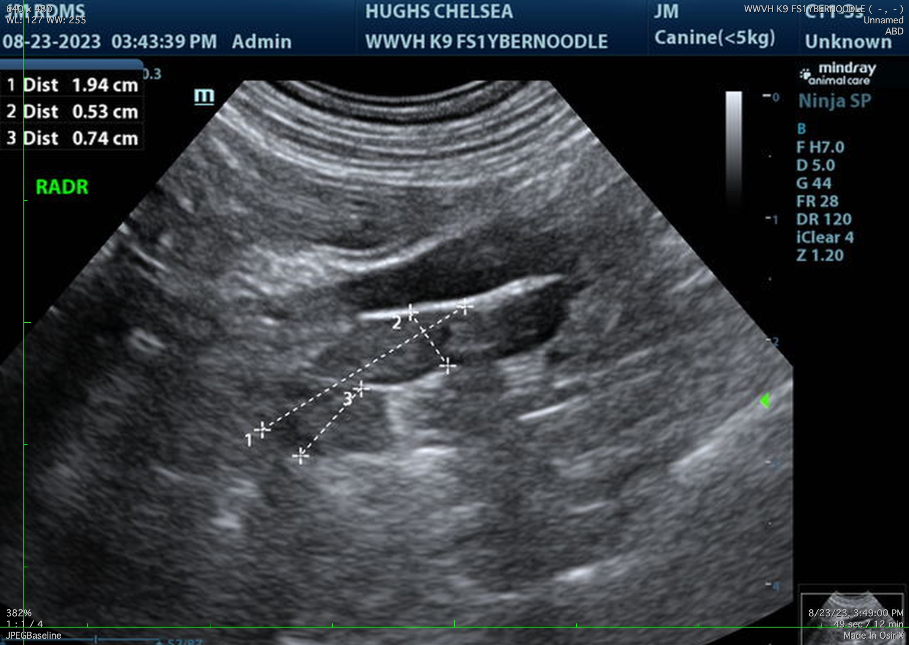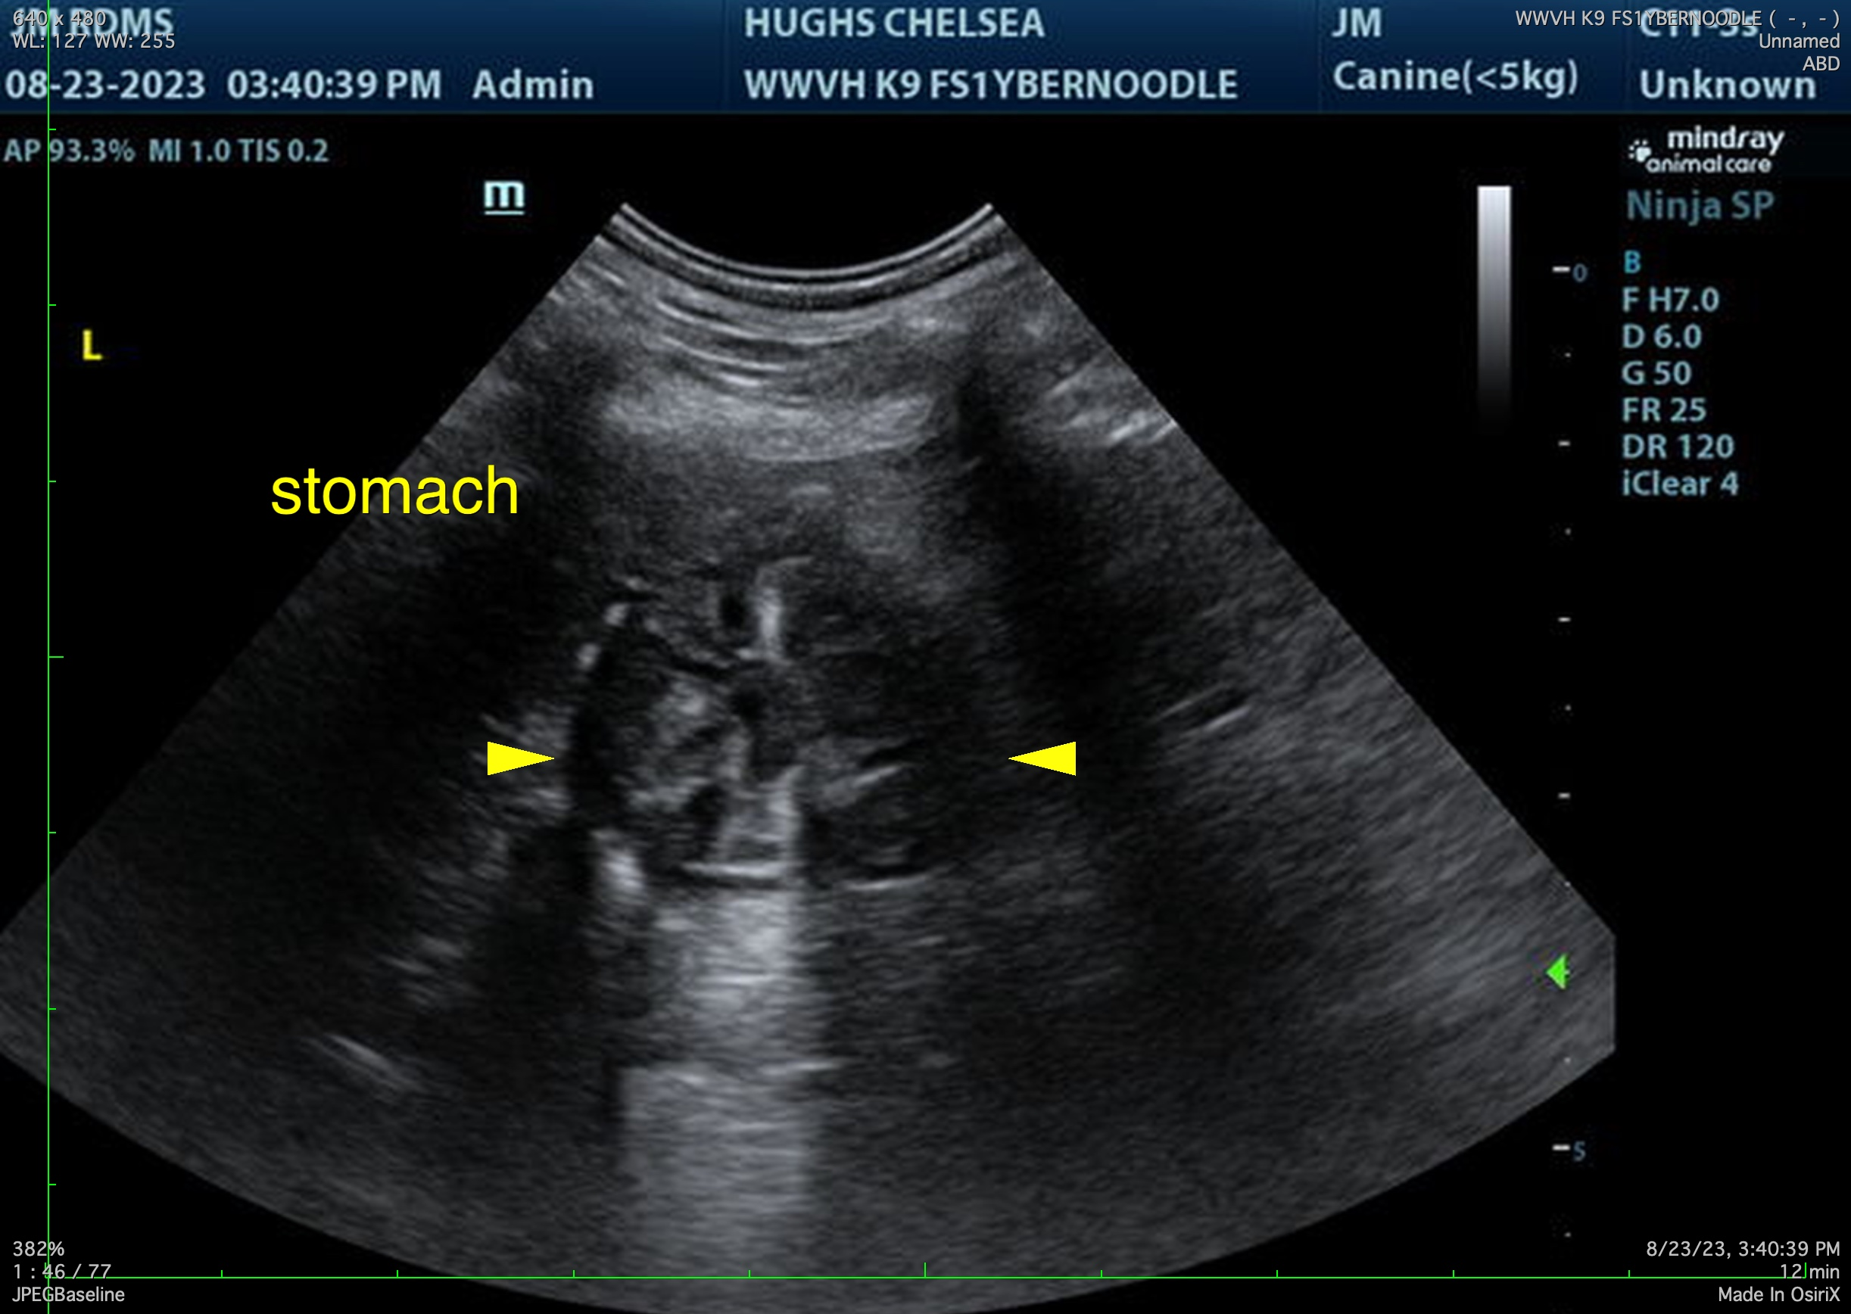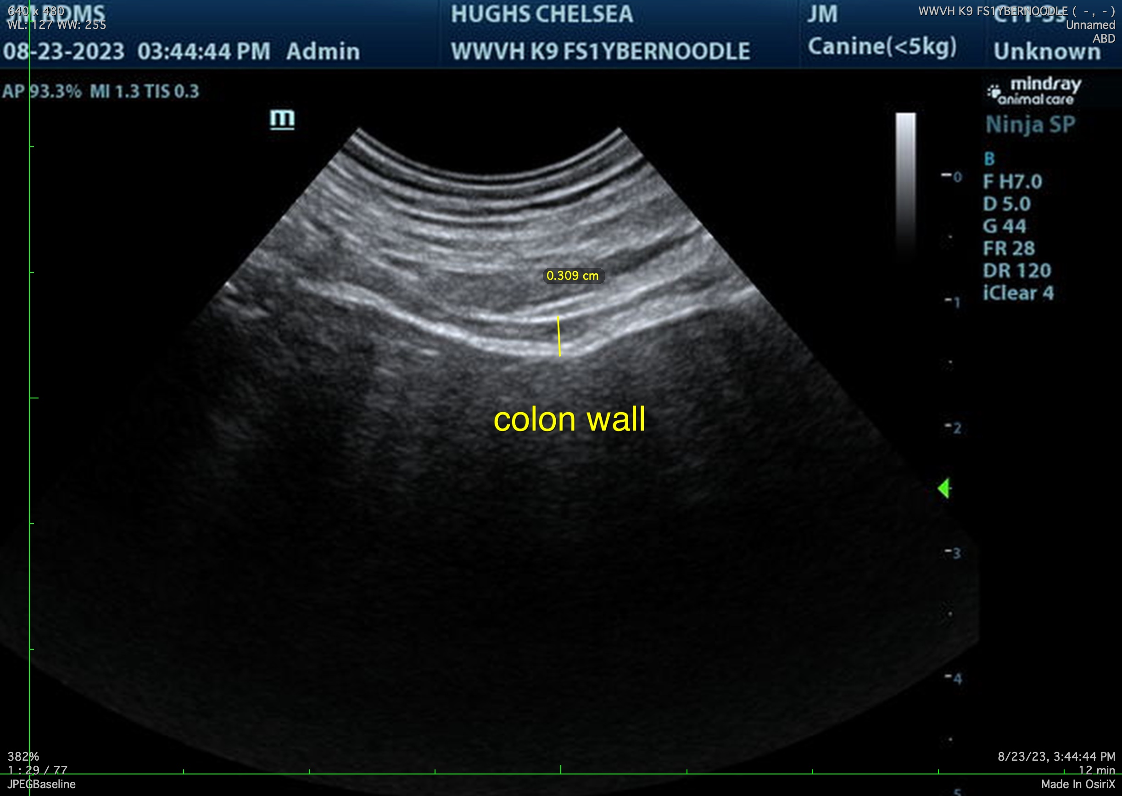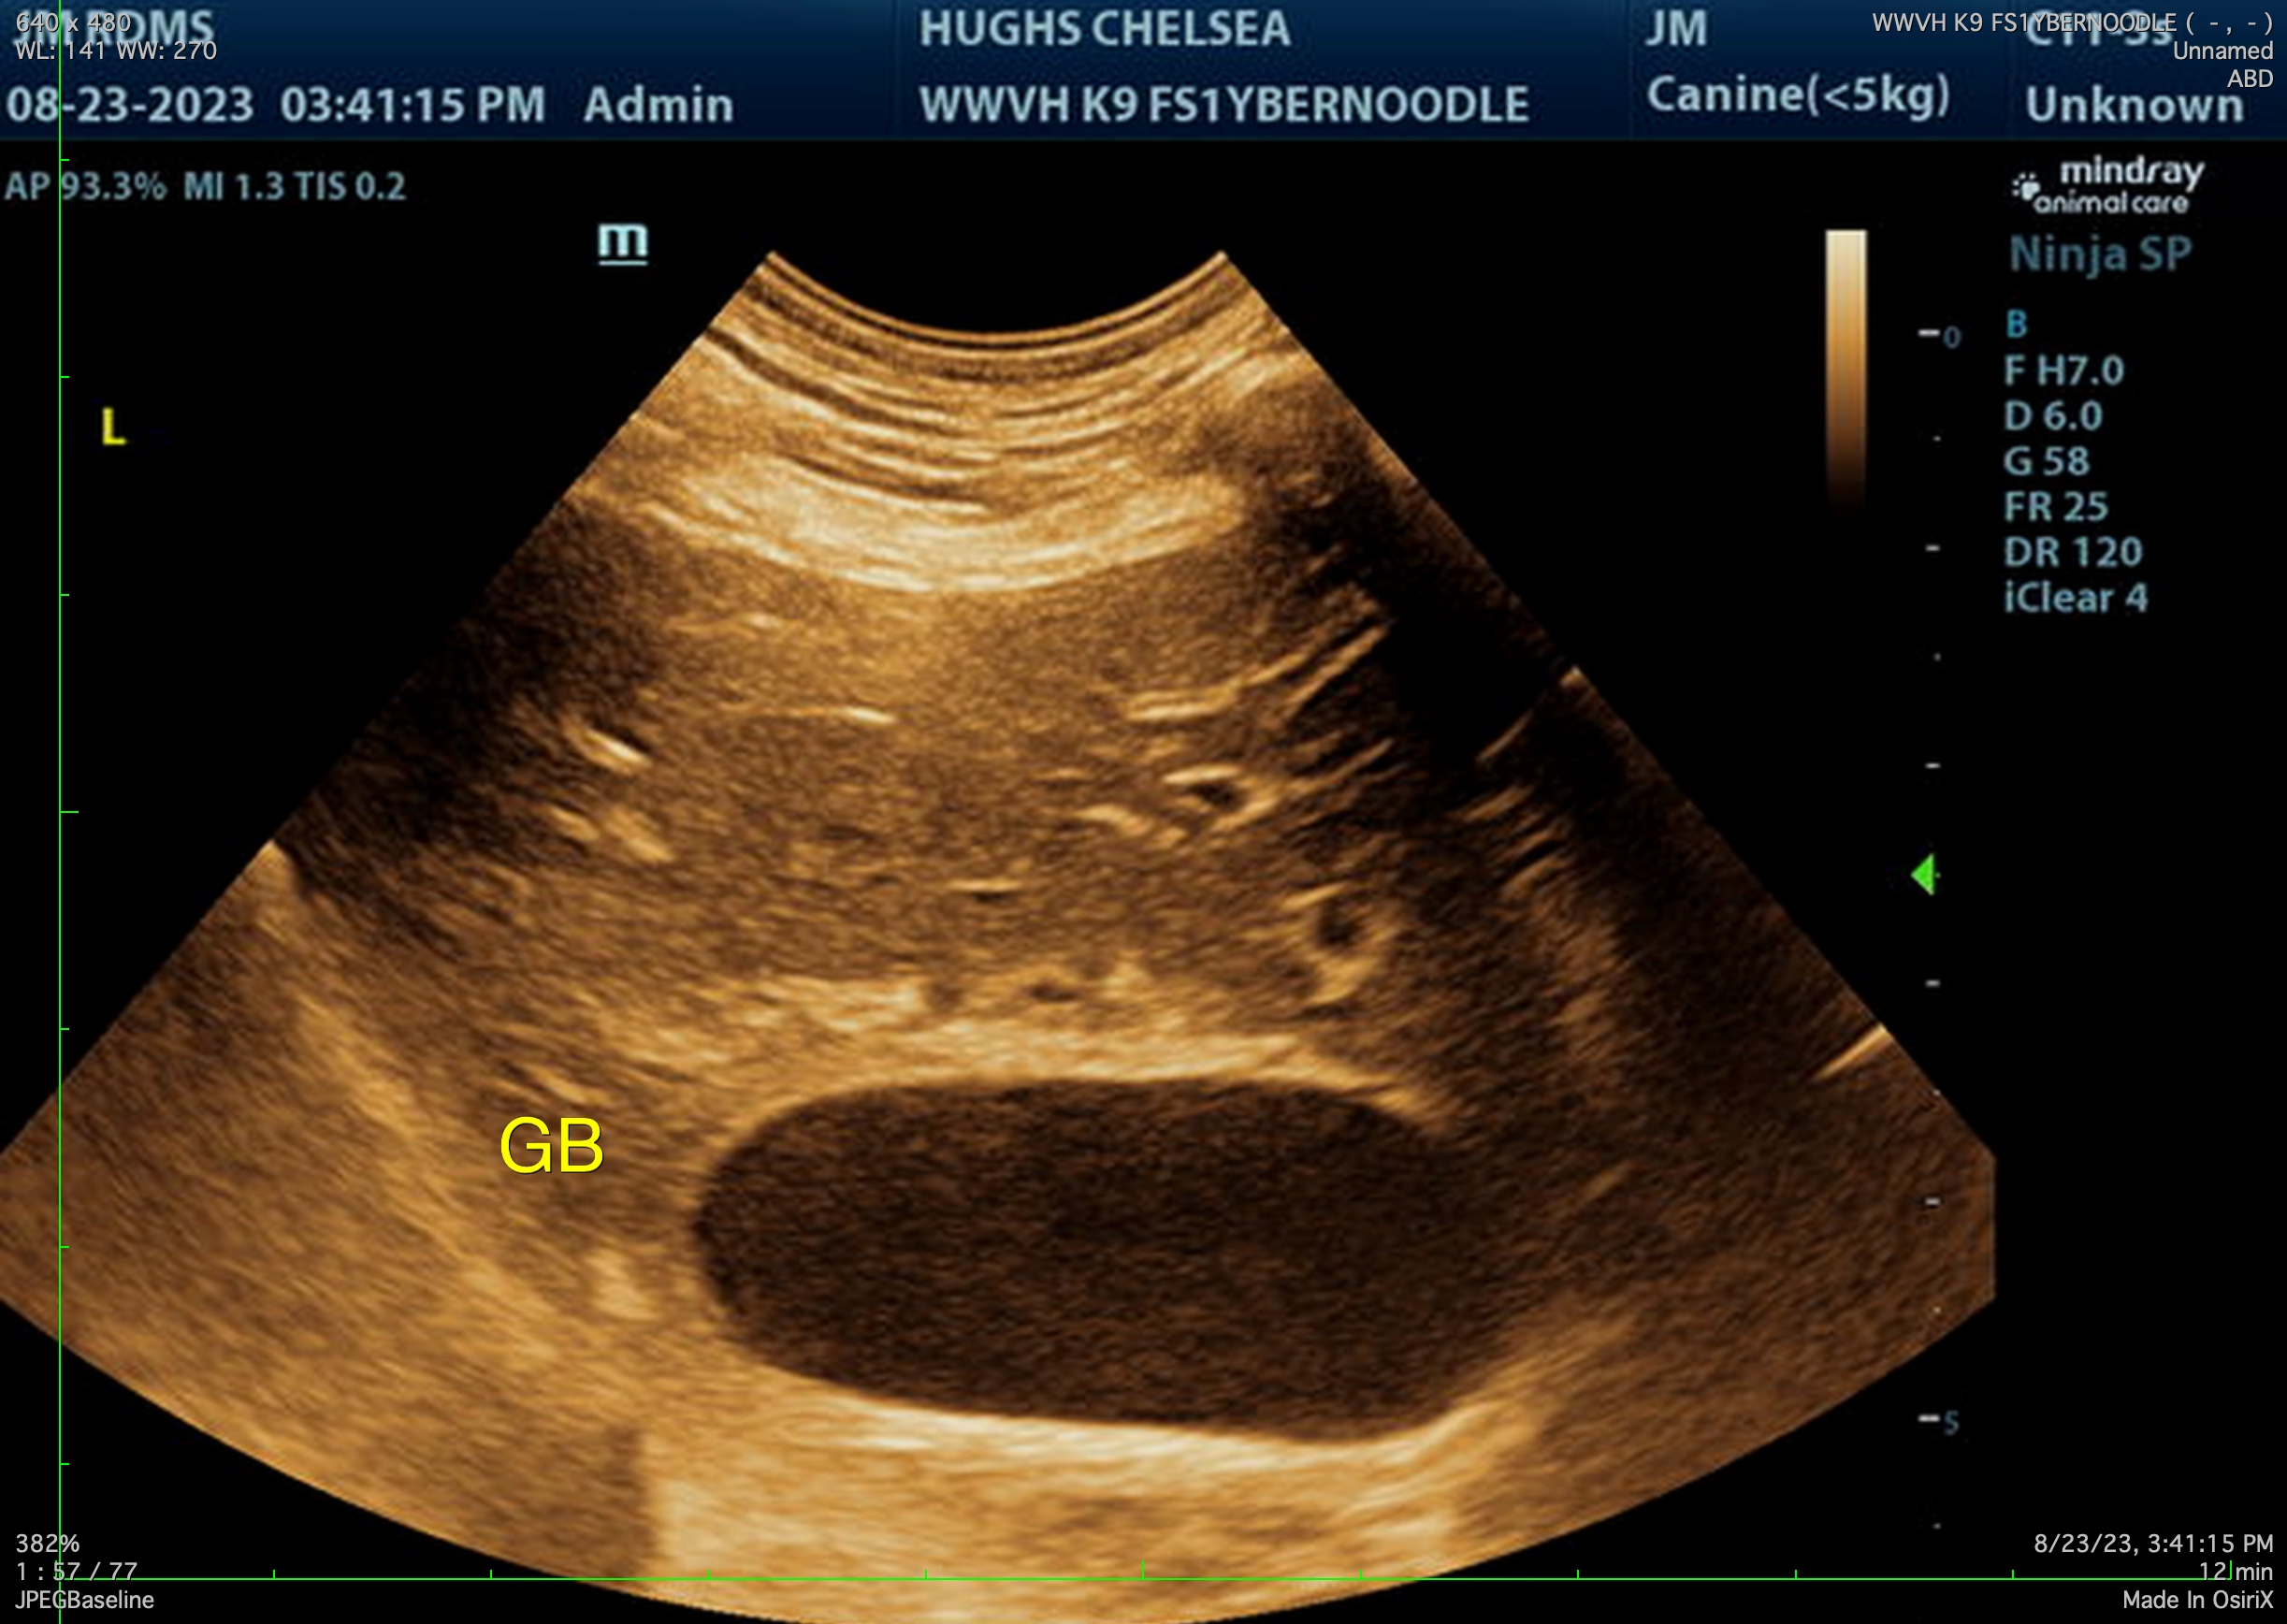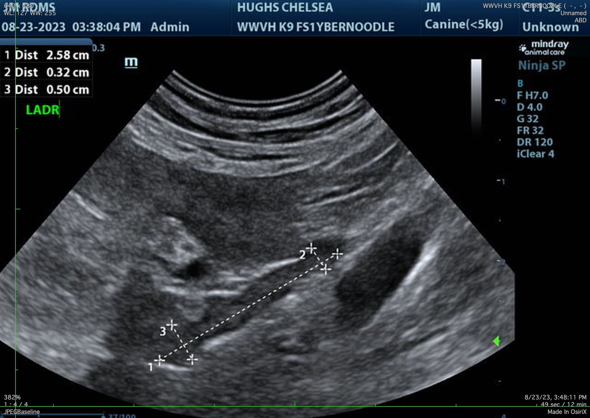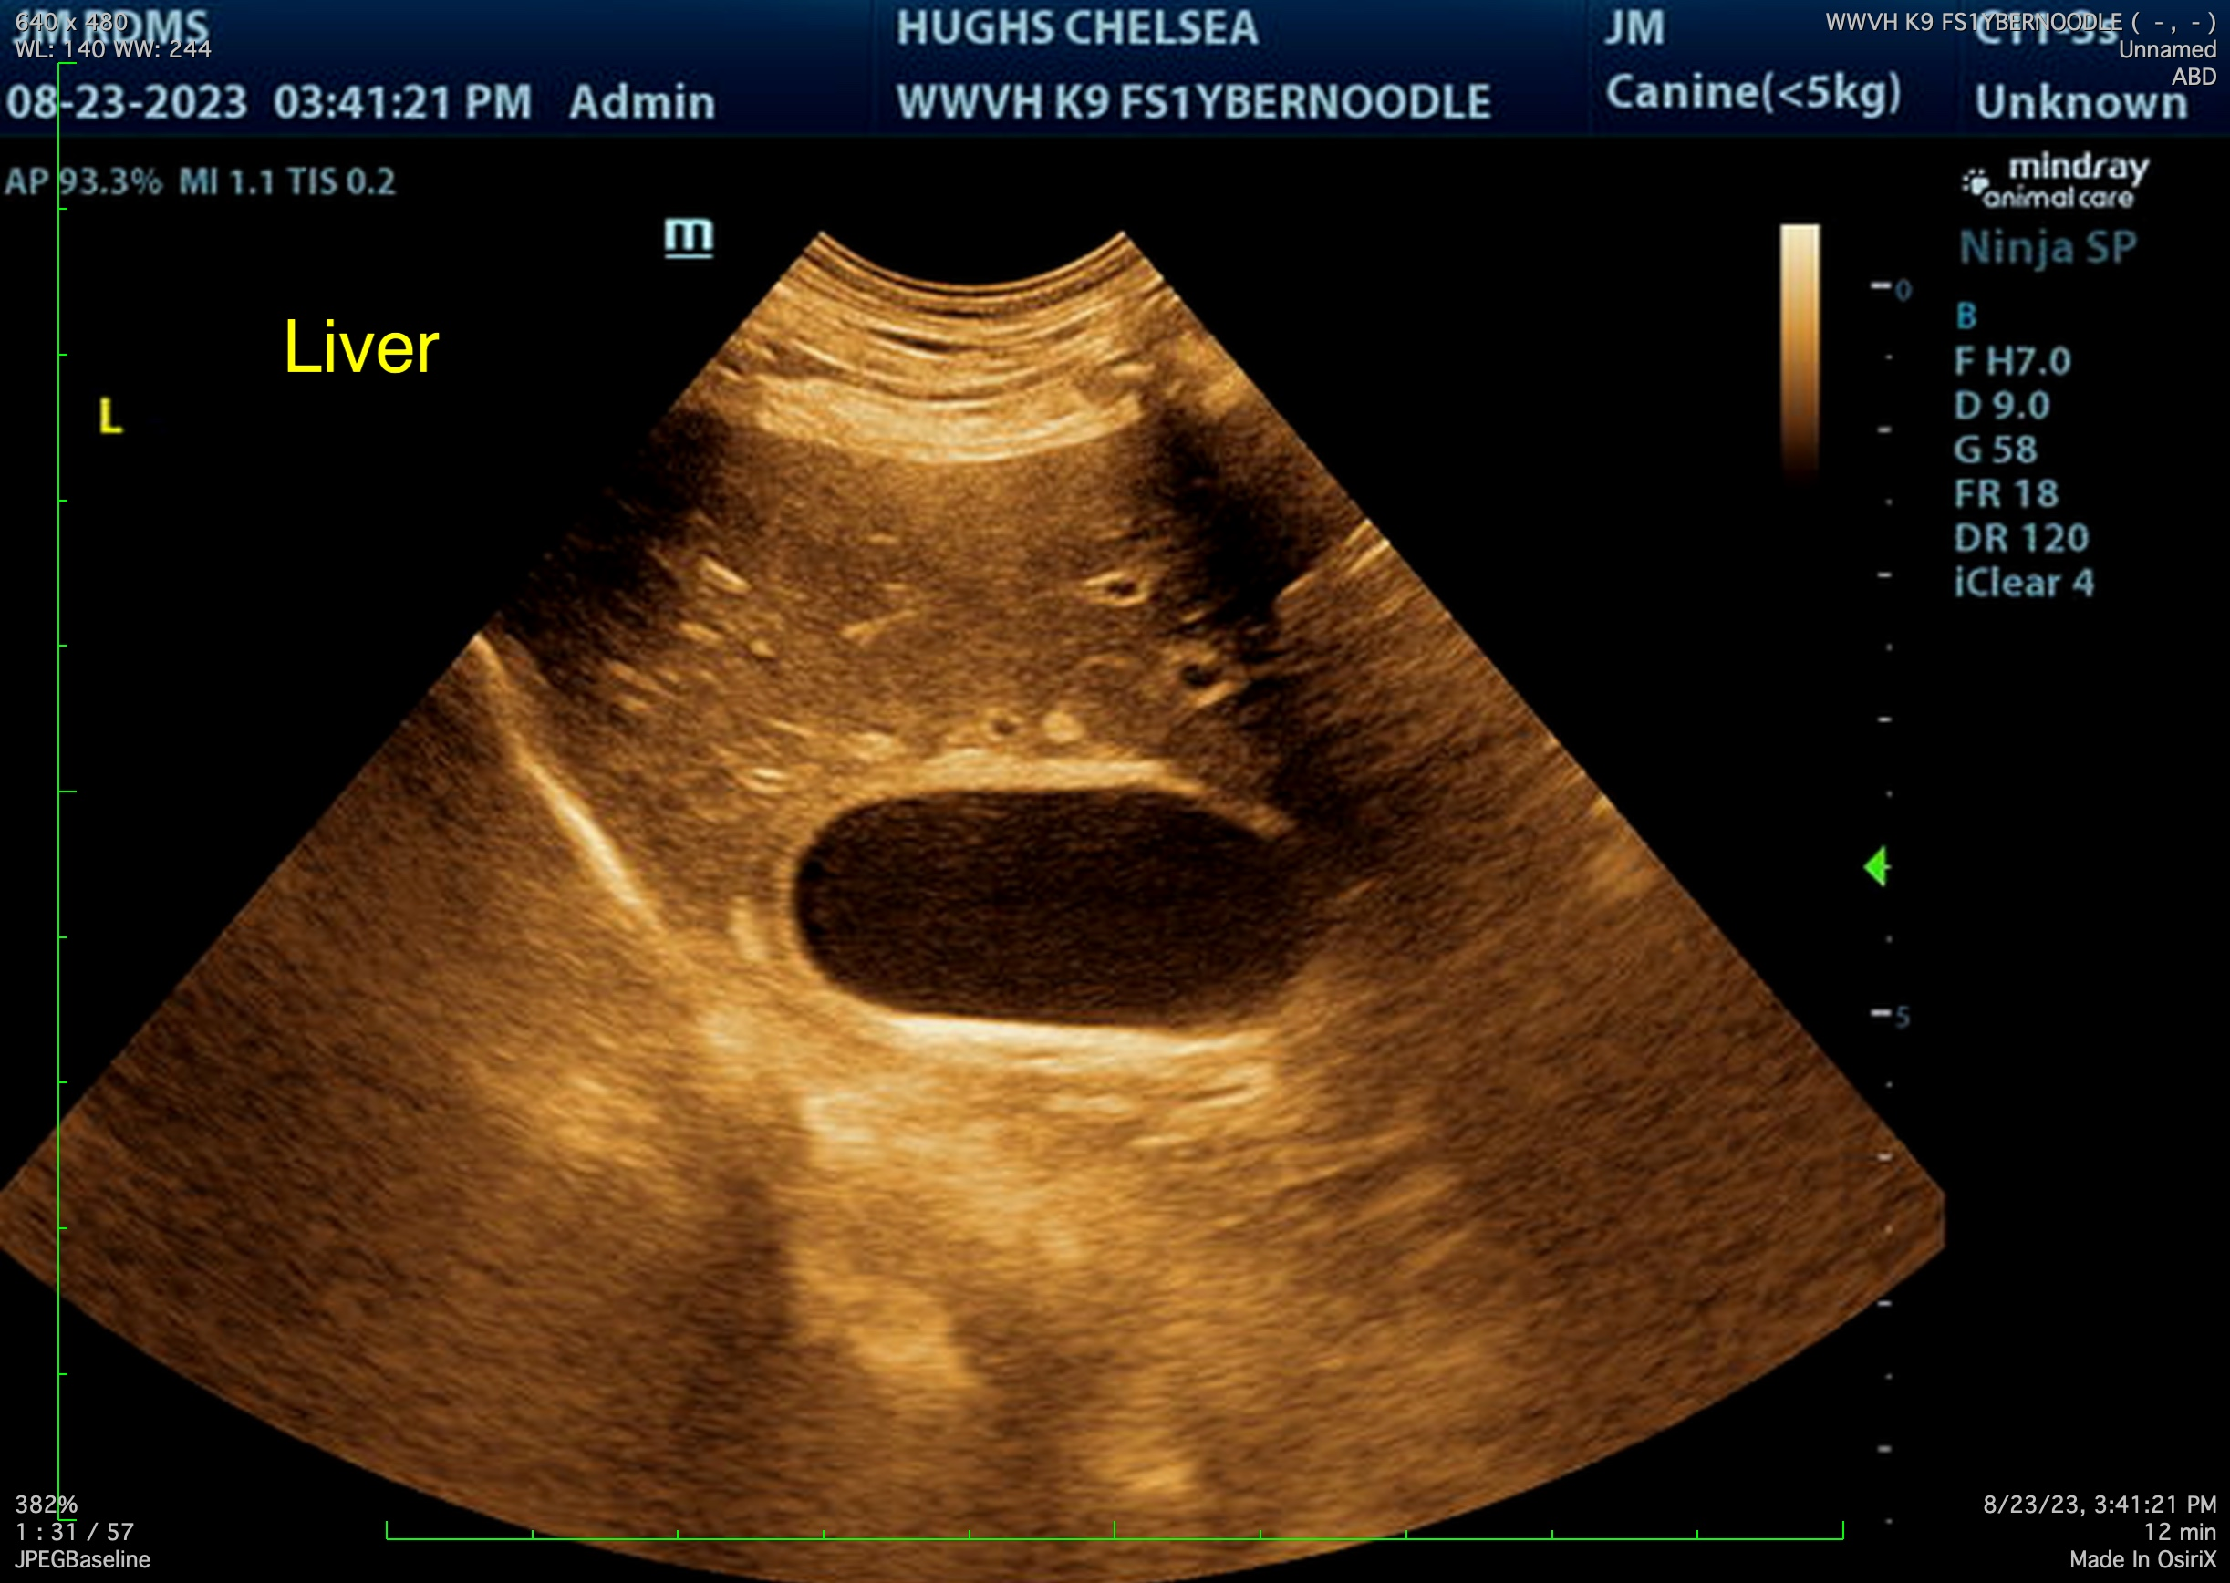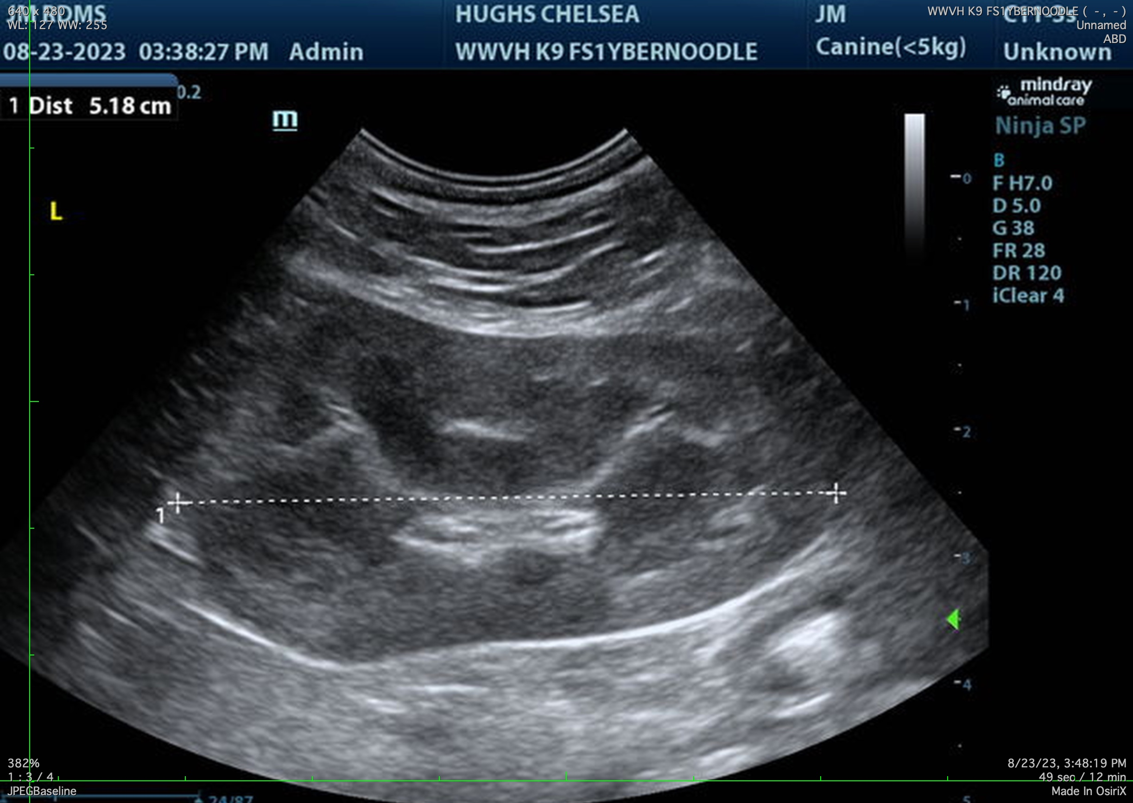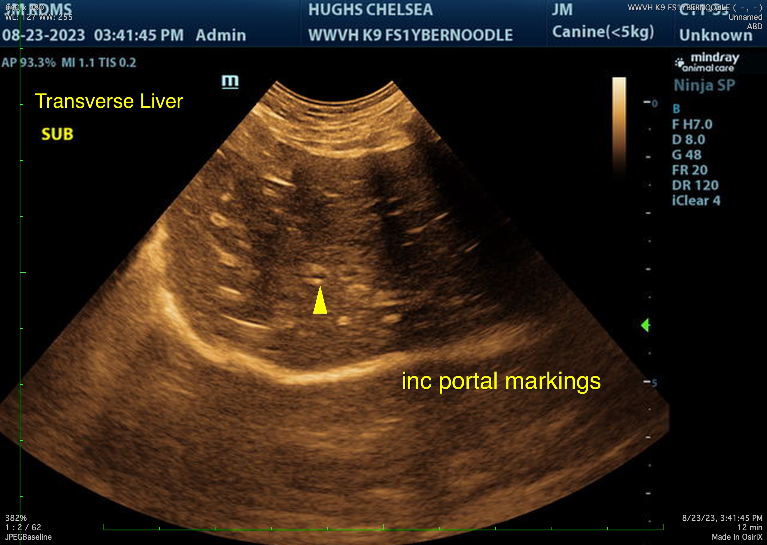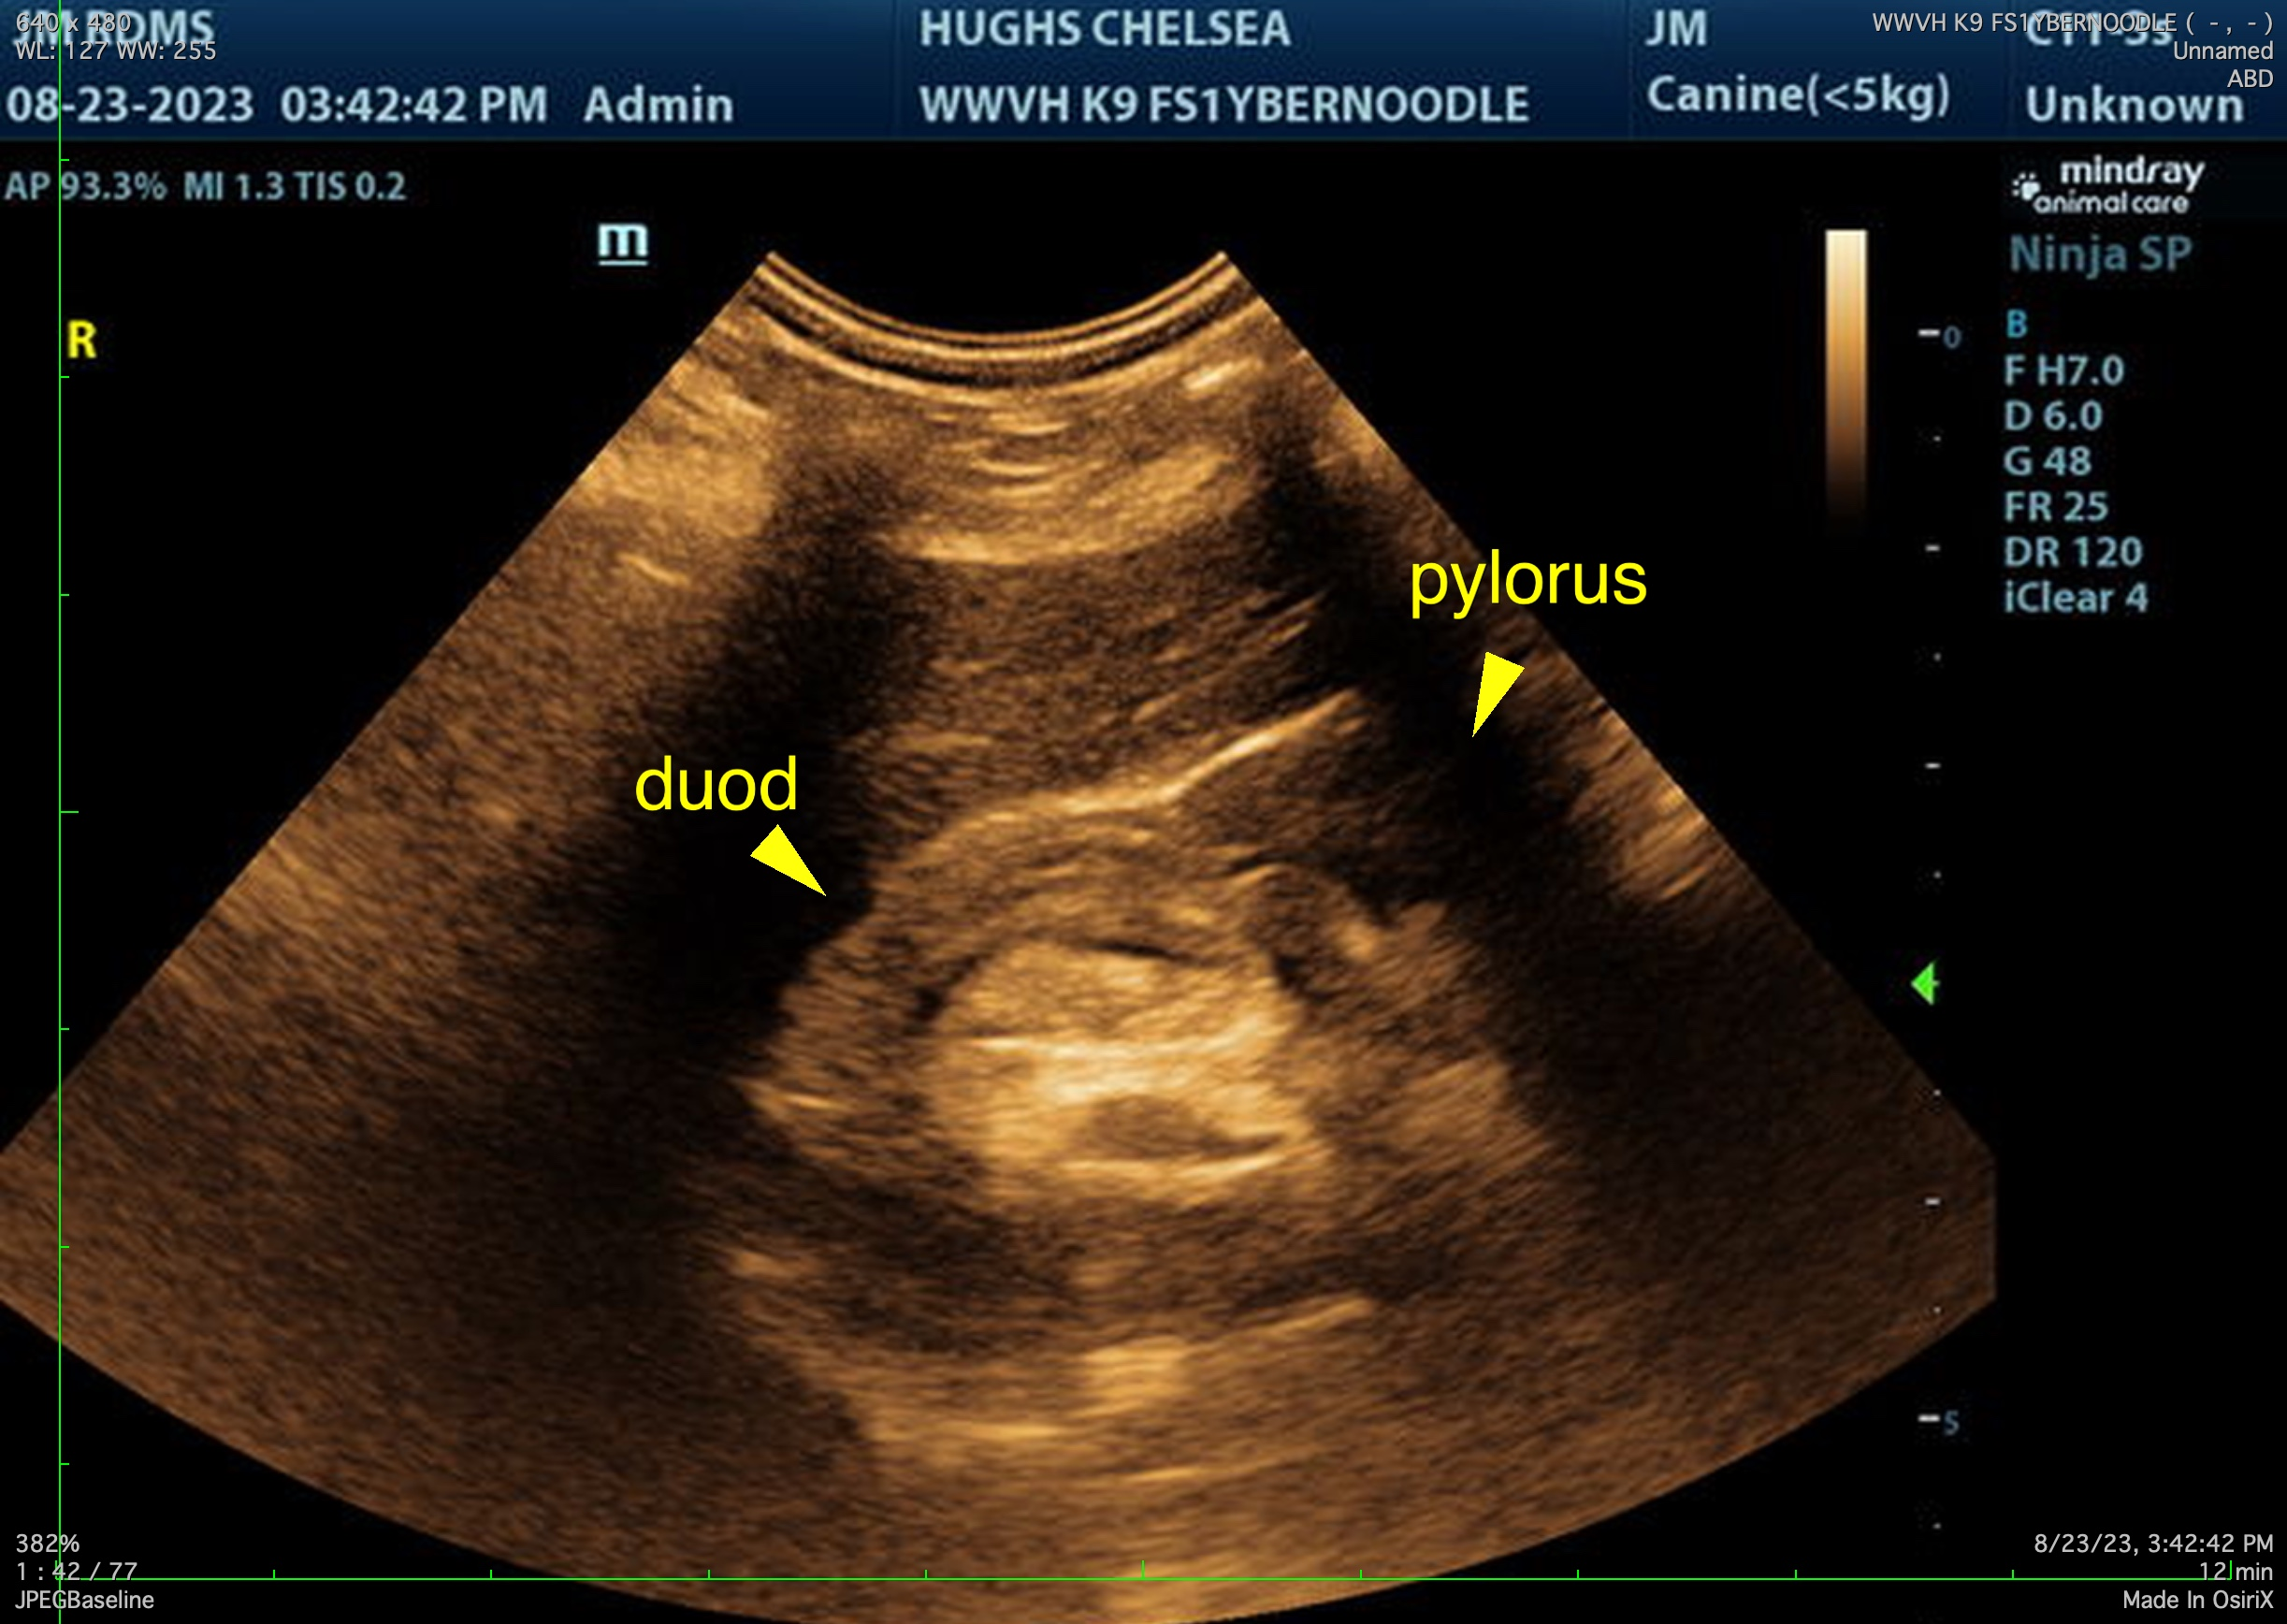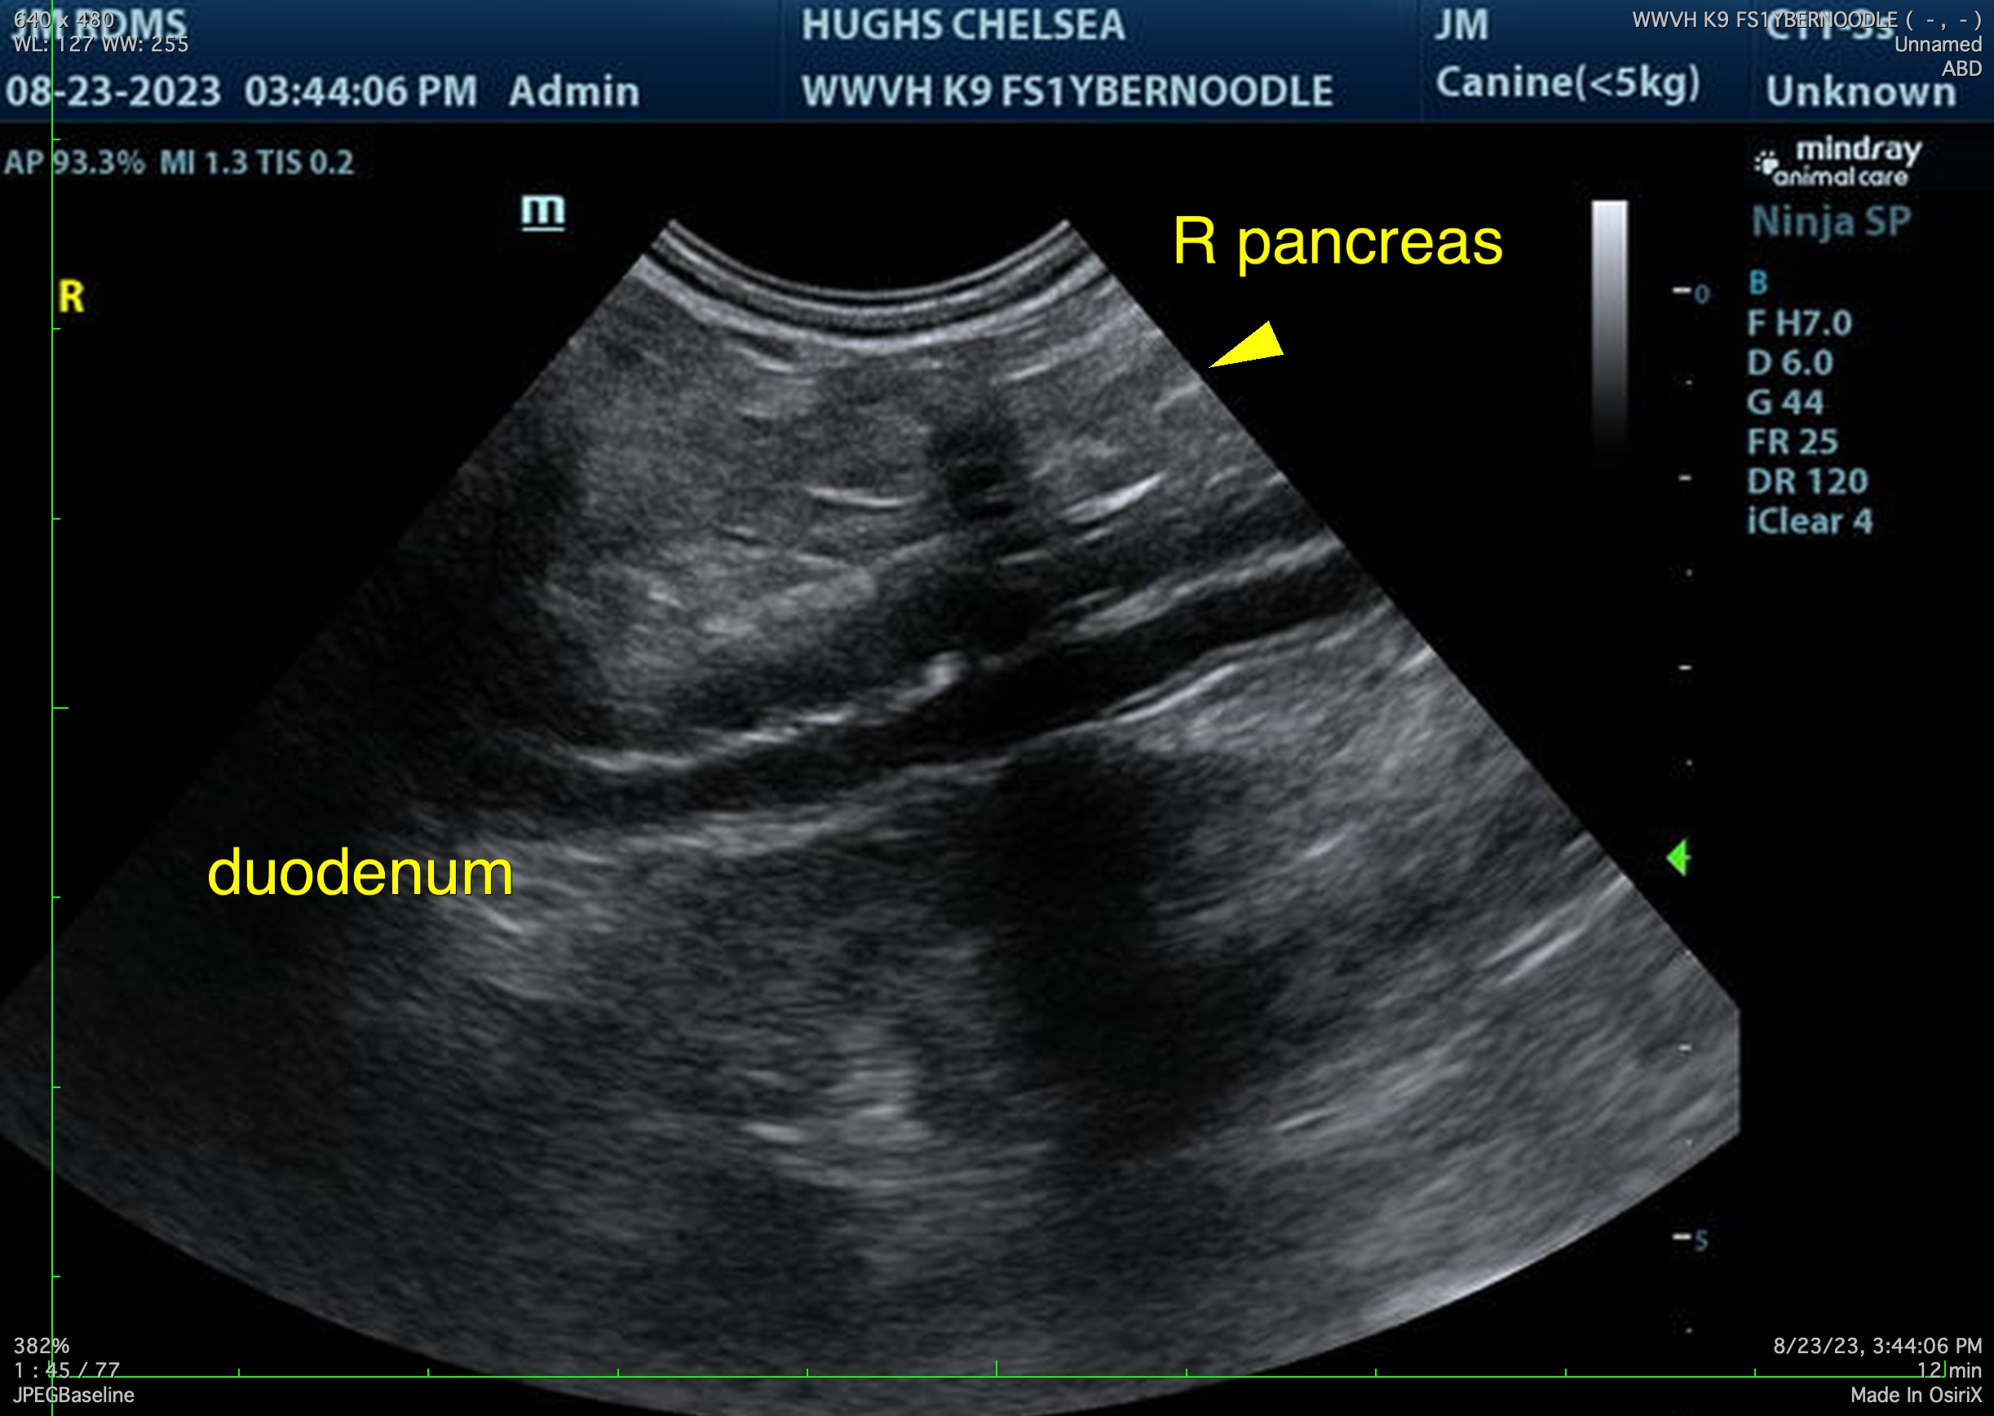

The information and recommendations provided are based on the images presented by the referring veterinarian/sonographer. No evaluation can be communicated regarding pathology that was not visible in the image/video clips provided.

Thank you for this referral. If the clinical or image interpretation does not parallel your findings or if I can be of any further assistance, please contact me.

Karen Ebersole, DVM, DABVP (Canine and Feline practice)
info@SonoPath.com

