PRESENTING CLINICAL SIGNS

p presented for about 5 day history of not eating. p is ADR/ lethargic
Abnormal PE/Chem/CBC/UA Results: dehydration at least 10%+ , firm irregular structure cranial abdomen

RADIOGRAPHIC STUDY OF THE ABDOMEN

2 orthogonal views

RADIOGRAPHIC FINDINGS

The body condition score is 5/9 ; the skin surface outlies the dorsal spinous processes.

Mild spondylosis is present at the endplates of T6/7.

Streaky abdominal detail is present in the ventral abdomen. Especially caudal to the stomach.
Diaphragm and abdominal wall are intact.

An oval mass lesion is located caudal to the stomach, displacing the intestine caudally.

The liver is located within the costal arch and the caudo-ventral lobe is pointed.

The spleen is just visible along the L abdominal wall.

The stomach contains a moderate amount of air; the small intestinal loops are caudally displaced, poorly outlined and appear of homogeneous and physiological size. The colon appears to be caudally displaced. Fecal balls are present in colon and rectum.

Both renal shadows have a physiological size, shape and opacity; the surfaces are smooth. The bladder is located in the abdominal cavity, poorly outlined and contains a small amount of homogeneous fluid opacity.

The region of the sublumbar lymph nodes appears physiological.

Heart and vessels appear small indicating hypovolemia.

RADIOGRAPHIC DIAGNOSIS

- Mass caudal to the stomach
- Streaky loss of abdominal detail
Incidental findings
- Spondylosis
- Hypovolemia

INTERPRETATION OF THE FINDINGS & FURTHER RECOMMENDATIONS

The mass lesion could be arising from the pancreas or the colon, possibly also the spleen or the mesentery. The abdominal detail is reduced by fluid (free and/or within the mesentery) which could be inflammatory, infectious, represent bile or hemorrhage. Peritoneal carcinomatosis is possible but less likely. Further diagnostic tests are essential and include abdominal ultrasound and obtaining a sample of the fluid. Surgery is recommended.

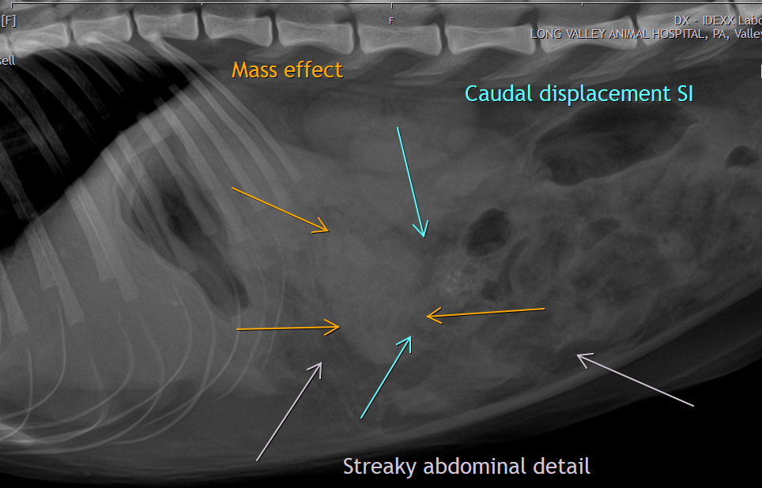

The information and recommendations provided are based on the images presented by the referring veterinarian. No evaluation can be communicated regarding pathology that was not visible in the image/video clips provided.

Thank you for this referral. If the clinical or image interpretation does not parallel your findings or if I can be of any further assistance please contact me.

Heike Rudorf, DVM, Dr. med. vet., DipECVDI, DVR
Dr.H.Rudorf@gmail.com

