PRESENTING CLINICAL SIGNS

History of frequent torn nail on the same toe (second right front toe). We trimmed the torn nail for the second time 2 weeks ago and was totally fine. However, as per the owner, they found the toe had gotten very swollen a couple of days ago. We sent home with antibiotics and anti inflammatory. Need to rule out any possible bone abnormality or lysis.

RADIOGRAPHIC STUDY OF THE FORE PAWS

Digit 2 Right Paw

A soft tissue swelling surrounds phalanges 1 to 3. The distal aspect of the swelling is flat and an ill-defined lucency extends proximally from the lateral aspect of the flattened region, terminating with the level of the P2/3 joint space.

The distal two thirds of the unguicular process of P3 are absent. The distal aspect of the remaining process shows irregular, permeative lysis as well as a small amount of faint new bone formation on its medial aspect. The lateral aspect of the unguicular crest appears to have two dorsal outlines.

RADIOGRAPHIC DIAGNOSIS

Digit 2 on R

- P3: destruction unguicular process
- P1-3: soft tissue swelling
- Possible infectious tract lateral aspect of swelling
INTERPRETATION OF THE FINDINGS & FURTHER RECOMMENDATIONS

The changes most resemble an infection which seems to be extending proximally towards the joint. Samples should be obtained to differentiate between inflammation, infection and tumor; the latter is less likely though. Samples should be submitted for histological examination. For bacteriology and sensitivity testing to be meaningful, the animal should be off antibiotic treatment for 5-7 days (this should be checked with the institution you use for the tests). Ultrasound of the joint can help identify an increase in synovial fluid which will have to be tapped. Alternatively, the digit can be surgically removed (at mid P1) and submitted for said examinations.

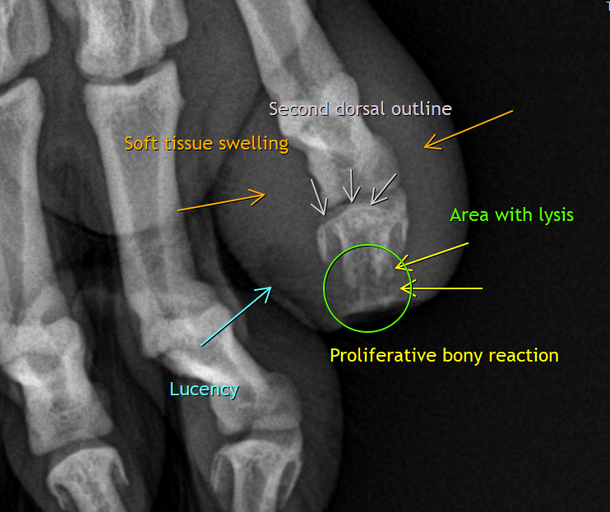
The information and recommendations provided are based on the images presented by the referring veterinarian/sonographer. No evaluation can be communicated regarding pathology that was not visible in the image/video clips provided.

Thank you for this referral. If the clinical or image interpretation does not parallel your findings or if I can be of any further assistance please contact me.

Heike Rudorf, DVM, Dr. med. vet., DipECVDI, DVR
dr.h.rudorf@gmail.com

