PRESENTING CLINICAL SIGNS
Presented for decreased appetite, lethargy, vomiting. Vomiting began on Thursday Feb 5th and resolved by Friday Feb 6th. Vomitus contained foamy white bile/mucus. There was mild improvement in clinical signs on Saturday Feb 7 and Sunday Feb 8. But as of Monday Feb 9 the lethargy and anorexia persisted and worsened. Crusts on the muzzle were first noted a couple days ago. Green ocular discharge started yesterday. Green nasal discharge was noted in the last couple days but seems to be more clear as of today. Pheobe has a history of allergies (otitis externa, pyoderma) that were being controlled with a combination of topical products (mouse, wipes, baths) and Zenrelia. O have noticed that when Pheobe takes the Zenrelia she is more lethargic and not herself. As such they have been using the Zenrelia on an as needed basis. Dentistry with extractions Nov 4 2025 where a hypoplastic trachea was diagnosed due to inability to properly advance the ET tube. Known vaccine reactor - becomes lethargic and vomits. Has a history of UTI's which has been well controlled with Aventi Urinary Chews
Abnormal PE/Chem/CBC/UA Results: Green ocular discharge OU - normal STT, negative fluorescein stain - Green nasal discharge - Increased lung sounds, and wheeze - Yellow crusts around muzzle, skin folds, anus - CBC and biochem revealed a monocytosis and thrombocytosis Current treatment for Pheobe included symptomatic care: maropitant q 24 hours for 5 days, amoxi -clav 187 mg PO q 12 hours for 10 days, Surolan to be applied topically to crusted skin
RADIOGRAPHIC STUDY OF THE THORAX
R/L lateral and VD are provided, totaling 4 radiographs for interpretation.
12.02.2026
RADIOGRAPHIC FINDINGS
The body condition score is 7-8/9 with a large amount of s.c. fat on one DV view
Congenital vertebral anomalies are located in the thoracic spine and especially at the thoraco-lumbar junction. The path of those ribs is altered. Manubrium and sternebra 1 are partially fused. The xiphisternum angels dorsally.
The cranial mediastinum is of physiologic size and opacity. The trachea diverges from the thoracic vertebrae and dips at the carina. The cervical trachea appears smaller than the thoracic one. A small amount of air is present in the cranial thoracic esophagus.
The degree of pulmonary expansion is fair, especially in left lateral recumbency where the gas filled stomach is placed well cranially. The lung lobes are aerated and extend to the thoracic boundaries. Pulmonary vessels are well outlined on the VD but slightly blurred on the lateral views.
The cardiac silhouette occupies 65% of the chest height and 3.5 intercostal spaces. The right side is round on the VD views.
RADIOGRAPHIC DIAGNOSIS
- Hypoplastic trachea
- Interstitial pattern
Incidental finding
- Congenital vertebral anomalies
- Congenital sternal anomalies

INTERPRETATION OF THE FINDINGS & FURTHER RECOMMENDATIONS
I can see no aspiration pneumonia. An interstitial lung pattern is a non-specific finding and accentuated by the only fair expansion of the lung field and obesity. Possible differential diagnoses for a true infiltrate include:
- Infection (bacterial, fungal e.g., candida, viral, Rickettsia, Spirochetes, parasitic e.g., angiostrongylus)
- Inflammation (allergic pneumonitis, eosinophilic bronchopneumopathy, smoke inhalation)
- Edema
Less likely
- Diffuse hemorrhage
- Early idiopathic fibrosis
- Tumor (e.g., lymphoma)
Fecal samples can be obtained to rule out parasites. Bronchitis can be present without radiographic evidence and thus bronchoscopy with broncho-alveolar lavage is recommended; samples should be submitted for bacteriological and cytological examination. However, the vascular outline in brachycephalic breeds is often poor due to the chest conformation and reduced inspiratory depth, combined with obesity. The lungs here appear relatively well aerated. Due to the chest conformation the cardiac silhouette is also altered in these breeds, but I can see no left sided cardiomegaly or pulmonary artery enlargement. A rounded right side is often due to the chest conformation but could represent right sided DCM which is seen in the English bulldog. Echocardiography will help rule this out should a murmur be present.
Vomiting in French Bulldogs can be due to gastro-esophageal intussusception which is usually transient. Esophagoscopy will show inflammation due to gastric reflux. Abdominal ultrasound is recommended in case mesenteric inflammation or gastro-intestinal wall layering or -thickness are altered.

TECHNICAL COMMENTS
Human fingers in the primary beam left lateral recumbency.
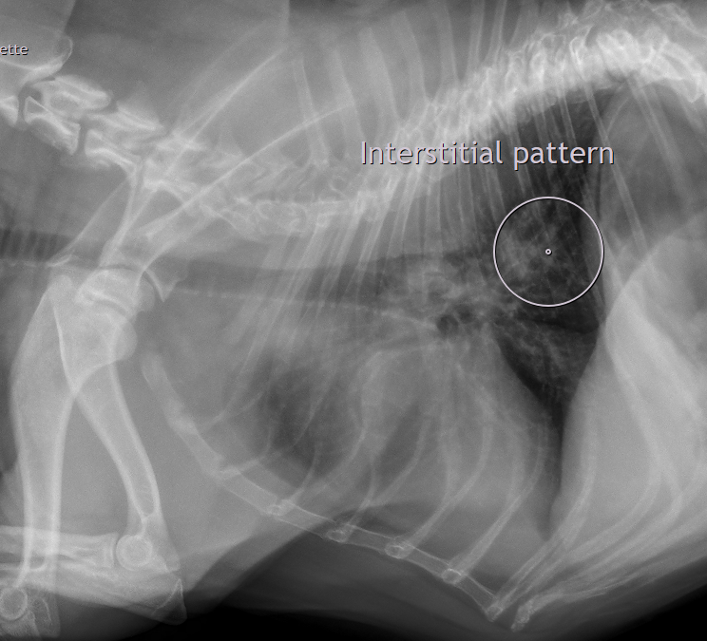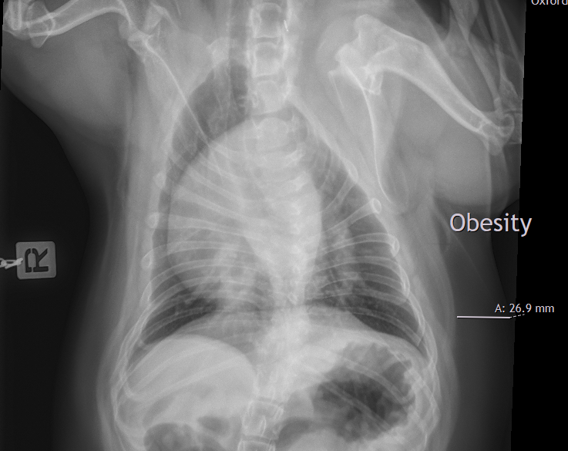
The information and recommendations provided are based on the images presented by the referring veterinarian/sonographer. No evaluation can be communicated regarding pathology that was not visible in the image/video clips provided.
Thank you for this referral. If the clinical or image interpretation does not parallel your findings or if I can be of any further assistance, please contact me.
Heike Rudorf, DVM, Dr. med. vet., DipECVDI, DVR
info@sonopath.com

