PRESENTING CLINICAL SIGNS
- P has been steadily losing weight over the last few months. Appetite has remained the same. P having diarrhea today, unsure if from diet change over the weekend or stress colitis (p does not travel well).
Abnormal PE/Chem/CBC/UA Results: 1/13/26 CBC- NSF Chem- TP 5.2 g/dL, ALB 2.2 g.dL UA- Sept 2025, unremarkable

ULTRASONOGRAPHIC EXAMINATION OF THE ABDOMEN
Urinary System
The bladder is moderately distended with anechoic urine. No uroliths are seen. The bladder wall is normal in appearance and thickness. No masses are seen.

The left kidney presents normal size with normal shape and architecture. Normal corticomedullary distinction. No pyelectasia, ureteral dilation or nephrolithiasis. The left kidney measured 6.1 cm in length.

The right kidney presents normal size with normal shape and architecture. Normal corticomedullary distinction. No pyelectasia, ureteral dilation or nephrolithiasis. The right kidney measured 5.6 cm in length.
Adrenal Glands
The left and right adrenal glands are not clearly visualized on this exam.
Spleen
The spleen is normal in size, shape, margination and echogenicity. No masses are seen.
Liver
The liver presents normal size and shape with smooth lobar margins. The parenchyma has normal echogenicity with normal echotexture. No focal lesions are seen. Intrahepatic bile ducts are normal. Normal vascular pattern.
The gallbladder presents normal size with anechoic contents. Normal gallbladder wall. No evidence of bile duct distention or obstruction.
Gastrointestinal
The stomach contains a small to moderate amount of ingesta. The stomach wall is diffusely normal in thickness measuring 4.0 mm in width. Diffusely, the jejunum appears normal in thickness and layering measuring 4.2 mm in width.
Pancreas
The visible pancreas is normal in size with normal echogenic parenchyma and surrounded by normal peri-pancreatic mesentery.
Free Abdomen
There are no enlarged abdominal lymph nodes seen on this exam. There are scant pockets of free fluid in the abdomen.
ULTRASONOGRAPHIC FINDINGS
- Gastric ingesta.
- Free abdominal fluid.
INTERPRETATION OF THE FINDINGS & FURTHER RECOMMENDATIONS
Given that the patient's albumin is low at 2.2 grams per deciliter, and the patient is having clinical signs of GI disease such as losing weight, and more recently, diarrhea, there is some concern that the albumin might be low due to protein losing enteropathy. Recommend performing a more global workup for gastrointestinal disease for this patient. Recommend a Texas A&M GI panel to evaluate for occult pancreatitis as a cause of the patient's GI disease and evaluating the patient's cobalamin and folate to determine if primary GI disease is present.
Also recommend adding a resting cortisol onto the GI panel to rule out hypoadrenocorticism as a cause of the patient's clinical signs and lab work abnormalities. Recommend full comprehensive fecal pathogen testing via a fecal pathogen PCR. Those can generally be submitted through IDEX or ANTAC
If no secondary cause is identified for the patient's gastrointestinal disease, consider either surgical or endoscopic GI biopsies to determine etiology of the suspected primary GI disease. Pending these further diagnostics, recommend switching the patient to a bland diet such as Royal Canin GI or Hill's ID. Prognosis is open pending further diagnostic workup.

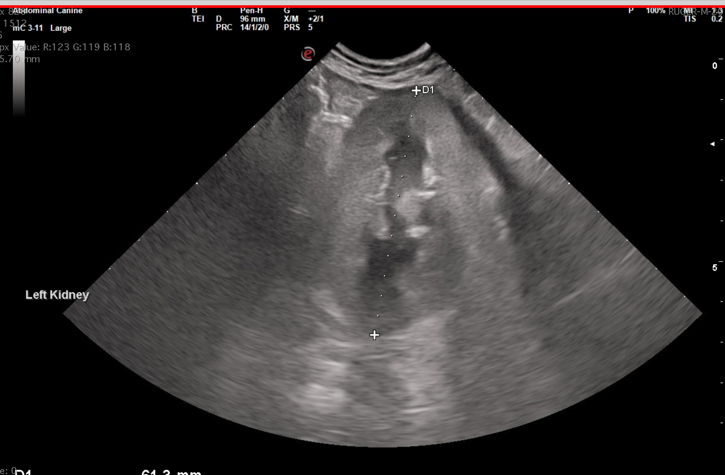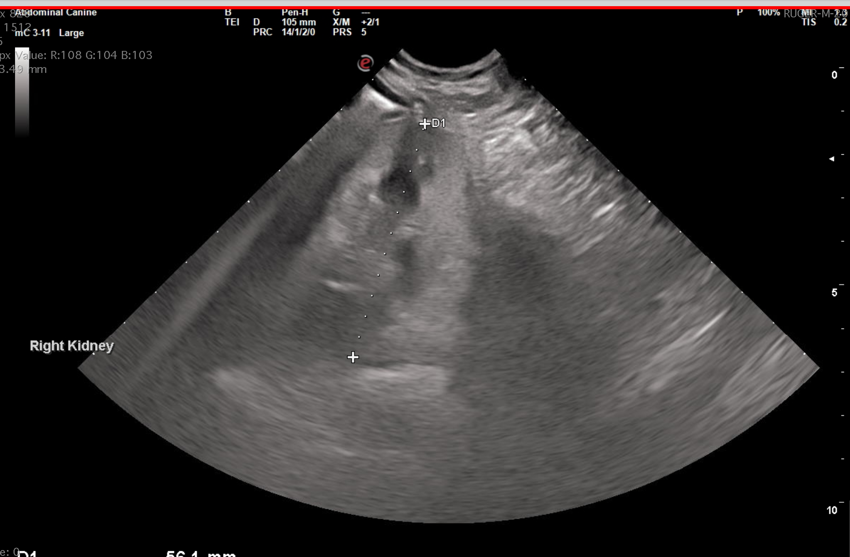
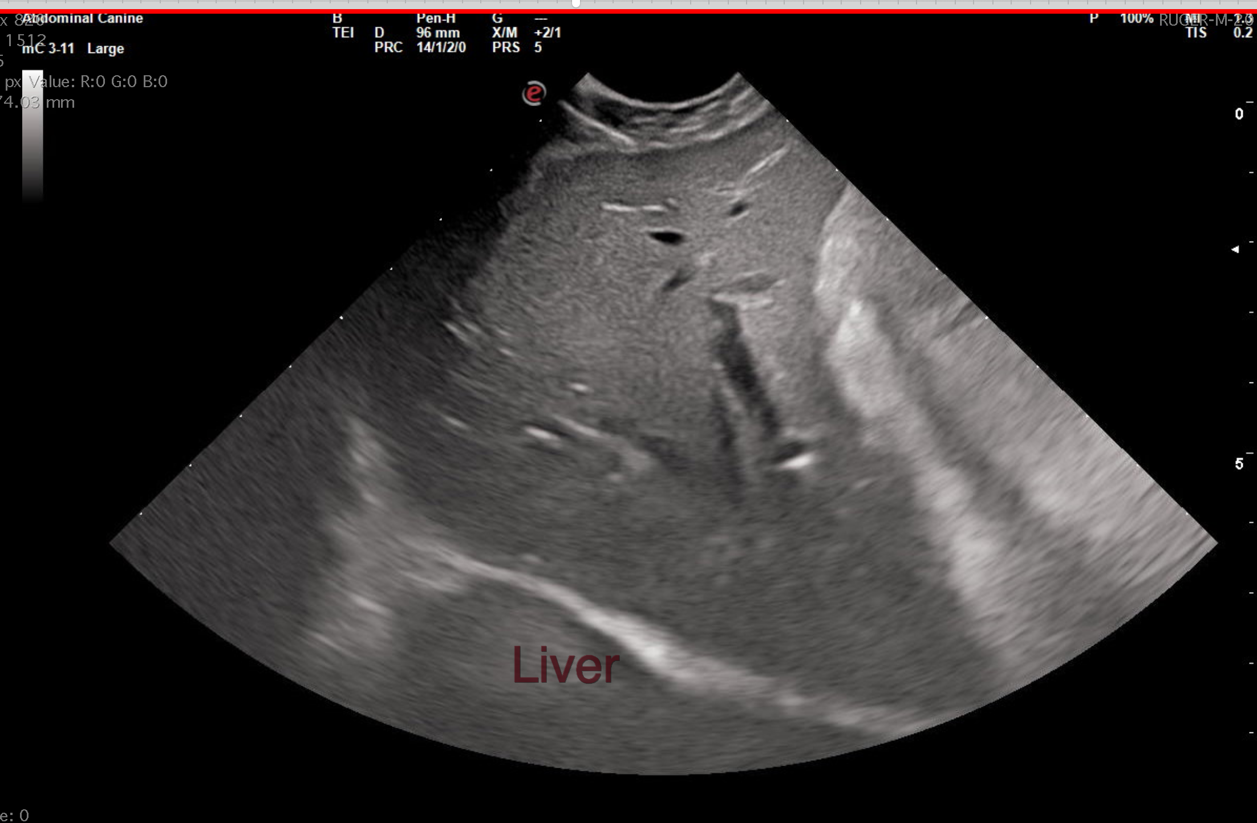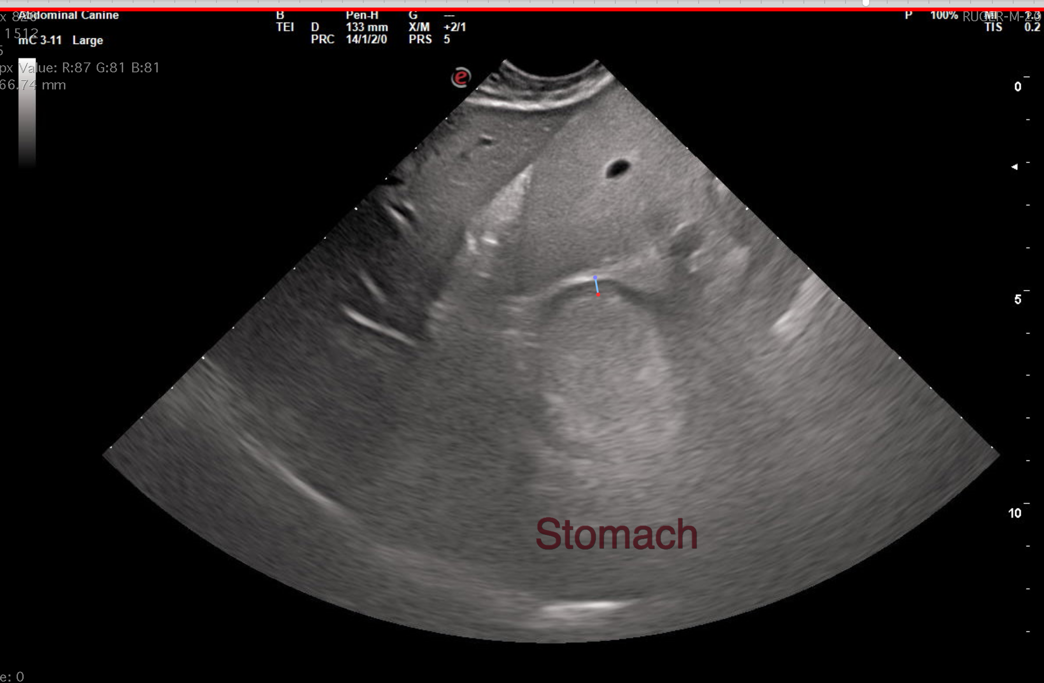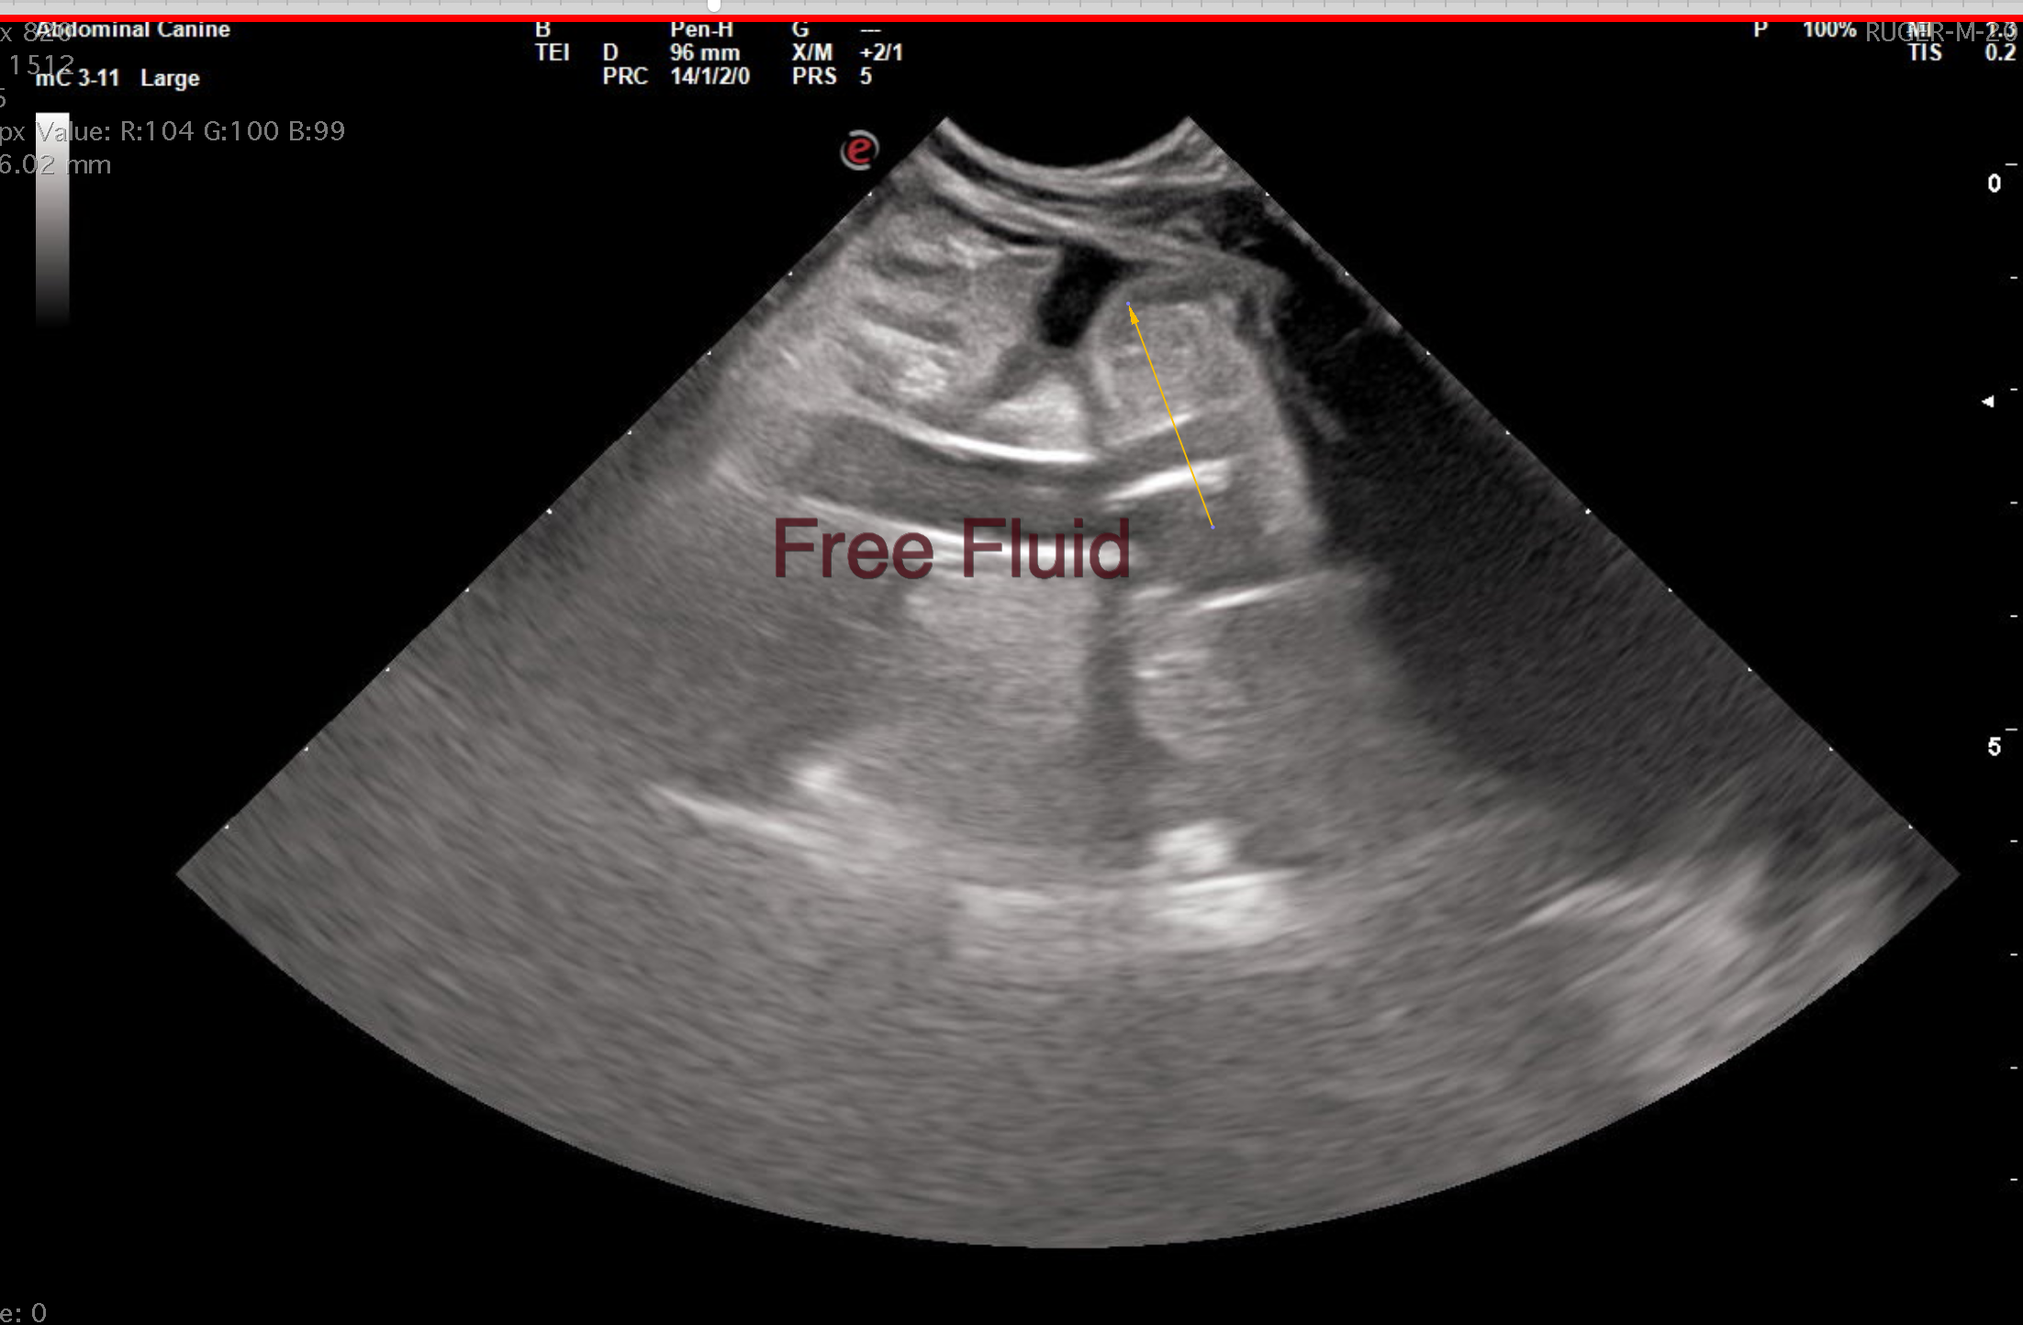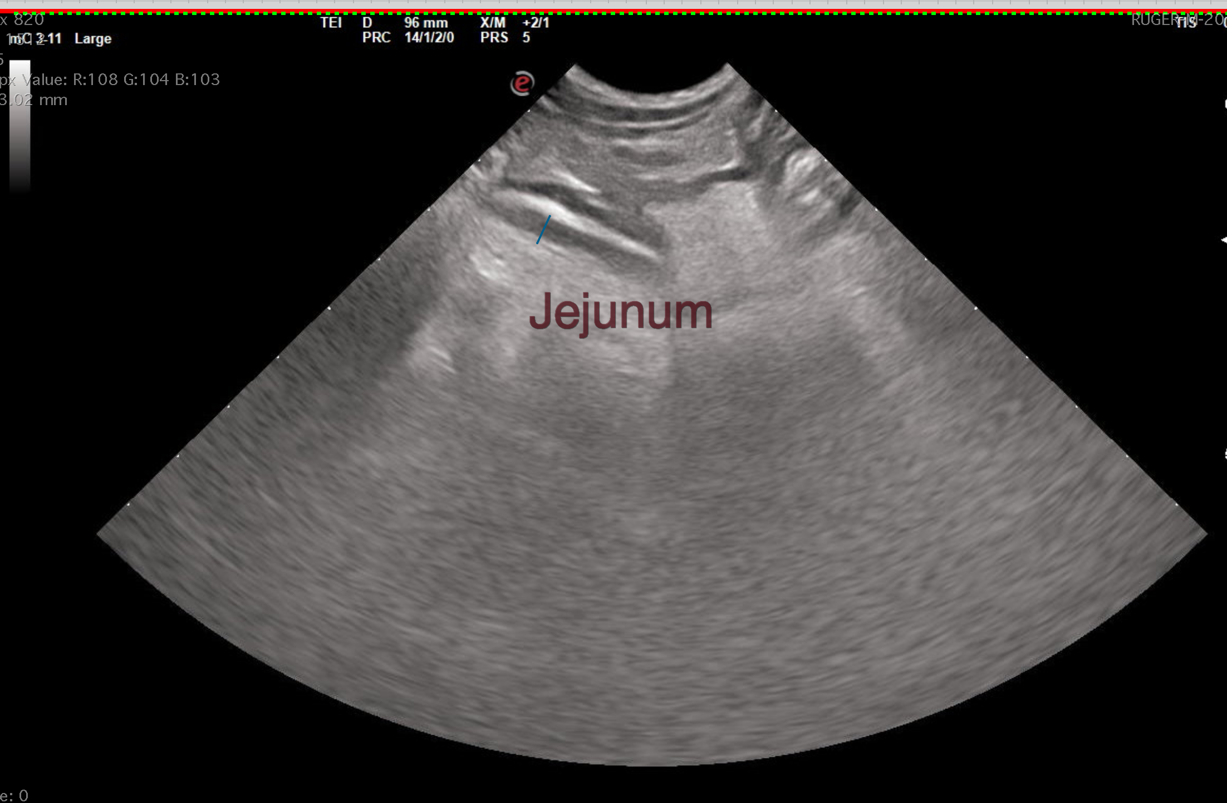
The information and recommendations provided are based on the images presented by the referring veterinarian/sonographer. No evaluation can be communicated regarding pathology that was not visible in the image/video clips provided.
Thank you for this referral. If the clinical or image interpretation does not parallel your findings or if I can be of any further assistance, please contact me.
Greg Kuhlman, DVM, DACVIM (SAIM)
Veterinary Internal Medicine Specialist
info@SonoPath.com

