PRESENTING CLINICAL SIGNS
History: 4 day hx of vomiting anorexia, and diarrhea Hx of epilepsy hypothyroidism primary lung tumor Grade 3/6 L apical systolic HM Current meds Cerenia and Metro
Abnormal PE/Chem/CBC/UA Results: ALT 175 all other WNL
ULTRASONOGRAPHIC EXAMINATION OF THE HEART & ABDOMEN
CANINE  CARDIAC  PARAMETERS | MR  VMAX  (m/s) | TR  VMAX  (m/s) | LA/AO  (Boon method) | LA/AO  (Heart Base; Swe) | FS  (%) | EF  (%) | EPSS  (cm)
NORMAL PARAMETER | 4.5-5.5 | <2.7 | 1.3 | <1.6 | 28-40 | 40-100 | <0.6
PATIENT | -- | -- | 1.0 | 1.2 | 50 | 90 | 0.1
CANINE  CARDIAC  PARAMETERS | HR  (BPM) | AV  VMAX  (m/s) | PV  MAX  (m/s) | BODY WEIGHT  (kg) | LA  2D short axis Base view  (cm) | LVIDd  Avg; 2D and m-mode short axis  (cm) | LVIDs  Avg; 2D and m-mode short axis  (cm)
NORMAL PARAMETER | 50-100 | 0.7-1.7 | 0.7-1.6
PATIENT | 100 | 1.28 | 1.10 | -- | 2.9 | 2.9 | --

Cardiac Presentation
The echocardiogram in this patient demonstrated normal left atrial size based on 3 different LA measurement methods. Chamber volumes and echogenicity were normal. The cranial and caudal mitral valve leaflets presented vegetative thickening consistent with endocardiosis. Doppler indicated measurable insufficiency. The left ventricle presented normal thicknesses with linear contour and was not dilated nor restricted. The myocardium presented normal echogenicity without subjective evidence of significant fibrotic or ischemic disease. Contractility of the ventricular walls was adequate and in normal range for this patient evidenced by the fractional shortening measurement and subjective evaluation of the different regions of the myocardium. The left ventricular outflow tract demonstrated normal laminar flow and subjective structural integrity. The right atrium and auricle revealed normal size, structure and content. No evidence of masses was noted or chamber overload. Tricuspid valvular assessment demonstrated adequate linear morphology. The right ventricle was of normal size (1/3 diameter of LV), chordae structure, myocardial echogenicity and thickness. Pulmonic tract assessment revealed normal valve structure, laminar flow, and diameter (approx.1:1 pa/ao ratio). No visible pericardial or free pleura fluid was noted. No echographically detectable evidence of infiltrative disease was visible. The cranial mediastinum and pericardial regions were free of masses in the visible window.
Urinary System
The urinary bladder, trigone, and pelvic urethra presented normal thicknesses and normal tone. The ureters were not visible which is normal. No uroliths or sediment were visualized and anechoic urine was present. No evidence of inflammatory or neoplastic changes were noted. Ureteral papillae were normal. The pelvic urethra was imaged 2.0 cm beyond the cystourethral junction.
The kidneys revealed largely normal size and structure, corticomedullary definition and ratio (cortex 1/3 of medulla) were essentially maintained with some mild age-related loss of curvilinear patterns regarding the capsule and C/M junction. The cortices presented largely uniform texture with some increased echogenicity expected for his age patient. Medullary structure differed distinctly from that of the cortex and no evidence of pelvic dilation was present. The left kidney measured 4.2 cm. The right kidney measured 4.05 cm.
Adrenal Glands
Both adrenal glands were visualized and recognized as having normal shape, size, position and echogenicity for this breed. The phrenic vasculature, glandular echogenicity and detail were unremarkable. Capsule, cortex, and medullary definition were normal for this age patient. The left adrenal gland measured 1.51 cm x 0.37 cm at the caudal pole and 0.41 cm at the cranial pole. The right adrenal gland measured 1.73 cm x 0.49 cm at the caudal pole and 1.17 cm at the cranial pole.
Spleen
The spleen presented a smooth homogeneous parenchyma hyperechoic to liver and renal cortical parenchyma. The capsule was smooth without noticeable expansion or deviation from within the spleen or adjacent pathology. The splenic vasculature demonstrated normal volume without signs of congestion or thrombosis. No sonographic evidence of acute or chronic inflammatory, neoplastic, or infarctual changes were noted.
Liver
The liver images from right and left intercostal as well as subcostal views revealed subjectively normal liver size, contour, and structure. Some mild age-related parenchymal remodeling was noted but likely not clinically significant at this time. Vascular and biliary tracts were of normal volume and no evidence of congestion was noted. The gallbladder presented some dependent debris with essentially normal contour. The cystic and common bile ducts were normal. Occasional parenchymal cysts were noted in the liver.
Gastrointestinal
Examination of the gastrointestinal tract revealed a stomach and intestine free of stasis, of normal wall thickness, acceptable curvilinear mural detail, and peristaltic activity. Small and large intestine demonstrated normal luminal chyme and stool consistency respectively. No obstructive or overt infiltrative disease was noted. No associated abnormal lymphatic activity was noted.
Pancreas
The base and limbs of the pancreas were observed to be largely isoechoic to surrounding omental fat. Pancreatic duct and capsular contour were acceptably normal and parenchyma respected normal curvilinear patterns. No overt evidence of active inflammatory or neoplastic disease was noted.
ULTRASONOGRAPHIC FINDINGS
- Stage B-1 valvular disease- no evidence of volume overload
- Age-related renal and hepatic changes
- Occasional parenchymal cyst in the liver
INTERPRETATION OF THE FINDINGS & FURTHER RECOMMENDATIONS
Supportive care should prove effective in this patient. Given the epilepsy history, if not under control, then CT of the skull is indicated. Given the lung pathology, chest CT would also be ideal. Largely geriatric abdominal changes.
The heart is stable without clinical disease. No overt contraindication for anesthesia of brief to moderate duration. I suggest Torbutrol premed, Propofol induction, Isoflo maintenance or similar protocol if anesthesia is desired. Blood pressure recommended if not already performed and target white coat negative systolic pressure of < 160 mmHg. If higher than this ACE-inhibitor is suggested to reach this level. Recheck echocardiogram is recommended in 6 months, earlier if murmur grade increases or clinical signs initiate.
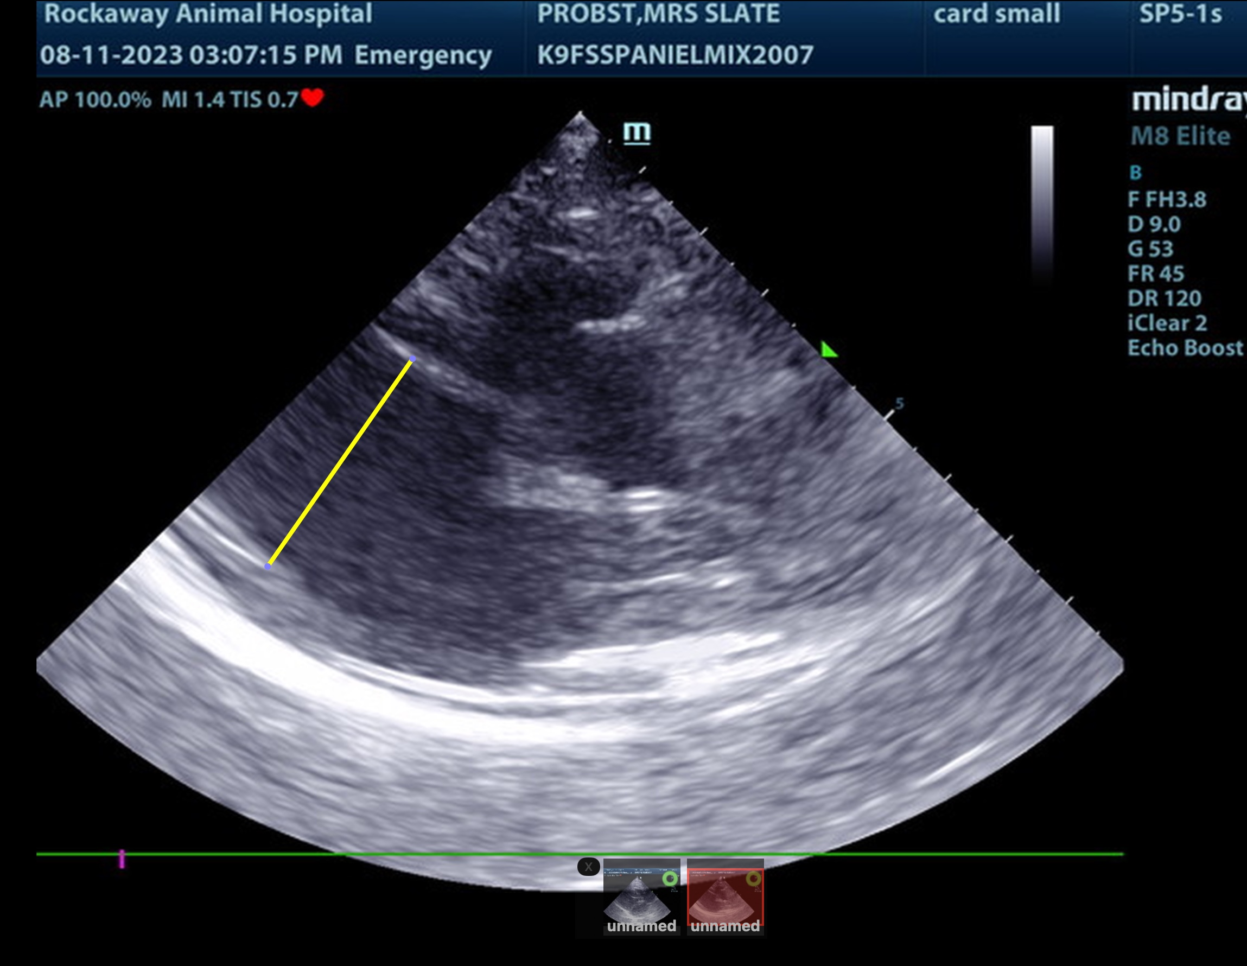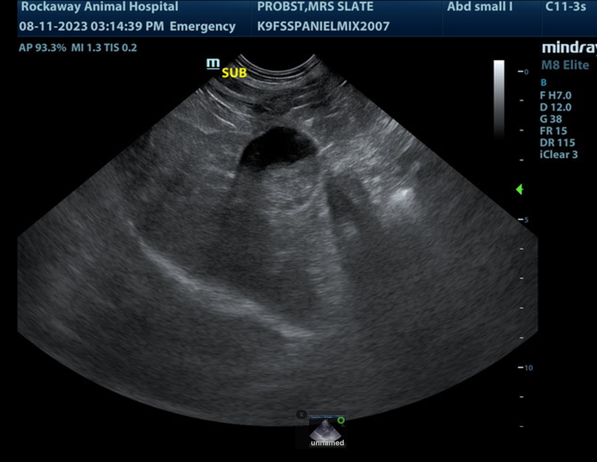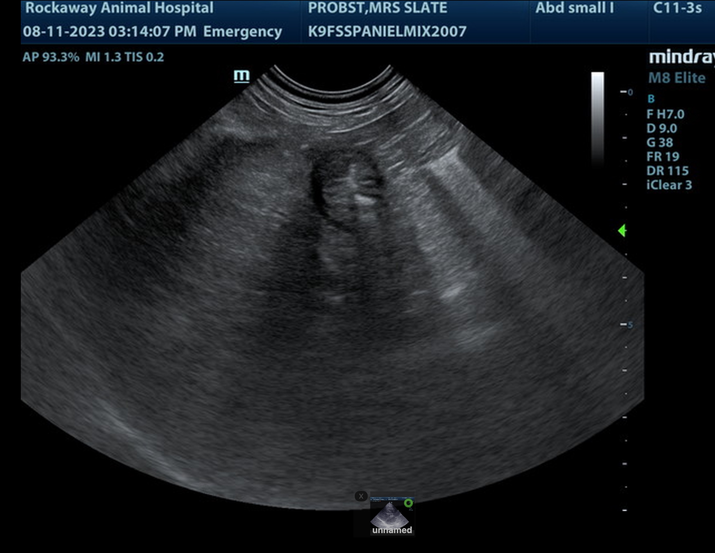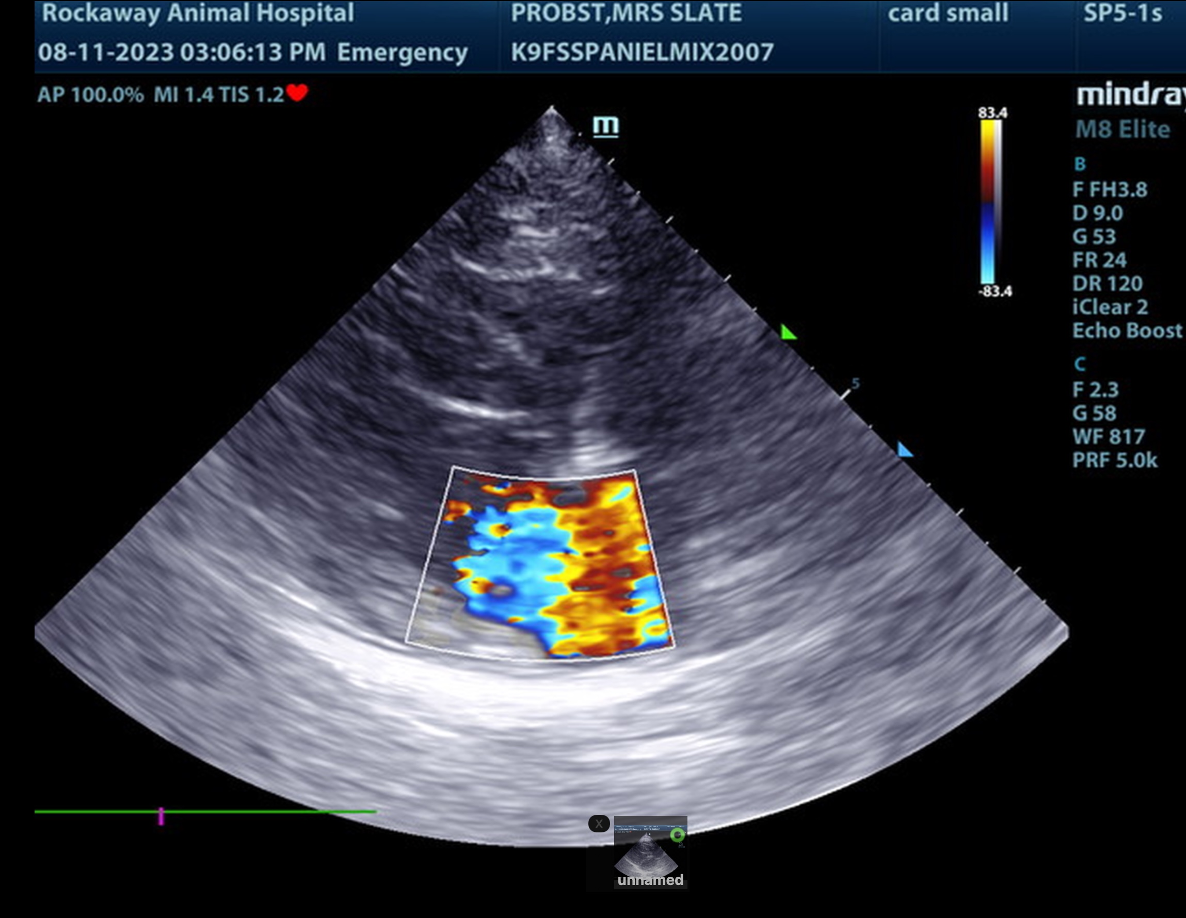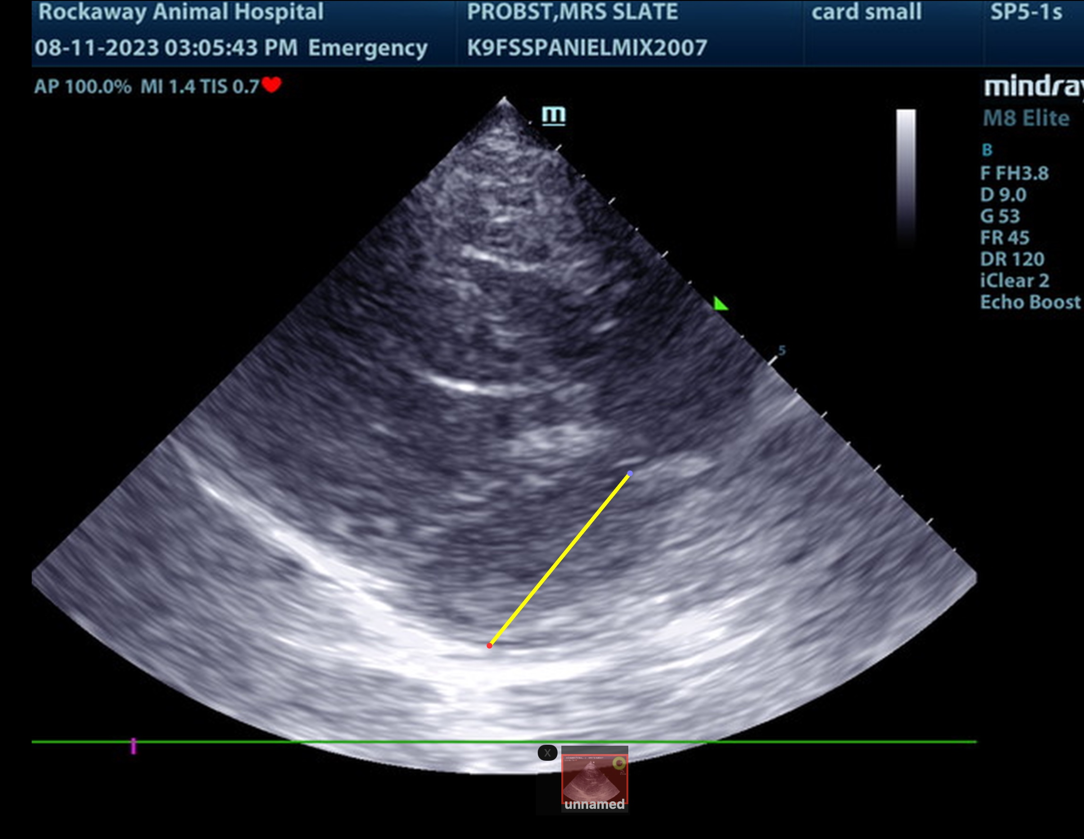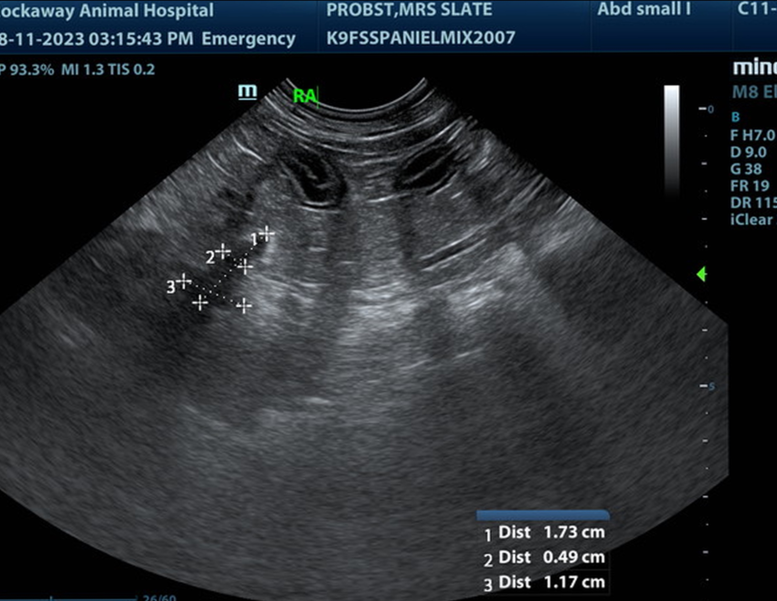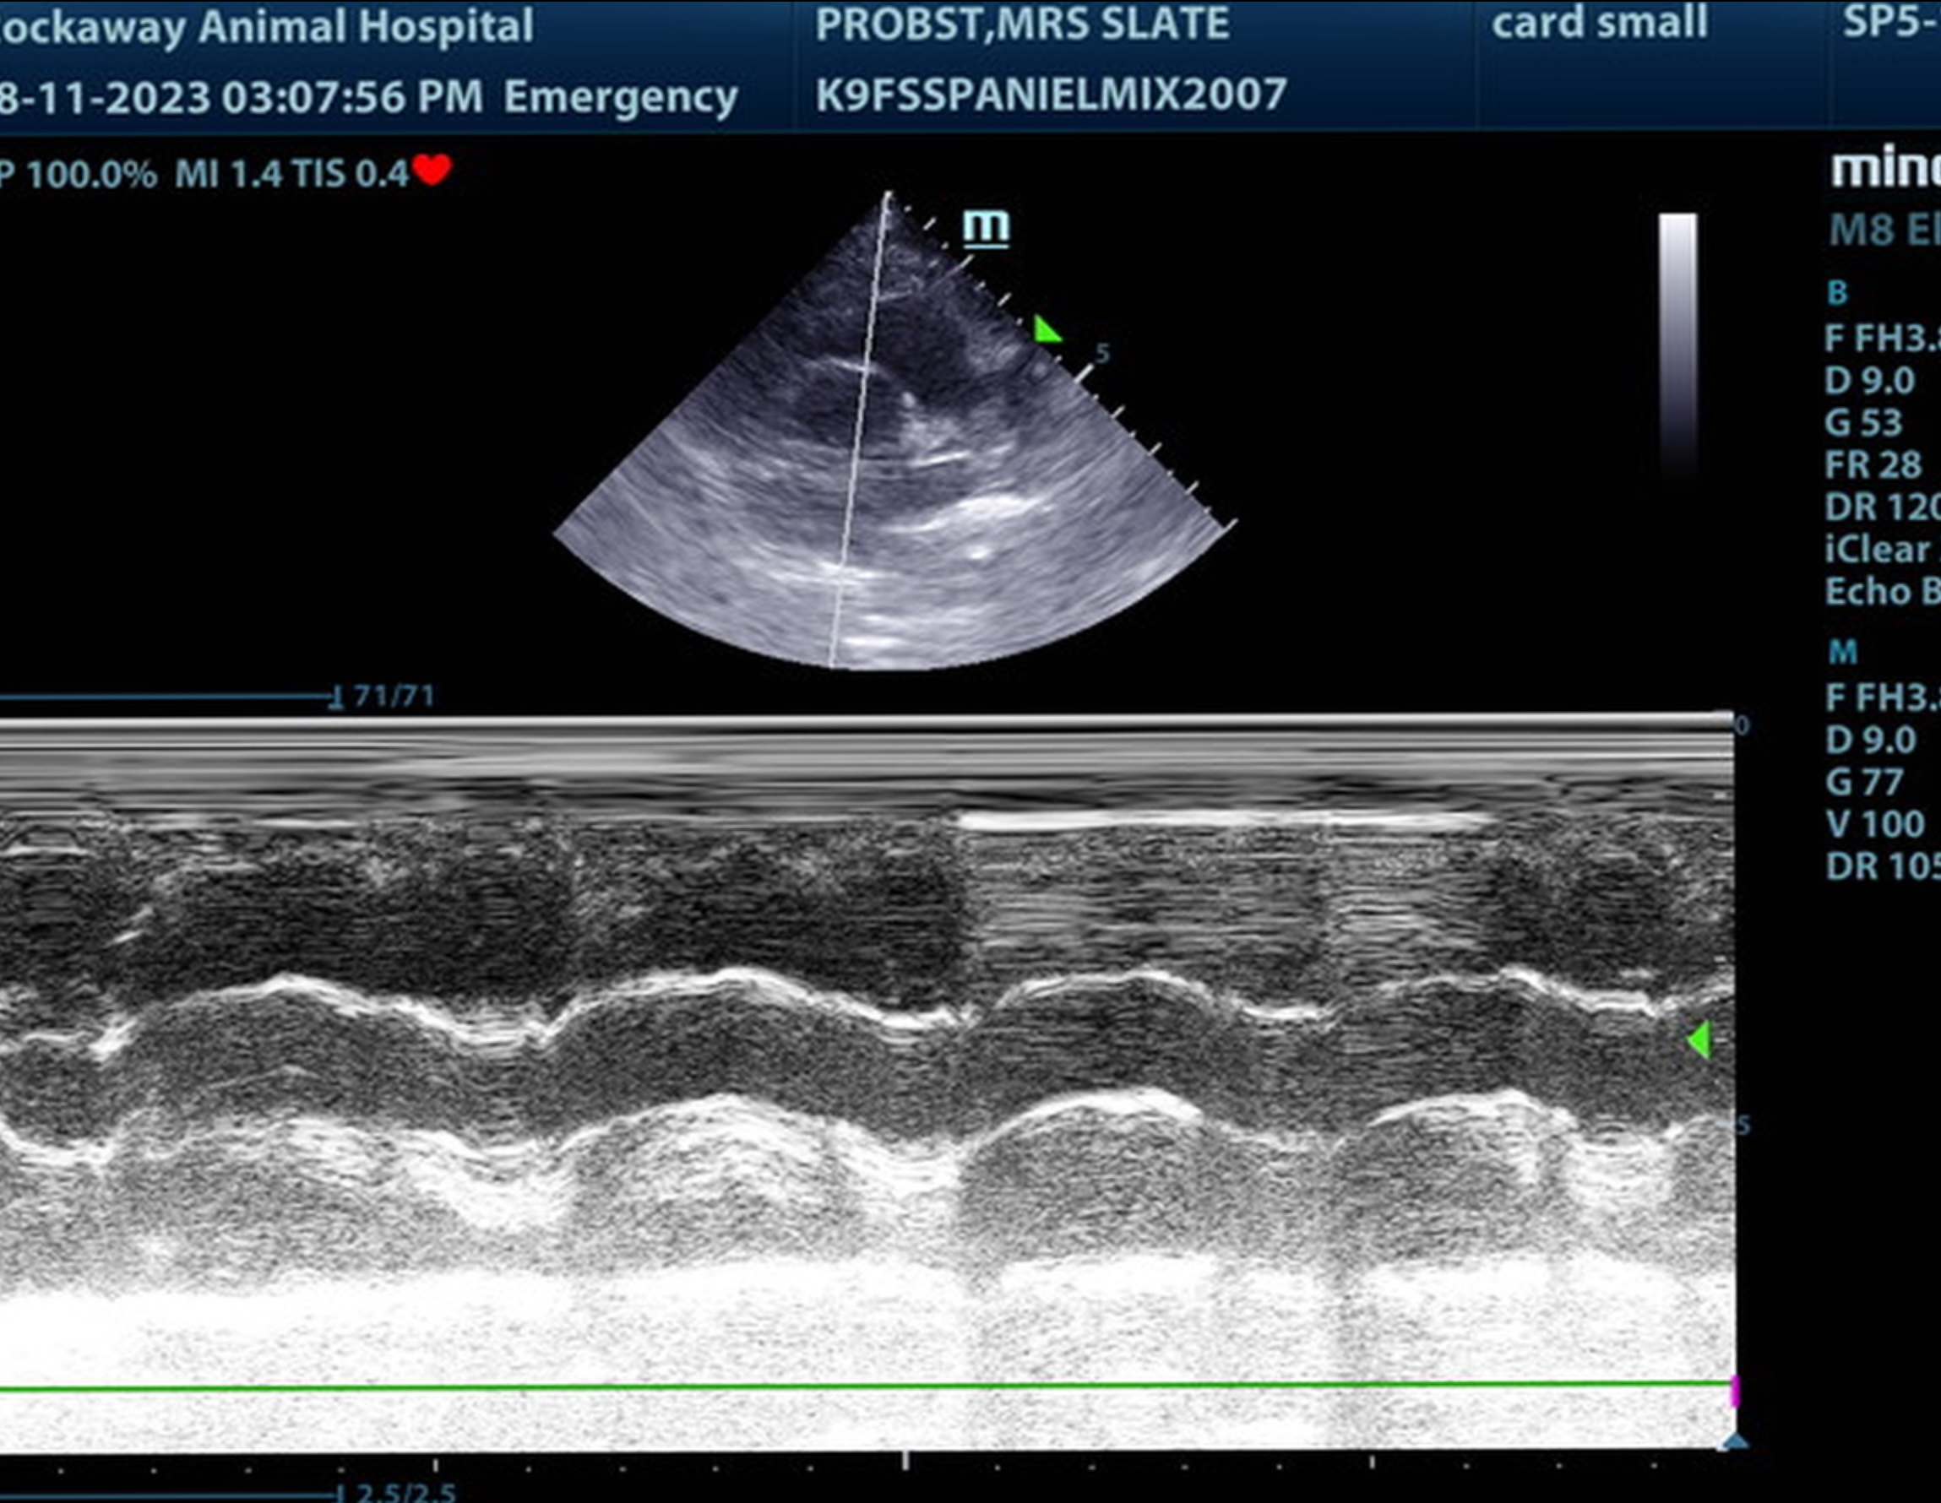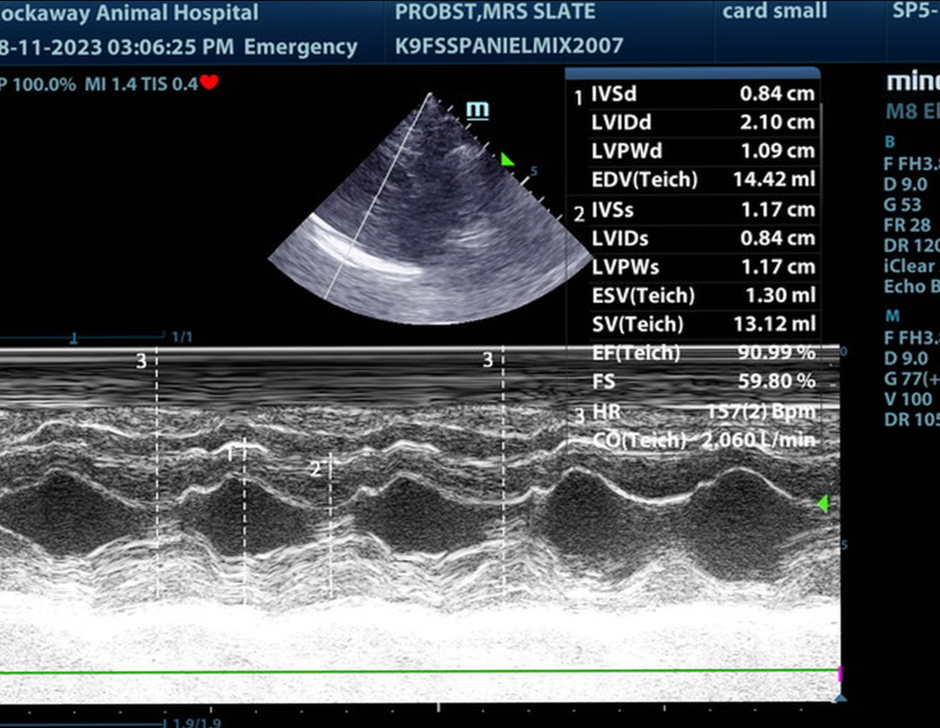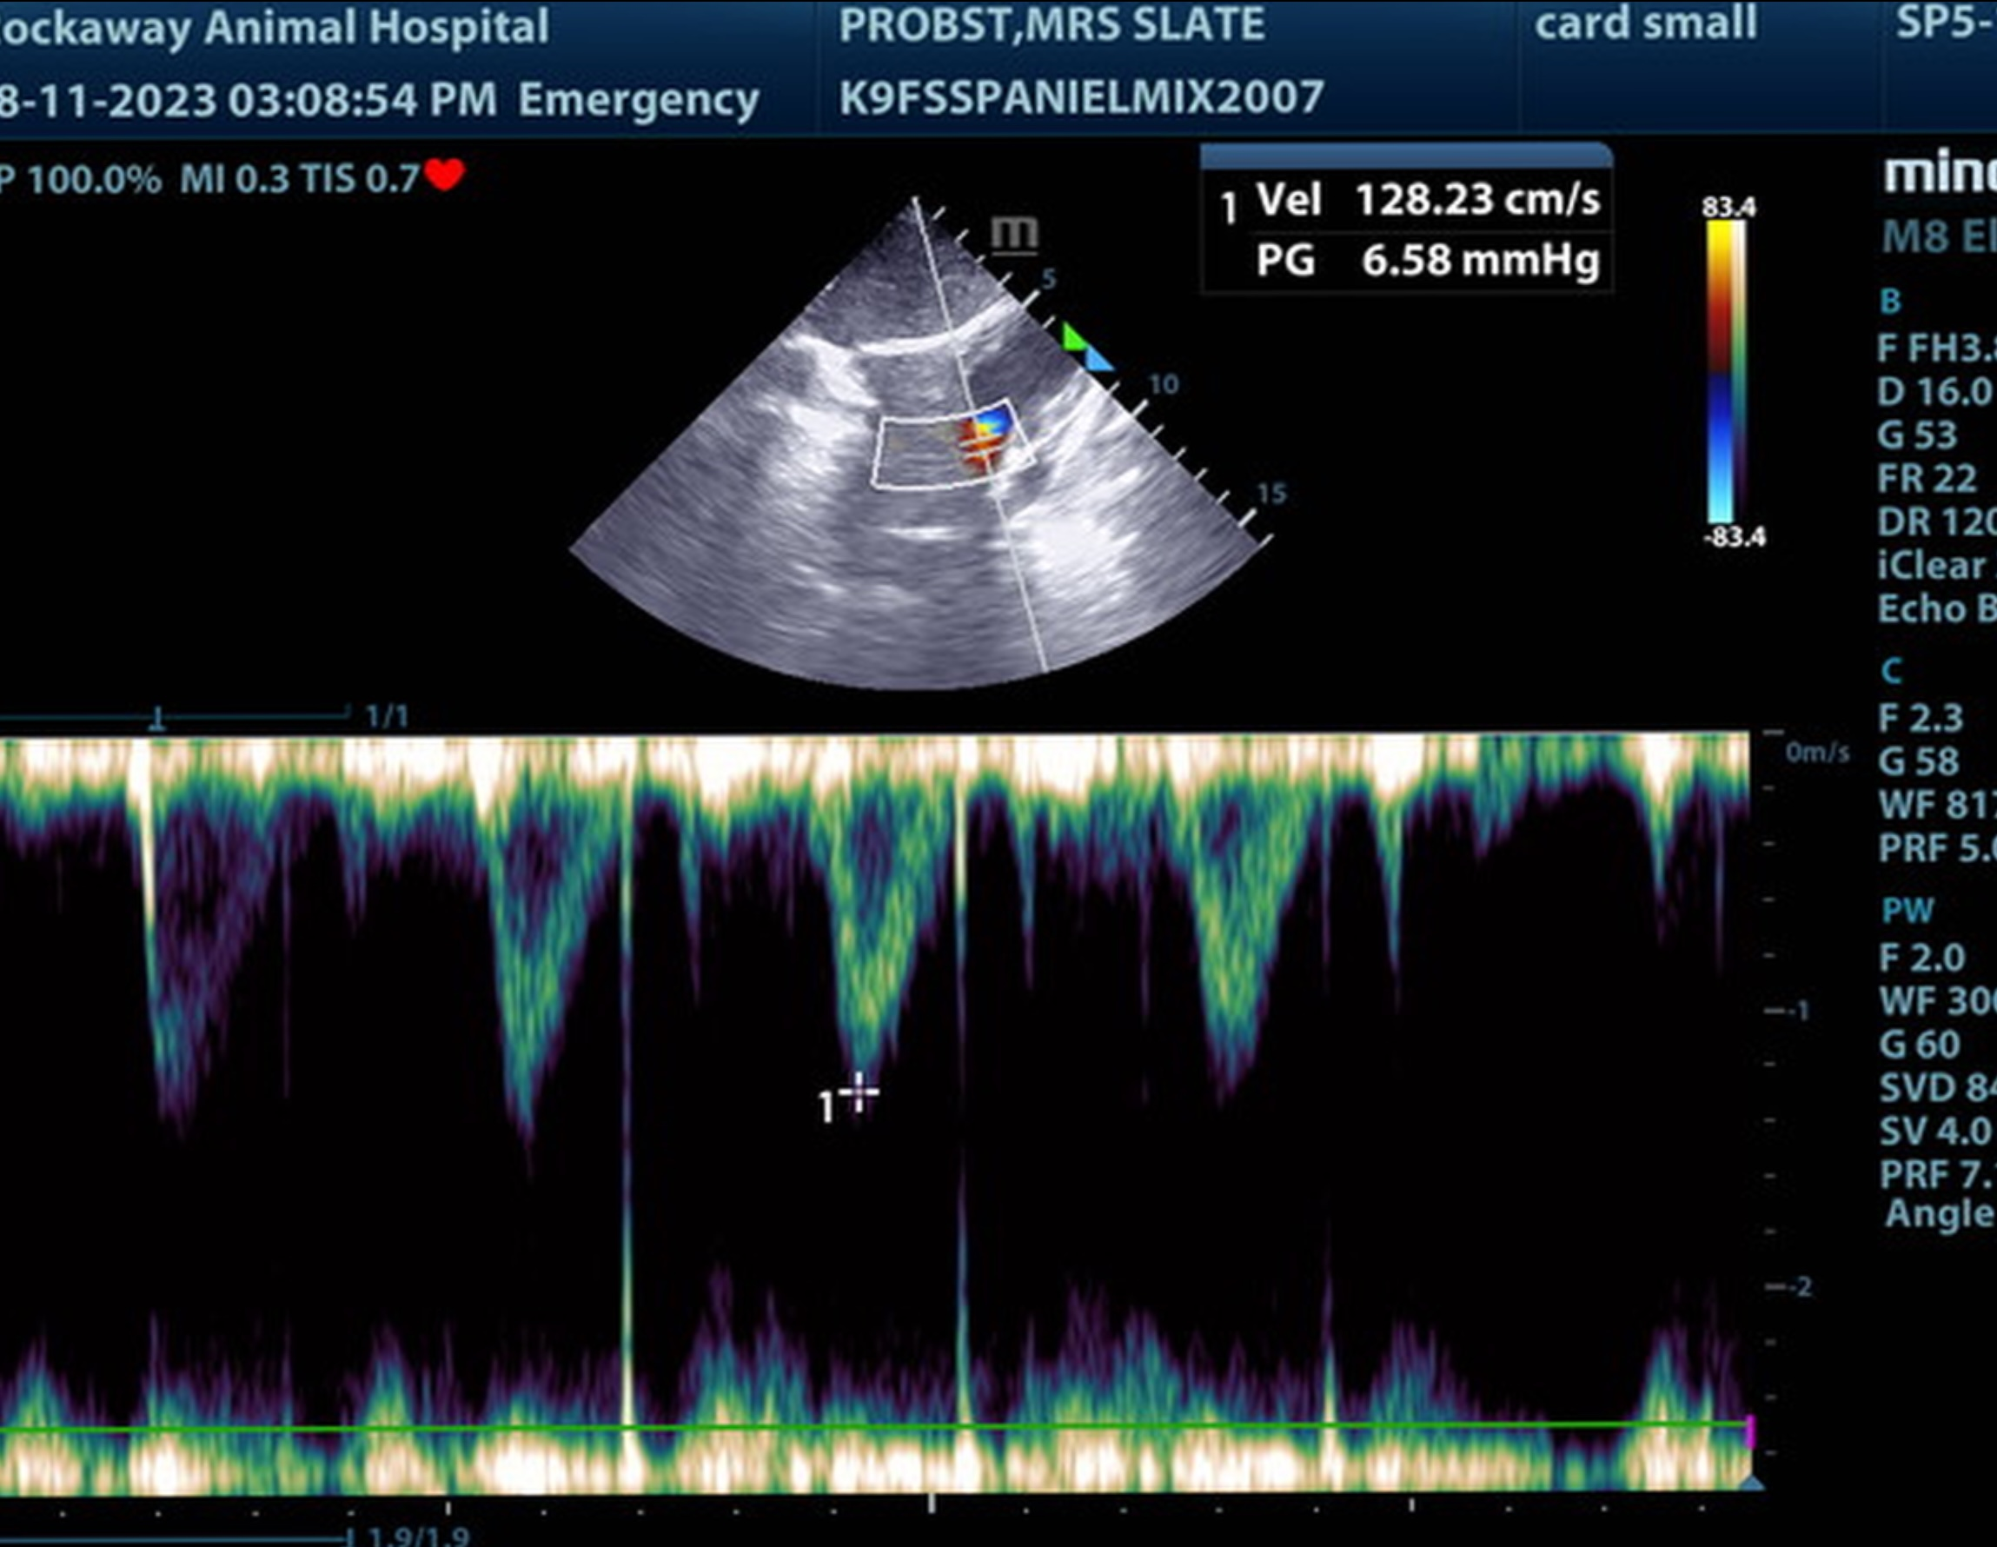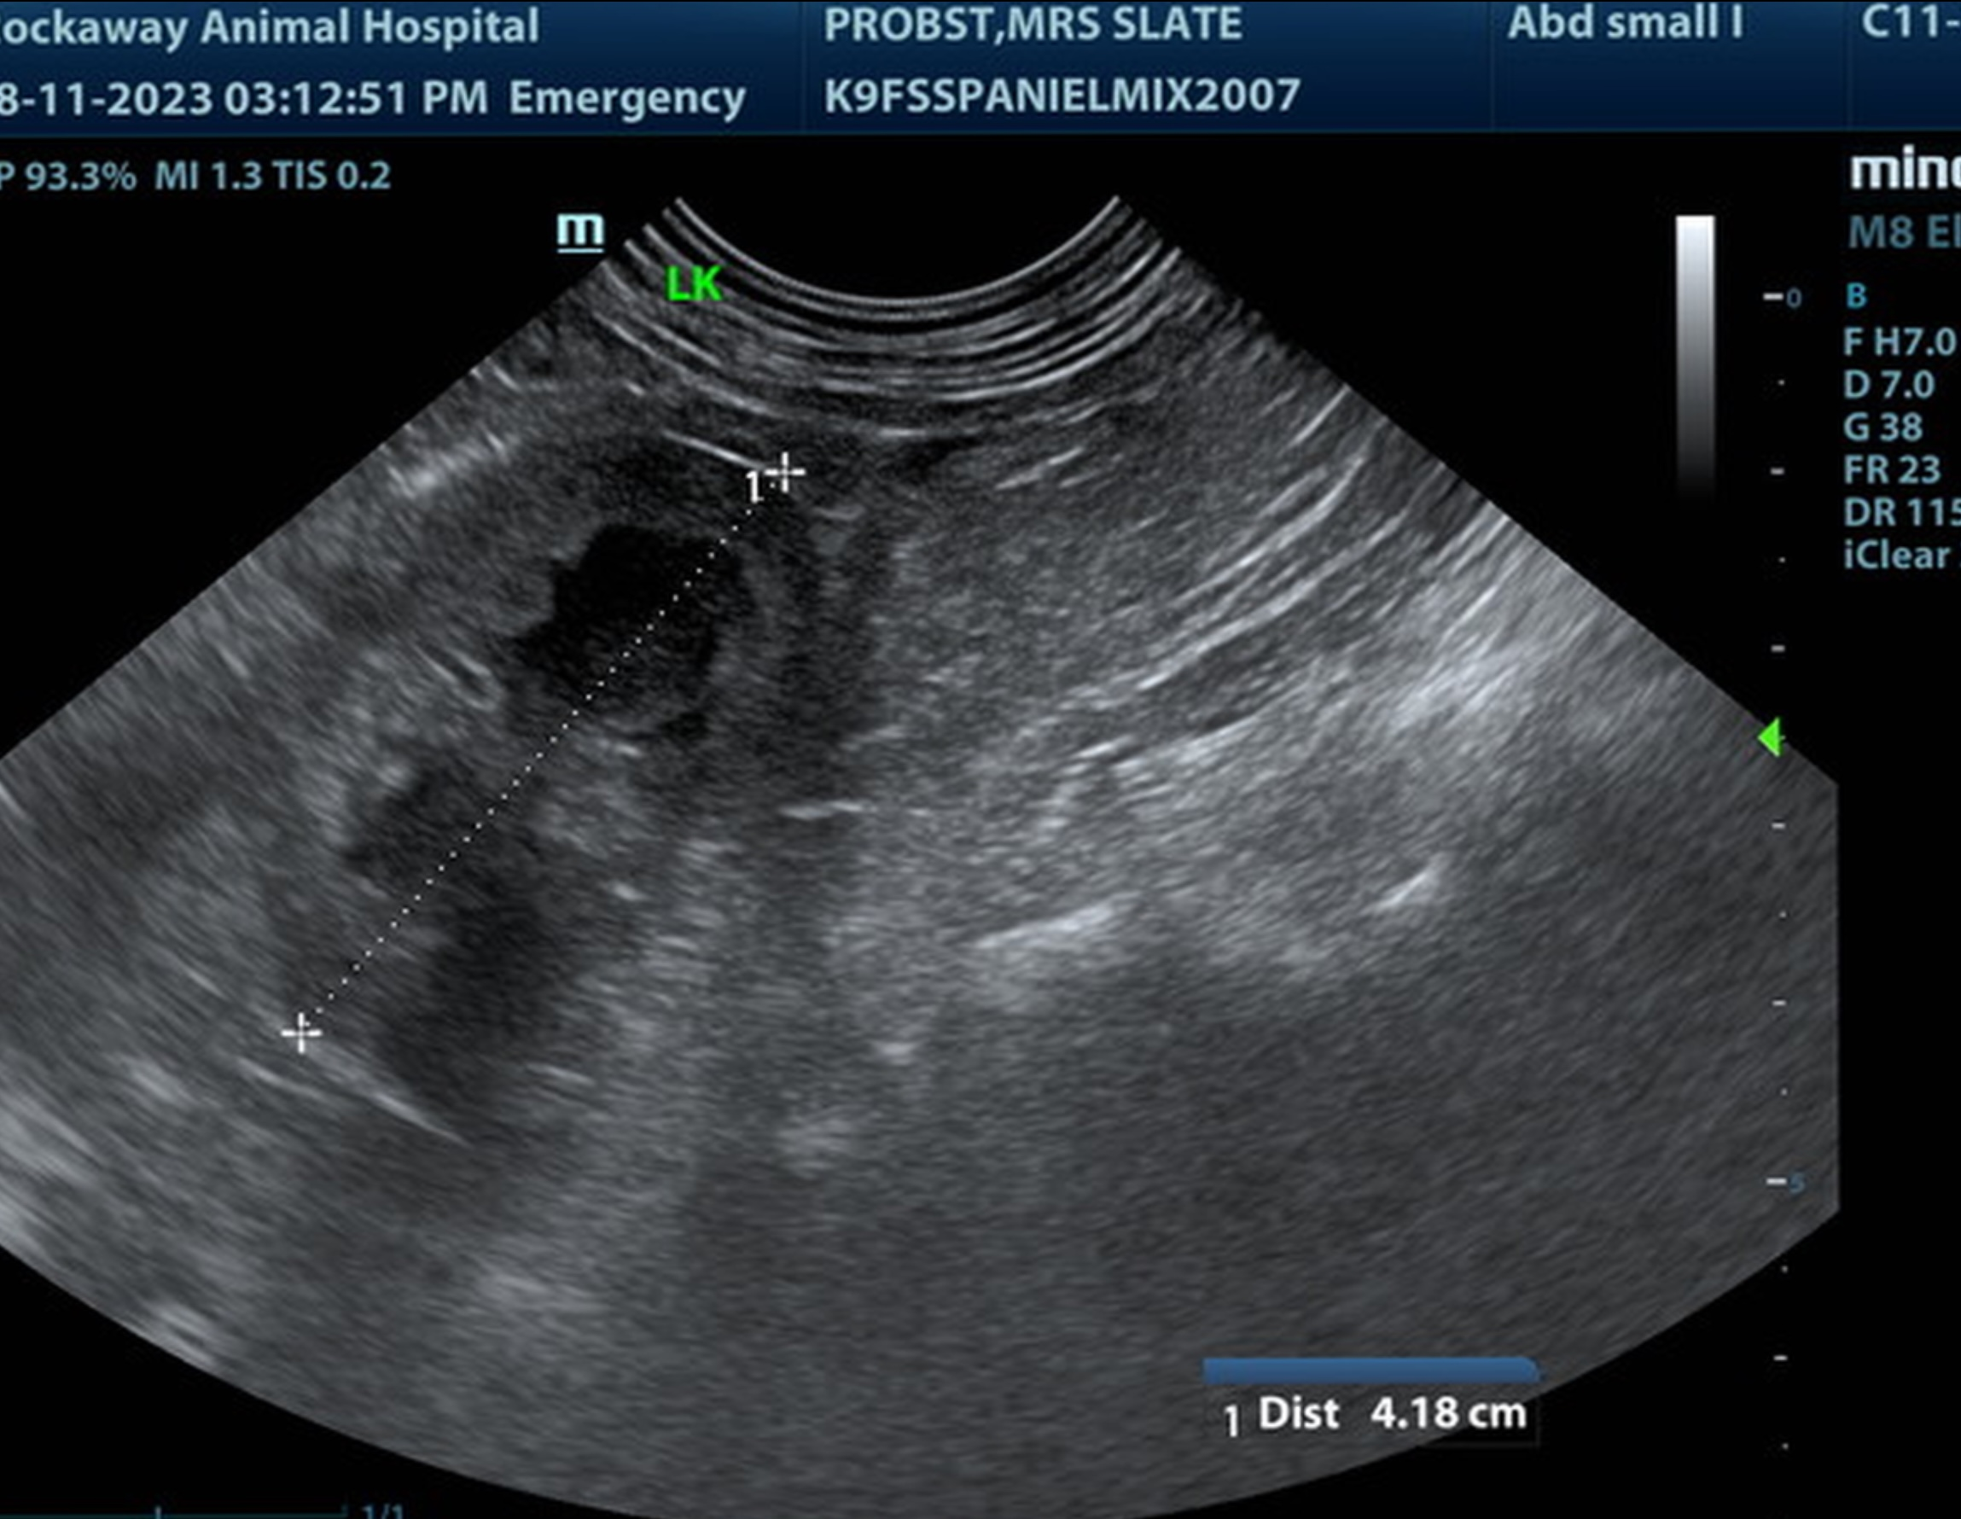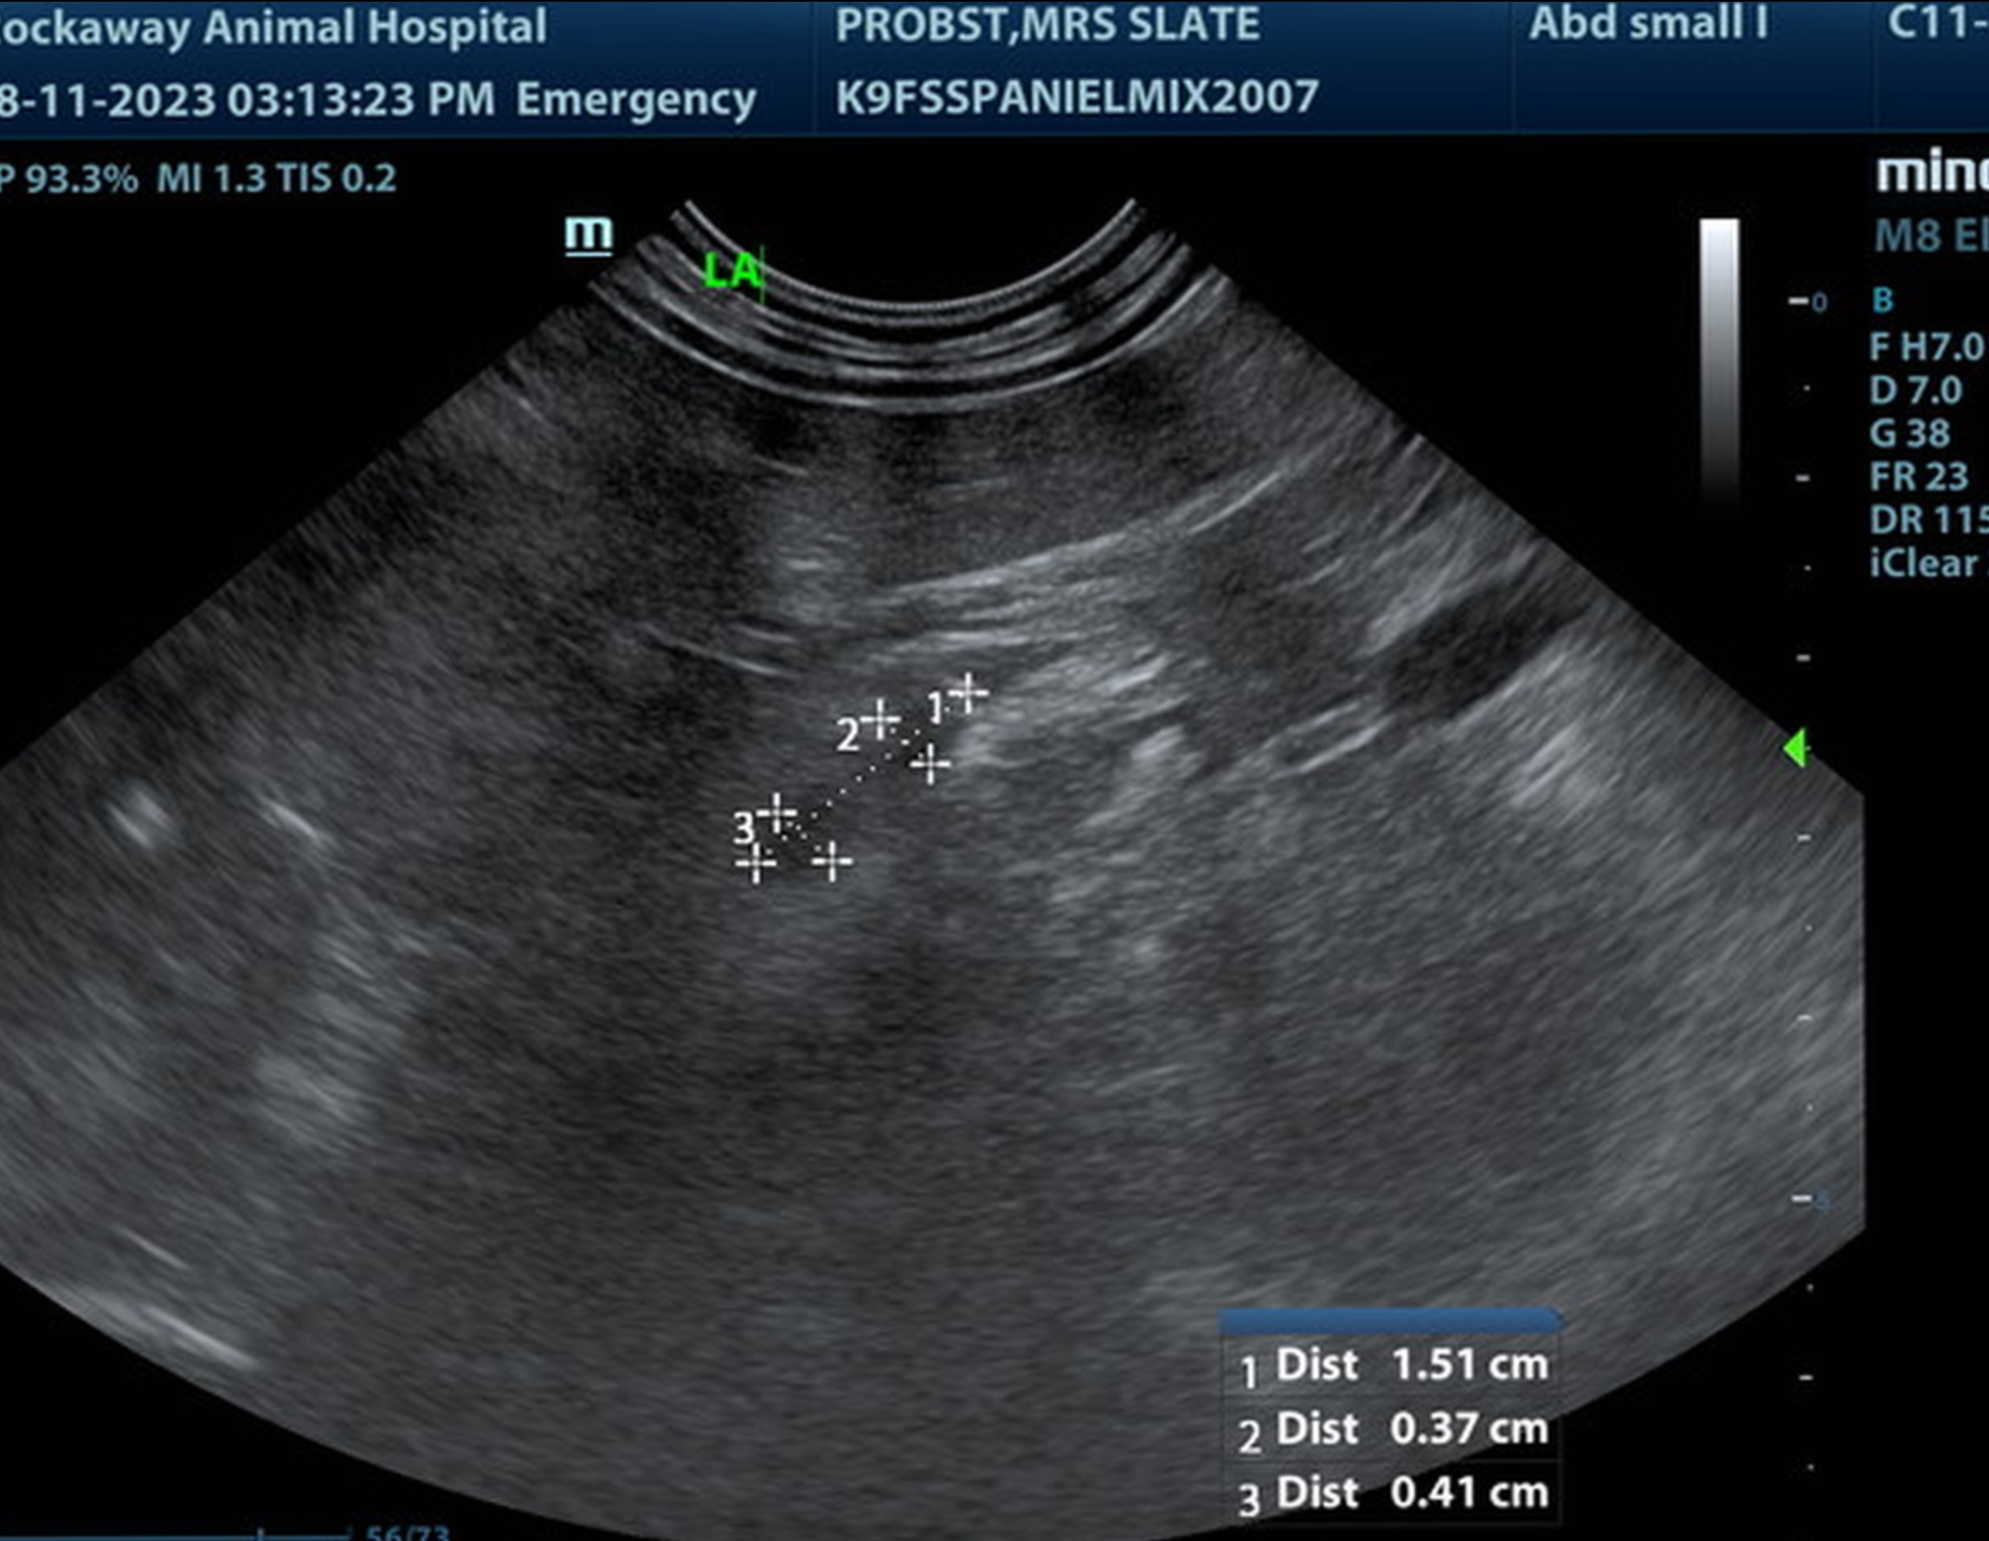

The information and recommendations provided are based on the images presented by the referring veterinarian. No evaluation can be communicated regarding pathology that was not visible in the image/video clips provided.

Thank you for this referral. If the clinical or image interpretation does not parallel your findings or if I can be of any further assistance please contact me.

Eric Lindquist, DMV, DABVP, Cert. IVUSS, CEO of SonoPath.com
info@SonoPath.com

