PRESENTING CLINICAL SIGNS
History: Clinically doing well at home. Recheck abdominal ultrasound from last done Jan 28, 2022. Mass was noted on last U/S. Would like to assess changes. Has been on Prednisolone and Buprenorphine.
Abnormal PE/Chem/CBC/UA Results: N/A
ULTRASONOGRAPHIC EXAMINATION OF THE ABDOMEN

Urinary System
The urinary bladder, trigone, and pelvic urethra presented normal thicknesses and normal tone. The ureters were not visible which is normal. No uroliths or sediment were visualized, and anechoic urine was present. No evidence of inflammatory or neoplastic changes were noted. Ureteral papillae were normal. The pelvic urethra was imaged 2.0 cm beyond the cystourethral junction.
The kidneys revealed normal size and structure, corticomedullary definition and ratio for this age. The cortices presented largely uniform texture with normal echogenic relationship to liver and spleen. Medullary structure differed distinctly from the cortex and no evidence of pelvic dilation was present. The capsules were acceptably uniform without significant irregularities. The left kidney measured 4.27 cm. The right kidney measured 4.28 cm.

Adrenal Glands
Both adrenal glands were visualized and recognized as having normal shape, size, position and echogenicity for this breed. The phrenic vasculature, glandular echogenicity and detail were unremarkable. Capsule, cortex, and medullary definition were normal for this age patient. The right adrenal gland measured 0.5 cm. The left adrenal gland measured 0.3 cm.

Spleen
The spleen presented a smooth homogeneous parenchyma hyperechoic to liver and renal cortical parenchyma. The capsule was smooth without noticeable expansion or deviation from within the spleen or adjacent pathology. The splenic vasculature demonstrated normal volume without signs of congestion or thrombosis. No sonographic evidence of acute or chronic inflammatory, neoplastic, or infarctual changes were noted.

Liver
The liver images submitted revealed subjectively normal liver size, contour, and structure. Parenchymal echogenicity was naturally coarse and hypoechoic to the spleen. Vascular and biliary tracts were of normal volume with no evidence of congestion. The gallbladder presented acceptably thin walls with primarily anechoic content. The cystic and common bile ducts were normal. No pathological hepatic lymphadenopathy was evident. No overt structural evidence of inflammatory, infiltrative or regenerative pathology was evident.

Gastrointestinal
Examination of the gastrointestinal tract revealed a stomach and intestine free of stasis, of normal wall thickness, acceptable curvilinear mural detail, and peristaltic activity. Small and large intestine demonstrated normal luminal chyme and stool consistency respectively. No obstructive or overt infiltrative disease was noted. No associated abnormal lymphatic activity was noted.

Pancreas
The base and limbs of the pancreas were observed to be largely isoechoic to surrounding omental fat. Pancreatic duct and capsular contour were acceptably normal and parenchyma respected normal curvilinear patterns. No overt evidence of active inflammatory or neoplastic disease was noted.
Free Abdomen
A large amount of abdominal fat was noted in this patient.

ULTRASONOGRAPHIC FINDINGS
- Structurally unremarkable abdomen
- A large amount of abdominal fat

INTERPRETATION OF THE FINDINGS & FURTHER RECOMMENDATIONS
No evidence of visceral disease. No evidence of masses noted in this sonogram, however, given the patient has been on Prednisolone, this may have suppressed a mass that may be in partial remission, especially if round cell neoplastic origin.

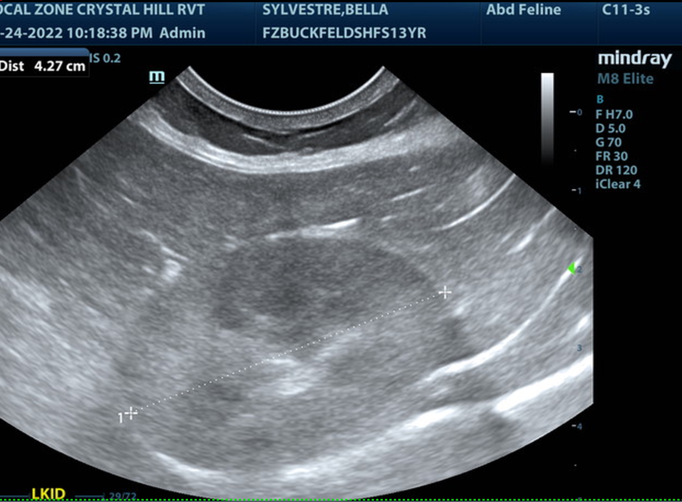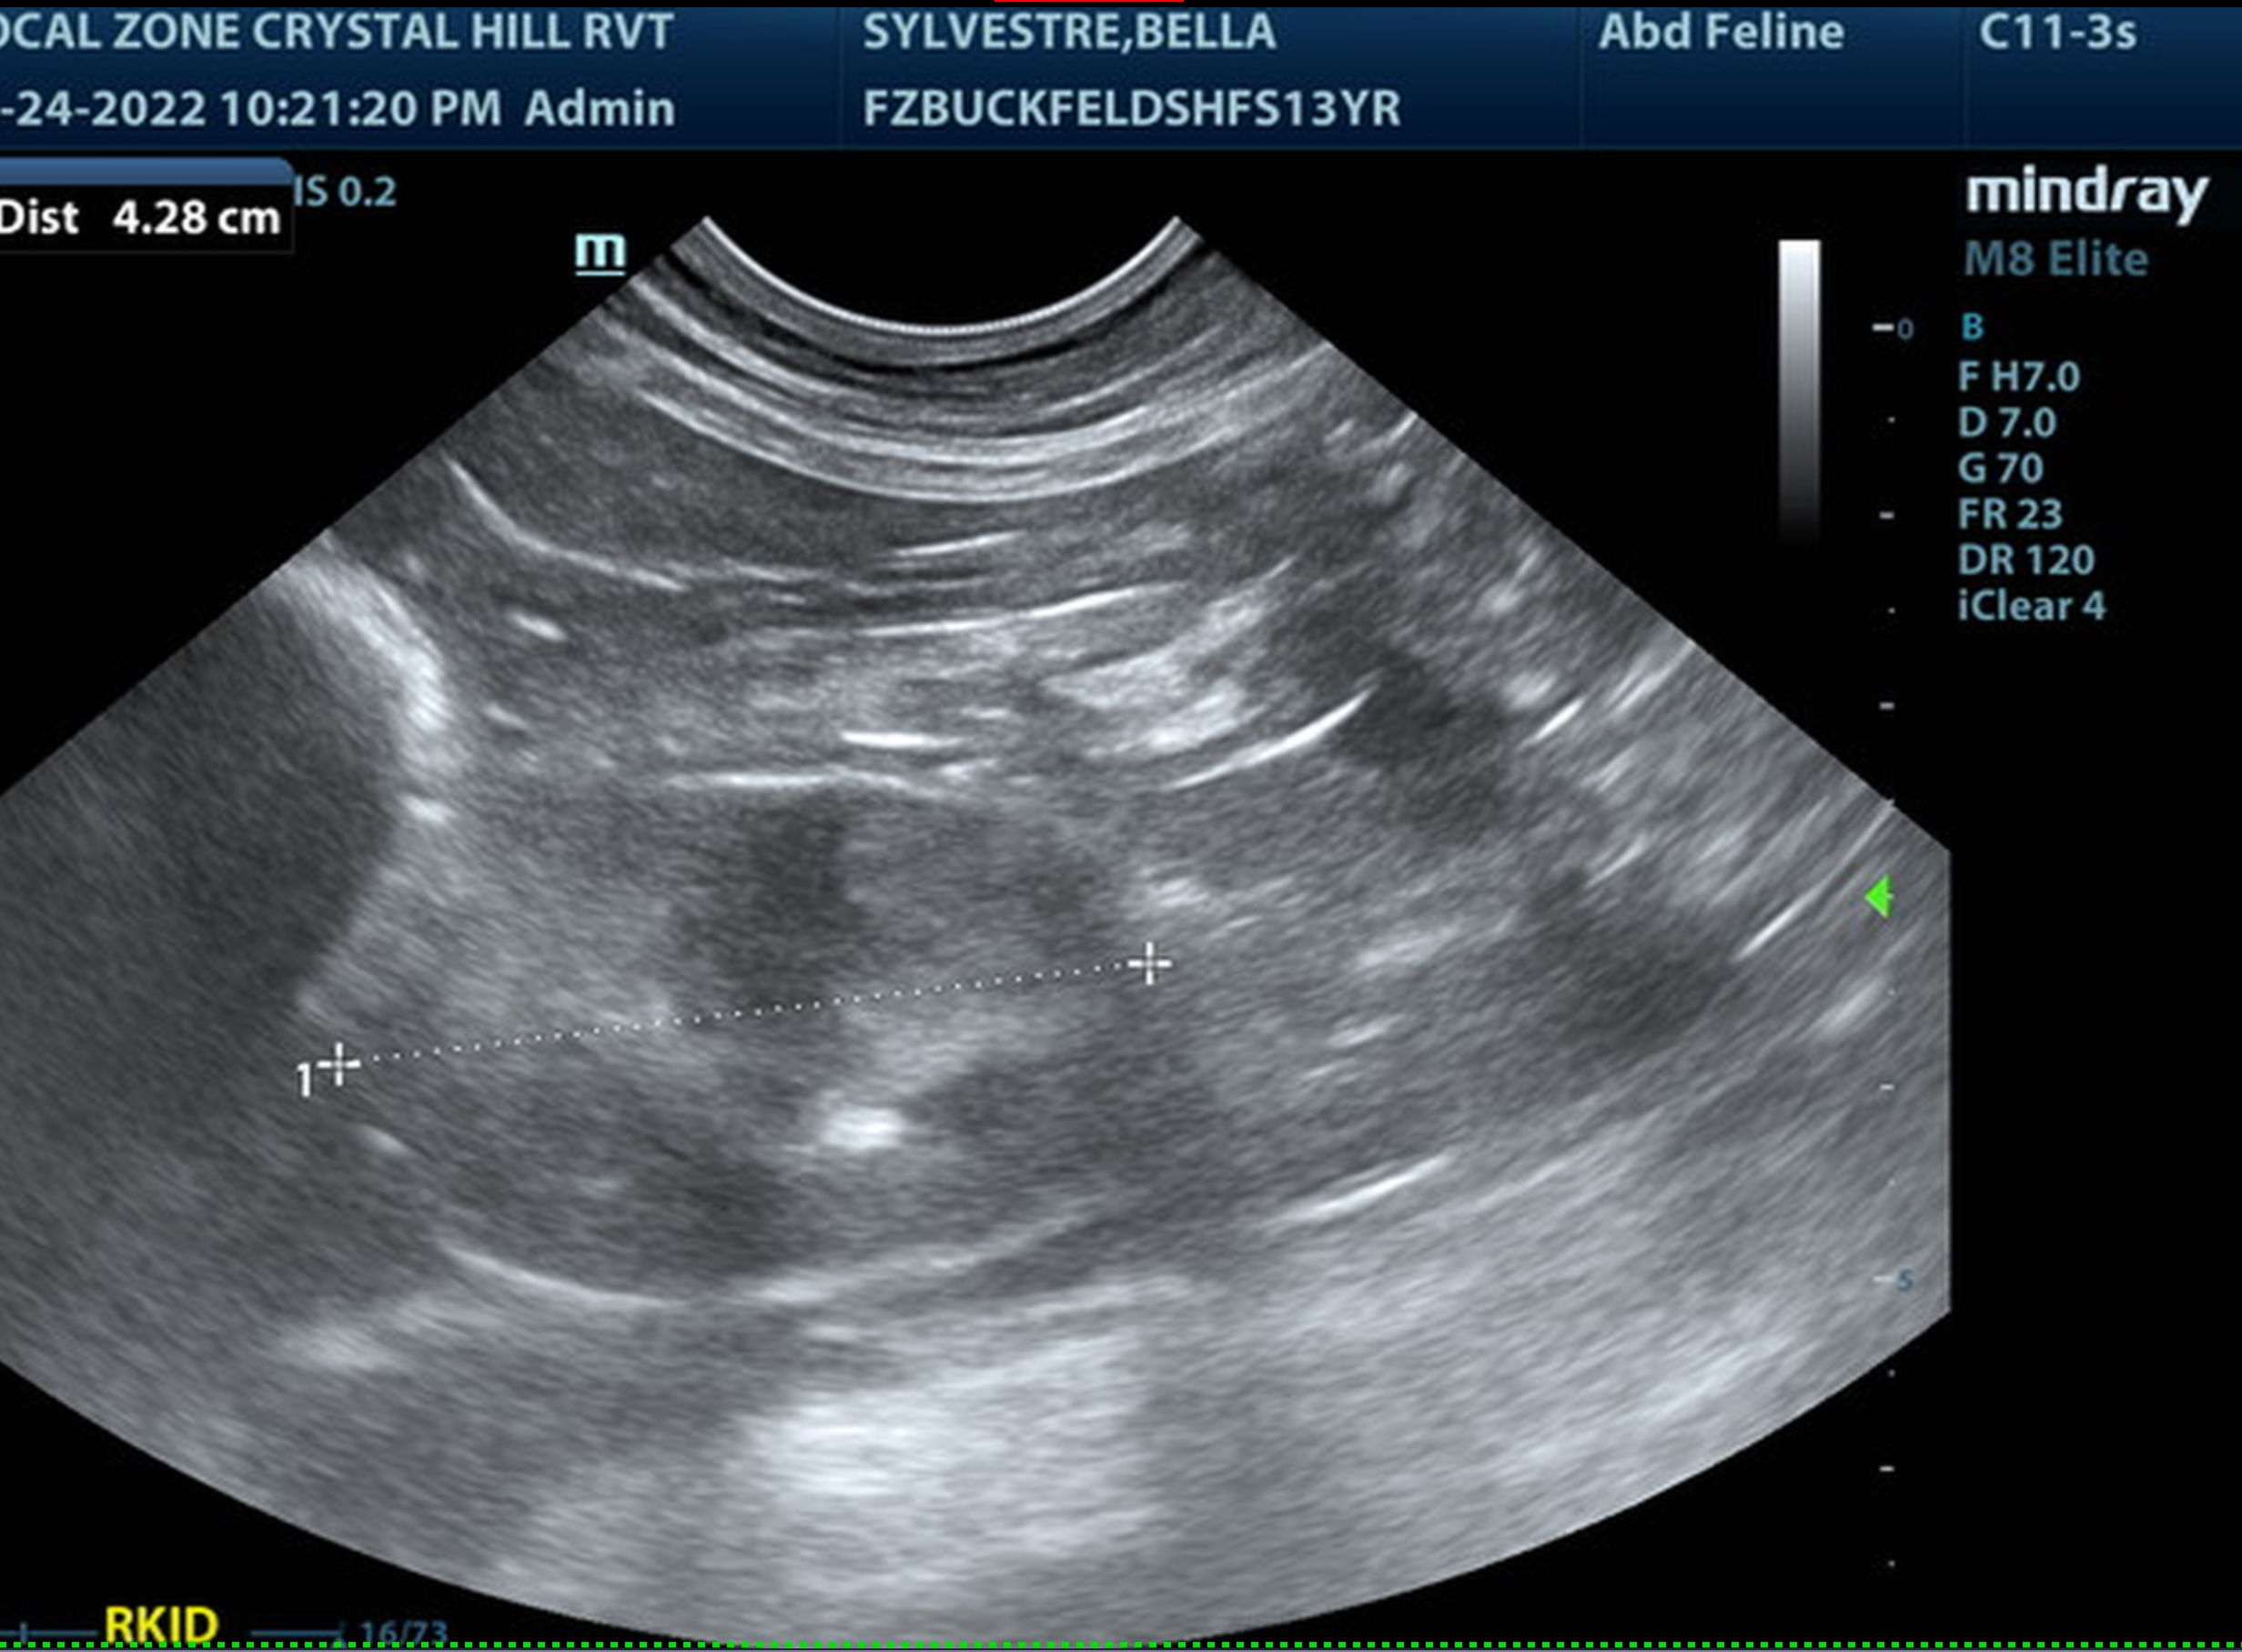
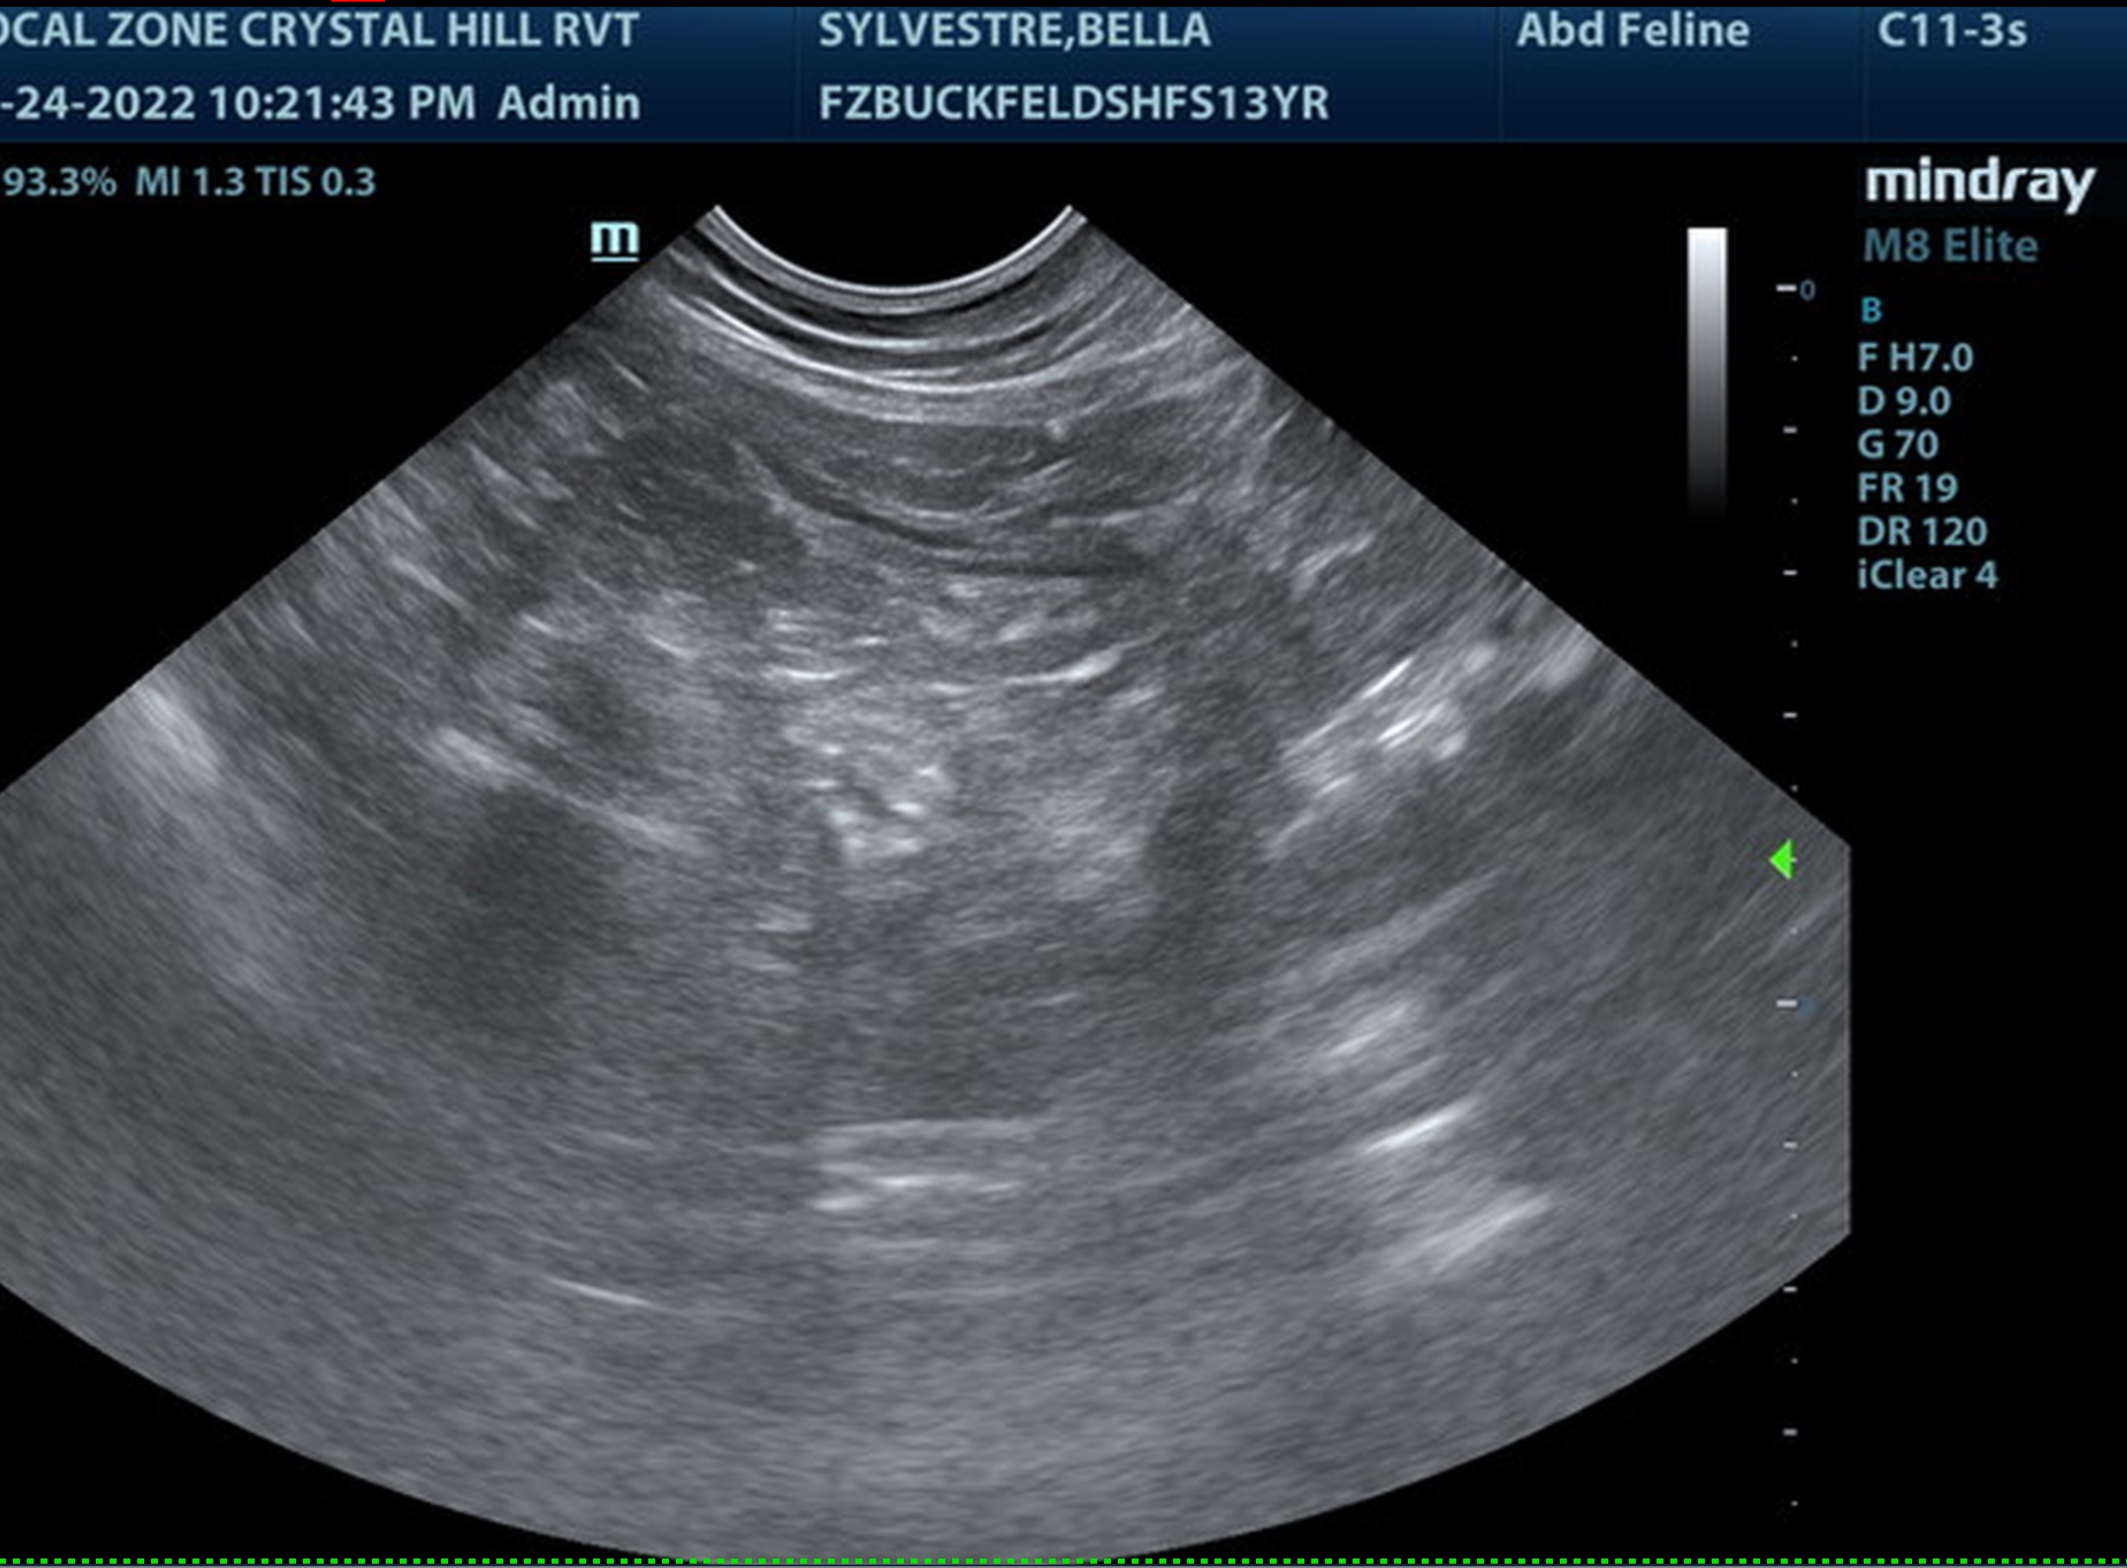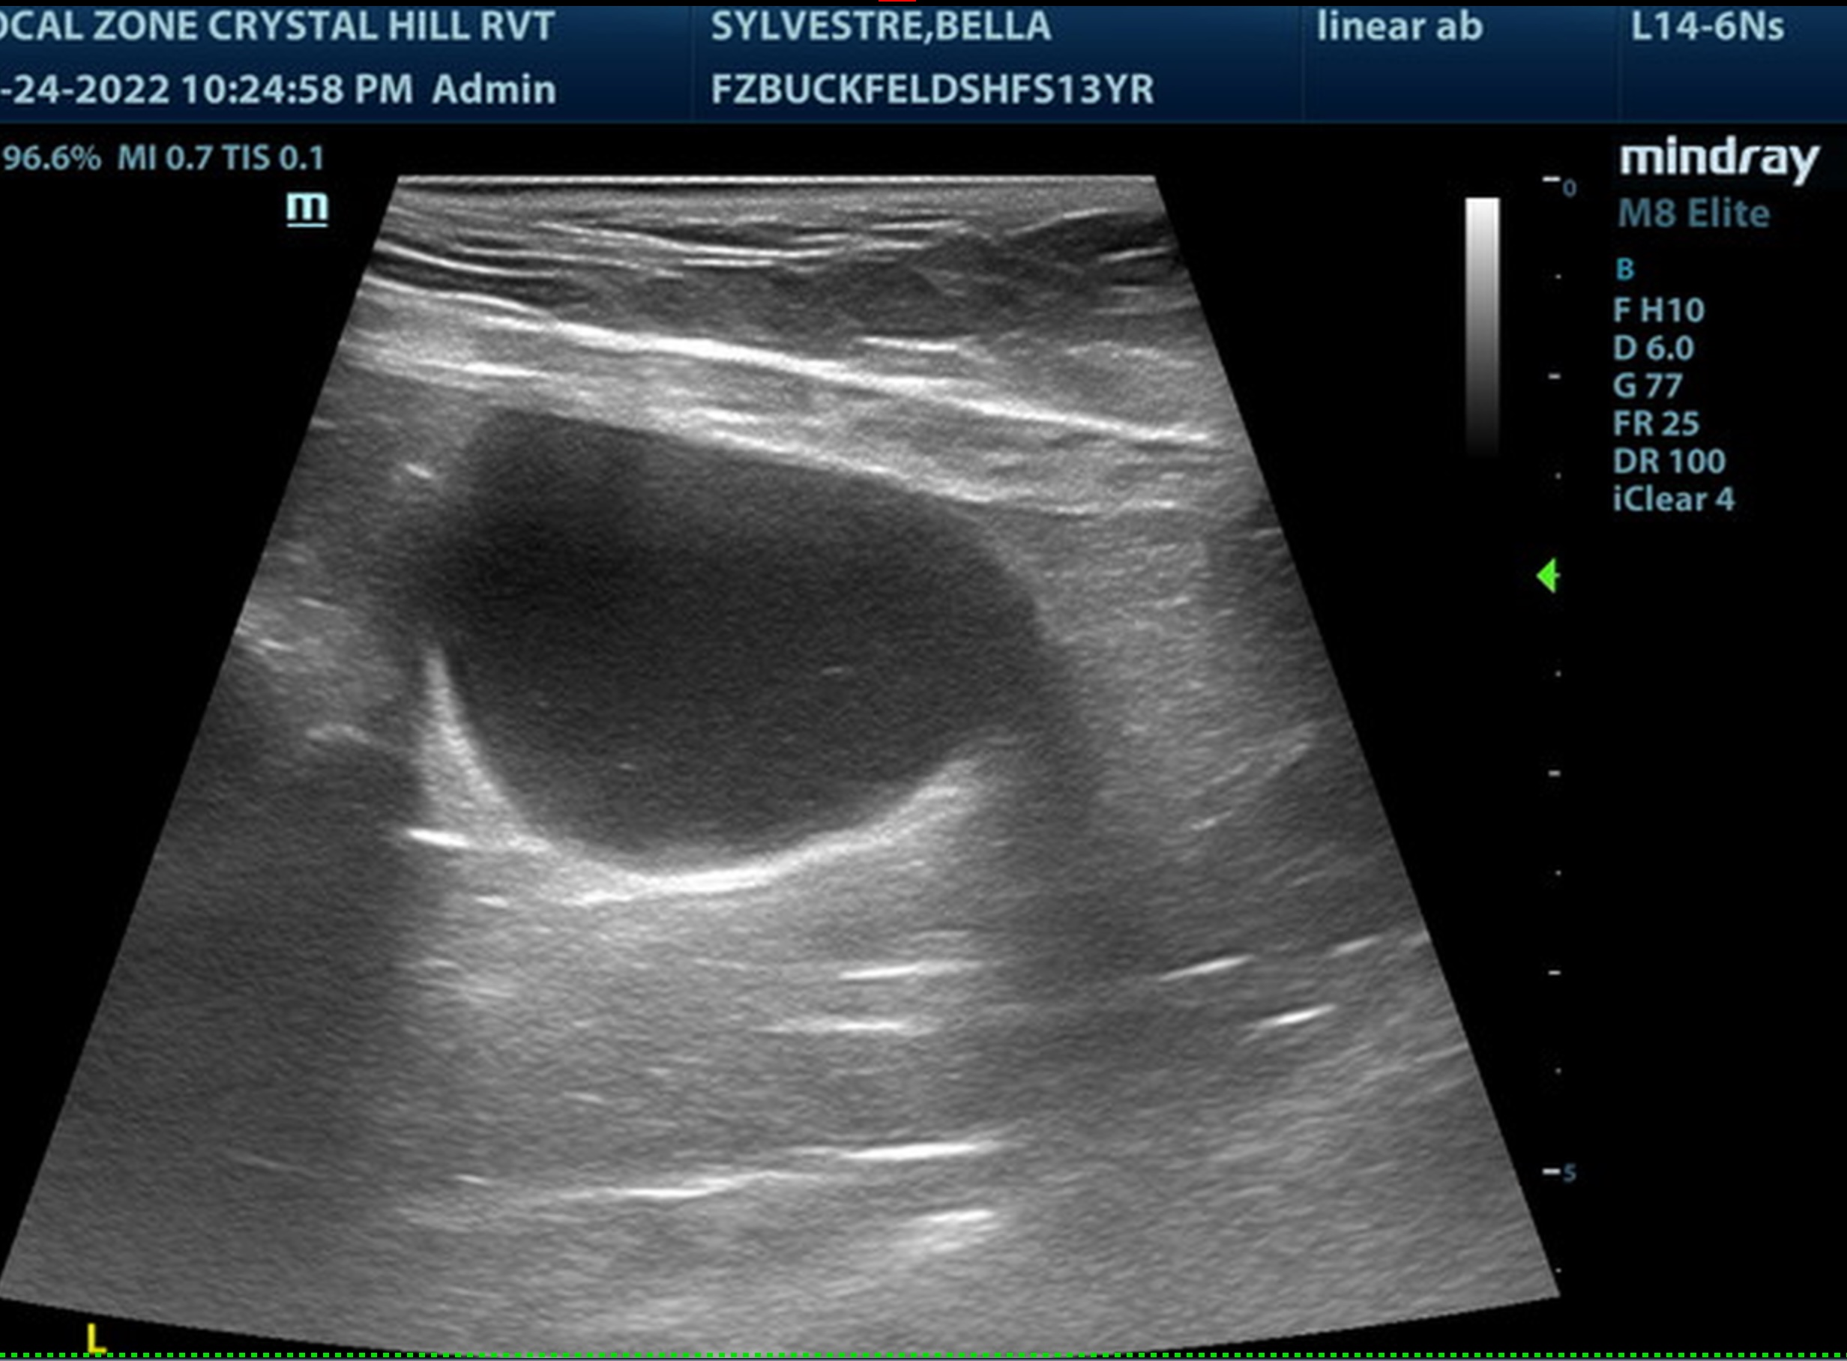
The information and recommendations provided are based on the images presented by the referring veterinarian. No evaluation can be communicated regarding pathology that was not visible in the image/video clips provided.

Thank you for this referral. If the clinical or image interpretation does not parallel your findings or if I can be of any further assistance please contact me.

Eric Lindquist, DMV, DABVP, Cert. IVUSS, CEO of SonoPath.com
Eric.Lindquist@SonoPath.com

