PRESENTING CLINICAL SIGNS
- Recheck echo- prev. stage B2 mitral dz
- Increased coughing intermittently
- Grade 4/6 L systolic murmur
- Current meds: Vetmedin 1.25mg BID, Spironolactone 6.25mg BID, Diphenoxylate 0.625mg BID
Abnormal PE/Chem/CBC/UA Results: ALT 190, ALKP 195, BUN 36
ULTRASONOGRAPHIC EXAMINATION OF THE HEART
CANINE  CARDIAC  PARAMETERS | MR  VMAX  (m/s) | TR  VMAX  (m/s) | LA/AO  (M-Mode) | LA/AO  (Heart Base; Swe) | FS  (%) | EF  (%) | EPSS  (cm)
NORMAL PARAMETER | 4.5-5.5 | <2.7 | 1.3 | Up to 1.6 | 28-40 | 40-100 | <0.6
PATIENT | 5.3 | 2.5 | 1.3 | 1.37 | 51 | 83 | 0.1
CANINE  CARDIAC  PARAMETERS | HR  (BPM) | AV  VMAX  (m/s) | PV  MAX  (m/s) | BODY WEIGHT  (lbs) | LAD  LA MAX 4 Chamber | LVIDd  Avg; 2D and m-mode short axis  (cm) | LVIDs  Avg; 2D and m-mode short axis  (cm)
NORMAL PARAMETER | 50-100 | 0.7-1.7 | 0.7-1.6
PATIENT | NM | 1.3 | 0.60 | 6.6 | 3.0 | 2.96 | --

Cardiac Presentation
The echocardiogram in this patient demonstrated normal left atrial size based on 3 different LA measurement methods. Chamber volumes and echogenicity were normal. Prolapse of the anterior mitral valve leaflet was noted. Doppler indicated measurable insufficiency. The left ventricle presented normal thicknesses with linear contour and was not dilated nor restricted. The myocardium presented normal echogenicity without subjective evidence of significant fibrotic or ischemic disease. Contractility of the ventricular walls was adequate and in normal range for this patient evidenced by the fractional shortening measurement and subjective evaluation of the different regions of the myocardium. The left ventricular outflow tract demonstrated normal laminar flow and subjective structural integrity. The right atrium and auricle revealed normal size, structure and content. No evidence of masses was noted or chamber overload. Tricuspid valvular assessment demonstrated adequate linear morphology. The right ventricle was of normal size (1/3 diameter of LV), chordae structure, myocardial echogenicity and thickness. Pulmonic tract assessment revealed normal valve structure, laminar flow, and diameter (approx.1:1 pa/ao ratio). No visible pericardial or free pleura fluid was noted. No echographically detectable evidence of infiltrative disease was visible. The cranial mediastinum and pericardial regions were free of masses in the visible window.
ULTRASONOGRAPHIC FINDINGS
- Compensated mitral insufficiency on the current protocol.
- Mitral valve prolapse.

INTERPRETATION OF THE FINDINGS & FURTHER RECOMMENDATIONS
Recommend maintaining the current protocol in this patient. Recheck echo in six months, earlier if any clinical signs initiate.

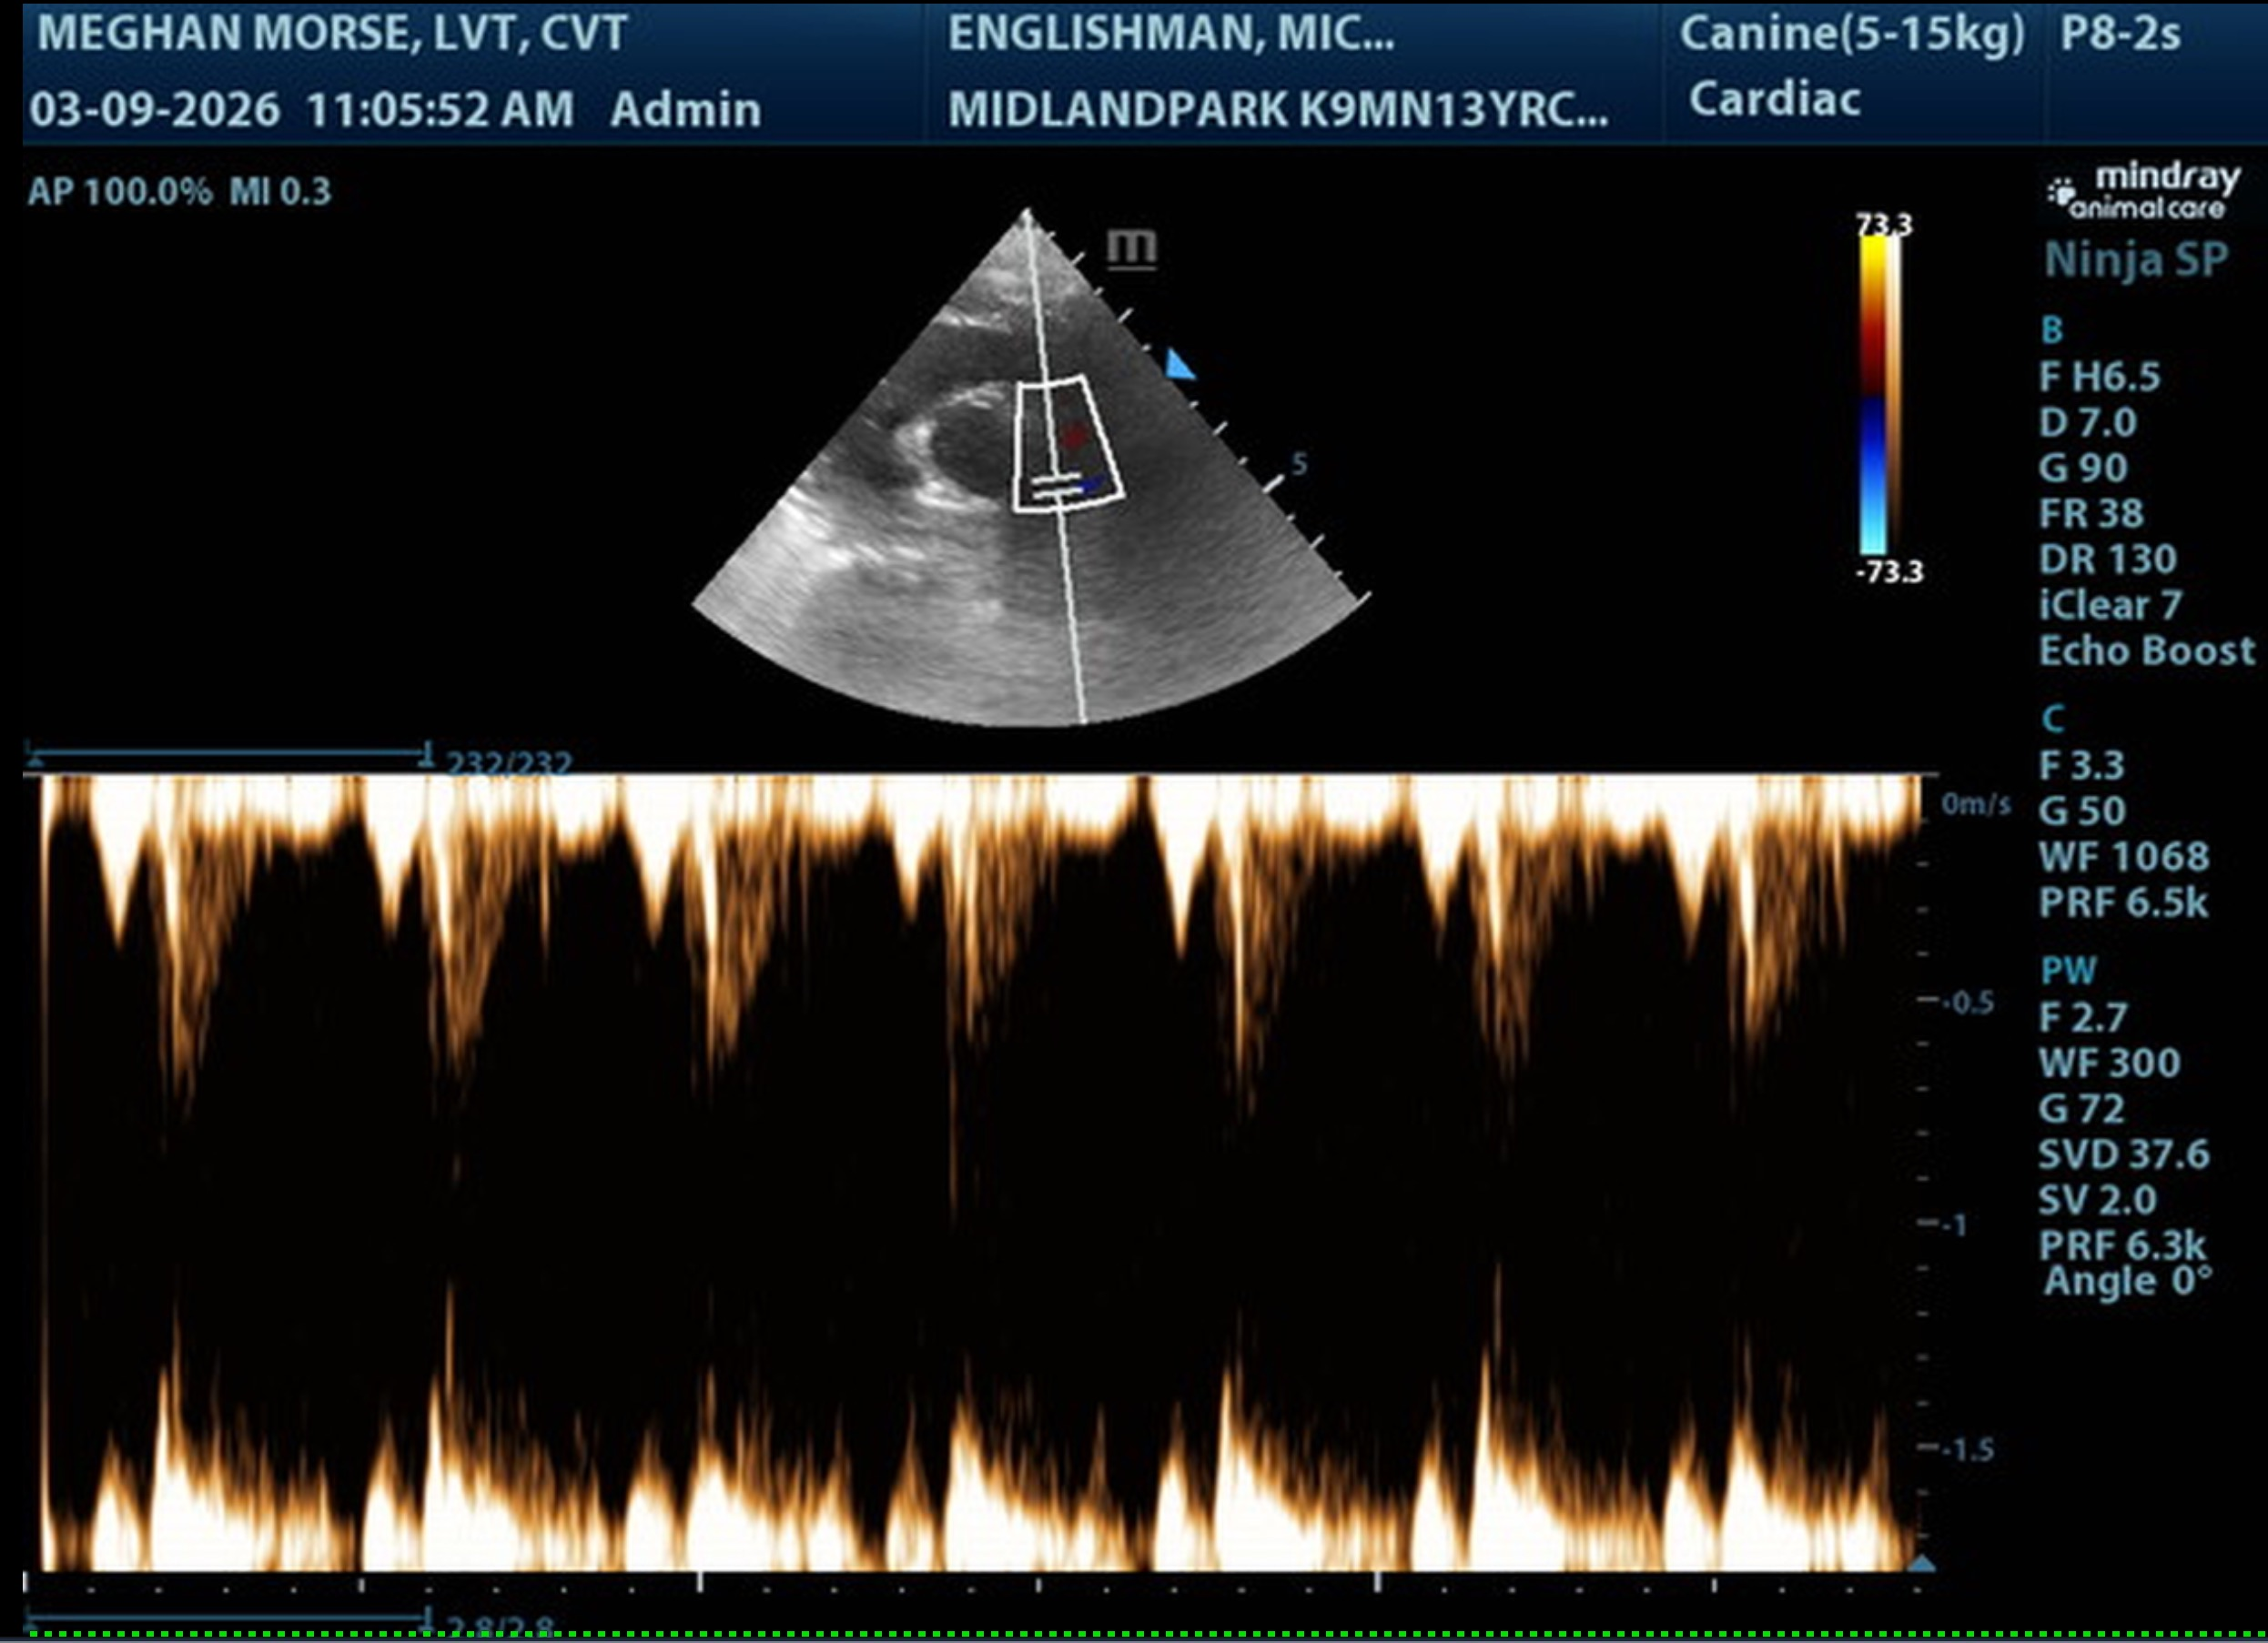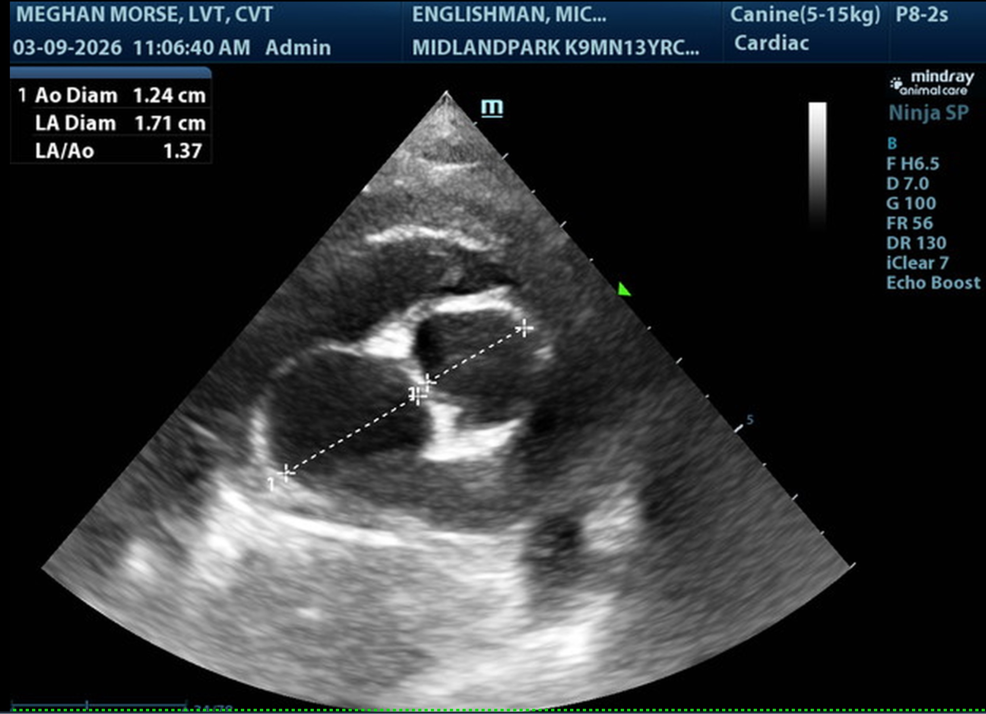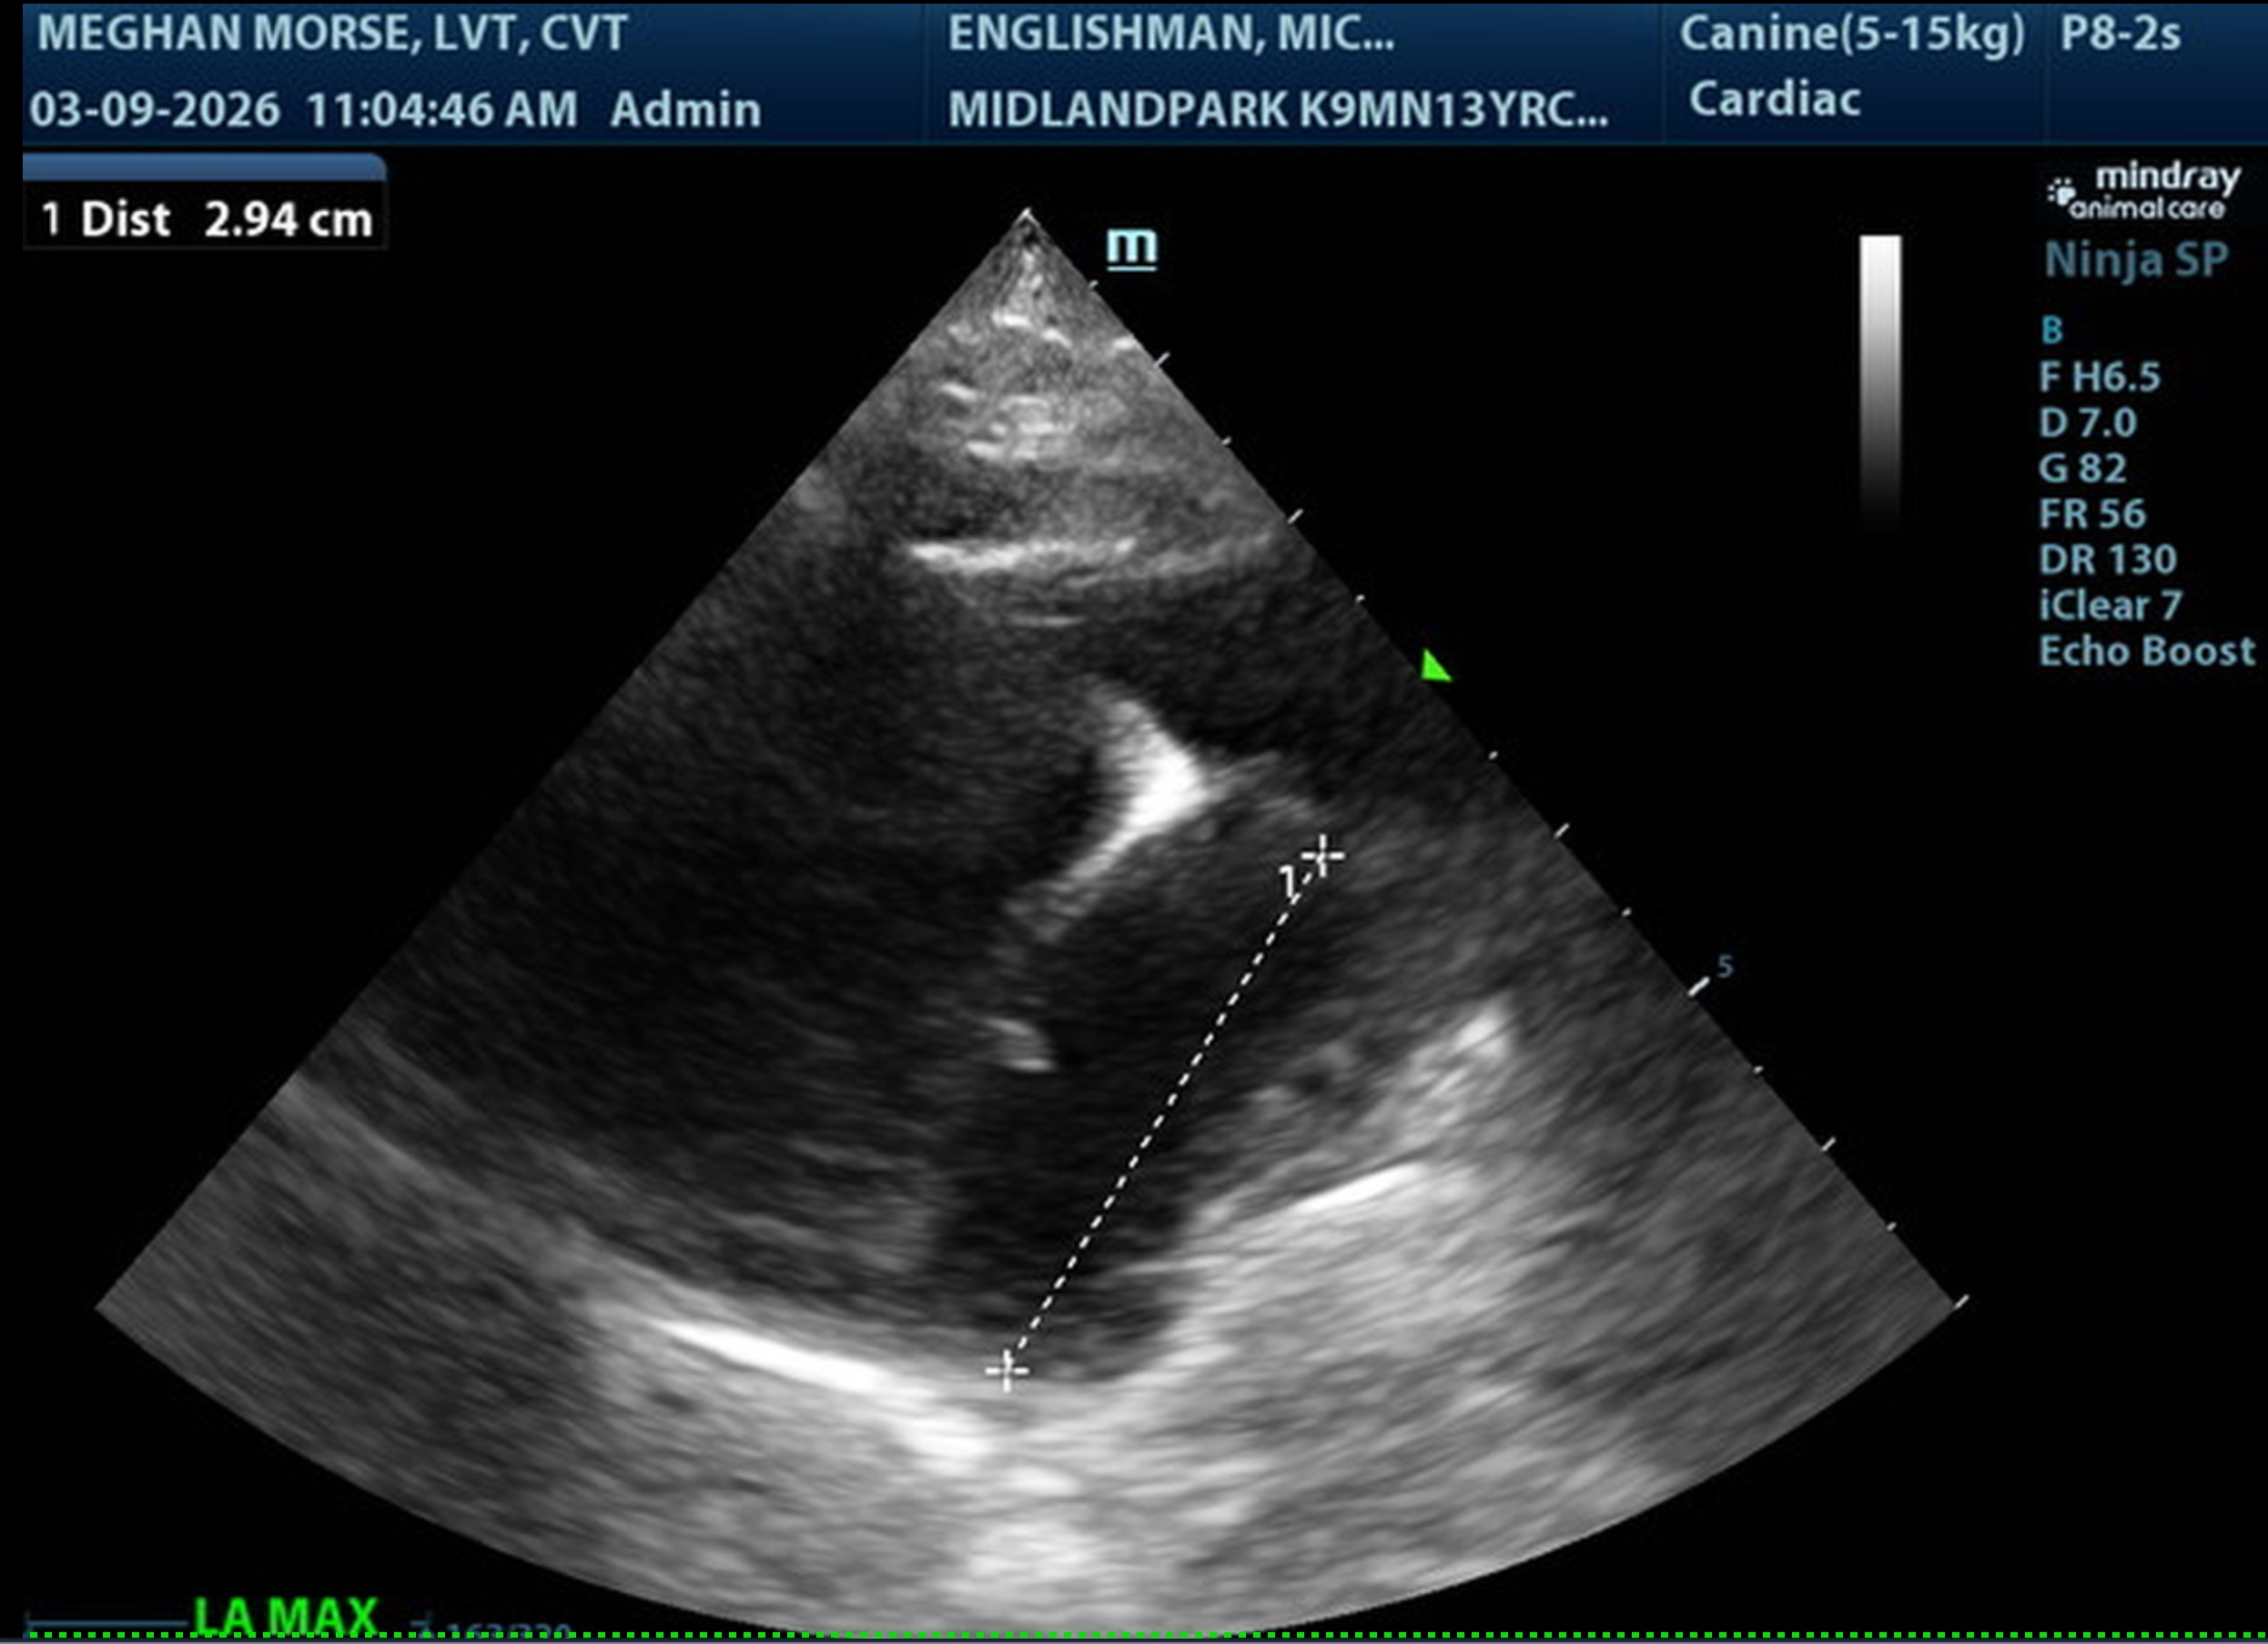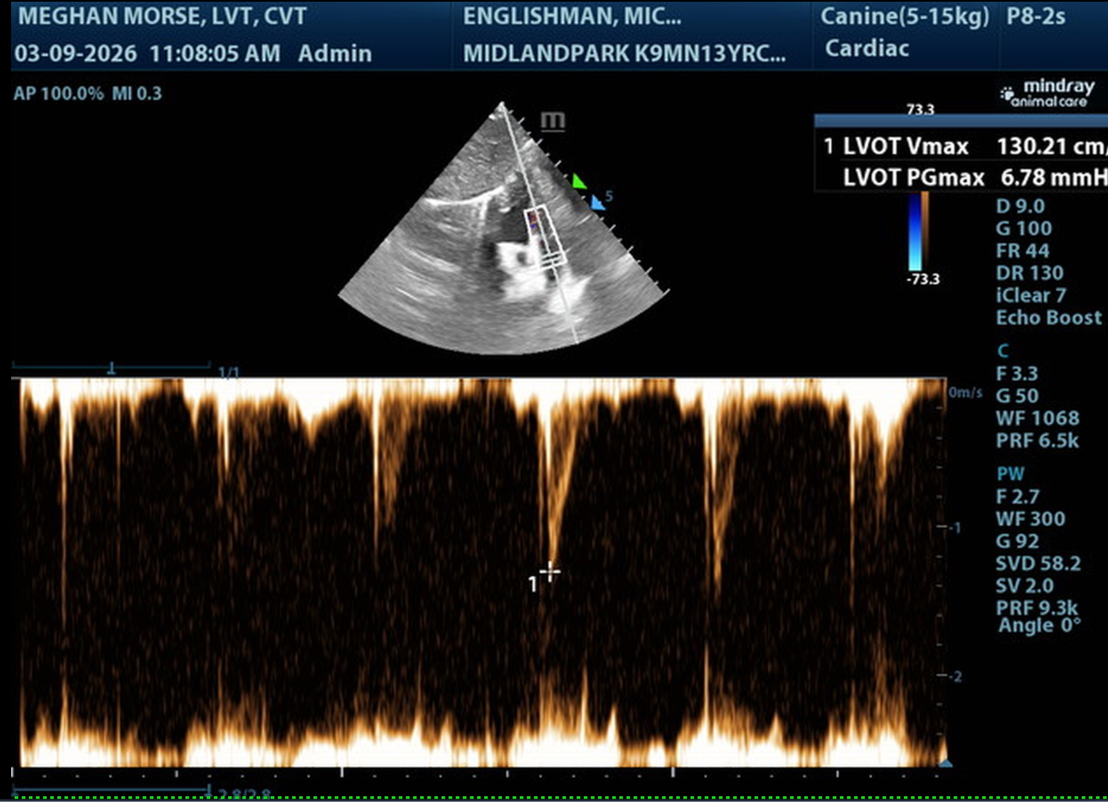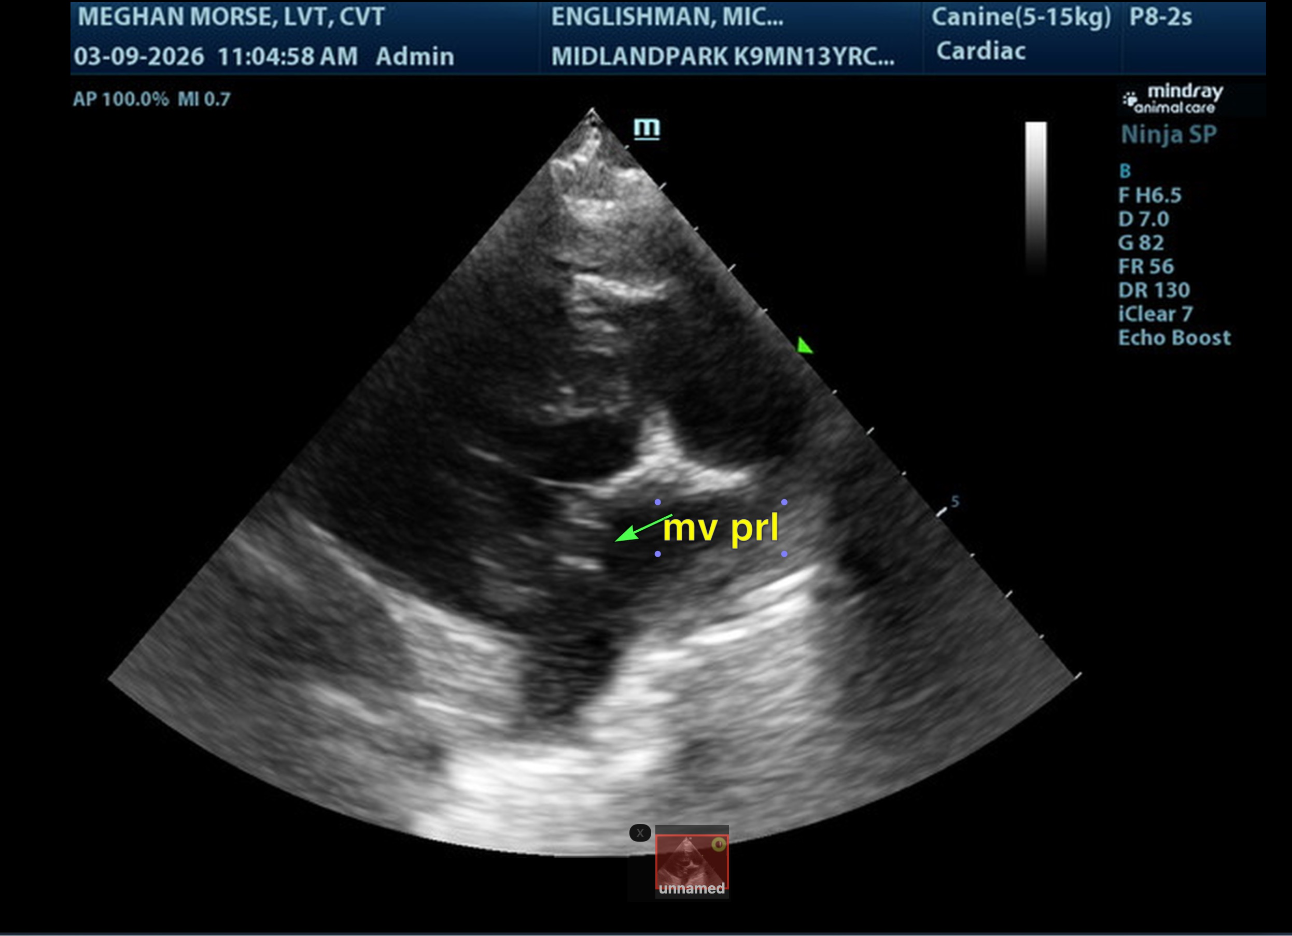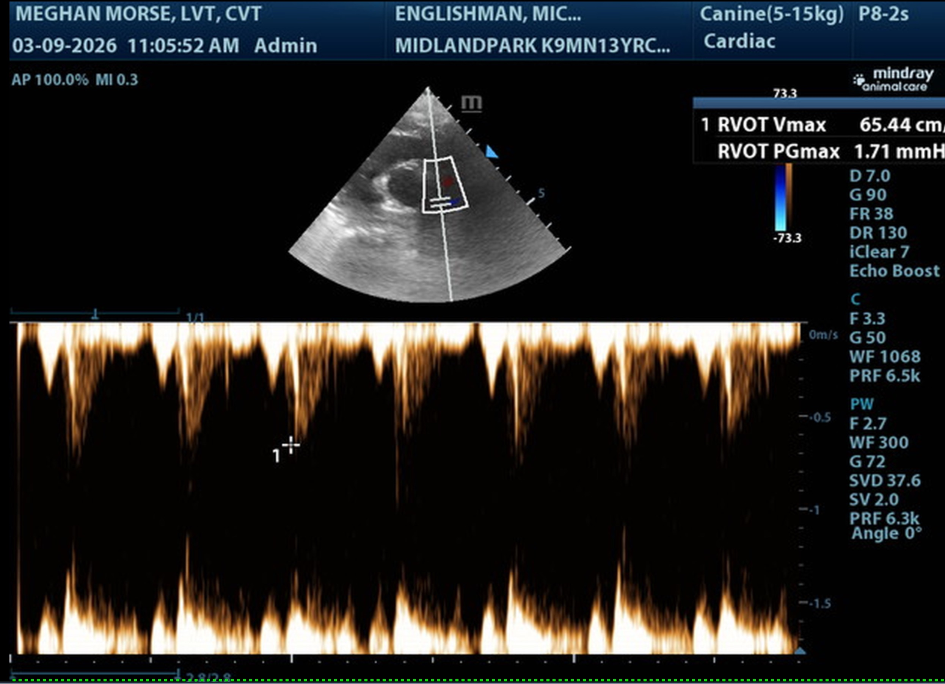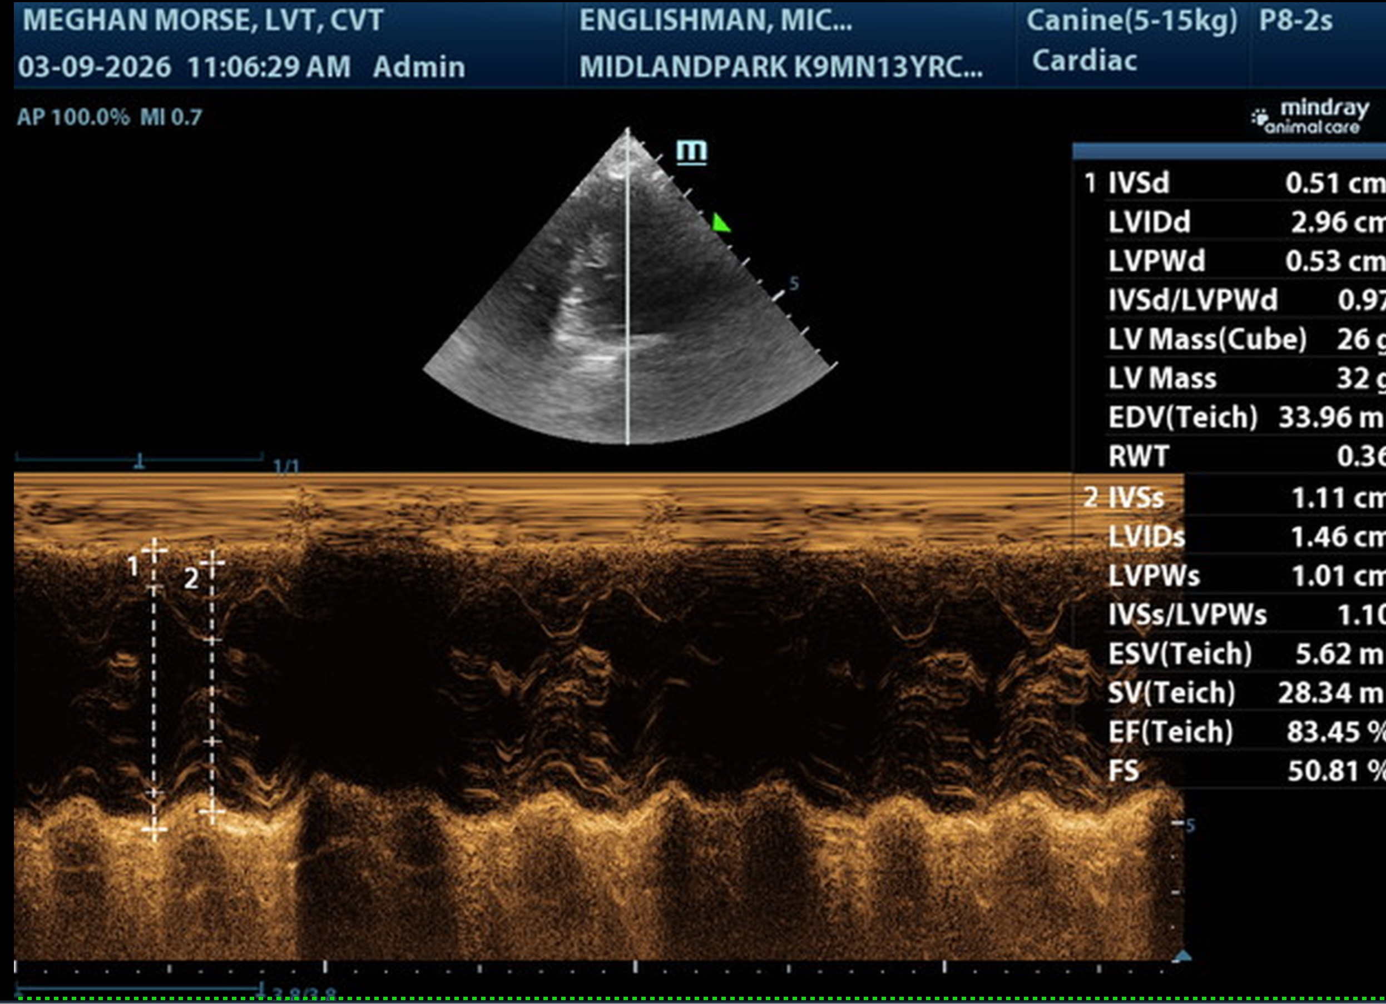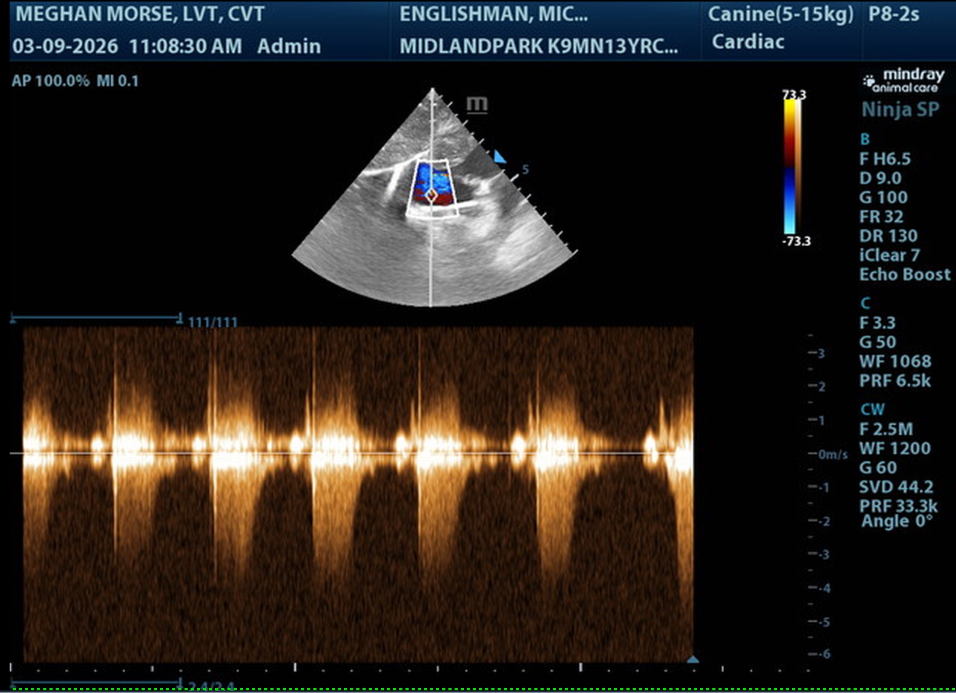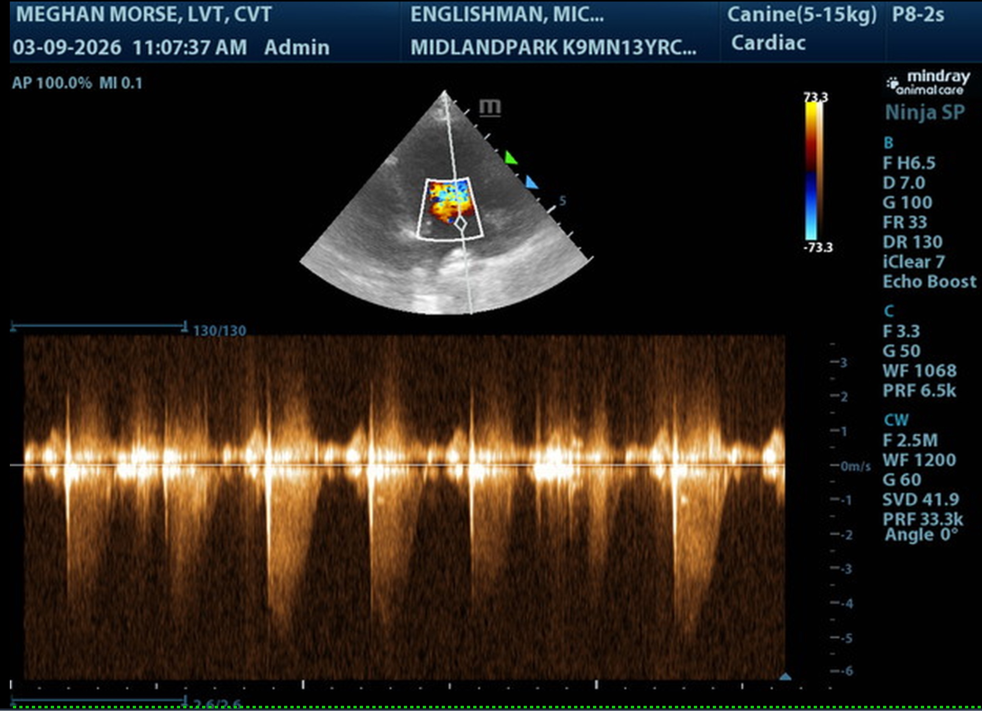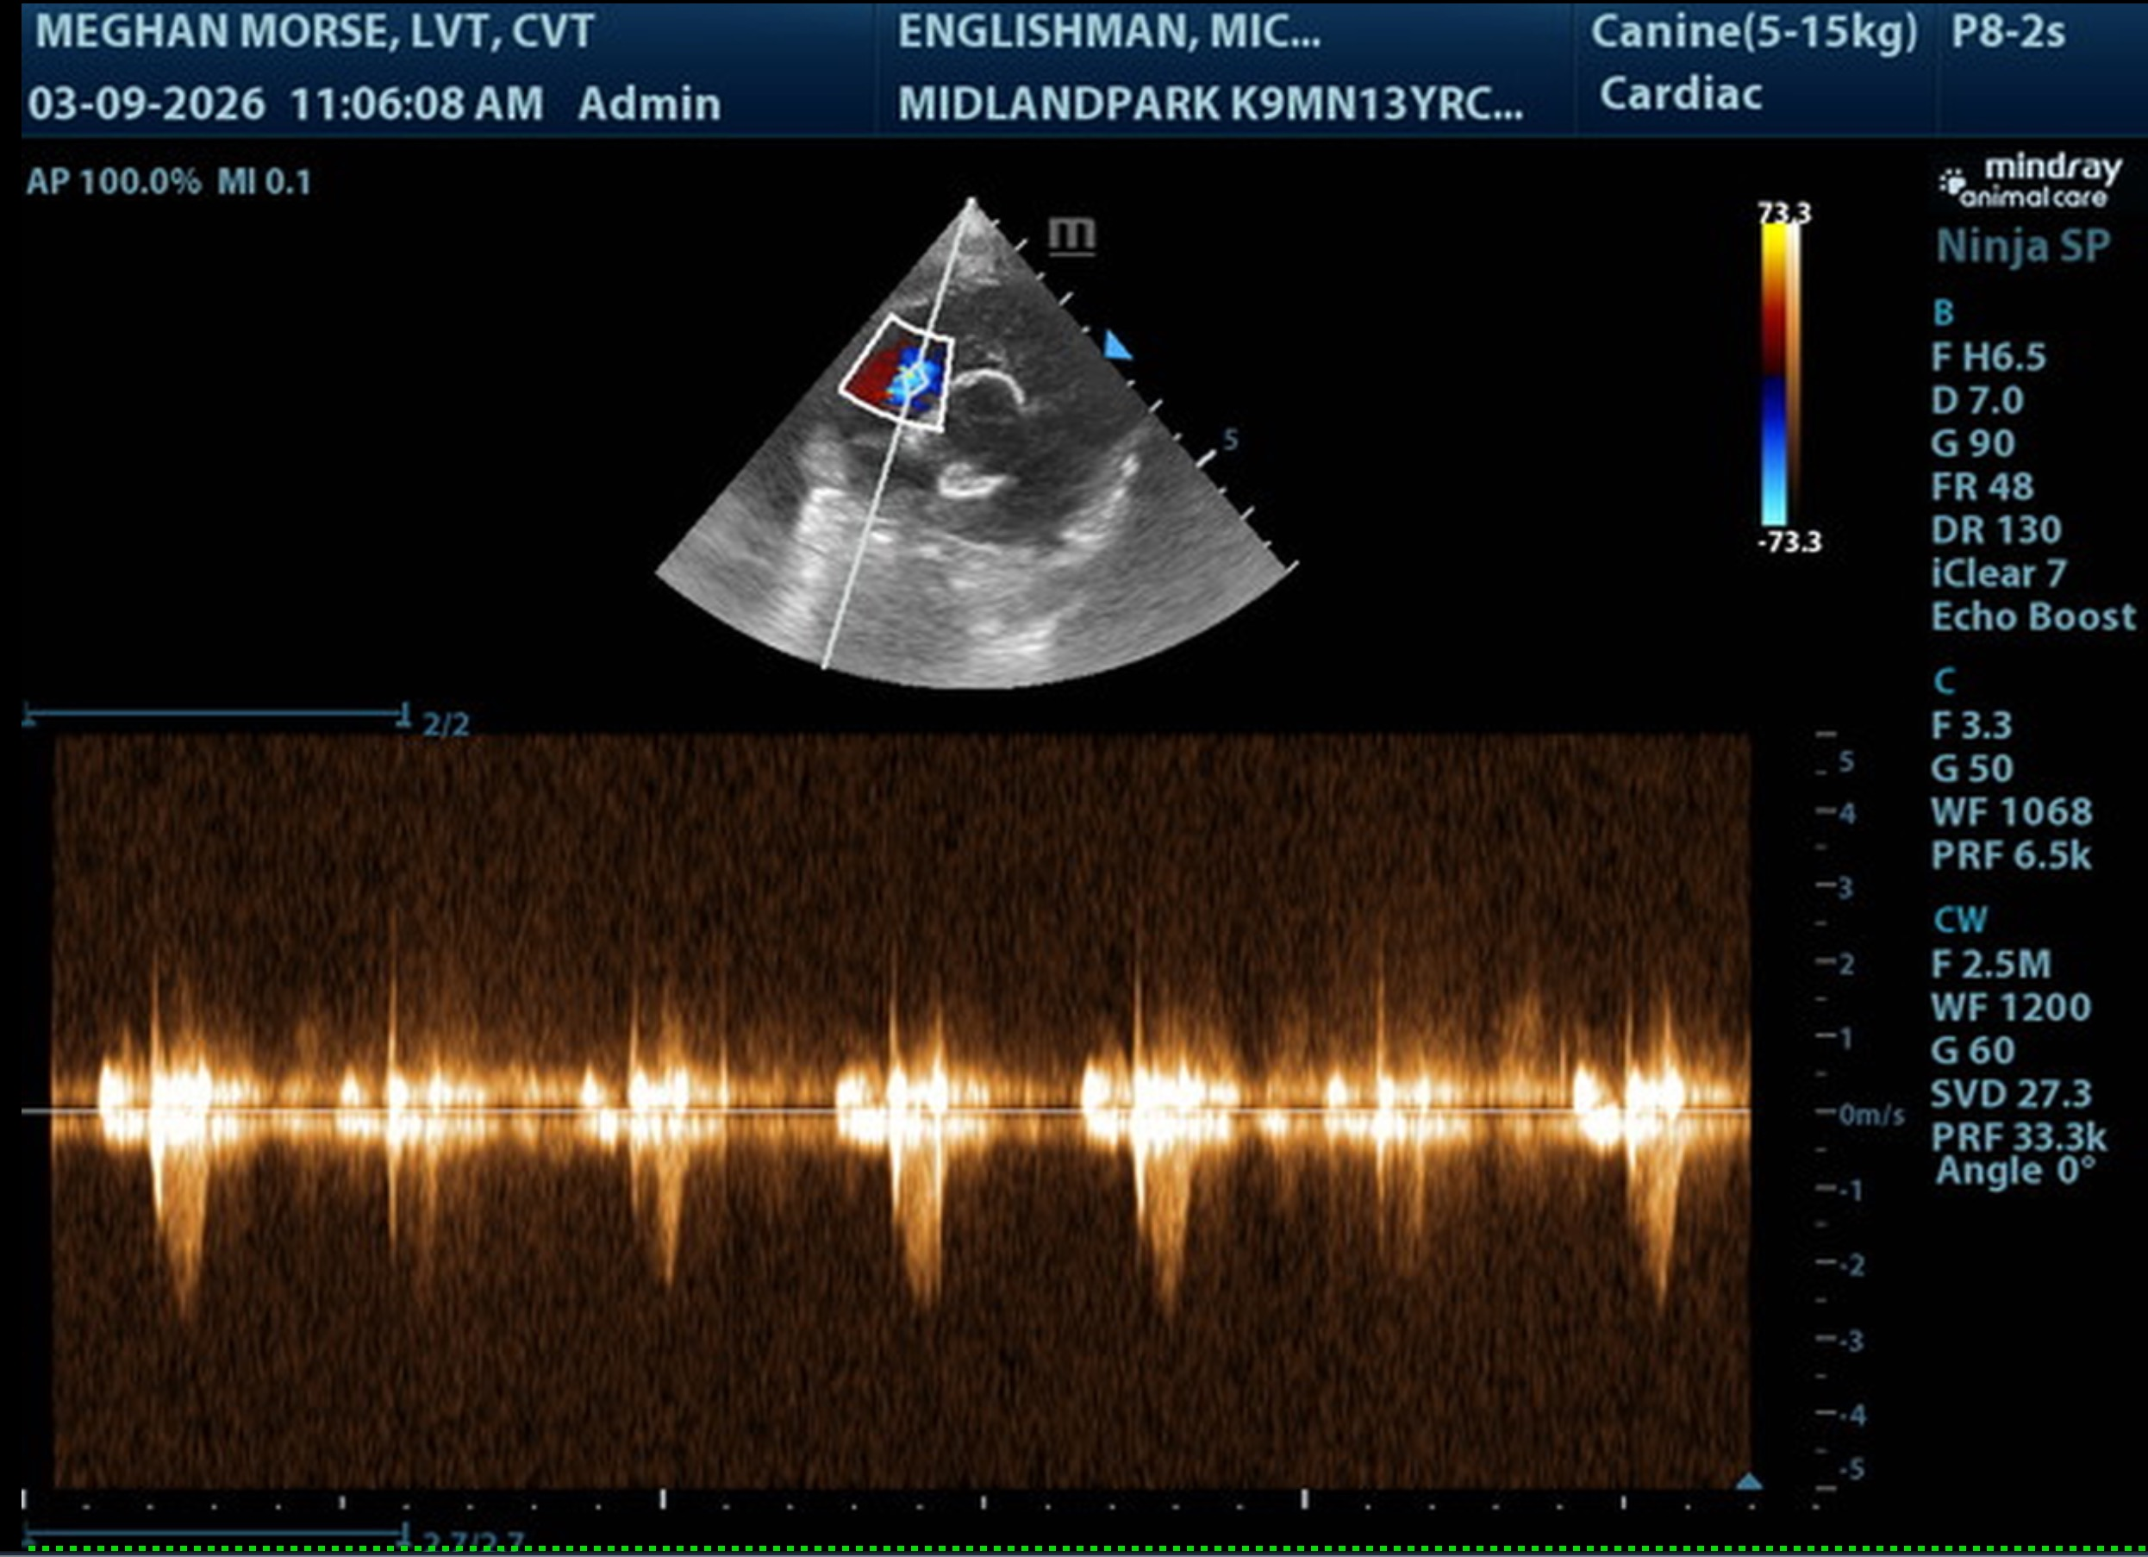
The information and recommendations provided are based on the images presented by the referring veterinarian/sonographer. No evaluation can be communicated regarding pathology that was not visible in the image/video clips provided.
Thank you for this referral. If the clinical or image interpretation does not parallel your findings or if I can be of any further assistance, please contact me.
Eric Lindquist, DMV, DABVP(CFM), Cert. IVUSS,
CEO, Owner, Founder -- SonoPath.com
info@SonoPath.com

