PRESENTING CLINICAL SIGNS
- p presented for not eating to the ER on 2/26 and has been treating outpatient with supportive therapy without much improvement. P seems nauseous when attempting to eat food. P presented today for continuation of the inappetence. P will only eat a little while on Entyce. P is BAR otherwise and nonpainful on palpation
Abnormal PE/Chem/CBC/UA Results: • BW at ER and repeat CBC on 3/2 was WNL • cPL was normal • Fecal test was neg • AXR today revealed a broken sewing needle in the area of the stomach but couldn't rule out whether it migrated toward liver or not.

ULTRASONOGRAPHIC EXAMINATION OF THE ABDOMEN
Urinary System
The urinary bladder, trigone, and pelvic urethra to a depth of 1.0 cm presented normal thicknesses and normal tone. The ureters were not visible which is normal. No uroliths or sediment were visualized, and anechoic urine was present. No evidence of inflammatory or neoplastic changes were noted. Ureteral papillae were normal.
The kidneys revealed normal size and structure, corticomedullary definition and ratio for this age. The cortices presented largely uniform texture with normal echogenic relationship to liver and spleen. Medullary structure differed distinctly from the cortex and no evidence of pelvic dilation was present. The capsules were acceptably uniform without significant irregularities. The left kidney measured 6.1 cm in length. The right kidney measured 6.1 cm in length.
Adrenal Glands
The left adrenal gland was visualized and recognized as having normal shape, size, position and echogenicity for this breed. The phrenic vasculature, glandular echogenicity and detail were unremarkable. Capsule, cortex, and medullary definition were normal for this age patient. The left adrenal gland measured 0.70 cm width.
The right adrenal gland was flattened and isoechoic measuring approximately 5.0 mm in width.
Spleen
The spleen presented mildly enlarged and folded upon itself cranially. No evidence of torsion was present. Splenic hilus was in lateral position yet vascularity appeared to be patent.
Liver
The liver images submitted revealed subjectively normal liver size, contour, and structure. Parenchymal echogenicity was naturally coarse and hypoechoic to the spleen. Vascular and biliary tracts were of normal volume with no evidence of congestion. The gallbladder presented acceptably thin walls with primarily anechoic content. The cystic and common bile ducts were normal. No pathological hepatic lymphadenopathy was evident. No overt structural evidence of inflammatory, infiltrative or regenerative pathology was evident.
Gastrointestinal
Examination of the gastrointestinal tract revealed a stomach and intestine free of stasis, of normal wall thickness, acceptable curvilinear mural detail, and peristaltic activity. Small and large intestine demonstrated normal luminal chyme and stool consistency respectively. No obstructive or overt infiltrative disease was noted. No associated abnormal lymphatic activity was noted.
Pancreas
The base and limbs of the pancreas were observed to be largely isoechoic to surrounding omental fat. Pancreatic duct and capsular contour were acceptably normal and parenchyma respected normal curvilinear patterns. No overt evidence of active inflammatory or neoplastic disease was noted.
ULTRASONOGRAPHIC FINDINGS
- Inverted splenic position- may be related to the clinical signs.
- Flattened right adrenal gland.

INTERPRETATION OF THE FINDINGS & FURTHER RECOMMENDATIONS
I recommend manual palpation of the spleen to assess for any discomfort. If the patient has discomfort upon palpation of the spleen, then proactive splenectomy is indicated. I feel that the spleen is at risk for torsion in this patient. There is no other evidence of pathology. I do recommend baseline cortisol or ACTH stimulation test given the age of the patient and the flattened right adrenal gland to rule out Addison’s disease. Chest radiographs, full CNS examination and orthopedic examination are warranted to assess for any other pathology that may be contributing to clinical signs.

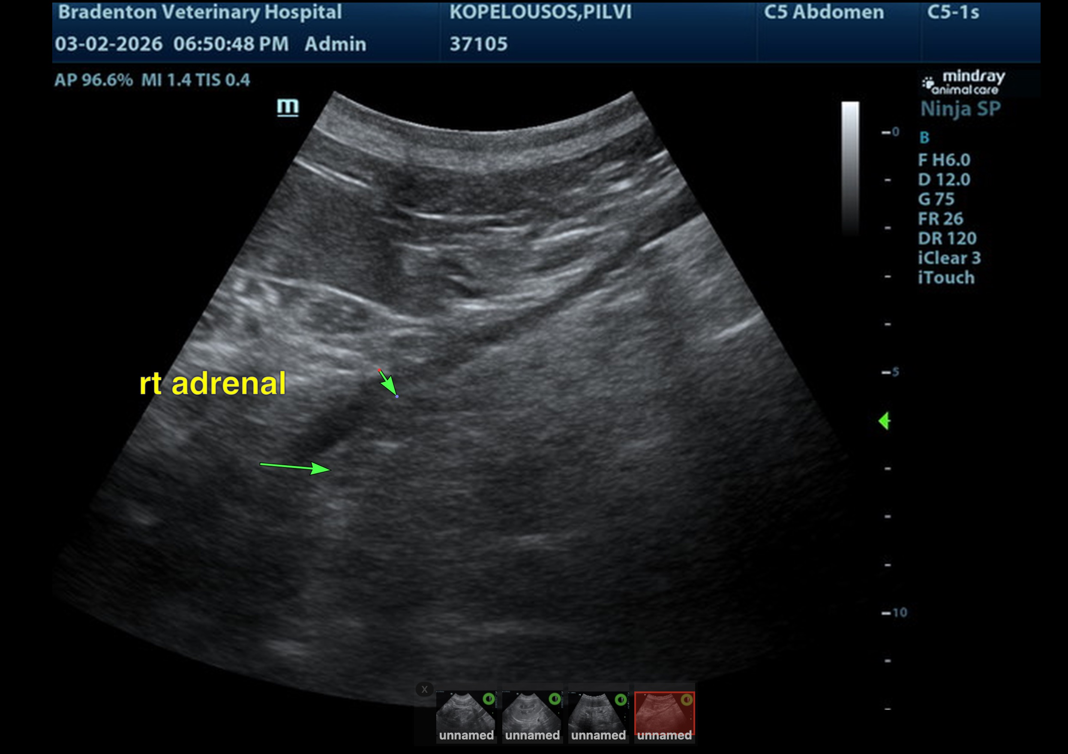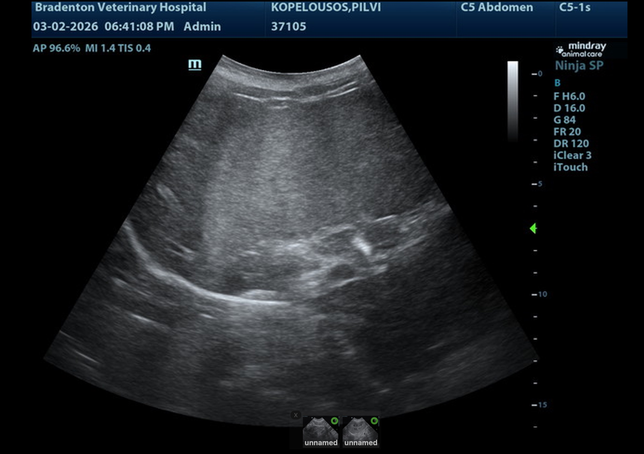
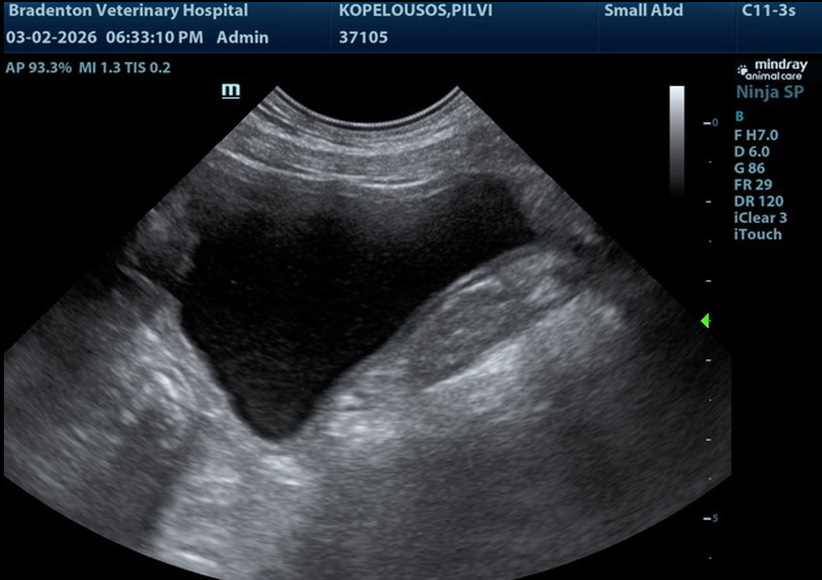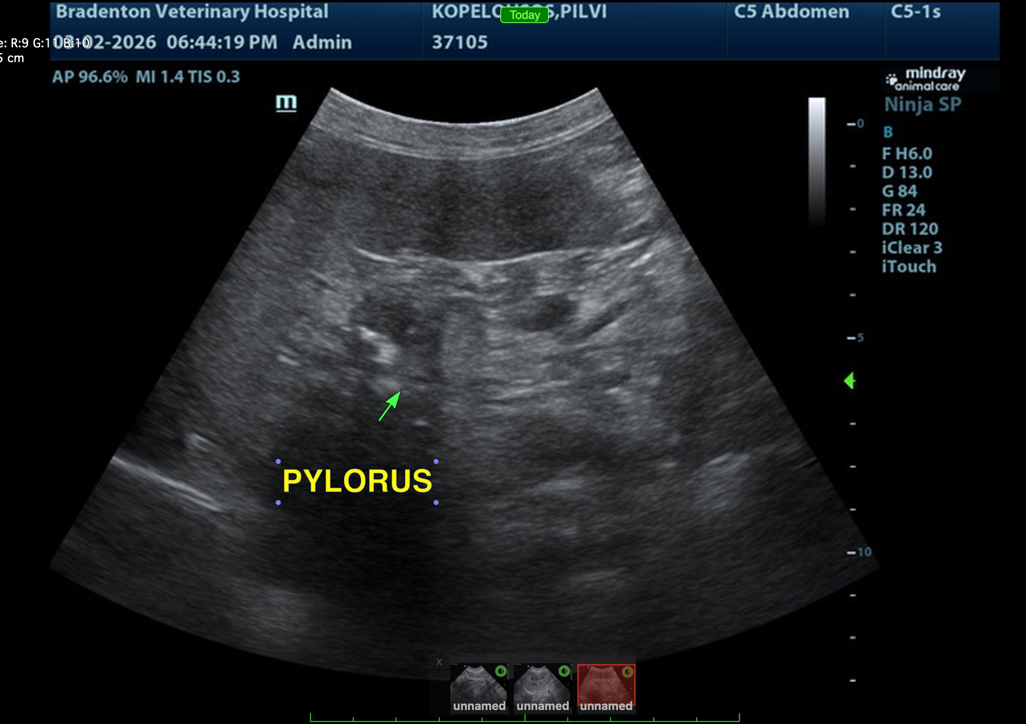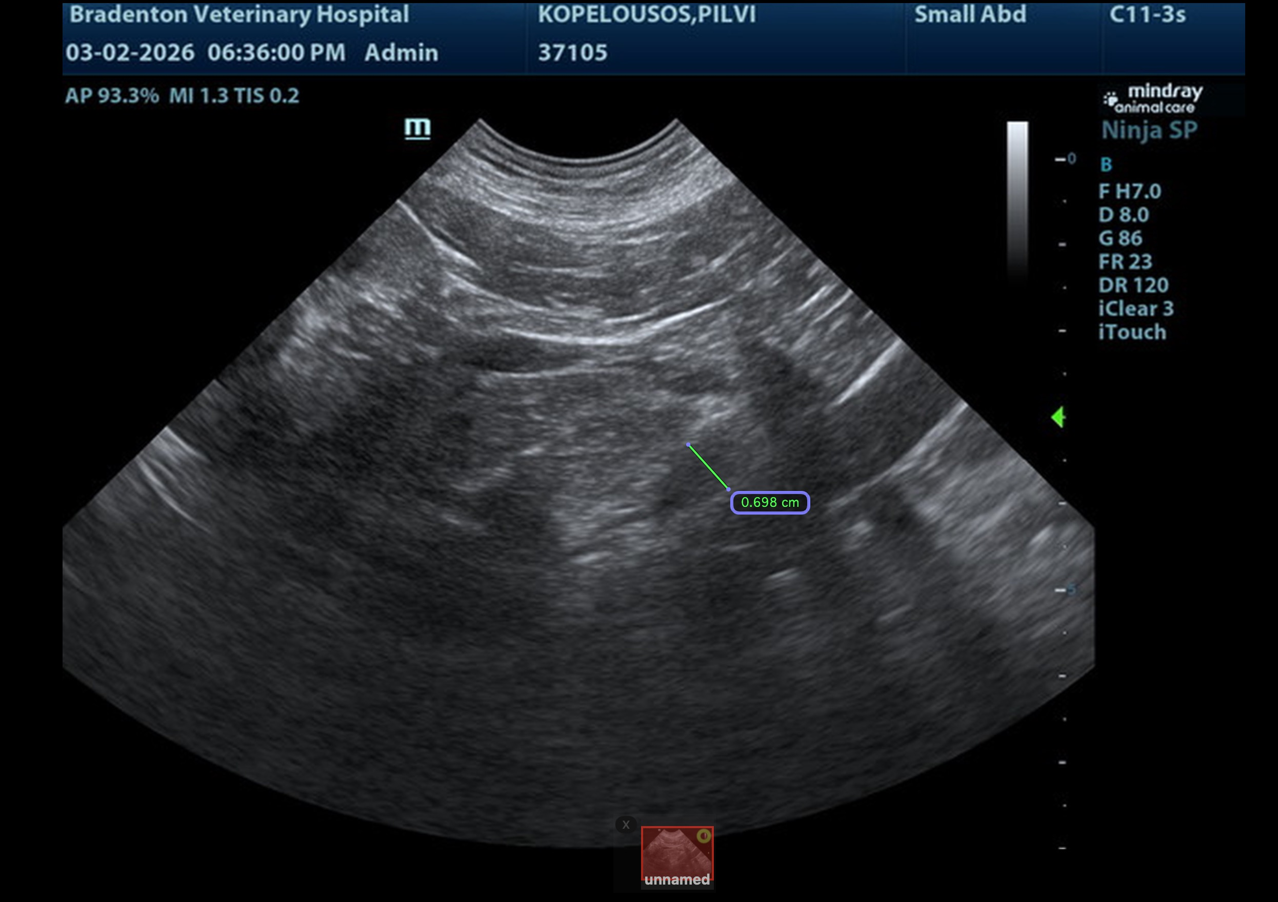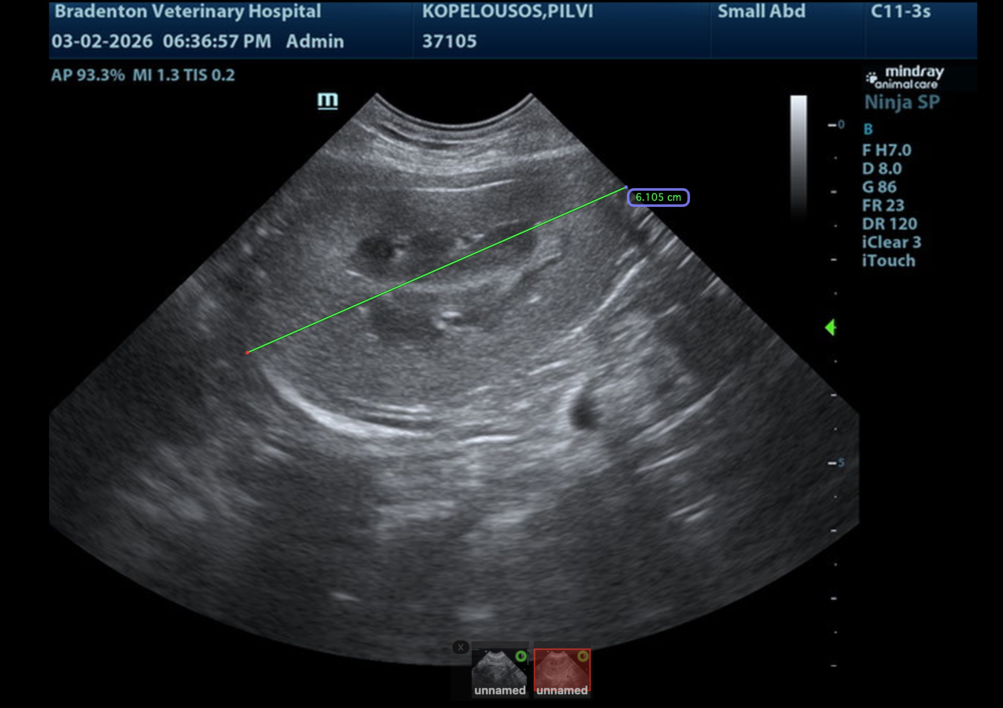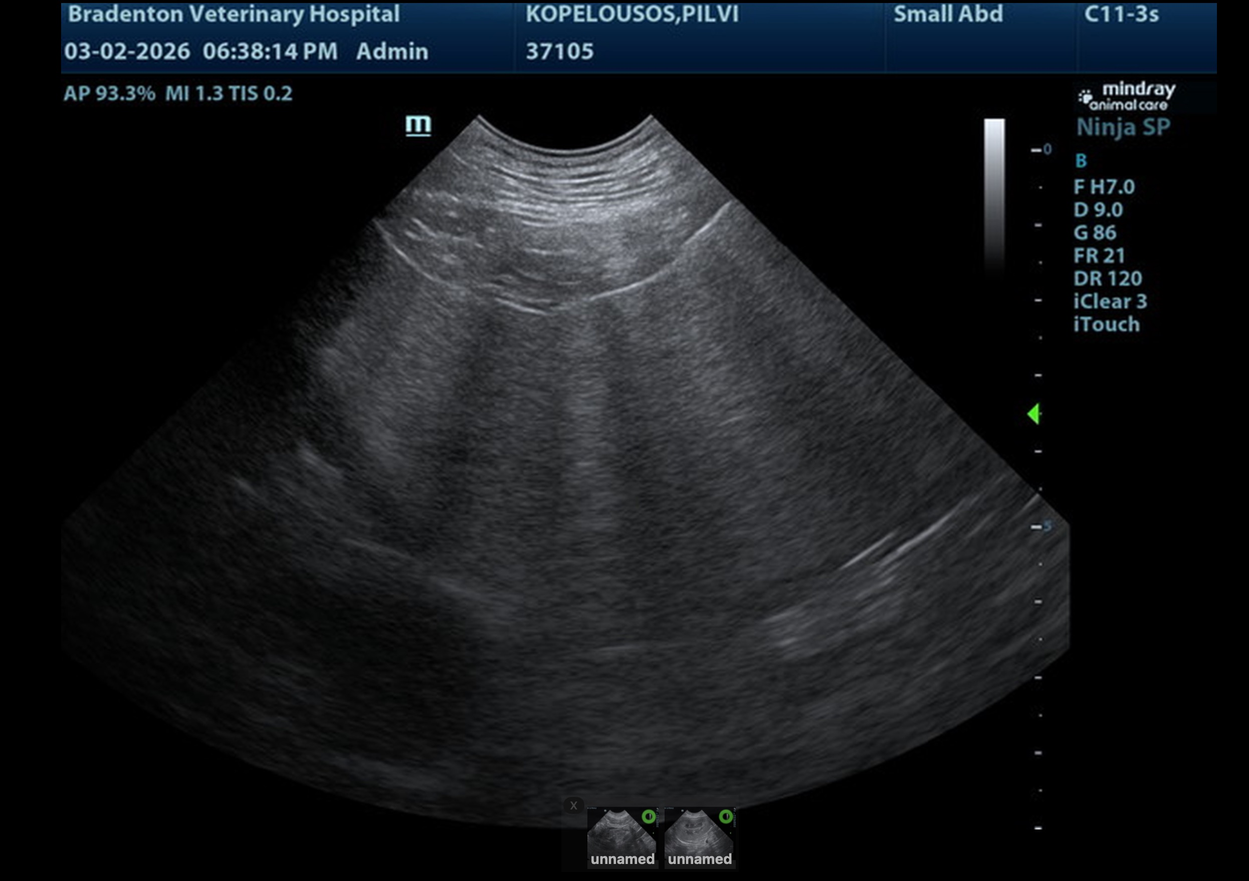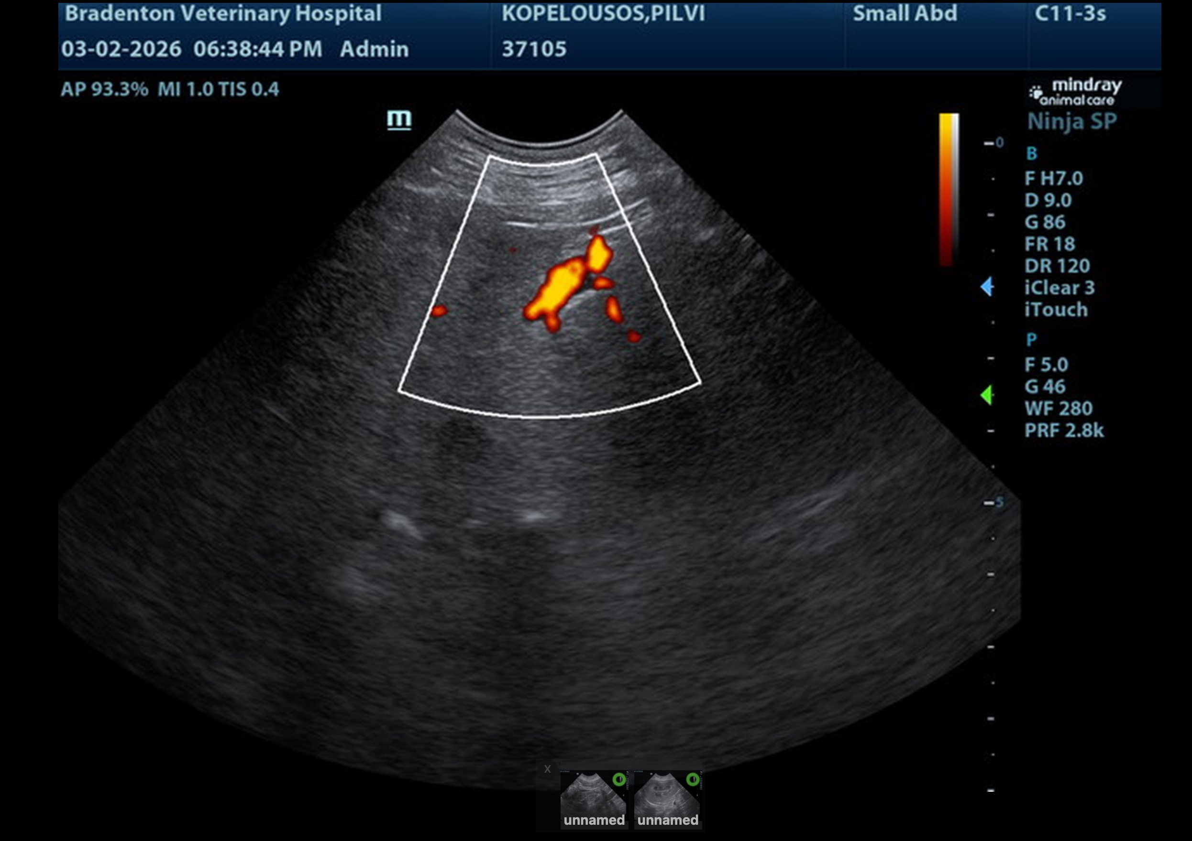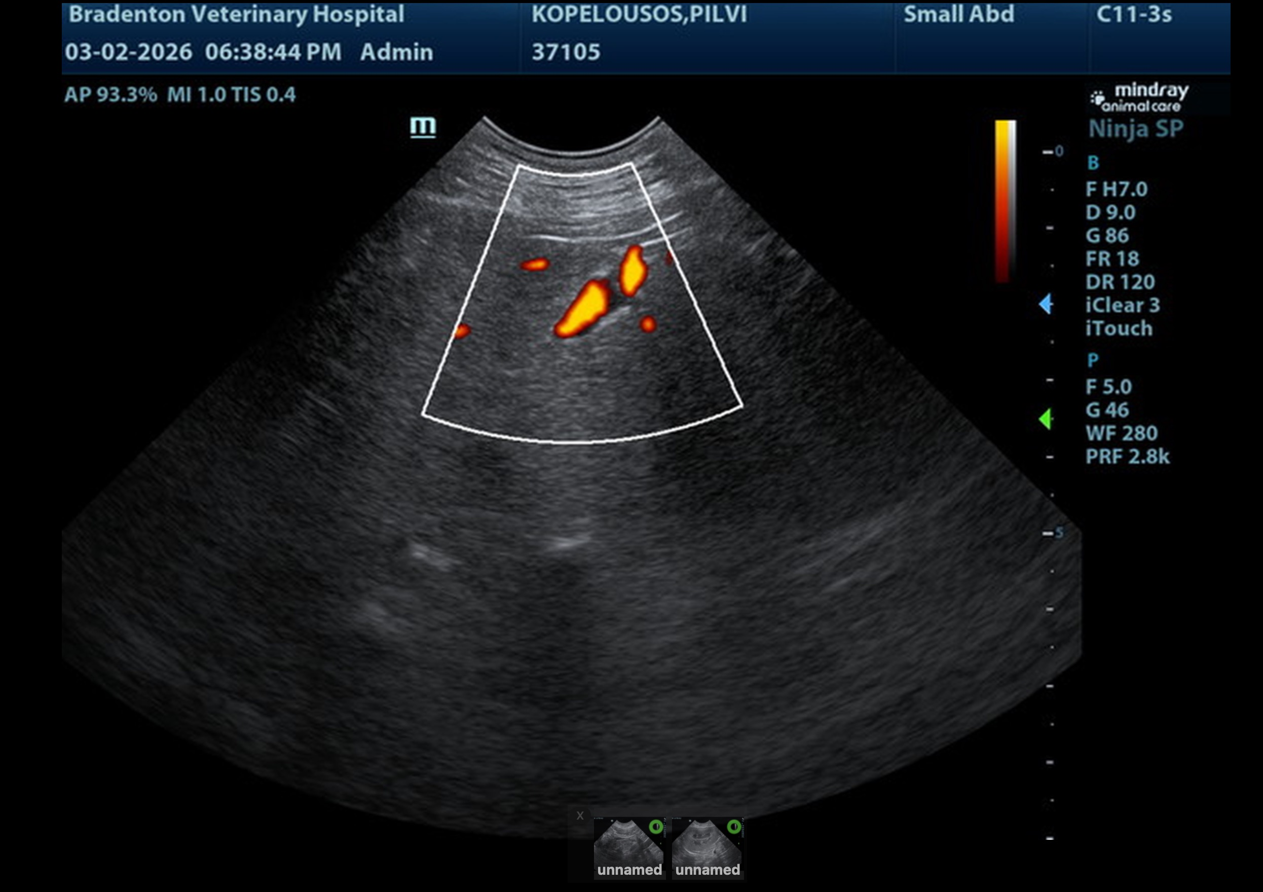
The information and recommendations provided are based on the images presented by the referring veterinarian/sonographer. No evaluation can be communicated regarding pathology that was not visible in the image/video clips provided.
Thank you for this referral. If the clinical or image interpretation does not parallel your findings or if I can be of any further assistance, please contact me.
Eric Lindquist, DMV, DABVP(CFM), Cert. IVUSS,
CEO, Owner, Founder -- SonoPath.com
info@SonoPath.com

