PRESENTING CLINICAL SIGNS
- Azotemia
- Grade II/VI HM
- Suspected bilateral cryptorchid
- Clinical findings - underweight, bilateral cryptorchid, severe azotemia, mandibular abscess, D+
- Current medications - Clindamycin, Clavamox, probiotics
- R/O FIP vs Lymphoma vs other
Abnormal PE/Chem/CBC/UA Results: BUN 144, Crea 6.5, SDMA 42.1, A/G ratio 0.6, WBC 16.9, RBC 5.2, HCT 23, Platelet 665, Neutrophils 15717, Monocytes 676, FELV/FIV - Negative

ULTRASONOGRAPHIC EXAMINATION OF THE ABDOMEN
Urinary System
The urinary bladder, trigone, and pelvic urethra presented normal thicknesses and normal tone. The ureters were not visible which is normal. No uroliths or sediment were visualized, and anechoic urine was present. No evidence of inflammatory or neoplastic changes were noted. Ureteral papillae were normal.
The kidneys revealed swollen contour and increased cortical echogenicity. Slight pyelectasia was noted in the right kidney. The left kidney measured 4.44 cm in length. The right kidney measured 4.55 cm in length.
Adrenal Glands
Both adrenal glands were not visualized.
Spleen
The spleen presented a smooth homogeneous parenchyma hyperechoic to liver and renal cortical parenchyma. The capsule was smooth without noticeable expansion or deviation from within the spleen or adjacent pathology. The splenic vasculature demonstrated normal volume without signs of congestion or thrombosis. No sonographic evidence of acute or chronic inflammatory, neoplastic, or infarctual changes were noted.
Liver
The liver images submitted revealed subjectively normal liver size, contour, and structure. Parenchymal echogenicity was naturally coarse and hypoechoic to the spleen. Vascular and biliary tracts were of normal volume with no evidence of congestion. The gallbladder presented acceptably thin walls with primarily anechoic content. The cystic and common bile ducts were normal. No pathological hepatic lymphadenopathy was evident. No overt structural evidence of inflammatory, infiltrative or regenerative pathology was evident.
Gastrointestinal
Examination of the gastrointestinal tract revealed a stomach and intestine free of stasis, of normal wall thickness, acceptable curvilinear mural detail, and peristaltic activity. Small and large intestine demonstrated normal luminal chyme and soft stool consistency respectively. No obstructive or overt infiltrative disease was noted. No associated abnormal lymphatic activity was noted.
Pancreas
The base and limbs of the pancreas were observed to be largely isoechoic to surrounding omental fat. Pancreatic duct and capsular contour were acceptably normal and parenchyma respected normal curvilinear patterns. No overt evidence of active inflammatory or neoplastic disease was noted.
ULTRASONOGRAPHIC FINDINGS
- Nonspecific nephritis, potential low-grade pyelonephritis.
- Soft stool in the colon.
- Structurally unremarkable abdomen otherwise.

INTERPRETATION OF THE FINDINGS & FURTHER RECOMMENDATIONS
Assessment for any evidence of UTI is indicated. A fecal test is recommended. The usual positions for abdominal cryptorchid were imaged in this patient yet no cryptorchid was noted. If cryptorchid is still suspected, then further imaging of the inguinal space is indicated. No overt suspicion of neoplasia, however, cannot be completely ruled out without 25-gauge FNA and coagulation panel would be appropriate. Prognosis is guarded. Toxin exposure should be considered as a potential in this patient.

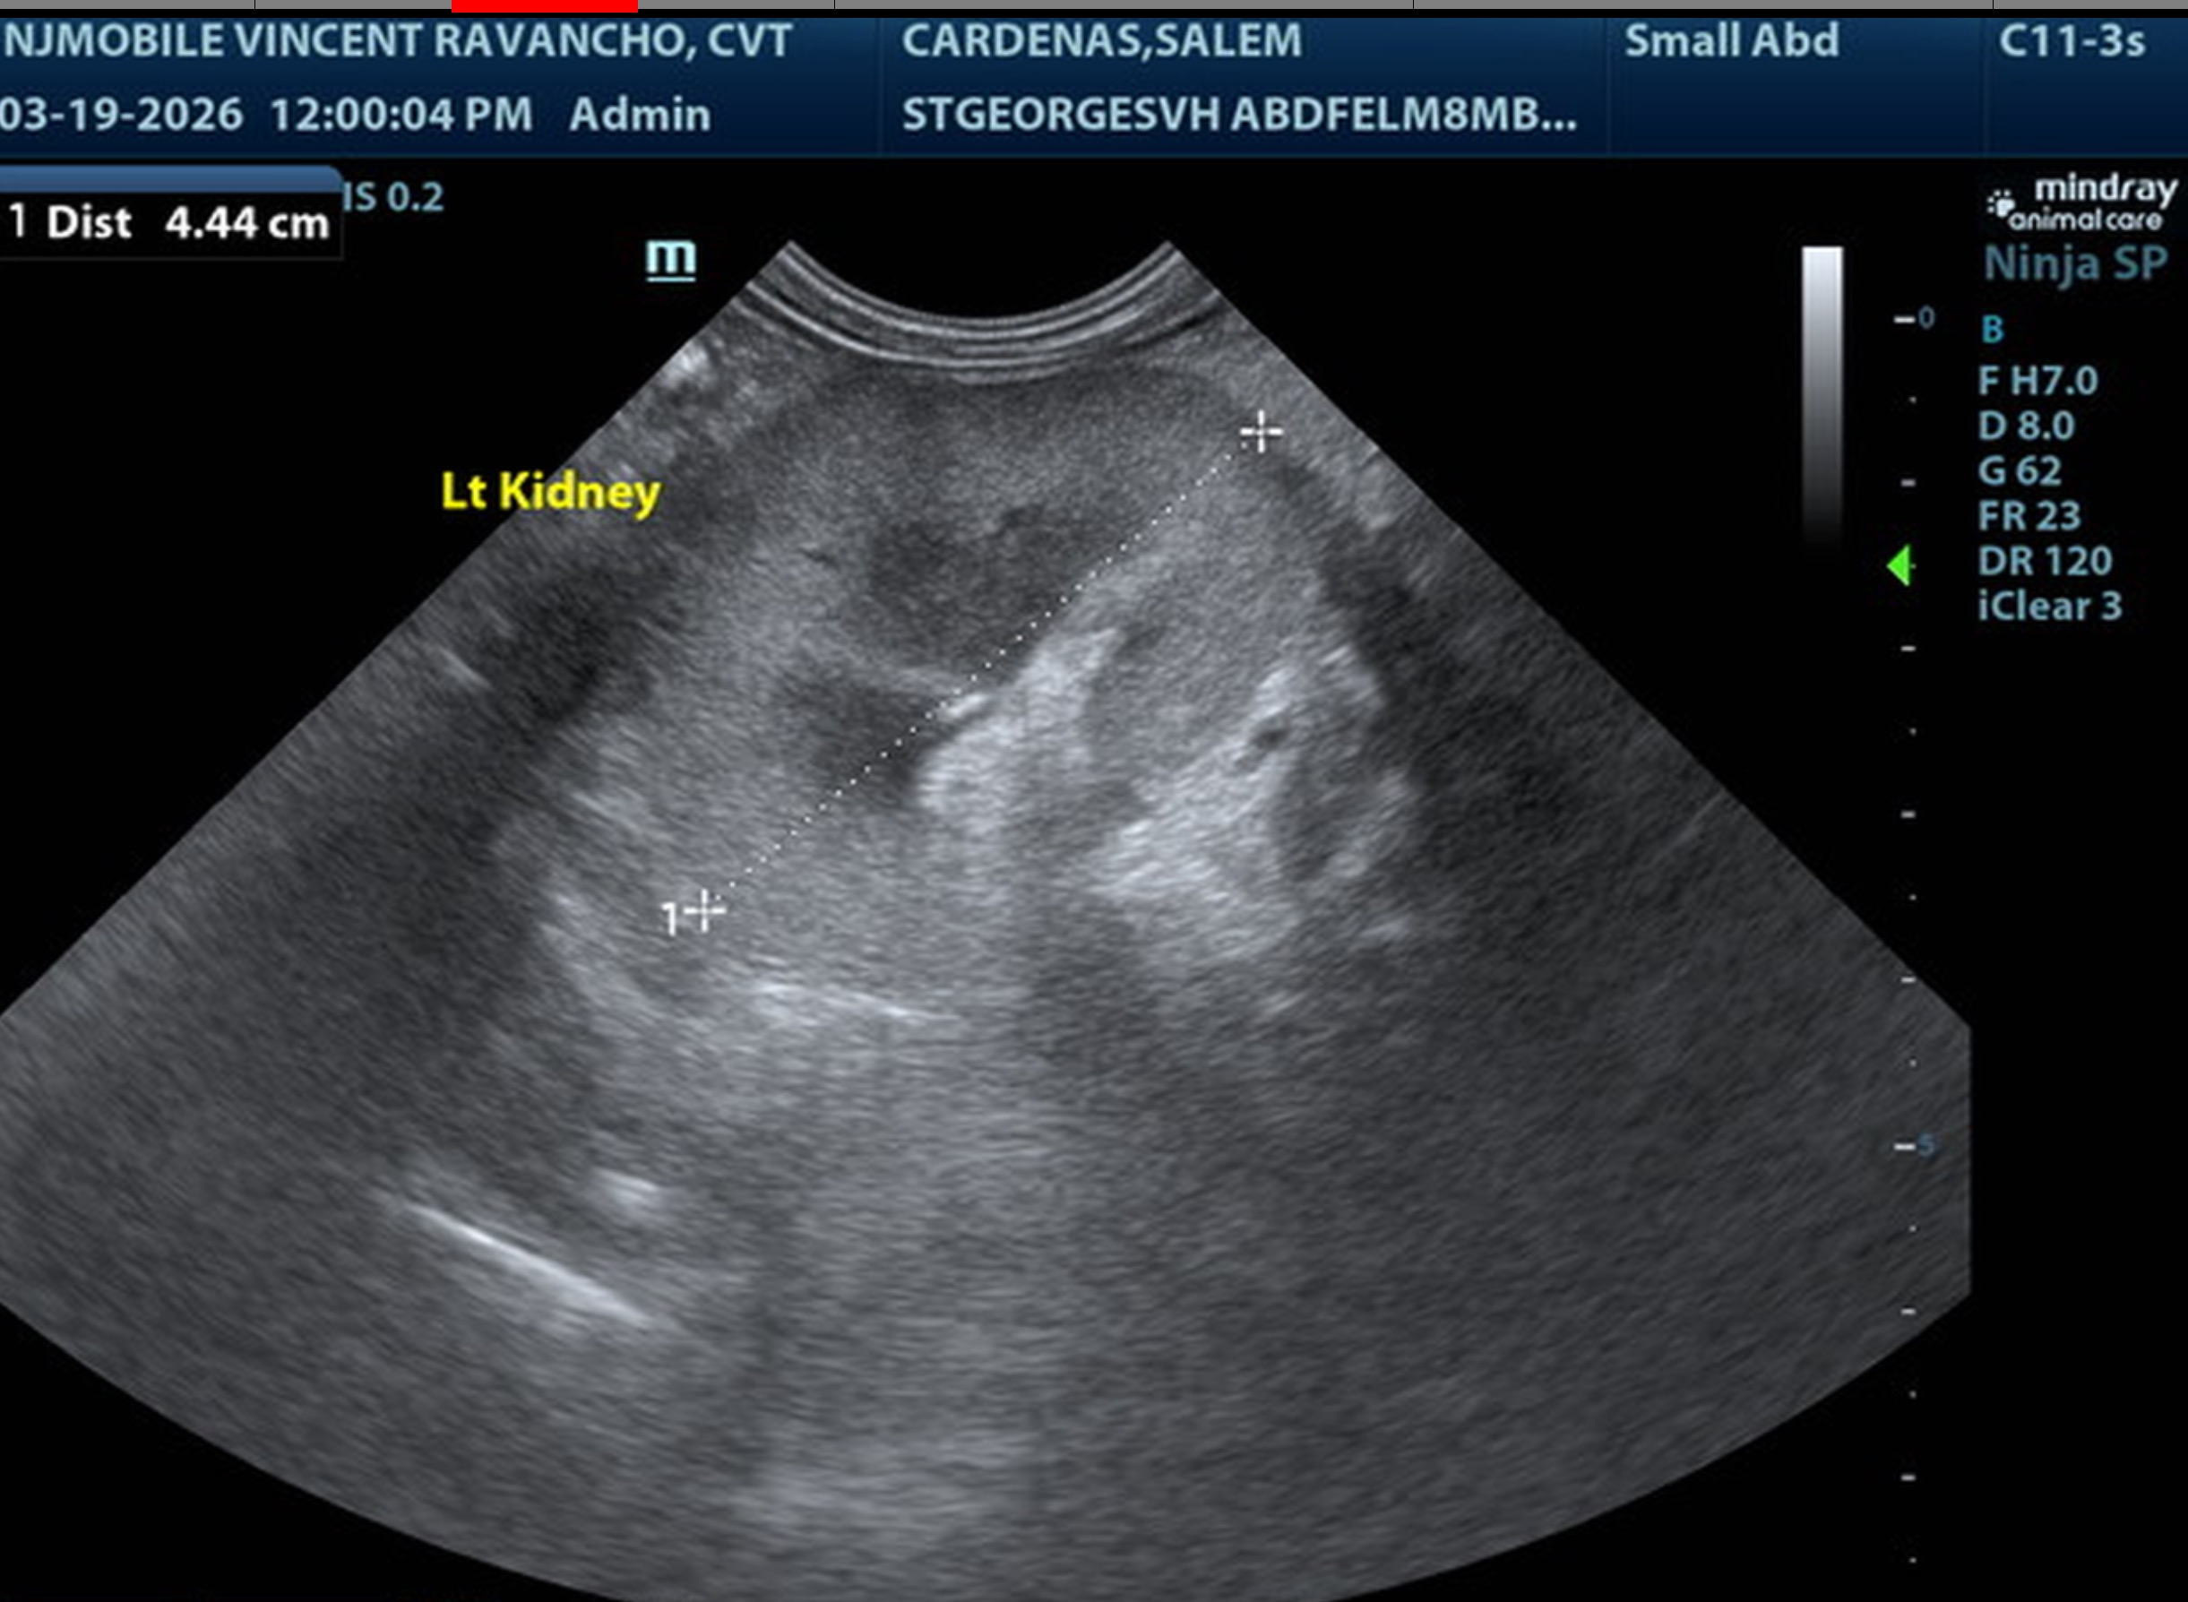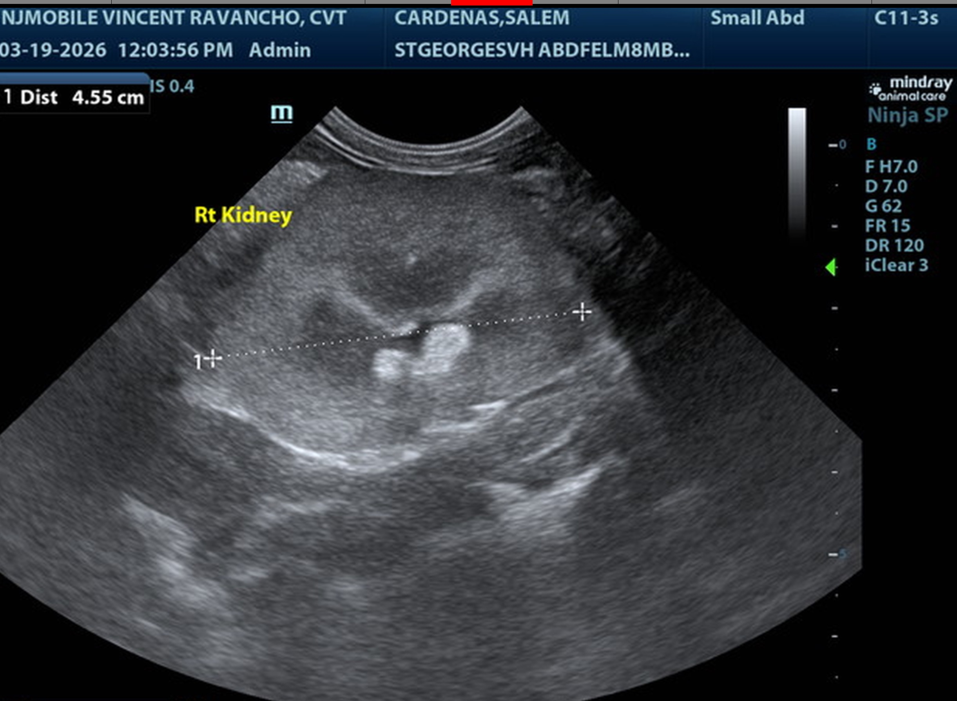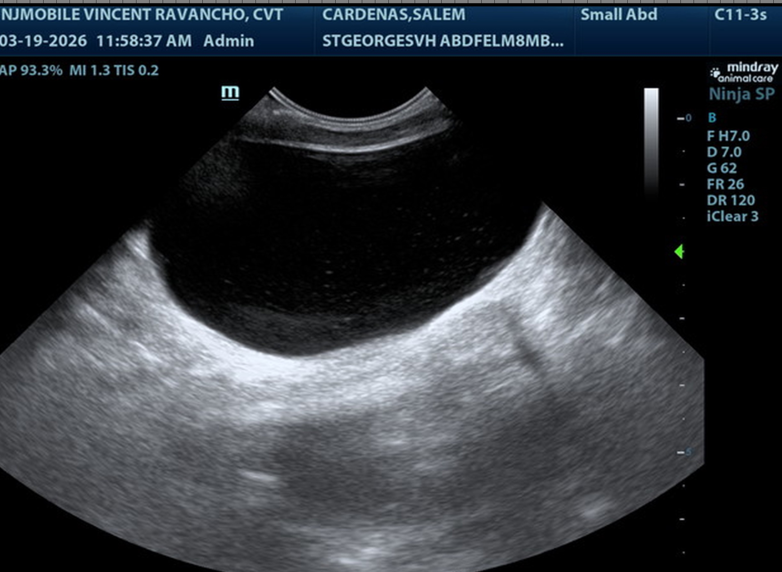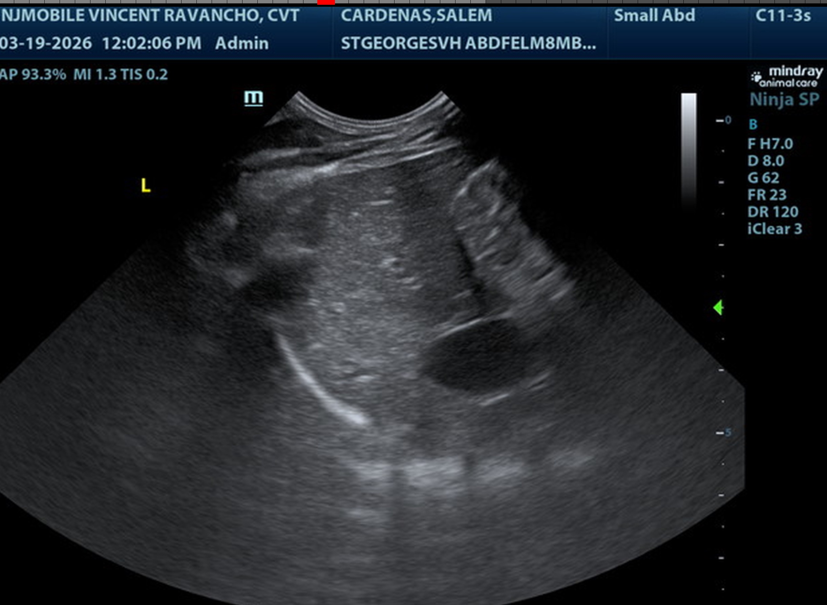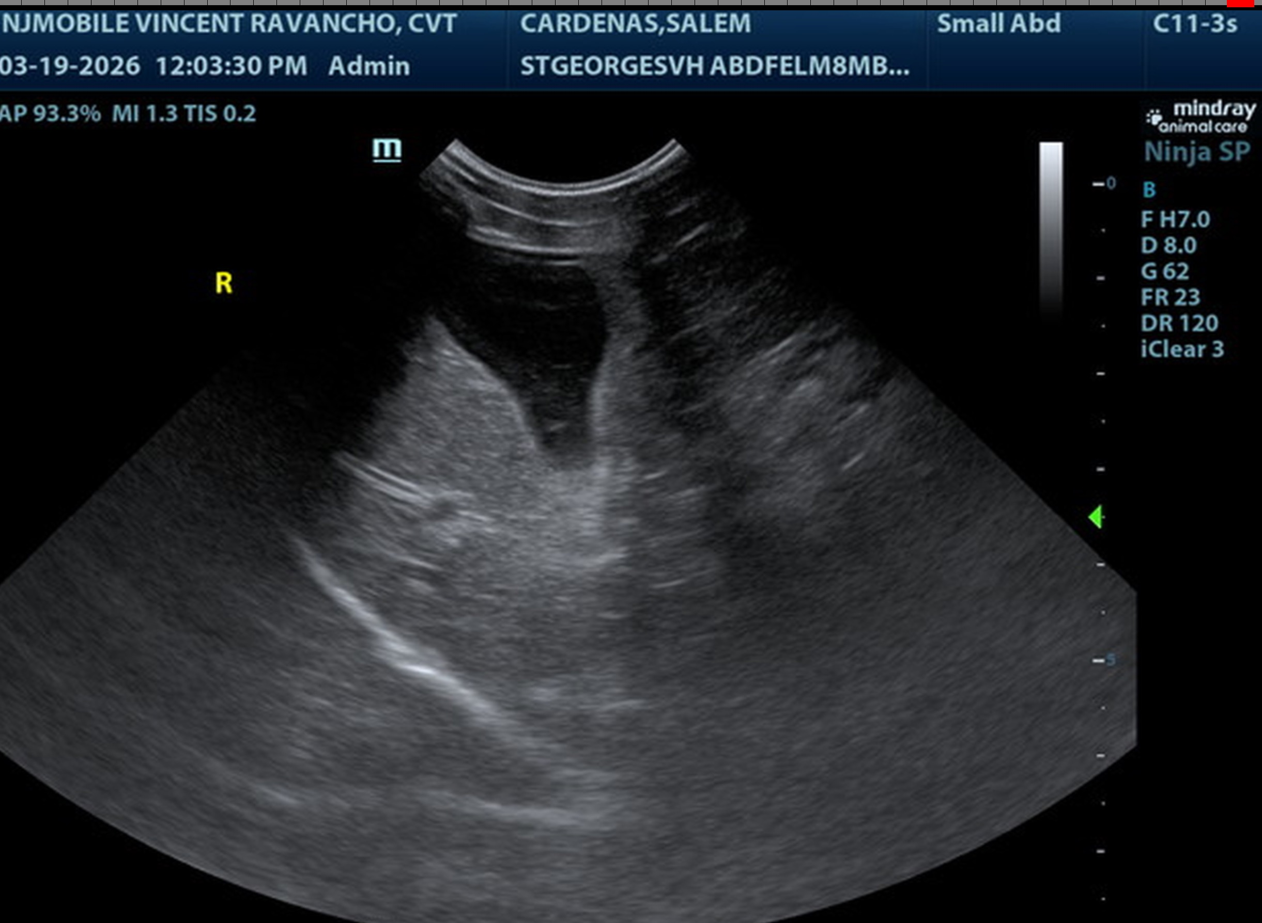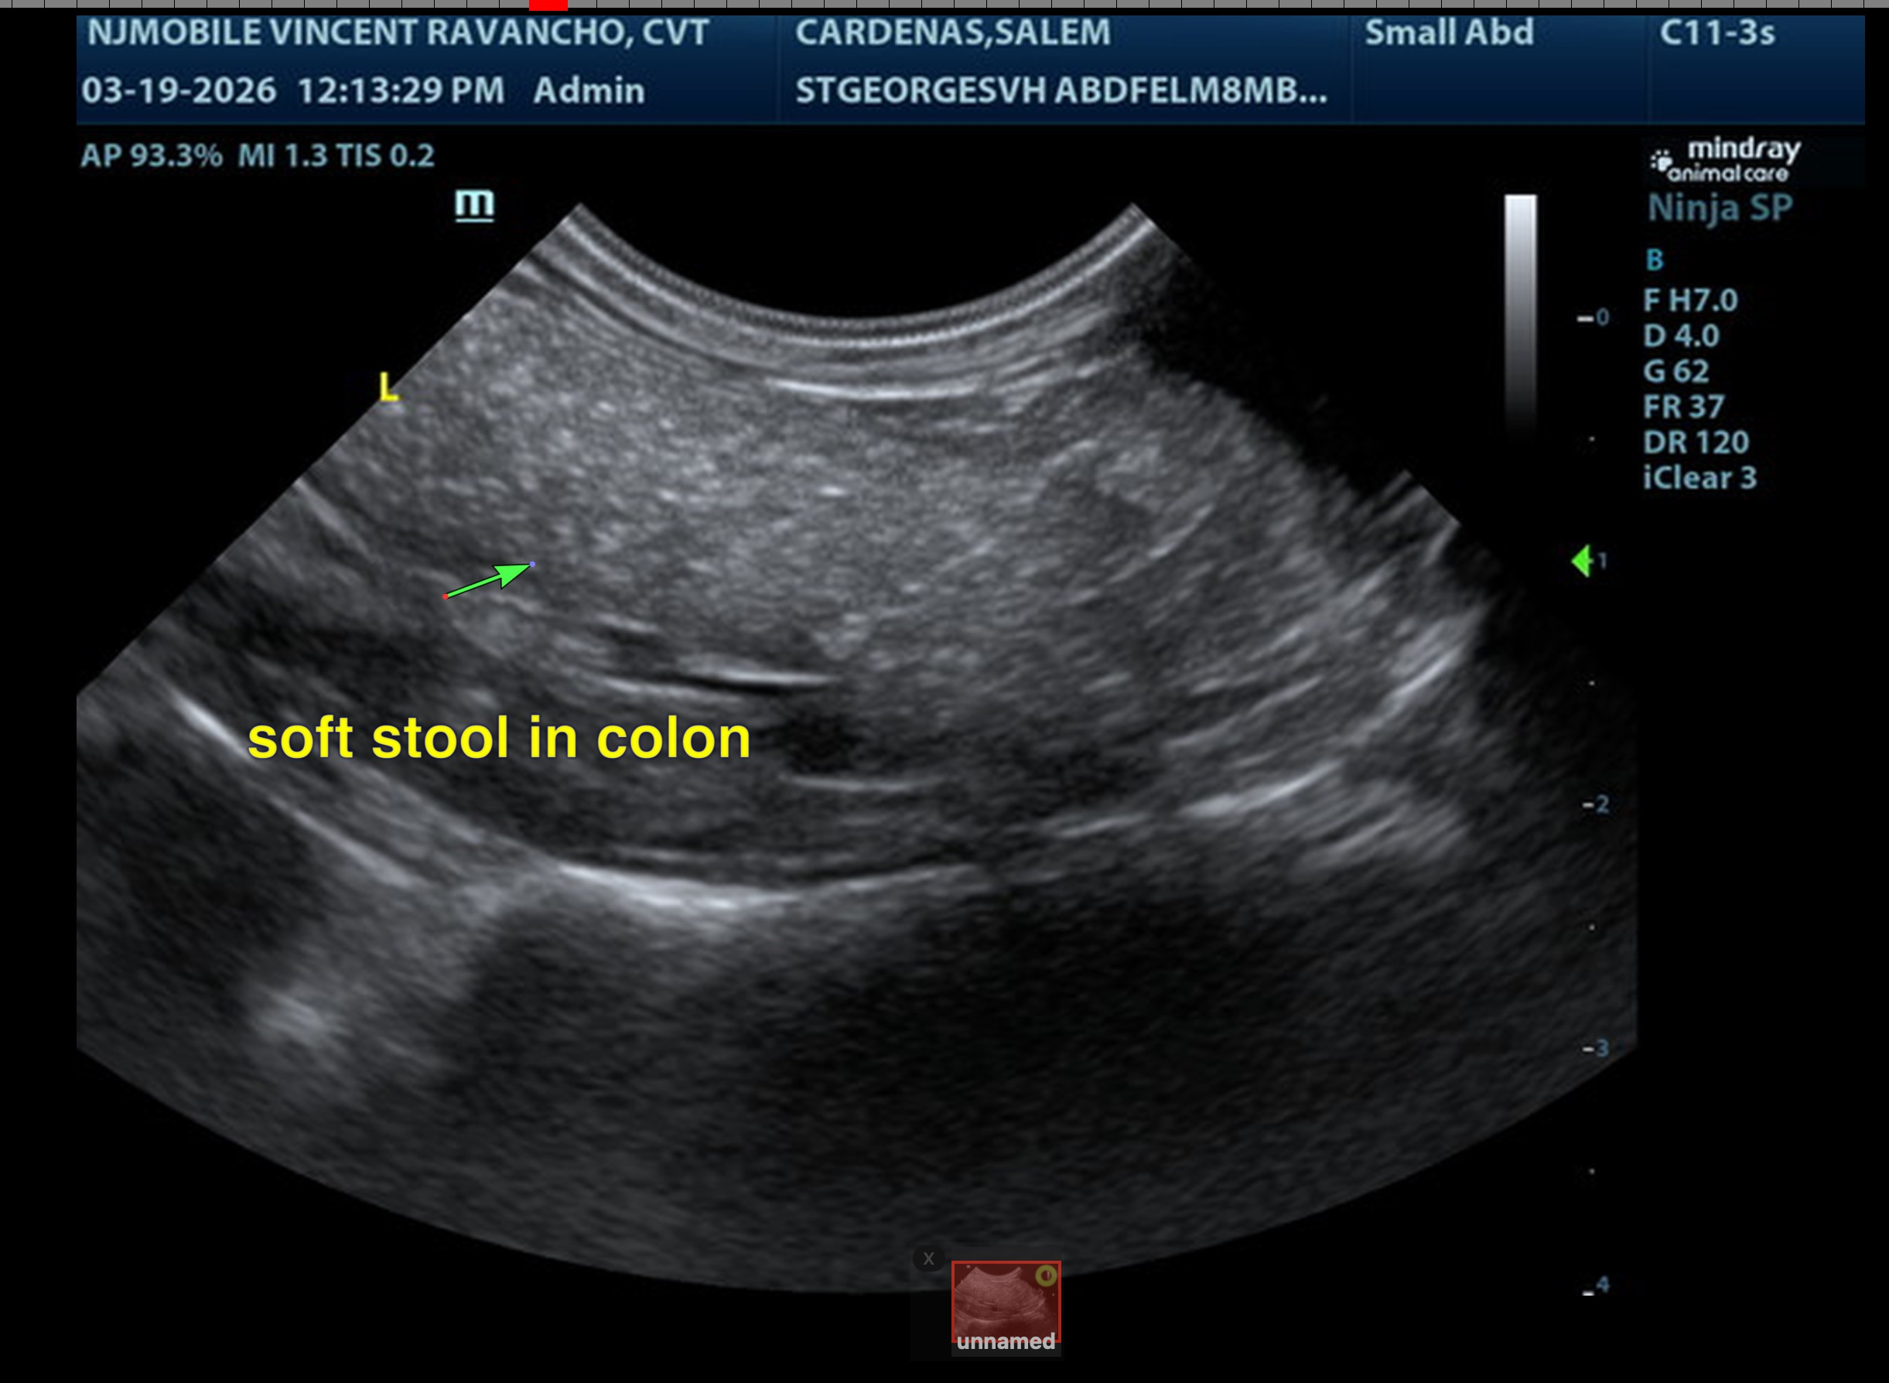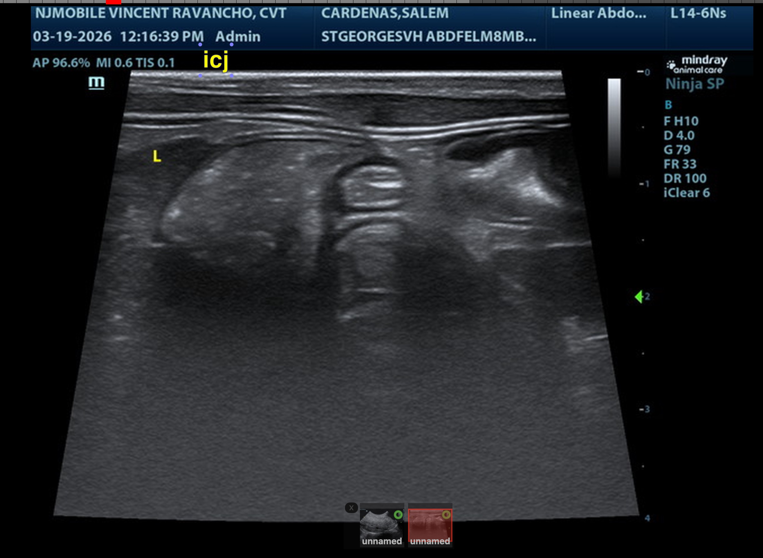
The information and recommendations provided are based on the images presented by the referring veterinarian/sonographer. No evaluation can be communicated regarding pathology that was not visible in the image/video clips provided.
Thank you for this referral. If the clinical or image interpretation does not parallel your findings or if I can be of any further assistance, please contact me.
Eric Lindquist, DMV, DABVP(CFM), Cert. IVUSS,
CEO, Owner, Founder -- SonoPath.com
info@SonoPath.com

