PRESENTING CLINICAL SIGNS
- Abdominal effusion.
Abnormal PE/Chem/CBC/UA Results: Frut: 203, Glu: 310, Creat:0.6, ATL<<10, ALK<10, RBC: 8.1, HCT: 30, WBC: 25, neut: 18, lymph: 7, mono0.2

ULTRASONOGRAPHIC EXAMINATION OF THE ABDOMEN
Urinary System
The urinary bladder, trigone, and pelvic urethra presented normal thicknesses and normal tone. The ureters were not visible which is normal. No uroliths or sediment were visualized, and anechoic urine was present. No evidence of inflammatory or neoplastic changes were noted. Ureteral papillae were normal.
The kidneys were enlarged with thickened cortices and slight coarse architecture and irregular contour. Some loss of corticomedullary definition was also present. The left kidney measured 5.6 cm in length. The right kidney measured 5.5 cm in length.
Adrenal Glands
Both adrenal glands were not visualized.
Spleen
The spleen presented with irregular contour and appeared volume contracted.
Liver
The liver presented largely normal with slight heterogenous parenchymal changes. The gallbladder and common bile duct were unremarkable.
Gastrointestinal
Examination of the gastrointestinal tract revealed a stomach and intestine free of stasis, of normal wall thickness, acceptable curvilinear mural detail, and peristaltic activity. Small and large intestine demonstrated normal luminal chyme and stool consistency respectively. No obstructive or overt infiltrative disease was noted. No associated abnormal lymphatic activity was noted.
Pancreas
The region of the pancreas revealed an enhanced nodular omentum with heterogenous parenchymal changes.
Free Abdomen
A large amount of echogenic ascites were noted in the abdomen. Enlarged mesenteric lymph nodes were present.
Heart
Normal cardiac presentation with areas of lung consolidations measuring up to 2.0 cm. The heart was unremarkable with normal volumes and contractility. Areas of B-line accumulation were noted.
ULTRASONOGRAPHIC FINDINGS
- Ascites with swollen kidneys.
- Volume contracted spleen.
- Nodular omental changes.
- Mesenteric lymphadenopathy.
- Heterogenous hepatic parenchymal changes.
- Lung lesion (also appeared diagnostic).

INTERPRETATION OF THE FINDINGS & FURTHER RECOMMENDATIONS
Cytospin of the abdominal effusion with immediate slide preparation +/- FIP titers would be appropriate, however, lymphomatosis, carcinomatosis, mastocytosis or FIP are primary differentials. Ultrasound guided FNA of the lung lesion is indicated. Dual cavity neoplasia is suspected.

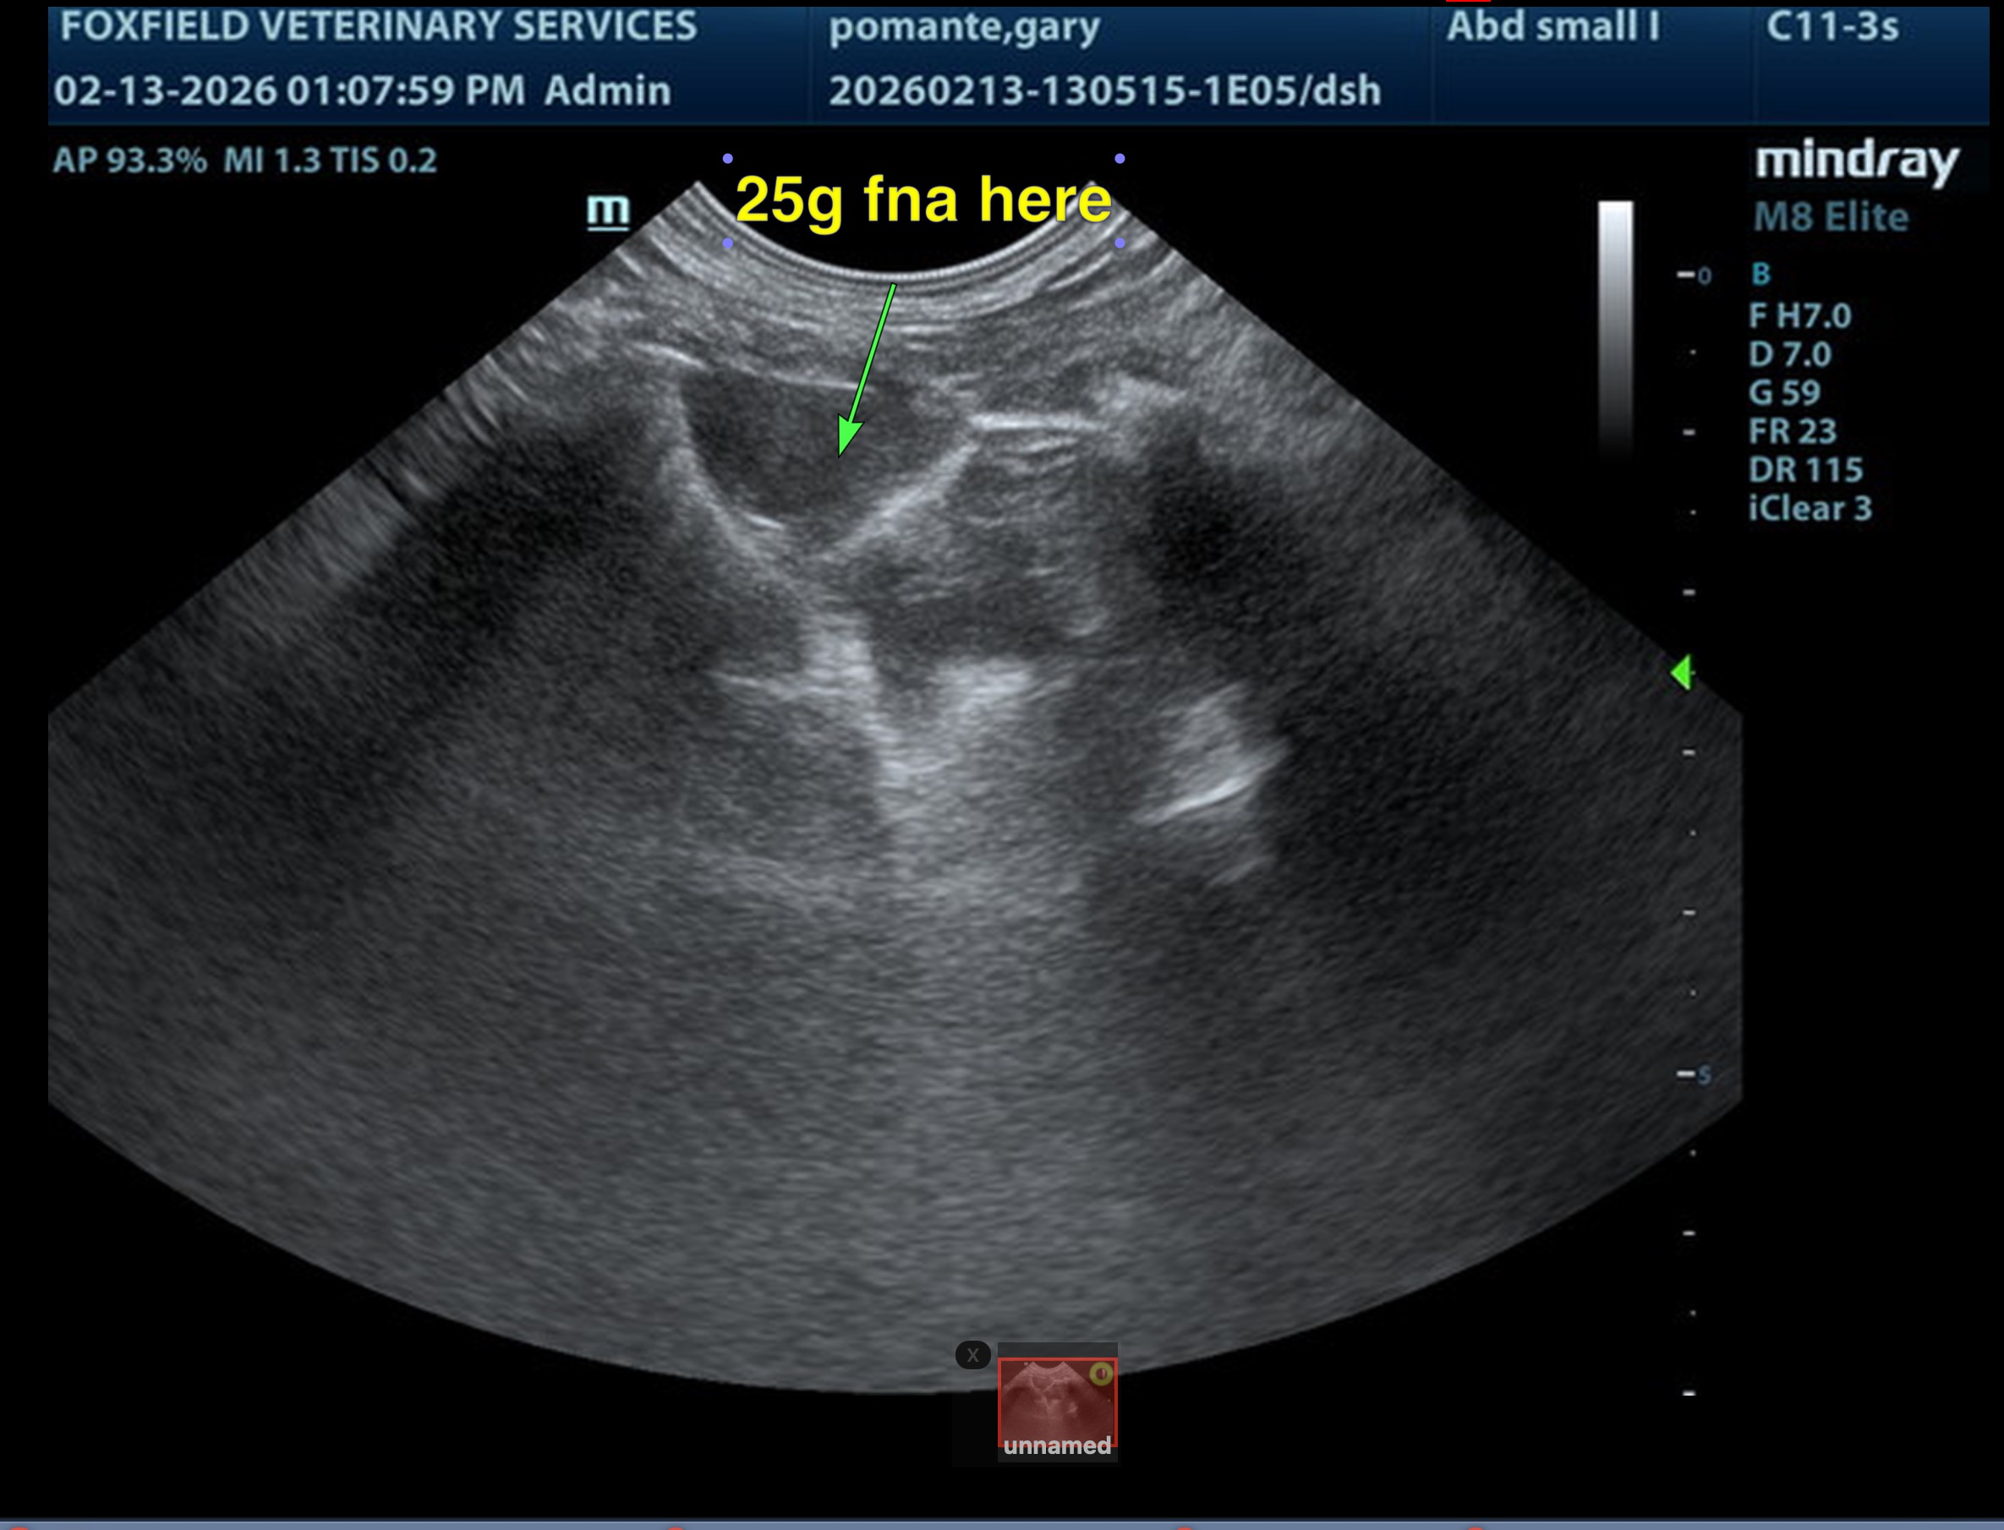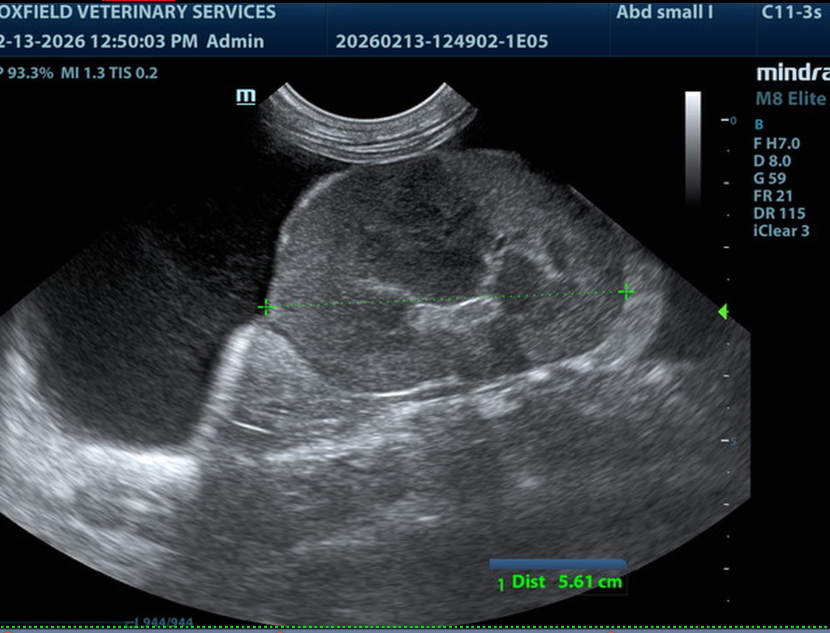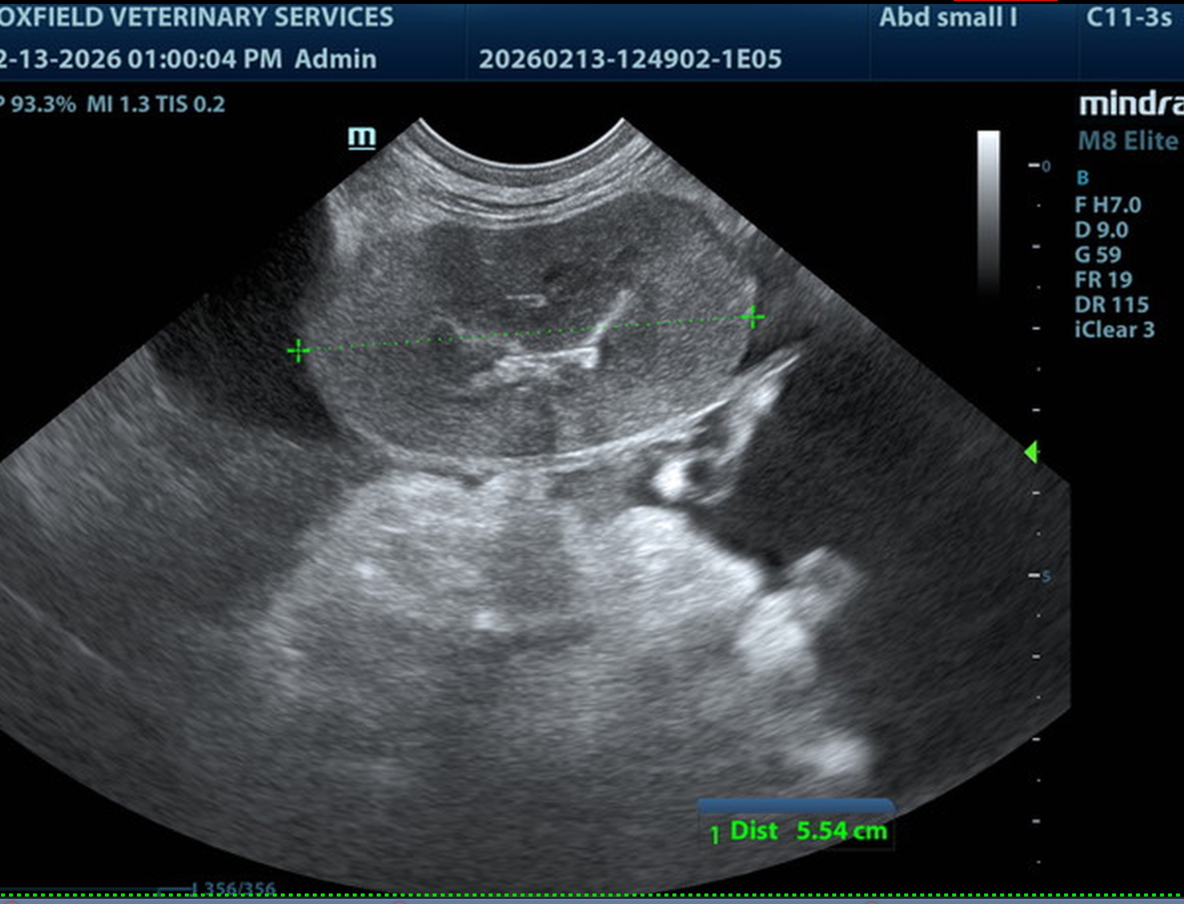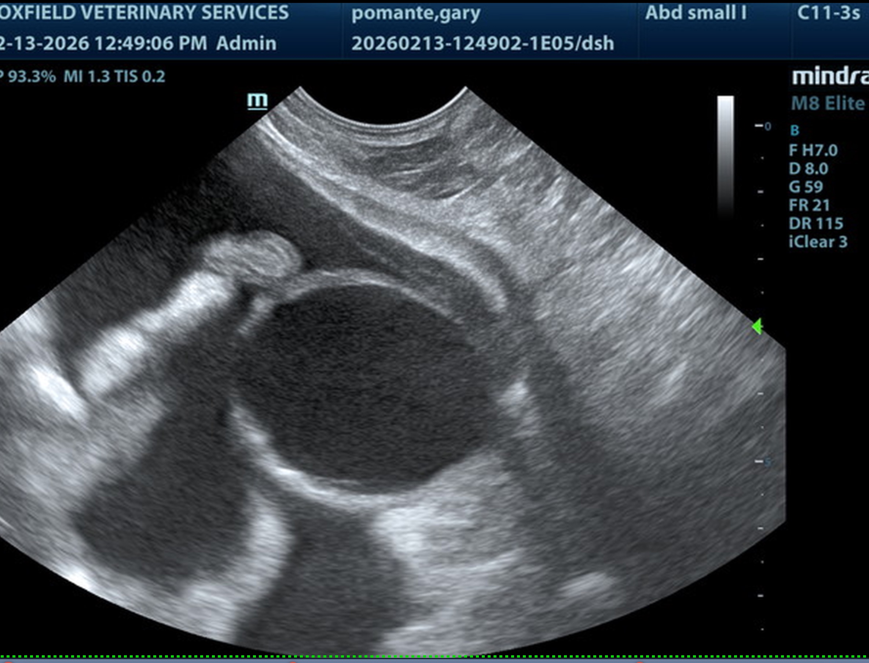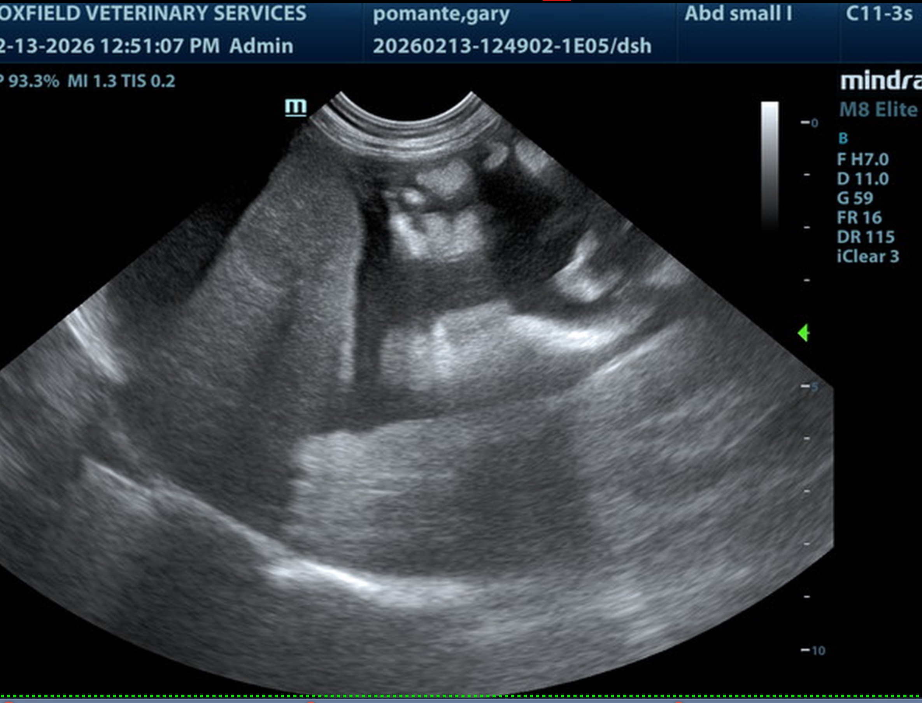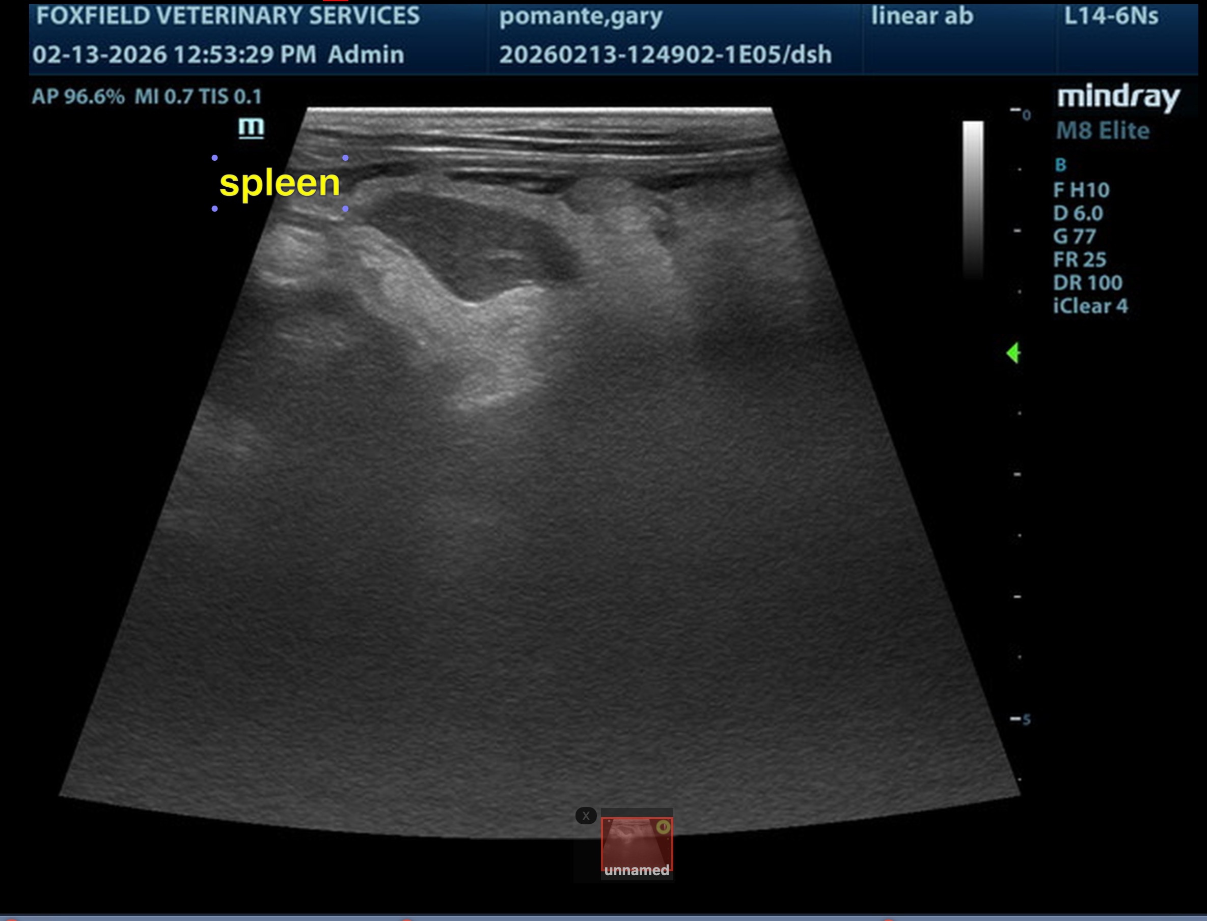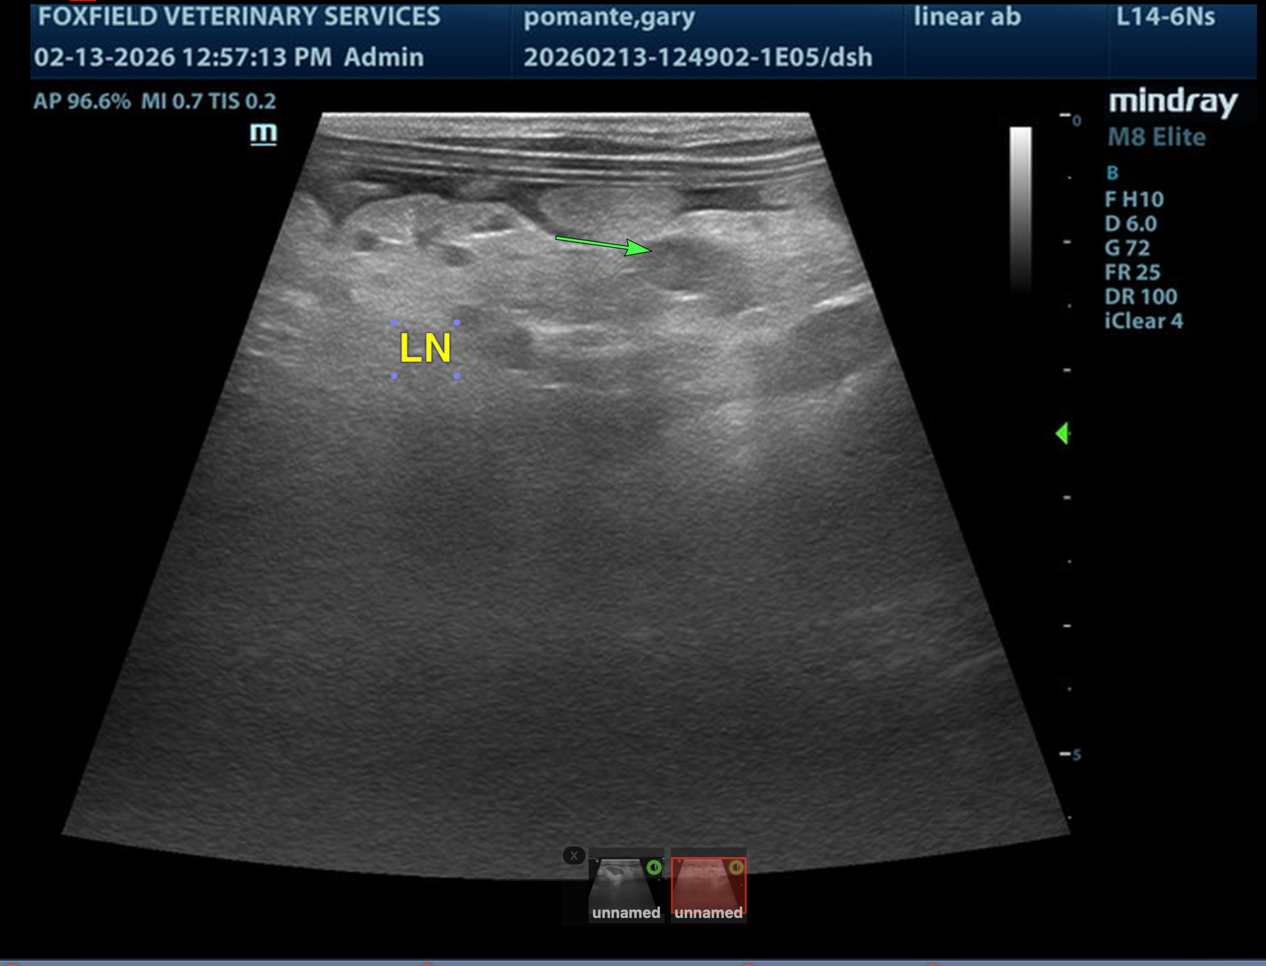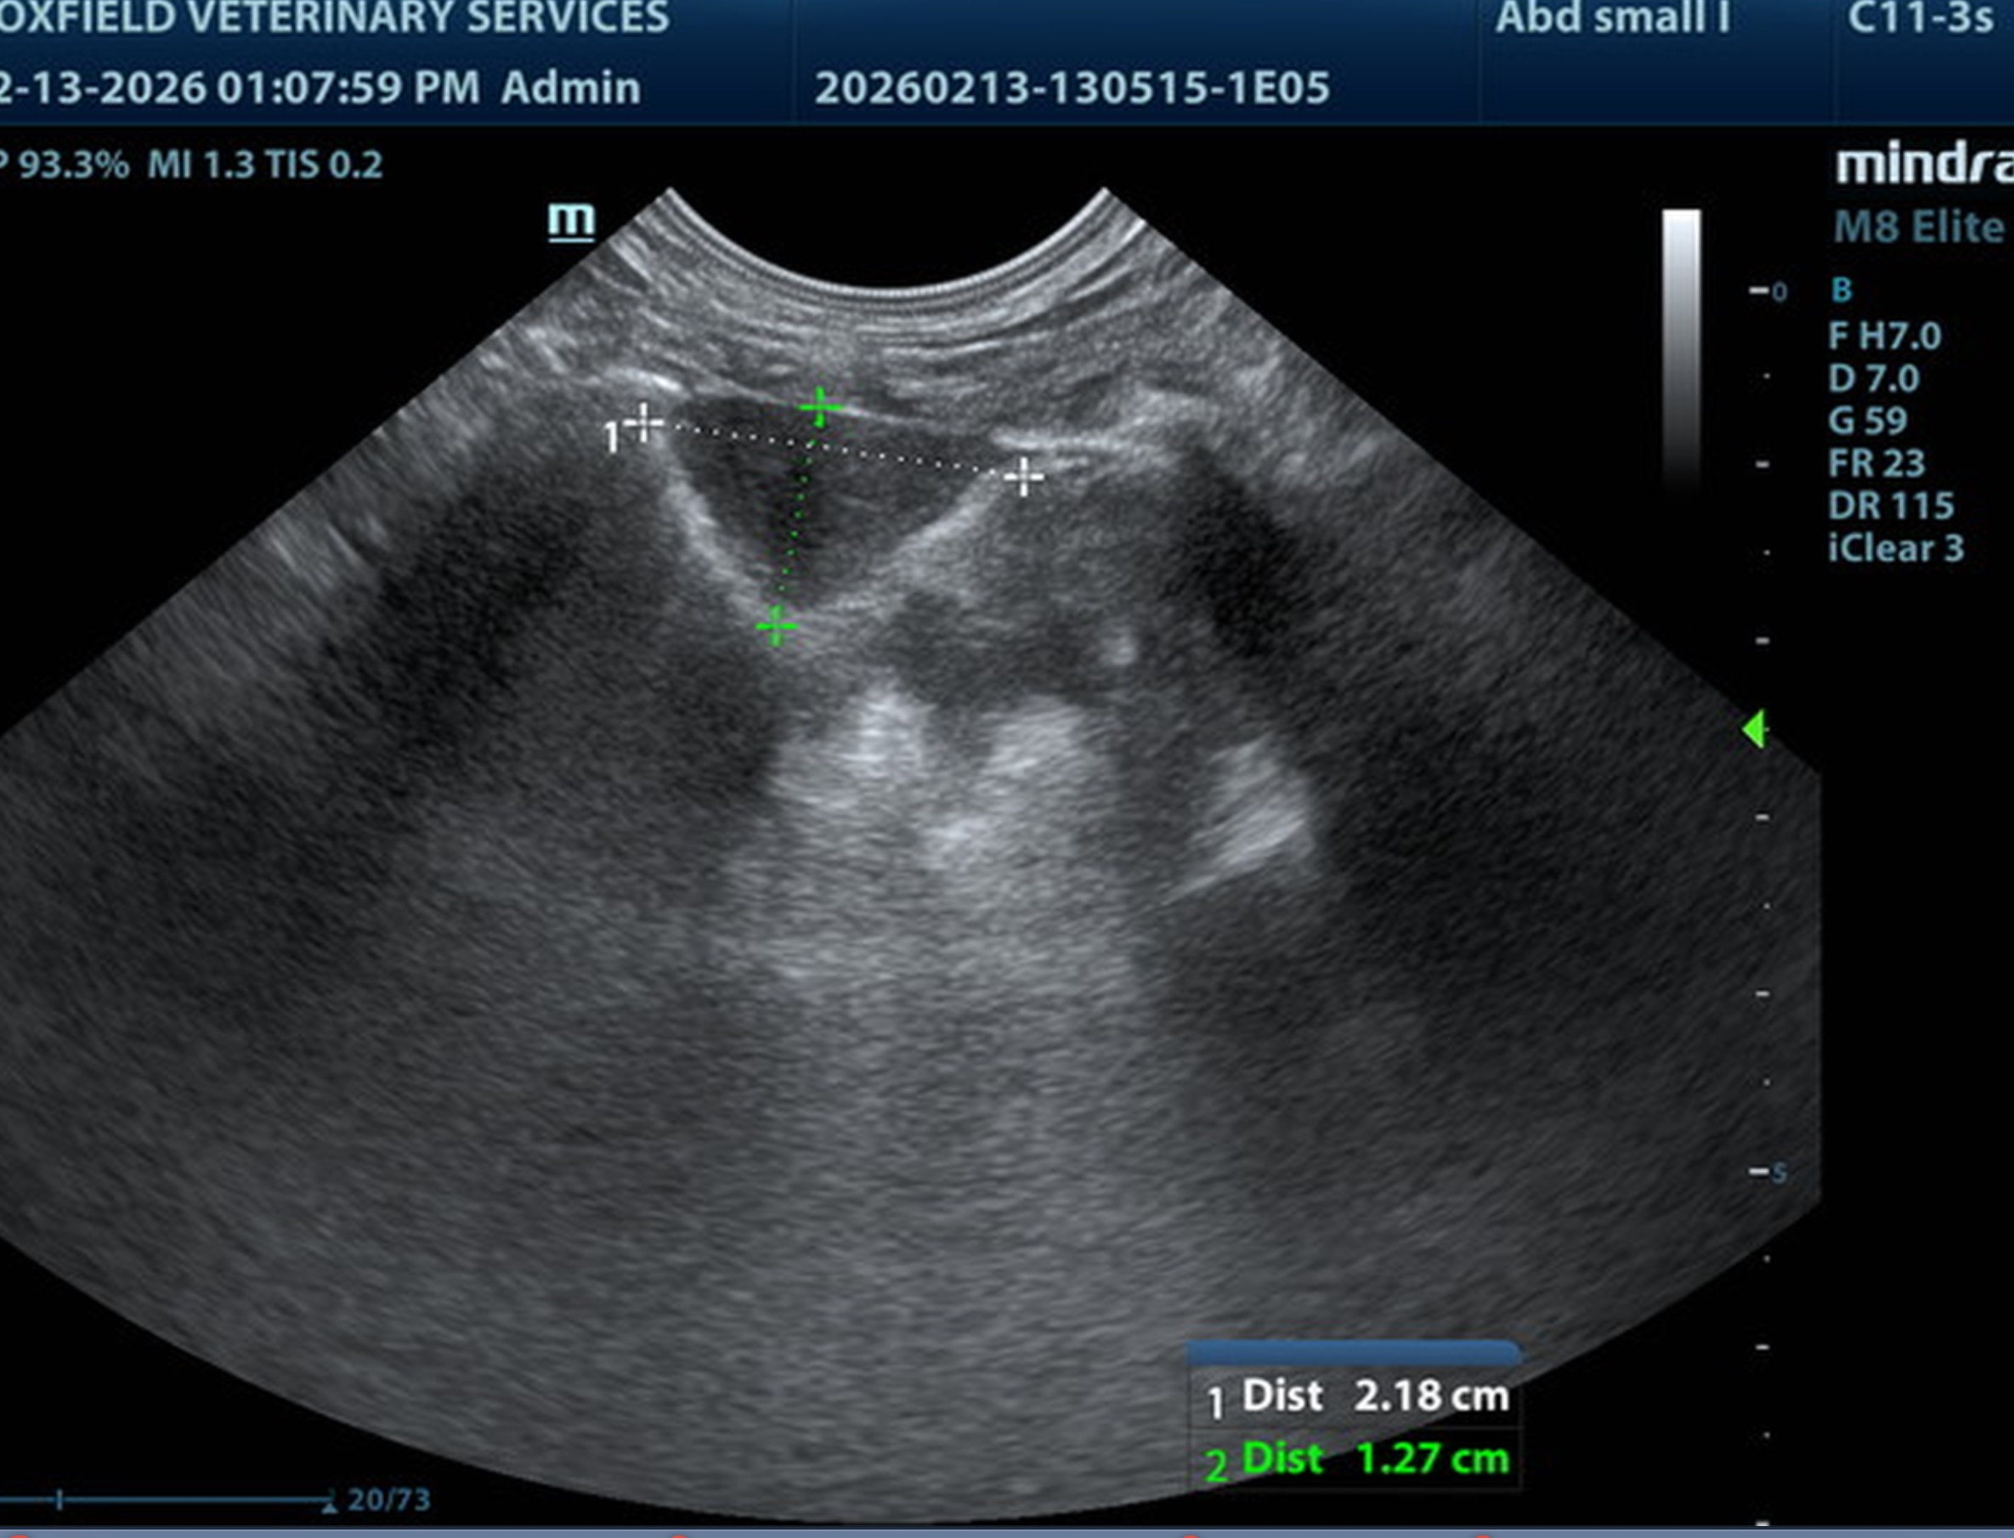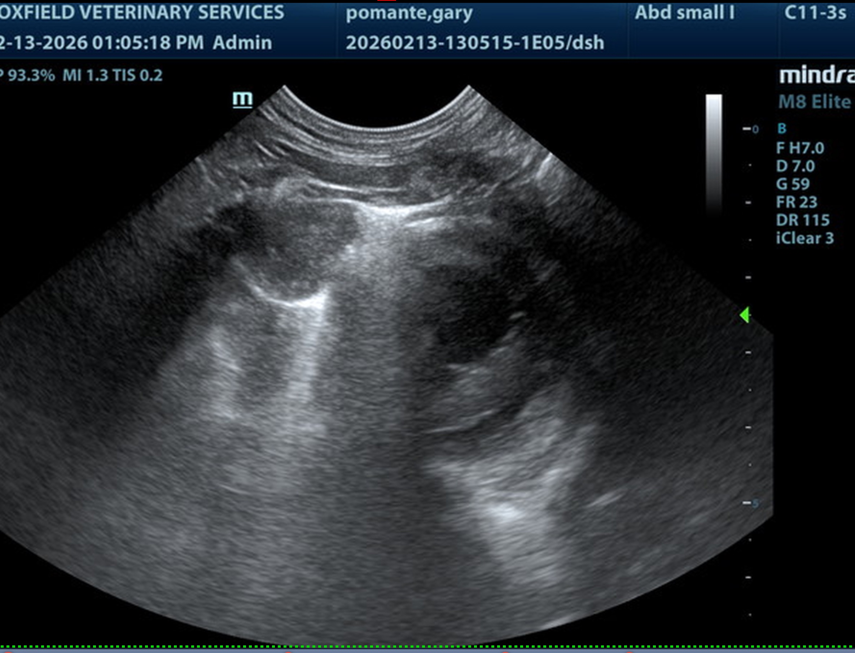
The information and recommendations provided are based on the images presented by the referring veterinarian/sonographer. No evaluation can be communicated regarding pathology that was not visible in the image/video clips provided.
Thank you for this referral. If the clinical or image interpretation does not parallel your findings or if I can be of any further assistance, please contact me.
Eric Lindquist, DMV, DABVP(CFM), Cert. IVUSS,
CEO, Owner, Founder -- SonoPath.com
info@SonoPath.com

