PRESENTING CLINICAL SIGNS
History: Presented 12/1 for vomiting and not eating, no further vomiting but appetite still not normal, enteritis too. I/VI murmur heart at emerg. hosp. (not heard today).
Abnormal PE/Chem/CBC/UA Results: Hgb 16.8 (16.2 H); PLT 87, Eos 0.09, GGT 21 (4H); Glob 2.9 (3L); alb/glob ratio 1.3 (1.2 H); CK 1022 (440 H)
ULTRASONOGRAPHIC EXAMINATION OF THE HEART & ABDOMEN
FELINE  CARDIAC  PARAMETERS | BODY WEIGHT  (kg) | HR  (BPM) | IVSd  (cm) | LVIDd  (cm) | LVWd  (cm) | FS  (%) | EF  (%)
NORMAL PARAMETER | ------ | 150-240 | 0.3-0.6 | 1.0-2.1 | 0.25-0.6 | 35-67 | 80-100
PATIENT | -- | 184 | 0.43 | 1.36 | 0.44 | 48 | 83
FELINE  CARDIAC  PARAMETERS | LA/AO  (Boon) | LA/AO  HEART BASE  (Sisson) | LA  2D 4-chamber long axis AS to FW (Sisson)  (cm) |  | LVOT VEL.  (m/s) | RVOT VEL.  (m/s) | IVRT  (m/)
NORMAL PARAMETER | <1.5 | 0.88-1.79 | 0.7-1.7 |  | <1.6 | <1.3 | 40-60
PATIENT | 1.4 | 1.4 | -- |  | -- | .83 | NM
Adapted from June Boon,Veterinary Echocardiography,1998
Sisson D et al. JVIM 1991; 5: 232, Jacobs et al. Am J Vet Res 1985; 46:1705

Cardiac Presentation
The echocardiogram in this patient demonstrated normal left atrial size based on 3 separate LA measurements. The cranial and caudal mitral valve leaflets presented normal linear structure and kinetics. The left ventricle presented normal thicknesses with linear contour and was not dilated nor restricted. The myocardium presented normal echogenicity without subjective evidence of significant fibrotic or ischemic disease. Contractility of the ventricular walls was adequate and in normal range for this patient evidenced by the fractional shortening measurement and subjective evaluation of the different regions and angles of the myocardium. The left ventricular outflow tract demonstrated normal laminar flow and subjective structural integrity. The right atrium and auricle revealed normal size, structure and content. No evidence of masses was noted or chamber overload. Tricuspid valvular assessment demonstrated adequate linear morphology and kinetics. The right ventricle was of normal size (1/3 diameter of LV), chordae structure, myocardial echogenicity and thickness. Pulmonic tract assessment revealed normal valve structure, laminar flow, and diameter (approx.1:1 pa/ao ratio). No visible pericardial or free pleura fluid was noted or extra cardiac pathology in the visible planes. The cranial mediastinum and pericardial regions were free of masses in the visible window.
Urinary System
The urinary bladder, trigone, and pelvic urethra presented normal thicknesses and normal tone. The ureters were not visible which is normal. No uroliths or sediment were visualized and anechoic urine was present. No evidence of inflammatory or neoplastic changes were noted. Ureteral papillae were normal.
The kidneys revealed normal size and structure, corticomedullary definition and ratio for this age. The cortices presented largely uniform texture with normal echogenic relationship to liver and spleen. Medullary structure differed distinctly from the cortex and no evidence of pelvic dilation was present. The capsules were acceptably uniform without significant irregularities. The right kidney measured 3.85 cm. The left kidney measured 3.77 cm.
Adrenal Glands
Both adrenal glands were visualized and recognized as having normal shape, size, position and echogenicity for this breed. The phrenic vasculature, glandular echogenicity and detail were unremarkable. Capsule, cortex, and medullary definition were normal for this age patient. The left adrenal gland measured 3.36 cm.
Spleen
The spleen presented a smooth homogeneous parenchyma hyperechoic to liver and renal cortical parenchyma. The capsule was smooth without noticeable expansion or deviation from within the spleen or adjacent pathology. The splenic vasculature demonstrated normal volume without signs of congestion or thrombosis. No sonographic evidence of acute or chronic inflammatory, neoplastic, or infarctual changes were noted. The spleen measured 0.81 cm.
Liver
The liver images submitted revealed subjectively normal liver size, contour, and structure. Parenchymal echogenicity was naturally coarse and hypoechoic to the spleen. Vascular and biliary tracts were of normal volume with no evidence of congestion. The gallbladder presented acceptably thin walls with primarily anechoic content. The cystic and common bile ducts were normal. No pathological hepatic lymphadenopathy was evident. No overt structural evidence of inflammatory, infiltrative or regenerative pathology was evident.
Gastrointestinal
A minor amount of retention of chyme was noted in the stomach. Some shadowing material was noted in the stomach consistent with hairball density. Minor small intestinal thickening was noted. Transit of chyme was normal. Minor increased submucosal echogenicity was noted. Curvilinear patterns were maintained otherwise. Some minor reactive mesentery was noted associated with the small intestine.
Pancreas
The base and limbs of the pancreas were observed to be largely isoechoic to surrounding omental fat. Pancreatic duct and capsular contour were acceptably normal and parenchyma respected normal curvilinear patterns. No overt evidence of active inflammatory or neoplastic disease was noted.
Free Abdomen
The epigastric lymph nodes were slightly enlarged, measuring 5.0 mm.
ULTRASONOGRAPHIC FINDINGS
- Normal echocardiogram
- Enteritis pattern with hairball density in the stomach
- Epigastric lymph nodes were slightly enlarged
INTERPRETATION OF THE FINDINGS & FURTHER RECOMMENDATIONS
Supportive care should prove effective. I recommend a fresh fecal smear and fecal floatation analysis. IV fluid support, hairball therapy and possible diet change are all indicated.

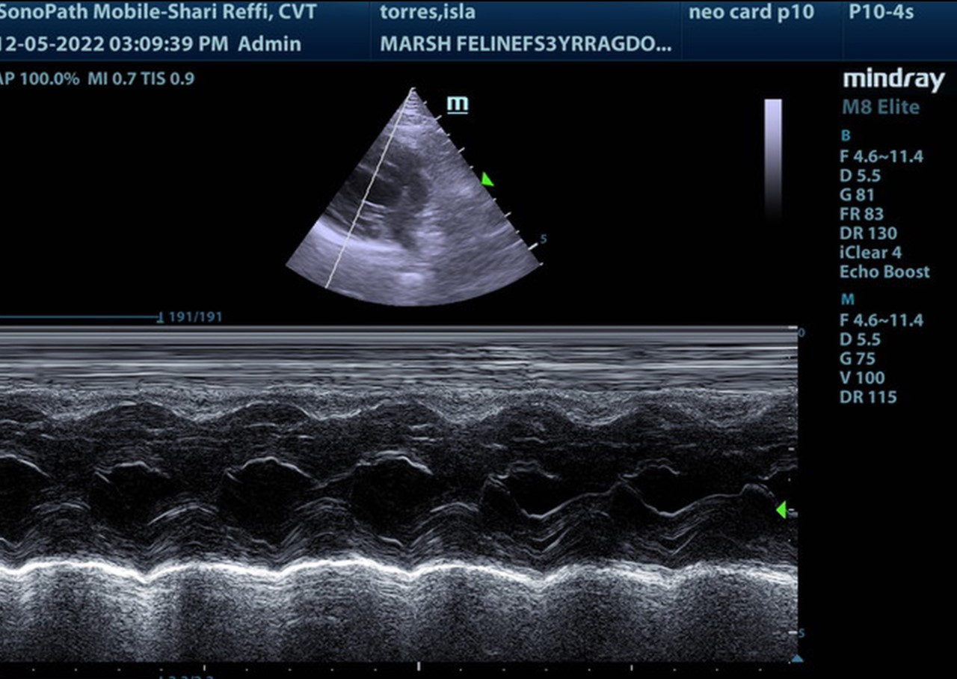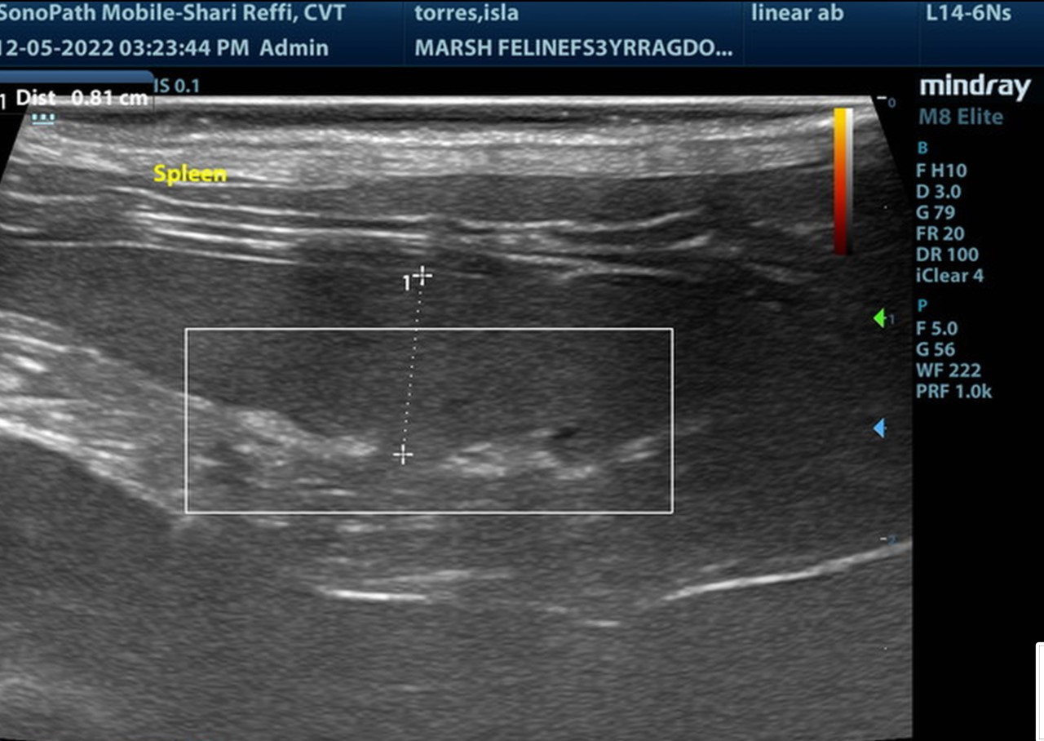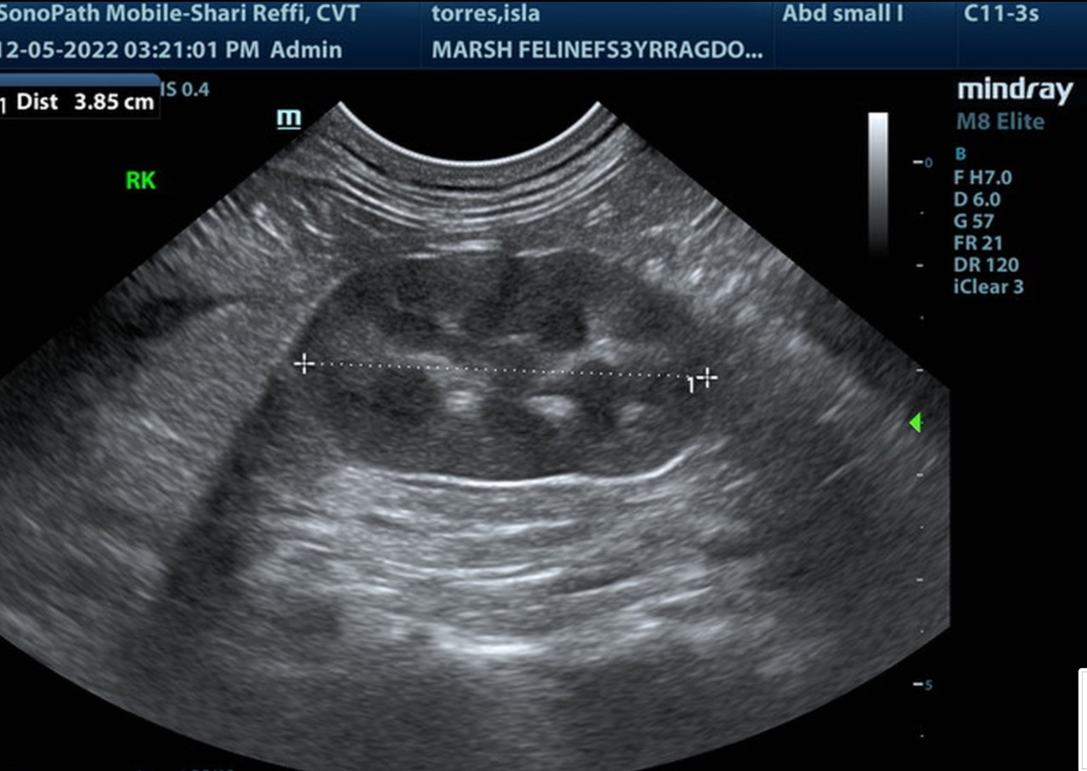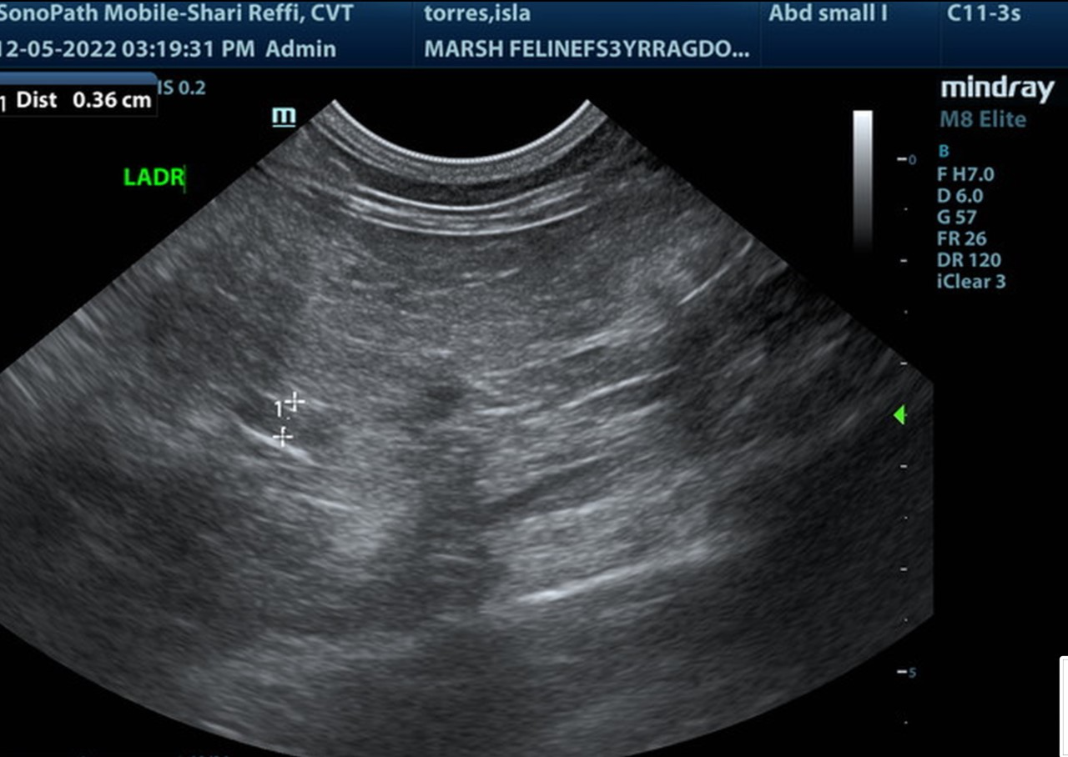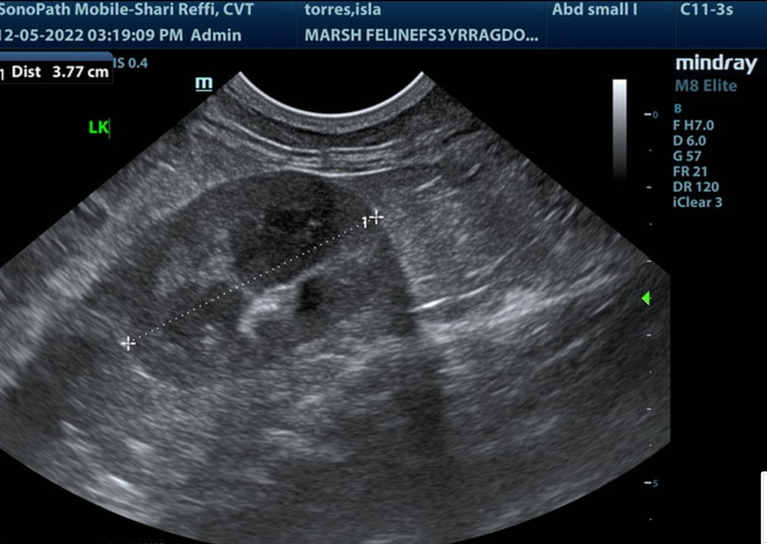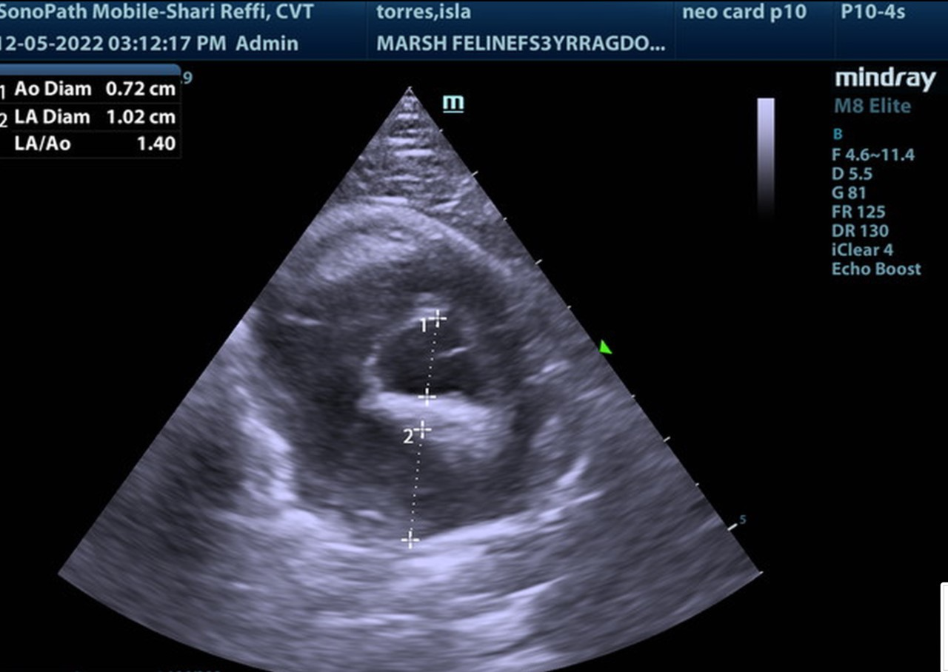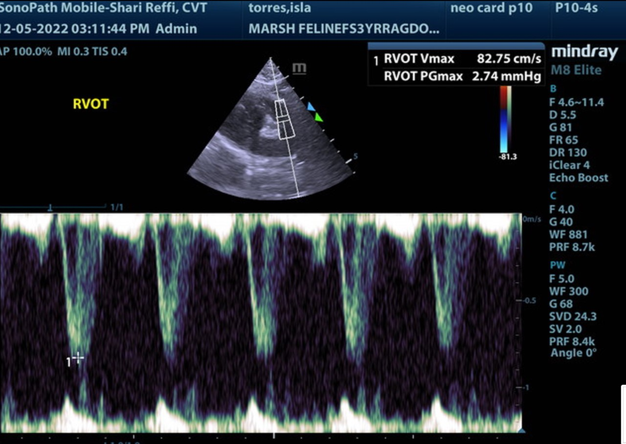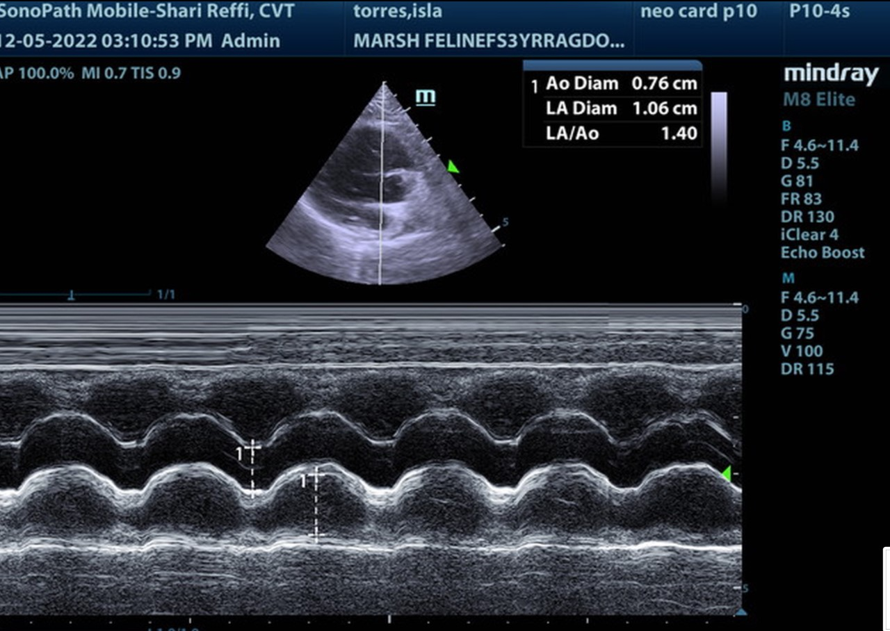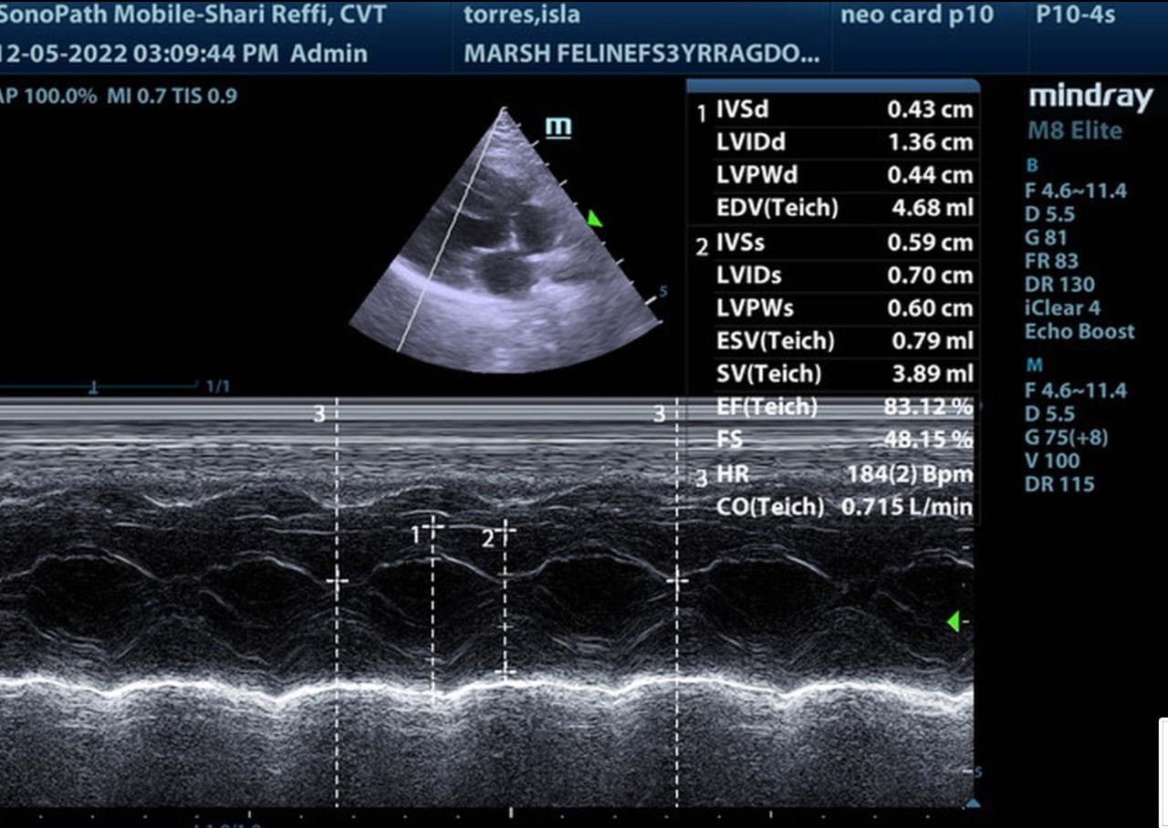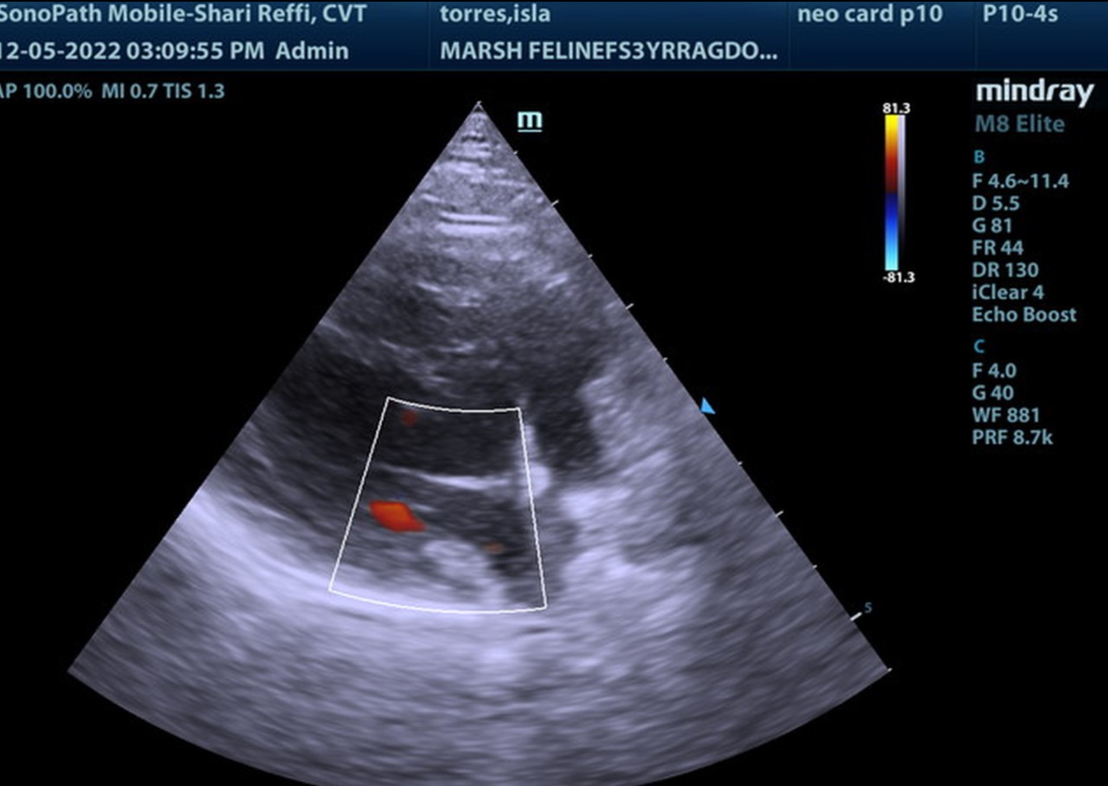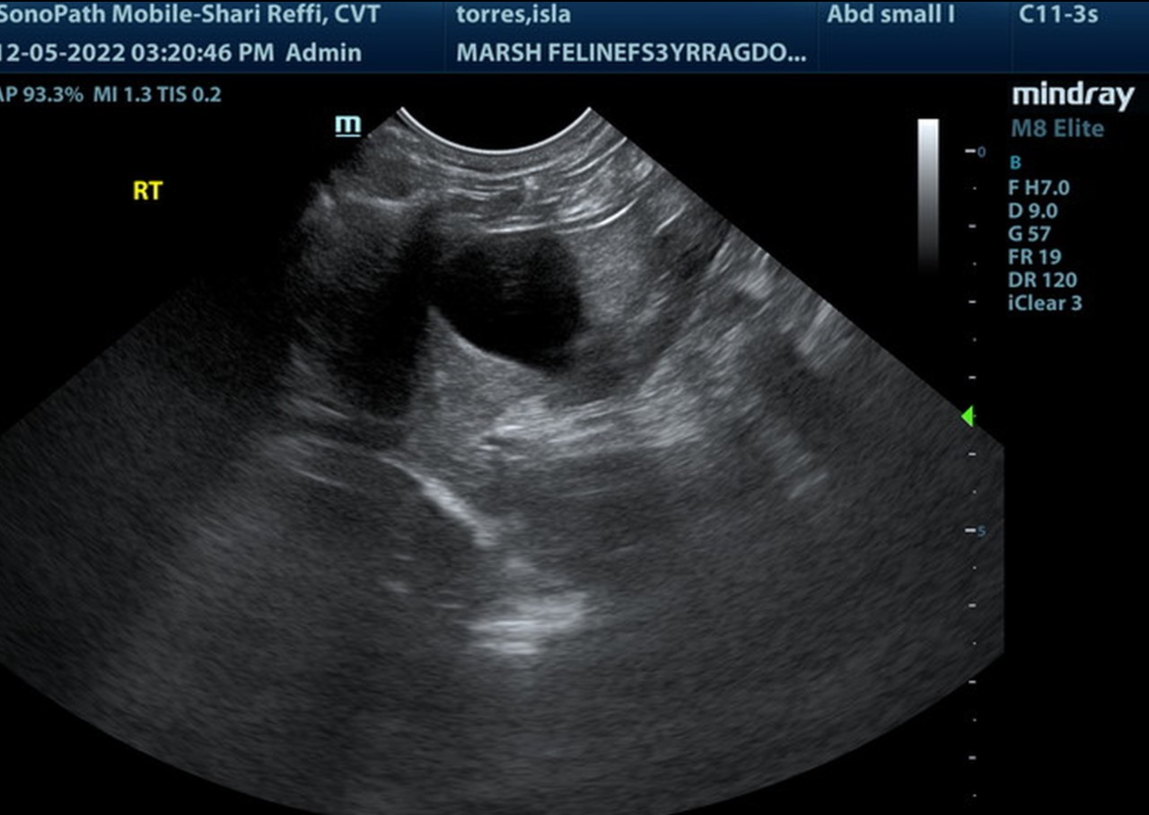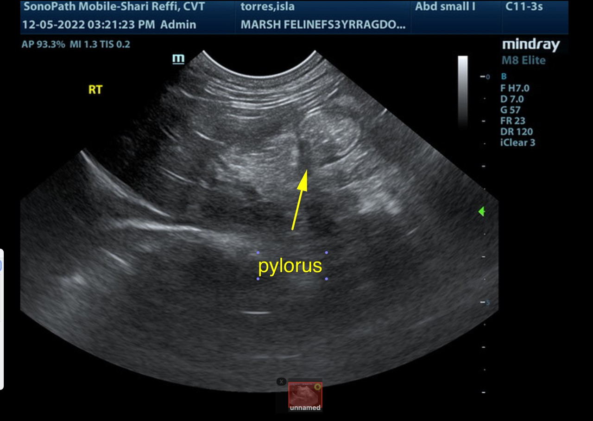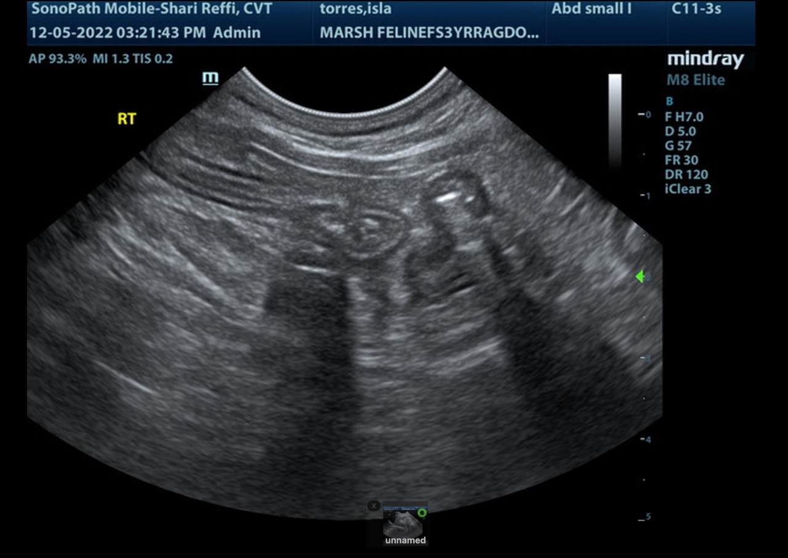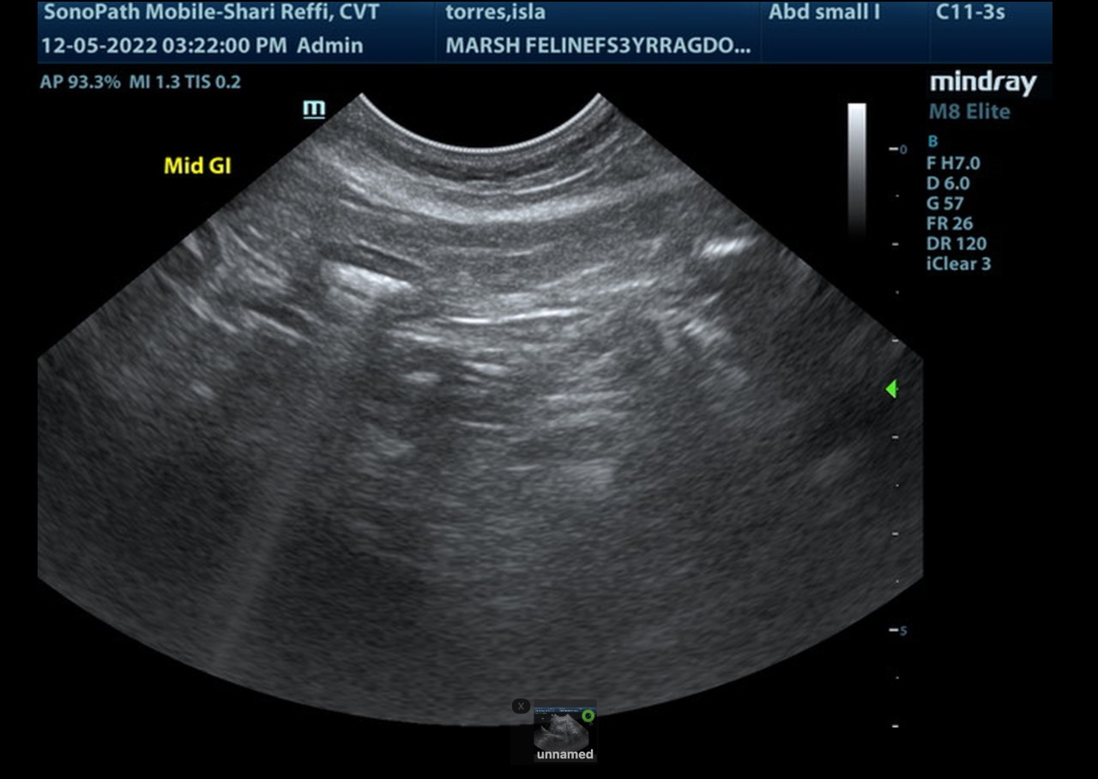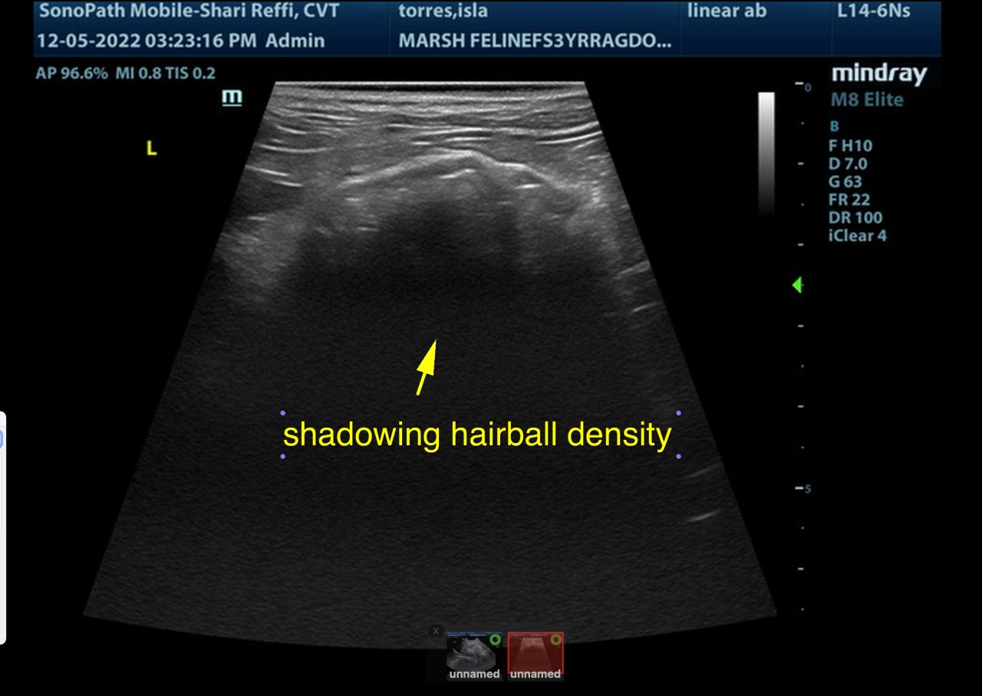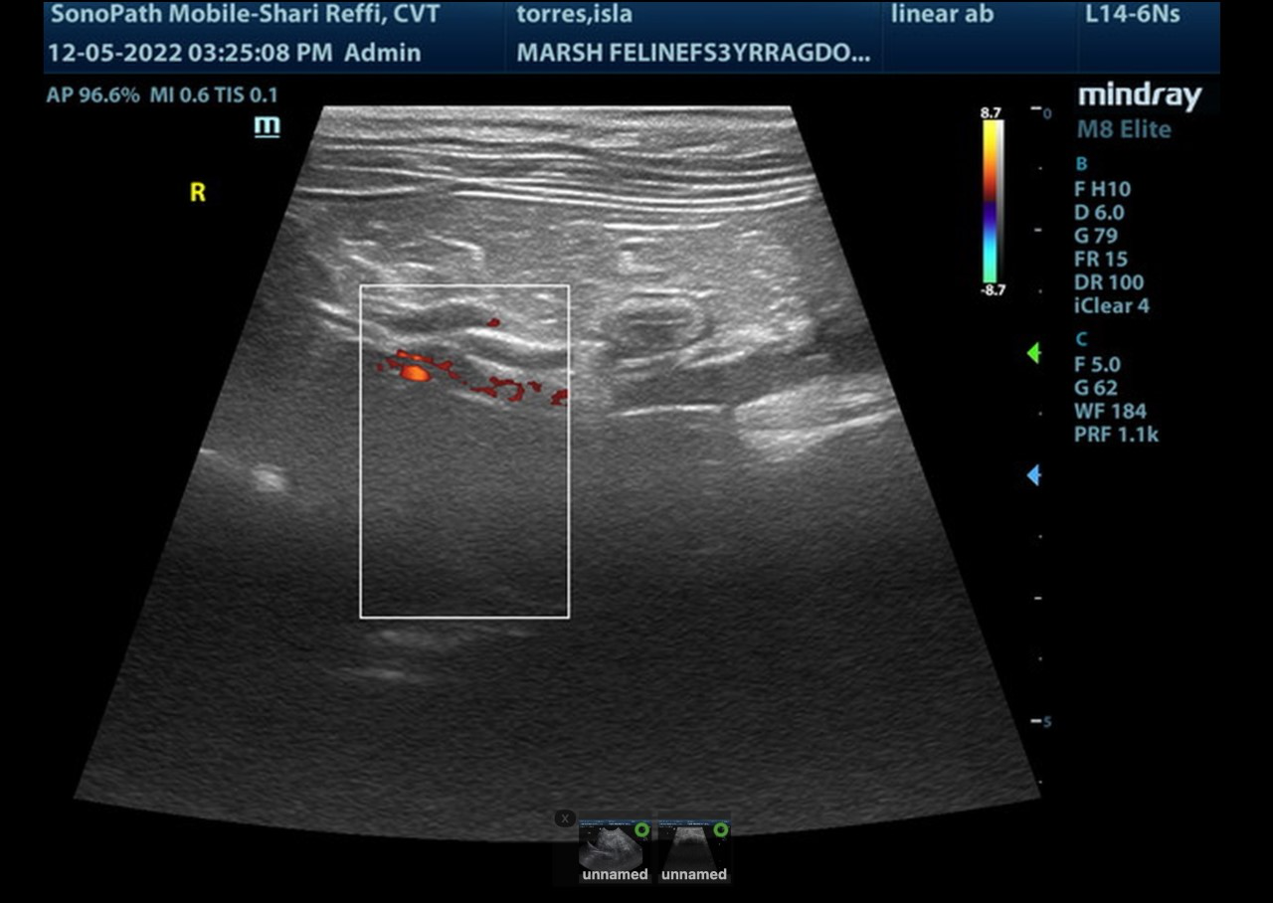

The information and recommendations provided are based on the images presented by the referring veterinarian. No evaluation can be communicated regarding pathology that was not visible in the image/video clips provided.

Thank you for this referral. If the clinical or image interpretation does not parallel your findings or if I can be of any further assistance please contact me.

Eric Lindquist, DMV, DABVP, Cert. IVUSS, CEO of SonoPath.com
info@SonoPath.com

