PRESENTING CLINICAL SIGNS
- Increase in ALP and GGT concerning for some liver/GB disease process.
- More elevated than last year.
- Overall p labs look good/stable but last year there was a mild increase in GGT (usually associated with GB changes) and this year there is an increase in ALP and GGT and the GGT is almost twice as high.
- Current meds: Apoquel 3.6 mg, fish oil pills, 1/2 Benadryl dose, Dasuquin and probiotic.
- Patient does need a dental cleaning.
Abnormal PE/Chem/CBC/UA Results: Labs attached.

ULTRASONOGRAPHIC EXAMINATION OF THE ABDOMEN
Urinary System
The urinary bladder, trigone, and visible pelvic urethra were of normal thickness. The ureters were not visible which is normal. There was normal wall layering with no masses, uroliths or abnormal thickening visualized. Urine was anechoic. No evidence of inflammatory or neoplastic changes were noted.
The right kidney has a smooth capsule and with mild hazing of corticomedullary definition. The right kidney measured 4.36 cm in length. Hyperechoic, shadowing foci present in renal parenchyma and calyces consistent with nephrocalcinosis. Spherical anechoic fluid accumulation consistent with cortical cyst.
The left kidney has a smooth capsule and with mild hazing of corticomedullary definition. The left kidney measured 4.05 cm in length. Hyperechoic, shadowing foci present in renal parenchyma and calyces consistent with nephrocalcinosis.
Adrenal Glands
Both adrenal glands were visualized and recognized as having normal shape, size, position and echogenicity for this breed and age. The visible phrenic vasculature was unremarkable. The left adrenal gland measured 1.99 cm in length and 0.56 cm at the caudal pole and 0.52 cm at the cranial pole. The right adrenal gland measured 1.8 cm in length and 0.48 cm at the caudal pole and 0.65 cm at the cranial pole.
Spleen
The spleen had a generally mottled parenchyma and a smooth capsule with perivascular hyperechoic nodules visualized most consistent with benign myelolipomas. There was normal splenic vasculature with no signs of congestion or thrombosis. No sonographic evidence of acute or chronic inflammatory, neoplastic, or infarct changes were noted.
Liver
The liver is subjectively normal in size with hyperechoic coarse parenchyma. There is a solitary hyperechoic nodule noted in the right liver measuring approximately 1.3 cm x 1.5 cm. No specific masses were seen.
The gall bladder is moderately distended with anechoic fluid, with hyperechoic non-shadowing gravity dependent debris present. There is no surrounding free fluid or signs of active inflammation.
Gastrointestinal
The stomach contains ingesta and gas shadowing. It measures at a normal thickness of with some variability due to the presence of rugal folds. The distinction of the gastric wall layers is adequate. No masses or focal lesions were observed.
The visualized areas of duodenum, jejunum and ileum have a relatively uniform diameter with minimal fluid distension. Wall thickness is normal. Bowel loops follow a curvilinear path with distinct wall layering maintaining the typical 1:3 muscularis: mucosa layer ratio. There were no focal lesions consistent with obstruction or a mass effect observed.
The ileocecal junction was not visualized. Sections of colon are visualized with formed fecal material and gas shadowing distally. There is no observed focal or generalized colon wall thickening or loss of layering.
Pancreas
The area of the pancreas was isoechoic to surrounding tissue with no overt inflammation. Pancreatic tissue was not distinctly visualized which is common.
Lymph Nodes
No clinically significant lymphadenopathy or abnormalities noted.
Free Abdomen
No masses or free fluid were noted.
ULTRASONOGRAPHIC FINDINGS
- Coarse liver with solitary hyperechoic nodule.
- Gallbladder debris.
- Degenerative renal changes with nephrocalcinosis and right renal cyst.
- Splenic myelolipomas.
INTERPRETATION OF THE FINDINGS & FURTHER RECOMMENDATIONS
Liver changes are a common benign age-related change, but infiltrative disease (lymphoma, MCT, other) cannot be definitively ruled out. The hyperechoic nodule is most likely benign. No other significant disruption of architecture noted to suggest significant pathology. In the face of elevated liver enzymes, fine needle aspirate is recommended to further characterize parenchymal changes, and bile acid profile to assess liver function, especially if any weight loss is noted or for baseline cytological assessment. Ultimately liver biopsy is often required for more definitive diagnosis. Empiric treatments (SAM-E, milk thistle, Vitamin E, ursodiol if bilirubin elevated or gallbladder sludge) could be tried and liver enzymes re-evaluated, especially if liver FNA does not show significant pathology before more invasive liver sampling is pursued.
Gall bladder debris may be an incidental finding given lack of surrounding inflammation. In the face of elevated ALKP ursodiol could be given as a choleretic and empiric treatments (SAM-E, milk thistle, Vitamin E) could be tried. If liver supportive medications do not improve liver enzymes, a course of empiric antibiotics (Clavamox, enrofloxacin) could be considered to cover for infectious cholangiohepatitis, though the lack of surrounding inflammation makes this less likely. Imaging should be rechecked on a routine basis for monitoring (q3-6mo) or if further significant increase in liver enzymes and/or new clinical signs are noted. If otherwise clinically indicated, investigation for endocrinopathy such as hyperadrenocorticism or hypothyroidism could be considered as an underlying cause predisposing to gall bladder debris accumulation.
Splenic changes are a common age-related change, and hyperechoic areas are most consistent with benign myelolipoma, but infiltrative disease (lymphoma, MCT, other) cannot be definitively ruled out. No significant disruption of architecture noted to suggest significant pathology. Fine needle aspirate could be considered to further characterize parenchymal changes if clinically indicated, especially if any weight loss is noted or for baseline cytological assessment.
Renal changes are likely age-related degeneration. Correlate clinical significance with semi-annual blood work/urinalysis findings and clinical signs.

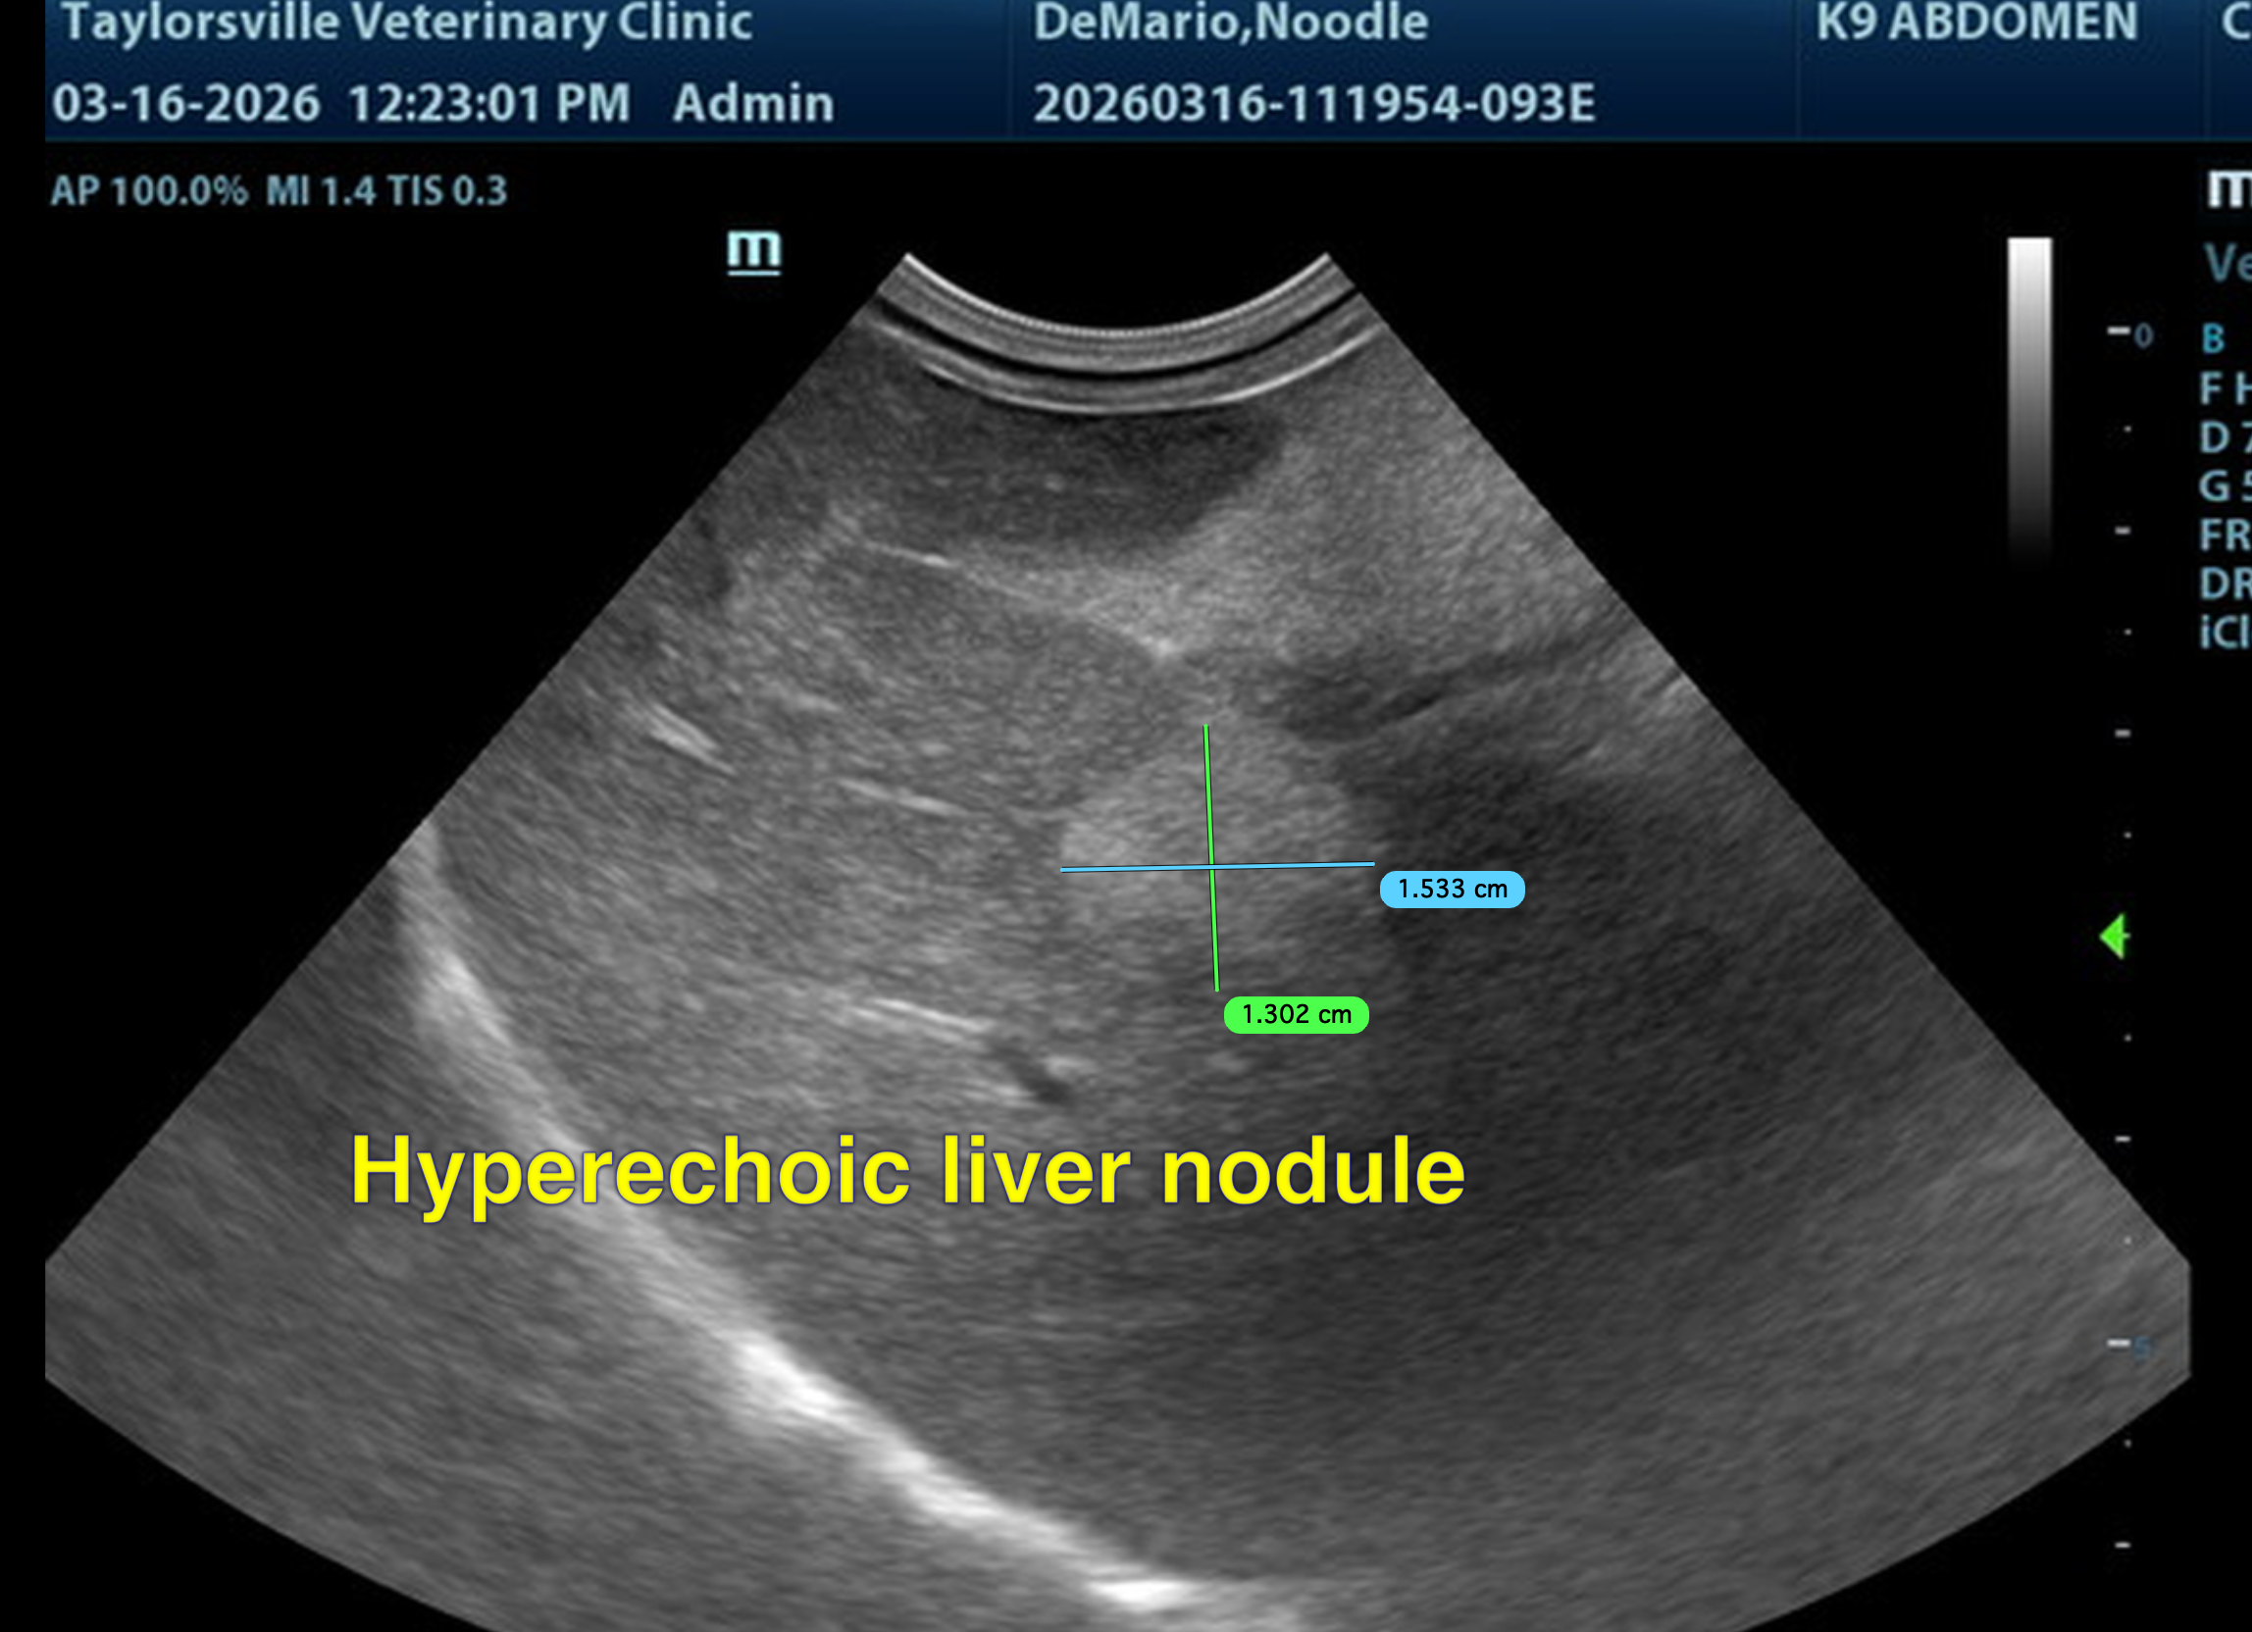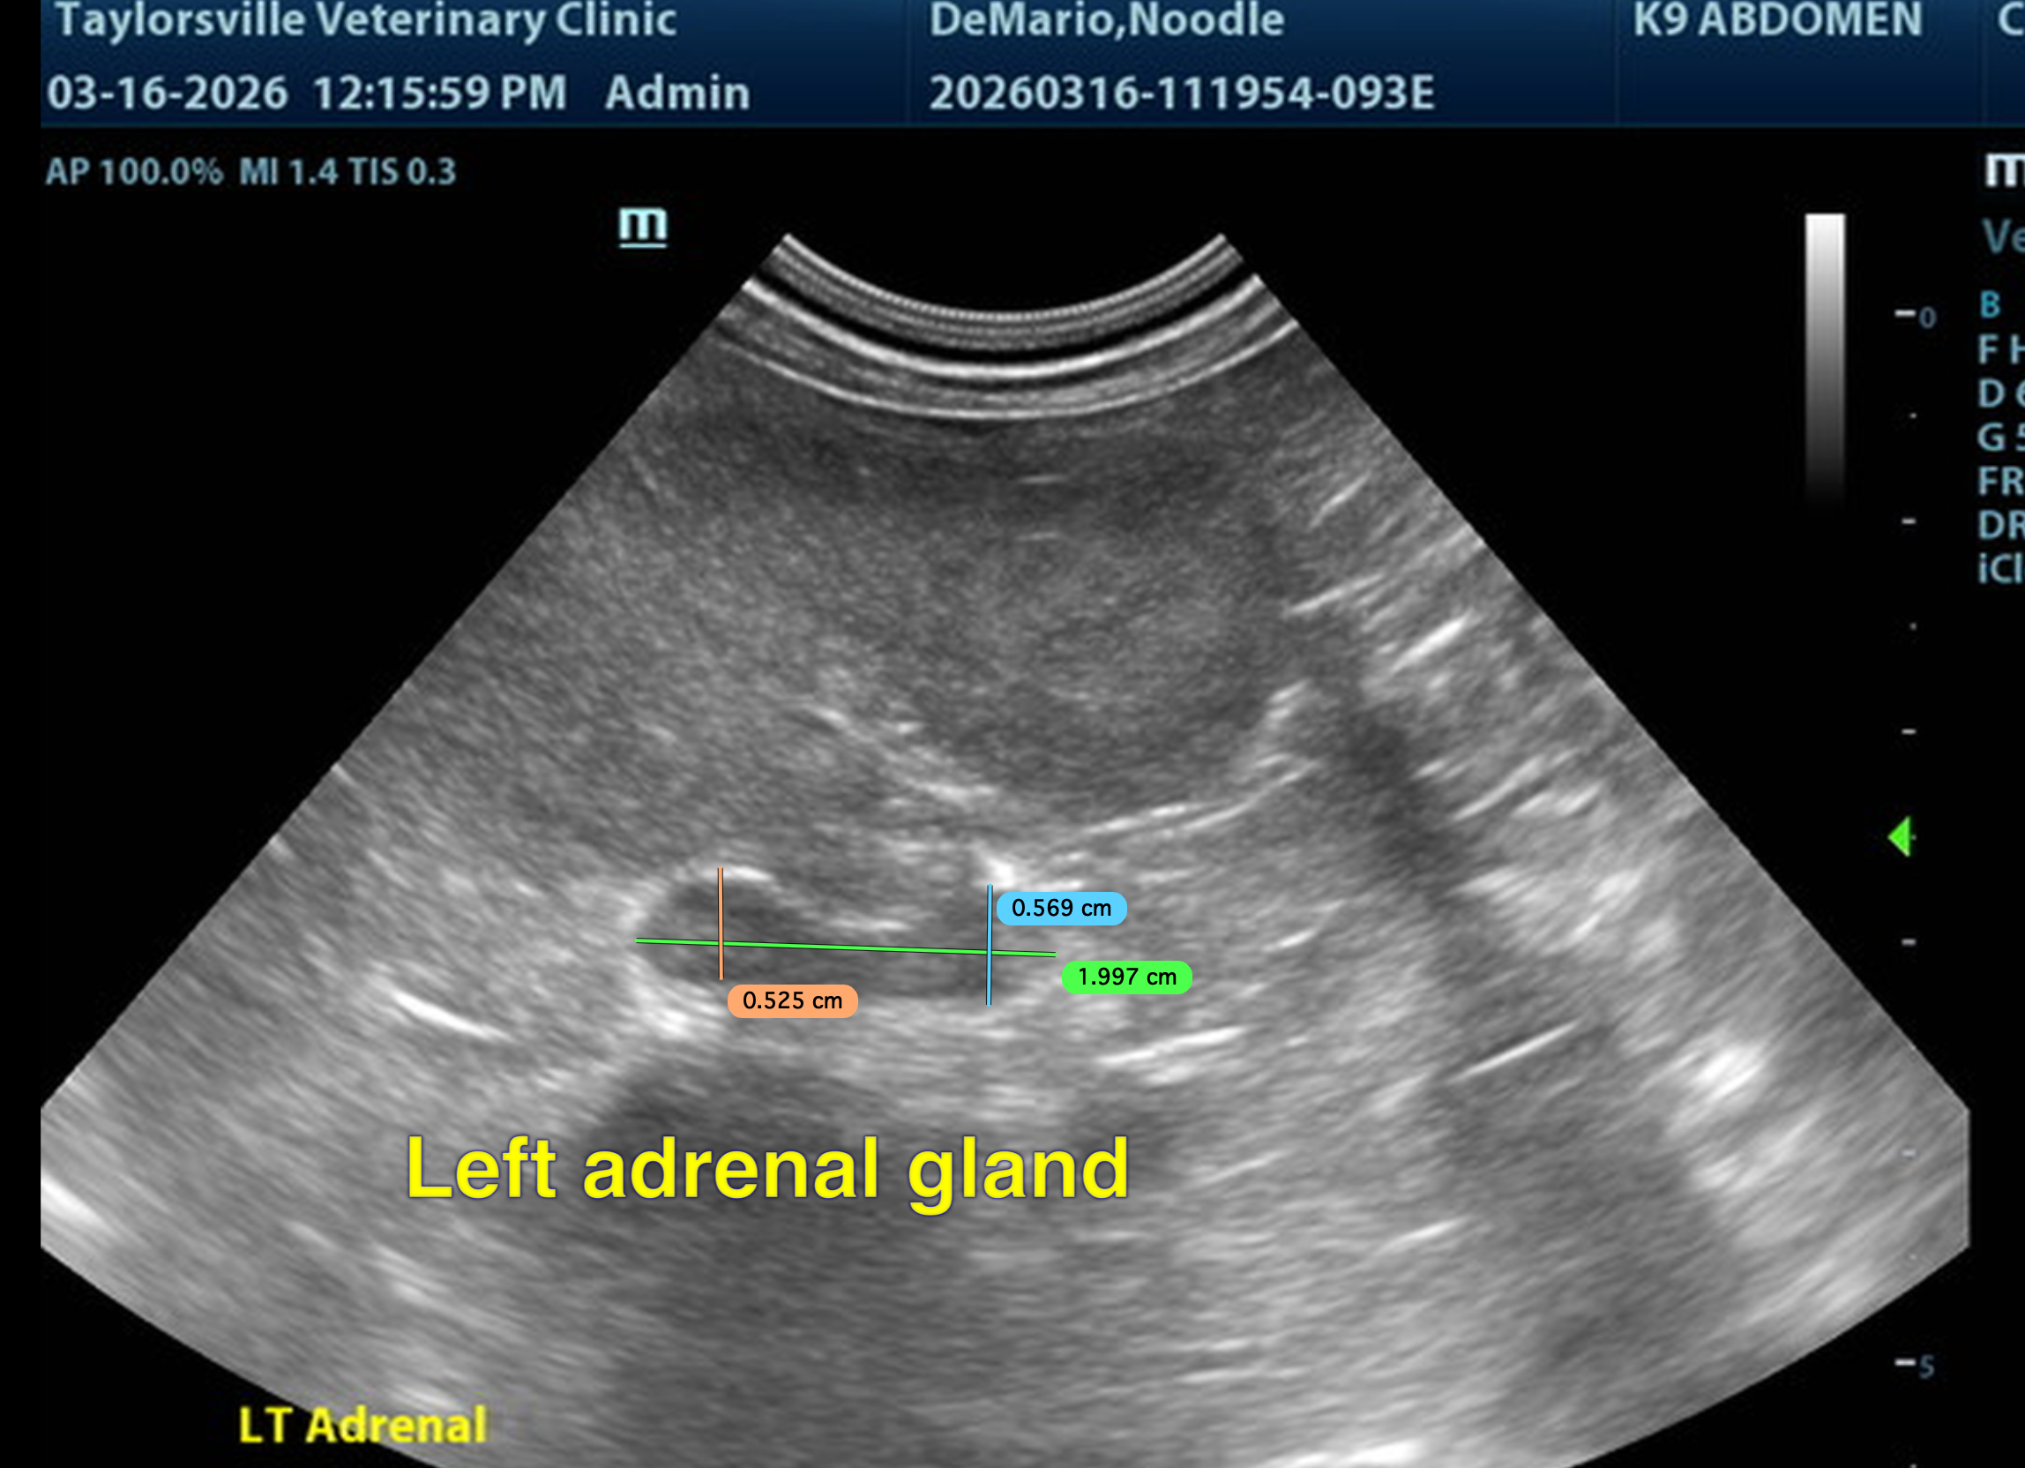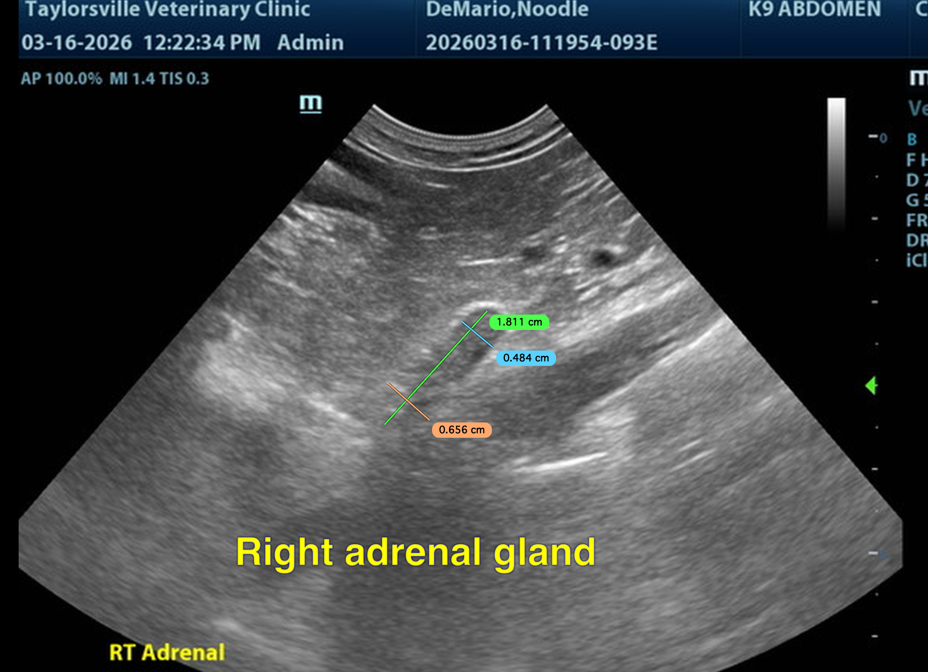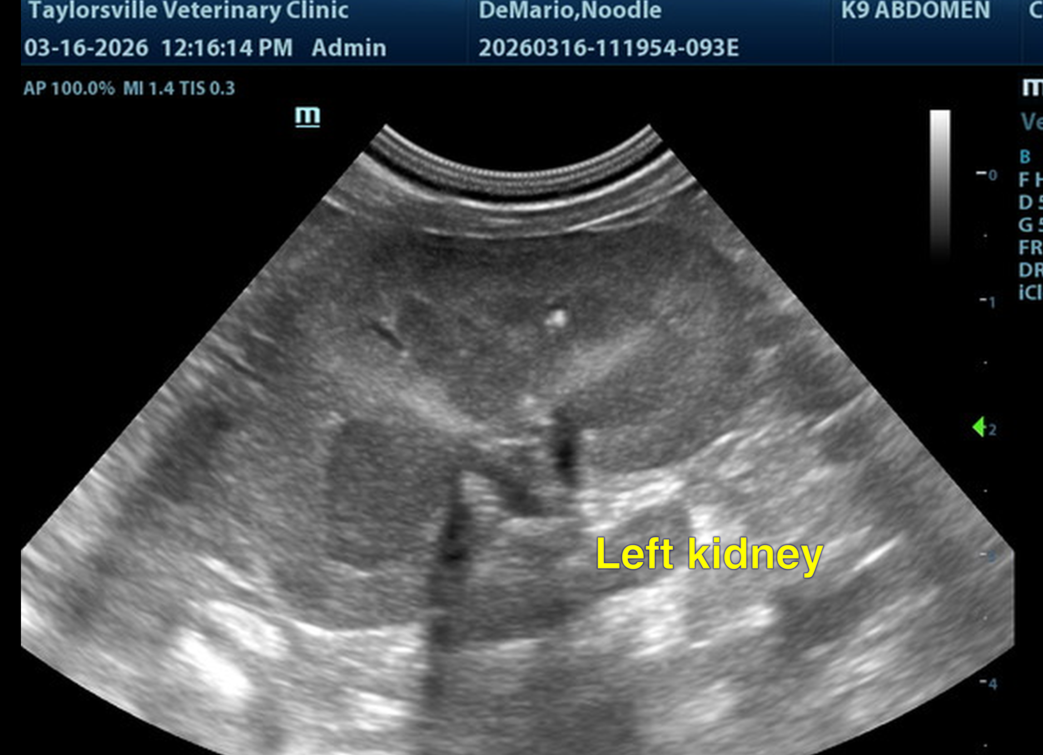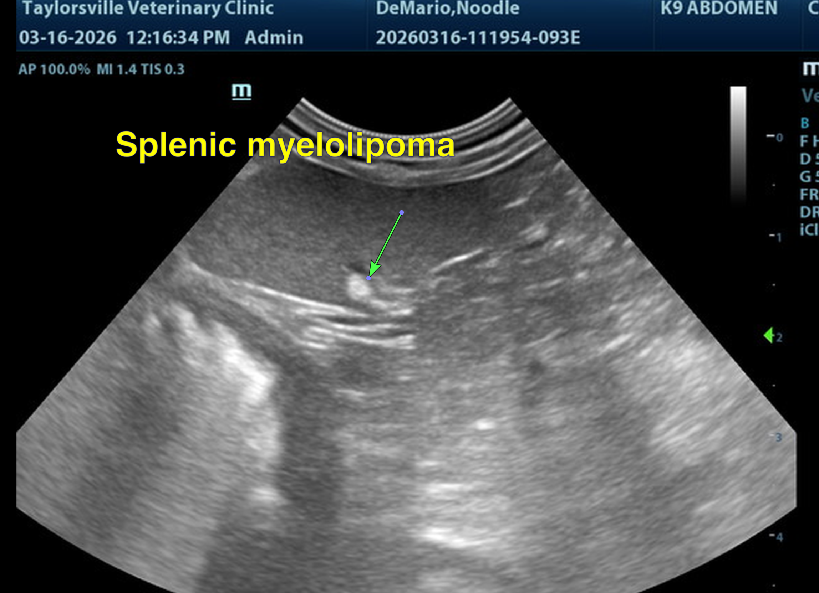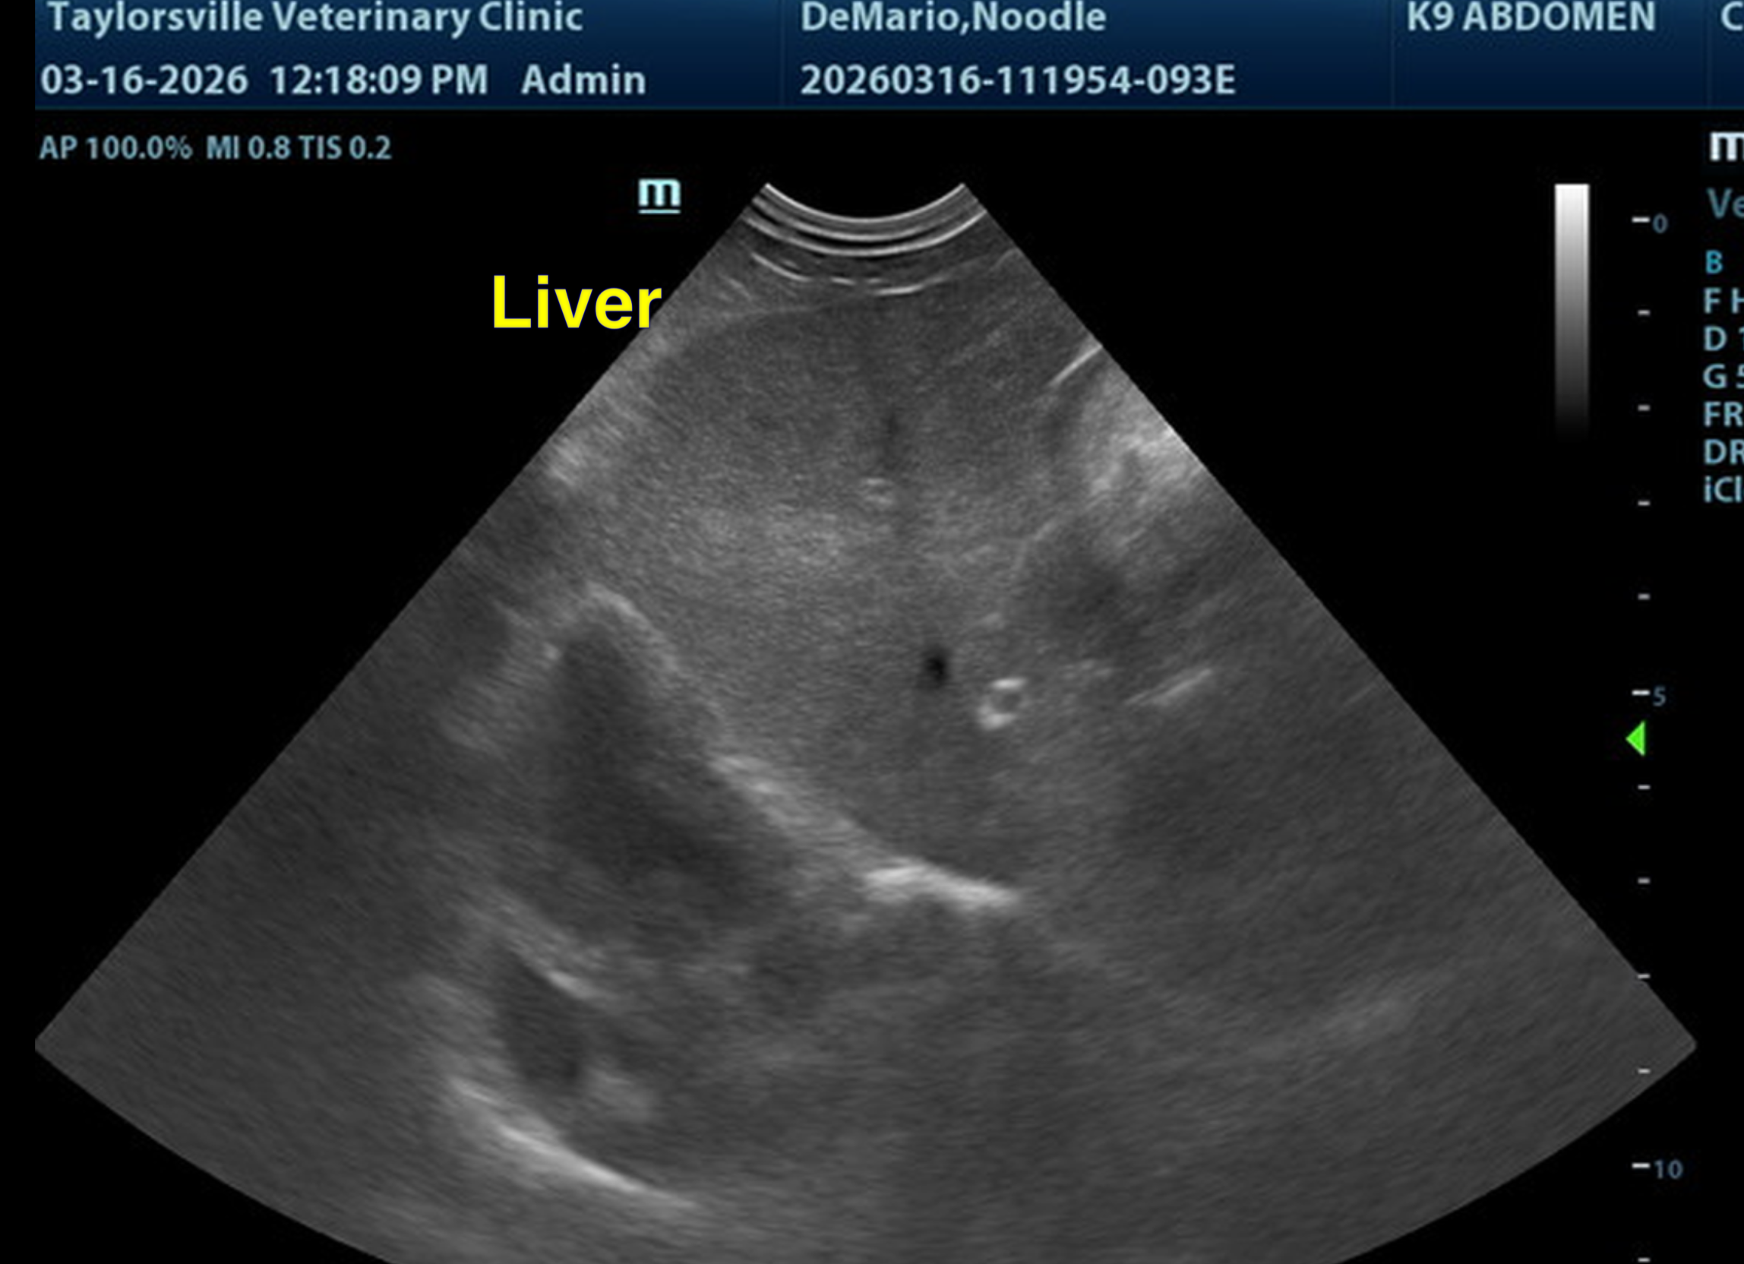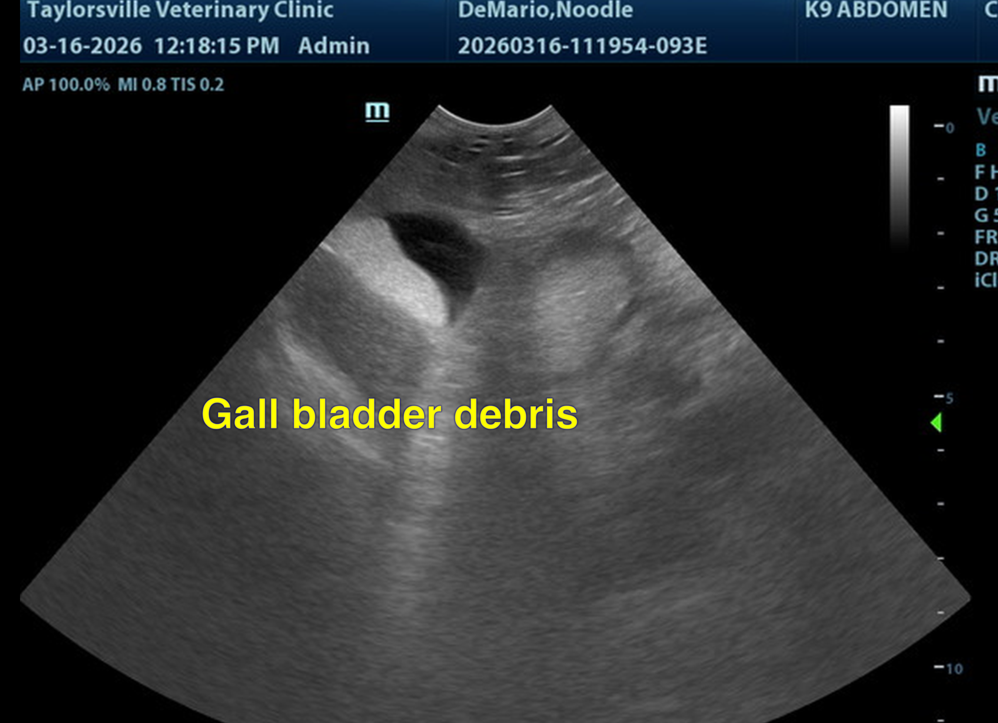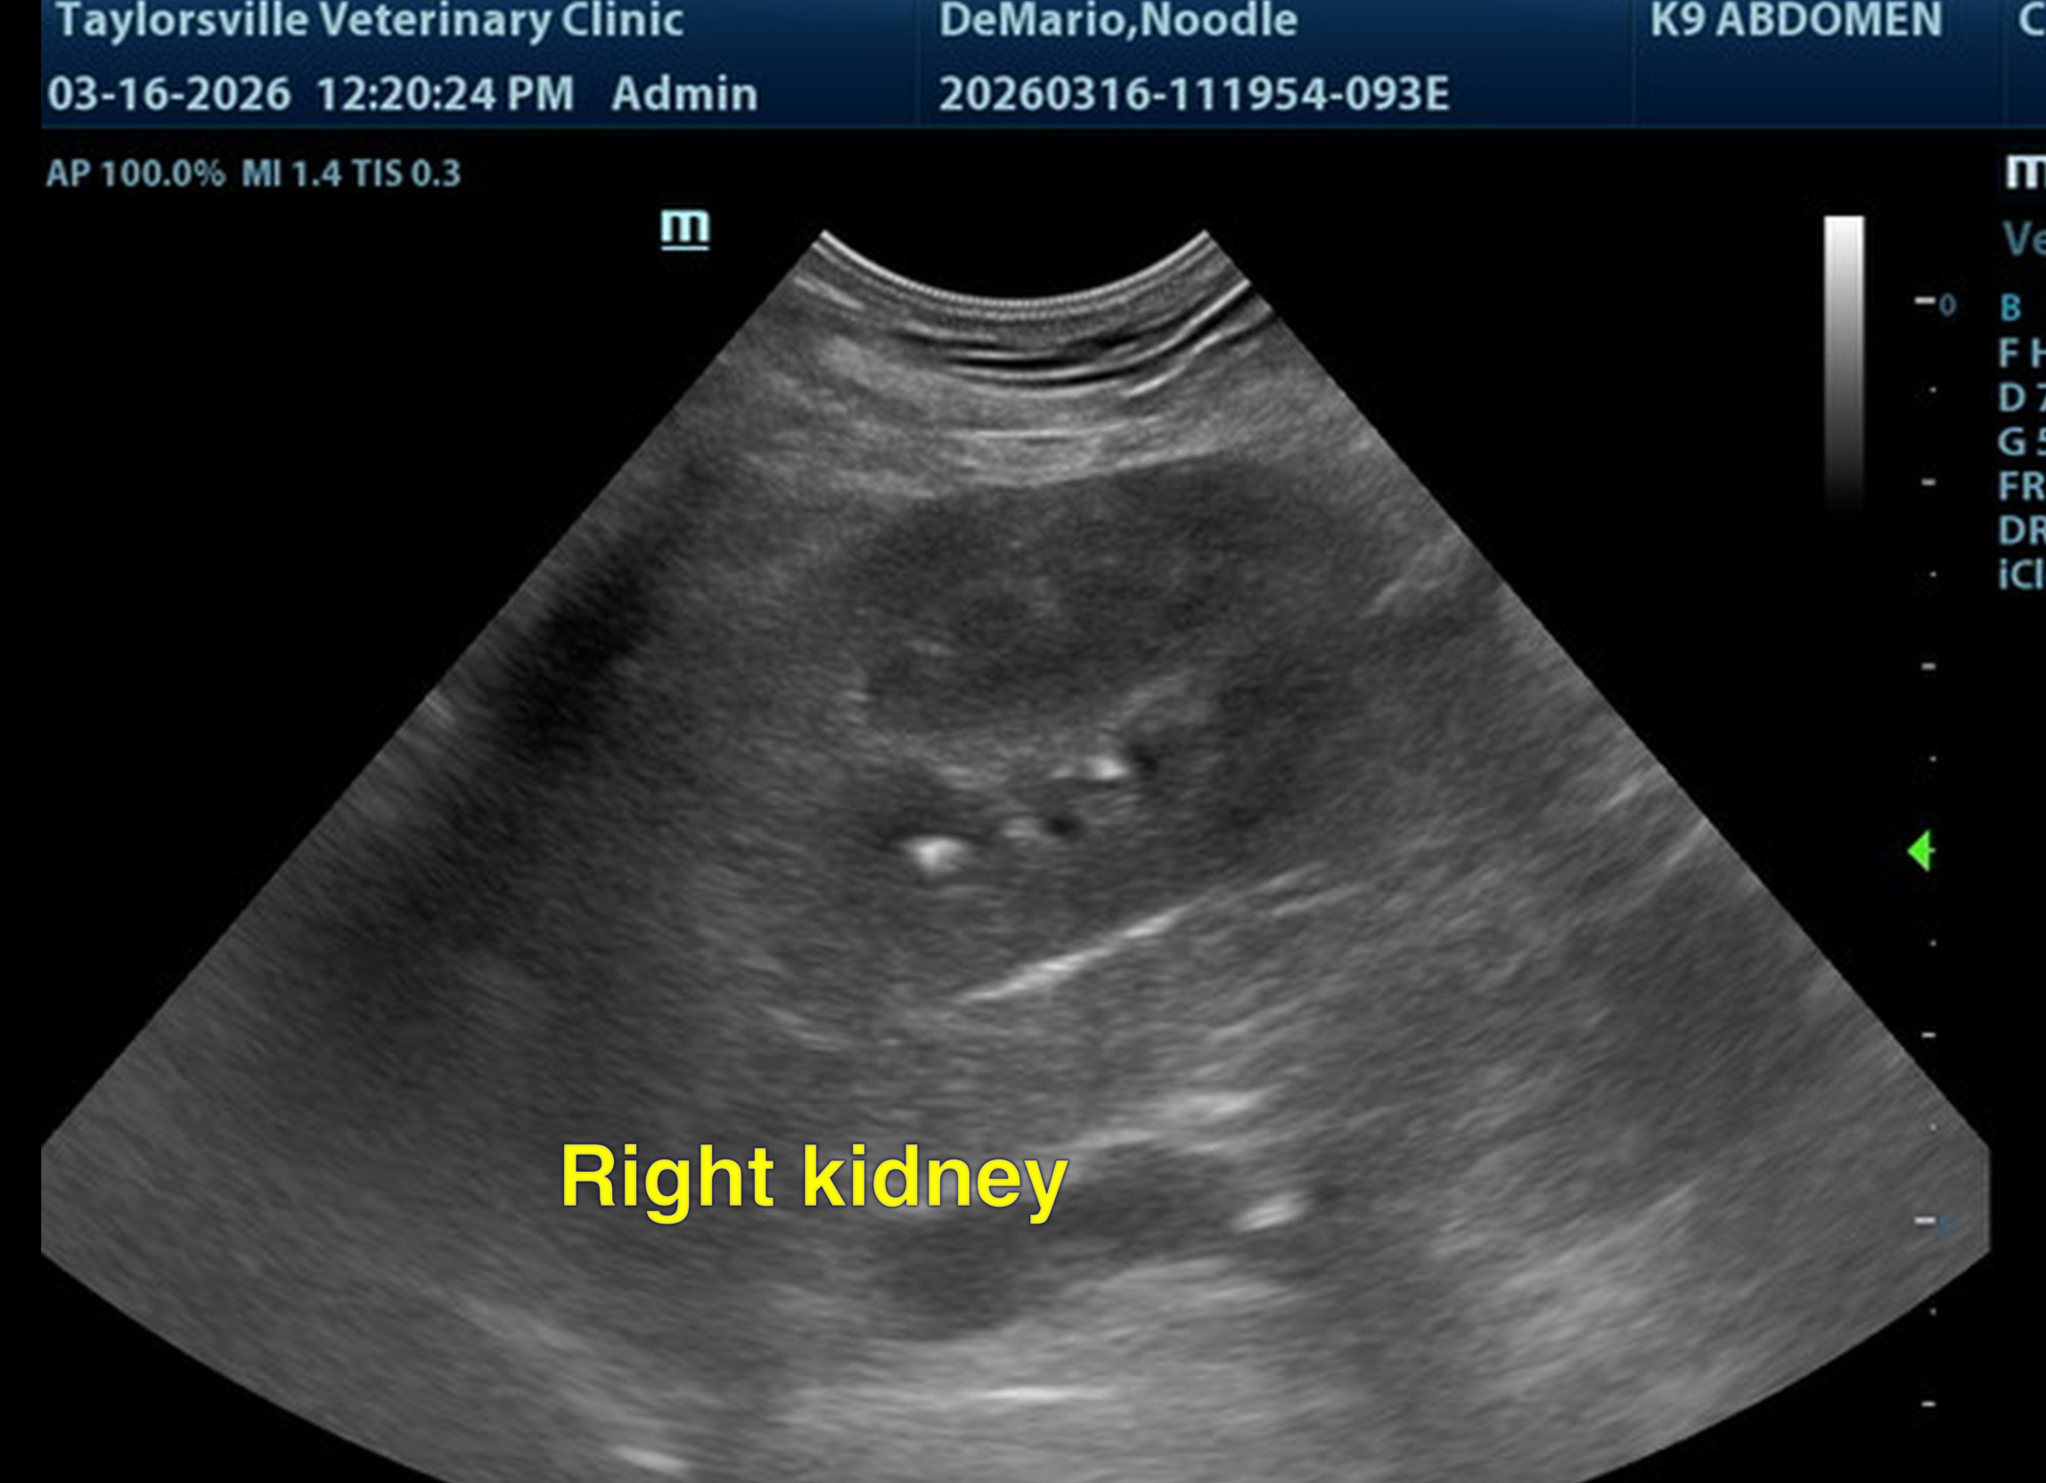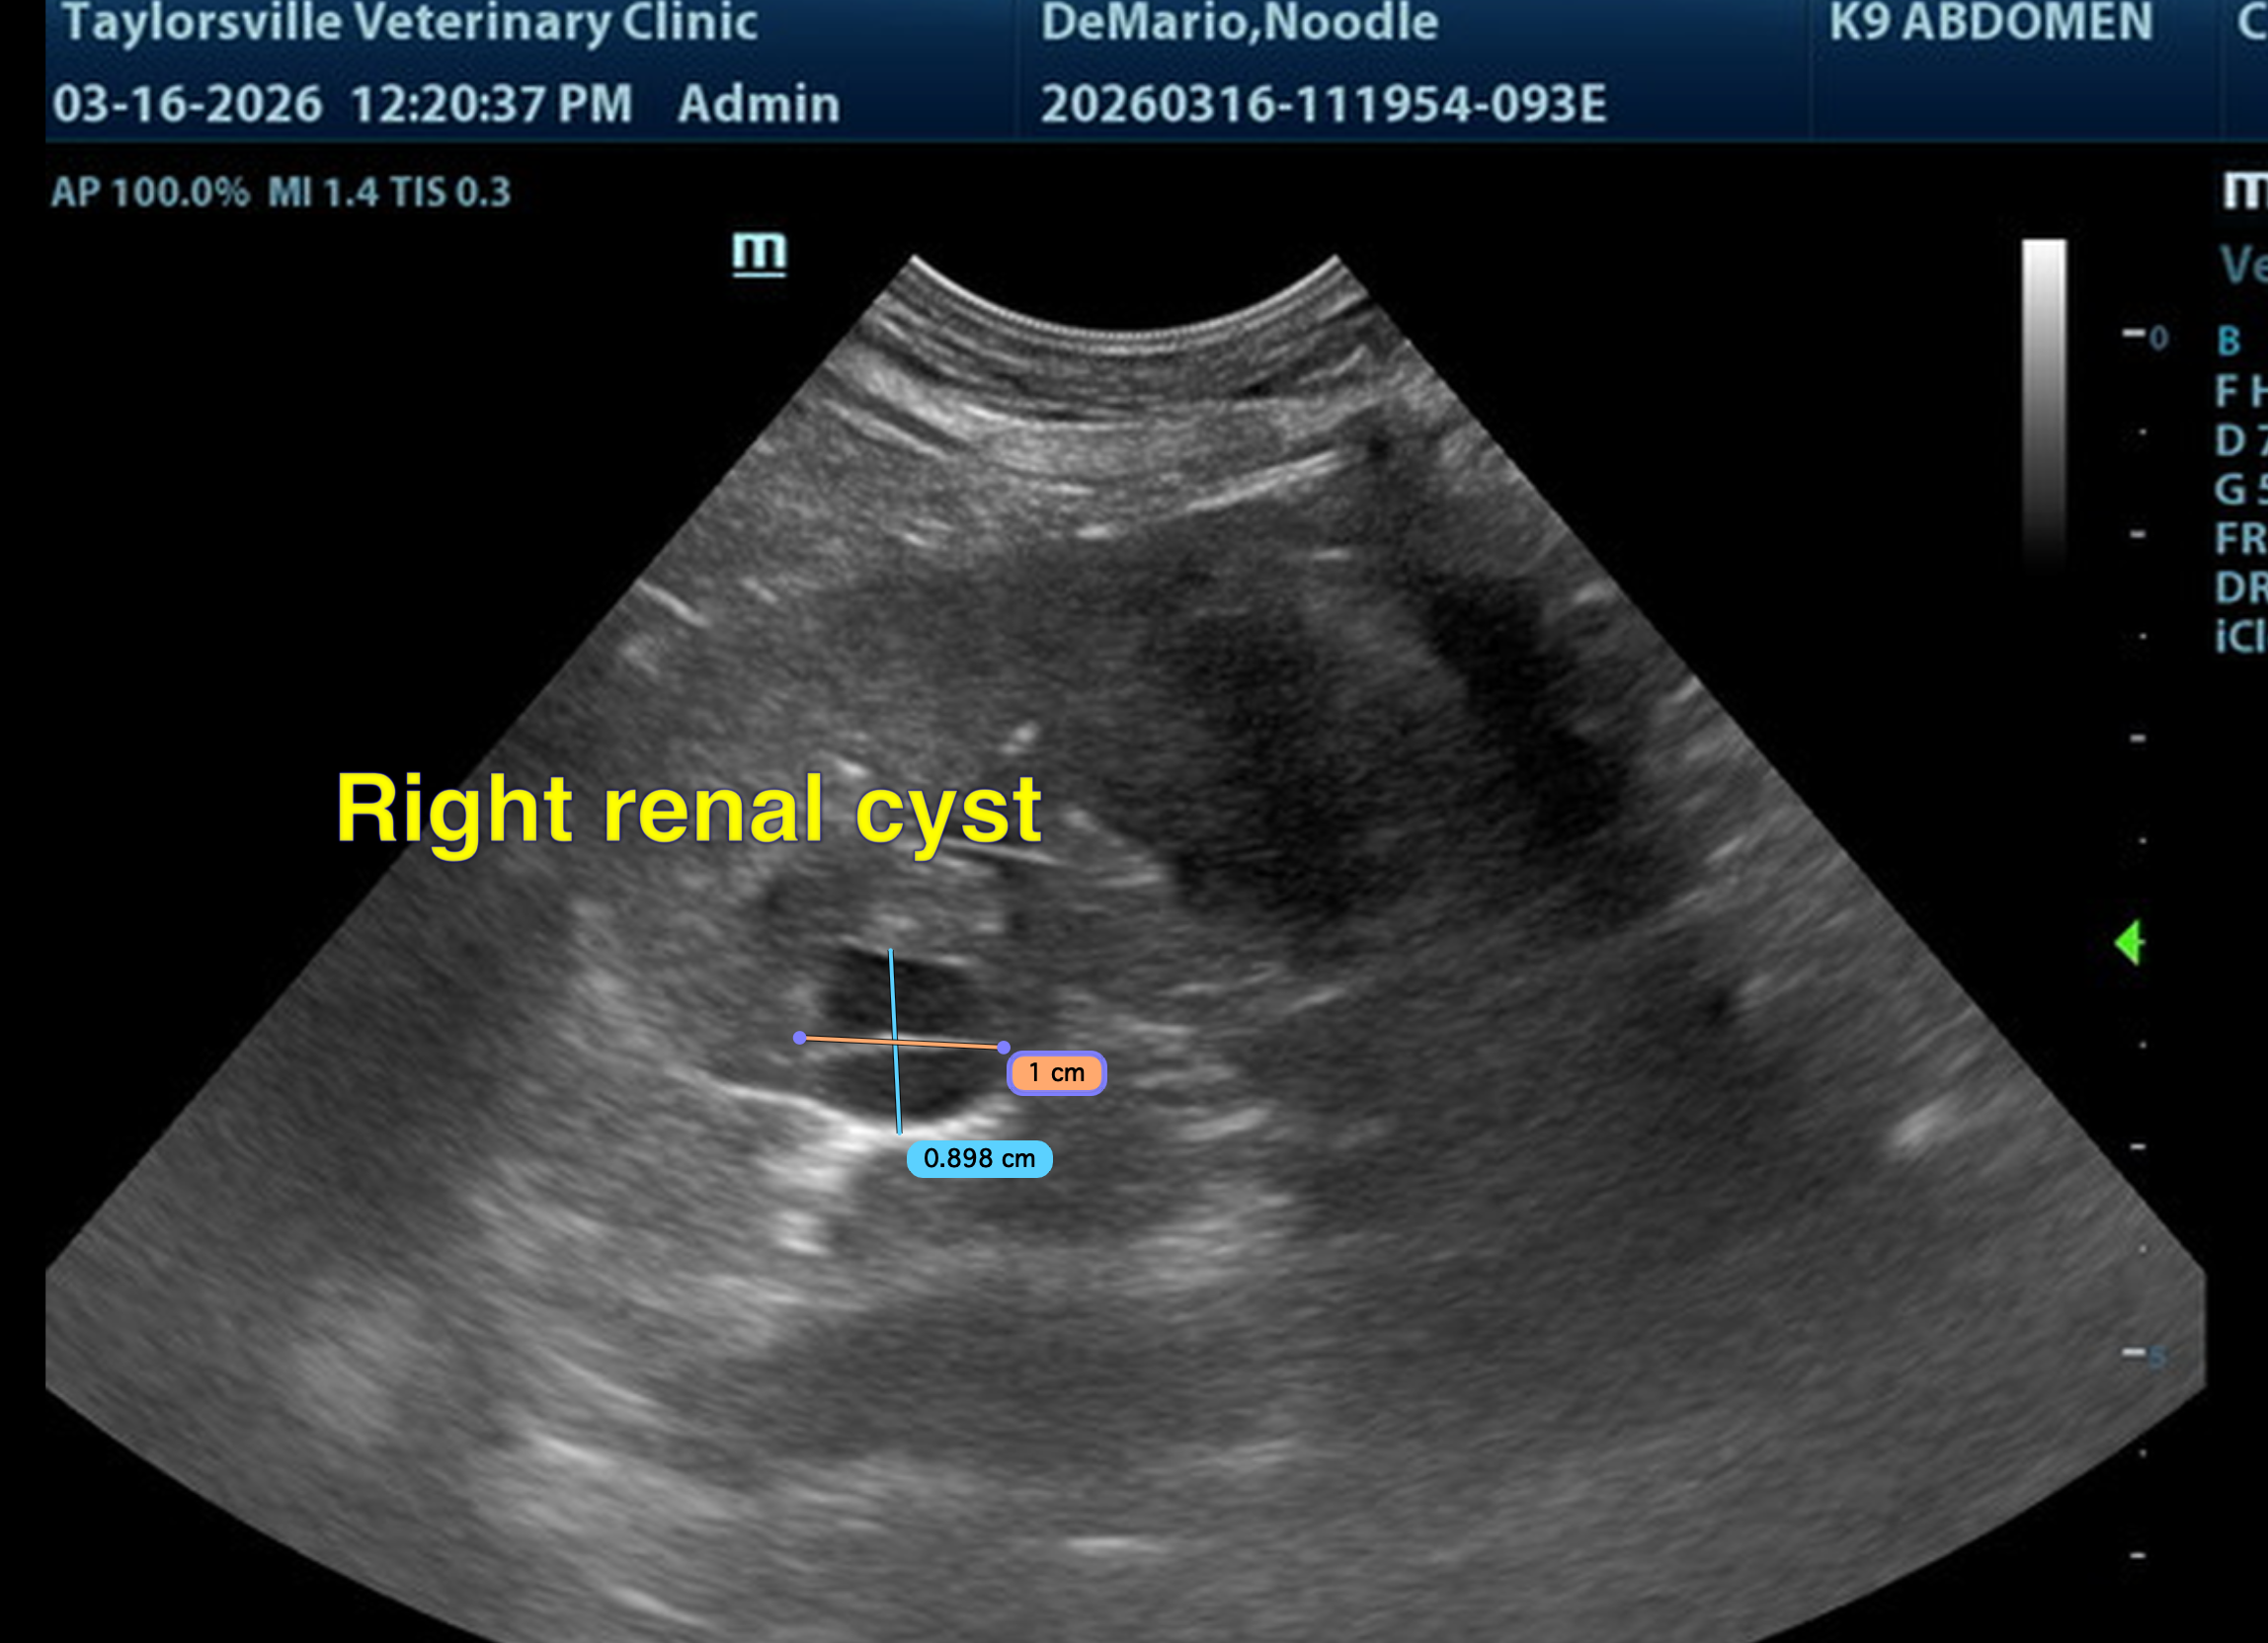
The information and recommendations provided are based on the images presented by the referring veterinarian/sonographer. No evaluation can be communicated regarding pathology that was not visible in the image/video clips provided.
Thank you for this referral. If the clinical or image interpretation does not parallel your findings or if I can be of any further assistance, please contact me.
Dr Brittany Sinclair, BVSc(hons), DACVECC
info@SonoPath.com

