PRESENTING CLINICAL SIGNS
History: mild elevation liver values owner wanted further evaluation
Abnormal PE/Chem/CBC/UA Results: alk phos 193 AST 74
ULTRASONOGRAPHIC EXAMINATION OF THE ABDOMEN

Urinary System
Urinary bladder is adequately distended with anechoic contents. No masses, inflammatory changes, echogenic sediment or cystoliths are observed. The urinary bladder, trigone and visible pelvic urethra are normal in thickness with a smooth mucosal surface.

Left kidney is normal in size (3.57 cm), shape and echogenicity. It has smooth peripheral margination. There is a normal 1:3 cortex to medulla ratio with appropriate corticomedullary distinction. A hyperechoic band parallel to the corticomedullary border is present. Non-obstructive linear multifocal hyperechoic diverticular foci with acoustic shadowing are noted. There is no evidence of pyelectasia, mineral or infarcts observed.

Right kidney is normal in size (3.48 cm), shape and echogenicity. It has smooth peripheral margination. There is a normal 1:3 cortex to medulla ratio with appropriate corticomedullary distinction. A hyperechoic band parallel to the corticomedullary border is present. Non-obstructive linear multifocal hyperechoic diverticular foci with acoustic shadowing are noted.There is no evidence of pyelectasia, mineral or infarcts observed.

Adrenal Glands
Left adrenal gland is normal in size (0.57 cm at cranial pole / 0.45 cm at caudal pole), shape and overall architecture, echogenicity and echotexture. Visible surrounding vasculature appears normal.

Right adrenal gland is normal in size (0.58 cm at caudal pole), shape and overall architecture, echogenicity and echotexture. Visible surrounding vasculature appears normal. The cranial pole is difficult to fully visualize in these images.

Spleen
Spleen is subjectively normal in size with a normal smooth capsular contour. Parenchyma is appropriately finely textured and homogenous with normal echogenicity relative to surrounding tissue (hyperechoic to liver). No focal nodules or masses are observed. Splenic vasculature appears normal.

Liver
Liver is subjectively normal in size with normal smooth curvilinear peripheral contour. Parenchyma is appropriately hypoechoic to the spleen in echogenicity and appropriately mildly coarse and homogenous in echotexture. No focal lesions are observed. Visible vasculature and biliary tree appear normal without distension or congestion.

Gallbladder is moderately distended with anechoic bile as well as suspended and gravity dependent echogenic debris. The wall is smooth without visible thickening. There is no evidence of cystic or CBD dilation. There is no evidence of effusion or inflammation.

Gastrointestinal
The visible stomach wall is normal in thickness and layering. The lumen of the stomach is mildly distended with very echogenic reverbation artifact from intraluminal gas. There is no evidence of obstruction, foreign material or infiltrative disease; however, complete visualization of far wall is partially inhibited by gas. Pyloric outflow tract appears patent.

The visible small intestines are normal in wall thickness and layering. Small intestinal motility appears adequate (1-3 contractions per min). The lumen of the small intestine is mildly distended with echogenic non-shadowing luminal contents and gas consistent with normal ingesta. There is no evidence of obstruction, foreign material or infiltrative disease.

The visible colon is normal in wall thickness and layering. Contents are consistent with normal formed feces and gas.

Pancreas
The observed pancreas appears appropriately isoechoic to surrounding omental fat. Visible capsule is smooth and normal in contour. Visible pancreatic parenchyma is homogenous and unremarkable. There is no visible pancreatic duct dilation. There is no evidence of active peripancreatic inflammation.

Free Abdomen
There is no evidence of peritoneal effusion. There is no apparent lymphadenopathy.

ULTRASONOGRAPHIC FINDINGS

- Subtle bilateral medullary rim sign with nonobstructive dystrophic mineralization bilaterally - This finding is of unknown clinical significance and can be a normal variant, often idiopathic. Medullary rim sign can be present with renal disease including FIP, (remove FIP if this is a dog) lymphoma, hypercalcemic nephropathy, Leptospirosis, tubular disease, other and should be interpreted in combination with other more specific indications of kidney disease such as isosthenuria, proteinuria, azotemia, etc. This is a common incidental finding in patients with diabetes mellitus.

- Moderate gallbladder debris - Cholecystic debris is of unknown clinical significance. It can be seen with biliary stasis from fasting or illness. Cholecystic debris is not necessarily related to hepatobiliary disease. Echogenic bile is most commonly an incidental finding in dogs and should be interpreted in combination with clinical signs such as nausea, inappetence, cranial abdominal discomfort and/or laboratory changes such as increased ALP and/or increased Tbili.

INTERPRETATION OF THE FINDINGS & FURTHER RECOMMENDATIONS

Differentials for a primary cholestatic liver enzyme pattern (increased ALP) are vast and non-specific. Differentials include, but are not limited to, benign nodular hyperplasia which occurs in 70% of older dogs and often does not result in an abnormal ultrasound, reactive or idiopathic/vacuolar hepatopathy, cholestasis and/or hyperadrenocorticism as well as many chronic non-hepatobiliary diseases such as chronic infections/inflammation from dental disease, IBD, neoplasia, hyperlipidemia, hypothyroidism, chronic pancreatitis, chronic stress, etc.

There is no ultrasonographic evidence of cholestasis. Adrenocortical testing such as a low dose dexamethasone suppression test could be considered if clinical signs of hyperadrenocorticism are present. Ursodiol could be considered if gallbladder sludge is noted. A fine needle aspirate of the liver could be considered if patient’s coagulation status is appropriate. Otherwise, recommendations include addressing any other concurrent disease and monitoring. If values are progressive, recheck imaging is recommended.

Specifically for this patient, given the mild increase, a course of empirical hepatic nutraceuticals, including Ursodiol can be considered, given the moderate gall bladder debris visualized.

Additionally, if not recently evaluated, complete work-up of the kidneys is recommended in the form of a urinalysis and, if indicated based on urinalysis results, urine culture are recommended. If protein is present in an otherwise quiet sediment, protein quantification with a urine protein to creatinine ration is recommended.

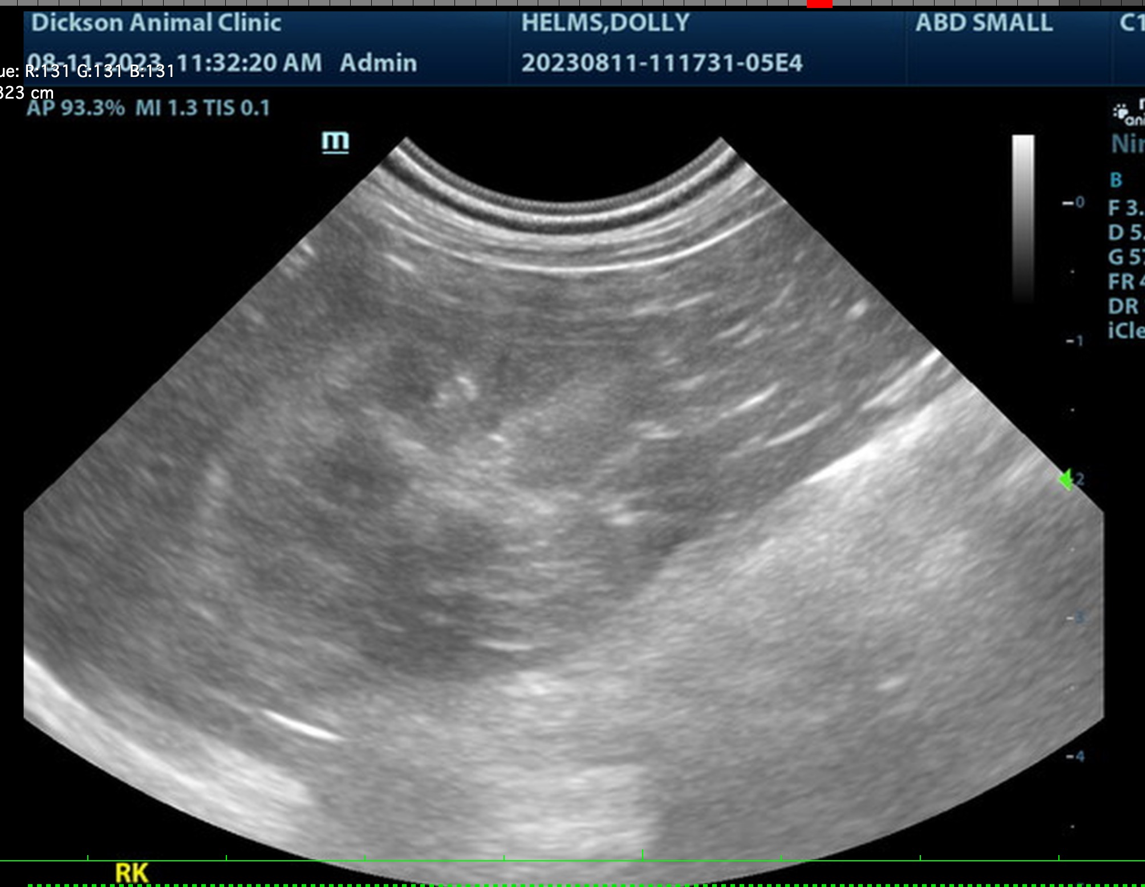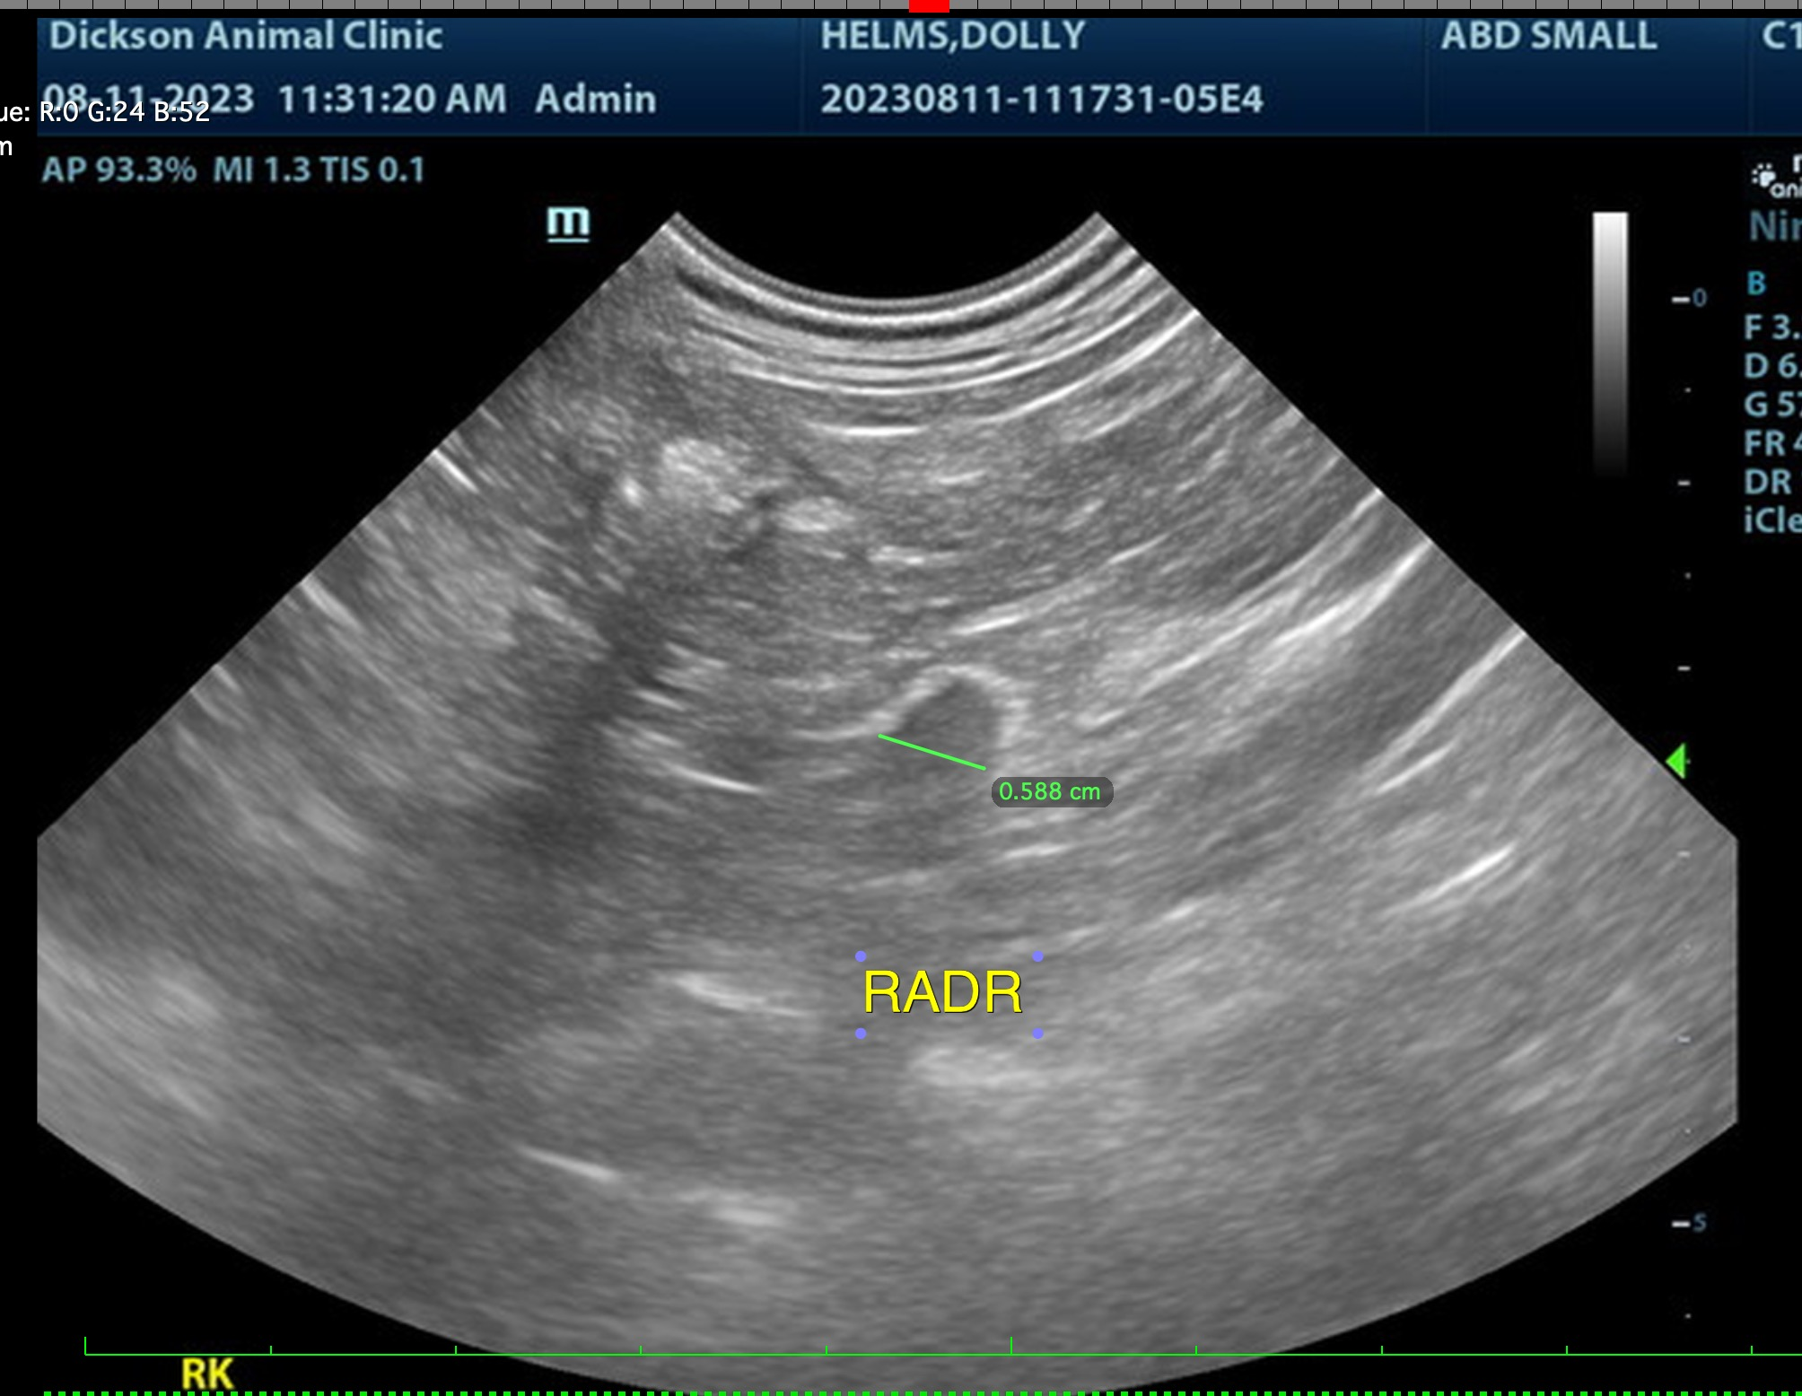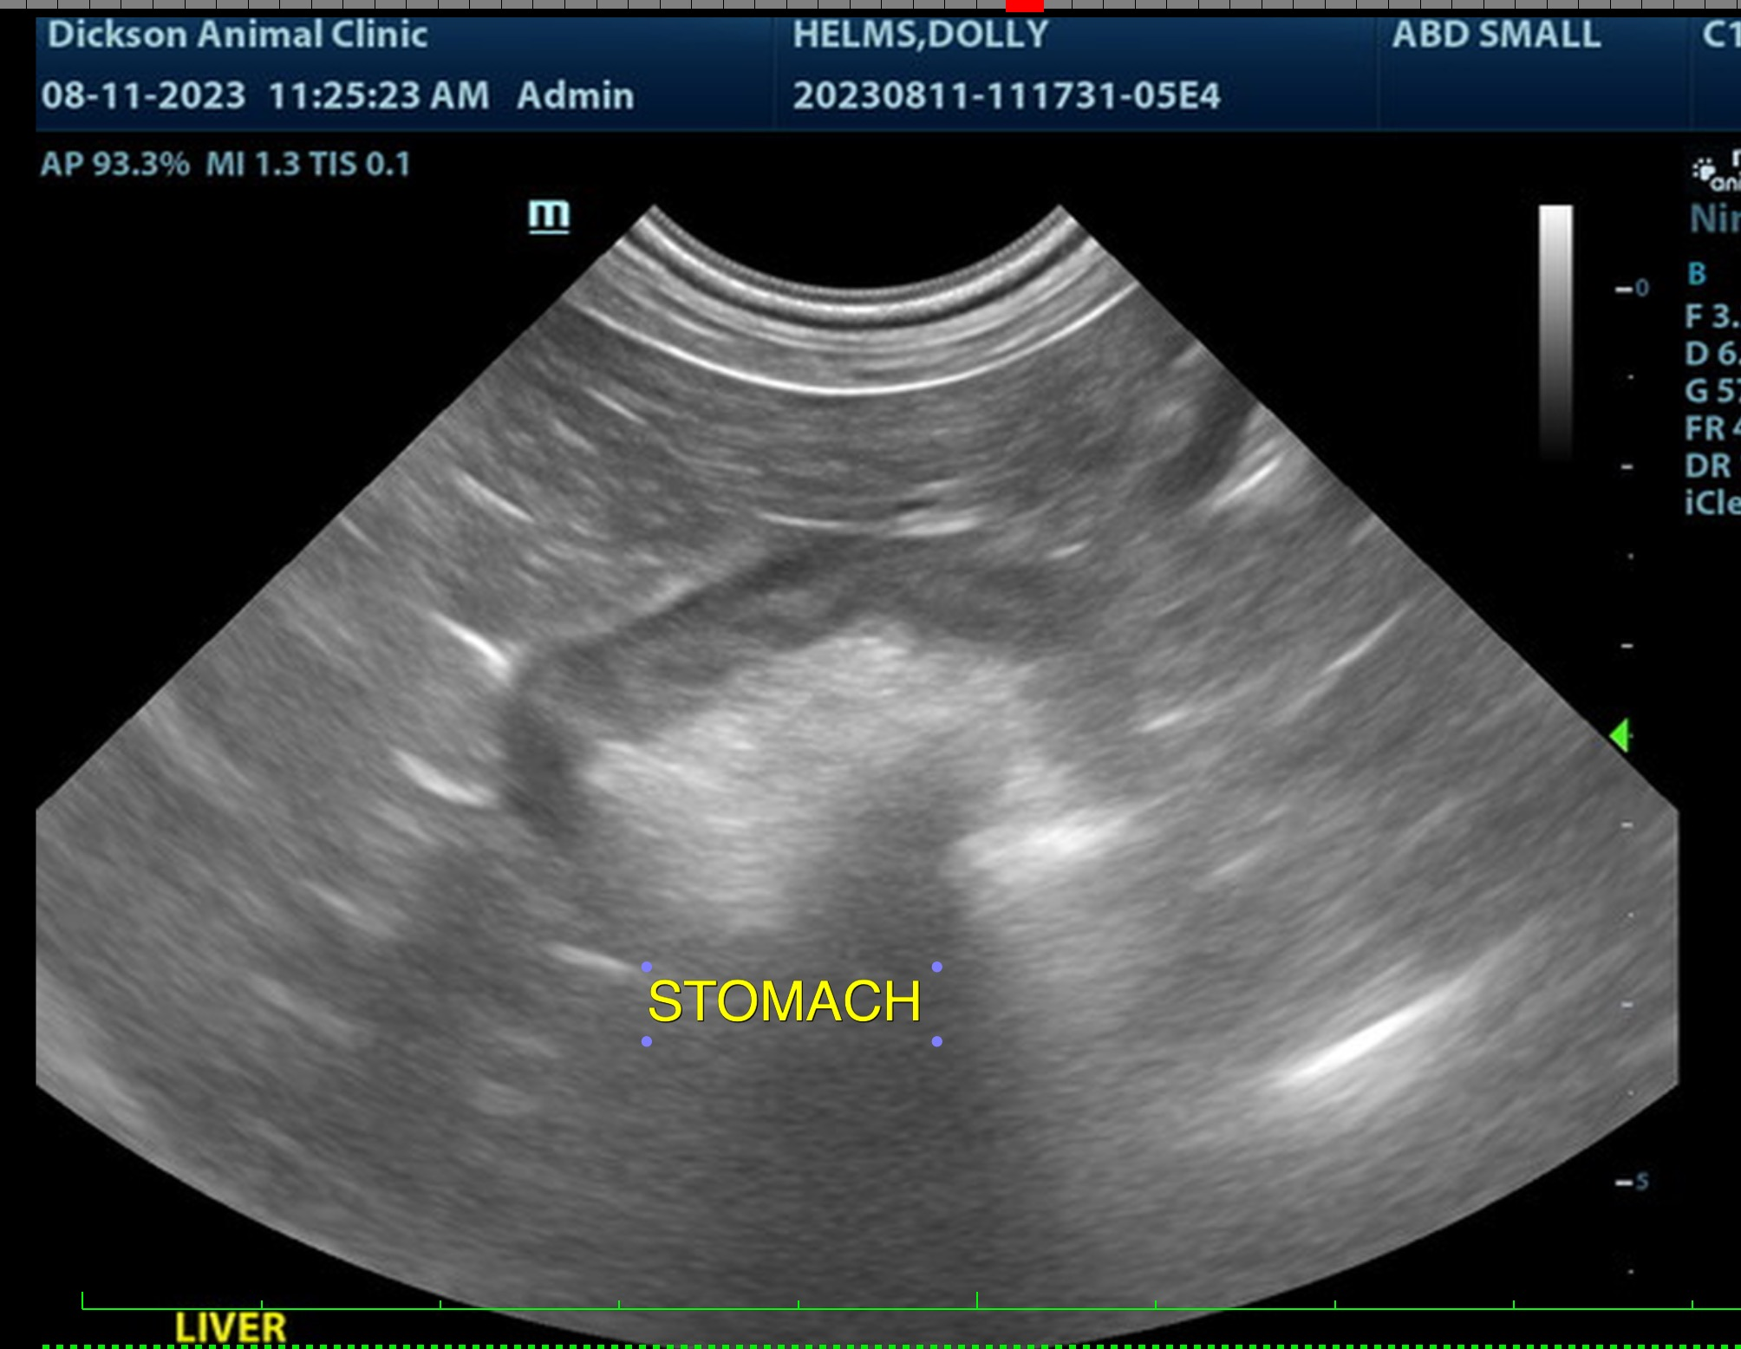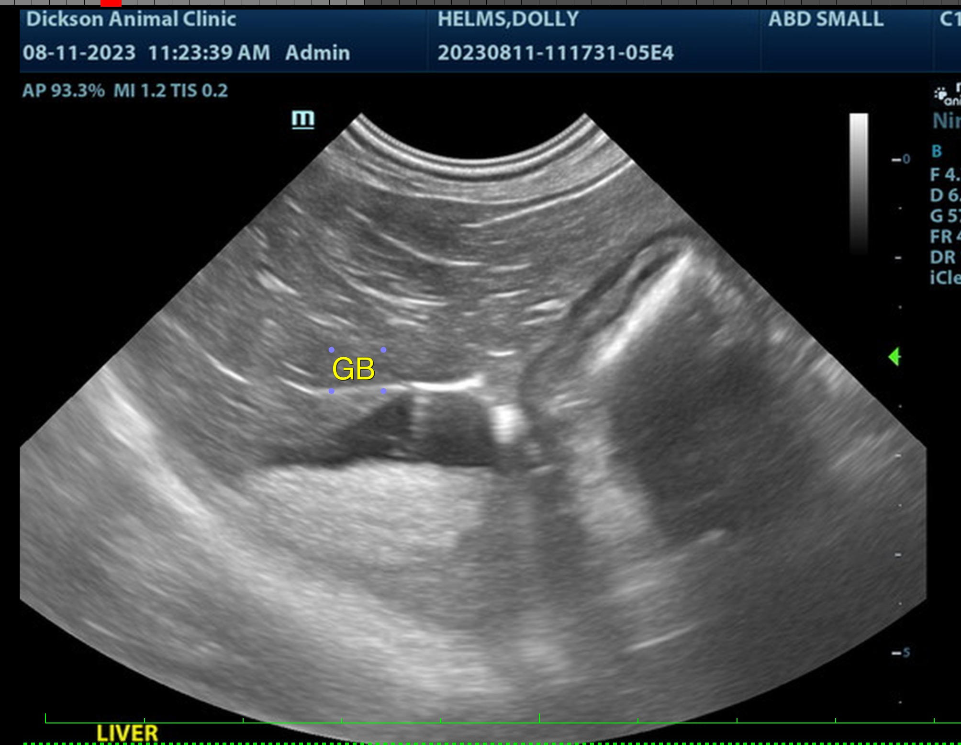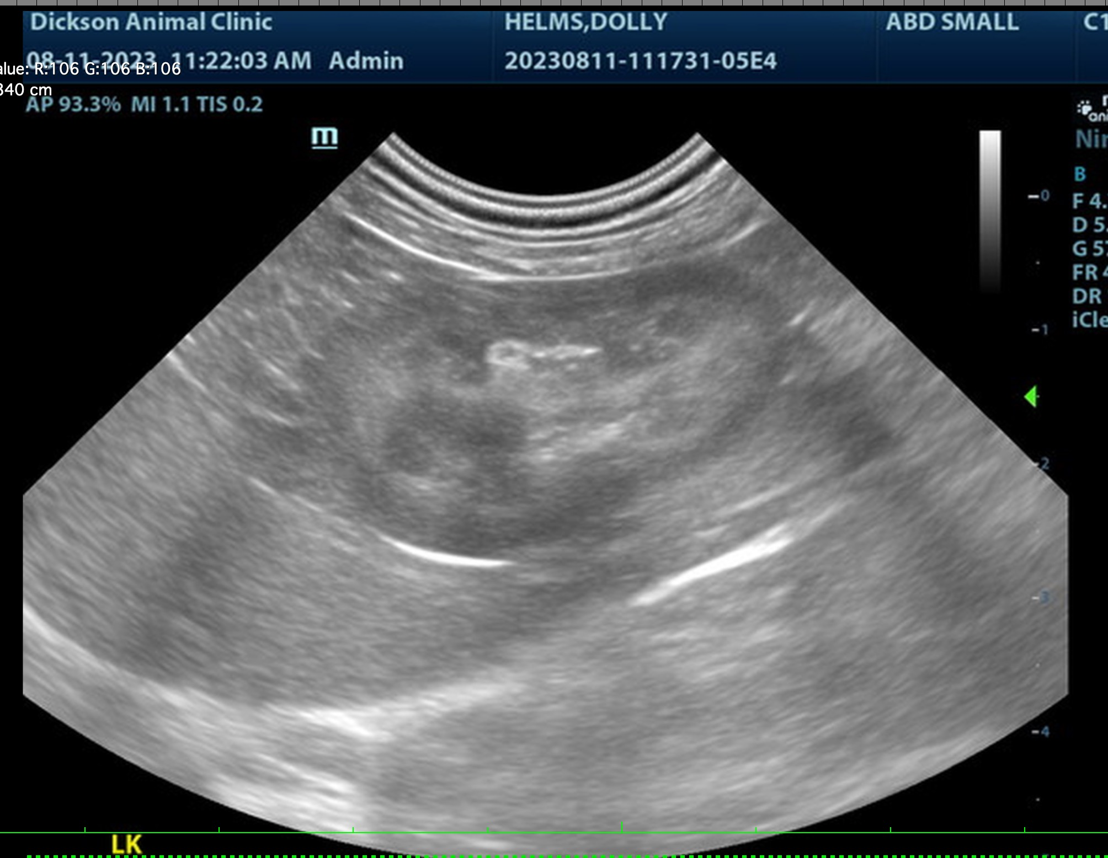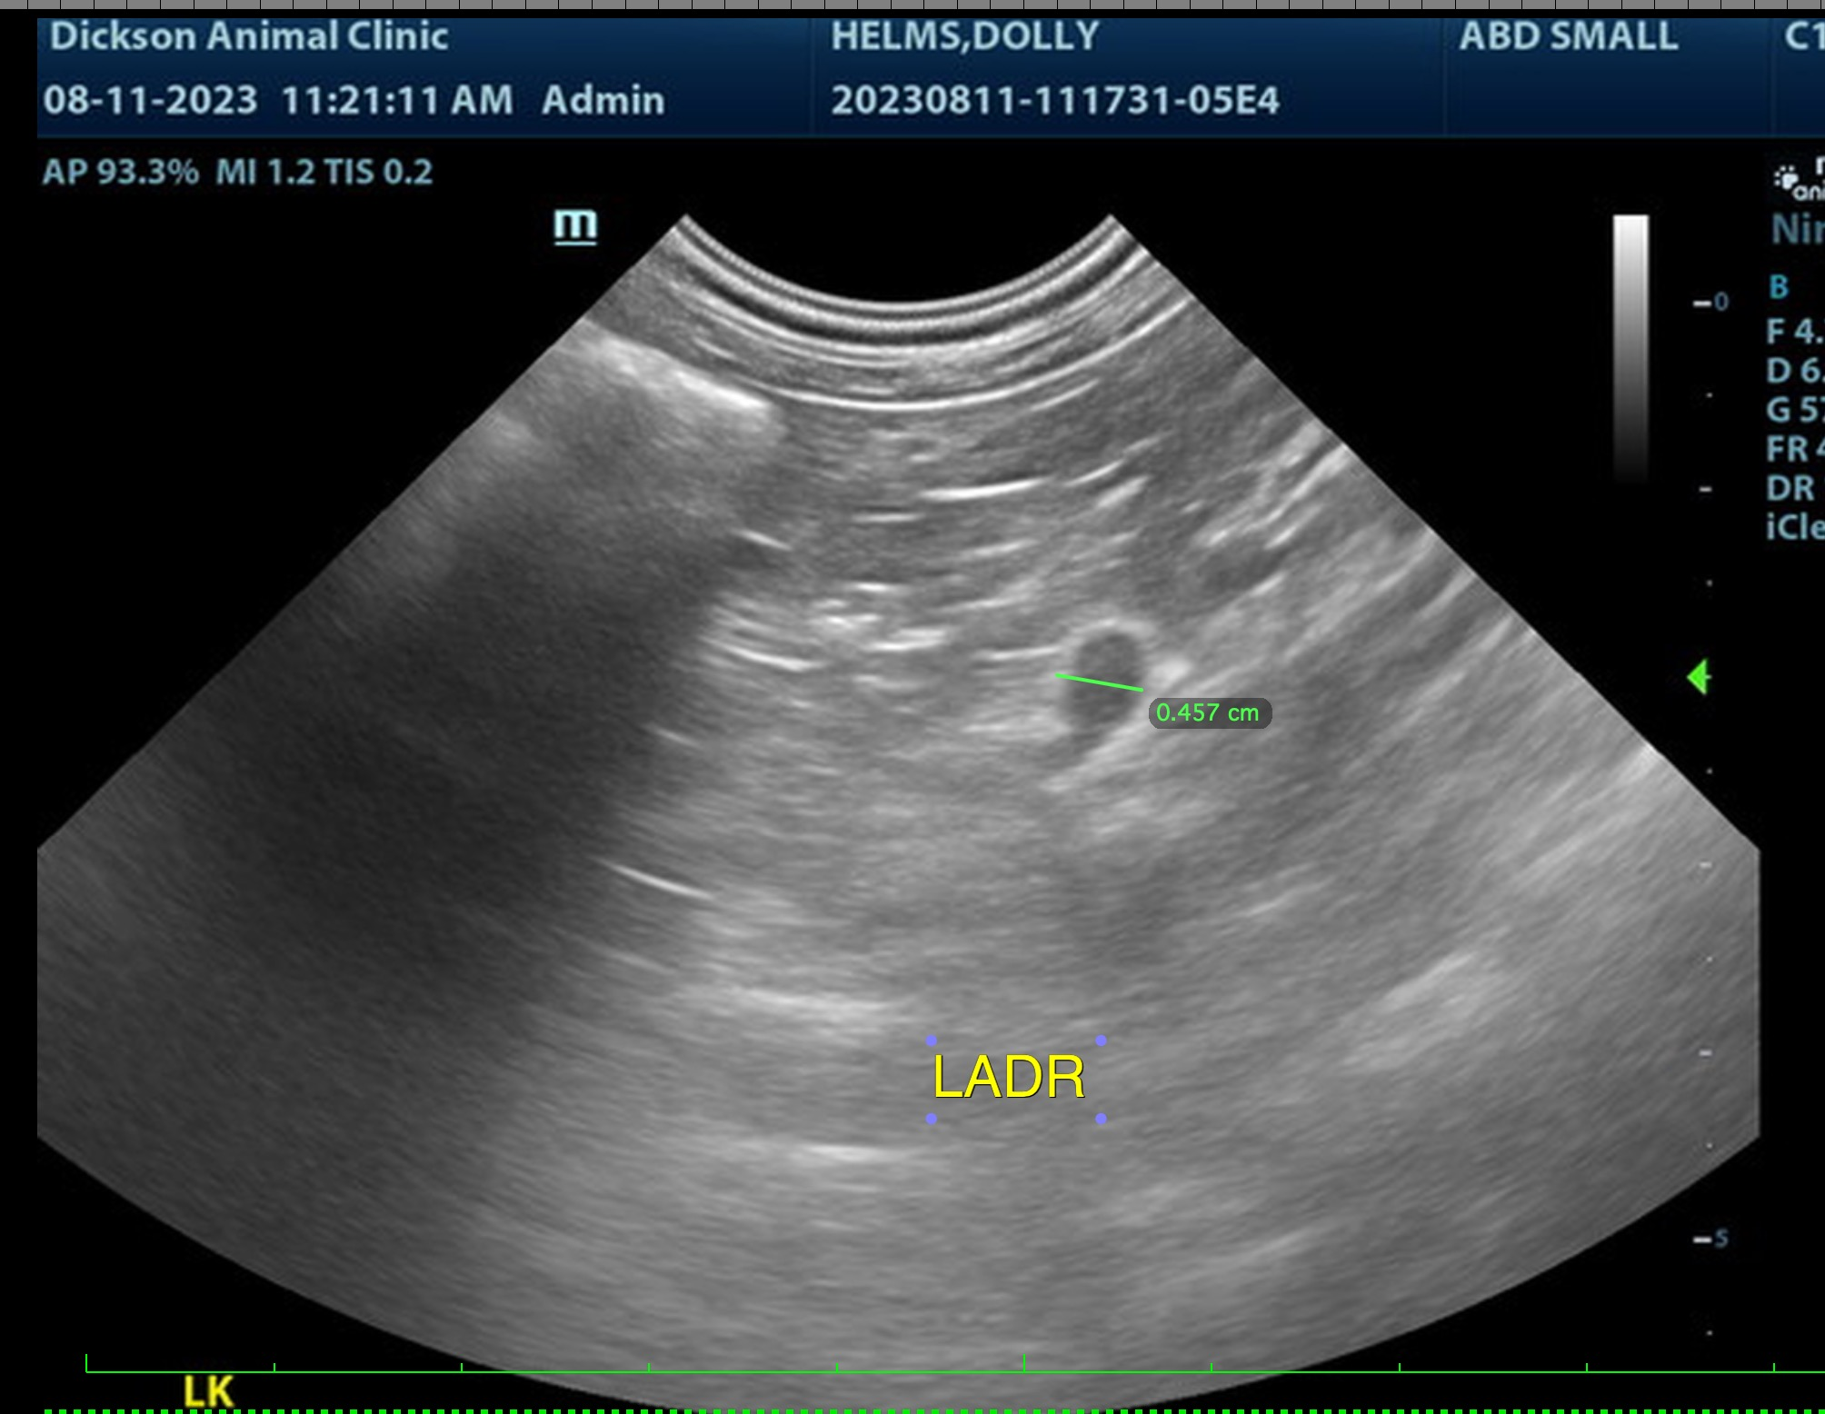

The information and recommendations provided are based on the images presented by the referring veterinarian. No evaluation can be communicated regarding pathology that was not visible in the image/video clips provided.

Thank you for this referral. If the clinical or image interpretation does not parallel your findings or if I can be of any further assistance, please contact me.

Beth Johnson, DVM DACVIM
info@SonoPath.com

