PRESENTING CLINICAL SIGNS
History: Pet was seen on 9/1/2022 for a wellness appt. O noted that she is slowing down. On PE her ears and MMs were pale. Mild non-regenerative anemia was detected on bloodwork. Along with hypoalbunemia 2.3. Today her anemia has slightly progressed and she's lost 1lb. -CBC in house: RBC= 4.4 (range: 5.6-8.8), was 4.7 on 9/1/22. HCT= 32.5 (range: 37-61), was 37.5 on 9/1/22. HGB= 10.9 (range: 13.1-20.5), was 11.8 on 9/1/22.

Radiographs of thorax and abdomen: Conclusion 1. Unremarkable thoracic radiographs. 2. Small liver. This finding should be correlated with bloodwork and clinical signs. Differentials include incidental individual variation, chronic hepatitis, or less likely portal-systemic shunting. 3. The rest of the abdominal structures are within normal limits.

Fecal antigen positive for hookworm infection.
Fecal occult negative -Urine pending
Abnormal PE/Chem/CBC/UA Results: CBC in house: RBC= 4.4 (range: 5.6-8.8), was 4.7 on 9/1/22. HCT= 32.5 (range: 37-61), was 37.5 on 9/1/22. HGB= 10.9 (range: 13.1-20.5), was 11.8 on 9/1/22.

Radiographs of thorax and abdomen: Conclusion 1. Unremarkable thoracic radiographs. 2. Small liver. This finding should be correlated with bloodwork and clinical signs. Differentials include incidental individual variation, chronic hepatitis or less likely portal-systemic shunting. 3. The rest of the abdominal structures are within normal limits.

Fecal antigen positive for hookworm infection. Fecal occult negative
Urine pending

ULTRASONOGRAPHIC EXAMINATION OF THE ABDOMEN

Urinary System
The urinary bladder wall is normal in thickness and the mucosal surface is smooth. The bladder is moderately distended. A small amount of suspended, echogenic debris is observed within the lumen. No masses, inflammatory changes or calculi are observed. Ureteral papillae and visualized portion of the proximal urethra, visible to a depth of 2 cm, are normal.

The left kidney is normal size (5.44 cm in length); normal shape and architecture with smooth peripheral margins. There is a normal 1:3 cortex to medulla ratio with minimal loss of corticomedullary distinction. There is no evidence of pyelectasia, nephroliths, infarcts or hydroureter.

The right kidney is normal size (5.88 cm in length); normal shape and architecture with smooth peripheral margins. There is a normal 1:3 cortex to medulla ratio with minimal loss of corticomedullary distinction. There is no evidence of pyelectasia, nephroliths, infarcts or hydroureter.

Adrenal Glands
The left adrenal gland is normal size (0.31 cm at cranial pole) (0.49 cm at caudal pole) (1.92 cm in length); normal shape; homogenous parenchyma. The glandular echogenicity and detail are unremarkable. Capsule, cortex, and medullary definition are normal. The phrenicoabdominal vein and surrounding vasculature are normal.

The right adrenal gland is normal size (0.83 cm at cranial pole) (0.36 cm at caudal pole); normal shape; homogenous parenchyma. The glandular echogenicity and detail are unremarkable. Capsule, cortex, and medullary definition are normal. The phrenicoabdominal vein and surrounding vasculature are normal.

Spleen
The spleen is prominent in size (2.79 cm in width at the level of the hilus) with normal curvilinear peripheral contours. There is appropriate echogenicity and echotexture. No focal lesions are observed. Splenic vasculature is normal.

Liver
The liver is normal to slightly small in size with normal curvilinear peripheral contours. The parenchyma is hypoechoic relative to the spleen and homogenous in appearance. Hepatic vasculature and intrahepatic biliary tracts are of normal volume with no evidence of congestion.

The gall bladder lumen is moderately distended. The wall is thin and smooth. Luminal contents are anechoic. The cystic and common bile ducts are normal/not seen.

Gastrointestinal
The gastric lumen is mildly distended with ingesta. The gastric wall is normal in thickness with a normal layering pattern. The small intestinal lumen is segmentally dilated with chyme. The small intestinal wall thickness is normal with a normal layering pattern and appropriate mural detail. Discreet masses are not identified. The colonic wall is normal. There is no evidence of an obstructive pattern.

Pancreas
The region of the pancreas is isoechoic relative to surrounding omental fat. No obvious parenchymal abnormalities are observed. There is no evidence of regional inflammation or effusion.

Free Abdomen
The peritoneal cavity is normal. There is no evidence of inflammation or effusion. The abdominal lymph nodes are normal/not visible.

ULTRASONOGRAPHIC FINDINGS

Primary Findings

- Suspected mild splenomegaly. This may be secondary to extramedullary hematopoiesis, lymphoid hyperplasia, antigenic stimulation, splenitis or emerging neoplasia (i.e., lymphoma).

- The remainder of the abdomen is unremarkable. An obvious cause for the patient’s anemia is not definitively identified in this study.

INTERPRETATION OF THE FINDINGS & FURTHER RECOMMENDATIONS

Given the mild splenomegaly, consider a fine-needle aspirate, if clotting status is appropriate.

Three-view thoracic radiographs are also recommended to assess for occult disease in the chest.

Other diagnostic considerations include the following:

- T4/free T4 by equilibrium dialysis
- CBC with reticulocyte count (send to a diagnostic lab for clinical pathology review).
- Comprehensive tick panel (send to NC State).

Depending on the results of the above diagnostics, a bone-marrow aspirate may be warranted.

An upper GI endoscopy should also be considered to assess for low-grade GI bleeding.

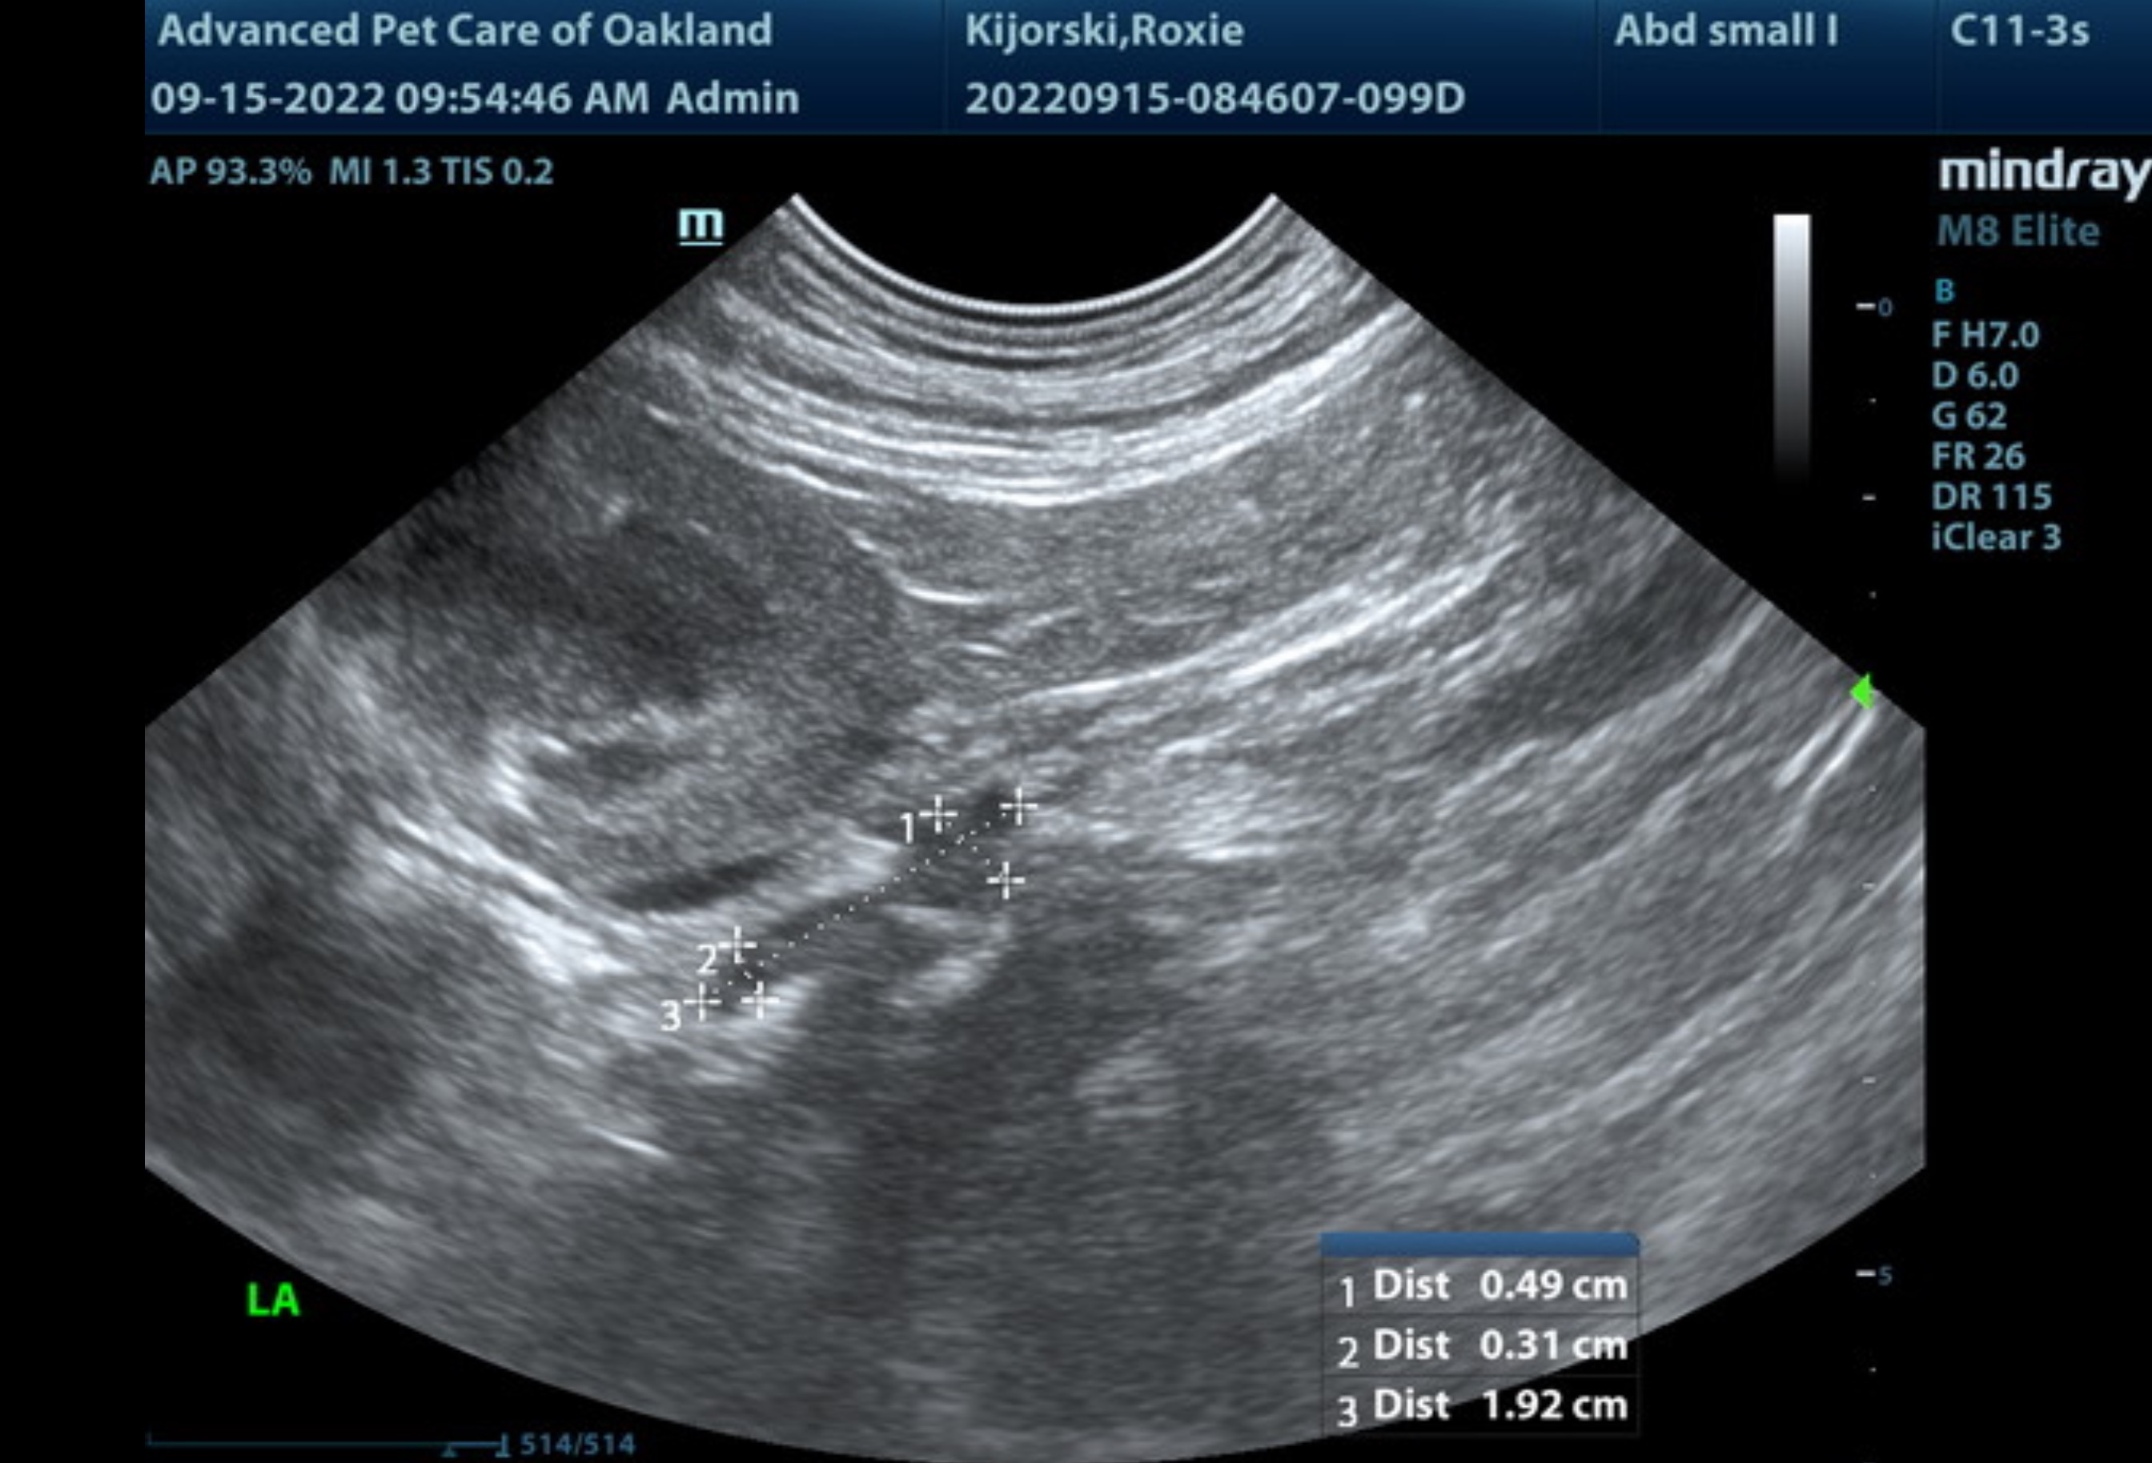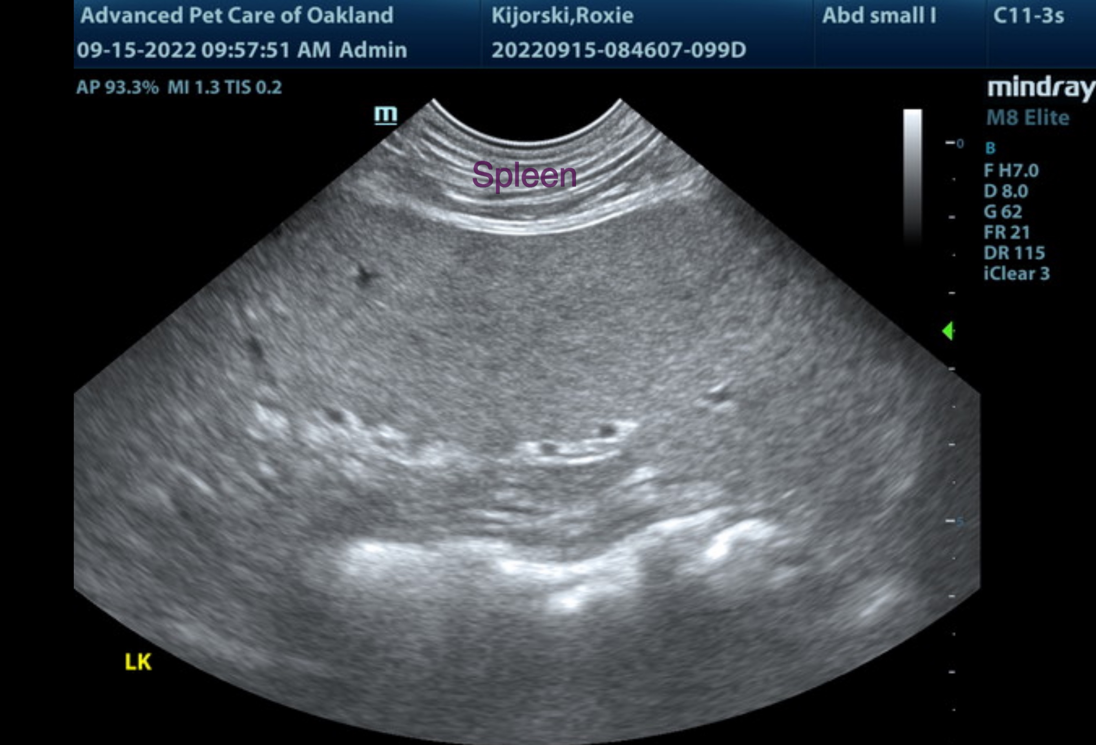

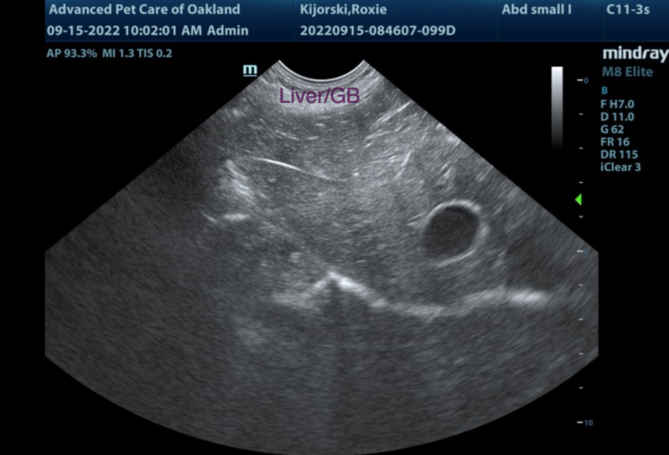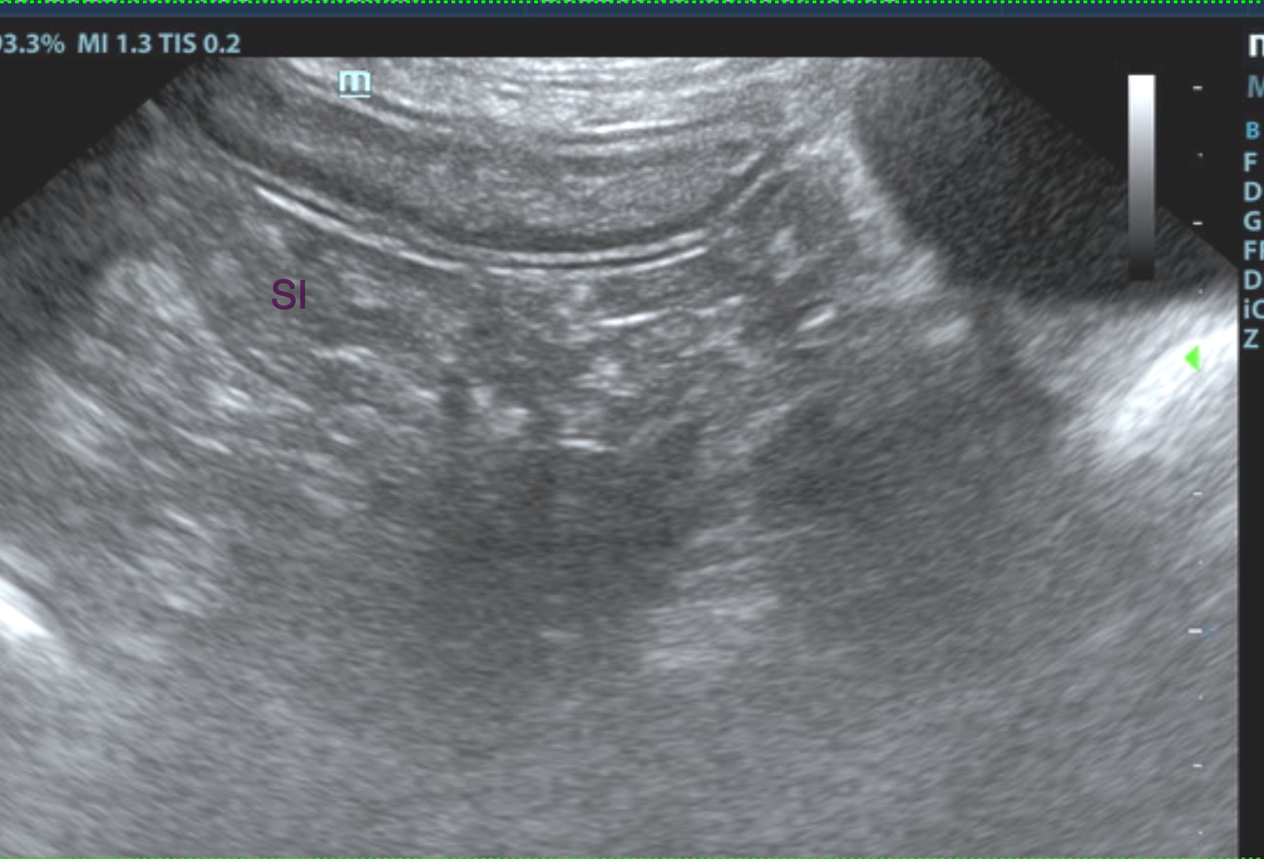

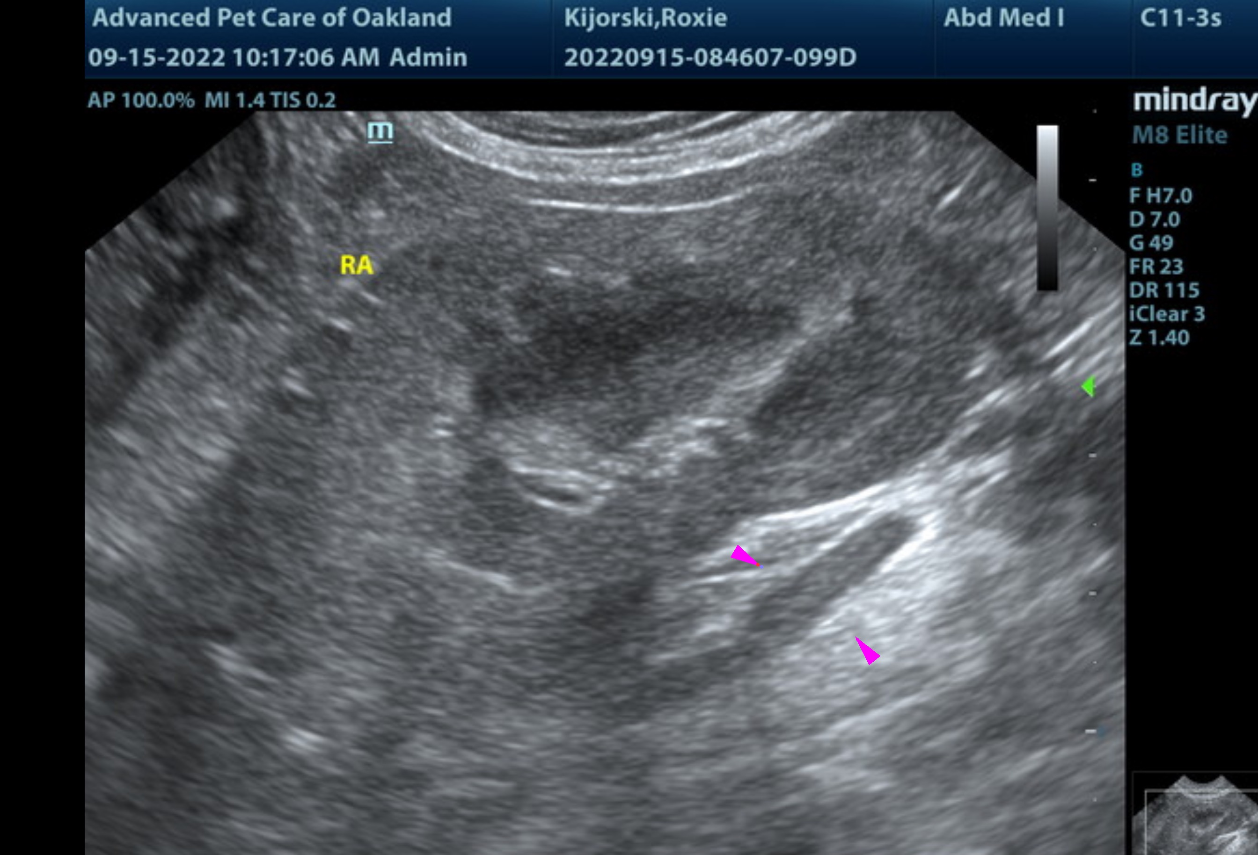

The information and recommendations provided are based on the images presented by the referring veterinarian/sonographer. No evaluation can be communicated regarding pathology that was not visible in the image/video clips provided.

Thank you for this referral. If the clinical or image interpretation does not parallel your findings or if I can be of any further assistance, please contact me.
Andrea Nicastro, MPH, DVM, Diplomate DACVIM (Small Animal Internal Medicine)
info@SonoPath.com

