PRESENTING CLINICAL SIGNS

Clinical Exam Findings: Focally extensive alopecia on dorsal head with erythema, adherent crusting and excoriation; alopecia over dorsal thorax with focal erosive lesion; alopecia on ventro-lateral neck with erosive lesion on right side of neck; very thin body condition; Perhaps most important clinical feature is rapid, progressive weight loss; patient was 8.75 lbs in Oct 2022; 8 lbs Dec. 1; 7.14 lbs Jan 14,2023

Abnormal lab-work values: Previous labs have been normal other than elevated WBC (neuts, eos, monos all elevated
Current Medications: Amlodipine 1.25 mg qd; Prednisolone 2.5 mg qd

ULTRASONOGRAPHIC EXAMINATION OF THE ABDOMEN

Urinary System
The urinary bladder, trigone, and pelvic urethra are normal in thickness and the mucosal surface is smooth. The bladder lumen is moderately distended with anechoic urine. No masses, inflammatory changes or calculi are observed. The region of the trigone and visible portion of the proximal urethra are normal.

The left kidney is normal in size (3.23 cm in length) with a normal shape, architecture and smooth peripheral margins. There is a normal 1:3 cortex to medulla ratio with normal corticomedullary distinction. There is no evidence of pyelectasia, nephroliths, infarcts or hydroureter. Renal vasculature is normal.

The right kidney is normal in size (3.49 cm in length) with a normal shape, architecture and smooth peripheral margins. There is a normal 1:3 cortex to medulla ratio with normal corticomedullary distinction. There is no evidence of pyelectasia, nephroliths, infarcts or hydroureter. Renal vasculature is normal.

Adrenal Glands
The left adrenal gland is normal in size (0.39 cm width). Normal shape and glandular echogenicity. The phrenicoabdominal vein and surrounding vasculature are normal.

The right adrenal gland is normal size (0.36 cm width). Normal shape and glandular echogenicity. The phrenicoabdominal vein and surrounding vasculature are normal.

Spleen
The spleen is normal in size (0.66 cm in width at the level of the hilus) with a normal capsular contour. There is appropriate echogenicity and echotexture. No focal lesions are observed. Splenic vasculature is normal.

Liver
The liver is subjectively normal in size with normal contours and structure. There is appropriate echogenicity and echotexture. No overt structural evidence of inflammatory, infiltrative, or regenerative pathology is evident. Vascular and biliary tracts are of normal volume with no evidence of congestion. No pathological hepatic lymphadenopathy observed. The portal vein to caudal vena cava ratio is approximately 1: 1.

The gall bladder is of normal contours and contains some dependent echogenic debris. The wall is normal in thickness. No choleliths are observed. The cystic and common bile ducts are normal. The duodenal papilla is normal in size (0.29 cm in width).

Gastrointestinal
The gastric lumen is not distended. The gastric wall and pylorus are normal in thickness with a normal layering pattern. The pyloric outflow tract is patent. The small intestinal lumen is not dilated. The small intestinal wall is normal to mildly thickened (up to 0.28 cm). There is disruption in the normal 1:3 muscularis: mucosal ratio, with a 1:1 ratio in several segments. Discreet masses are not identified. The colonic wall is normal. There is no obvious evidence of an obstructive pattern.

Pancreas
The pancreas is diffusely enlarged with irregular peripheral contours. The parenchyma is hypoechoic relative to surrounding omental fat. A 2.32 cm mass effect is observed in the left limb, along with a few smaller hypoechoic nodules. The pancreatic duct is not overtly dilated. The mesentery effacing the serosal surface is slightly hyperechoic.

Free Abdomen
Trace free fluid is observed. Numerous, severely enlarged lymph nodes are observed throughout the cranial to midabdomen, particularly at the mesenteric root. The lymph nodes create a >8.00 cm mass effect in the midabdominal region. The nodes are rounded and hypoechoic. Surrounding mesentery is hyperechoic.

Other
A brief echocardiogram reveals no evidence of pericardial effusion or obvious right atrial/auricular mass.

A brief visualization of the thorax reveals numerous ringdown lesions.

ULTRASONOGRAPHIC FINDINGS

Primary Findings

- The severe diffuse lymphadenopathy is more concerning for infiltrative neoplasia, with a lower possibility of severe lymphadenitis (i.e., pyogranulomatous).

- Mass effect in the pancreas. Again, neoplasia (i.e., adenocarcinoma, other) is suspected, with a lower possibility of severe pancreatitis.

- Peritonitis is present, likely secondary to lymph node and pancreatic pathology.

- The small intestinal wall changes could be consistent with inflammatory bowel disease or emerging lymphoma.

- The ringdown lesions in the thorax are consistent with pulmonary parenchymal disease.

Secondary Findings

- Minor age-related renal changes

INTERPRETATION OF THE FINDINGS & FURTHER RECOMMENDATIONS

- Three-view thoracic radiographs are recommended to assess for pulmonary metastases.

- Consider fine-needle aspirates of the enlarged abdominal lymph nodes and pancreas (if clotting status is appropriate). Twenty-five gauge-needles should be used. However, given the severity of the abdominal lesions, the prognosis for this patient is considered guarded and palliative care should be considered in lieu of aggressive diagnostics/treatments.

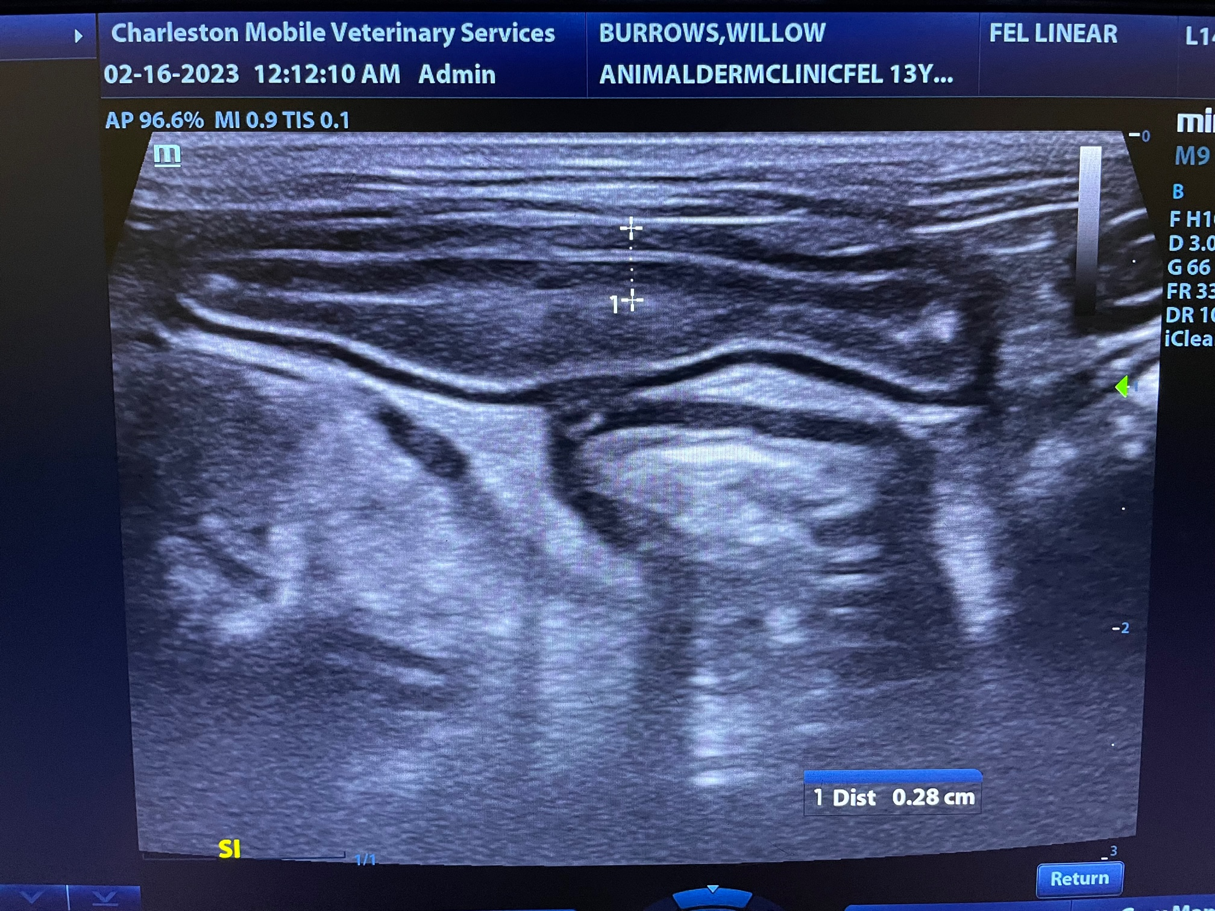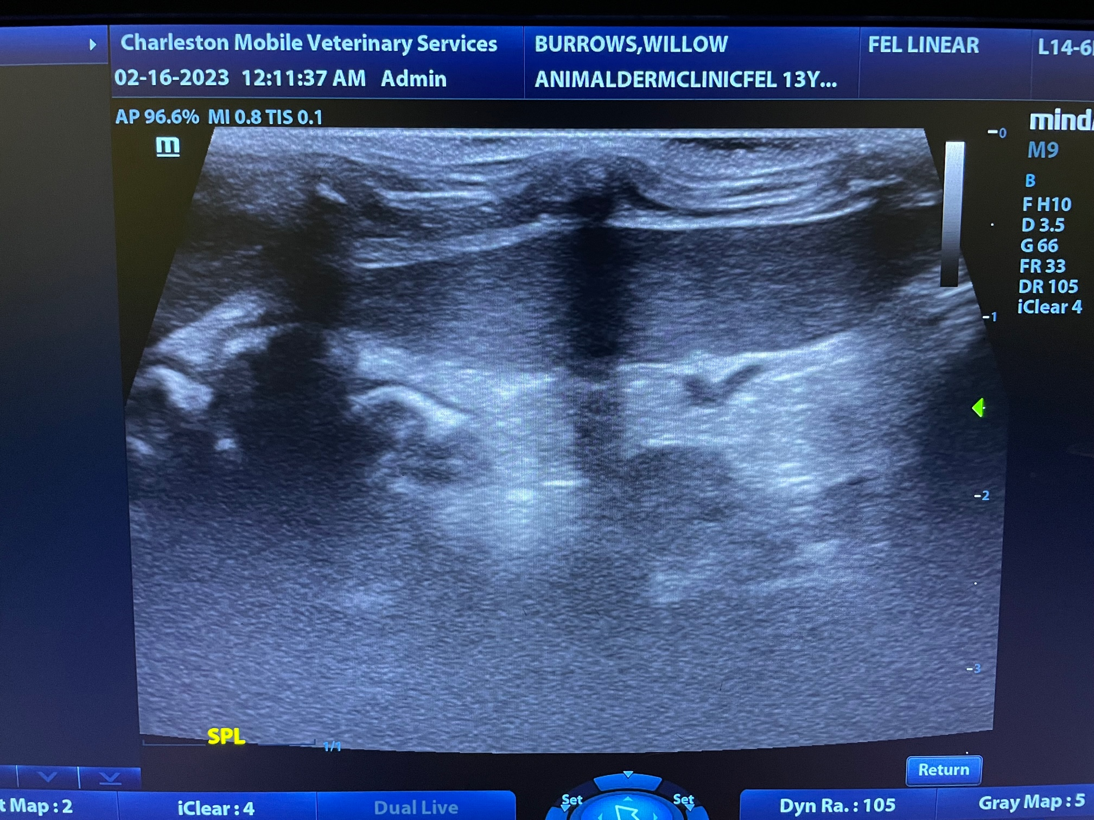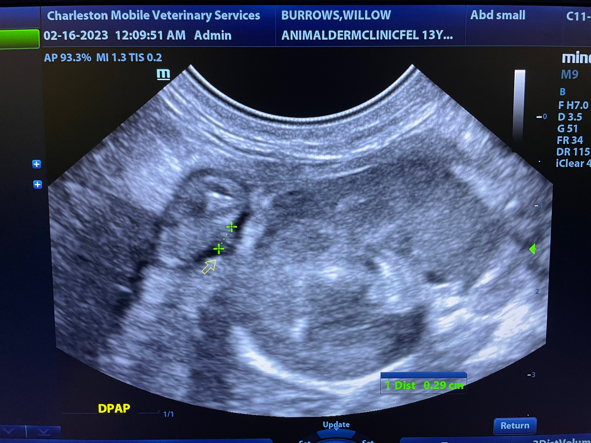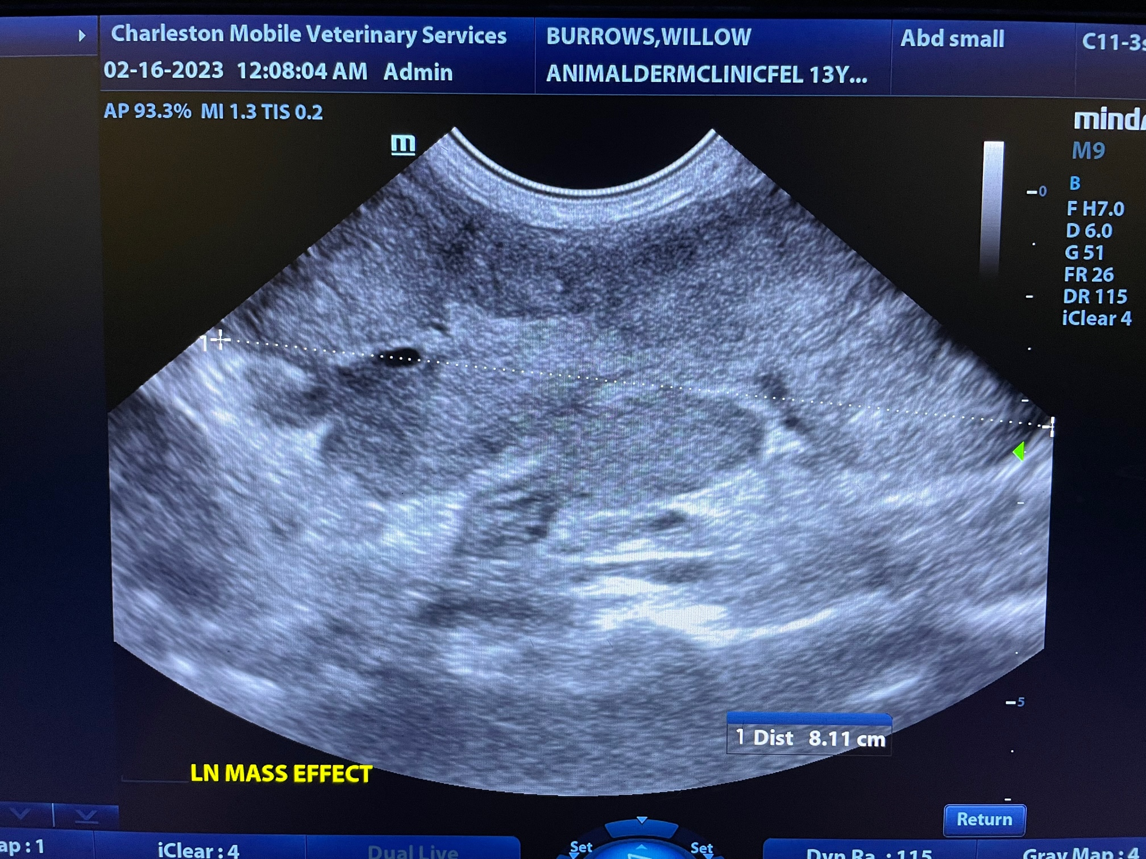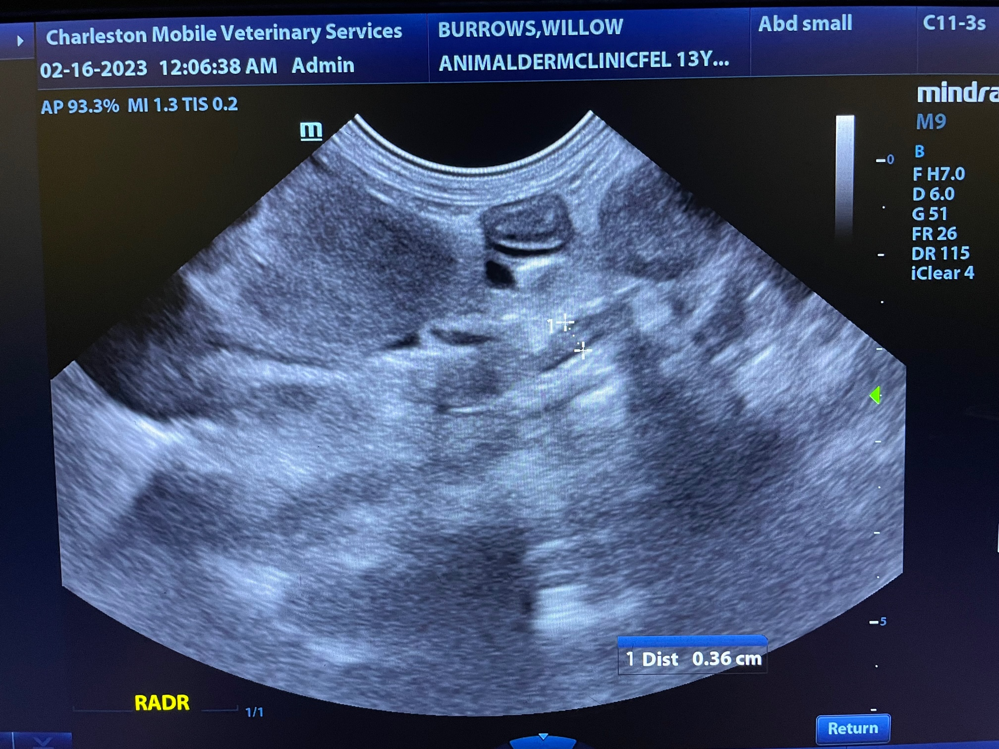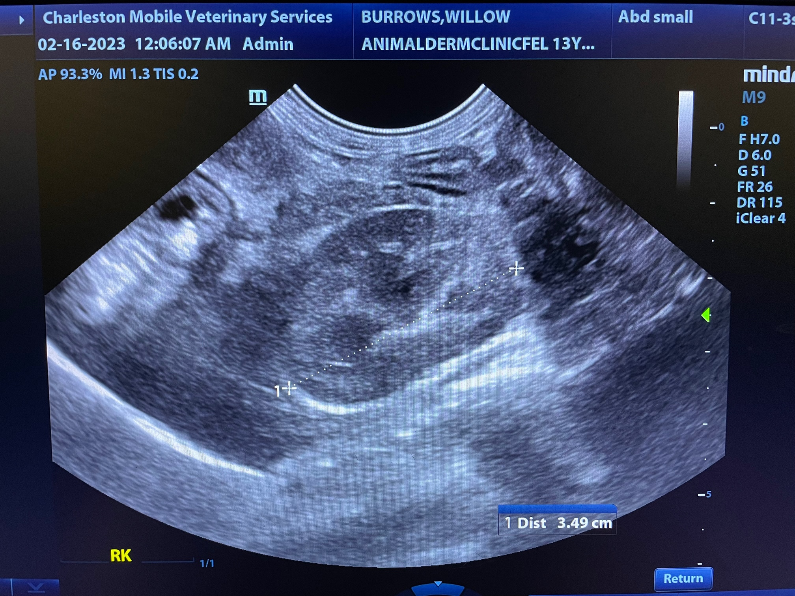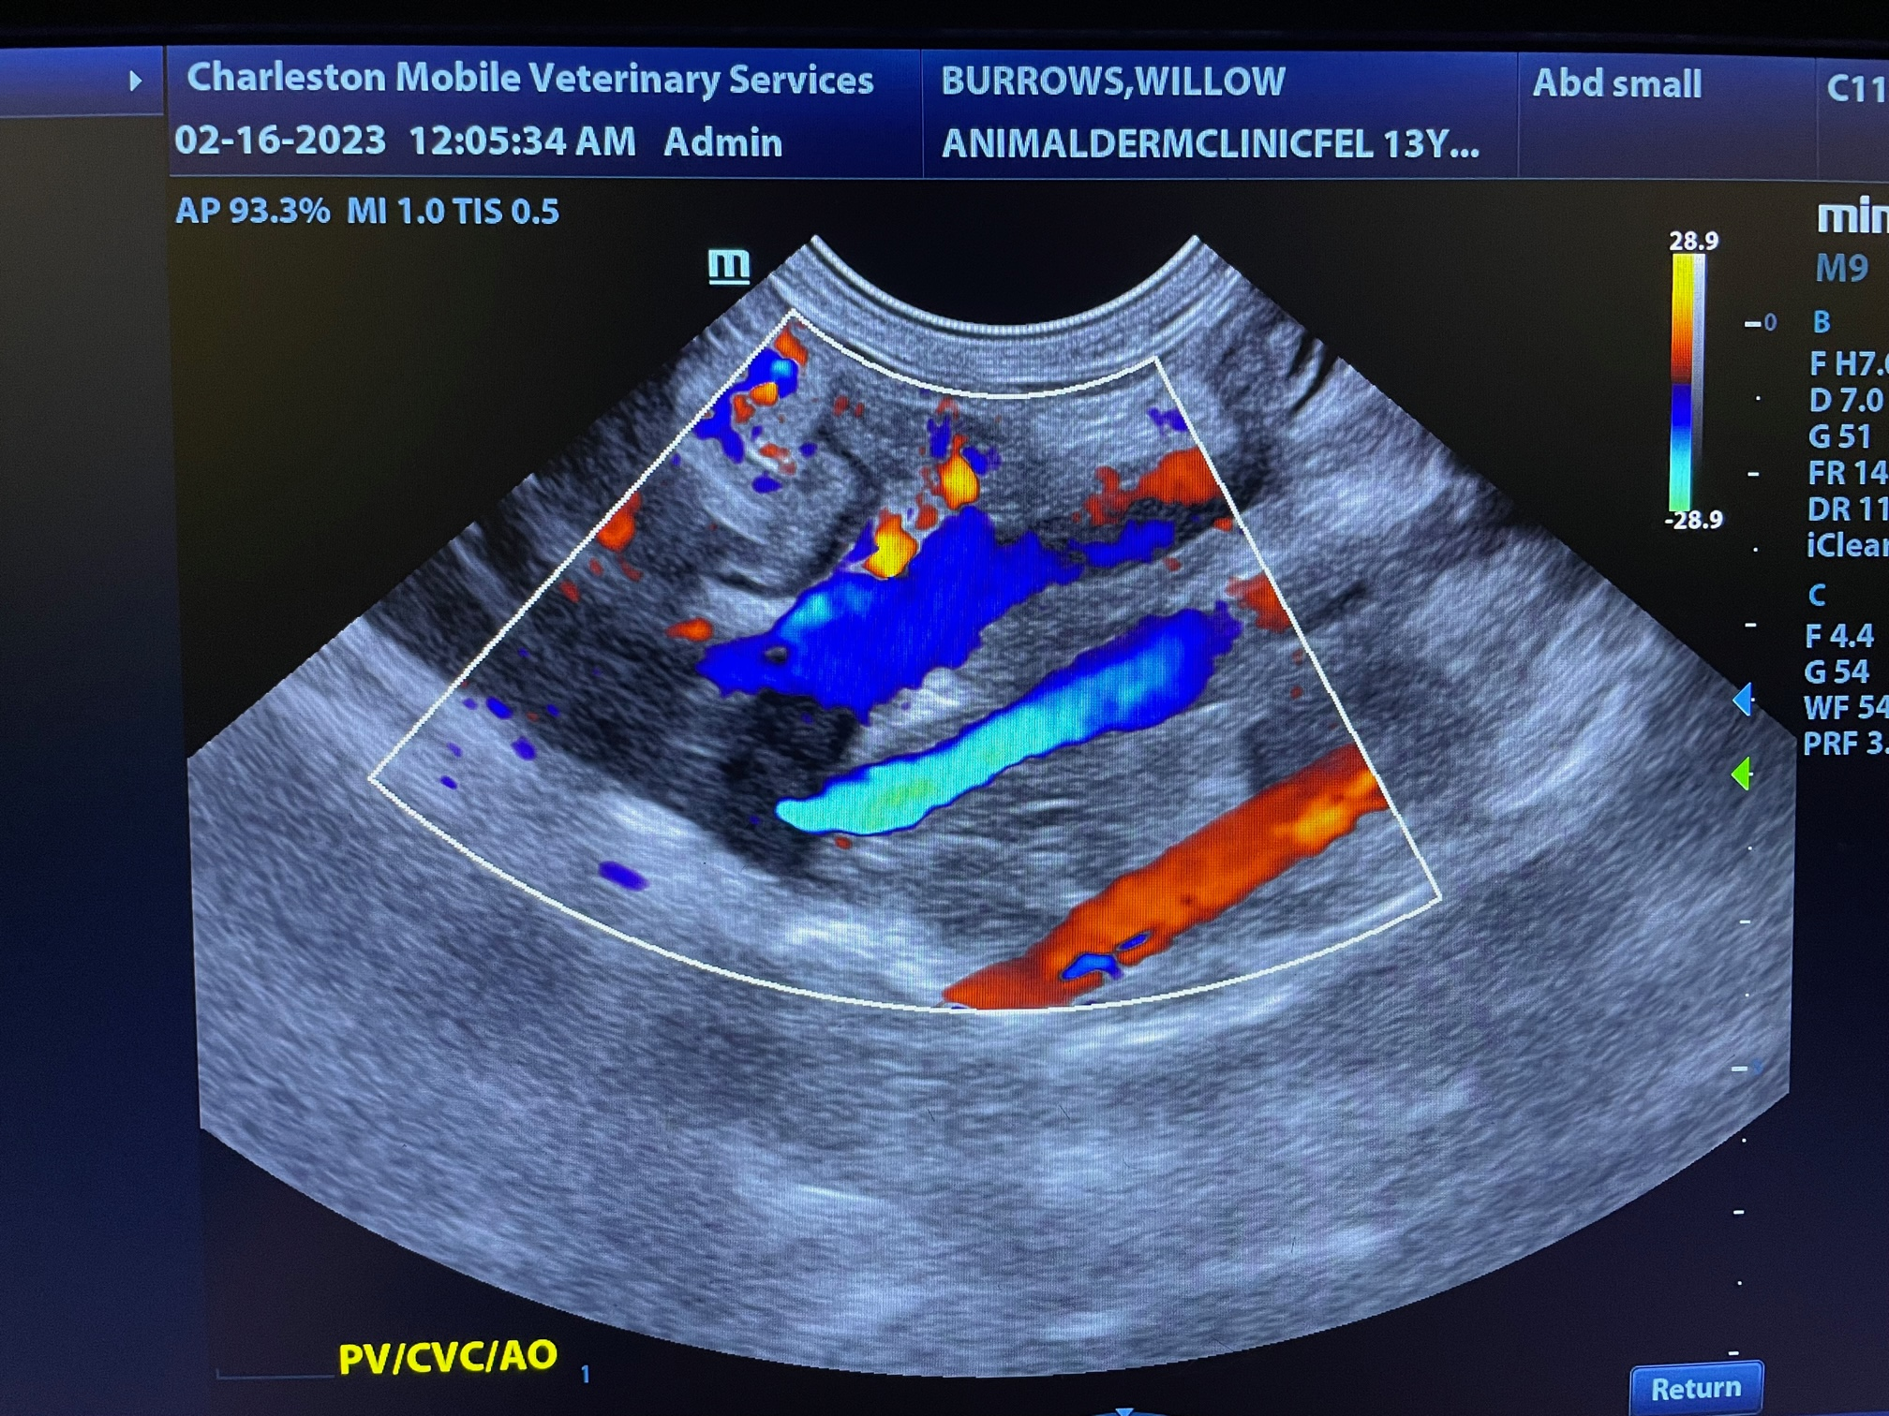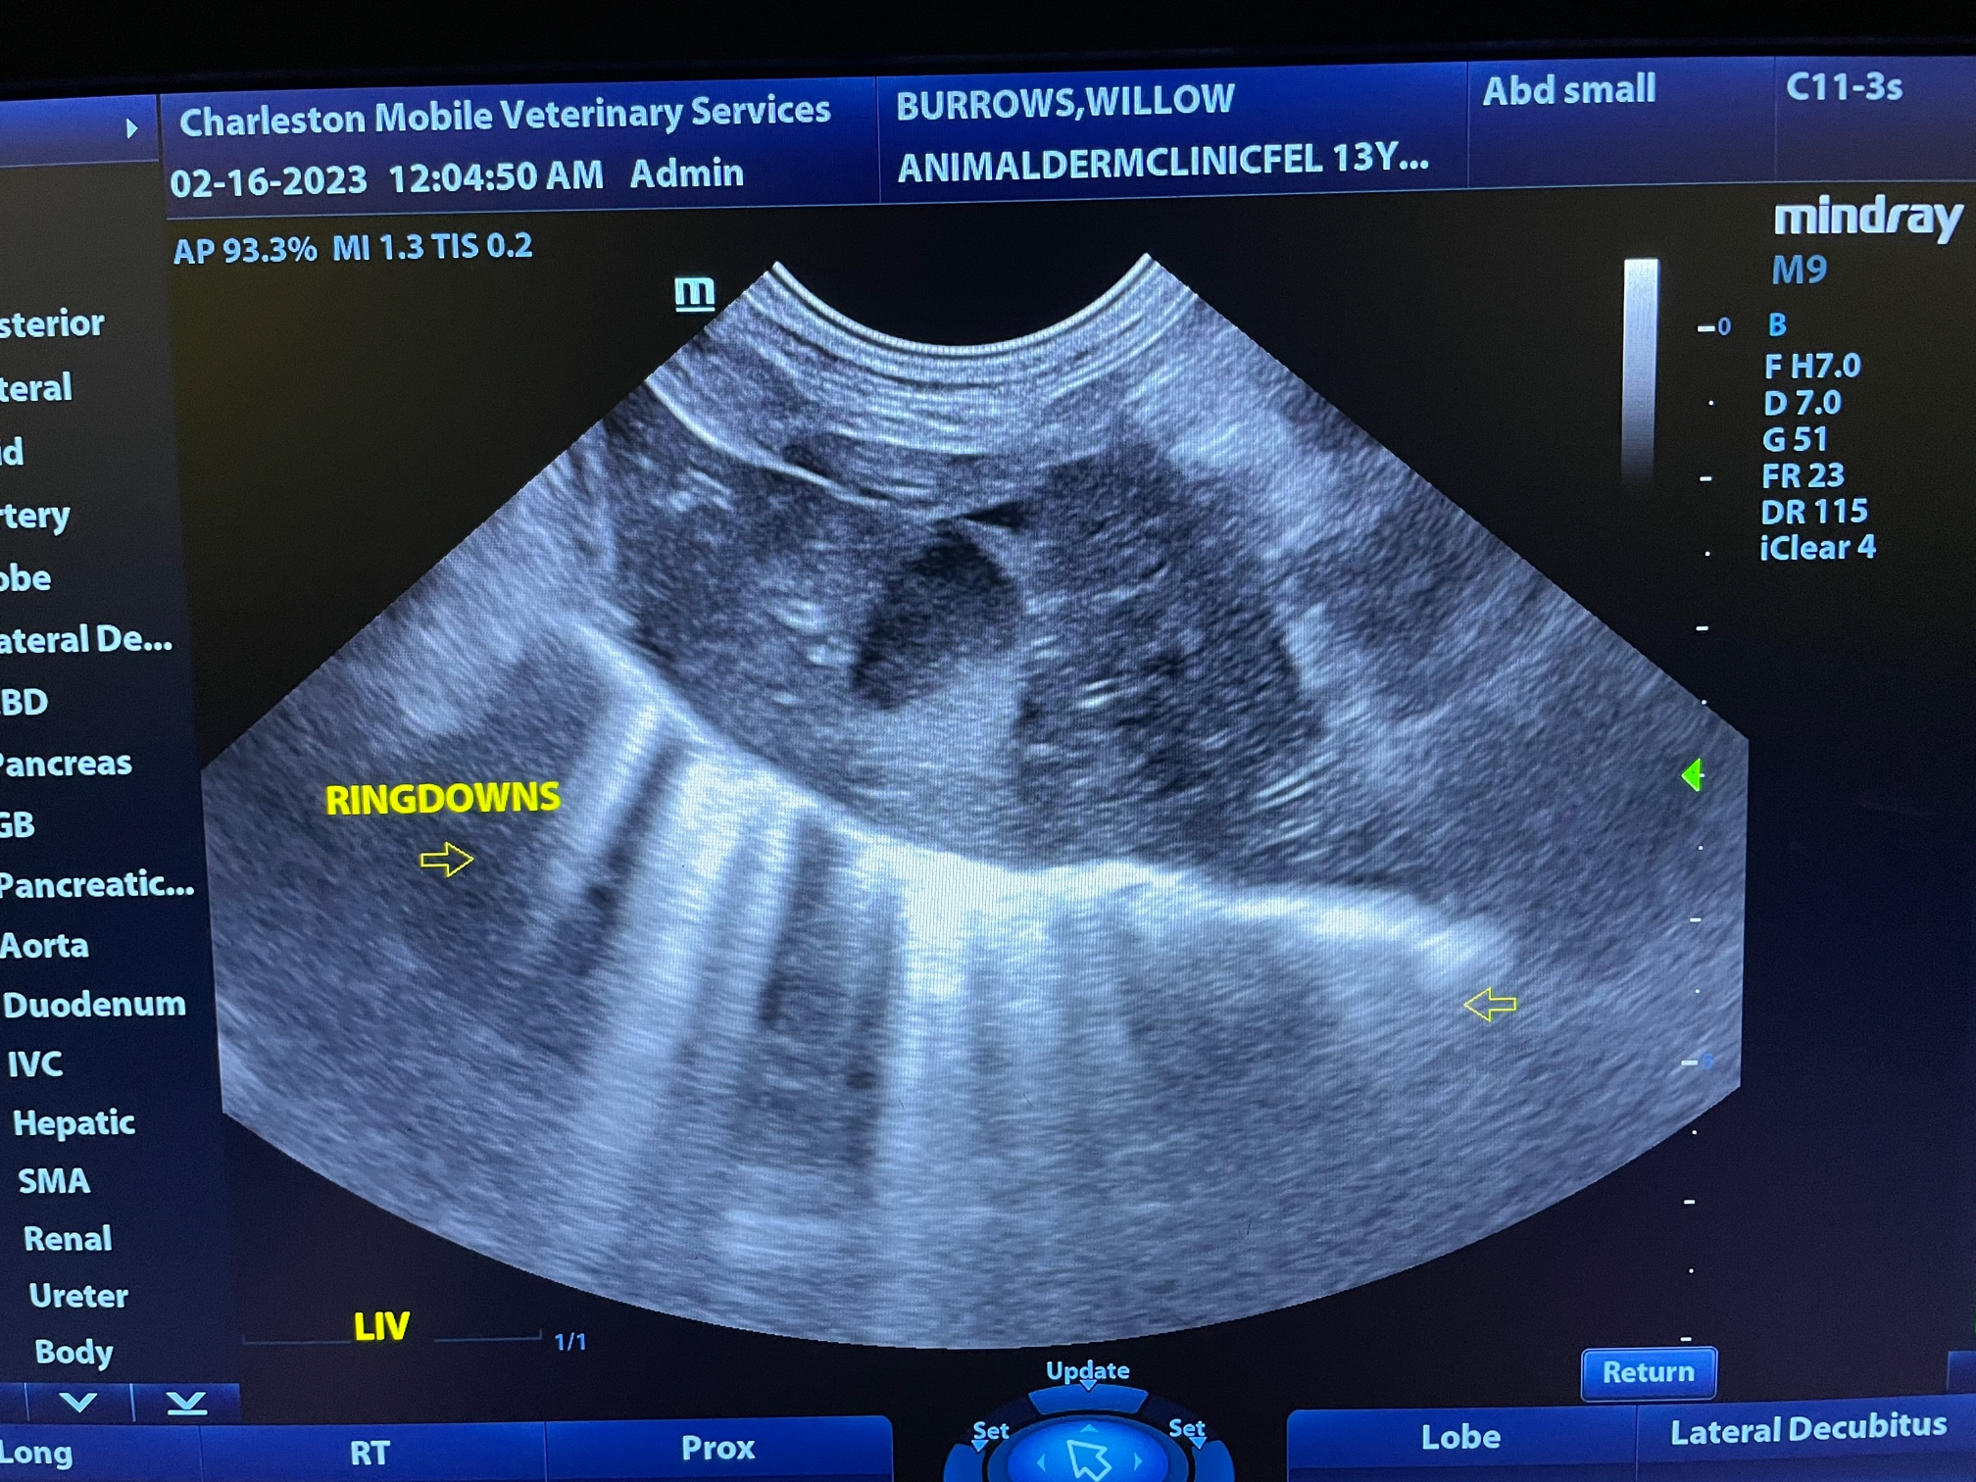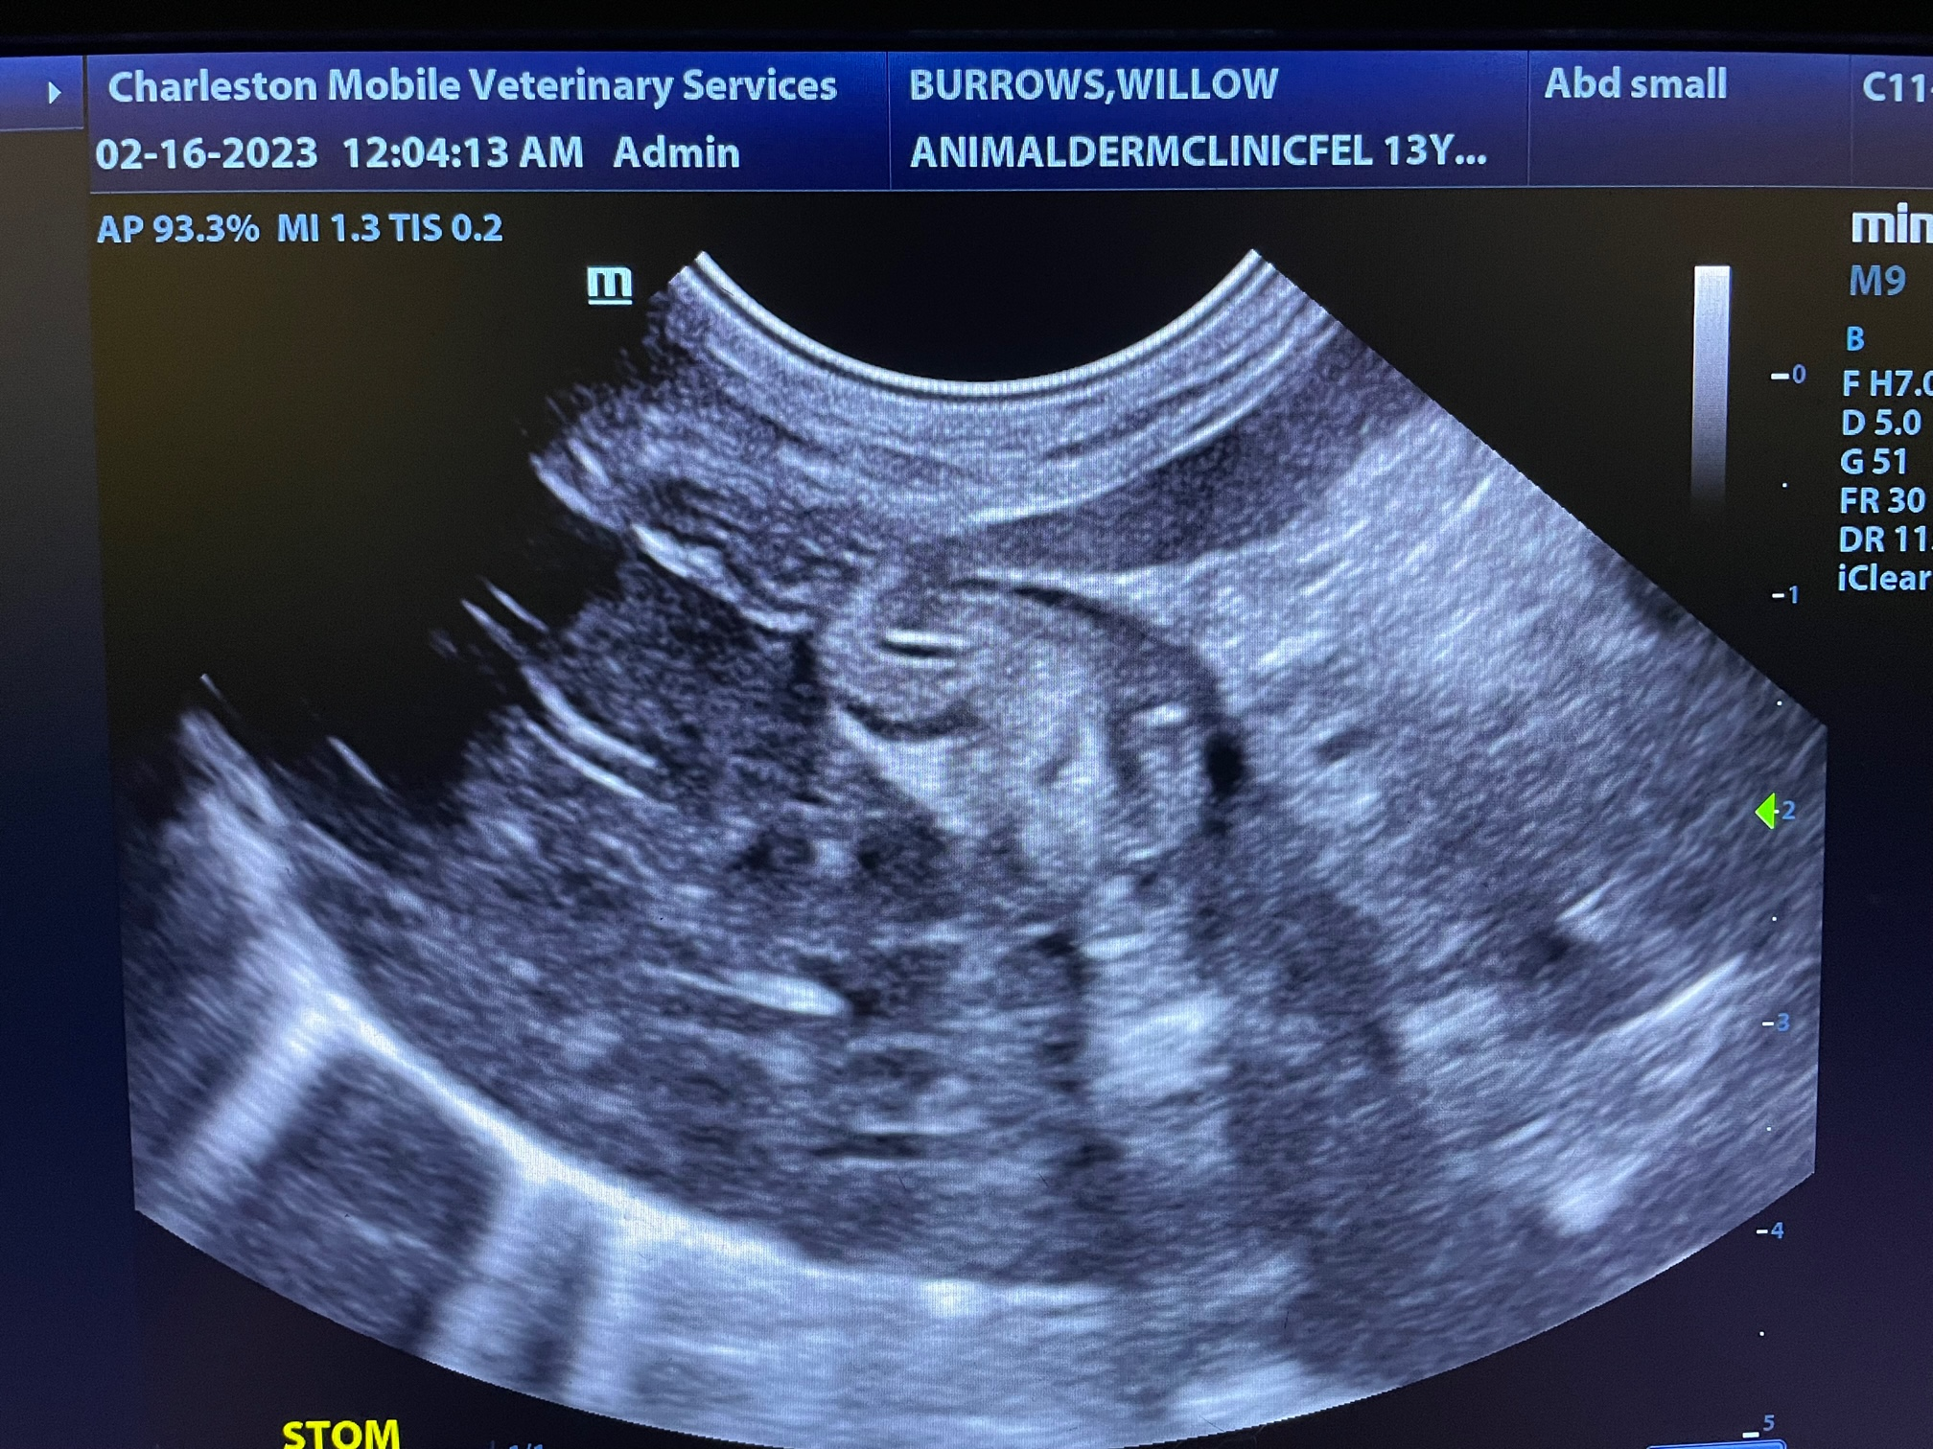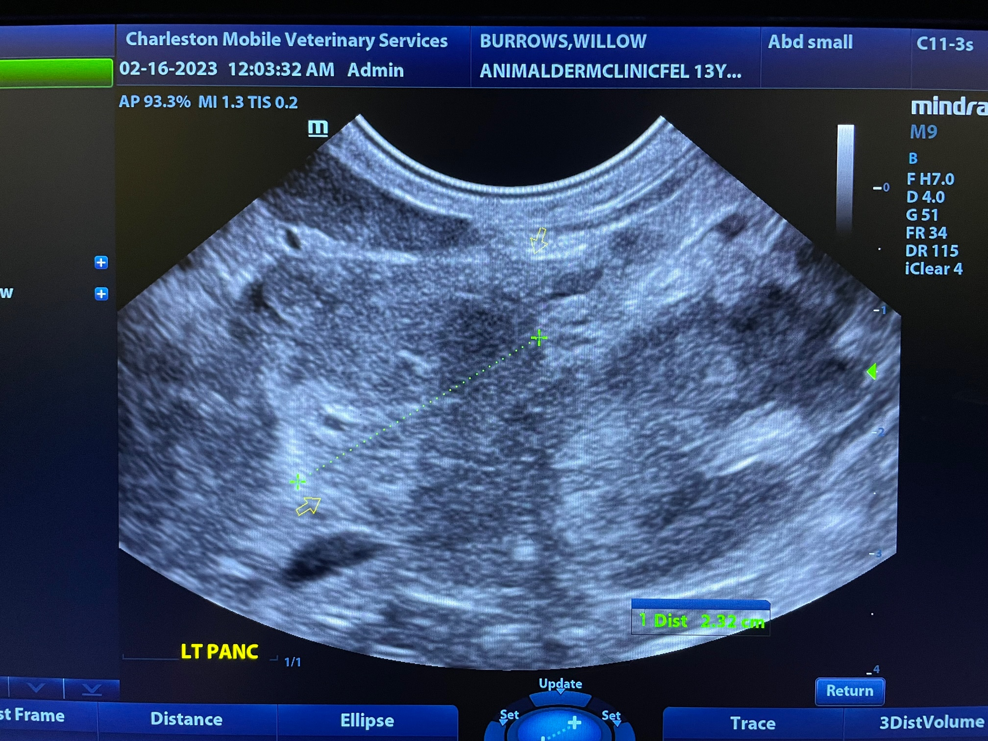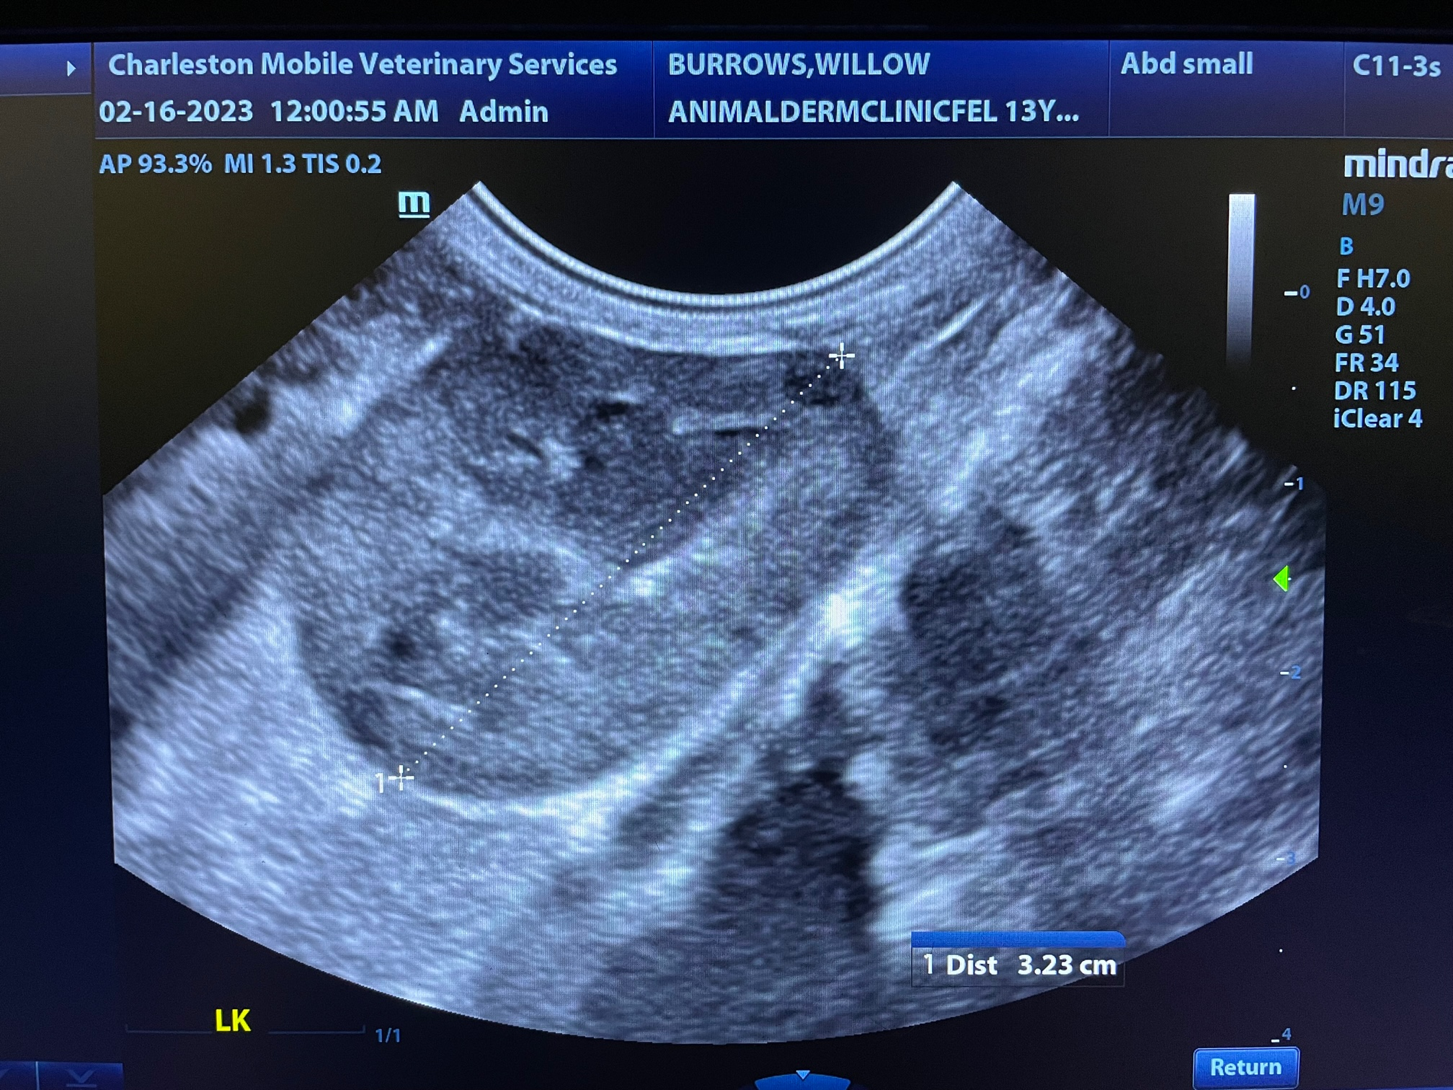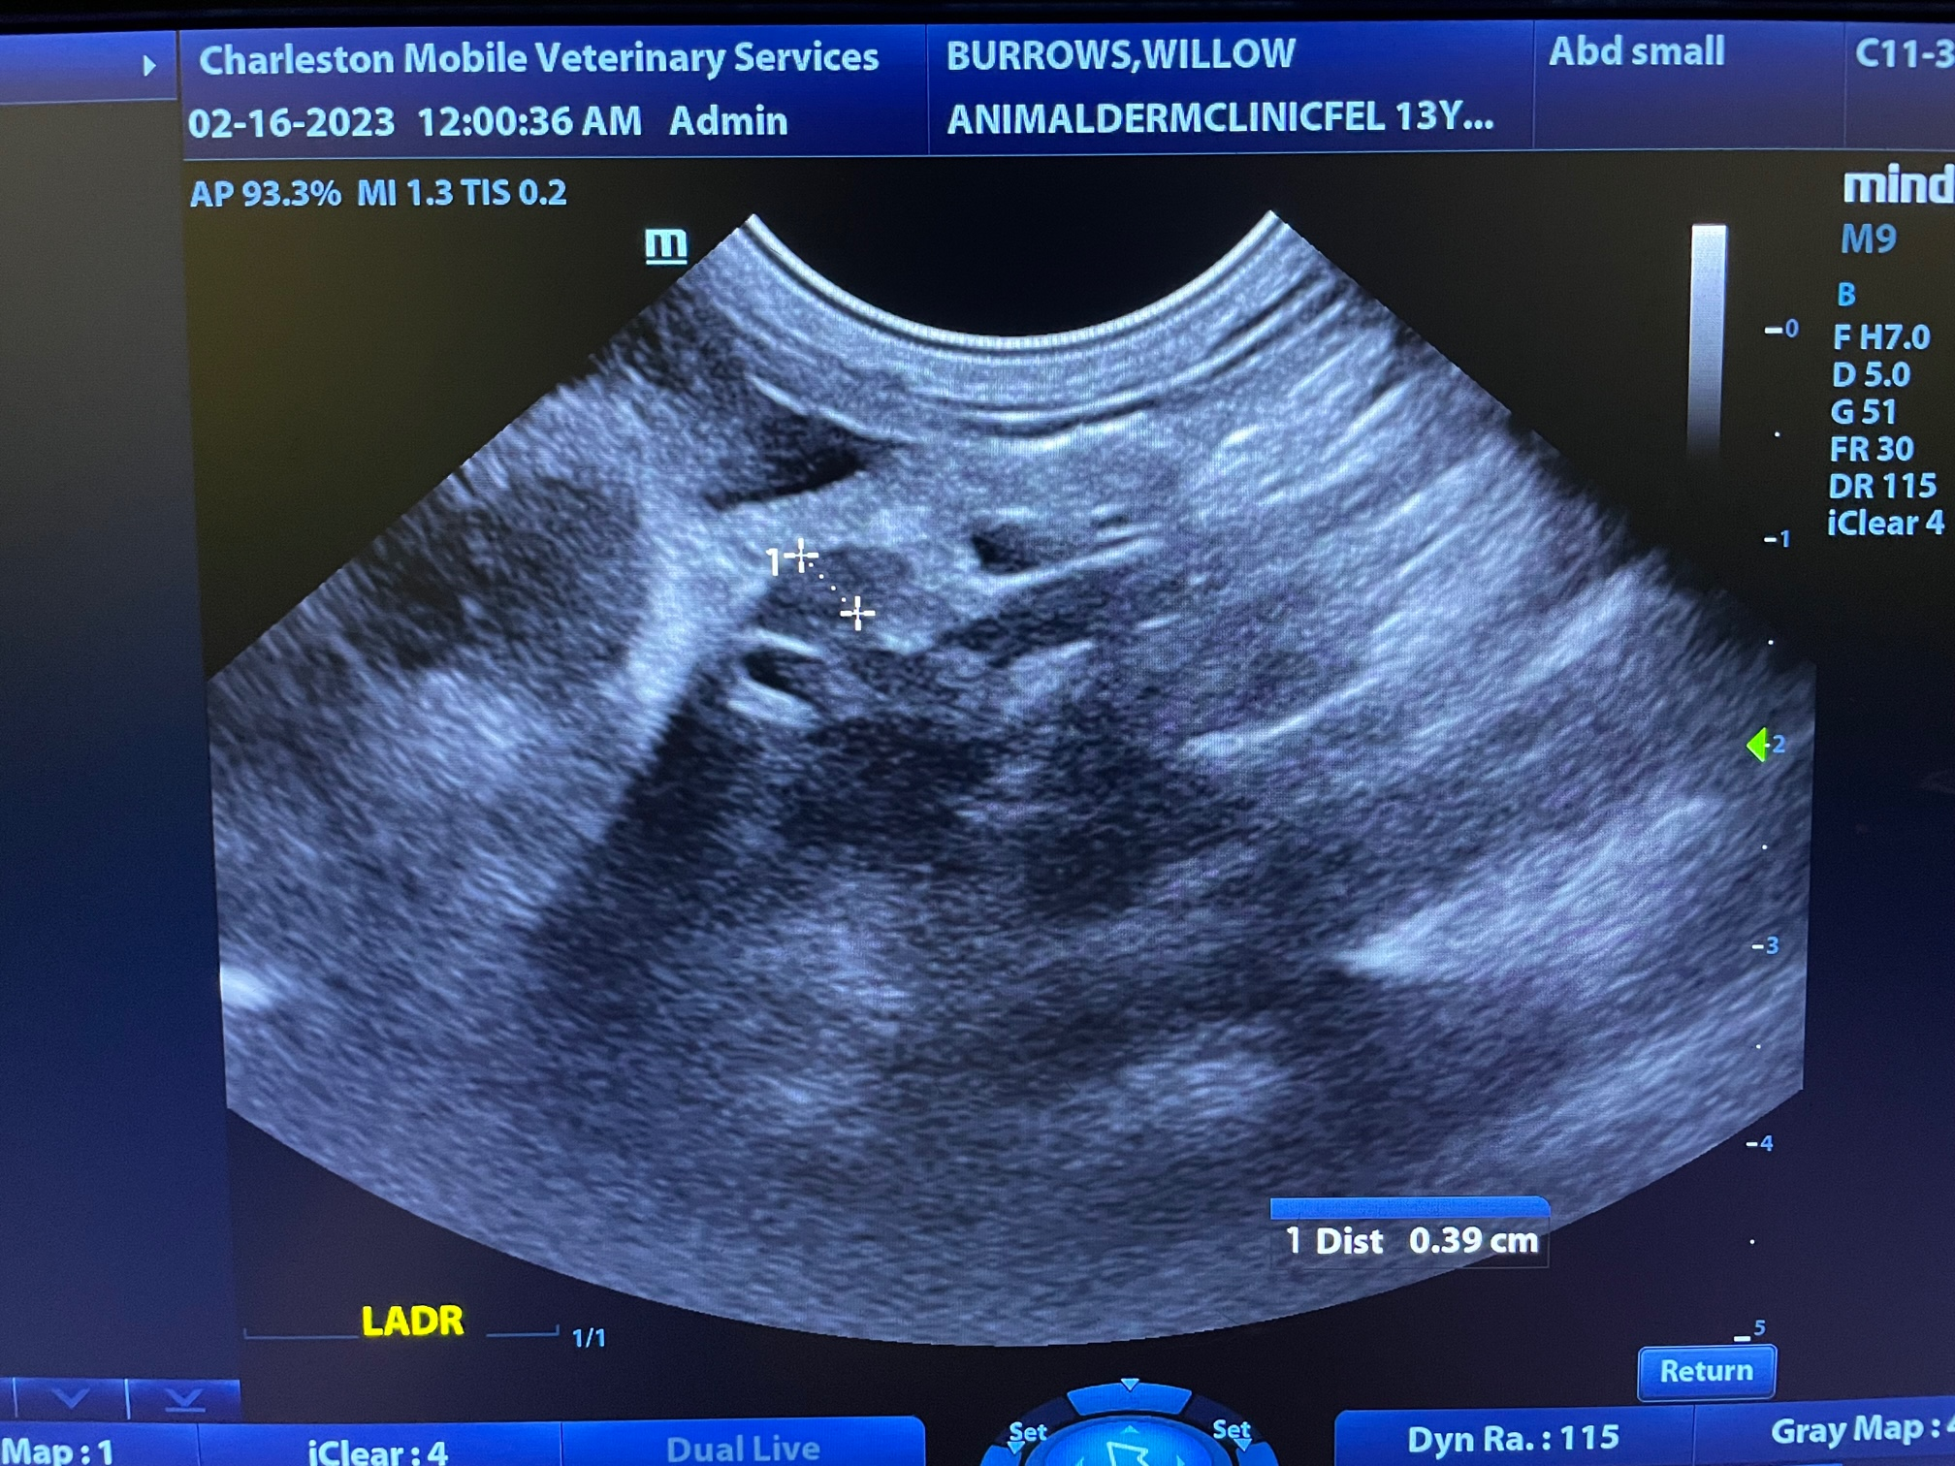

The information and recommendations provided are based on the images presented by the referring veterinarian/sonographer. No evaluation can be communicated regarding pathology that was not visible in the image/video clips provided.

Thank you for this referral. If the clinical or image interpretation does not parallel your findings or if I can be of any further assistance, please contact me.
Andrea Nicastro, DVM, Diplomate DACVIM (Small Animal Internal Medicine)
info@SonoPath.com

