PRESENTING CLINICAL SIGNS

History: Substantial weight loss. No obvious gastroenteritis signs. History of hypertrophic cardiomyopathy. Bloodwork is pending.

ULTRASONOGRAPHIC EXAMINATION OF THE ABDOMEN

Urinary System
The urinary bladder, trigone, and pelvic urethra are normal in thickness and the mucosal surface is smooth. The bladder is mildly distended. A small amount of suspended echogenic debris is observed within the lumen. No masses, inflammatory changes or calculi are observed. The region of the trigone is normal.

The left kidney is normal size (3.34 cm in length) with a normal shape, architecture and smooth peripheral margins. There is a normal 1:3 cortex to medulla ratio with molo corticomedullary distinction. There is no evidence of pyelectasia, nephroliths, infarcts or hydroureter. Renal vasculature is normal.

The right kidney is normal in size (2.89 cm in length) with a normal shape, smooth peripheral margins, and normal internal architecture. There is poor corticomedullary distinction. Several hyperechoic shadowing diverticular foci are observed. There is no evidence of pyelectasia, infarcts or hydronephrosis. Renal vasculature is normal.

Adrenal Glands
The left adrenal gland is normal size (0.35 cm width). Normal shape and glandular echogenicity. The phrenicoabdominal vein and surrounding vasculature are normal.
The right adrenal gland is normal size (0.48 cm width). Normal shape and glandular echogenicity. The phrenicoabdominal vein and surrounding vasculature are normal.
Spleen
The spleen is normal in size (0.53 cm in width at the level of the hilus) with a normal capsular contour. There is appropriate echogenicity and echotexture. No focal lesions are observed. Splenic vasculature is normal.

Liver
The liver is subjectively normal in size with normal contours and structure. There is appropriate echogenicity and echotexture. No overt structural evidence of inflammatory, infiltrative, or regenerative pathology is evident. Vascular and biliary tracts are of normal volume with no evidence of congestion. No pathological hepatic lymphadenopathy observed.

The gall bladder lumen is moderately distended. The wall is thin and smooth. A small amount of suspended echogenic debris is observed within the lumen. The cystic and common bile ducts are normal.

Gastrointestinal
The stomach and intestine are free of stasis and exhibit normal peristaltic activity. The gastric lumen is not distended. The gastric wall and pylorus are normal in thickness with a normal layering pattern. The pyloric outflow tract is patent. The small intestinal lumen is segmentally dilated with chyme (mild). The small intestinal wall thickness is normal with a normal layering pattern and appropriate mural detail. Discreet masses are not identified. The colonic wall is normal. There is no evidence of an obstructive pattern.

Pancreas
The left limb is visible with normal curvilinear peripheral contours. The parenchyma is mildly hypoechoic relative to surrounding omental fat. No focal lesions are observed. The pancreatic duct is visible but not overtly dilated (0.21 cm in diameter).

Free Abdomen
Trace free fluid is observed. One to two prominent mesenteric lymph nodes are visualized (the largest measuring 0.70 cm in length). The nodes are normal in shape and echogenicity.

Other
A brief echocardiogram reveals subjective right, +/- left atrial enlargement.

ULTRASONOGRAPHIC FINDINGS

Primary Findings

- Bilateral chronic age-related renal changes with right dystrophic mineralization

- Subjective right +/- left atrial enlargement

- Trace ascites. Differentials include increased hydrostatic pressure (i.e., secondary to congestive heart failure), increased vascular permeability (i.e., due to vasculitis), low oncotic pressure, other. Correlation with the patient’s clinical history is recommended.

Secondary Findings

- The pancreatic changes may be a normal variant for this patient or could be consistent with mild, chronic pancreatitis. Correlation with clinical findings is recommended.

- The urinary bladder debris could be consistent with cells, crystals, exfoliated material and/or lipid droplets.

INTERPRETATION OF THE FINDINGS & FURTHER RECOMMENDATIONS

- Consider a repeat echocardiogram to assess for progression of the hypertrophic cardiomyopathy. Further recommendations should be based on the patient’s lab work results.
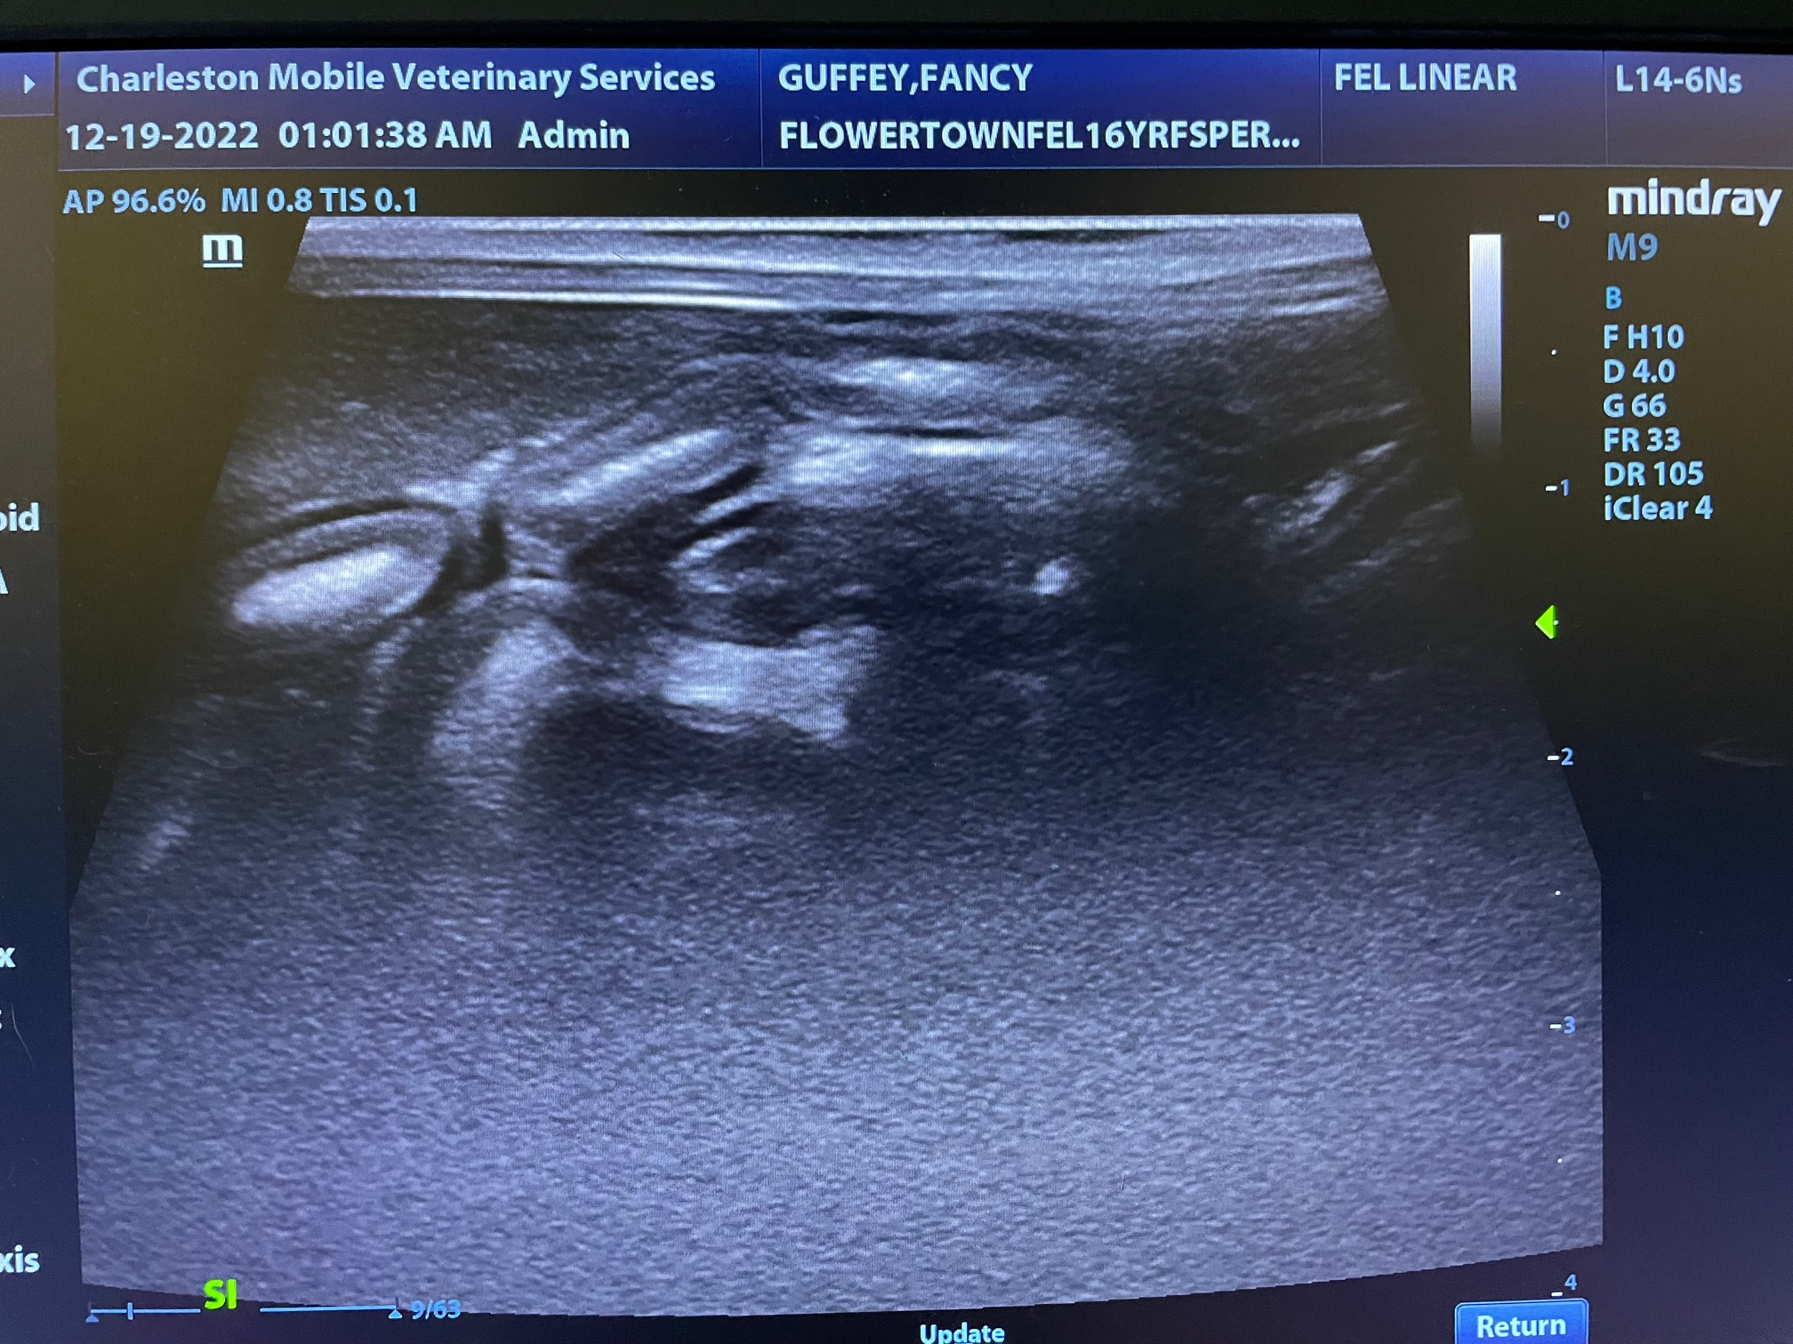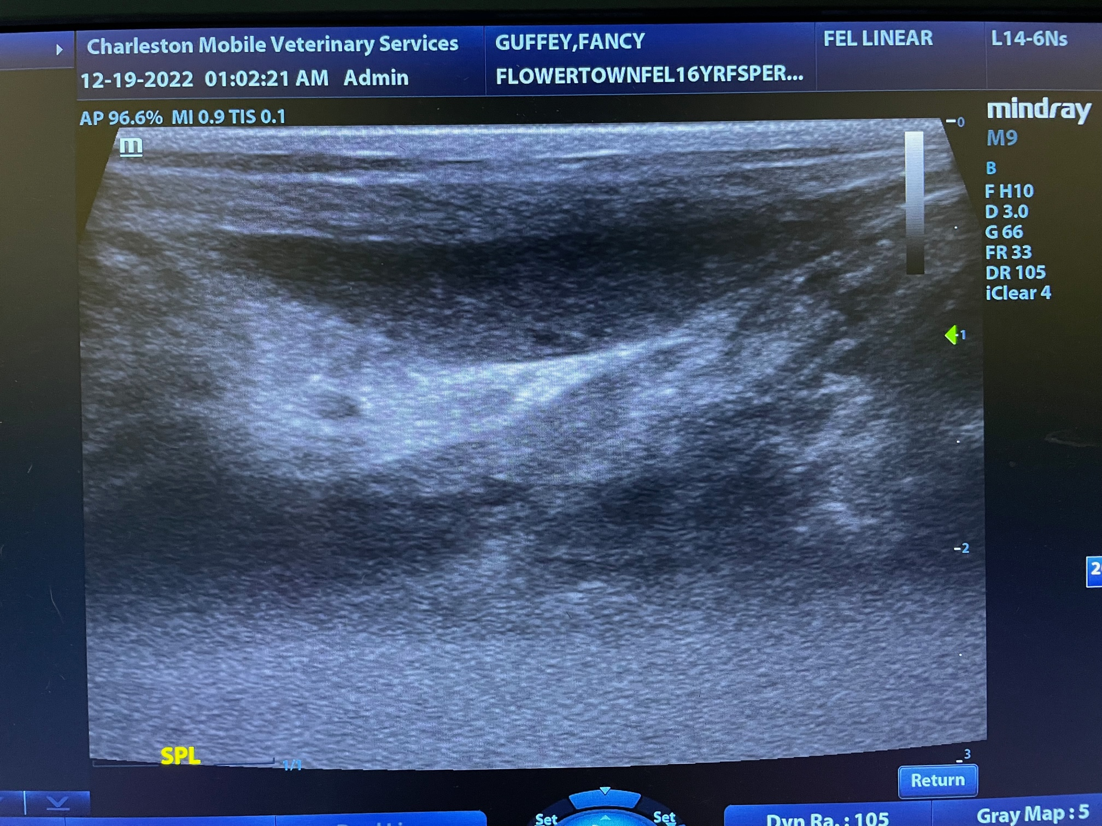
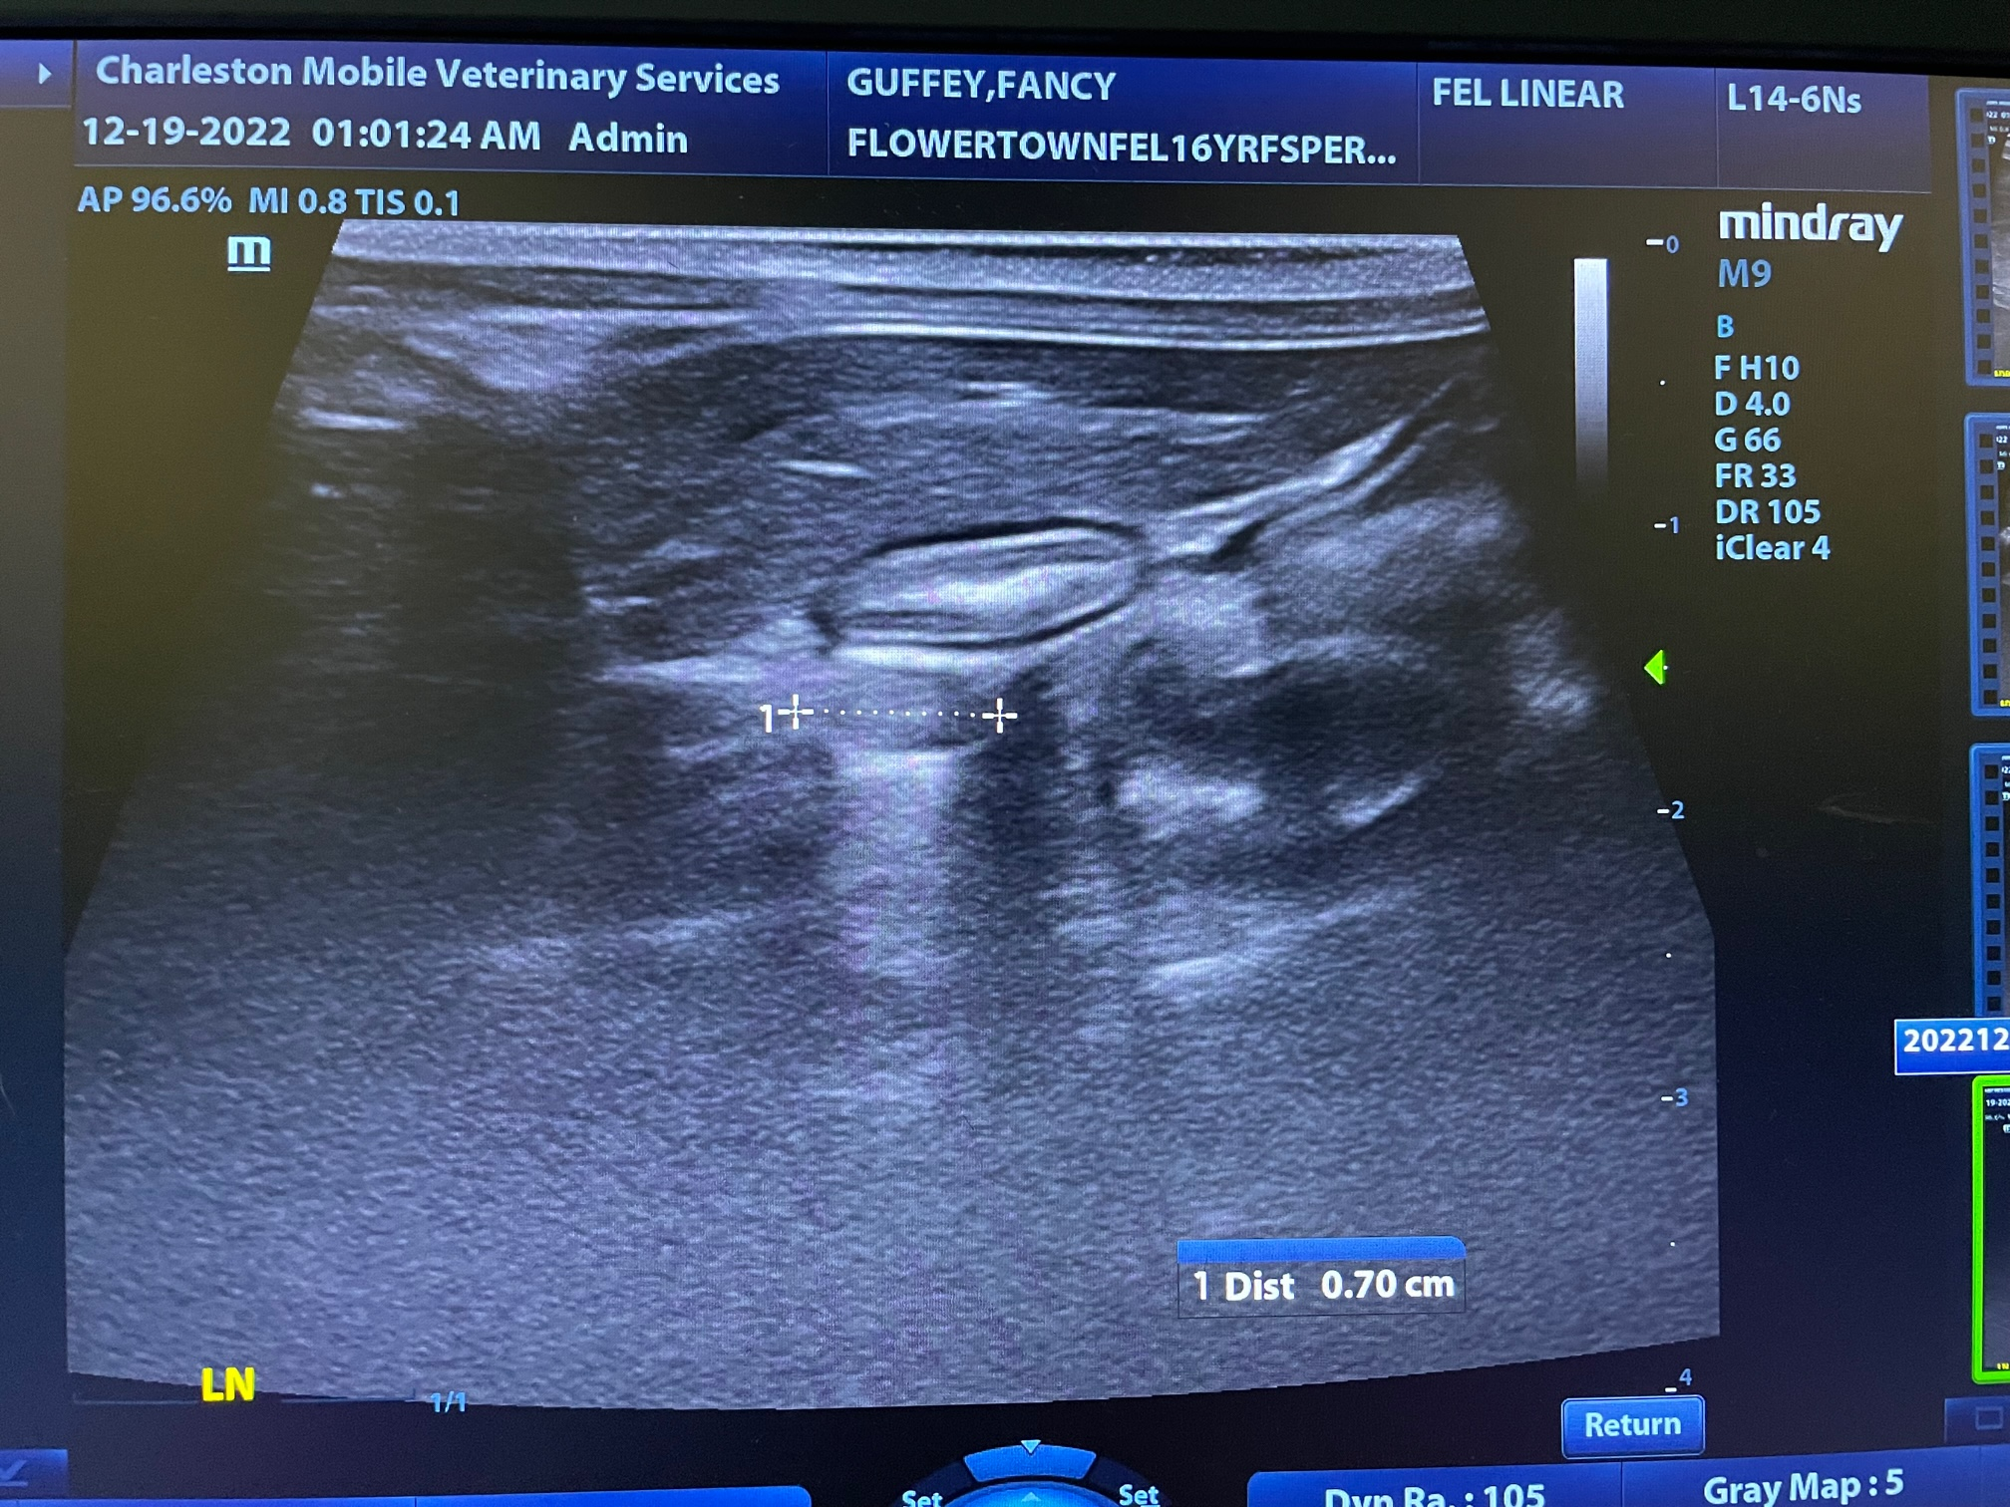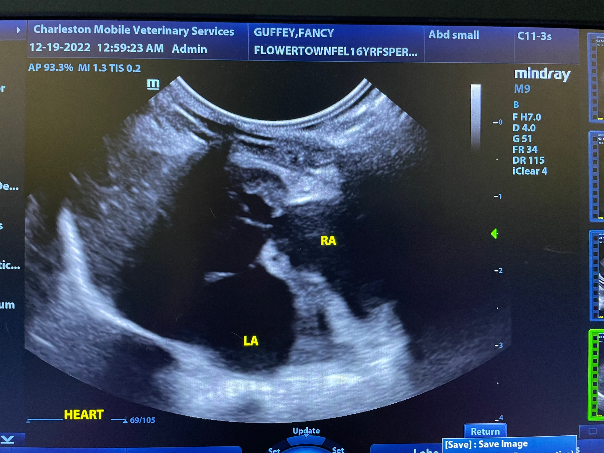
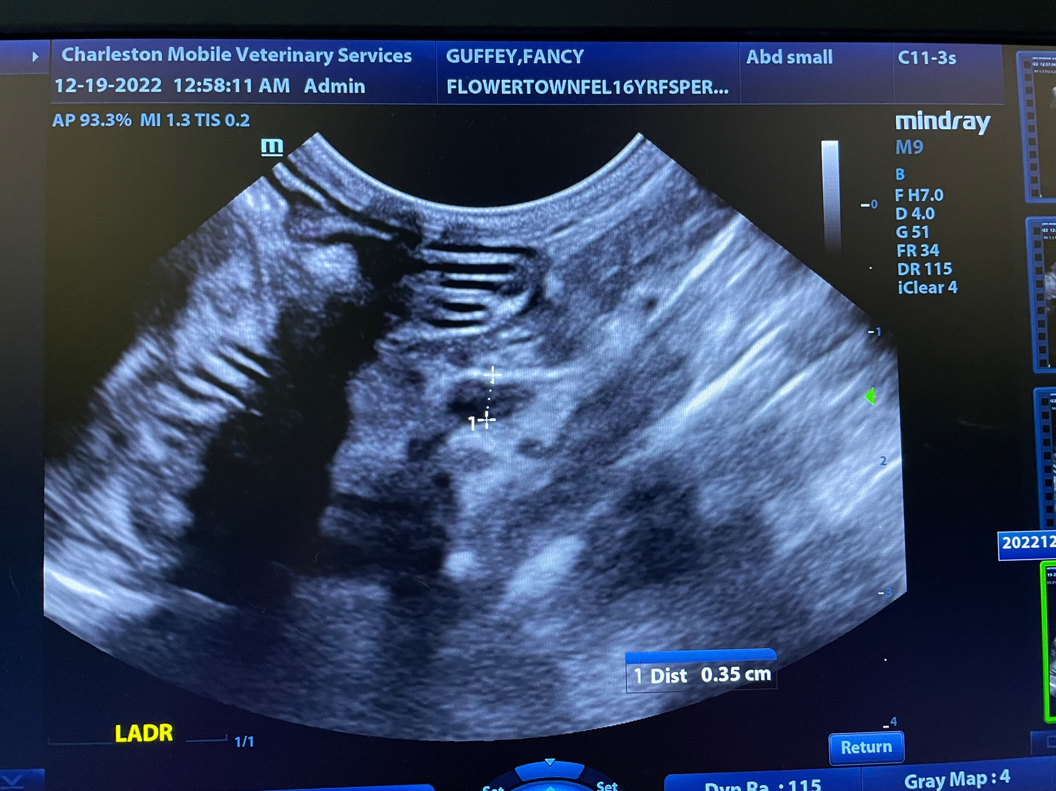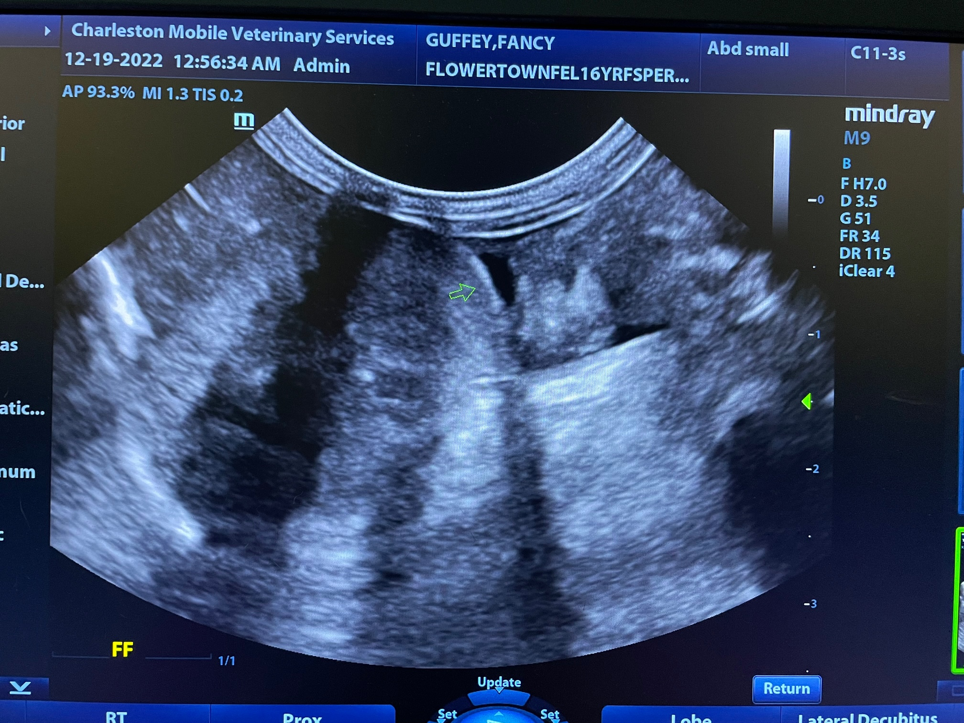
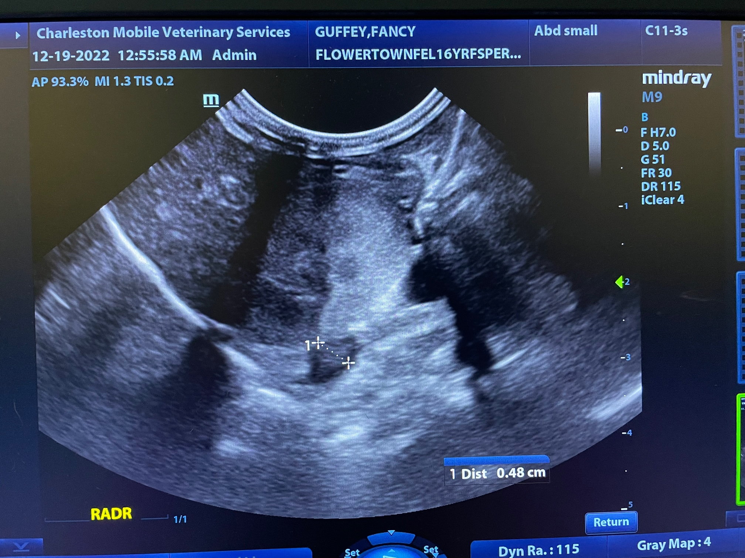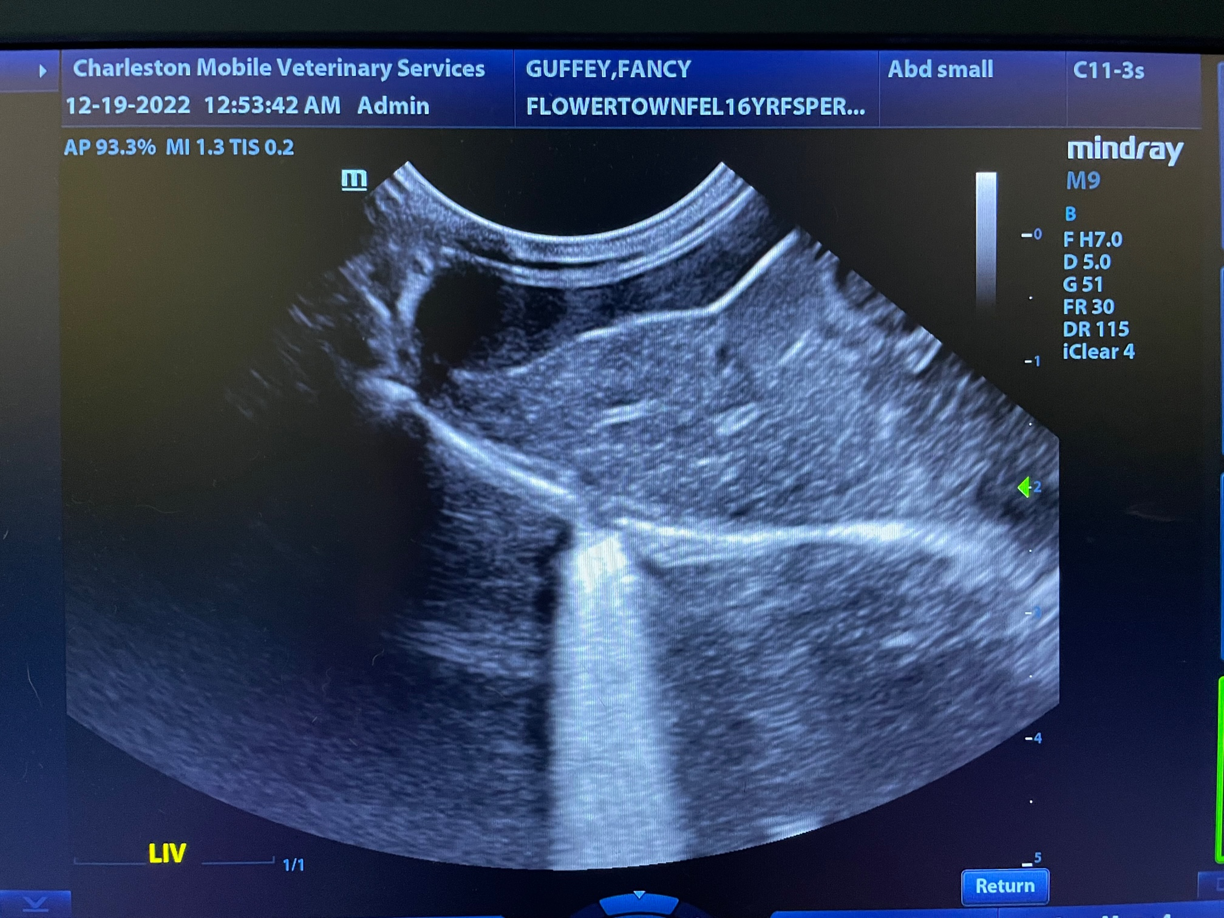
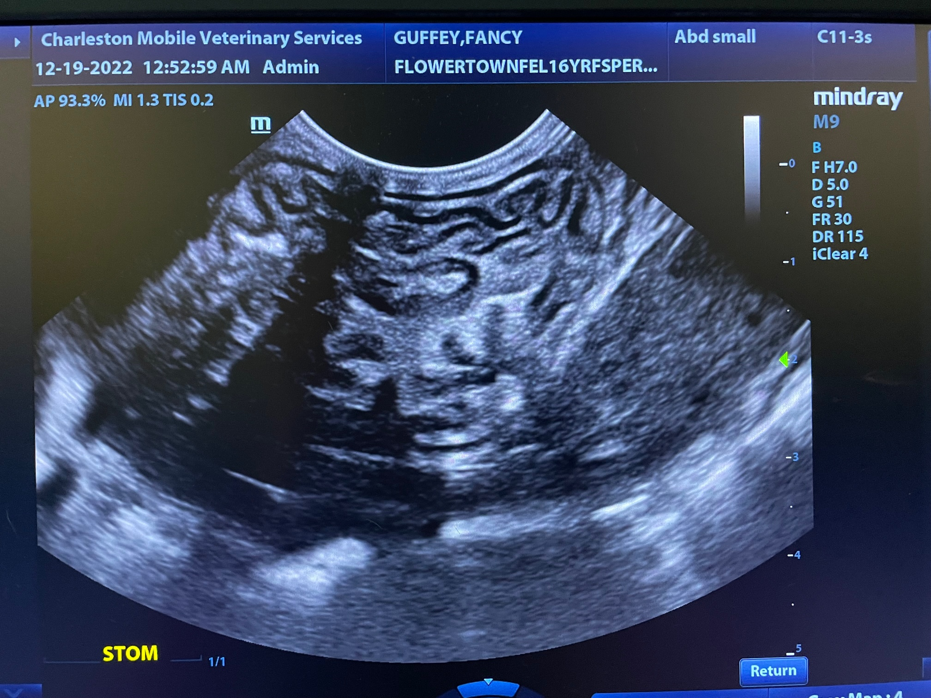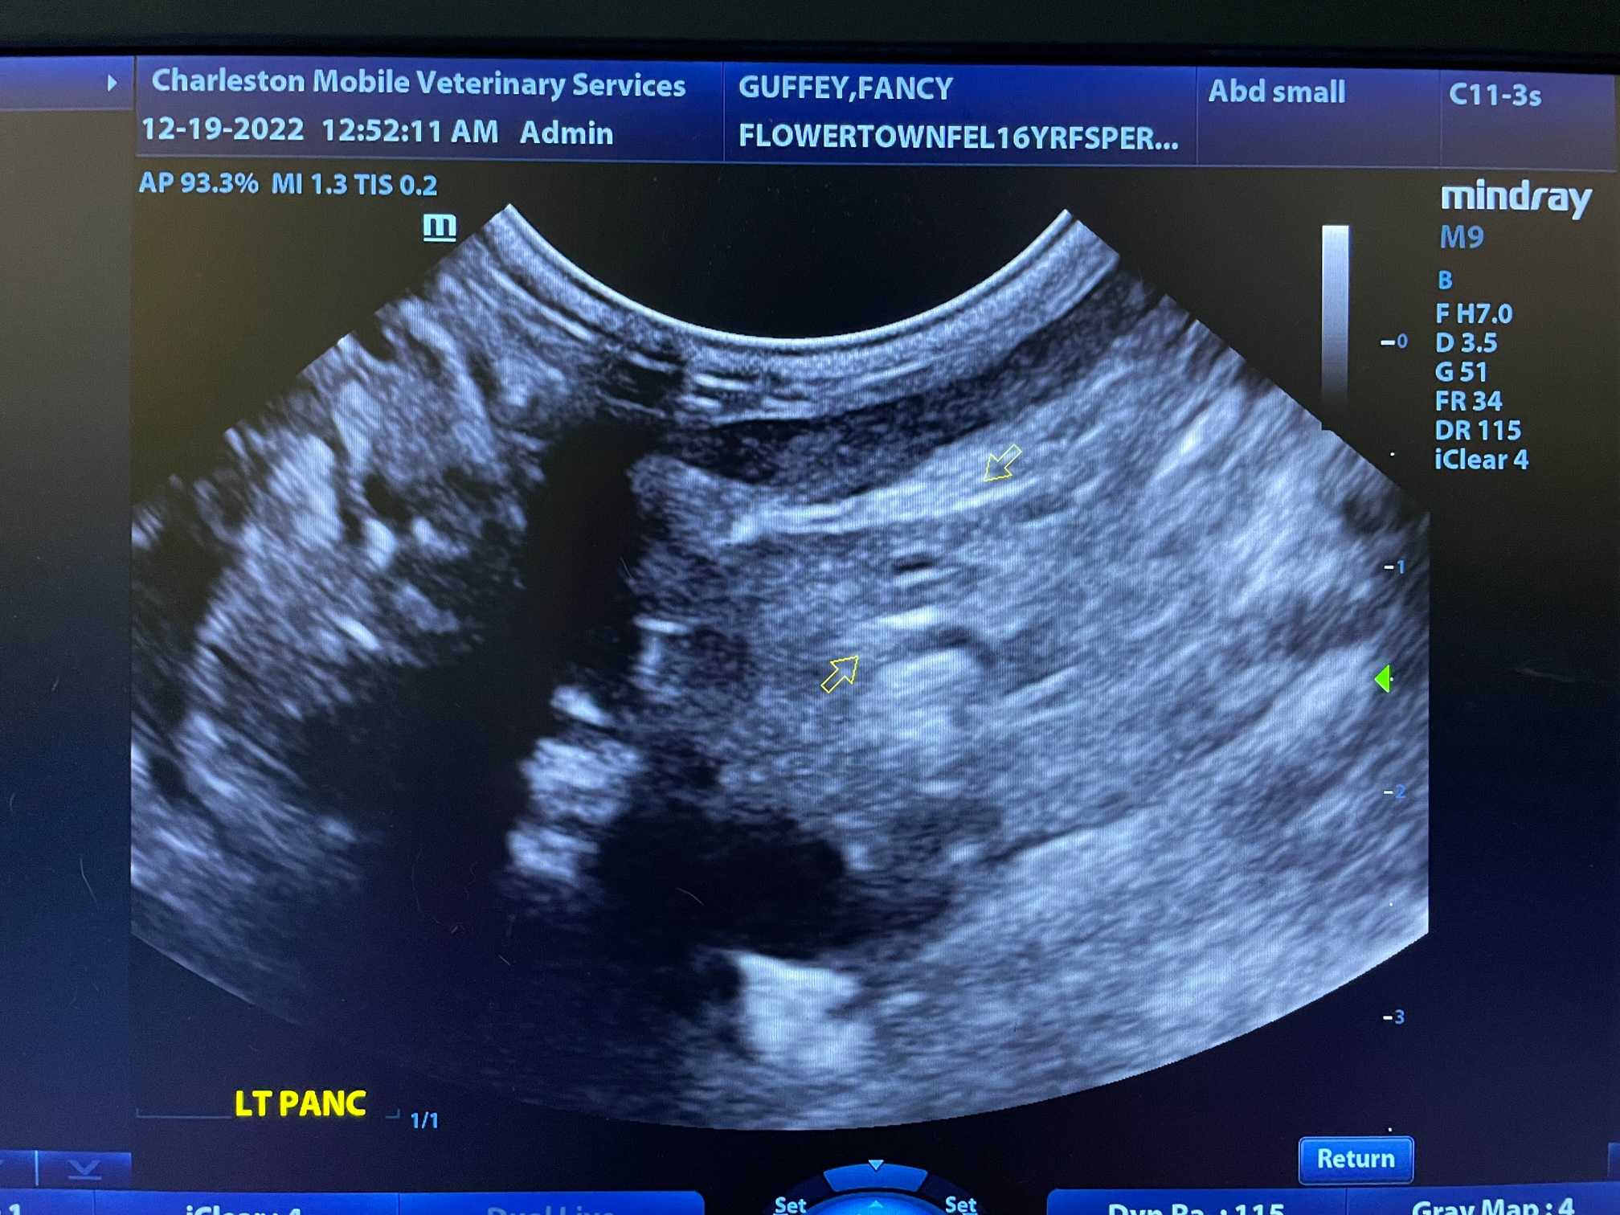
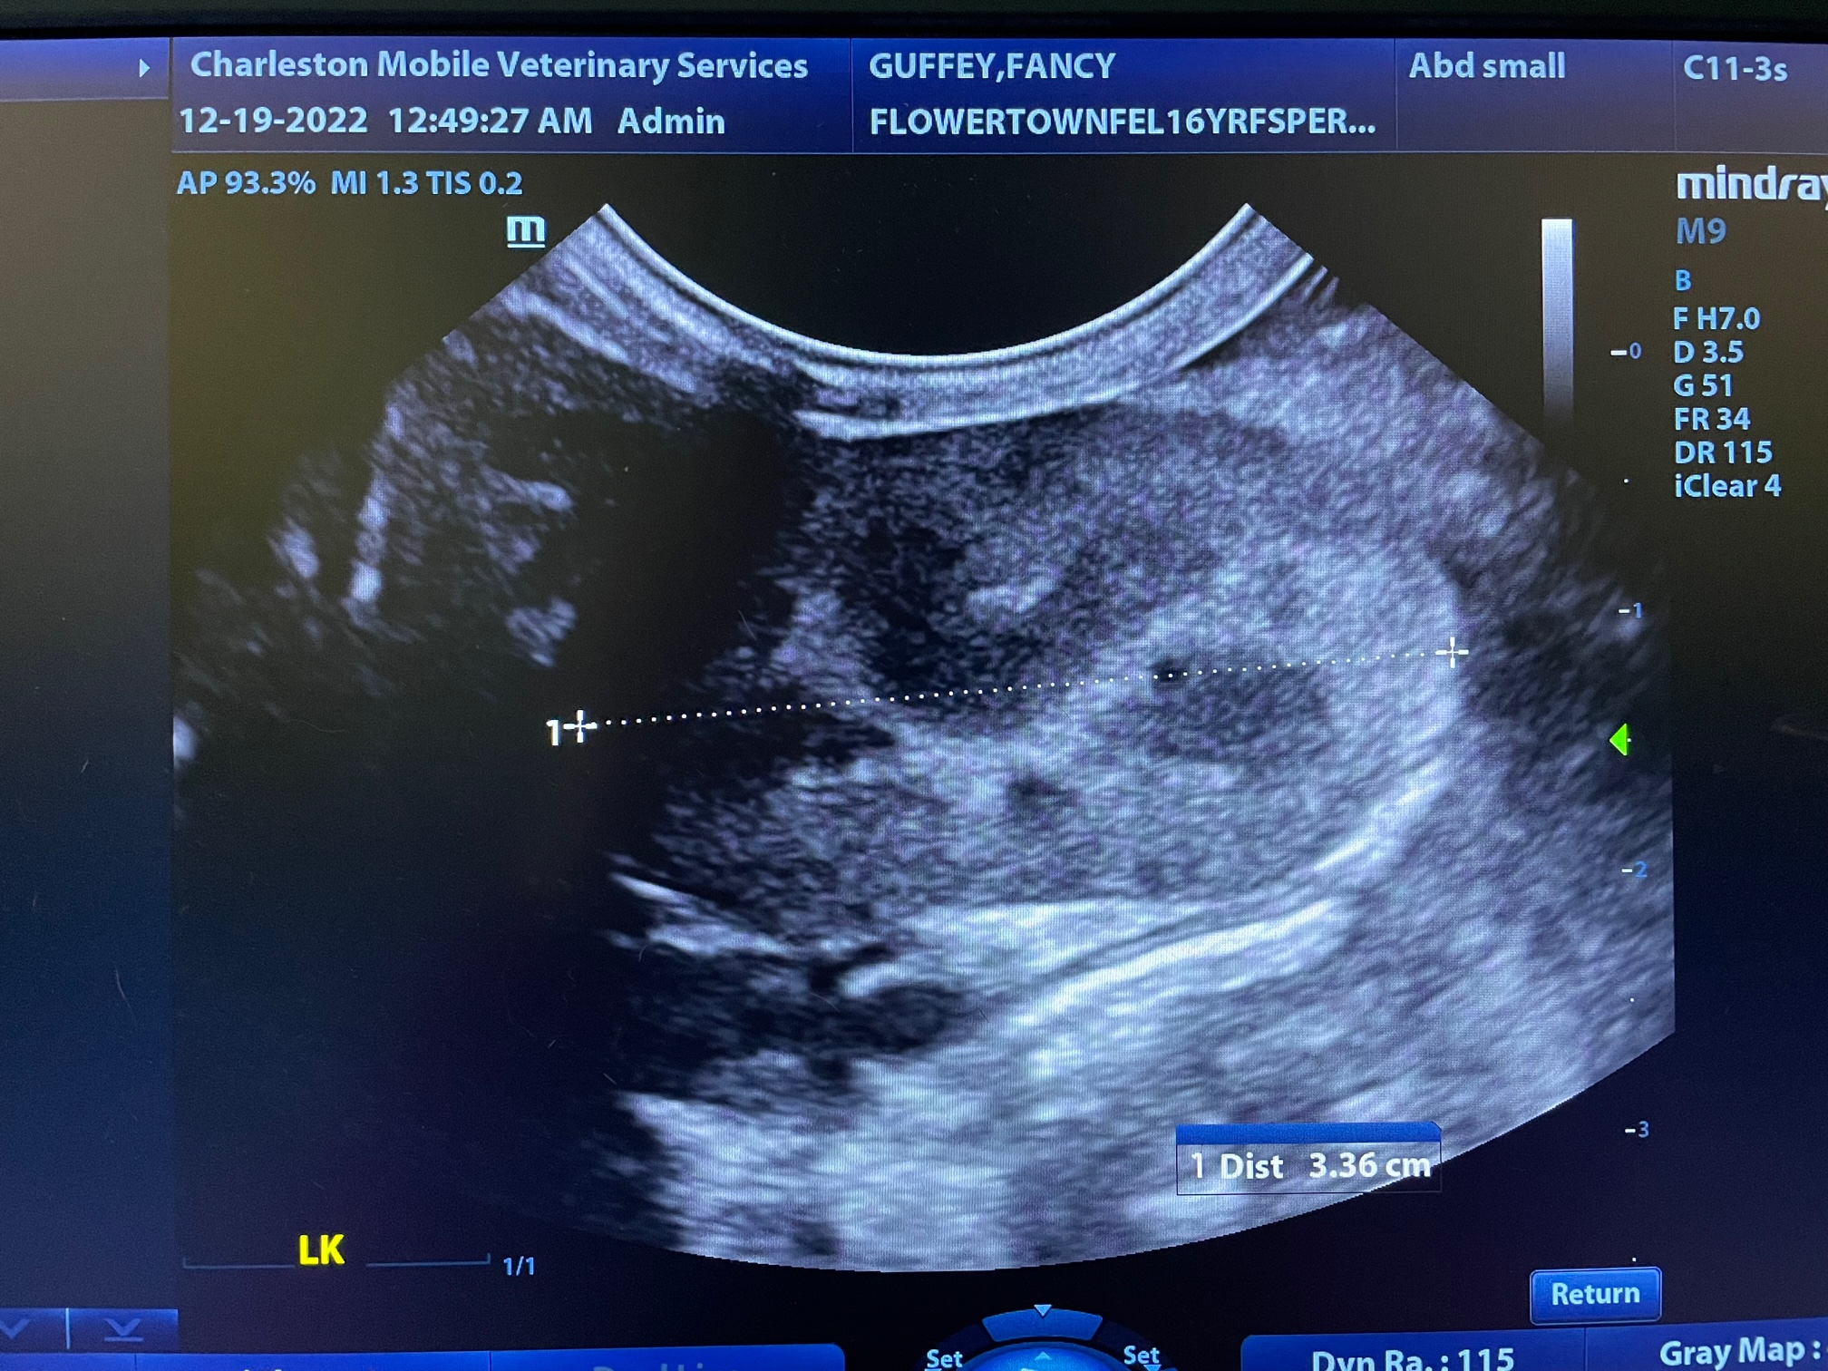

The information and recommendations provided are based on the images presented by the referring veterinarian/sonographer. No evaluation can be communicated regarding pathology that was not visible in the image/video clips provided.

Thank you for this referral. If the clinical or image interpretation does not parallel your findings or if I can be of any further assistance, please contact me.
Andrea Nicastro, DVM, Diplomate DACVIM (Small Animal Internal Medicine)
info@SonoPath.com

