PRESENTING CLINICAL SIGNS
History: Slow progression of weight loss. Intermittent vomiting that temporarily responds to diet change.
Abnormal PE/Chem/CBC/UA Results: Lab-work overall unremarkable (CBC, chem, T4 attached). Creat 2.2 (0.9-2.3) with USG 1.036 on follow up UA.
ULTRASONOGRAPHIC EXAMINATION OF THE ABDOMEN

Urinary System
The urinary bladder, trigone, and pelvic urethra are normal in thickness and the mucosal surface is smooth. The bladder lumen is moderately distended with anechoic urine. No masses, inflammatory changes or calculi are observed. Ureteral papillae and visualized portion of the proximal urethra, visible to a depth of 1-2 cm, are normal.

The left kidney is normal size (3.04 cm in length); normal shape and architecture with smooth peripheral margins. There is a normal 1:3 cortex to medulla ratio with mild to moderate loss of corticomedullary distinction. There is no evidence of pyelectasia, nephroliths, infarcts or hydroureter.

The right kidney is normal size (3.50 cm in length); normal shape and architecture with smooth peripheral margins. There is a normal 1:3 cortex to medulla ratio with mild to moderate loss of corticomedullary distinction. There is no evidence of pyelectasia, nephroliths, infarcts or hydroureter.

Adrenal Glands
The left adrenal gland is normal size (0.37 cm width). Normal shape and glandular echogenicity. The phrenicoabdominal vein and surrounding vasculature are normal.

The right adrenal gland is normal size (; 0.46 cm width). Normal shape and glandular echogenicity. The phrenicoabdominal vein and surrounding vasculature are normal.

Spleen
The spleen is subjectively normal in size with a normal capsular contour. There is appropriate echogenicity and echotexture. No focal lesions are observed. Splenic vasculature is normal.

Liver
The liver is normal to slightly prominent size with normal curvilinear peripheral contours. The parenchyma is isoechoic relative to the spleen. An approximately 1.89 cm irregular anechoic cyst is observed on the left side. The remaining parenchyma is homogenous. Hepatic vasculature and intrahepatic biliary tracts are of normal volume with no evidence of congestion.

The gall bladder lumen is moderately distended. The wall is thin and smooth. Luminal contents are anechoic. The cystic and common bile ducts are normal/not seen.

Gastrointestinal
The gastric lumen is moderately distended with echogenic fluid. The gastric wall and pylorus are normal in thickness with a normal layering pattern. The pyloric outflow tract appears patent. The small intestinal lumen is segmentally dilated with chyme. The small intestinal wall thickness is normal with a normal layering pattern and appropriate mural detail. Discreet masses are not identified. The ileocecocolic junction and colonic wall are normal. There is no evidence of an obstructive pattern.

Pancreas
A portion of the pancreas is obscured by the gastric distention. In the visualized portions, no obvious pathology is observed

Free Abdomen
There is no evidence of free fluid. One to two prominent lymph nodes are observed near the aortic trifurcation, the largest measuring 0.67 cm in length. The nodes are relative normal in shape and echogenicity. In addition, a few prominent colic lymph nodes are also seen, the largest measuring 0.54 cm in length. Surrounding mesentery is hyperechoic.

ULTRASONOGRAPHIC FINDINGS

Primary Findings

- If the patient was fasted for this study, gastric ileus and/or a primary gastrointestinal motility disorder should be a consideration. Other considerations include inflammatory bowel disease, food allergy/intolerance, infectious/parasitic disease, underlying metabolic issue, other.

Secondary Findings

- Bilateral chronic age-related renal changes

- The hepatic cyst most likely represents a benign lesion.

- The prominent abdominal lymph nodes are most consistent with reactive lymphadenitis or lymphoid hyperplasia. Neoplastic infiltration is considered less likely.

INTERPRETATION OF THE FINDINGS & FURTHER RECOMMENDATIONS

- Given the patient’s clinical history consider the following:

- Fecal evaluation for ova and Giardia
- GI panel including serum cobalamin and folate, TLI and PLI
- Consider transitioning to a hydrolyzed protein or limited antigen diet, if not already performed.
- Also consider three-view thoracic radiographs to assess for occult esophageal disease, herniation, etc.
- Ultimately, GI biopsies (i.e., endoscopic or surgical) may be necessary to get a definitive diagnosis.

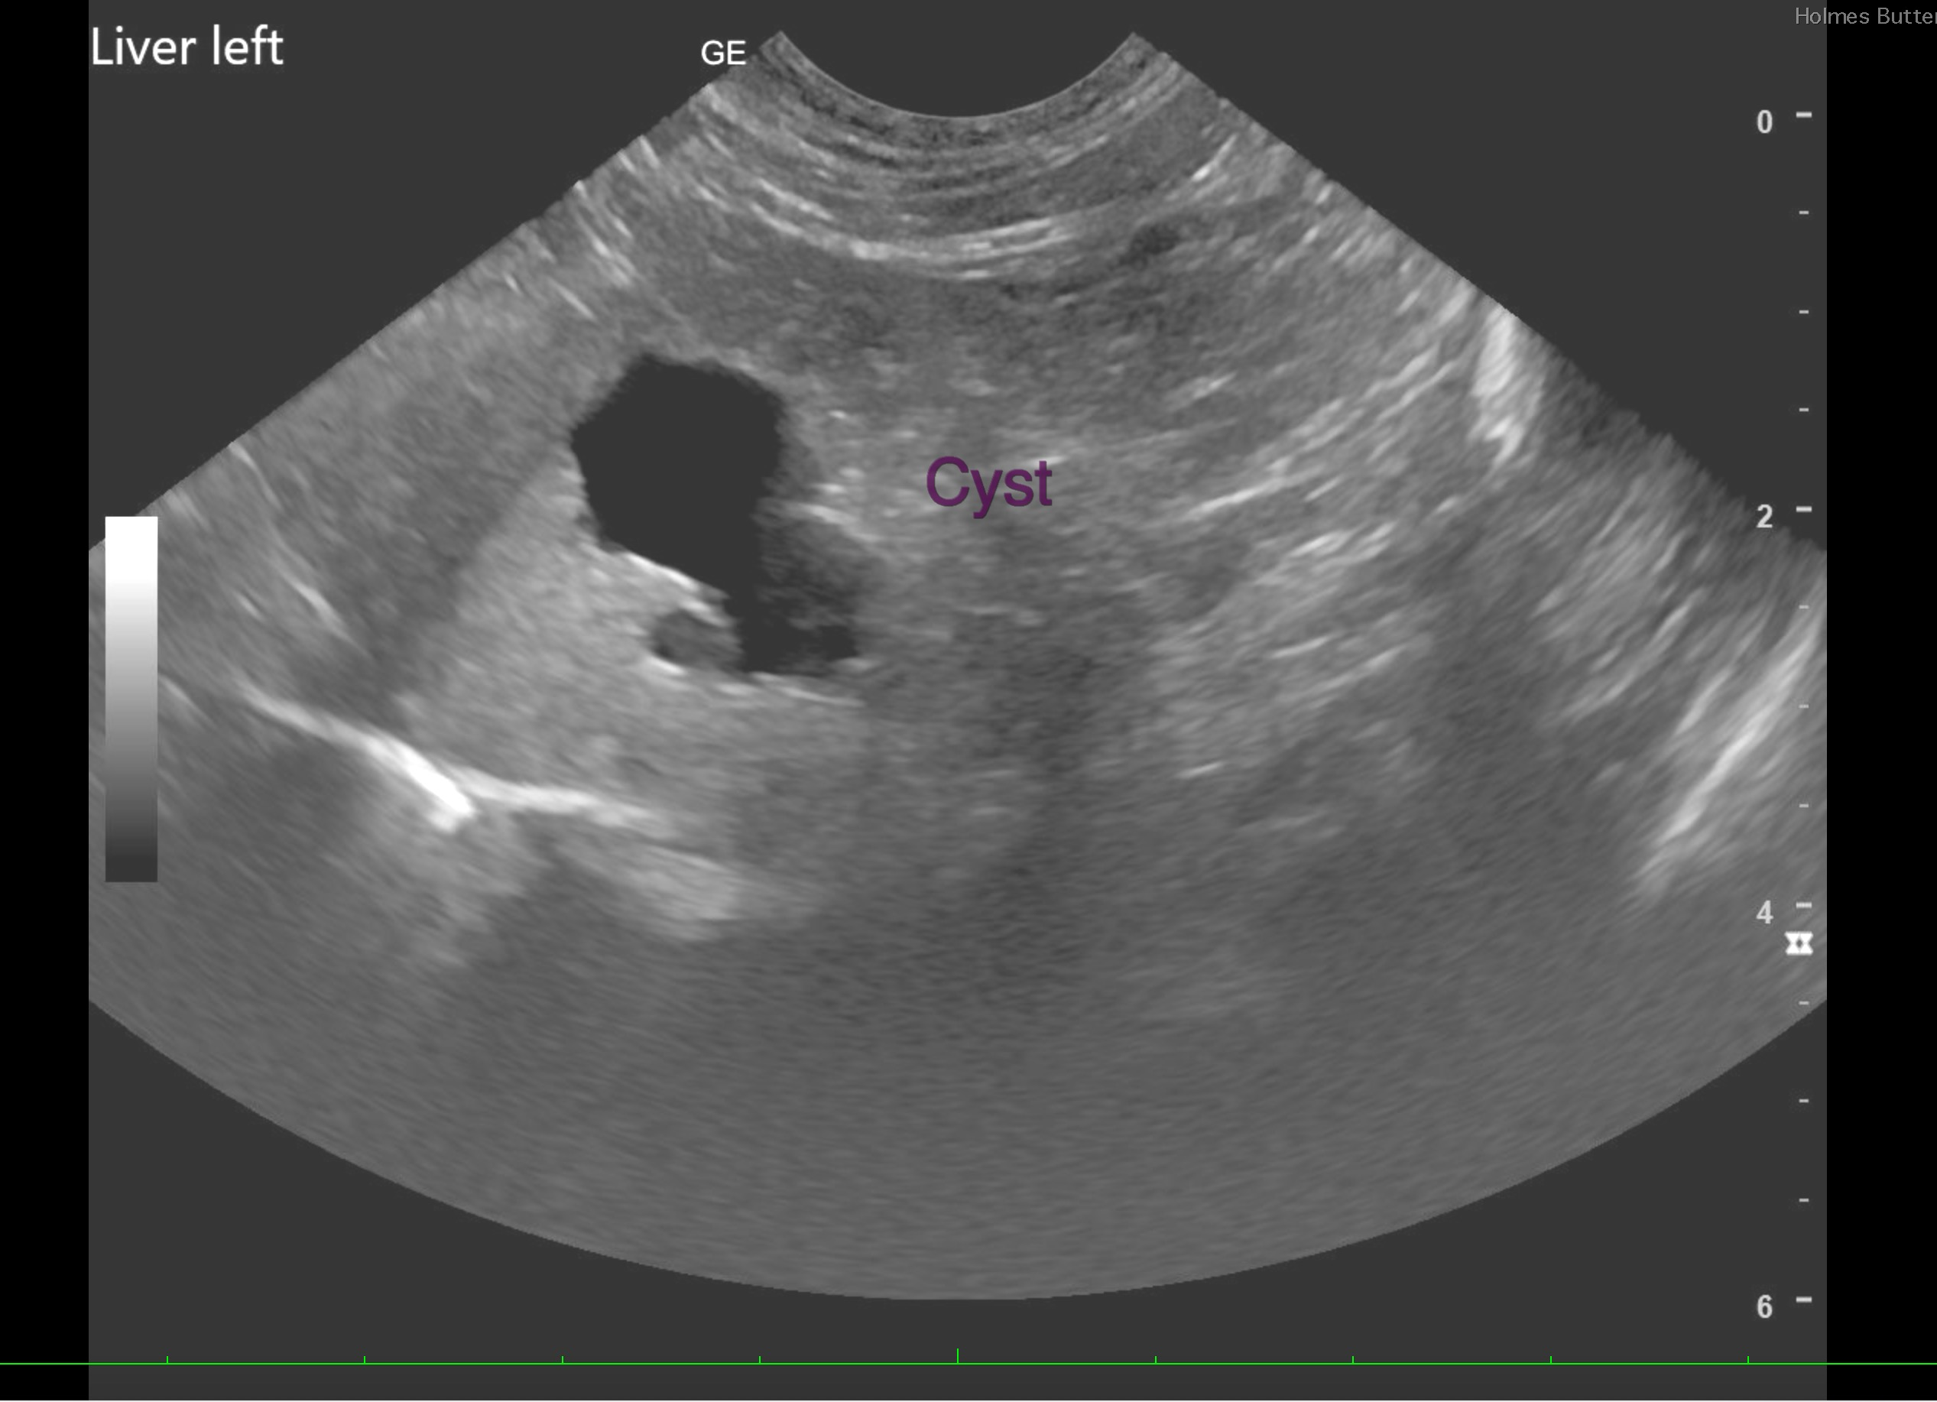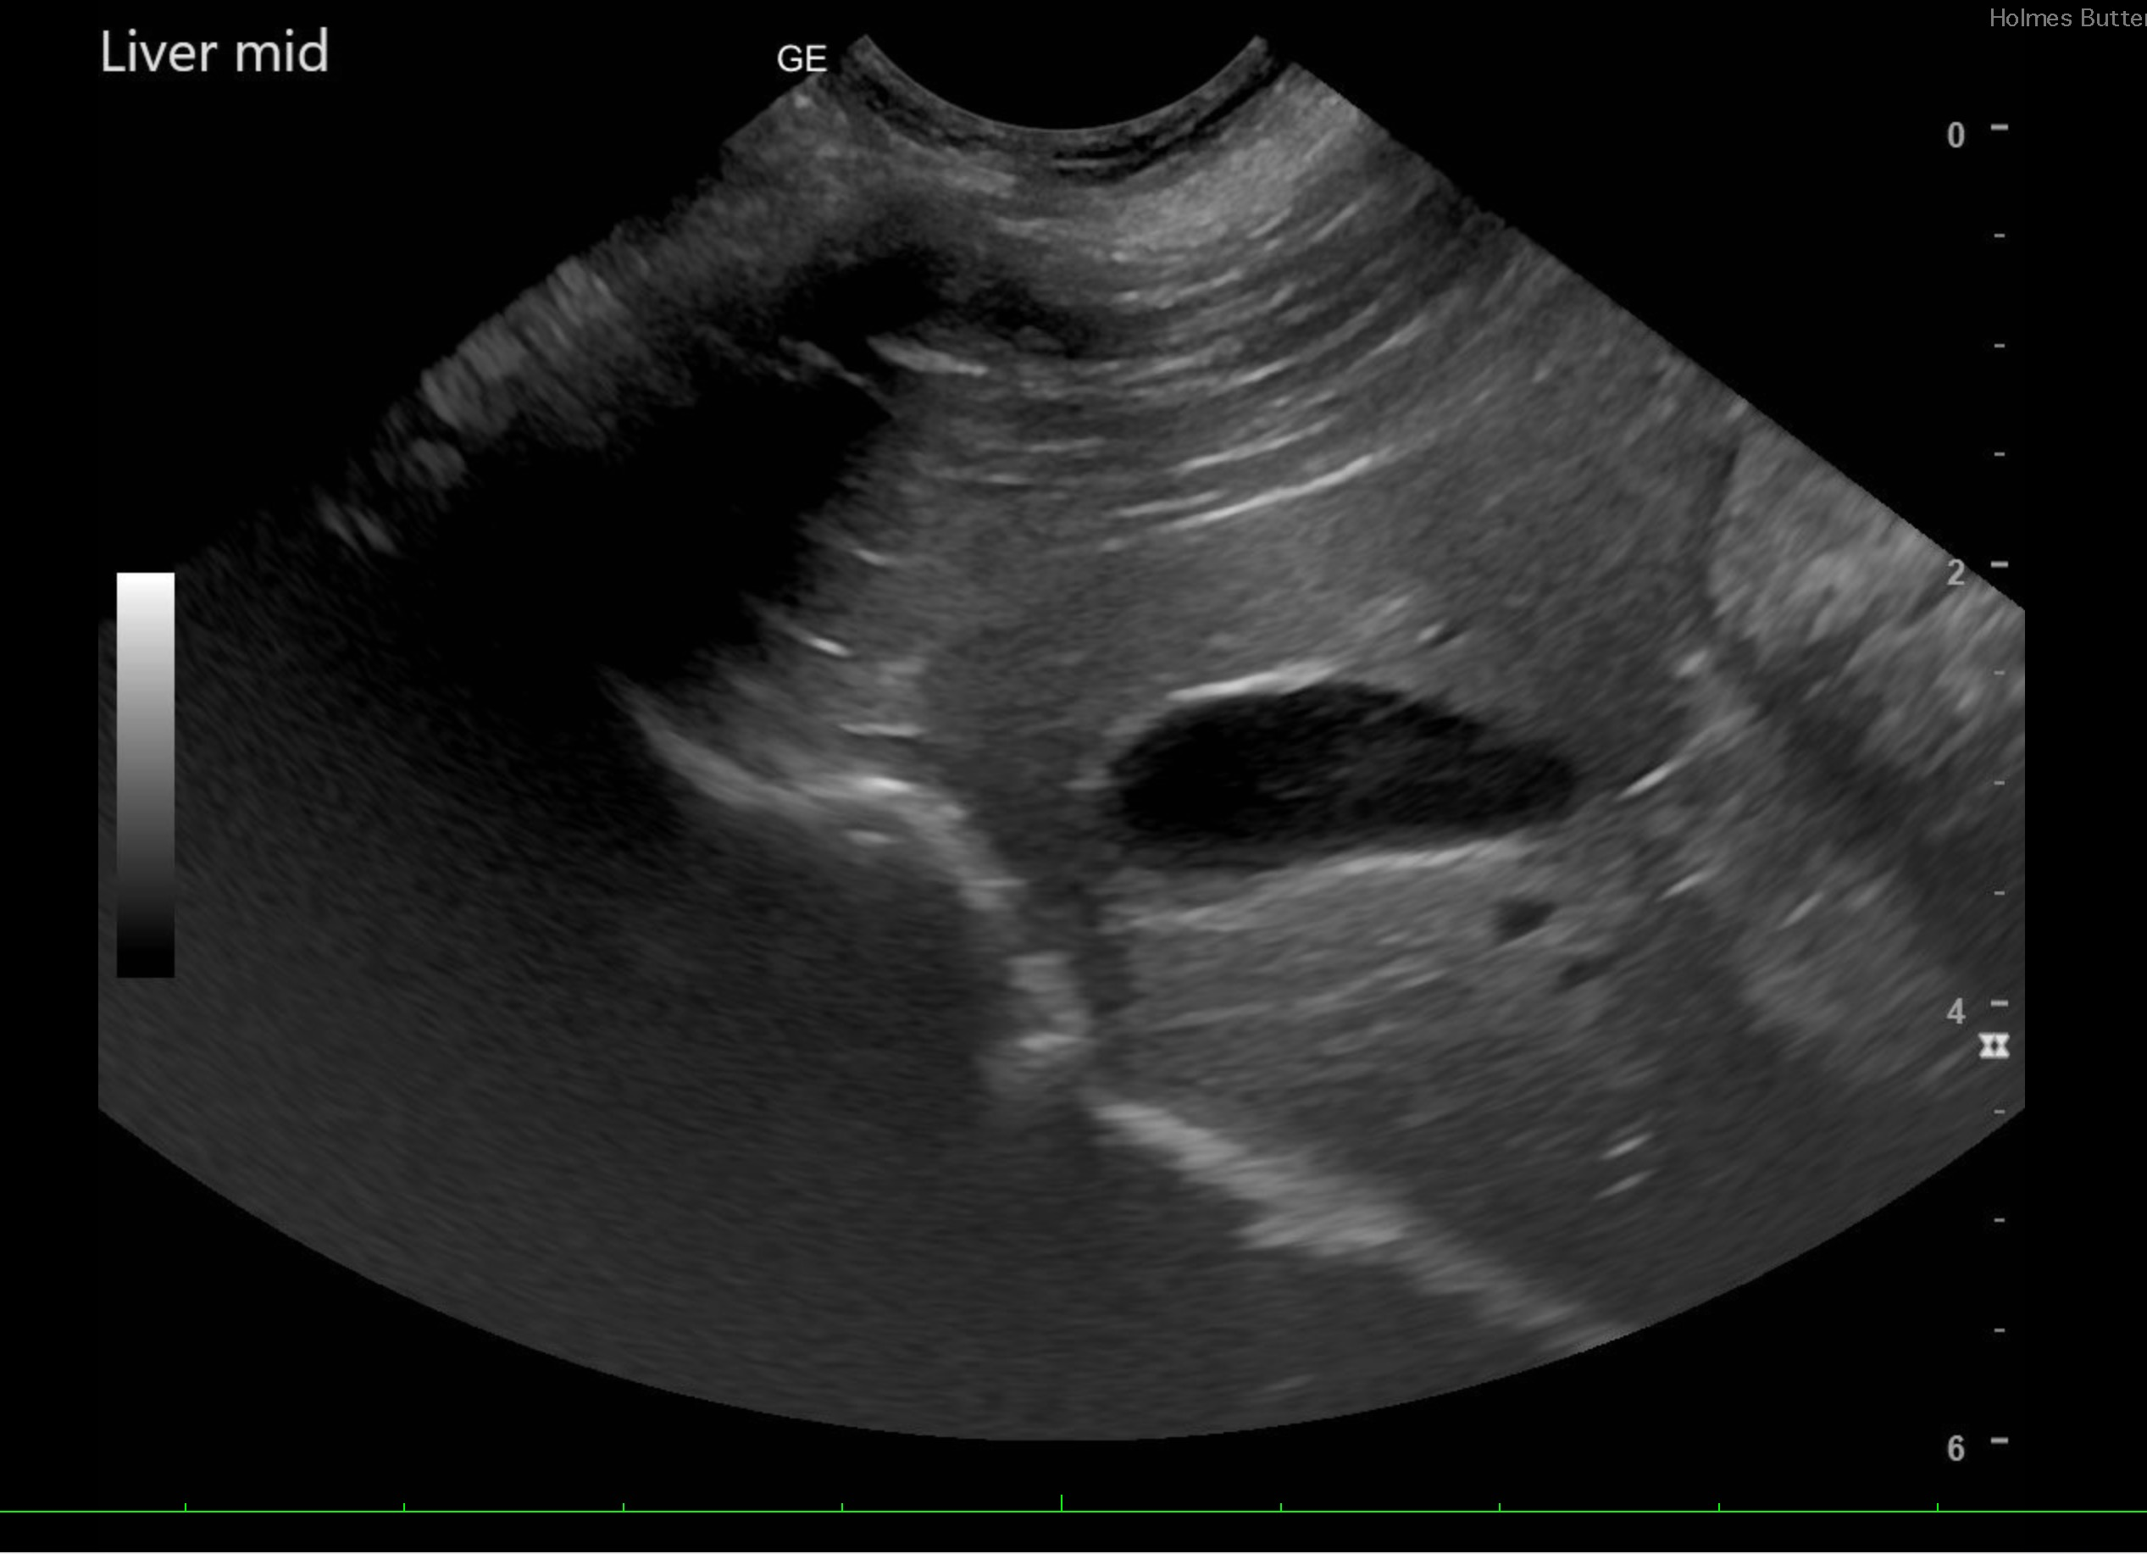

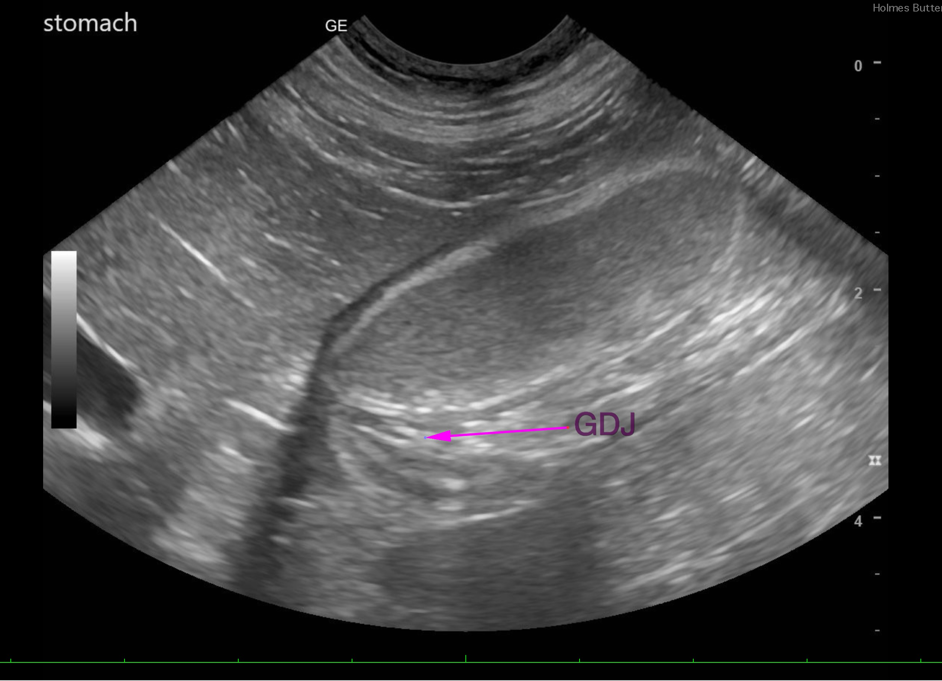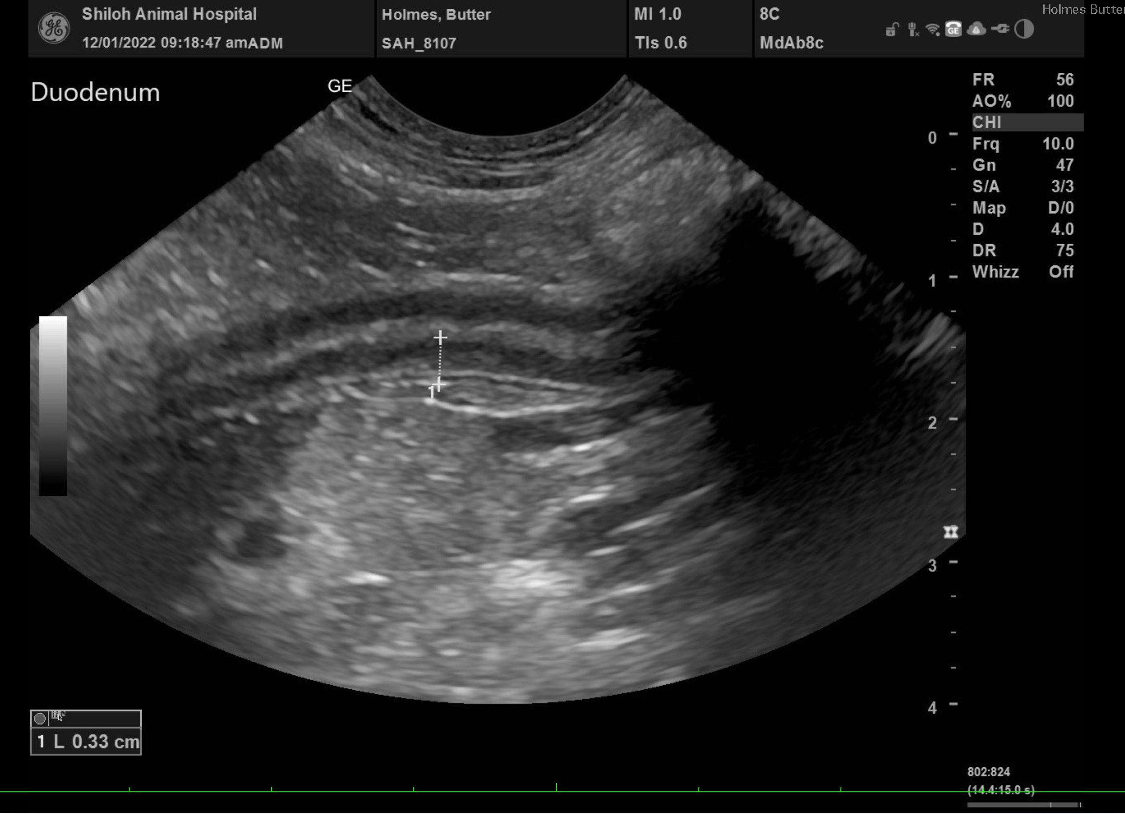

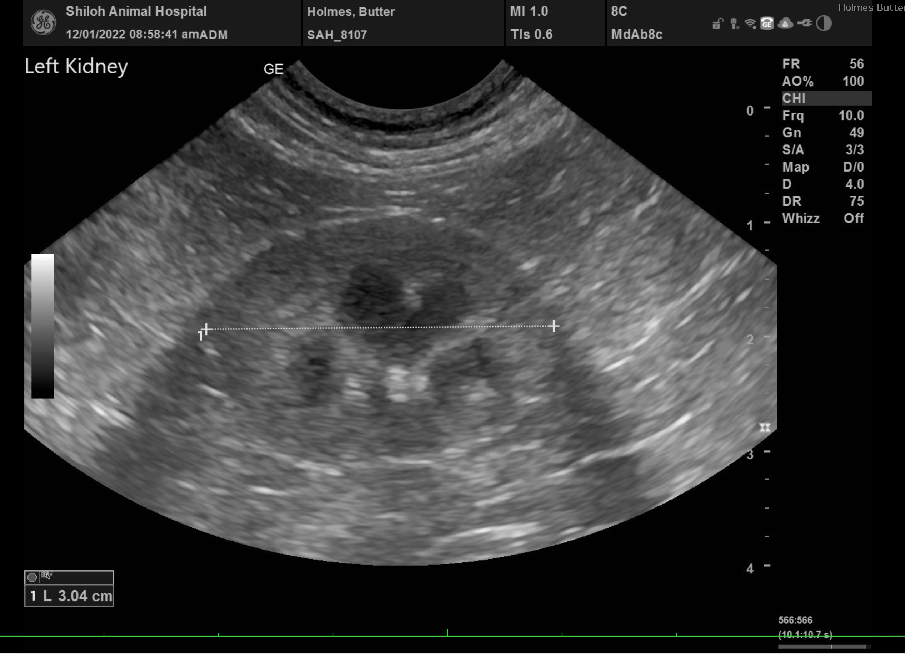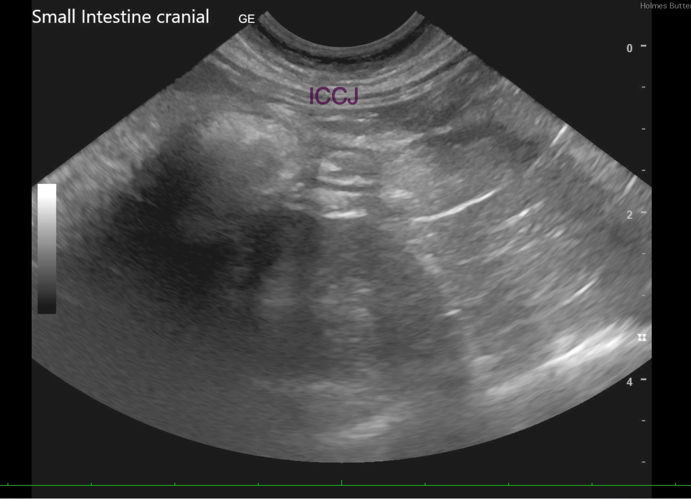

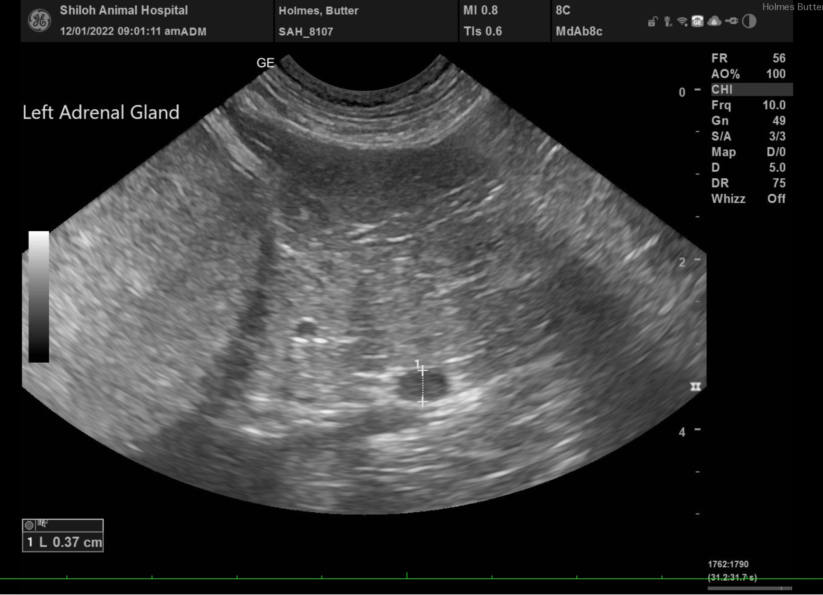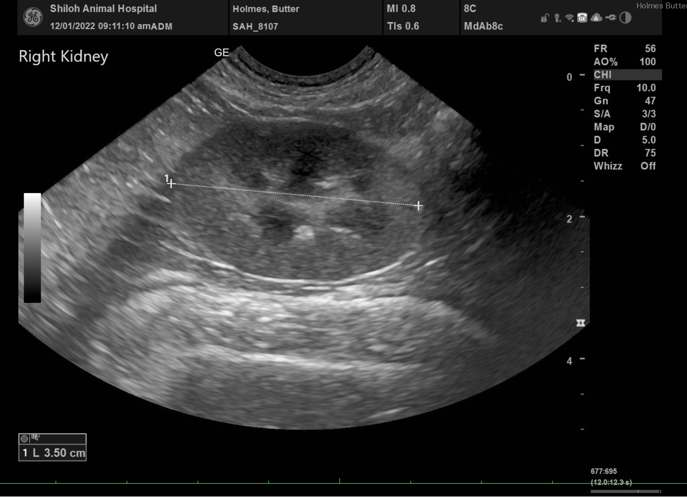

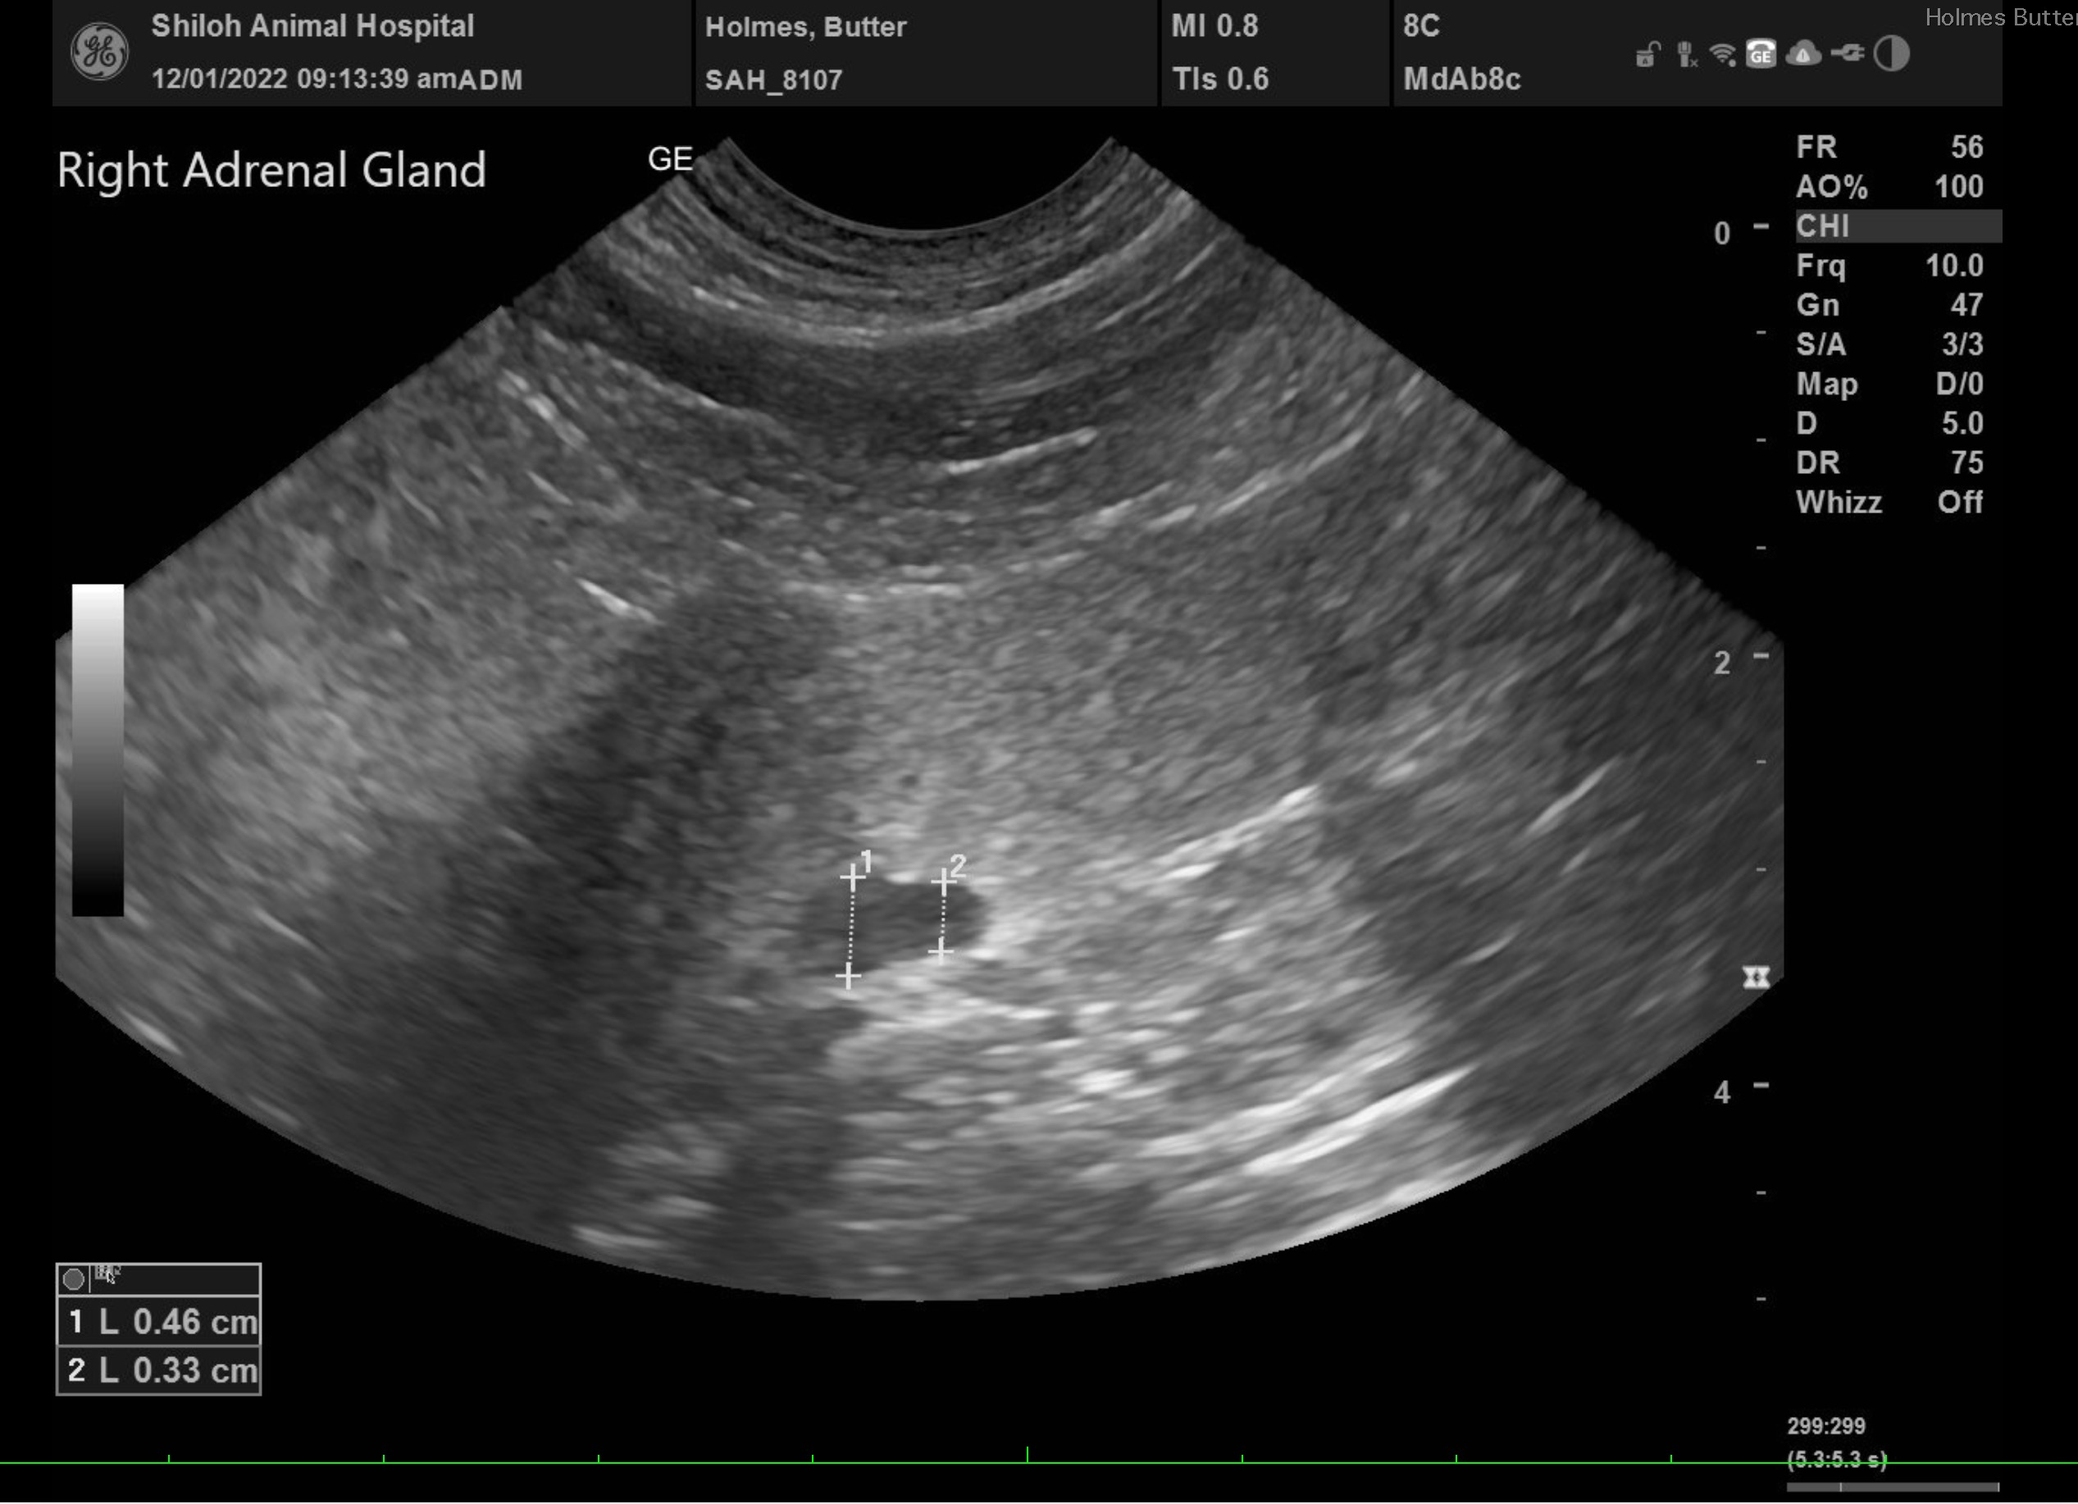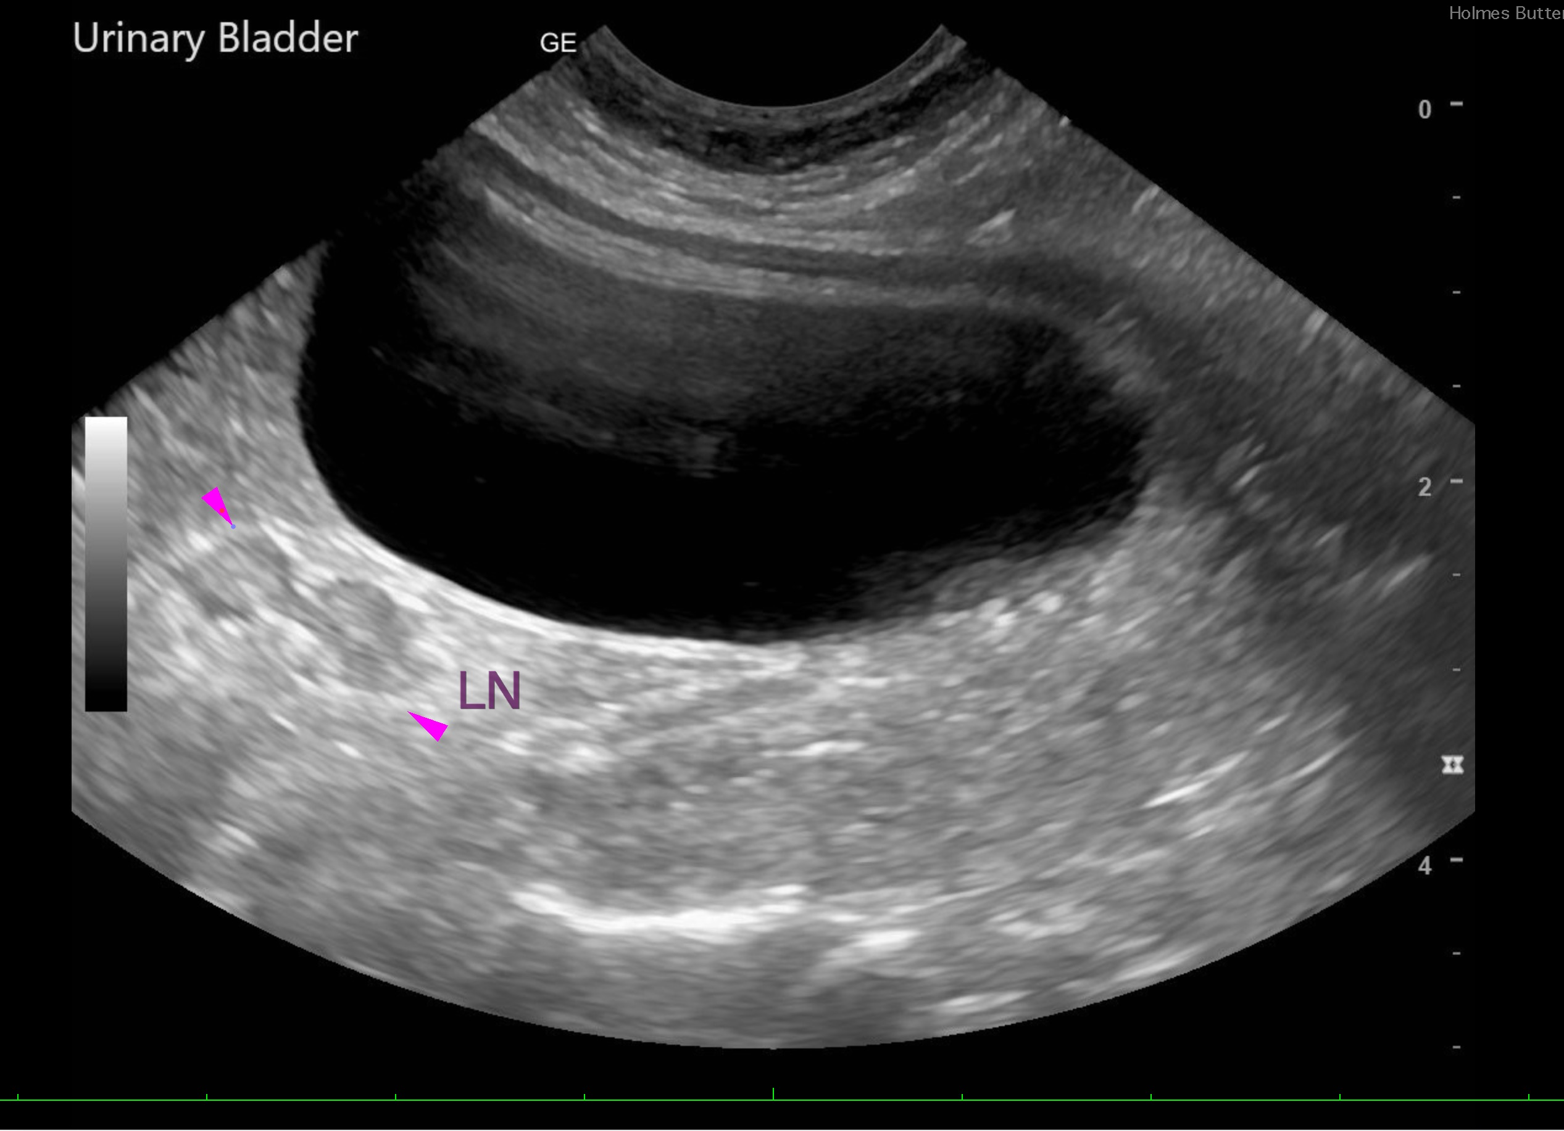

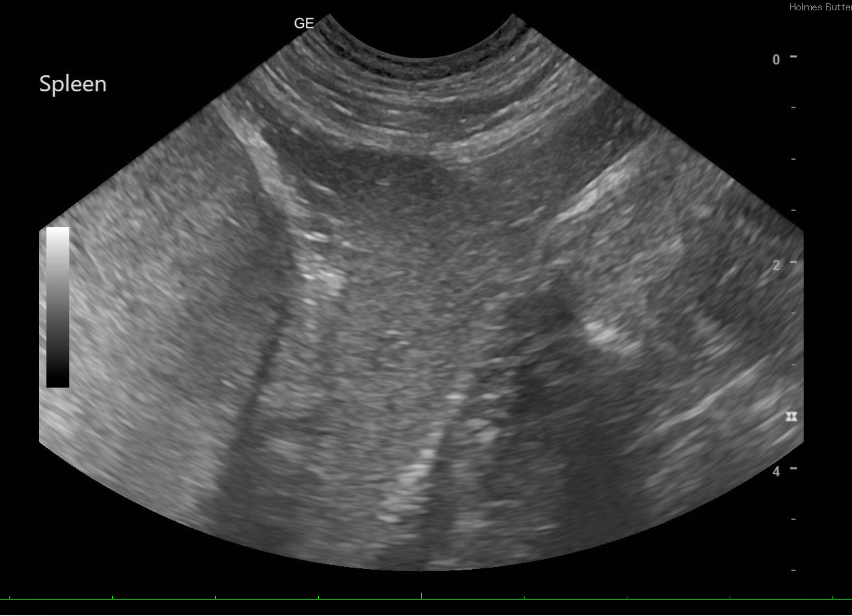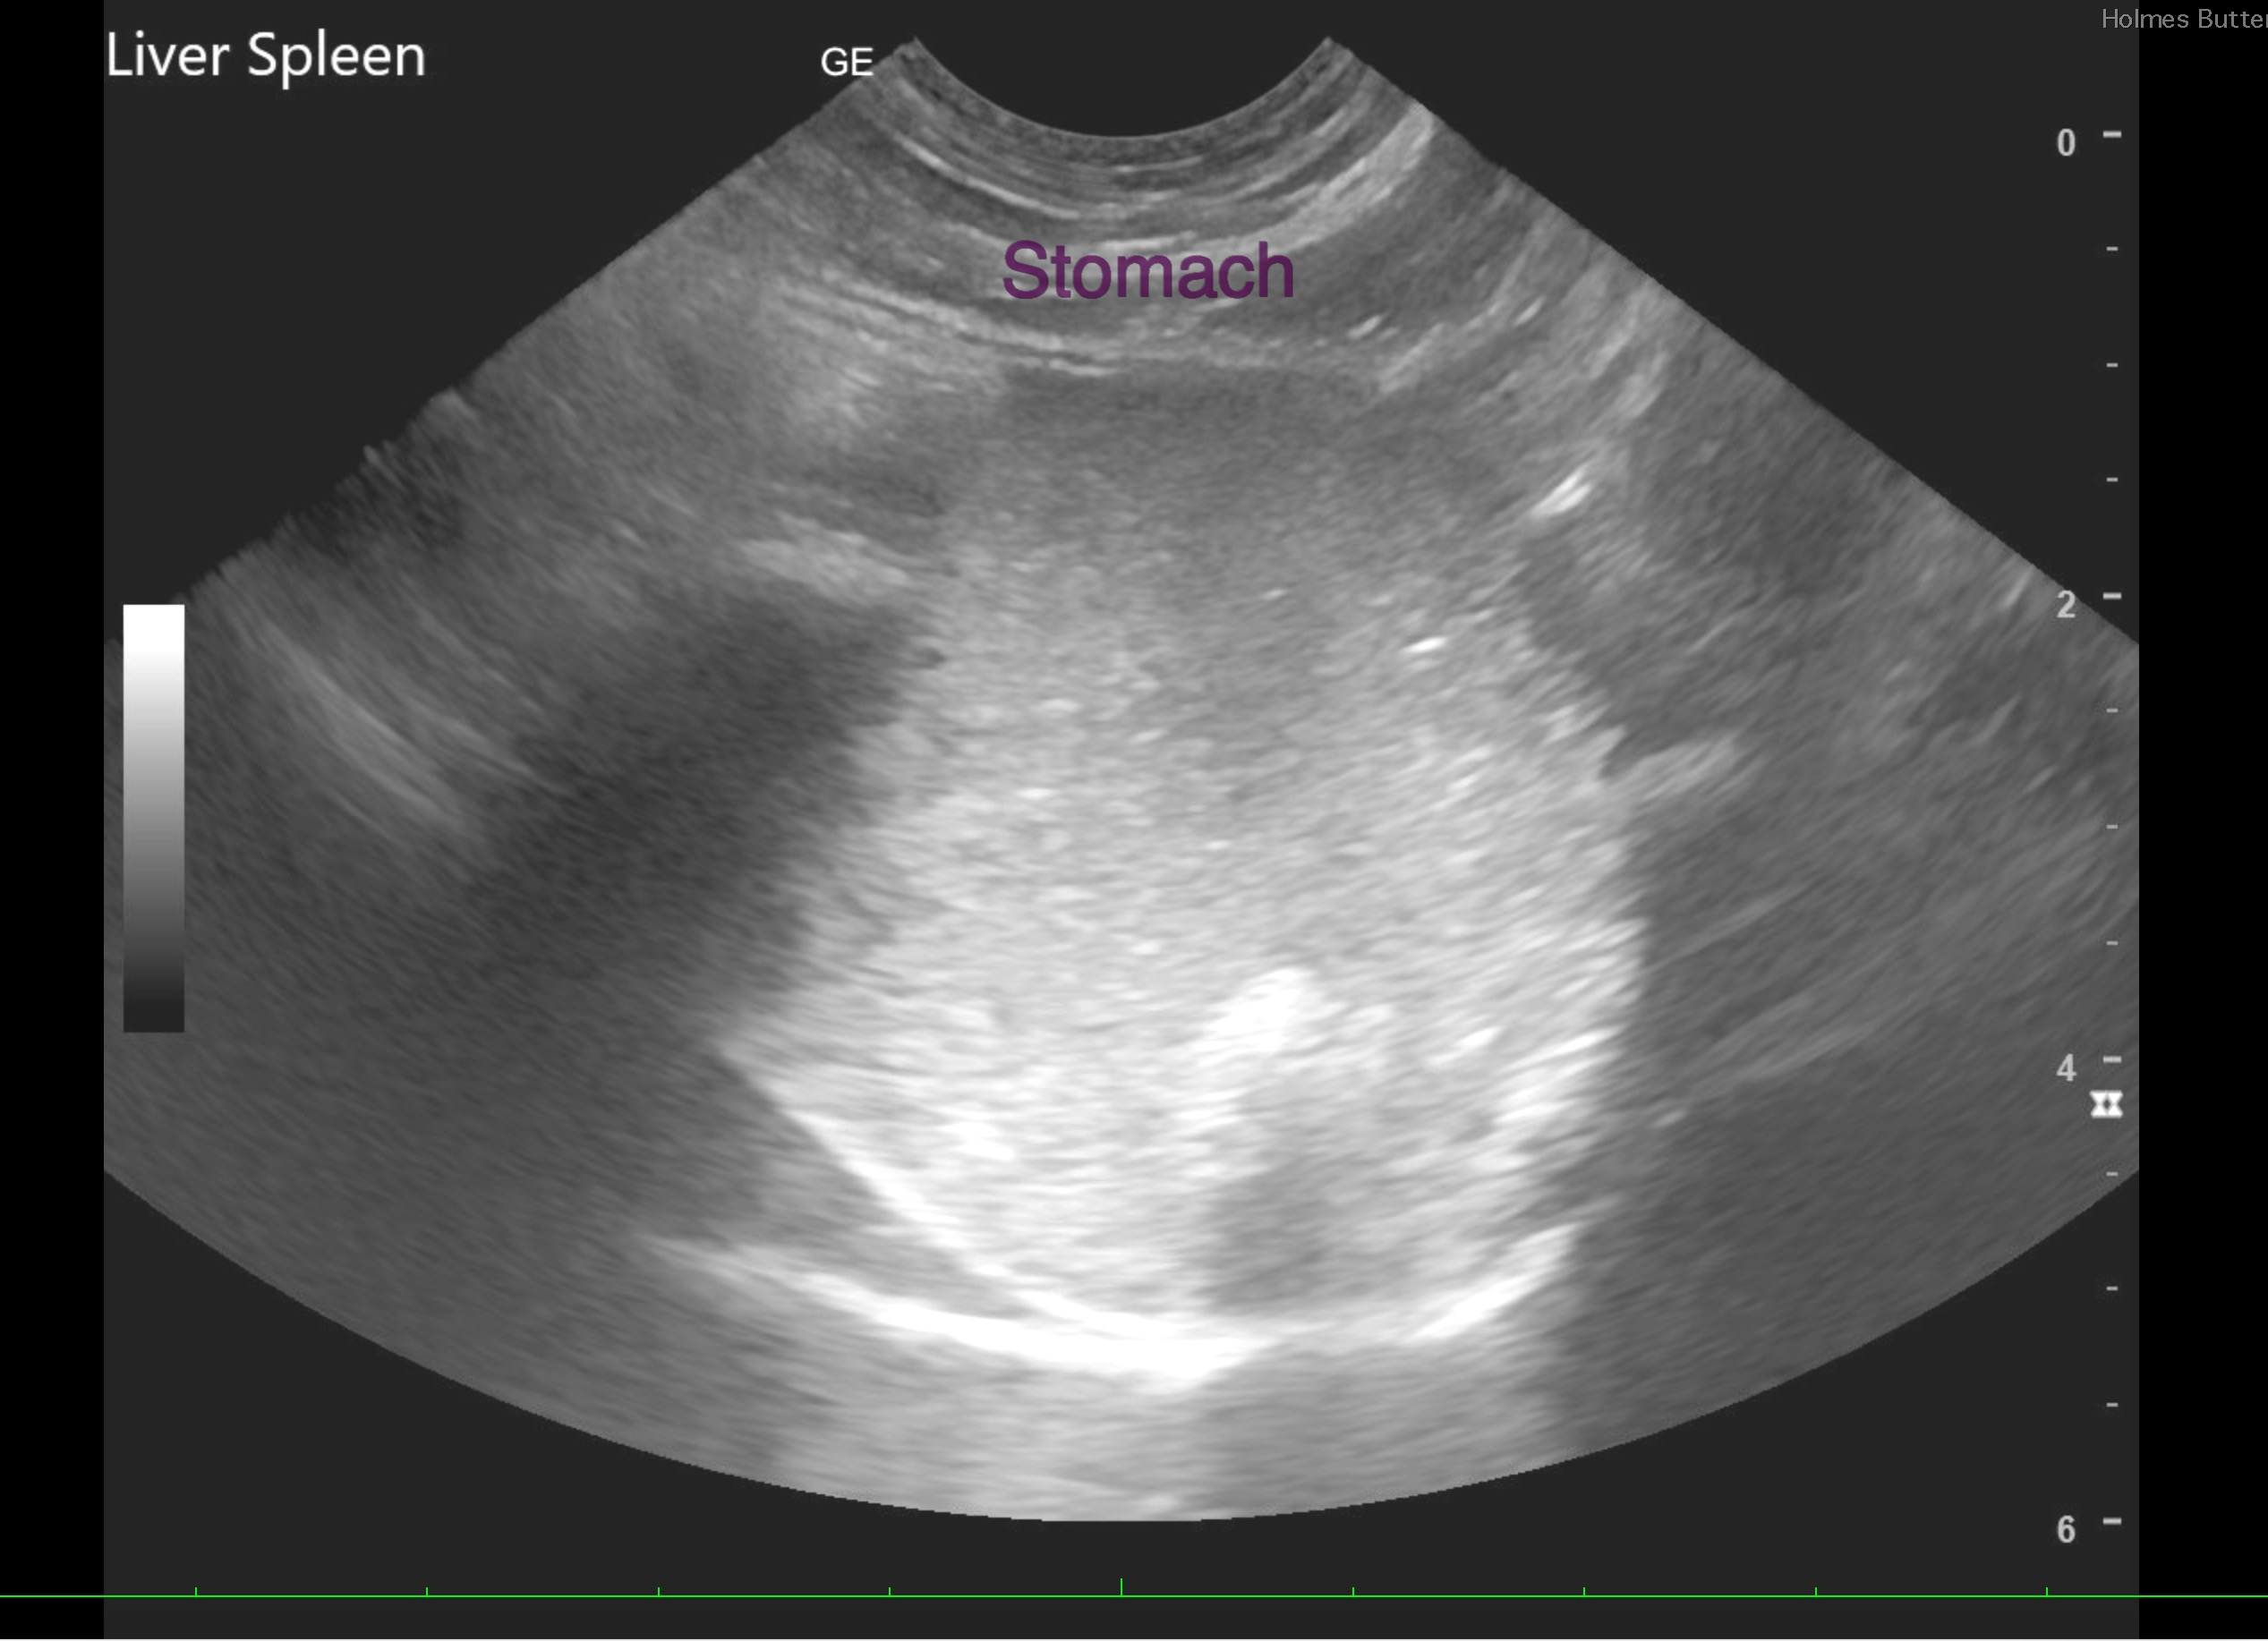

The information and recommendations provided are based on the images presented by the referring veterinarian/sonographer. No evaluation can be communicated regarding pathology that was not visible in the image/video clips provided.

Thank you for this referral. If the clinical or image interpretation does not parallel your findings or if I can be of any further assistance, please contact me.
Andrea Nicastro, DVM, Diplomate DACVIM (Small Animal Internal Medicine)
info@SonoPath.com

