PRESENTING CLINICAL SIGNS
Approx 4 mm mass of lateral 5th digit of L forelimb
Moist dermatitis of 4-5th interdigital space

CYTOLOGY SUBMISSION
Lateral digit mass

OBSERVATIONS
Lateral digit mass: Submitted are 9 excellent images of cells collected from the digital mass on Ellie. The majority of the cells are round cells. There are scattered neutrophils in the collection. The round cells have eccentric nuclei and some have halos next to the nuclei. There are binucleated cells in the collection. The cytoplasm is dark to granular. These cells are surrounded by RBCs.

INTERPRETATION OF THE FINDINGS & FURTHER RECOMMENDATIONS
Lateral digit mass - Round cell tumor suggestive of a plasmacytoma.

COMMENTS
The cellularity is supporting a round cell tumor and most likely a plasmacytoma. Excision is encouraged with a follow up biopsy to confirm the mass and excision. Malignancy is not suggested. Another possibility is a severe inflammatory process due to ruptured keratinized cyst but the cellularity is most consistent with a plasma cell tumor that is benign.

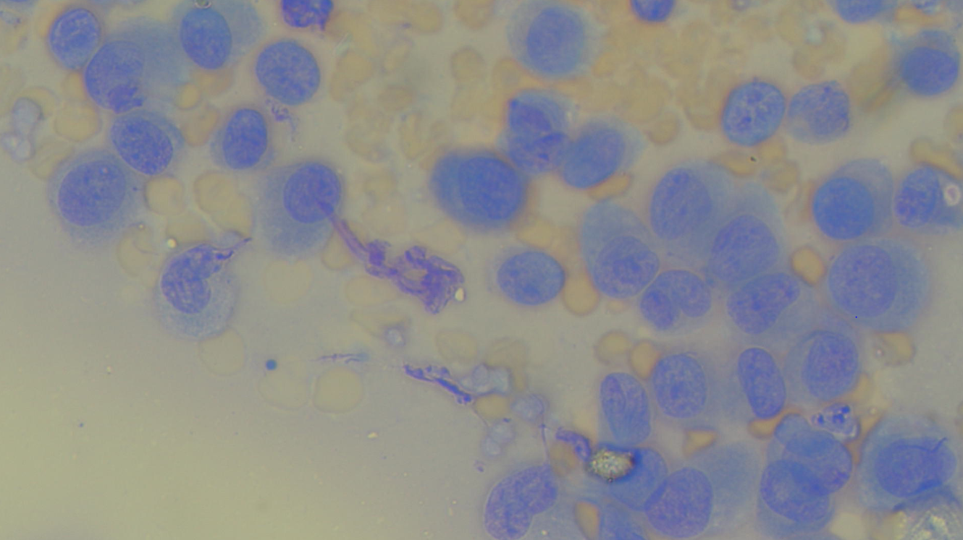
The image shows a representative group of cells collected from Ellie. Note the eccentric nuclei.

The information and recommendations provided are based on the images presented by the referring veterinarian. No evaluation can be communicated regarding pathology that was not visible in the image/video clips provided.

Thank you for this referral. If the clinical or image interpretation does not parallel your findings or if I can be of any further assistance please contact me.

L.D. McGill, DVM, Ph.D., DACVP
8288 Top of the World Drive
Cottonwood Heights, UT 84121
ldmcgill.vetpath@gmail.com
cell: 801-865-1220

